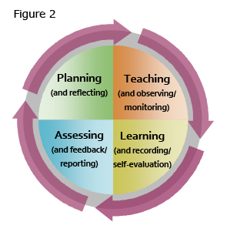
In this essay I will look critically at the effective use of assessment within a Key Stage Two classroom. I will link what I have observed to relevant research and theory. I will then reflect on this while describing my idea learning environment. My essay is based on a visit to a Key Stage two classroom in an Urban Primary school. There are 660 pupils on roll and 30.5% are on Free School means (FSM). The pupil teacher ratio is 20:1. Taking into consideration ethical issues, in accordance with BERA regulations, the school name and any individuals will remain anonymous (BERA 2018). Assessment for Learning (AfL) is a formative approach which is used throughout the lesson to allow the teacher to gain an understanding of the learners progress (Bates, 2016, p. 251). AfL will be the main focus of my observation however I will also observe the lesson to indicate the use of Assessment of Learning (AoL), this is a summative approach which is used at the end of the lesson by a teacher to gauge whether the children have learnt the skills outlined in the objectives of the lesson (Bates, 2016, p. 251). To gather the information I will be keeping a running record of events.
The teacher began by asking the children to recall their previous learning and to indicate what skills they had developed whilst completing the previous task, recapping and assessing to gain an understanding of where the children were in their learning. After questioning the children on their previous learning the teacher introduced the Learning Objective (An objective was set for their current year group and also the year group above). The children were asked to RAG their understanding of the Learning Objective at the start, with Green= fully understand, Amber = Understand somewhat and Red = Don’t understand at all (Appendix A). This would give the teacher a good understanding of where the children’s learning was at. The teacher went on to explain that the skills learned previously would be built upon and applied in the lesson.
The teacher set the children to work in mixed ability groups to look at a variety of information flyers, asking the children to list the common features. I had noticed that the teacher was moving around the various groups, questioning them on their decisions and at times providing support to some learners in gathering the information needed. After some time the teacher gathered the pupils back as a class and explained that together they would form a Success Criteria for their learning (Appendix B). This was particularly interesting as I felt the children were far more engaged in suggesting their own Success Criteria. This is an approach I would be keen to adopt while teaching as I feel the children become far more engaged in their learning when they fully understand what they need to do to be successful. The teacher explained the other two Success Criteria to the children and asked for thumbs up to show that they had understood what skills they would be using to complete the task.
As the children were on task the teacher was observing their learning and feeding back as the lesson was going on, asking questions in order to assess their understanding of the task and also move their learning on. I noticed the teacher was talking with one particular child about the way they had spelt a word. The teacher pointed out the child had misspelt the word and had asked how they could check the correct spelling. The child fetched a dictionary and corrected the word in red pen. When I asked the child why they had used red pen their response was “It stands out so that we can see our mistakes” The child had moved their learning on independently after initial prompting from the class teacher. It was apparent at this point that the children were used to this method and were very independent in doing so. Being independent learners is a common feature in the class I observed, and is linked heavily to Donaldson’s Successful Futures. Through his four purposes, Donaldson wants the education system in Wales to promote independent learners (Donaldson, 2015, p. 29).
As the teacher observed the learning the AfL was present in the marking. To indicate very good work or ‘wow-words’ the teacher would highlight the work in pink. If the teacher wanted more explanation on a particular thing they would highlight the word in green (Appendix C). If a word was highlighted in green the children could offer oral feedback to explain their learning further. The teacher had pointed out to me that highlighting the work pink gave the child a sense of achievement and this would be of benefit to their self-esteem. The teacher indicated that when providing feedback it was vital that it always began with a positive and that there is always a positive in every piece of work. Likewise it was also important to indicate there is always further learning that can be done. This was evident in this teachers approach as it was apparent in the approach and learning style that positive reinforcement was used not only as an assessment tool but also in behaviour management of the class.
At the end of the lesson the teacher asked the pupils to RAG their Success Criteria in order to assess how their learning had gone, and also to go back to the learning objective and RAG it again (some children had changed the colour they had first used, which showed they had a better understanding of the skills, whilst others kept it the same). The teacher explained to me that this would be looked at by the teaching staff in weekly meetings to identify pupil progress and confidence in their own learning. The children were then asked to self-assess their work honestly and also provide a way forward for their learning. Before asking them to write their self-assessment the teacher gathered ideas from the pupils as to what kinds of sentences they could come up with in order to assess their work with meaning. The teacher explained to me that they shared the ideas as a class as it offers ideas to those who find self-assessment tricky and it also shows understanding of what they have learnt.
Throughout my observation I had decided to use written notes as a running record for my observations to use for future reference. This was a useful way of keeping a record of the AfL present. However writing events down as they occur can be tricky, especially when more than one event is happening within the classroom. In order to capture a better understanding of the assessment in the classroom, next time I would consider using event sampling (Cohen, et al., 2011, p. 463). I would use this style of observation to note down when any form of assessment would take place within the class.
In my observations I have also taken photographic evidence and work samples to show that assessment was present. These have been included in Appendix. I have also included the consent form (Appendix E) that shows that permission was given to take the work off site. With this observation in mind I will explore and critically evaluate the effective use of assessment within the primary school, with close focus on AfL.
Constructivists are of the view that children build on their prior knowledge, this can be simply by listening to the teachers and to construct new knowledge (Grigg, 2015, p. 137) However Grigg (2015, p.137) points out that a balance is needed when teaching as a constructivist as sometimes teachers can become too focused on assessing and monitoring their pupils and fail to spend enough time teaching them. This theory of learning has come mainly from the work of Jean Paiget. He believed that children should be allowed to question, explore and construct their own learning (Grigg, 2015, p. 137). He believed that children learn best from doing things themselves rather than being spoon-fed by a teacher (Grigg, 2015, p. 137). Through his studies on child development, Piaget concluded that children could not understand new information if they had no prior knowledge or understanding of what was being taught (Mcblain, 2014, p. 40). Children build on their previous knowledge, Jean Piaget developed the idea that in order to absorb new information you must be able to connect it to existing knowledge (Arthur, et al., 2006, p. 51). Arthur, et al. (2006, p,51) provides a modern day example of this. When walking into a new restaurant for the first time, you will know the process of what is going to happen. You may never have been into the restaurant before, however because of your previous knowledge of how restaurants work you will link this to new learning and know what to expect. This was seen in the observations I undertook. The teacher began the lesson by asking the children to recall their previous learning and the skills they used and needed to complete the task. Piaget believed that intelligence was a fixed trait. He developed the thinking of schemes, these are what can be described as the building blocks of knowledge. Children build on these schemas and can draw on previous learning to develop new building blocks (Aubrey, K and Riley, A, 2016, p. 37).
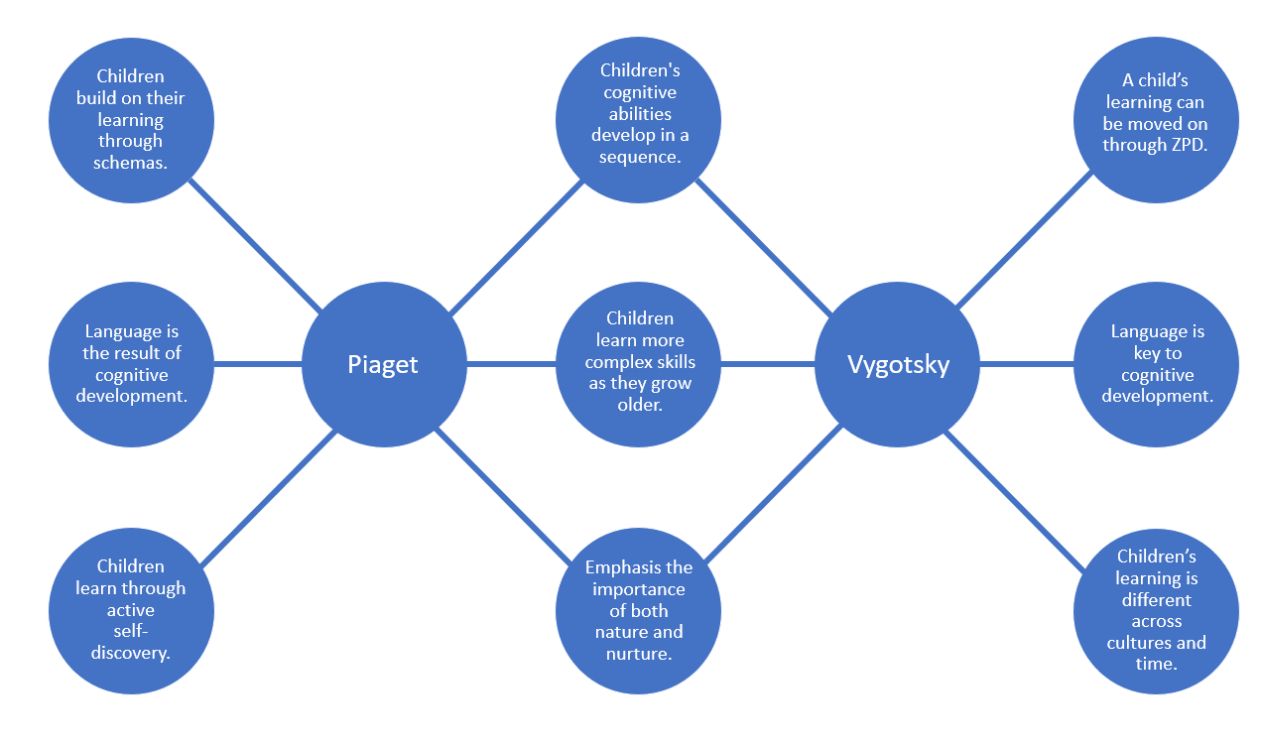
Over the years Piaget’s theory was somewhat criticized by the work of Lev Vygotsky who adopted a more social view to children’s learning. Vygotsky’s ideas and concepts of education come from the social constructivists point of view. This is that both culture and environment have an impact on a child’s learning and from this children build an understanding (Aubrey, K and Riley, A, 2016, p. 48). Vygotsky developed the idea of the Zone of Proximal Development (ZPD). The ZPD is described the gap between what a learner can do independently and what they can do with the help of educators and peers (Grigg, 2015, p. 139). This took on a slightly different view from Paiget, in which children can learn much more from their peers (peer assessment). Vygotsky noted that children pass through this zone at different rates and therefore teachers should stay away from teaching the same concept and the same time in the same way because it will be largely ineffective (Grigg, 2015, p. 139). Vygotsky mentions that assessment should focus on the development of the child with the assistance of adults and peers. However this would be difficult to implement in practice (Aubrey, K and Riley, A, 2016, p. 52). The double bubble below points out the differences and similarities in Piaget’s and Vygotsky’s work.
Both understood the value assessment plays in a child’s development, however their views differed on how this was best achieved.
In the literature examining the use of effective assessment and good quality feedback, there is overwhelming evidence in support of its place within education. “Assessment and feedback are critical to the process of teaching and learning” (Bates, 2016, p. 251) Black and Wiliam are regarded as the two most influential people on the subject of formative assessment and their findings have led to changes in policy and practice (Bates, 2016, p. 252). Black and Wiliam (1998, p. 1) describe the classroom as a black box, in which numerous factors are fed in, for example teachers, pupils, rules, standards and tests etc. From the ‘black box’ the output that should follow is pupils that are more knowledgeable and should have better test results. Black and Wiliam (1998, p. 1) pose the question that how can anyone be sure that better output will come if we don’t study what is happening inside the box itself?
The answer usually given is that it is up to teachers: they have to make the inside work better. However according to their report, this answer is not valid for two reasons. Firstly, it is at least possible that some changes in the inputs may be counterproductive and make it harder for teachers to raise standards (Black & Wiliam, 1998, p. 2). Secondly, it seems strange, even unfair to leave this entirely on the shoulders of teachers. If there are ways in which policy makers can directly help and support the everyday classroom task of achieving better learning, surely these ways should be prioritised (Black & Wiliam, 1998, p. 2).
The argument set out by Black and Wiliam (1998, p. 3) is that a teacher needs to know about their pupils, what their learnings enjoy and what they find difficult. Teachers must understand that these vary from pupil to pupil. This was seen to be true of the classroom I observed. The teacher had a very good understanding of the pupils and was able to build on this. The lesson was structured around what they wanted to learn. The overarching theme was generated from the pupils themselves. From their research Black and Wiliam concluded that there are five key principles that form the base for effective Assessment:
- Learners are actively involved in their own learning.
- Effective feedback is essential and this must be based on clear learning outcomes or intentions.
- Teachers are more flexible and can adapt their teaching style in response to assessment results.
- Learners can self-assess and can confidently assess the learning of their peers.
- The impact of AfL motivates and gives confidence to learners (Bates, 2016, p. 252).
Using assessment in the classroom has a significant impact on a child’s development. In a study carried out by Black and Wiliam on effective assessment, the results determined that the impact was between 0.4 and 0.7 effective growth. To put the effect size of assessment into context, Black and Wiliam (1998, p. 3) noted that an effect size of 0.7 in recent Mathematical testing, would have raised the score of a nation in the middle of the league table to the top five.
The Sutton report backs the research carried out by Black and Wiliam. The report by the Sutton Trust looked into improving children’s learning and the tool kits that were on offer to do this. Afl is based on the idea that children need to know at what level of learning they are at and what tools they need to get further up the ladder of learning (Higgins, et al., 2011, p. 3). Much research shows that Afl works, the average effect size is around 0.8. However the Sutton report notes that this is only possible when class sizes are a lot smaller. A study by The Kings Medway Oxfam Formative Assessment Project (KMOFAP) found that in a large class size the average effect size was a lot lower at only 0.32, or half a GCSE grade (Higgins, et al., 2011, p. 3). The cost of AfL is very low, however there is clear evidence to show that professional development is needed in the field in order for teachers to carry out purposeful and meaningful AfL within the classroom (Higgins, et al., 2011, p. 10). The report also looked into effective feedback. The report concluded that good quality feedback is best directed at the task. Focus on what is right then what is wrong. Feedback should encourage the learner and not threaten their self-esteem. This was evident in the observation, the teacher would provide good positive feedback orally to pupils and the school had adopted an assessment tool of ‘tickle pink’ to provide this feedback. Feedback should always identify what the child has done well before offering improvements and should never be in comparison with another pupil (Arthur, et al., 2006, p. 361).
Feedback should be a ‘minute to minute process’ rather than given at the end of the lesson (Government, 2010, p. 26). Dunn (Bates, 2016, p. 33) says that this is easier said than done, but is not impossible. In sector leading practice on the use of assessment, Estyn (2017) noted that all staff were involved in the assessment of pupils and high quality training was provided in various areas of effective assessment such as feedback and AfL .Estyn (2017) recognised that children and staff needed to work collaboratively to come up with effective learning objectives and success criteria as this allowed children to access and develop a number of skills.
Having clear learning objectives and success criteria are a fundamental part in AfL. Displaying and discussing these at the start of a lesson allows children to understand what is asked of them during the lesson (Dunn, 2011, p. 36). Children in the class I observed had generated their own success criteria in small groups which were then fed back to the teacher and collaboratively a whole class success criteria was produced on the board by the teacher. Arthur, et al (2006, p. 358) point out that effective planning enables good learning opportunities and t do this the teacher must set clear objectives that focus on the skill and not the activity. Good planning also allows for teachers to find out what the pupils already know, this forms the platform to build on (Arthur, et al., 2006, p. 358). Also an element of pupil choice needs to be added and time needs to be set aside for plenaries so that children can reflect back on the end goal (Arthur, et al., 2006, p. 358). Dunn (2011, p. 37) notes that open ended learning objectives are the best for assessing children because it personalises the child’s learning far more. The learning objective set out by the teacher was linked to the Literacy skills needed to use and develop in the lesson. According to Dunn (2011, p. 41) assessment can only work effectively if, firstly children understand the learning objective and secondly, that the success criteria is a step by step guide that will help them achieve the objective. Hattie (2012, p. 51) notes that the success criteria needs to be clear and allow the learner to know that by completing each criteria they will reach the end goal successfully which it the learning objective set out by the teacher. In the lesson I observed the children were asked to RAG their learning objective, this was a tool in which the teacher could assess who understood the skills being developed.
Literature focusing on the subject of assessment has an overwhelming argument that its use within a classroom is of huge benefit to a child’s development. However it does not come without its limitations. Black and Wiliam (1998, pp. 3 -4) noted that good quality assessment would mean significant changes to the way teachers approach classroom practice. Clemson (1991, p. 19) argues that teachers must be firstly fully understand assessment before being able to assess children in their learning, the process of which is rather complex. Many of the difficulties surrounding assessment of children are within the teacher themselves, confidence is needed (Clemson, 1991, p. 31). Murphy (1999, p. 19) adds to this argument by pointing out that as a nation we give priority to grades over moving children’s learning on. Pupils themselves are more concerned with their grade at the end of a piece of work as opposed to focusing on the advice and how to move their learning forward (Murphy, 1999, p. 119). Wiliam favours an approach that would support teachers own judgement of pupils achievement and should replace all forms of testing. He continues to note that this is common practice in Sweden (Arthur, et al., 2006, p. 353). He goes as far as to say that this approach would also tackle the underachievement of boys, because the all or nothing approach to testing allows boys to believe they can make up lost ground at the last minute. Wiliam continues by suggesting that in this style of testing, pupils would be given a range of assessments (not all pupils undertaking the same) that would cover all aspects of the curriculum and allocated at random (Arthur, et al., 2006, p. 353). This he concludes would shift the focus of teachers simply teaching for the test and look more at celebrating what individuals have achieved in their learning journey (Arthur, et al., 2006, p. 353).
In conclusion having read around the subject of assessment it is clear that when used effectively the many different approaches to AfL have a beneficial impact on a child’s development. I will certainly ensure that I take on board the styles and keep in mind the importance of AfL within my own teaching experience. I will also try my best to adopt a mixture of constructivism and social constructivism practice within my classroom. From the literature read I have understood the importance of allowing children to build their own experiences within the learning environment. This approach will also be of benefit when implementing Donaldson’s Successful Futures.

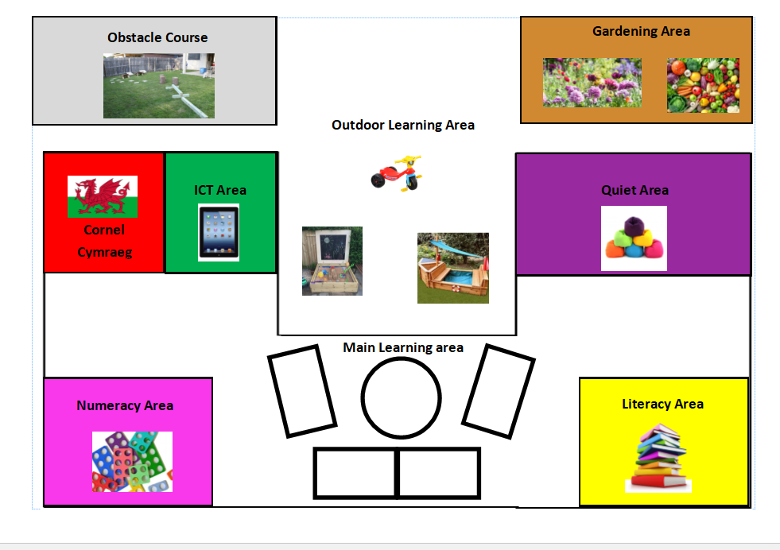

I have designed my ideal learning environment for a Year Three classroom with the view of Donaldson’s Successful Futures and Areas of Learning and Experience (AOLE) replacing the current curriculum and making the curriculum more of a continuum. Below is a description of how I would set up my ideal classroom.
Main Learning area:
This formal teaching area will have tables and chairs set in clusters to encourage group work and discussion between pupils. Research by Marx, Fuhrer & Hartig (1999) concluded that pupils engage much more in lessons when they are sat in a classroom set up like this as opposed to rows (ACER, 2018). Choosing to set up my classroom in this style therefore would promote more of a social constructivism classroom style where pupils will be encouraged to engage and discuss their learning.. The children would be sat in different seating depending on their ability grouping for English and Maths. The reason for this is to allow children to work in differentiated groups, as this removes some barriers in their learning whilst still allowing the child’s learning to move on (Grigg, 2015, p. 279). This is where I will adopt the approach of Vygotsky to assist in my learning style. Using the method of the ZPD to move the child on in their learning (Aurbery & Riley, 2016, p. 51).
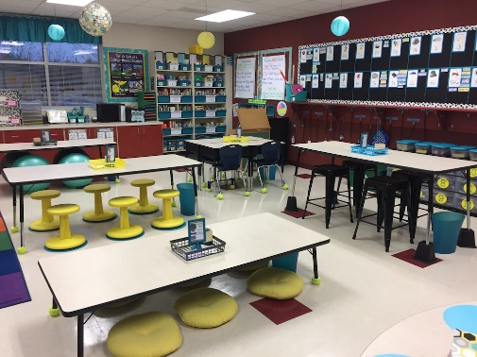
The final element of my main learning area will be the addition of flexible seating. Studies show that children learn best when they are sat comfortably, and as every child is unique then their choice of seating will differ (System, 2017). Giving children the choice of seating gives them a sense of empowerment and choice of their learning environment. It also has physical benefits too. If children are rocking, bouncing or leaning they are increasing their oxygen levels which has proven to keep minds more alert and focused (System, 2017). Flexible seating also promotes collaborative learning (System, 2017). This type of seating will there for add to my idea of a social constructivists classroom.

Cornel Cymraeg
“Pupils should be given opportunities, where appropriate, to develop and apply knowledge and understanding of the cultural, economic, environmental, historical and linguistic characteristics of Wales” (Government, 2003, p. 4)
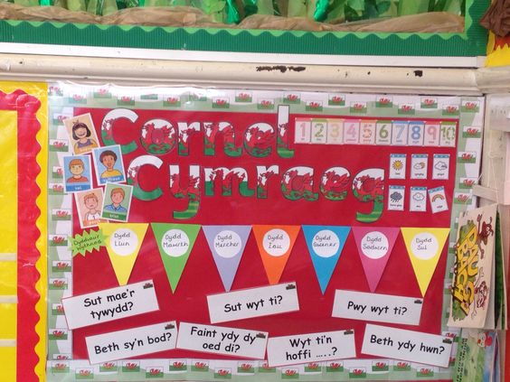
The “curriculum Cymreig” outlines the importance of understanding what is unique about our country and to promote a sense of belonging (Government, 2003, p. 4). Article 7 of the UNCRC states that all children have the right to have a nationality (Unicef, 2018). My cornel Cymraeg will celebrate all things Welsh. The main focus will be on ‘Y Filltir Sgwar’ (My home). The Welsh Government (2003, p,6) point out that opportunities should be taken to allow children to understand the diversity of Wales while promoting a sense of belonging and promote a deeper understanding of the country we live in. However the Welsh Government continue by noting the need to ensure the curriculum delivered is unique to the area and ensure that it does not promote a stereotypical Welshness.
In this area, children will have opportunities to develop their understanding of Wales and where we see ourselves within the World. They will be given a variety of ways to do this whilst developing the LNF and DCF skills. Donaldson’s Successful Futures document (Donaldson, 2015, p. 30) outlines four key purposes, one of which is to promote ethically, informed citizens of Wales and the World. This is also in keeping with the UNCRC, Article 30 notes that every child has the right to speak their own language (Unicef, 2018). My Cornel Cymraeg will help ensure that this purpose is met.
Quiet Area
“Improving the health and well-being of the nation has been an important feature of Welsh Government policy and support to schools for many years” (Donaldson, 2015, p. 45).
My decision to include a quiet area in my classroom is because of the increasing need to focus on children’s health and well-being. In the New Curriculum there is an AOLE dedicated to Health and Well-being. The focus of this area focuses only on a child’s mental well-being, with increasing numbers of mental health cases in Wales (Wales.nhs.uk, 2018) it is necessary to address the issues . If a child is feeling anxious, upset or in need of a few moments of quiet they can go to the quiet area. The area will be decorated with soft furnishings and calm atmosphere to help the child. It is important to have somewhere to go and find a safe haven. In accordance with the UNCRC every child has the right to feel safe (Unicef, 2018). In reality for some children this designated quiet area would be their only chance of a safe place.
Outdoor area
My outdoor learning area will act as an extension to the more traditional indoor classroom. The outdoor area will be set up to make the most of learning experiences that are on hand. The Welsh Government stress the importance of using the outdoors as it offers unique learning experiences and also allows children to access stimuli such as the weather (Government, 2009, p. 2). The outdoors allows learners to move around, make noise, take risks and be creative (Government, 2009, p. 2).
My outdoor area will also have a fitness area which includes a climbing wall, mini obstacle course, skipping ropes and hoops. The area will be designed to promote a healthy life style. The reason I have decided to include a fitness area is due to the every growing concerns surrounding childhood obesity. Figures taken from the NHS show that seven in every 10 children are overweight. 27.1% of children in Wales are overweight with reception aged children more likely than the Welsh average to be obese (NHS, 2018). Public Health Wales has noted that only 51% of children were reported as undertaking the recommended amount of physical activity of at least one hour a day for five or more days of the week (NHS, 2018). Because of these figures I will introduce 5 minutes of daily exercise to help children physically and mentally prepare for their learning.
The outdoor space will also include a garden to develop Scientific knowledge of the world. A great gardening area will promote a child’s sense of care towards something they have grown from scratch (Bilton, 2010, p. 133). . Gardening also helps children’s motor coordination (Bilton, 2010, p. 133). With Donaldson’s purpose of developing enterprising, creative contributors in mind (Donaldson, 2015, p. 30), the garden area will act as an entrepreneurship project, which will allow the children to grow flowers and vegetables and then sell them to parents to make money for the class that can be spent on items they wish.

ICT area
My ICT area has been placed into my ideal learning environment with the understanding of the ever growing technology industry. Children are far more computer literate today and jobs of the future will ask for ICT skills. With this in mind this area of my classroom will allow children to develop their ICT skills as well as engaging with aspects of the DCF independently using the latest technology. The concept of this area is to allow children to practice their computer skills, and develop DCF skills.
There are some concerns over the over use of ICT equipment by the modern child. Dr Aric Sigman (Margalit, 2016) in his research explains that too much screen time can have a detrimental effect on a child’s development. He continues by adding that parents that use electronic devices to educate their children, are in fact doing more harm than good. However (Cockburn, 2001, p. 213) makes the point that useful ICT can be of benefit to children because it opens up a wider range of questions and solutions, and it is also useful to learners because it often does the job that normal paper and pencil methods cannot. With this in mind the ICT time will be limited to children and will be for educational reasons only. Children will use this area to develop skills, however it will run alongside the more traditional pencil and paper method as opposed to purely using ICT for everything.
Literacy and Numeracy area
In Donaldson’s Successful Futures, the emphasis is a continuum of Literacy, Numeracy and DCF through all AOLEs (Donaldson, 2015, p. 40). With this in mind I have decide to include a Literacy and Numeracy are which will be in keeping with the Foundation Phases continuum provision. Both areas will be language rich and provide continuum provision for skills that have been taught in the main teaching area. This will allow children to further develop their LNF skills and also promote independent learning. My literacy area will also have a reading section “Few would doubt that without the ability to read for meaning and pleasure, children and young people are seriously disadvantaged in life” (Grigg, 2015, p. 172). My reading area will contain books of age ability and at the level of the learners. The books be of a variety of generous in to familiarise the children with different types of writing, which will be of benefit to them when learning different literacy skills.
Classroom displays
All classroom displays will be bilingual (Welsh and English) to encourage pupils to use both languages confidently. Learning more than one language has many advantages, being bilingual opens more opportunities for jobs in the future (Grigg, 2015, p. 357). Also this will help toward the Governments objective to have one million Welsh speakers by 2050.
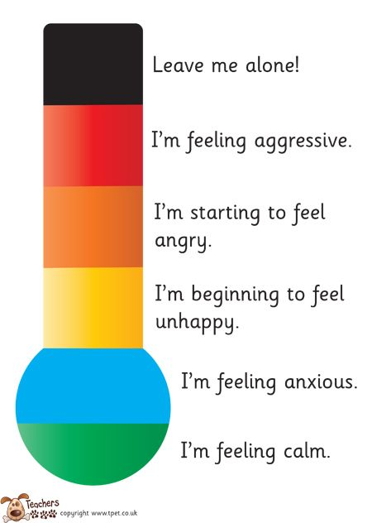
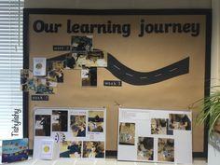
The classroom will have a ‘my learning journey wall’ to promote AfL within the classroom to promote independent learning. My decision to have this in the classroom was based on the overwhelming research into the beneficial approach assessment has on the children and promotes more independent learning which is heavily linked to Donaldson’s Successful Futures.
There will also be a feelings wall. Upon arrival in the morning children will place a picture of themselves on the corresponding feeling that best describes their mood. From this I will be able to evaluate the mood of the children and discuss any issues if needed. This display will tie in with the quiet area.

My classroom displays will also contain a reward style chart. I will introduce the concept of a ‘Dojo’ behaviour system to reward children for good work within the classroom. This idea is developed from the behaviourists theory based on the link between stimulus and reward and that a child can become familiar with being rewarded for doing something correctly. (Grigg, 2015, p. 135). My behaviour chart will focus more on individual achievements that are not always academically based. Children will be rewarded for their manners, achievements outside of school and their behaviour towards others.
In conclusion my ideal learning environment will take on board elements of constructivism, social constructivism and behavioural theories and implement them within my classroom. The classroom id set up to promote independent learners with Donaldson’s four key purposes driving the learning. LNF and DCF will flow through all areas to help embed skills learnt in the main learning environment. Every child’s well-being will the most important aspect of my classroom. Having happy children that feel safe will allow learning of the highest quality to take place.

Appendix A
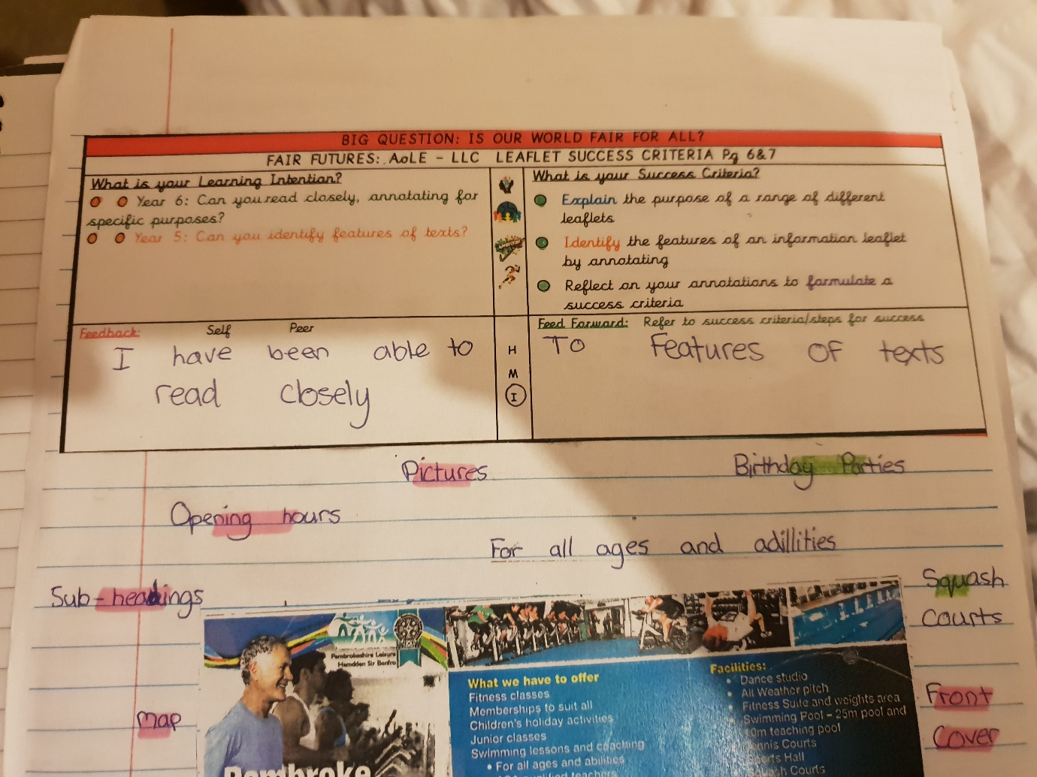
Appendix B

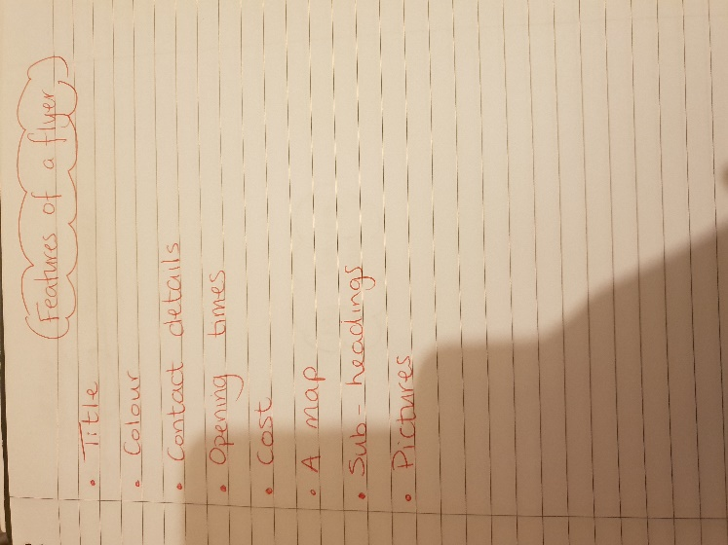

Appendix C
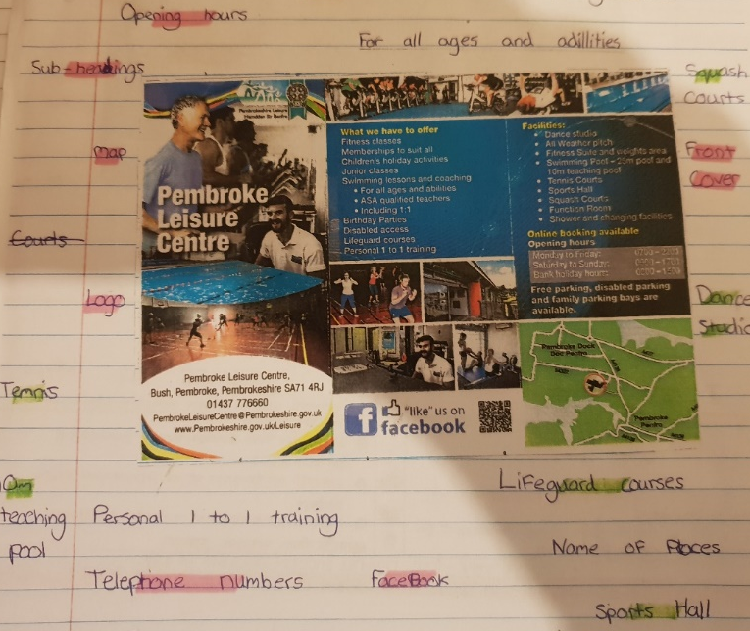

Appendix D

Appendix E

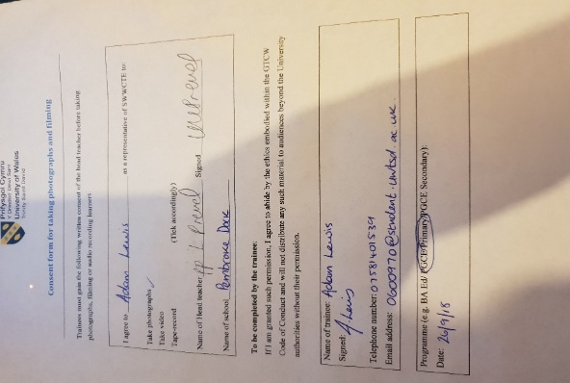

Bibliography
ACER, 2018. Teacher Evidence Inside Action. [Online]
Available at: https://www.teachermagazine.com.au/articles/classroom-layout-what-does-the-research-say
[Accessed 4th October 2018].
Arthur, J., Grainger, T. & Wray, D., 2006. Learning to Teach in the Primary School. London: Routledge.
Aubrey, K and Riley, A, 2016. Understanding & Using Educational Theories. London: Sage.
Bates, B., 2016. Learning Theories Simplified. London: Sage.
BERA, 2018. ETHICAL GUIDELINES FOR EDUCATIONAL RESEARCH, London: BERA.
Bilton, H., 2010. Outdoor Learning in the Early Years Management and Innovation. 3 ed. Oxon: Routledge.
Black, P. & Wiliam, D., 1998. Inside the Black Box, s.l.: s.n.
Clemson, D. & Clemson, W., 1991. Primary Assessment. 1 ed. Cheltenham: Stanley Thornes Ltd.
Cockburn, A., 2001. Teaching Children 3 to 11. London: Sage.
Cohen, L., Lawrence, M. & Morrison, K., 2011. Research Mwthods in Education. 7th ed. London: Routledge.
Donaldson, G., 2015. Successful Futures, Cardiff: OGL.
Dunn, D., 2011. How to become an Outstanding Primary Teacher. London: Continuum International Publishing Group.
Estyn, 2016. Effective feedback to support independent learners, Cardiff: Estyn.
Government, W., 2003. Developing the Curriculum Cymreig, Cardiff: Welsh Government.
Government, W., 2009. Foundation Phase Outdoor Learning Handbook. Cardiff: Welsh Government.
Government, W., 2010. How to develop thinking and assessment for learning in the classroom, Cardiff: Welsh Government.
Grigg, R., 2015. Becoming an Outstanding Primary School Teacher. 2 ed. Oxon: Routledge.
Hattie, J., 2012. Visible Learning for Teachers Maximizing Impact on Learning. London: Routledge.
Higgins, S., Coe, R. & Kokotsaki, D., 2011. Toolkik of strategies to improve learning, Durham: The Sutton Trust.
Margalit, L., 2016. Psychology today. [Online]
Available at: https://www.psychologytoday.com/us/blog/behind-online-behavior/201604/what-screen-time-can-really-do-kids-brains
[Accessed 4 October 2018].
Mcblain, S., 2014. How Children learn. London: Sage.
Murphy, P., 1999. Learners, Learning and Assessment. 1 ed. London: SAGE.
NHS, 2018. NHS. [Online]
Available at: http://www.wales.nhs.uk/
[Accessed 10 October 2018].
Printerest, 2018. Printerest. [Online]
Available at: https://www.pinterest.co.uk/
[Accessed 7 October 2018].
System, S., 2017. Top 10 Benefits of a Flexible-Seating Classroom. [Online]
Available at: https://smithsystem.com/smithfiles/2017/11/29/top-10-benefits-flexible-seating-classroom/
[Accessed 2nd October 2018].
Unicef, 2018. UNCRC. [Online]
Available at: https://www.unicef.org.uk/what-we-do/un-convention-child-rights/
[Accessed 28th September 2018].

