Zachary Dunworth
DUN21865112
HND Applied Computing
Computer Architecture and Operating Systems

Contents
Introduction 1
Key functions of general Operating systems 1
Process Management 1
Memory Management 3
File management system 3
Device management 4
Windows OS CLI commands 5
dir 6
ipconfig 6
tasklist 7
netstat 8
Systeminfo 10
Copy 10
del 11
shutdown /r 11
help 12
cls 12
Linux OS CLI commands 14
ls -l 14
pwd 14
cd 15
help 15
adasdasdasd 16

Introduction
This report has been made to explain the operating systems and their roles during computer management. This report will include the key functions for each operating system, the use of Windows and Linux OS CLI Commands, and the OS and CLI scripts. By the end, there will be a conclusion which will explain what I have learned overall.

Key functions of general Operating systems

Process Management
Process management is a job of the operating system where it looks after all the programs (called processes) that are running on a computer. When you open an app like Google Chrome or Word, the operating system creates a process for it. If you open many apps, the OS must manage all of them together, so they do not crash into each other. 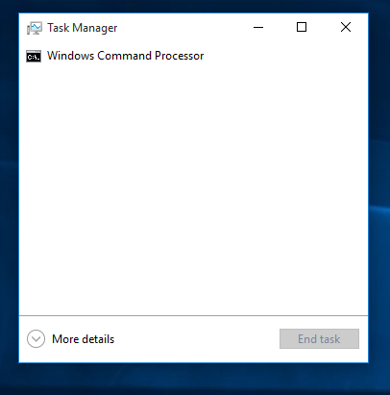

Memory Management
A memory management is a key function that handles the system's RAM. It makes sure that each process and application have sufficient memory while trying to stop conflicts. Memory management includes things like allocation, deallocation, paging, segmentation, and swapping.
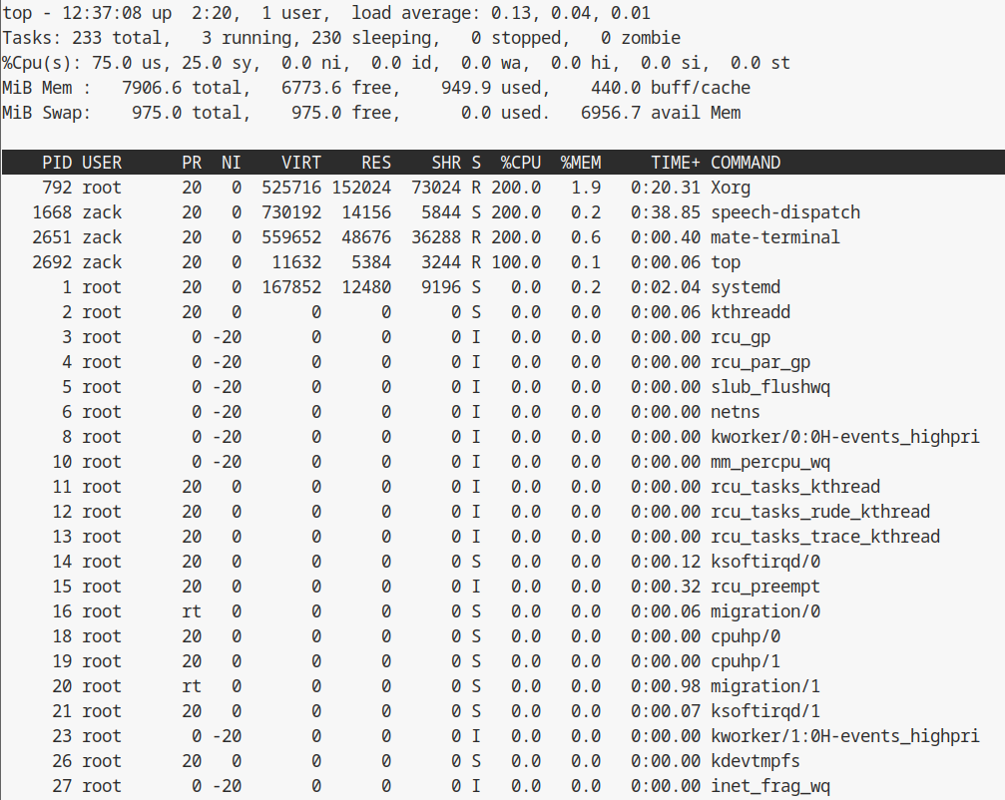

File management system
A File Management System is a tool or system that helps organize, store, and manage electronic documents and digital assets within an operating system or a specialized software suite. It enables users to create, delete, modify, and access files and directories, often including features like version control, access permissions, and backups.
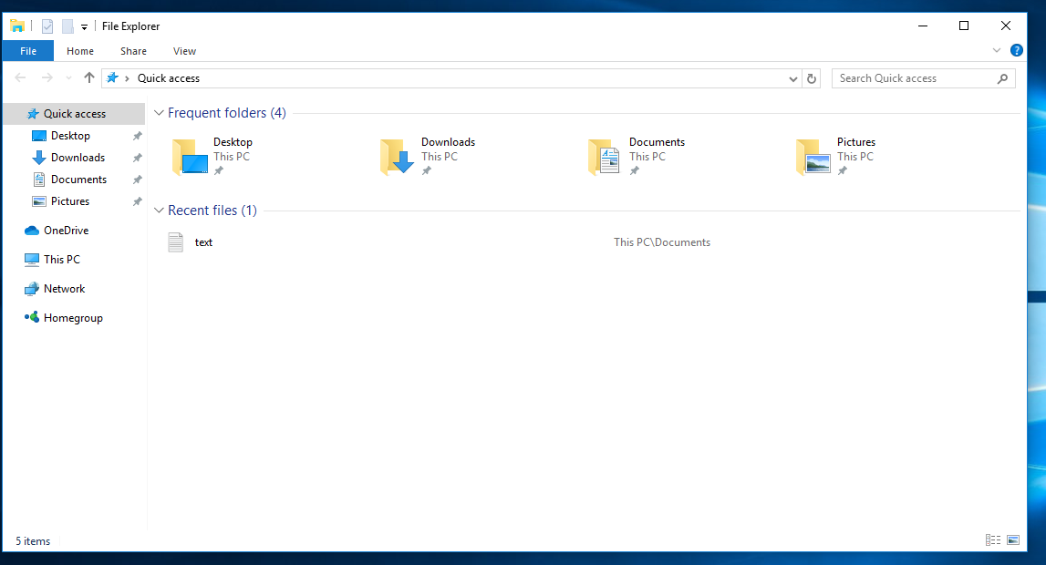

Device management
Device management is the process of administering and maintaining devices within an organization, including computers, mobile devices, and other IoT devices. It involves configuring devices, securing them, enforcing policies, and ensuring compliance with organizational standards.
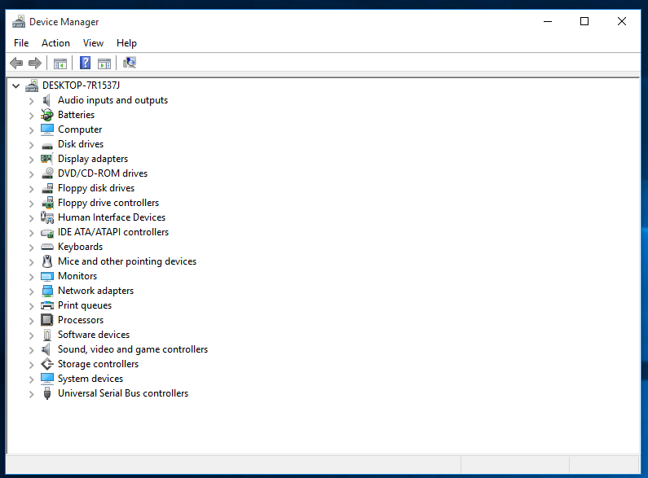

Windows OS CLI commands

dir
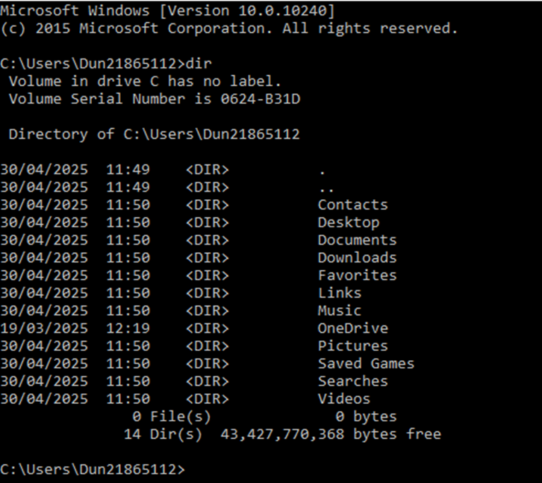
The dir command, which stands for directory, is a windows command that shows a list of all the files and folders in your computer. When you type the dir command in the Command Prompt and press Enter, it displays the names, sizes, and dates of files and folders that are stored in that location.

ipconfig
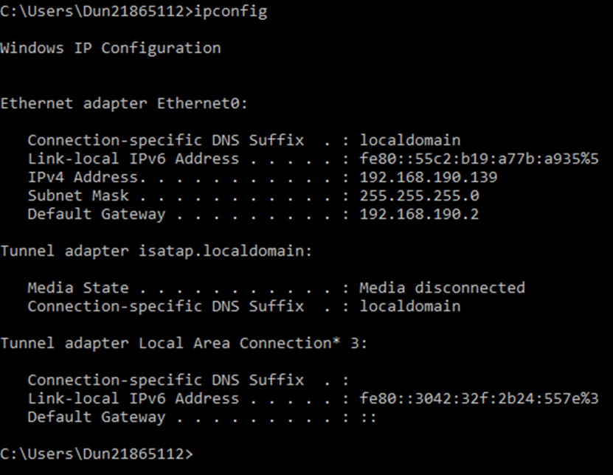
ipconfig is a command prompt. When you type in ipconfig in the command prompt, it shows your IP details, which include IPv4 address, Subnet Mask, and Default gateway. It is usually used for checking and troubleshooting IP

tasklist
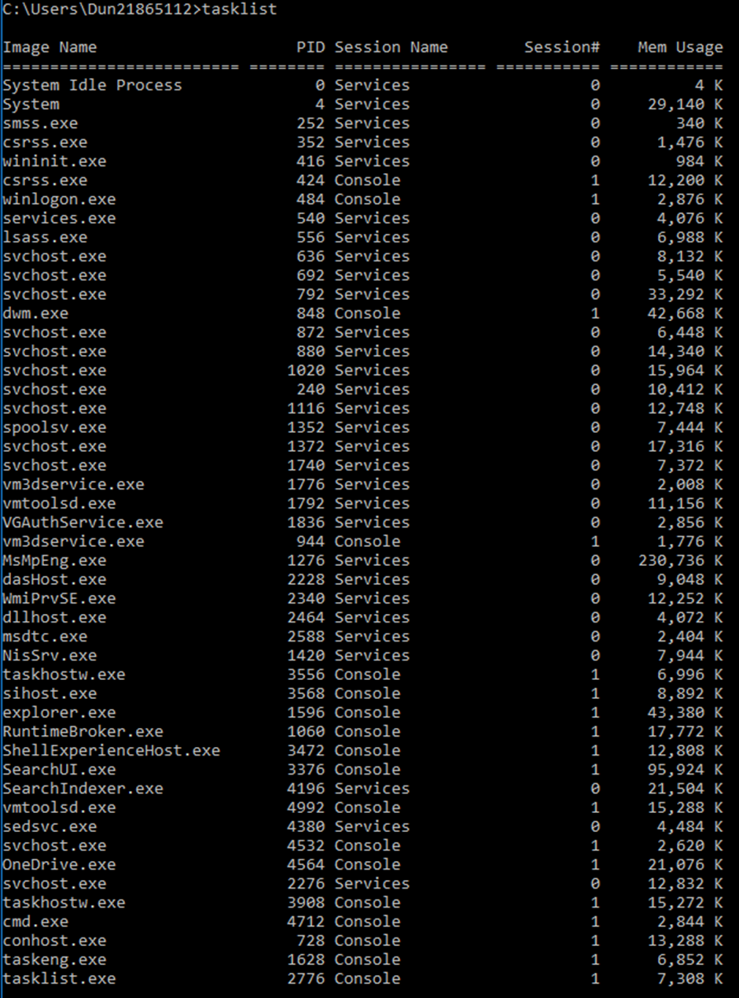
The tasklist command in Windows shows a list of all the programs and background processes that are running on your computer right now. It shows information like the name of each program, its process ID, and how much memory it is using.

netstat
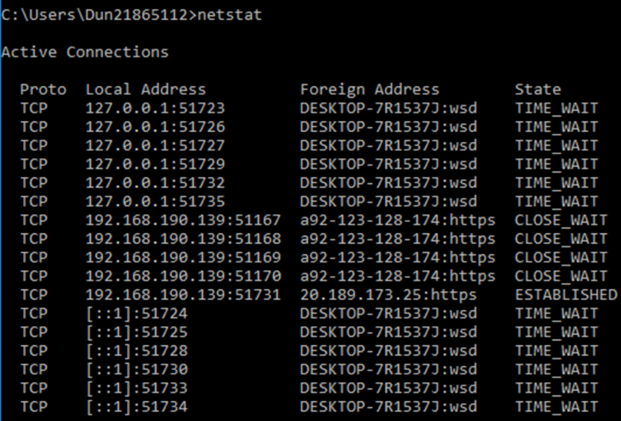
The netstat command, which stands for network statistics, shows information about your computer’s network connections. It displays details like which ports are open, which IP addresses your computer is connected to, and the status of those connections.

Systeminfo
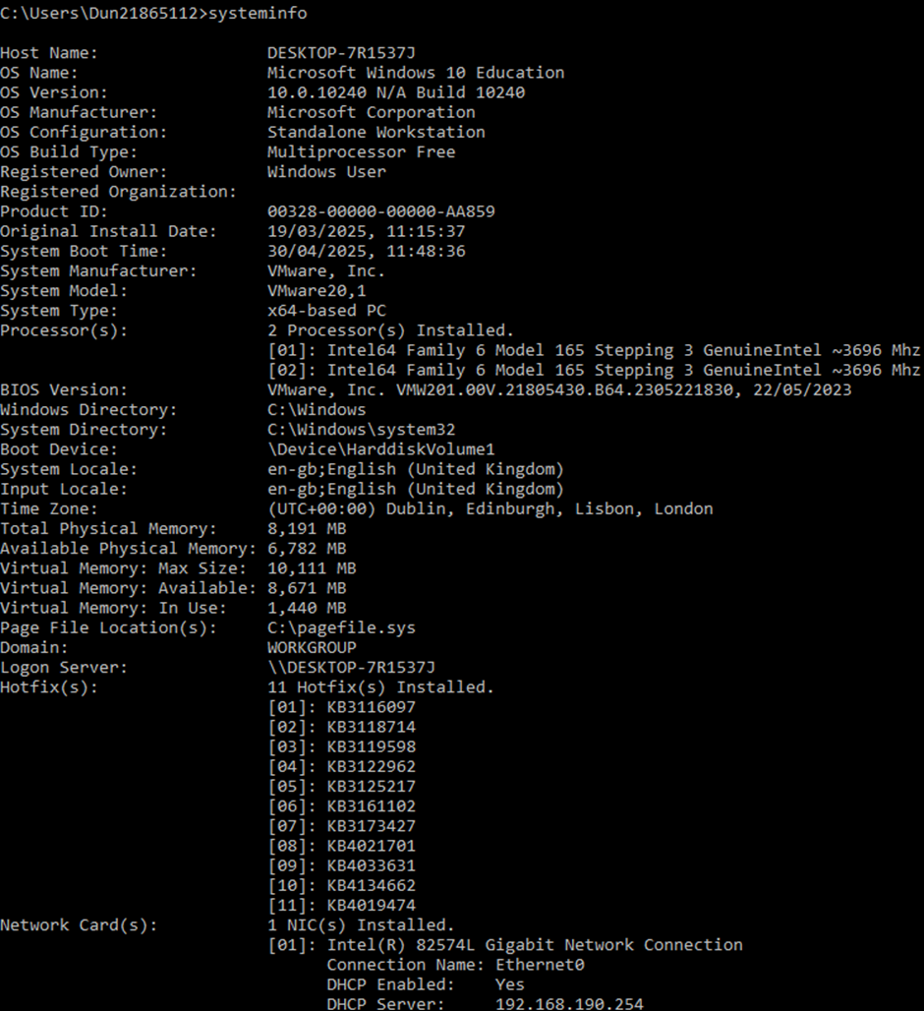
The systeminfo command, which is system information, in Windows shows information about your computer’s system. It displays things like the Windows version, computer name, processor type, installed memory, and network information.

Copy
The copy command in Windows makes a copy of a file. You tell it which file you want to copy and where you want to put the copy.

del
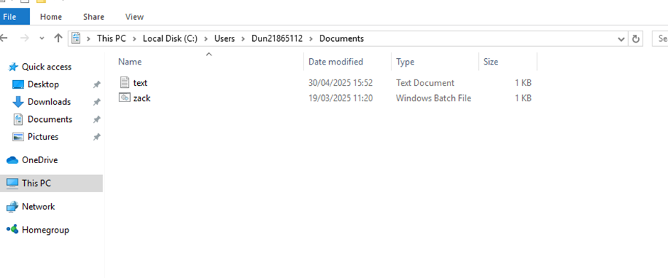
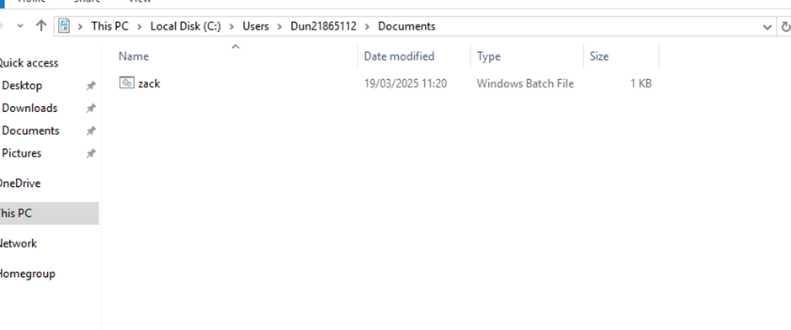
The del command in Windows is used to delete a file. It doesn’t go in the recycling bin.

shutdown /r
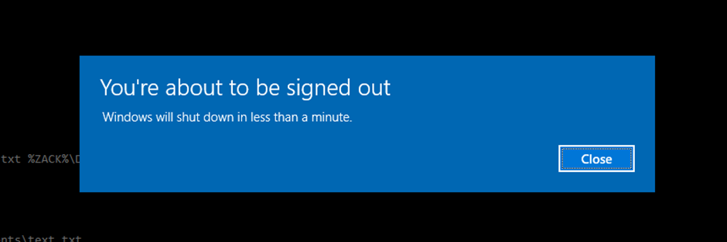
A shutdown/r command makes the computer restart when you type it in. When you do, a pop up will appear telling you that windows will be signed out in less than a minute. And then it restarts.

help
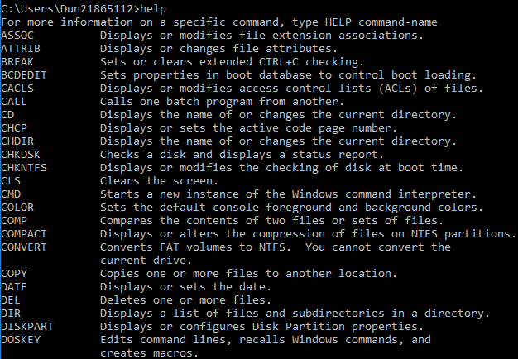The help command shows you all the types of commands and what they do next to them.

cls
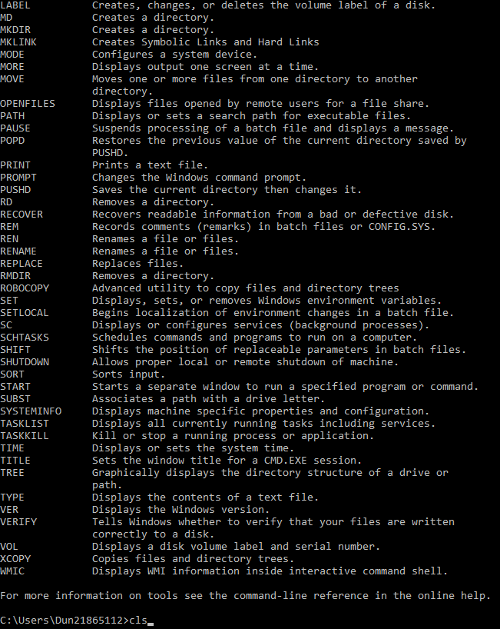
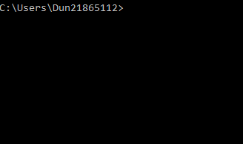
The cls command makes it so that the command prompt erases the whole display so that you have a much clearer screen.

Linux OS CLI commands

ls -l
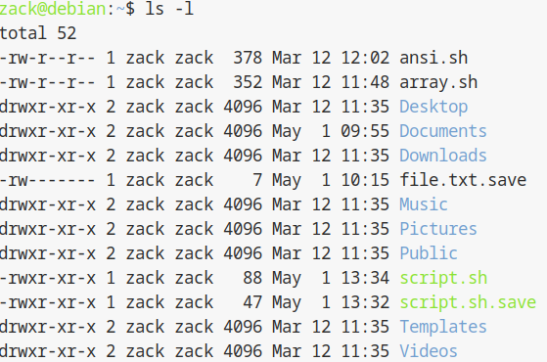
The ls –l command in Linux shows you all the current lists of the files in your system with details on the left.

pwd
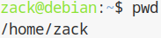
The pwd command shows you the current directory when you type it in. It stands for print working directory

cd
The cd command lets you change files. It stands for change directory
help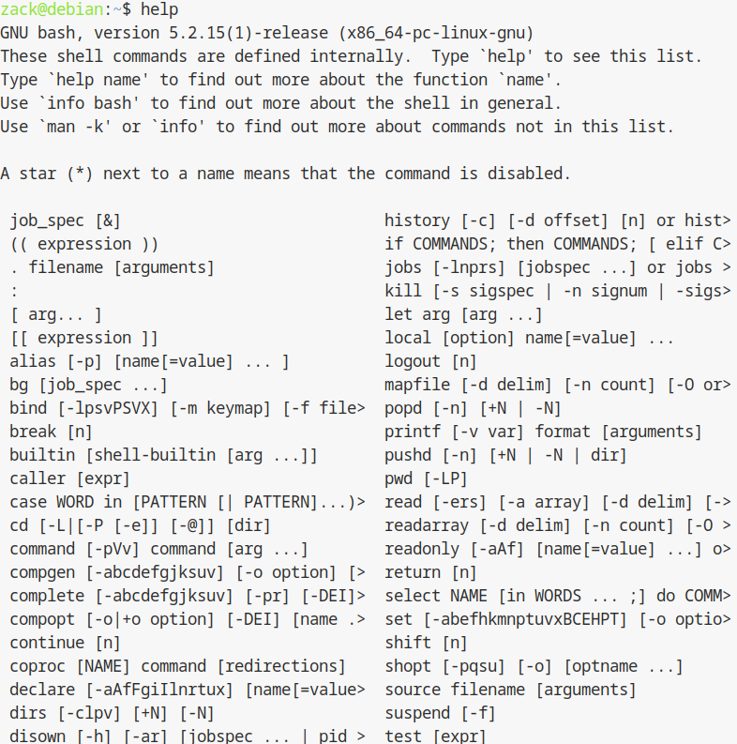
The help command in Linux tells you all the usable commands and what they do.

Echo
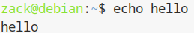
The echo command in linux repeats the text you have typed next to it.

Times
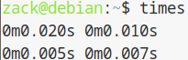
The times command in Linux is used to measure how long a program or command takes to run.

Nano

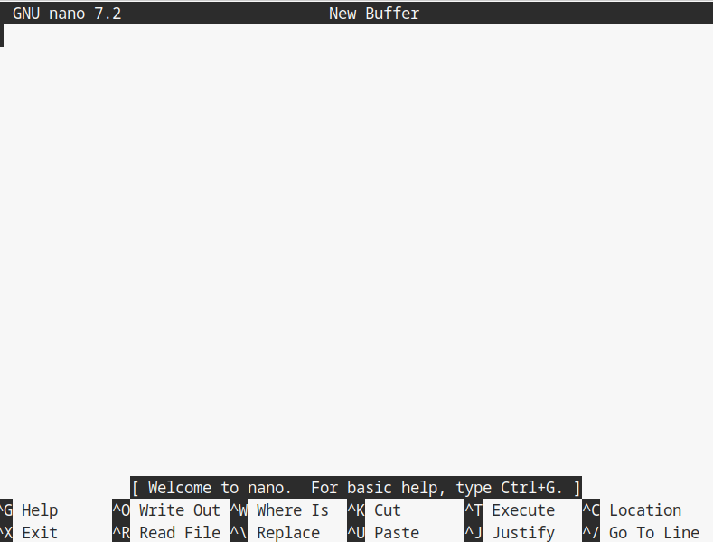
The nano command opens a simple text editor inside the Linux terminal. It lets you create, edit, and save text files easily.

mkdir
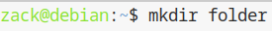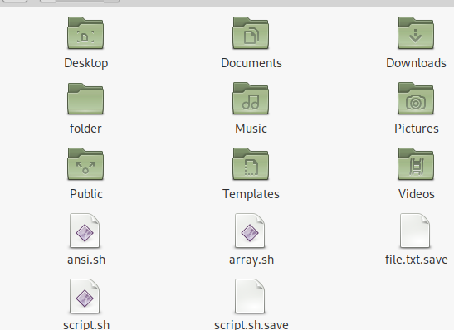
The mkdir command is used to create a new directory in Linux. You can name it anything.

ls
The ls command is used to list all the files and folders in the current directory.

clear
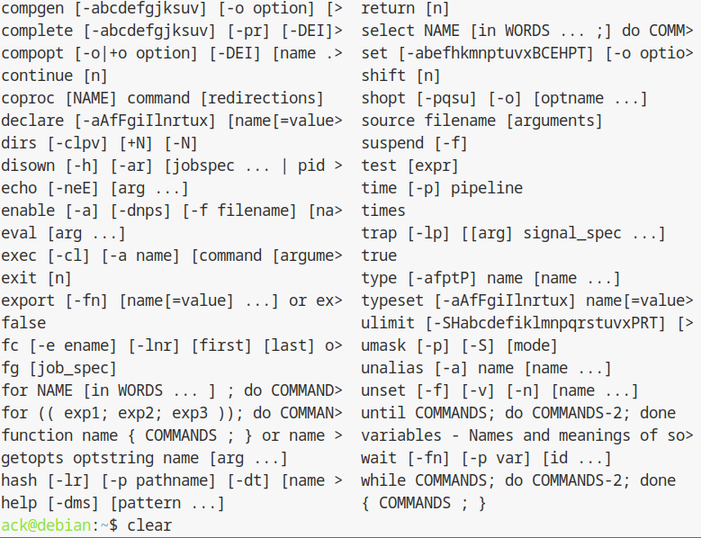

The clear command is used to clear the terminal screen. When you run it, it removes all the previous text and gives you a clean, empty terminal window to work in.

Windows OS scripts
This code is to demonstrate the features of the scripts i have explained during the report. I used a notepad to type all of it in.
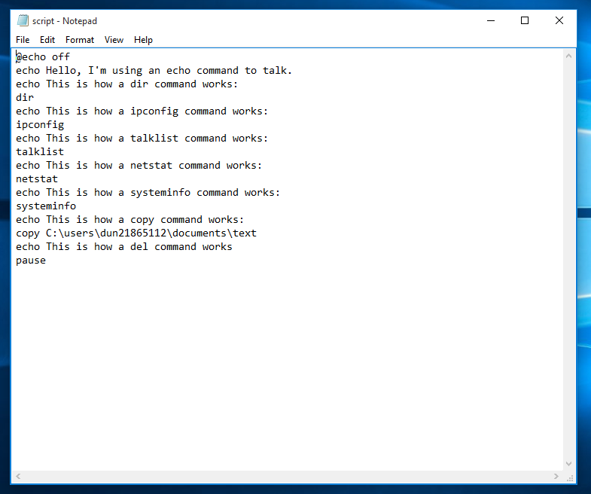
Then, i saved the notepad as a batch file so that it could make the scripts work
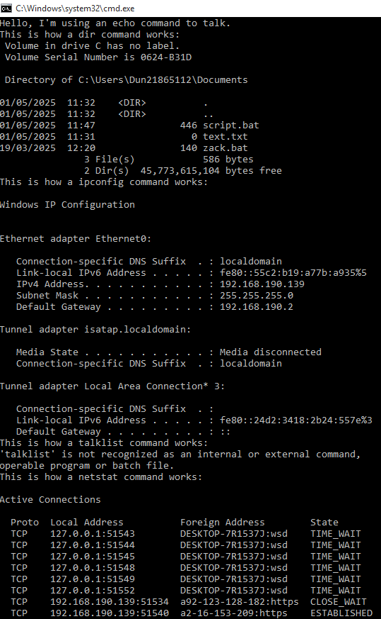

Key features of using Windows OS scripts
- Scripts can automatically do repetitive tasks like copying files, deleting folders, backing up data, or setting up systems.
- Scripts can create, move, copy, or delete files and folders.
- Scripts can change system settings like network setup, user permissions, or installed software.
- Scripts can make decisions using if statements

Linux OS scripts
By using linux os scripts, i used nano to edit the script.
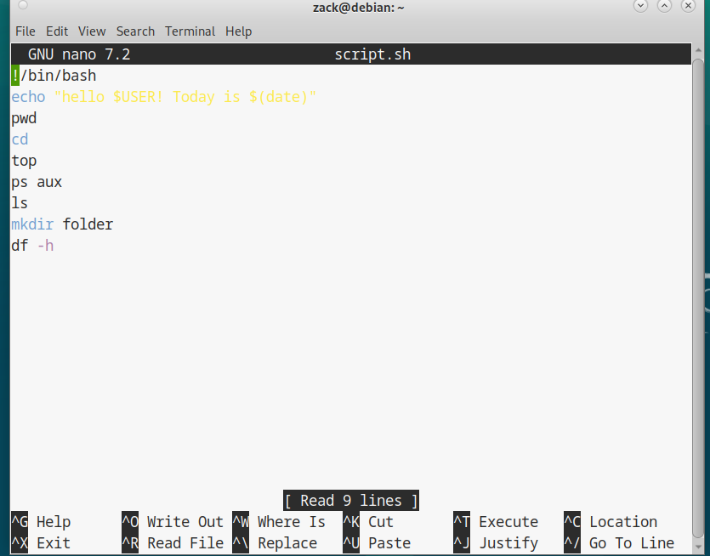
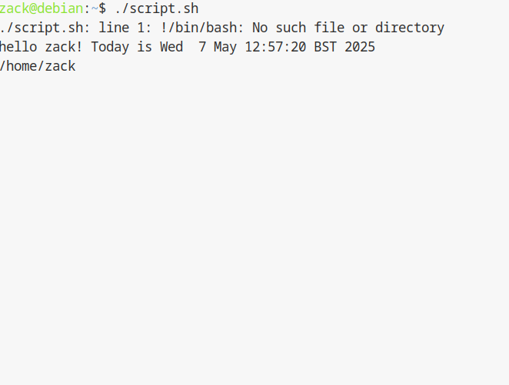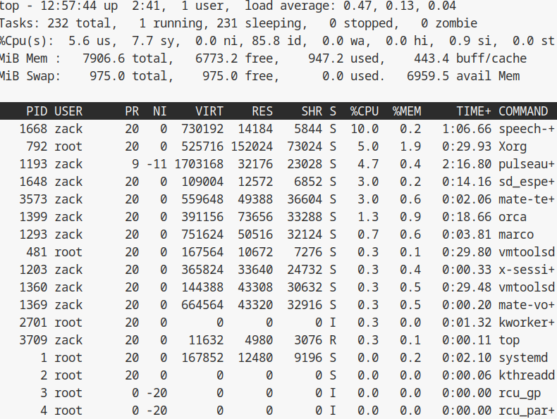

Key features of Linux OS scripting
- Bash scripts can do tasks like creating files, backups, software installation, and system updates.
- Scripts can create, copy, move, rename, and delete files and folders automatically.
- Bash scripts can manage users, permissions, processes, and even control services

Conclusion
In this report, I have managed to explore and use the functions of operating systems and how they manage computers such as memories and files. I have practiced using Windows and Linux commands, learning commands such as echo and ls.
I have also created and tested the scripts in both windows by using batch and linux by using bash seeing how scripting can do important tasks like file backups, system updates, and user management writing scripts helped me understand how processes can be controlled, scheduled, and managed to save time and reduce errors.
This assignment has help me to get a deeper understanding of how operating systems work and how powerful scripting can be for professional IT tasks.

References
[1] Microsoft Corporation, “Windows Commands,” Microsoft Learn, 2024. [Online]. Available: https://learn.microsoft.com/en-us/windows-server/administration/windows-commands/windows-commands.
[2] Ubuntu Documentation, “Using the Terminal,” Ubuntu Help, 2024. [Online]. Available: https://help.ubuntu.com/community/UsingTheTerminal
[3] TutorialsPoint, “Batch Script Tutorial,” TutorialsPoint, 2024. [Online]. Available: https://www.tutorialspoint.com/batch_script/index.htm
[4] Microsoft Corporation, “Introduction to PowerShell,” Microsoft Learn, 2024. [Online]. Available: https://learn.microsoft.com/en-us/powershell/scripting/overview

