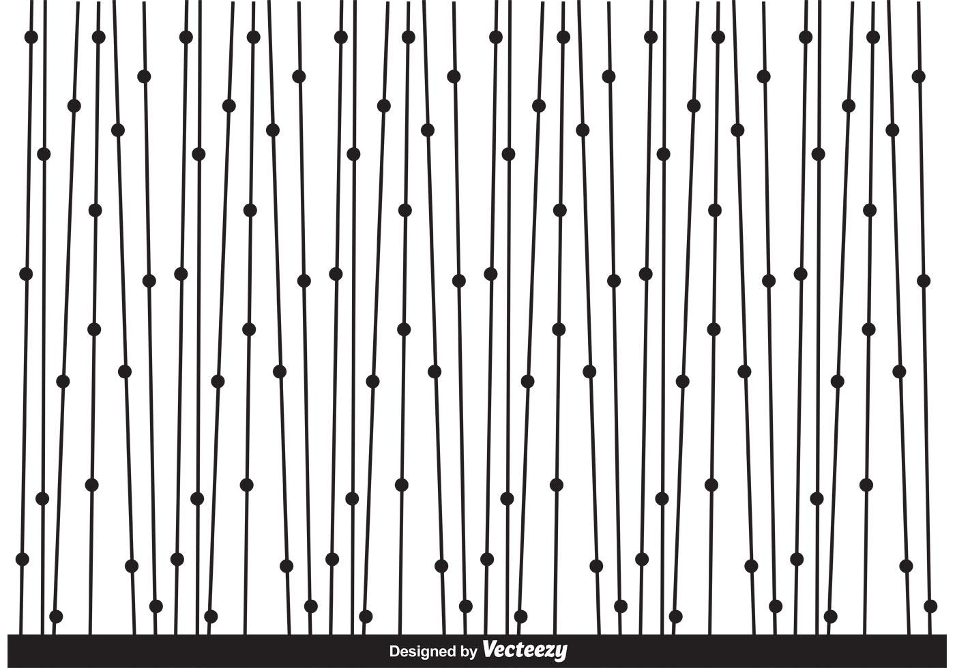
Budgeting
CHLOÉ CHIGNELL 1702365
^{LEVEL FIVE BUSINESS MANAGEMENT}
UNIVERSITY OF WALES TRINITY SAINT DAVID
March 2019
Management Accounting - M5X00854
Budgeting: a report in fulfilment of 30% the Management Accounting module in Level Five of the Business Management BA(Hons) degree at Swansea Business School within the University of Wales Trinity Saint David.
Table of Contents
Introduction 3
Budgeting Methods 3
Traditional/Basic 3
Incremental 3
Zero-Based 3
Activity Based 4
Analysis 4
Weaknesses/Barriers 4
Balance Scorecard 5
Beyond Budgeting 5
Advantages 5
Weaknesses 6
Private and Public Sector 6
References 7
Appendices 7

Keywords:
ZBB | Zero Based Budgeting
ABC | Activity Based Costing
KPI | Key Performance Indicators
BB | Beyond Budgeting

Introduction
Traditional methods of budgeting are now seen as more of a restricting, costly and time-consuming routine which is to become obsolete in the modern rapidly changing environment, as opposed to the crucial financial management tool a budget should be. There are many different methods of traditional budgeting, each with shared and individual weaknesses. Use of these traditional methods create barriers between the management who use them and success. Beyond Budget is one response to solve the issues with traditional budgeting. This new method of budgeting focuses on the decentralisation of management rather than focusing on the traditional structure of hierarchy and centralised leadership.

Budgeting Methods
Budgeting methods have grown and progressed throughout the years into different models.

Traditional/Basic
Traditional budgeting consists of taking the previous budget as the base and adjusting expenses depending on basic variables such as inflation rates, consumer demand and the market position/situation. Incremental budgeting is very similar to this basic method.

Incremental
Incremental budgeting takes the basics used above but also includes expected changes for the next fiscal year (Tucker, 1982). Lots of managers use this type of budgeting because it is seen as the easiest to apply. It doesn’t require in-depth analysis to figure out whats going to happen, just simple facts and figure which happened before and are going to happen in the future. The biggest issue with this method is that it encourages managers to use up budgets. This wasteful spending isn’t discovered and goes unnoticed.

Zero-Based
Similar to Incremental Budgeting, Zero-Based budgeting (ZBB) looks at the projected costs for the next year and uses them to forecast the budget. But this method of budgeting doesn’t look at the previous year’s performance at all, just the expected spending for the following year (Phyrr, 2012). This allows managers to find irrelevant costs and eradicate them, even if there was no variance in the previous year.

Activity Based
Activity Based Budgeting follows the basis of Activity Based Costing (ABC). ABC is an alternative form of budgeting, like absorption costing. It looks at non-direct costs which absorption costing misses. ABC looks at the cost drivers to make the non-direct costs into direct costs (Hansen, 2011).

Analysis
Each of these budgeting methods hold their own advantages and disadvantages, but a lot of the issues seem similar. See Appendix A for a table summery of disadvantages and advantages.

Weaknesses/Barriers
Many critics have said that traditional budgeting methods promote various barriers to successes, some common disadvantages to the models include the models being bureaucratic, not prioritising, encouraging high spending to meet targets, and being short term.
A big issue with tradition types of budgeting is that it only includes or considers the high-level bosses, leading to bureaucracy within the organisation. There is less motivation from staff and lower level employees as they don’t have control, input or understanding of the budget. Even though, without them, the business wouldn’t run (Schein, 2010).
A big issue which is seen across most businesses, and most people have had single-handed experience of, is the issue with setting targets. The fear of losing a budget if its not spent one term, even though it may be needed another, causes managers to spend unnecessarily to keep their budgets. This wastes lots of money and resources and leads to another issue with target; cushioning (Hope & Fraser, 2000).
The idea of decentralisation is the main barrier which traditional budget methods don’t support and is seen as a key part in aiding success for an organisation (Vonasek, 2011). Although, the basis of traditional budgeting promotes decentralisation within an organisation (King, et al., 2010).

Balance Scorecard
One attempt at overcoming the issues with traditional budgeting is Kaplan and Norton’s (BalScorecard) Balance Scorecard. This strategy looks at both the financial and non-financial elements of a business. Kaplan and Norton’s aim in developing the scorecard was to align the performance of the business with the long-term strategies a business has by incorporating their strategic goals (BalScorecard). Instead of starting with the finances, the balance score starts by looking at the mission and visions of the business, then identified the Key Performance Indicators (KPI’s) to give a broader view of how the business is doing. The scorecard holds four perspectives which each has its own focus and its own KPI’s. the four perspectives are financial, customer, internal and capacity. Of course, this has its own advantages and disadvantages. Some advantages are that it involves everyone in the business and that it is hugely flexible. Some drawbacks of it are that it can lead to having too many KPI’s, it can be difficult to balance the four perspectives too.

Beyond Budgeting
Beyond Budgeting (BB) is more of a budgeting philosophy than a method, much like the scorecard, it attempts to overcome many of the issues traditional budgeting methods have. BB looks at moving ‘beyond’ the idea of budgeting due to the vas and inherent flaws it holds. The issues it tries to overcome are the rigidity/lack of flexibility, reinforcing barriers between internal departments and that they don’t address the stakeholders. BB also combats issues the Balance Scorecard tackles by making the budgets more long-term and strategically focused and being beneficial to everyone, not just the senior managers (Hope & Fraser, 2000). Techniques such as rolling forecasts and market related targets replace the traditional finance budgets seen previously.

Advantages
One advantage of BB is that it promotes a faster response meaning a change can happen quicker. This immediate sighting of change and improvement is not only good for encouraging the people within the business, its also good for finances as issues are resolved quickly. Other advantages include promoting Innovative strategies, lower costs and loyal customers.

Weaknesses
Its hard to identify weaknesses in a philosophy as there are no set rules of what to do, just ideas of how to think/approach situations. Although you can analyse the assumptions made to force the philosophy to work.
Firstly, its assumed that the company is working in a decentralised way without hierarchy which is only now becoming more common in current companies. It creates a self-managed working environment which is better for more fulfilled employees (Mullins & Christy, 2016).
Secondly, whilst BB is an outstandingly strong and coherent model, it needs without a strong understanding of the drivers, otherwise it becomes ineffective (Hope & Fraser, 2000).

Private and Public Sector
Budgets having different goals depending on the sector the organisation works at. The private sector is focusing on how money is being made and increasing it, whereas the public sector doesn’t need to worry where the money comes from, just where it goes. This leads to budgets in the public sector being more about value for money. An experiment was carried out comparing the public and private sectors decision making practice (Nutt, 2006). It was found that the public sector managers want budget decisions which are derived from bargaining with agency people, rather than decision which are backed by analysis, whereas private sector managers want analysis, not bargaining (Nutt, 2006).

References
Baker, R., 1969. Organizational theory in the public sector. Organizational theory in the public sector, 6(Feb.), pp. 15-31.
Hansen, S. C., 2011. A theoretical analysis of the impact of adopting rolling budgets, activity-based budgeting and beyond budgeting. European Accounting Review, 20(2), pp. 289-319.
Hope, J. & Fraser, R., 2000. Beyond Budgeting. Strategic Finace, 82(4), p. 30.
King, R., Clarkson, P. M. & Wallace, S., 2010. Budgeting practices and performance in small healthcare businesses. Management Accounting Research, 21(1), pp. 40-55.
Mullins, L. J. & Christy, G., 2016. Management and Organisational Behaviour. 10th ed. London: Pearson.
Nutt, P. C., 2006. Comparing Public and Private Sector Decision-Making Practices. Journal of Public Administration Research and Theory, 16(2), pp. 289-318.
Phyrr, P. A., 2012. Handbook of Budgeting. 6th ed. s.l.:Wiley.
Schein, E. H., 2010. Organisational Culture and Leadership. 4th ed. San Francisco: Jossey-Bass.
Tucker, H. J., 1982. Incramental Budgeting: Myth or Model. Western Political Quarterly, 35(3), pp. 327-338.
Vonasek, J., 2011. Implementing Responsibility Centre Budgeting. Journal of Higher Education Policy and Management, 33(5), pp. 497-507.

Appendices
Appendix A – table of budget analysis from various research
Advantages | Basic | Inc | Zero | ABC
Easy to implement | X | X |  | X
Easy to prepare | X
Various departments |  | X |  | X
Continuity of funding |  | X
No large deviations |  | X | n/a | X
Popular |  | X | X
Eliminates rivalry between deps | X | X
Change seen immidetly |  | X
Works for compays with fixed funding |  | X
Promotes decentralisation | X |  | X | X
Accuracy |  |  | X
Grows/adapts with organisation |  |  |  | X
Eliminates cushioning |  |  | X
Disadvantages | Basic | Inc | Zero | ABC
Fixed/rigid, no flexibility | X |  | X
Bureaucratic (Less motivation as prepped by big bosses) | X |  | X | X
Excessive reliance on last year | X | X
No priority | X | X |  | X
Time consuming |  | X | X | X
Enocrages high spending/ no incentive for reduced spending (cushioning, target issues) | X | X |  | X
Disconnects from reality | X | X
No incentive for innovation |  | X
Hit your budhget get your bonus | X | X |  | X
Short term |  |  | X

