

BA Business Management Entrepreneurship (LCBB5001)

Student name: Ana-Maria Budau
Student ID: 2030929
Table of Contents
Introduction 3
Task 1 4
Task 2 9
Conclusion 12
Reference list 13

Introduction
An entrepreneur is a person capable of operating a business by themselves. Entrepreneurship-based self-analysis helps individuals to obtain the knowledge and skills required to run a business (Akhmetshin et al., 2019). In this study, a discussion on the various personal skills and weaknesses relevant to entrepreneurship. A SWOT analysis will be conducted along with a skills audit. The individual skills audit will be created to match the skills, behaviour and trait of an entrepreneur. A business idea of organic catering is chosen. Macro-environment analysis will be done using PESTLE analysis in the UK to understand the suitability of the business idea for operation.

Task 1
Identify relevant skills, behaviour and trait of an entrepreneur and conduct a personal SWOT analysis and a skill audit to match your own skills, behaviour and trait
Some of the traits, skills ad behaviour of an entrepreneur includes visionary approach, problem-solving skills and risk-taking ability. Being open to challenges an taking them head on is also an important trait that an entrepreneur should embody (Refer to Appendix A). Multitasking abilities are also identified as a key behaviour that an entrepreneur should have.

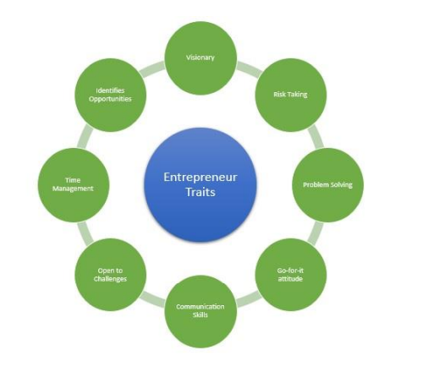
Figure 1: Traits and skills of an entrepreneur
(Source: taken from Appendix A)
Among the identified traits, skills and behaviour, I possess the problem-solving skill which is one my strengths. At the same time, communication skills are also recognised an important, which is my weakness. Thus, working on it would be highly efficient as an entrepreneur.

SWOT analysis
Strengths  What do you do well?  What unique resources can you draw on? What do others see as your strengths? | Weaknesses  What could you improve?  Where do you have fewer resources than others?  What are others likely to see as weaknesses?
I am good with managing team members as I have management skills strongly prevailing in me. Management skills are considered one of the most important entrepreneurial qualities (Almahry et al., 2018). In terms of resources, I can draw on include my problem-solving skills which help to navigate through difficult situations that may arise in entrepreneurship. In the view of others, I have good technical skills which are highly required to operate modern businesses. Others view me as someone who is dedicated, driven and focused on the goals that I set as an entrepreneur to establish my business. | One of my weaknesses is my leadership skills. I lack the ability to take charge of the situation. Although I am good at managing my team, the ability to initiate, direct and command a situation is absent from me. Leadership skills are identified as the most essential quality that an entrepreneur should possess (Sousa, 2018). I think the language barrier is a lack of resources that others may have an edge over me. English is a language I struggle with which is majorly used in the business sector. Lacking the resource of vocabulary also affects my communication skills at times. Others might see the language issue as a key problem in me which is a restriction to my leadership quality as well.
Opportunities  What opportunities are open to you? What trends could you take advantage of?  How can you turn your strengths into opportunities? | Threats  What threats could harm you? What is your competition doing?  What threats do your weaknesses expose to you?
One of my strengths is technical skills which open the opportunity to utilise the digitalisation trend prevailing currently. Digitalisation brings a positive change in the approach an entrepreneur takes to deal with employees (Labanauskaitė et al., 2021). I can utilise my technical skills to integrate digital operations in my sector and ensure that my employees can perform efficiently. Another trend is sustainability which can be applied by using my management skills. Sustainable business practices would require the entrepreneur to make smart decisions that are environmentally friendly. Management skills can be used as an opportunity to run an efficient t long-term sustainable business. | Communication is the most necessary tool for an entrepreneur to lead his business. Lacking the skills of communication and leadership signifies major threats to me. I might not be able to build a solid foundation with my team due to a lack of leadership skills. It can be harmful for my business idea to receive funds and get exposure in the market. My language barrier is the main issue that exposes me to threats. It is difficult for a business culture to break down language with translation for language barrier-based people (Sutherland et al., 2019). My competitors are good with the English language which is helping them excel with communication. Some of them are reading more books to increase their vocabulary while others have joined English learning tuition.
Table 1: SWOT analysis
(Source: Created by the learner)
Individual skills audit
SKILLS I HAVE | EXAMPLE
Management skills | During our class lessons, we are put into groups of 5 for a presentation. I used my management skills to divide the tasks among the 5 of us. I ensured that my team members were satisfied with their tasks and were given so, based on competency. We scored the highest marks in class and I was credited for my management skills by my peers and teacher.
Technical skills | Various computational projects are performed in class. I often answer well in class regarding any technical questions. I am good at understanding the logic and binary digits. Technical issues are many times solved by me in class. MS word, PowerPoint and excel are often used by us where I offer a helping hand to the tutor as I am considered good with technical skills.
Problem-solving skills | Puzzles are solved during gameplay activities. I am usually the fastest in class to solve puzzles and answer problem-based questions. I also provide solutions to internal conflicts that might arise between peers.
SKILLS I’D LIKE TO  IMPROVE | HOW? EXAMPLE?
Leadership skills | In order to improve my leadership skills, I will start taking initiative in group projects. For instance, I will select the team members based on competency and communicate with them about my idea. I would emphasise the betterment of all of us that we would generate from the group work. Improvement in leadership is done through individual cognitive differences (Guzmán et al., 2020). I will also read more books to enhance my cognitive ability to take charge of situations. Practising self-affirmation will also help me achieve this skill.
Communication skills | Communication skills will be improved by taking part in social events, social media campaigns and debates. I will take initiative and join various social events in a class to communicate with peers. I will also observe my teachers to learn about the etiquette required for efficient communication as an entrepreneur. Sounding crude or uneducated in any form of communication can be detrimental to entrepreneurial practice (Guffey and Loewy, 2022). For instance, I will write blogs for social media campaigns to practice communication online. Interaction with peers will be increased to increase my confidence level.
Language improvement | I can improve the language barrier by learning English ad using a translator. For instance, I would join English learning tuition which would help me improve the language. I will also practice speaking in English with peers and teachers to consistently improve the language. Reading books and watching English shows will be added to my daily activity. I will ensure to use a translator till I have completely learned the language.

Table 2: Individual skills audit
(Source: Created by the learner)

Task 2
Conduct a PEST analysis on the UK macro environment to understand the current market position before setting up your business
Political
A corruption index score means a country with a high score is low in corruption. It means that if the score has increased corruption level has decreased. In the case of the UK, a vast drop has been recorded from 80 in 2018 to 77 in 2019 signifying that the corruption rate has begun to increase in the state.

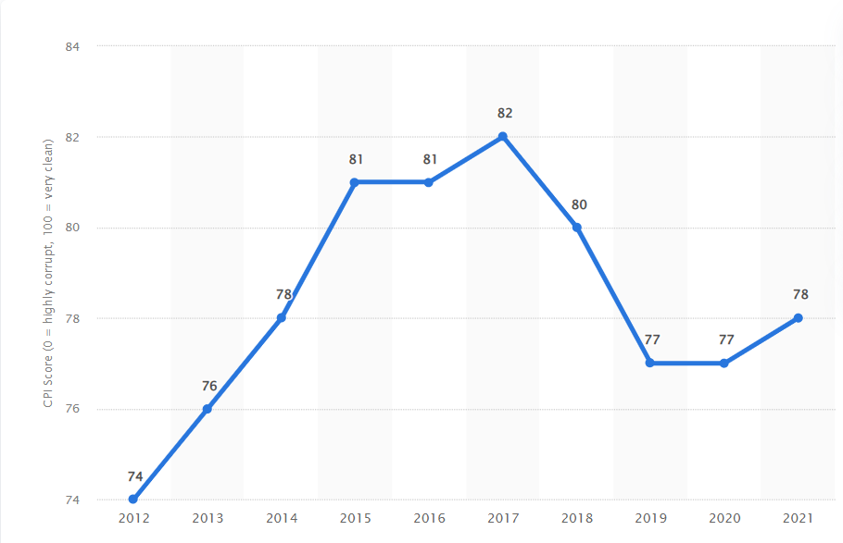
Figure 1: Corruption index of the UK
(Source: Statista, 2022)
Political scenario is essential to understand the potential for business establishment in the UK. Corruption index highlights the level of unethical practice that goes on within a political sector of a country. The corruption index score has increased for the UK from77 in 2020 to 78 in 2021 (Statista, 2022). It implies that there is political unrest but the potential for betterment within the UK. A high chance of improvement in unethical practices is favourable for a new business. Organic catering ideas would find it convenient to sustain in the political scenario of the UK. Additionally, the political stability index score of the UK is 0.54 as of 2021 (Theglobaleconomy, 2022). It is an average score and neither in favour nor extremely negative. Although there is a need for the upgradation of political conditions in the UK there is potential for the business idea to flourish with a strong internal structure. In order for the business idea to sustain in the UK corruption rate and stability index ate evidence to determine the condition.
Economic
The GDP rate is significant to identify the economic revenue a country gains. In the year 2022, the GDP rate of the UK is 4.2% implying that the country's economic condition is average. However, it is estimated that a fall of 1.4% would occur by 2023 (Statista, 2022). Falling in the GDP rate signifies an economic threat as it would affect the business scenario largely. Opening a new business would be favourable considering the present condition but the firm needs to have enough self-preserved funding. At the same time, the business can easily gain profitability in an emerging economy. However, the inflation rate is evidence of the major economic pitfall a nation is going through. As of 2022, the inflation rate in the UK is 6.5% (Statista, 2022). It is a high percentage and implies that economically the country may not be stable. It is necessary for the new business to utilise its own funds and not entirely depend on UK investors. Although inflation rate excludes price changes in food and energy consumption it is still not favourable to establishing a business in the UK.
Social
In order to flourish in the UK, it is essential to understand the social condition of the population. The lifestyle, characteristics, income and cultural aspects play a significant role in comprising a state's social scenario. In the year 2021 per capita income was 31,793 British pounds in the UK (Statista, 2022). Per capita index is the income of the population of the state. An increase of 2,106 pounds has been achieved in 2921 compared to the previous year. It implies that the people can afford to purchase organic food from the new business as they have stable earnings. The UK population rate has increased over the years. In 2022 the population of the UK stands at 67.95 million (Statista, 2022). It shows that the country has a dense population and there is an opportunity for the new business to capture a large market share. It is also estimated that the population would go up to 68.27 million by 2023 which implies that there is potential for capturing a vast target market in the UK. The new business has favourable conditions to establish and sustain the business in the UK as the social conditions are quite favourable.
Technological
Technological investment shows the value the state puts on technology for operating businesses. It would be highly useful for the new business to succeed in the UK with a positive technological approach by the state. It is estimated that an increase in the GDP will occur in the UK by 2.8% due to technological investment made by the state (Statista, 2022). It means that the country is suitable for including and integrating advanced business technology. It will be highly necessary to use technology for enriched organic catering services. R&D expenditure also signifies the level of technological awareness a state has. In the year 2019, the UK has investment 1.76 % of its GDP in R&D growth (Statista, 2022). It shows that there is vast opportunity in the technology advancement that organic catering can utilise for efficient services. At the same time, social media users have increased in the UK which is an opportunity for the new business to utilise for sales. As of 2022, there are 57.6 million active social media users in the UK (Statista, 2022). It shows that technologically the UK has a favourable environment that the organic catering business can benefit from.
Legislative
Legislative norms are essential to abide by as it represents the legal framework of a state. Consumer protection and safety are some of the key legislative requirements that businesses need to maintain. The Data Protection Act 2018 states that consumer and employee data need to be strictly protected and avoided data breaches (Legislation.gov.uk, 2022). Organic catering businesses would highly ensure to abide by this Act by providing strict and password-protected operations in the sector. Consumer data would also have to be kept confidential. Details like name, address, contact and bank details are crucial sensitive data that need to be protected to operate in the UK efficiently.
Environmental
Several environmental norms need to be maintained while operating a business in the UK. The Pollution Prevention and Control Act 1999 is established to ensure that pollution level is controlled in the state (Legislation.gov.uk, 2022). It would be necessary for the organic catering business to ensure that the business operations comply with environmental welfare parameters and does not release pollution. Additionally, organic catering is based on providing environment-friendly food which requires the business to comply with environmental norms more strongly. It would be a beneficial opportunity to operate in the UK by ensuring that environmental standards are met.

Conclusion
It can be concluded that entrepreneurship is an emerging trend in business culture. I possess a lot of qualities that an entrepreneur should have. Management, problem-solving and technical skills are some of my strengths. Utilising the strengths provide vast opportunities. At the same time, my weaknesses in leadership and communication skills along with the language barrier would be improved by the measures mentioned in the skill audit. My business idea of organic catering services requires a macro environment analysis for establishment in the UK market, As per the PESTLE analysis, the UK is mostly a suitable country with stable socio-political and advanced technology factors. However, the economic condition needs to be considered along with abiding by legislative and environmental laws.

Reference list
Akhmetshin, E.M., Mueller, J.E., Yumashev, A.V., Kozachek, A.V., Prikhodko, A.N. and Safonova, E.E., (2019). Acquisition of entrepreneurial skills and competences: Curriculum development and evaluation for higher education. Journal of Entrepreneurship Education, 22(1), pp.1-12.
Almahry, F.F., Sarea, A.M. and Hamdan, A.M., (2018). A review paper on entrepreneurship education and entrepreneurs’ skills. Journal of Entrepreneurship Education, 21(1), pp.1-7.
Guffey, M.E. and Loewy, D., (2022). Essentials of business communication. Cengage Learning.
Guzmán, V.E., Muschard, B., Gerolamo, M., Kohl, H. and Rozenfeld, H., (2020). Characteristics and Skills of Leadership in the Context of Industry 4.0. Procedia Manufacturing, 43, pp.543-550.
Labanauskaitė, D., Župerkienė, E., Kumpf, A., Šimanskienė, L. and Koller, S.M., (2021). Development of digital and entrepreneurial competences for the future labour market needs. Entrepreneurship and sustainability issues, 8(3), pp.565-581.
Legislation.gov.uk, (2022). Data protection Act 2018 Available at: https://www.gov.uk/data-protection#:~:text=The%20Data%20Protection%20Act%202018%20is%20the%20UK's%20implementation%20of,used%20fairly%2C%20lawfully%20and%20transparently (Accessed: 21 November 2022)
Legislation.gov.uk, (2022). ENVIRONMENTAL PROTECTION, ENGLAND AND WALES Available at: https://www.legislation.gov.uk/uksi/2018/1227/made#:~:text=England%20And%20Wales-,The%20Environmental%20Protection%20(Miscellaneous%20Amendments)%20(,England%20and%20Wales)%20Regulations%202018&text=The%20Secretary%20of%20State%20makes,Communities%20Act%201972(1) (Accessed: 21 November 2022)
Sousa, M.J., (2018). Entrepreneurship skills development in higher education courses for teams leaders. Administrative sciences, 8(2), p.18.
Statista, (2022). Active social media audience in the United Kingdom (UK) in February 2022 Available at: https://www.statista.com/statistics/507405/uk-active-social-media-and-mobile-social-media-users/ (Accessed: 21 November 2022)
Statista, (2022). Consumer price index (CPI) inflation rate excluding food and energy in the United Kingdom from January 1989 to October 2022 Available at: https://www.statista.com/statistics/1317058/uk-core-inflation-rate/#:~:text=In%20October%202022%20the%20core,and%20energy%20from%20its%20calculation (Accessed: 21 November 2022)
Statista, (2022). Corruption perception index score of the United Kingdom from 2012 to 2021 Available at: https://www.statista.com/statistics/868971/corruption-perception-index-in-the-uk/ (Accessed: 21 November 2022)
Statista, (2022). Forecasted annual growth of gross domestic product in the United Kingdom from 2000 to 2027 Available at: https://www.statista.com/statistics/375195/gdp-growth-forecast-uk/#:~:text=During%202022%20the%20gross%20domestic,9.4%20percent%20contraction%20in%202020 (Accessed: 21 November 2022)
Statista, (2022). Gross domestic product per capita in the United Kingdom from 1955 to 2021 Available at: https://www.statista.com/statistics/970672/gdp-per-capita-in-the-uk/#:~:text=In%202021%2C%20gross%20domestic%20product,pounds%20when%20compared%20with%202020 (Accessed: 21 November 2022)
Statista, (2022). Long-term gross domestic product growth from investment in digital technology in the United Kingdom from 2020 to 2040 Available at: https://www.statista.com/statistics/1295712/uk-gdp-growth-from-investment-in-digital-tech/ (Accessed: 21 November 2022)
Statista, (2022). Share of GDP expenditure on research and development in the United Kingdom (UK) from 2000 to 2019 Available at: https://www.statista.com/statistics/461746/share-of-gdp-expenditure-on-research-and-development-united-kingdom-uk/ (Accessed: 21 November 2022)
Statista, (2022). Total population of the United Kingdom (UK) from 2015 to 2025 Available at: https://www.statista.com/statistics/263754/total-population-of-the-united-kingdom/ (Accessed: 21 November 2022)
Sutherland, W.J., Taylor, N.G., MacFarlane, D., Amano, T., Christie, A.P., Dicks, L.V., Lemasson, A.J., Littlewood, N.A., Martin, P.A., Ockendon, N. and Petrovan, S.O., (2019). Building a tool to overcome barriers in research-implementation spaces: The Conservation Evidence database. Biological Conservation, 238, p.108199.
Theglobaleconomy, (2022). United Kingdom: Political stability Available at: https://www.theglobaleconomy.com/United-Kingdom/wb_political_stability/ (Accessed: 21 November 2022)

