Carys Rees

2003859

BSC Computing (Data and Information Systems)

Software Development Assignment (ACCB4017)

19/04/2021

Contents
PART A (UNDERSTANDING) 3
Variables 3
IF Statements 3
While Loops and For Loops 7
While Loop 7
For Loop 8
PART B (IMPLEMENTATION) 9
Q1 Show how variables can contain different types of values 9
Specific Problems 9
Pseudo Code 9
Logical Steps 10
Code 10
Testing 11
Q2 Calculate the number of carrots that can grow on a vegetable bed 13
Specific Problems 13
Pseudo Code 13
Logical Steps 14
Code 14
Testing 15
Q3 Calculate the discount for the products and prices entered 16
Specific Problems 16
Pseudo Code 16
Logical Steps 17
Code 18
Testing 20
Q4 Treasure Hunt 22
Specific Problems 22
Pseudo Code 22
Logical Steps 22
Code 23
Testing 24
Conclusion 26

PART A (UNDERSTANDING)

Variables
A variable in python is a place where the pre-defined values are stored. The type of variable can also change depending on the input type. The types of variables are, integers (whole numbers), decimals (e.g. 3.45), strings (letters) and float. It is also case sensitive meaning if you name something ‘type’ and another variable ‘Type’, with the capital then they are defined as two different variables to the system and will therefore store different information. However, programmers find this bad practice as it makes things a lot more complex for them to remember what is stored in the variable.
There are seven rules to abide by when creating variables. These are: -
- Variable names must start with a letter or _
- Variable names cannot start with a number
- Variable names can only contain alphanumeric characters A-Z, a-z, 0-9, _
not special characters ? ! $ % & () £ “
- Variable names cannot be reserved words (words that are part of the Python Language print() input if else elif)
- Variables are case-sensitive myName myname MYNAME
- Variables should be self-describing
- Camel casing (every word except for the first begins with a capital letter)

IF Statements
An if statement is code to make a decision in a program. The comparison operators for these statements are == (equal to), > (greater than), >= (greater than or equal to), < (less than), <= (less than or equal to), != (not equal to).
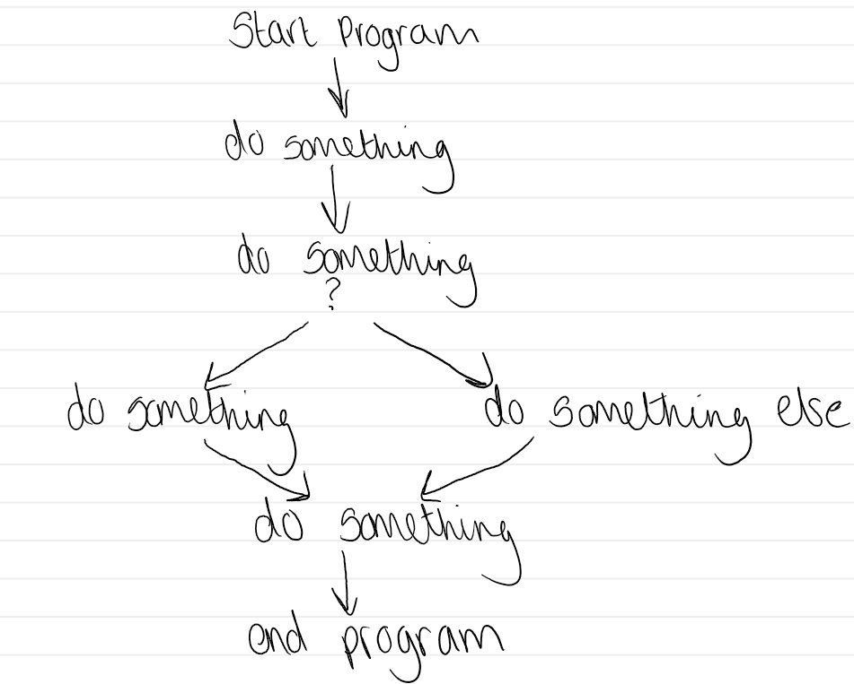
The diagram above shows the process of an if statement. The program starts and immediately does something, this could be printing “Welcome to the program”, then it does something else, and this is the question stage in which the program will ask a question and the user is required to answer it, which leads to the if statement. The program is saying that if the user enters ‘this’ then do it, else they enter something that does not fit the criteria then do something else. And then it will print the results and the program will finish.
To understand this concept better, there is a demonstration of an if statement below.
favNumber = 15
print("Please try to guess my number")
userNumber = int(input())
if userNumber == favNumber:
print("Good guess!")
elif (userNumber >= 16) and (userNumber <= 20):
print("Warm!")
elif (userNumber <= 10 and userNumber <= 5) or (userNumber >= 21 and userNumber <= 25):
print("Cold!")
else:
print("Totally Wrong!")

This is an example of the if else statement being used. It is a guessing number game. The variable at the top is pre-determined as 15, therefore the program is asking the customer to guess the number, and they will input an integer. The if statement is saying that if userNumber is favNumber then to print “Good gues!”, and this is where the complexity begins. So, it is saying elif the userNumber is greater than or equal to 16 and userNumber is less than or equal to 20 then print “Warm!”. And the next elif is userNumber is less than or equal to 10 and userNumber is less than or equal to 5 OR userNumber is greater than or equal to 21 and userNumber is less than or equal to 25, then print “Cold!”. Else, if none of those numbers are entered then to print “Totally wrong!”.
The statement elif, means that there is another condition that could be met, and this allows the programmer to have multiple conditions in one if statement, which makes it simpler and easier to comprehend. The and statement within the elif statement means that within that one line, there are two conditions that need to be met in order to print that line of text, and if it does not meet both conditions then it goes onto the next statement. It is important to remember that when writing that line of code that the variable (userNumber) is being typed again, otherwise the program will not understand what it is supposed to do.
The or statement means that the two conditions that are written on the line do not need to be met, as long as one or the other is met then to print that line of code.

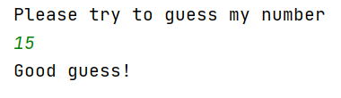
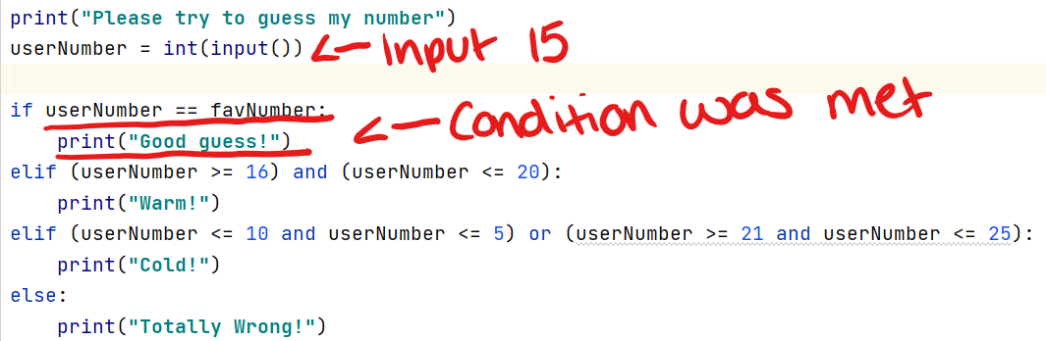
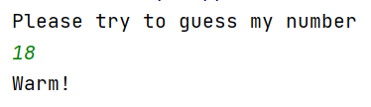
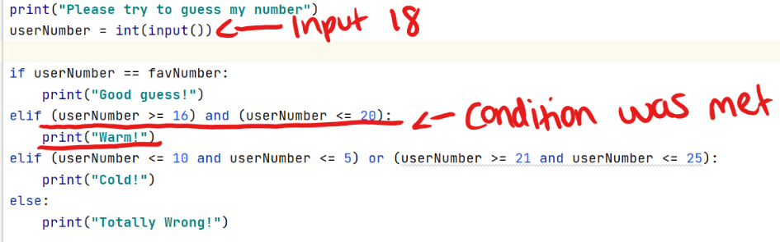
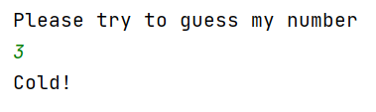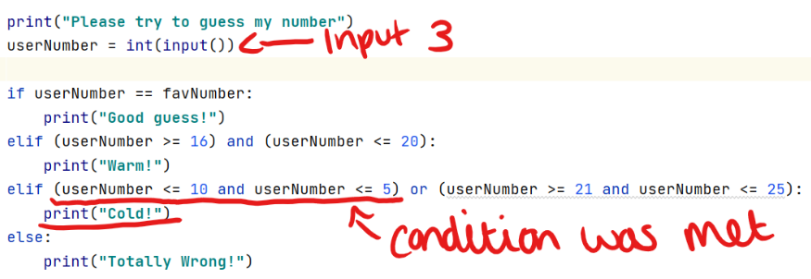
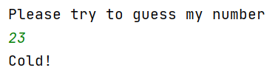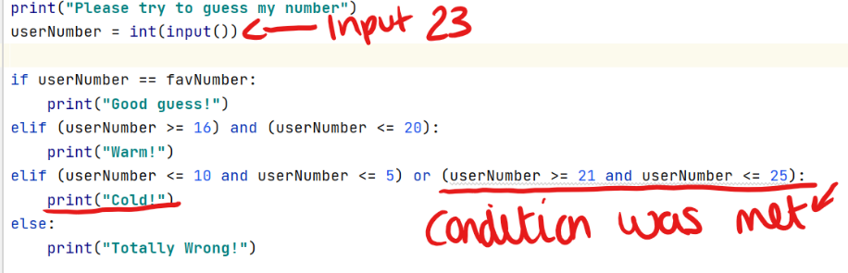
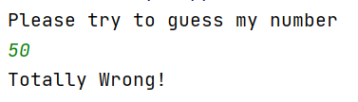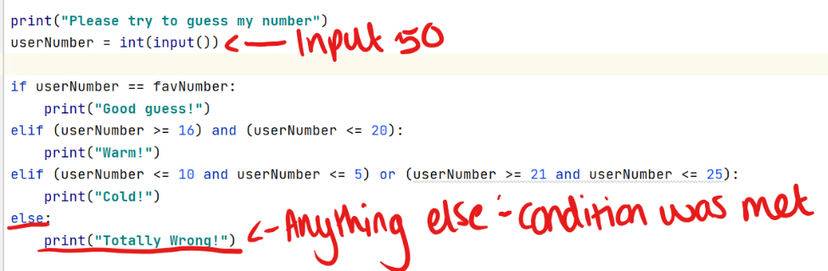
The testing stage is shown above, in which the program is restarted every time so that the user can enter a different number to satisfy the various elif statements. It is clear to see that the program is working, and the if statement is fully functional.

While Loops and For Loops

While Loop
There are two main forms of loops in python, while loops and for loops. The while loop is used when the user does not necessarily know in advance how many times, they want it to be repeated, and the number of times it goes around the loop (iteration). And validation is a good application. A while loop is different than if statements as more arguments can pass through. An example will be shown below.
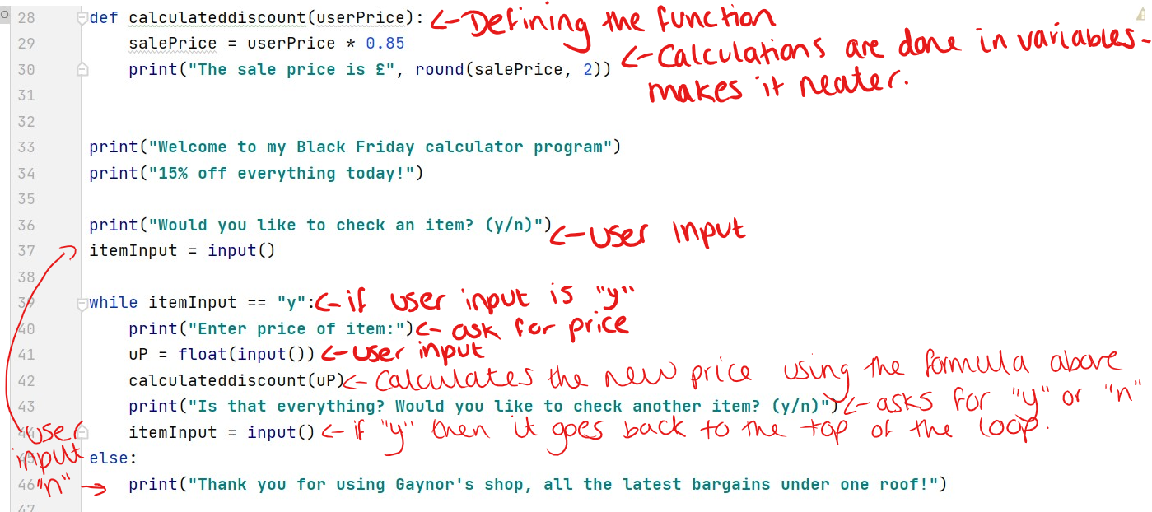
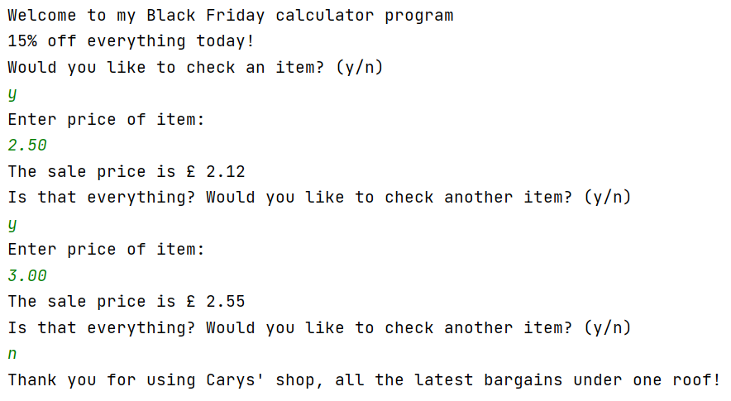
This is the result of the code above. This shows that the loop will continue going unless the user enters no then it will finish and this is the main comparison between the while loop and for loop.

For Loop
The for loop is used by the programmer when they do know exactly how many times round the loop it will go (iteration). This is a useful way to count up or down, do calculations and/or print something so many times. The difference between a while loop and a for loop is that in a while loop the number of times it will go around is undetermined whereas with a for loop the amount of times the loop will happen is determined by the user, as they specify the starting and end point along with the increments in which it will increase or decrease.
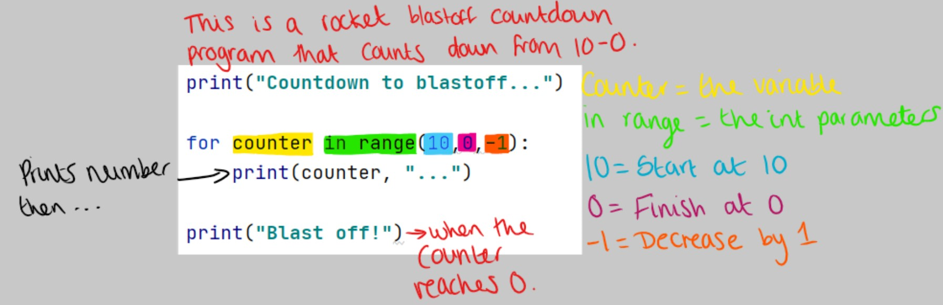
The screenshot above shows a simple program of how the rocket blastoff countdown work. The user has determined the for loop to start at number 10, finish at 0 and to decrease by 1 each time, until it gets to the desired number. When it prints the blastoff it will add “…” to the end of each line to make it look more pleasing to the user. Then after it gets to 0 it will print blast off. Here is the result below.
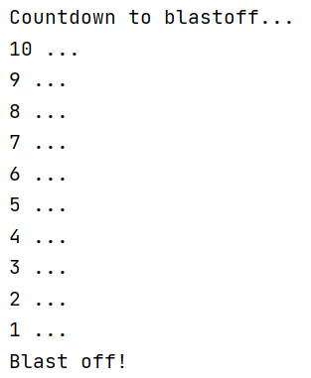This is the for loop in action.

PART B (IMPLEMENTATION)

Q1 Show how variables can contain different types of values

Specific Problems
For this exercise, the user will be prompted to enter data, therefore validation needs to be used. This is to ensure that the correct information has been entered. For example, the number of doors will need to be above 1 as no car has 1 door. To do this, a while loop will need to be used so that if the data entered does not align with the validation, then it prompts the user to enter data again. This is a simple program as the user is prompted to enter the car information whilst checking its validation and then printing the results.

Pseudo Code
BEGIN
Input car make
While string is empty
Prompt user input
Else
Store input
Input car model
While string is empty
Prompt user input
Else
Store input
Input car mileage
While int is empty
Prompt user input
Else
Store input
Input car doors
While int is empty
Prompt user input
Else
Store input
Print car make, model, mileage, doors
END

Logical Steps
- Prompt the user to enter the car make
- Check user has entered data (if not back to step 1)
- Prompt the user to enter the car model
- Check user has entered data (if not back to step 3)
- Prompt the user to enter the car mileage
- Check numbered entered for car mileage is above 0 (if not back to step 5)
- Prompt the user to enter the number of doors
- Check number entered for number of doors is above 0 (if not back to step 7)
- Print the car make, model, mileage, and doors

Code
print("Please enter the car make:")
carMake = input()
while (carMake == ""):
print("Sorry, not applicable. Try again:")
carMake = input()
else:
print("Car make noted!")
print("Please enter the car model")
carModel = input()
while (carModel == ""):
print("Sorry, not applicable. Try again:")
carModel = input()
else:
print("Car model noted!")
print("Please enter the mileage on the car")
carMileage = float(input())
while (carMileage < 1):
print("Sorry, not applicable. Try again:")
carMileage = float(input())
else:
print("Car mileage noted!")
print("Please enter the number of doors the car has")
carDoors = int(input())
while (carDoors < 2):
print("Sorry, not applicable. Try again:")
carDoors = int(input())
else:
print("Car doors noted!")
print("You have a", carMake, carModel, "and the mileage is", carMileage, "with", carDoors, "doors!")
print("Thanks for using this service!")

Testing
- Normal Values
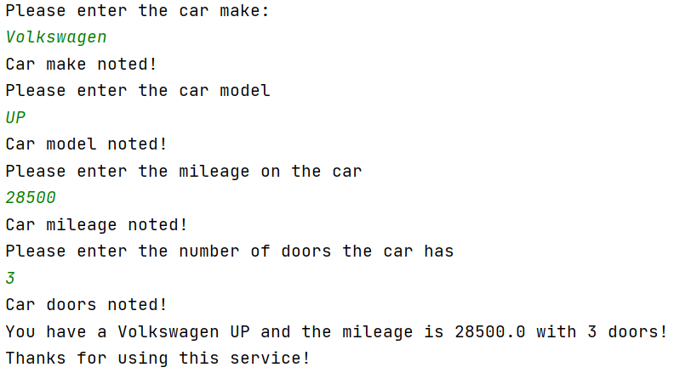
Result: Program performed as expected, correct information printed.
- Blank Input Field for Car Make
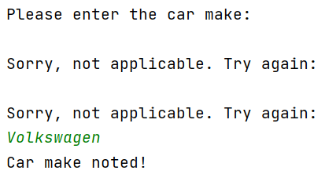
Result: Program prevented blank input values being entered, prompted user to input again.
- Blank Input Field for Car Model
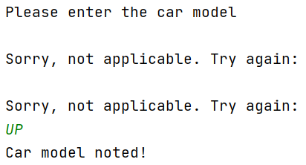
Result: Program prevented blank input values being entered, prompted user to input again.

- Test boundary for car mileage input entry
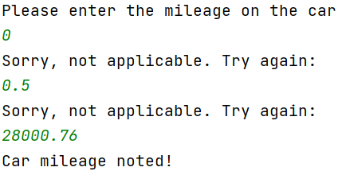
Result: Program prevented boundary value 0 and less than 1 being entered.
- Out of range values
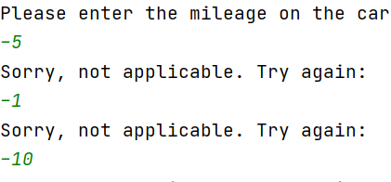
Result: Program prevented out of range values being entered.
- Test boundary for car doors input entry
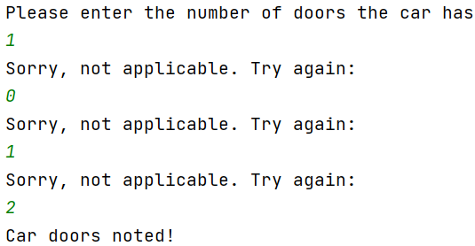
Result: Program prevented boundary value 0 and less than 2 being entered.
- Out of range values
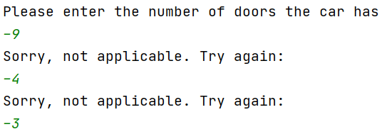
Result: Program prevented out of range values being entered.

Q2 Calculate the number of carrots that can grow on a vegetable bed

Specific Problems
This is a more complex exercise as the program asks the user to input the height and width of the vegetable bed and to calculate the number of carrots, they can grow with a set area per carrot. Therefore, a while loop will again need to be used so that when the user is prompted to enter the height and width of their vegetable bed then they answer with an integer above 0.

Pseudo Code
BEGIN
Print input width of vegetable bed
User Input
While width of vegetable bed is less than 0
Prompt user input
Else
Store Input
Print input height of vegetable bed
User Input
While height of vegetable bed is less than 0
Prompt user input
Else
Store Input
Divide veg width by 8 (rounding down total to the nearest integer)
Divide veg height by 8 (rounding down total to the nearest integer)
Multiply totals
Print totals
END

Logical Steps
- Prompt the user to enter the width of the vegetable bed
- Check number entered for width is above 0 (if not back to step 1)
- Prompt user to enter the height of the vegetable bed
- Check number entered for height is above 0 (if not back to step 3)
- Calculate first total by doing vegWidth // vegBed (8), which rounds down total to the nearest full number
- Calculate second total by doing vegHeight // vegBed (8), which rounds down total to the nearest full number
- Calculate final total by multiplying total 1 by total 2
- Print the results of the number of carrots that can fit in a vegetable bed

Code
print("Welcome to the carrot calculator!")
print("Please enter the width of the vegetable bed:")
vegWidth = int(input())
while (vegWidth <= 0):
print("Sorry, it must be above 0. Try again:")
vegWidth = int(input())
else:
print("Width of the vegetable bed noted!")
print("Please enter the height of the vegetable bed:")
vegHeight = int(input())
while (vegHeight <= 0):
print("Sorry, it must be above 0. Try again:")
vegHeight = int(input())
else:
print("Height of the vegetable bed noted!")
vegBed = 8
total1 = vegWidth // vegBed
total2 = vegHeight // vegBed
total3 = total1 * total2
print("You are able to get", total3, "carrots in your vegetable bed!")

Testing
- Normal Values
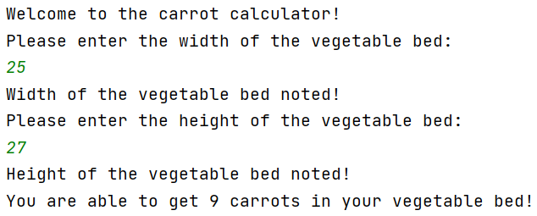
Result: Program performed as expected, correct answer calculated.
- Test boundary for width input entry
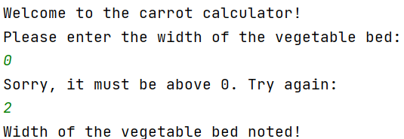
Result: Program prevented boundary value 0 being entered.
- Test boundary for height input entry
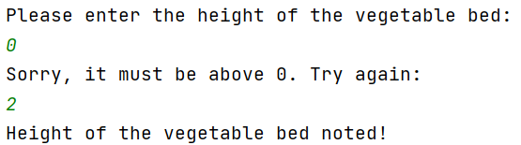
Result: Program prevented boundary value 0 being entered.
- Out of range values
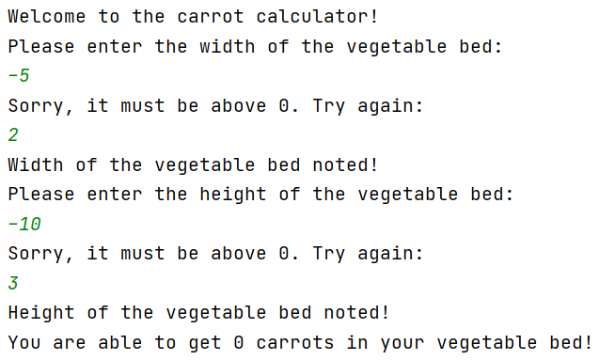
Result: Program prevented out of range values being entered.

Q3 Calculate the discount for the products and prices entered

Specific Problems
This is a much longer exercise as there needs to be a validation with every input, there are 10 of them. A while loop will need to be used again as the input needs to meet the validation if not it prompts the user to enter data again, making it unsuitable for a for loop. Then the prices will need to be added together and then calculating a 15% discount, rounding to two decimal places.

Pseudo Code
BEGIN
Prompt user input for products
While string is empty
Prompt user input
Else
Store input
Prompt user input for prices
While int is empty
Prompt user input
Else
Store input
Print products and prices in lists
Calculate 15% discount
Print discounted price
END

Logical Steps
- Prompt the user to enter product 1
- Check product was entered (if not back to step 1)
- Prompt user to enter price 1
- Check number entered is above 0 (if not back to step 3)
- Prompt the user to enter product 2
- Check product was entered (if not back to step 5)
- Prompt user to enter price 2
- Check number entered is above 0 (if not back to step 7)
- Prompt the user to enter product 3
- Check product was entered (if not back to step 9)
- Prompt user to enter price 3
- Check number entered is above 0 (if not back to step 11)
- Prompt the user to enter product 4
- Check product was entered (if not back to step 14)
- Prompt user to enter price 4
- Check number entered is above 0 (if not back to step 15)
- Prompt the user to enter product 5
- Check product was entered (if not back to step 17)
- Prompt user to enter price 5
- Check number entered is above 0 (if not back to step 20)
- Print the products and prices in a list (round the price for the 5 products by 2 decimal places)
- Add all the prices together
- Print the total amount together (rounded by 2 decimal places)
- Calculate the 15% discount and print (rounded by 2 decimal places)

Code
print("Enter Product 1:")
product1 = input()
while (product1 == ""):
print("Sorry, answer is not applicable. Try again:")
product1 = input()
print("Enter Price of Product 1:")
price1 = float(input())
while (price1 <= 0.00):
print("Sorry, answer needs to be above £0.00. Try again:")
price1 = float(input())
print("Enter Product 2:")
product2 = input()
while (product2 == ""):
print("Sorry, answer is not applicable. Try again:")
product2 = input()
print("Enter Price of Product 2:")
price2 = float(input())
while (price2 <= 0.00):
print("Sorry, answer needs to be above £0.00. Try again:")
price2 = float(input())
print("Enter Product 3:")
product3 = input()
while (product3 == ""):
print("Sorry, answer is not applicable. Try again:")
product3 = input()
print("Enter Price of Product 3:")
price3 = float(input())
while (price3 <= 0.00):
print("Sorry, answer needs to be above £0.00. Try again:")
price3 = float(input())
print("Enter Product 4:")
product4 = input()
while (product4 == ""):
print("Sorry, answer is not applicable. Try again:")
product4 = input()
print("Enter Price of Product 4:")
price4 = float(input())
while (price4 <= 0.00):
print("Sorry, answer needs to be above £0.00. Try again:")
price4 = float(input())
print("Enter Product 5:")
product5 = input()
while (product5 == ""):
print("Sorry, answer is not applicable. Try again:")
product5 = input()
print("Enter Price of Product 5:")
price5 = float(input())
while (price5 <= 0.00):
print("Sorry, answer needs to be above £0.00. Try again:")
price5 = float(input())
print("Products Entered:")
print(product1, round(price1, 2))
print(product2, round(price2, 2))
print(product3, round(price3, 2))
print(product4, round(price4, 2))
print(product5, round(price5, 2))
totalPrice = price1 + price2 + price3 + price4 + price5
print("The total amount is £", round(totalPrice, 2))
staffDiscount = totalPrice * 0.85
print("The Total with Staff Discount is £", round(staffDiscount, 2))

Testing
- Normal Values
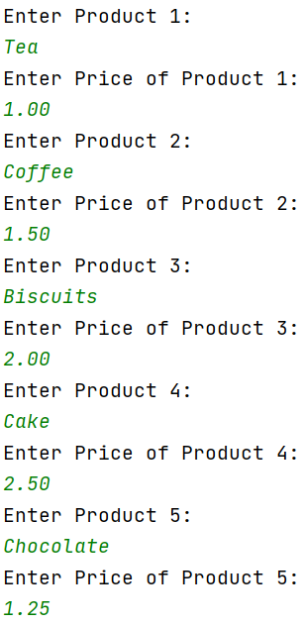
Result: Program performed as expected, correct information printed.
- Test blank input entry for all 5 products
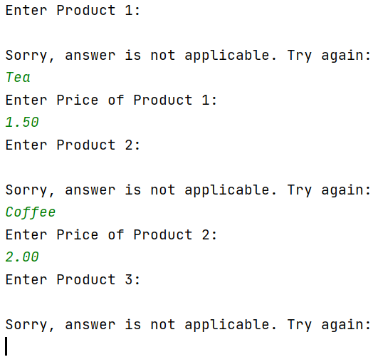
Result: Program performed as expected for all 5 products, correct code printed.

- Test entry 0 for 5 prices
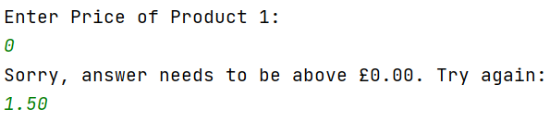
Result: Program performed as expected for all 5 prices, correct code printed.
- Out of range values
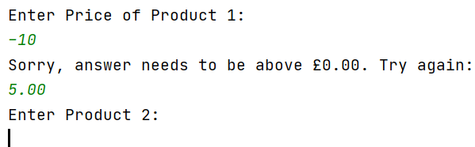
Result: Program prevented out of range values being entered for all 5 prices.

Q4 Treasure Hunt

Specific Problems
This is a very complex exercise as there are many validations to consider here. From first glimpse, it is clear to see that when the user enters their guess there needs to be a validation on the numbers to ensure they only enter numbers 0-15. For this there will need to be while loops in it, along with some if statements. The numbers also need to be randomised every time the user gets it incorrect, which makes it harder for the user to get the answer correct the first time.

Pseudo Code
BEGIN
Play game?
User input
IF userInput == yes
Print choose position
Else
Goodbye
Print choose position
User input
While userGuess != randomiser
Print sorry not right. Try again
User input
Else
Print Winner
Print number of turns
END

Logical Steps
- Prompt user to enter yes or no
- Check answer is y or n (if not back to step 1)
- Prompt user to enter position
- Check number is 0 and above or 15 and less (if not back to step 3)
- Loop around until user chooses correct position

Code
import random
def welcome():
print("Welcome to my Treasure Hunt!")
print("Would you like to play my random number guessing game? (y/n)")
def lost():
print("Sorry not right")
print("Have another go!")
print("Choose position: (0-15)")
def win():
print("Winner! Well Done!")
print("You guessed the answer in", noOfGuesses, "turns!")
print("Thank you for using my Treasure Hunt Game. See you next time!")
myMap = [0, 0, 0, 0, 0, 0, 0, 0, 0, 0, 0, 0, 0, 0, 0, 0, 1]
random.shuffle(myMap)
noOfGuesses = 1
welcome()
play = input()
if play == "y":
print("Good Choice.")
print("Choose position: (0-15)")
myguess = int(input())
elif play == "n":
print("Sorry to see you go. Goodbye!")
exit()
else:
print("Answer not applicable. Please enter your answer again: (y/n)")
play = input()
print("Choose position: (0-15)")
myguess = int(input())
while (myMap[myguess]!=1):
lost()
noOfGuesses += 1
myguess = int(input())
else:
win()

Testing
- Normal Values
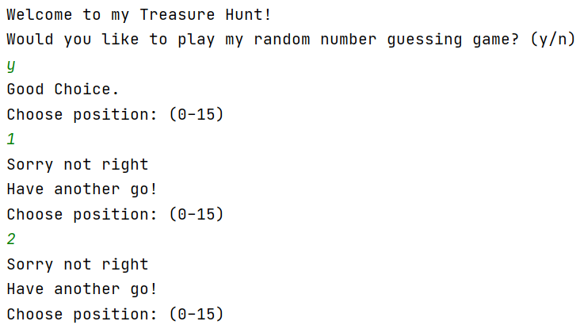
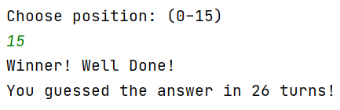
Result: Program performed as expected, correct answer calculated.
- Test other inputs for yes or no
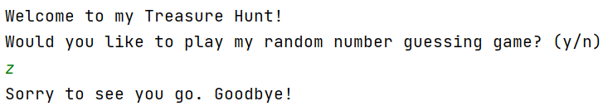
Result: Unfortunately, this was not successful as it should have prompted the user to input their answers again. So, I will alter the code now.
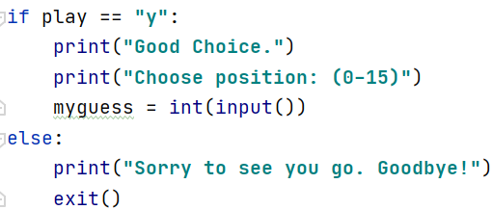
This is the code before. This allowed errors to be made as the else does not only define “n”, but all letters.
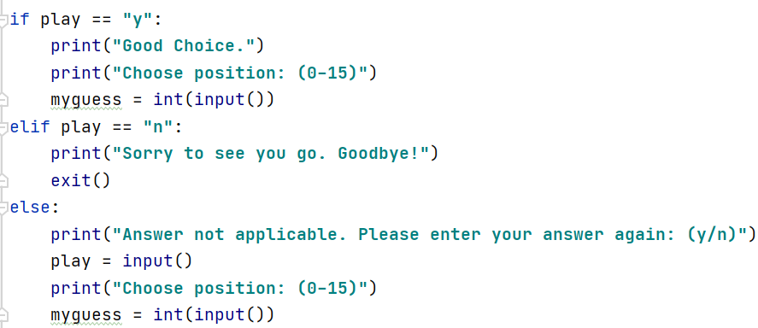
Therefore, I have now changed the code so that I had an elif statement that exit the program when “n” is entered and for any other letter they are able to enter their choice for whether they want to play again.
- Out of range values for positions
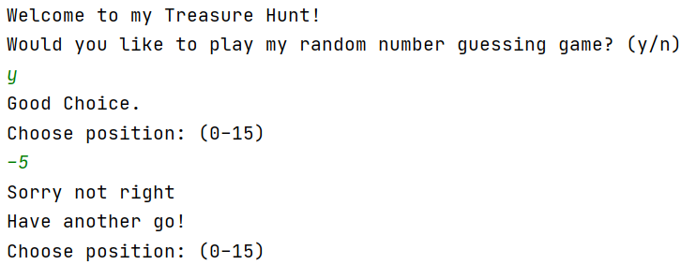
Result: This is not the exact answer that was wanted when testing out of range values. The code could have given a different statement saying it was out of range. However, it does specify that the user should enter a number between 0 and 15. The validation is correct as the numbers are contained in a list consisting of 15 numbers.
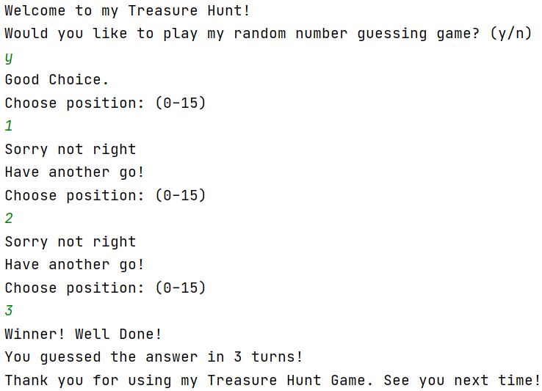
And this is the final printed code.

Conclusion
In conclusion, a variable is a place where the pre-defined values are stored. The type of variable can also change depending on the input type. The types of variables are string, int and float. An if statement is code to make a decision in a program. The comparison operators for these statements are == (equal to), > (greater than), >= (greater than or equal to), < (less than), <= (less than or equal to), != (not equal to). The statement elif, means that there is another condition that could be met, and this allows the programmer to have multiple conditions in one if statement, which makes it simpler and easier to comprehend. The while loop is used when the user does not necessarily know in advance how many times, they want it to be repeated, and the number of times it goes around the loop (iteration). The for loop is used by the programmer when they do know exactly how many times round the loop it will go (iteration). Finally, all these functions are important factors within python programming, and it would not exist without.

