Professional & Career Development

Student Name &ID: Ramatulai Sesay & 1710620.

Tutor: Mary March

Table of Contents
Introduction 3
Review of Self-Evaluation 4
Johari Window 4
Getting Know Myself 6
Learning Style and Research 8
Significance of Being Aware about Learning Style: 8
Learning style: 8
Honey and Mumford Style of Learning 9
VAK Style of Learning 9
Reflection on Learning Style 11
SWOT Analysis 14
Potential Job Role 17
Career Objectives 18
Professional Development Plan/Action Plan 21
Sample of personal orientation 24
Conclusion 25
References 26
Appendices 28

Introduction

Each and every individual has own surrounding where they are belonging and everyone has interest to learn different skills or knowledge from the people around. In order to determine the right skills and also choose the development of career, a person needs to follow different types of career development plan and the execution of planning in practically, finally which will bring out the development for an individual. There is no ending of personal learning and everyone wants to develop interpersonal skills and professional skills in order to boost the career with different objectives. As like others, I have personal career choice and that's why I need to develop some skills and utilise that skill in a proper manner. SWOT analysis is the best way to determine personal skills and also evaluate the improvement areas to grab opportunity in career path. Smart objective is a best way to set benchmark for a personal career and of the develop career professionally. Johari window is also common theoretical model to evaluate the communication skills that is highly required for a person to compete personally and strongly. This assignment will be developed with different types of individual choices and practices by relating with theoretical models that can help a person to carry on the career pathway properly and also find out the best opportunities for career. I always eagerly wait for suggestion from any kind of people in my surrounding because this will help me to create a space to share my words and also I will be able to learn by communicating with them. I don’t have much work experience. I have desire to complete my academic degrees and as well to extend the communication skills. This life cycle will help me to guide in future and formulate the plans by forwarding me in professional career too. I have used life graph to show my entire academic and professional life.
Job Left
Started Skills for Workplace
Part-time casual job
1 to 5---- 10---15---- 20---------25--------- 30---- 35----40----- 45----- 50----- 55----- 60-----65----- 70
5 10 15 20 25 30 35 40 45 50 55 60 65 70

L-3 Diploma in Business
Basic Academic learning
-
+
Personal learning (home)

Get living benefits

Review of Self-Evaluation

Moral values on the principles of life cycle helps a person to implement different packages in practical life and also evaluate the standard dance performance by own judgement. Every person has some competencies that needs to find out by proper visualisation and also evaluation (McMillan and Weyers, 2006). I have some personal values those help me to promote my honesty in practical work and everyone has some ethical beliefs principles of life leading that helps to carry on every activity with more confidence. I always try to follow up difference situation positively and also practically in order to determine the scenario and appreciate the situation whatever it is easy or complex. Positivity is a best method to find the mental peace and also achieve own goal in life. From the very beginning of my childhood I have several plans to implement in future for a peaceful life leading. My religion is also suggesting me continuously to find the authenticity in every task of life and also find out the best result by using modesty and honesty towards that work.

Johari Window

In order to develop personal skills and professional career every person needs to be expert in interacting with people. Communication skills is a big asset for a personal development because a person who is competent to manage communication with others that person will surely be a good colleague, a good leader and also a good client for business (Cottrell, 2010). Johari window helps to find out the open this of mind in order to manage communication and it is developed with 4 different parts, those are: open, blind, hidden and unknown quadrants.
Open Quadrant of Johari window talks about the commonness of information to individual and other group of people in surrounding (Koprowska, 2014). This open quadrant also represent the information is available to all. Blind quadrant talks about the information availability by others not individual. Just the reverse impact in hidden quadrant, because individuals are well known about the information whereas nobody else is known about that. Some of the information are available but nobody is personally known about the information or some others are also not known about that information in unknown quadrant.
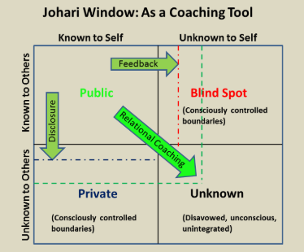
Figure: Johari Window.
Source: (Koprowska, 2014).
By considering the principles of Johari Window and also the characteristic of every spare of this model, some of the skills and attributes can be connected with my understanding level (Grant, 2015). If I consider myself and the Johari window, I can tell that I am a quick learner because I can easily find out the actual message in any circumstances of business and also learn from the situation or performance from other. I try to give concern towards my colleague, my near people, family member and all the connected people. Because of the availability of information from them and my deep understanding about that information, I can categorise myself with the Open Quadrant of Johari window.
Performance appraisal is the best way to determine a person’s competency and also suggest about the necessary improvements according to the present execution of skills (Evans, 2006). HR department in my organisation regularly assess the individual performance of everyone and also how they perform in different situation of organisation. I always welcome the evaluation of my performance from HR department at the day also suggest me regularly so that I can improve my personal skills which will guide me while performing for organisation. I am sincere about my job role and also I personally believe about the individual assessment to improve own skills. according to the last performance appraisal report the HR manager notified me that, I have failed to maintain regular performance output which can be affect me in near future.
Expansion of my open Quadrant needs to drive with blind quadrant in order to improve my professional work responsibilities and also facilitate the aspects that will help me to develop my career. I am the kind of person who is always like to support the peers, colleagues and near people who are connecting with me to fulfill the job duty.

Learning Style and Research

Learning style is the way to seek knowledge from surrounding and also this is a great of learning steps to adopt different information from the surrounding (Covey, 2013). Learning is necessary for every person in order to develop personal skills and also professional attitude by enriching knowledge about workplace (Maund, 2017). In order to develop personal skills, a person needs to always welcome knowledge and learning opportunities.

Significance of Being Aware about Learning Style:

The significance of individual learning style can be different and all the probable significance are useful for the career development of a person.
- To identify the stages of learning how a person will be able to learn individually and also apply it to the professional of real life.
- To boost up the attitude for learning.
- To develop the thinking ability in order to resolve the critical situation
- To extend the ability and mentality to accept new information

Learning style:
The learning style has different significance on basis of the nature. Different learning styles are applied for different person according to their learning ability and skills. Honey and Mumford learning style is widely used for the learners, VAK learning style is also popular approach which will be discussed below:

Honey and Mumford Style of Learning
According to the viewpoint of Honey and Mumford learning style, a learner has four different ways to learn from the surrounding and these are as follow:
Activist- The activist learners always search a learning from the surrounding and the person always likes to learn new ideas and always want to experience new things willingly (Sternberg & Zhang, 2000). An activist learner always looks for the own experience and the person tries to find out the strength points to meet the uncertainties.
Theorist- The theorist learners like to learn from the real life situations and they also prefer to take risk because they have prior knowledge from the past events and confidence to handle that consequence. The nature of theorist learners is very positive as they are practical about life and situation.
Pragmatist- The pragmatist learners like to learn from different experimental methods and they always try to use their all processes by applying theoretical and logical approaches to find out different solutions. The pragmatist learners like to follow up the situation with trial error basis.
Reflector- The reflectors like to learn from observation of surrounding and always try to configure different factors to meet the situation with on learning and personal analysis (Duff and duffy, 2002).

VAK Style of Learning

Visual- Visual learners learn from the visual orientation of different messages. In order to learn from the visual representation learning providers like to choose graphical presentation table chart in order to create a visualise media of learning.
Auditory- Auditory learners like to learn from listening and auditory learners always talks with their surrounding people and prefer to learn from there command (Prashnig, 2006). Different audio and hearing messages try to reach with conventional information to auditory learners.
Kinesthetic- Kinesthetic learners prefer to learn from physical experience. Here the learner wants to touch or Hold something for personal judgement and also boost the understanding.
My Learning Style:
VAK learning style is practical learning approach as the combination of both visual and personal understanding is connected here (Bandura, 2015). The VAK learning question arise and quizzes are given below:
The criteria for marks of this quiz are:
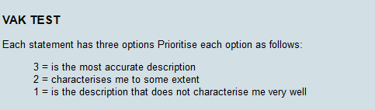

Questionnaire with my answers:
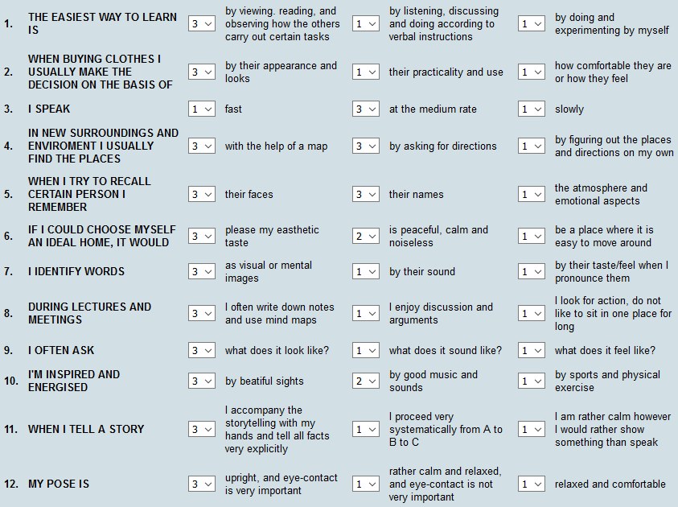
The result of my VAK learning style quiz:
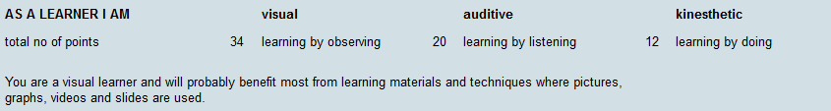
According to the findings and result of VAK learning method, I can see myself as visual learner makers I have seen in 34 number, I have contradictory score. On the other hand, quiz number 20 is reflecting myself as auditory learner. At the same time, number 12 is representing me under kinesthetic section. As a visual learner, the graphical presentation and visual charts always help me to analyse the situation and awesome best of my knowledge properly because this also help to create comparative analysis gives inside myself.

Reflection on Learning Style
Skills | Visual | Auditory | Kinesthetic | Reflection
Leadership | Through watching visual presentation on leadership theories. Learning from different visual presentation, models and theories. |  |  | I regularly try to follow up the presentation when I get free time to access my computer and I always try to find out the leadership skills by visual messages from different expertise.
Ethics | By observing the concept messages on different benefits of ethical consideration and its visual presentation. |  |  | I will feel motivated in order to maintain different ethical standards while I am a performer at my organisation and this will also help me to regularly analyse the situation and think about the positive approaches.
Team Building |  | Different audio clips to learn about team building competency. |  | I will be able to manage good communication with my team and I will be able to set different strategies on basis of the learning through audio clips.
Conflict Resolver |  |  | Try to mitigate inner conflict by physical abilities. | I can take part in my organisation to mitigate the physical balance or inner conflict with my physical ability. where I can play role to stop people who are connected with the conflict and also show positive behavioral approach throw my body language so that they can feel relax to each other.
Numerical Skills | By considering different graphical presentation and numerical data. |  |  | I can properly analyse the mathematical uses in financial terms because there are many graphical presentations are available in the financial presentations. I will be able to comparatively analyse the performance of organisation and also determine the values those are numerically present in my front.
Time Management | By observing the presentation on time management skills and strategies |  |  | I can become more competent to manage time and also take proper attempt to set strategies by observing regular presentations on time management skills and attitude of setting strategies in this field.
Communication |  |  | By interacting with people through body language and meet communication through my gesture, tone of voice, facial expression etc. | I can develop my skill communication and positive environment through my facial expression body language and also showing the professional attitude by good command.
Motivator | By observing the videos on different theories of motivation and package discussions to be more motivated. |  |  | YouTube different social media groups are good sources to regularly follow up the videos on motivational theories and practices. There are different experts are available with their lectures in YouTube so I can learn from their series videos.
Negotiator |  | By listening and understanding the lectures of different experts in negotiation skills. |  | I should find voice lectures of different experts in negotiation skills management and also online discussions with visual and audio please that can support a person to set strategies, take positive steps in order to negotiate with people and make balance with the demand of both parties.
Written Skills | By observing the reading materials and graphical representation in order to develop writing skills. |  |  | Writing skills are fully connected with the enthusiasm of a person and also the approach to learn willingly (McMillan, 2006). A person can learn writing skills by observing different video lectures of different expert with different subject. The development of writing skills will help to officially manage communication with upper bosses and also create a good professional image in organization (Wilson, 2009).

SWOT Analysis

SWOT analysis is a good way to individually judge the personal skills a brief SWOT analysis is given below.
Strengths | Weaknesses
I am competent at:  - I have good ability to manage communication with my peers and colleagues.  - I like to willingly perform in the complex situation because there are many learning opportunities are available there.  - I can reckon myself as a workaholic person and this helps me to in which my career plan and also professional learning. | My improvement area:  - I need to be more professional to manage communication and in time delivery of speech  - Sometimes I feel hectic while interacting with different group of people but this is a big weakness of mine.  - I need to extend my proactive approach in every state of professional and personal career.
My special resources:  - I have real life experiences over 7 years in job as I have performed in an information centre in London which helped me to communicate with different clients around the world.  - I have sound knowledge about good communication skill management and also work with different team members in order to assist them individually and also serve the information according to requirement of clients. | The areas where I lack in resources than others:  - Some of my colleagues have more relevant degrees and training compared to me.  - Some of my colleagues are really efficient in time management and complete tasks faster than me.
Strengths of mine in other people’s eyes:  - I am passionate about my work and also my workplace.  - I have good interpersonal skill that help me to feel confidence always. | Weaknesses of mine in other people’s eyes:  - I have track history to timely complete big number of tasks in a rush time.  - On some occasions I have failed to manage with communication with business clients and that's why I was negatively marked by the upper management.

Opportunities | Threats
Available opportunities to me:  - I have the opportunity to switch my career to any Research Organisation or the consultancy firms where I will be able to manage more relationship with different clients and it will help to enrich my professional career also.  - I am currently pursuing at UWTSD where I have learnt different communication skills from the academic presentation and co-curricular activities in academic content. And I am pretty sure about the good implementation any creation of opportunity for these skills in future. | Threats that can hamper my career:  - Competition in professional career is rising day by day and there are many people are coming with their competency in different job role. So that I need to be very much active to hold my position otherwise it will be a big threat for me.  - If I fail to manage my job role with proper time management skills, I will not be able to create a good image in organisation and this will also negatively represent me whatever I have skills or other competencies.
Ways of turning strengths into opportunities:  - I have the ability to interact with people according to their perception so I need to utilise this is skill together support in order to boost my confidence  - By applying high consideration and concentration on my skills I will be able to properly execute my role in current position of job at OC&C Strategy.  - As I am a visual learner, I have the opportunity to make sense about reality and also just the situations according to different models. By using these skills, I will be able to solve different complexities in business and this will help to promote my academic and professional career also. | Threats induced by personal weaknesses:  - My habit to feel nervous while managing communication with big number of people may drag my confidence in future.  - Lacking to manage individual task in proper time will surely reduce my work quality and it will also work as a threat for me in career growth at OC&C Strategy.

I have provided at SWOT analysis on basis of my performance and skills that I have currently. some of the points of been mentioned hair on the fees of my competency in different paste special in the communication management. Along with the present skills I have some weaknesses that I have mentioned in the brief assessment of SWOT analysis above. Due to my liking in time management skills I have failed to manage my tasks sometime according to the estimated deadline but I have good interaction skills that I need to execute properly to retain balance in work performance management; otherwise it can play as a big threat for me.
As I mentioned earlier that I have been working for 7 years in a research consultancy from where I have played role as a communication manager and their I have managed different professional communication with the clients. By considering my skills, I can tell about that I have good opportunity to obtain different knowledge vitalizing my personal skills and interactional ability. In my present organisation OC&C Strategy, I have good image towards my colleagues and I need to improve my skills more professionally, so that the professional opportunities will be easier to grab.

Potential Job Role

As a communication manager I need to manage communication with different business clients in my organisation and I need to perform some additional duties to follow up the records of different major clients in business, so that the communication can be effectively managed. As my primary duty to follow up the routine work of different group of employees inside organisation and regularly serve messages to them about their performance. Sometimes I need to play role as a potential manager where I need to consult with the employee group and also note down their queries to further interacting with the top management. As I have expertise to interact with different group of people by observing their mentality and also their requirements. So I have a desire to perform in different multinational organisations where I will get the emerging opportunity to maintain steady growth in career and execute my competencies properly.
The rationale behind choosing this career pathway is mainly my expertise to manage communication with different business group of people. As I believe that, every person has some skills that can help a person to perform in a better way inside organisation and also boost professional career. So, if I can execute my role properly then it will help to enrich my experience and carry out my dream in future hopefully. A good communication manager is always helpful for the customers, for the organisation and for the business clients. this is the silent reason behind I have chosen the ambition.

Career Objectives

As an employed professional I have certain career objective and I have target to match that objective with smart plan.
I have completed my SMART objective template and added on Appendix.
I have set up periodic target with different layers of SMART objective plan to shift my career as a good customer relationship or communication manager in a multiple organisation.

Professional Development Plan/Action Plan

The individuals who are employed in organisation with different skills and knowledge are needed to regularly improve their present skills by personal analysis (Pritchards, 2008). In order to develop knowledge and skill, a person needs to professionally judge the action and also carry out action plan to find out loops in performance. Throughout a professional development plan or Action Plan, I will be out the able to set proper development stages.
I have also completed my Personal Career Development (PDP) template and added on Appendix.

In my PDP, I have developed the Action Plan will help me to gain some skills and also in which my knowledge as a good customer relationship manager.

Sample of personal orientation

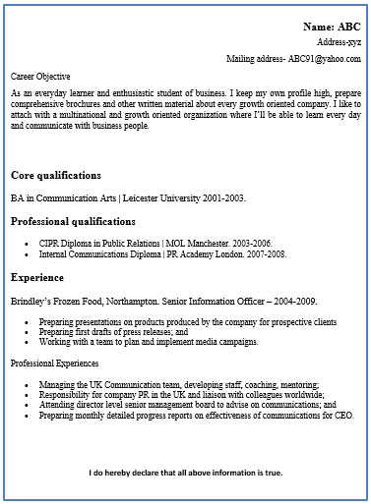

Conclusion

There are different ethical values and principles need to consider by and professional in organisation while performing with different surrounding. Theoretical approaches have been developed to practically evaluate the performance and also reengineering the performance in order to match with the business objective. The assignment has been developed with different career management plans and objectives with self-evaluation, so that I can perform better way in my present organisation and also achieve the target of my desire position in a multinational organisation.

References

- Bandura, A. (2015). Social Learning Theory (Bandura) | Learning Theories. [online] Learning Theories and Models Summaries (in Plain English).[online] Available at: <http://www.learning-theories.com/social-learning-theory-bandura.html> [Accessed 3 Feb. 2018].
- Covey, S. and Collins, J. (2013). The 7 habits of highly effective people. London: Simon & Schuster.
- Cottrell, S. (2010) Skills for Success: The Personal Development Planning Handbook (2nd edition). Hampshire: Palgrave MacMillan.
- Duff, A., & Duffy, T. (2002). Psychometric properties of Honey & Mumford’s Learning Styles Questionnaire (LSQ). PERSONALITY AND INDIVIDUAL DIFFERENCES, (1), 147
- Evans, C. and Sadler‐Smith, E. (2006). Learning styles in education and training: problems, politicisation and potential. Education + Training, 48(2/3), pp.77-83.
- Grant, K. and Dumay, J. (2015). Leading Issues in Knowledge Management. Reading: Academic Conferences and Publishing International.
- Koprowska, J. (2014). Communication and interpersonal skills in social work. 4th ed. New Delhi: SAGE Publications Pvt. Ltd, p.14.
- Maund, A. Schriek, M. and Tinkler, P. (2017). Certificate in Higher Education: Skills for the Workplace Student Yearbook. Sage Publications.
- McMillan, K. and Weyers, J. (2006). The smarter student: Skills and strategies for success at university, London: Prentice Hall.
- Morgan, P. (2016). The Business Student’s Guide to Study and Employability. Sage Publications

- Sternberg, R. J. and Zhang, L. (2000) Perspectives on Thinking, Learning, and Cognitive Styles. Mahwah, N.J.: Routledge
- Wilson, E A and Bedford, D (2009) Study Skills for Parttime Students Harlow: Pearson
- Prashnig, B. (2006). Learning styles in action. Stafford :Network Continuum Education
- Pritchards, A. M. (2008) Studying and Learning at University: Vital Skills for Success in your Degree. London: Sage Publications.

Appendices

SMART Objectives:
Name: Ramatulai sesay

Skill | Specific Objective | Measures | Attainable? | Realistic? | Time
Formulation of fundamental business objectives in order to ensuring the profitability and contribution in organization. | I want to professionally develop my career in multinational companies where I will be able to manage communication with different business icons and my target is to show my competency in organisational performance. | Currently I can evaluate myself and if I give score according to my skills and target, then I can be pleased with only 20% of skills at present situation but I need to improve more than 80% to hold the position I want to go. | I have found different reading articles and guidelines from the professionals in business sectors to achieve a business objective and also groom the personal career according to business plan. By considering these materials, I confidently believe this object is obviously attainable if I can properly manage my dream and the present career management. | In order to contribute in the business growth and a multinational company I need to be very much competent with my skills. So this communication manager role can be a good choice because there is no alternative of communication whatever the business organisation and the job position is. | I have a target to shift my career goal in a multinational company within upcoming year 2019.
Management of business deal. | The skills I want to achieve is effective communication management with the legendary players in business, because performing in a multinational organisation, among different business icons is not so easy if I fail to hold that confidence and execute my communication skills to deal with any harder situation in business. | I have 30% expertise so far to manage that type of communication but I need to improve it more than 60% or 65% to get better result. | I have good relationship with the management level employees and I regularly learn from their movements in organisation. Because of my good relationship, I always get support from them and also execute my role properly to carry out my plan for shifting the career to the multinational organisation. | As a a communication manager I need to perform among different background people so that I need to conscious about the business objective and also their views. | I have a plan to take different professional training programs and attend professional career development seminars to boost my knowledge to achieve the objective within July 2019.
Customer relationship management skill. | Customers are the major party to represent a business and also represent the performance of insiders. In order to manage good customer relationship, I need to follow up their requirement and also regularly manage communication with the decision makers. | As a relationship manager in my current position I have some skills to maintain customer relationship but I need to further extended more than 40 to 50% for getting better result. | There is no ending of learning and everyone is a learner in business. I need to regularly improve my skills by gathering knowledge and information from different practical situation in business. there are many life oriented case studies are available for generating knowledge and I always need to welcome those. as I have some knowledge while I am performing for OC&C Strategy, but I need to extend it more. | Customer relationship management skill will help me to represent my communication skills to the top management and this will also help me to boost up my professional career. | I will achieve this objective by November, 2019.

Professional Development Plan/Action Plan
Name: | Ramatulai Sesay | Student Number: | 1710620

Start and completion date | Skill and knowledge that I will develop | The measures I need to take to achieve the skill/knowledge | Resources and support I need for achieving the skill/knowledge | Success criteria | Provider
Start: by December, 2018  Complete: by April, 2019. | Skills to management good relationship with business clients. | I have to regularly follow up the article and real case study for business to properly judge the competencies of different professionals in this stage. | I need to in which my technical knowledge to operate computer and technically manage the business functions to communicate with business clients according to their needs and also present data properly so that they will be able to understand and easily make communication with me. | I am capable of making communication with new Client or the beach parties in organisation. as I have also sound knowledge about the internet which is a great platform to maintain communication. | Any professional institution where the professional courses and training are provided can be useful for me.
Start: January, 2019  Complete: June, 2019 | Boost up knowledge to interpret the financial records and ensure trusted environment among the client | In order to boost up this knowledge, I need to study more about the financial terms and basic calculation in financial assessment so that I will be able to easily interact with the client and reach information. | I will required to study the financial books, article and regular newspaper blogs to keep proper sense about the way to gain that learning. | I need to develop my financial knowledge properly so that I can easily understand the business performance and also represent this to the business line while interacting with them. | There are many financial books are available in market and the author of blog, book writers are the information providers here.
Start: march, 2019  Complete: September, 2019 | Development of Administrative skills in order to control the situation properly. | By participating with different professional training programs in order to govern the employees and also execute role in the administrative work management. | I need support from the professionals in my organisation who add expertise in this administrative skills and also support from the external trainers to develop fundamental basement about this skill. | I am partially groomed to control the business situations with good administrative skills. | Professional training organisations and the experienced workers in my organisation.

