A Report Focussing On:

Seismic Design of Buildings

Module Code – ACBA6018

Word Count Required – 2000 (+/- 10%
Word Count: 2200

Prepared for:
S. Bitar

Created By:
E. Evans (2211009)

Submission Deadline – 5th May 2026

Table of Contents
1. Introduction 3
2. Structural & Architectural Considerations 4
3. Structural Considerations 5
3.1 Ductility 5
3.2 Capacity Design 5
3.3 Structural Regularity & Symmetry 6
3.4 Lateral Load-Resisting Systems 6
4. Architectural Considerations 9
References 13

Table of Figures
Photo 1: Bangkok’s Park Origin towers earthquake skybridge break (B1M 2025) 3
Photo 2: Plastic Hinge displayed on a beam where areas become plastic in order to bend (Rong, 2023) 5
Photo 3: Conventional systems (Sohail, 2024) 7
Photo 4: Self-Centring system (Yun, 2021) 7
Photo 5: Tuned mass damper (Walters Group, 2022) 8
Photo 6: Extreme Loading seismic design (Extreme Loading, 2025) 9
Photo 7: Earthquake codes for concrete (Shumak, 2023) 11
Photo 8: Earthquake codes for steel (Shumak, 2023) 11

1. Introduction
This report will be focussing on the fundamental structural and architectural requirements for the design of seismic buildings to ensure the safety, functionality and resilience of structures that are subjected to seismic forces such as earthquakes and ground movements. Earthquakes are some of the most destructive natural hazards and will cause devastating damage to buildings, infrastructure and communities. The main objective of designing for seismic forces is to ensure that structures do not collapse and occupants can safely evacuate, in some cases the structures may be designed to prevent damage completely but with the main purpose of occupant safety. For example, modern seismic design philosophy allows controlled damage while maintaining life safety such as the damage to a skybridge connecting two high rise buildings breaking away in Thailand which was designed to prevent one swaying tower from pulling the other down to preserve lives (Jiro Takagi, 2019).

In this report there will be consideration of the different aspects of seismic design in buildings while reviewing design code requirements, methods and different structural systems that can be implemented to ensure a building is earthquake resistant.
Photo 1: Bangkok’s Park Origin towers earthquake skybridge break (B1M 2025)

2. Structural & Architectural Considerations
Seismic design of buildings has changed a lot over the years and have shifted from strength based approaches to performance based design philosophies, extensive research has been undertaken in order to understand how buildings respond to seismic events and how the structural/architectural design influences the performance of the structure (Elide Nastri, 2025).
Modern seismic design key principles are:
- Performance Based Design (PBD) – Advanced approach to design structures to meet specific predefined performance goals such as damage control during seismic activity, modern approach to possibly bypass certain code limits to be flexible in design (Jianhai Liang, 2025).
- Ductility & Inelastic Behaviour – Structural members designed to bend and deform without breaking, allowing the structure to dissipate energy rather than failing (Bachmann, 2003).
- Capacity Design - Hierarchy of Strength approach which attempts to avoid undesirable modes of failure. Ductile elements such as beams fail before brittle while critical elements like columns or foundations have a favourable hierarchy of strength to dissipate energy (Sujin S. George, 2012).
- Structural Configuration & Regularity – Utilising uniform layouts to avoid stress concentrations for predictable behaviour under seismic loads (StruCalc, 2025).
- Base Isolation & Energy Dissipation – Use of dampers or flexible materials to reduce energy transferred to the structure (StruCalc, 2025).
- Lightweight Construction - Use of lighter materials reduces inertial forces that a building experiences during seismic activity, the heavier the structure the greater the inertial forces it is subjected to (KIMPUR, 2025).
- Redundancy – Providing multiple load paths to ensure stability in the structure if one element fails (StruCalc, 2025).

3. Structural Considerations

3.1 Ductility
Structures are designed to withstand predictable loads as seismic forces can be highly dynamic and unpredictable. The importance of ductility is widely recognised as the most crucial parameter in seismic design, ductile structures perform significantly better than brittle during seismic activity (Structural Engineering India, 2025). Ductility in a structure allows for predictable movement, dissipation of loads and large deformations without collapse, while providing warnings before any failure (Andrew O’Donnell, 2016). Steel structures can implement designed ‘plastic hinges’ that deform enough to twist when under critical load and act as a hinge that returns when dissipating seismic energy, making them advantageous for seismic design. Ductility through reinforced concrete can be achieved through adequate reinforcement detailing, confinement of concrete using stirrups to avoid shear failure (Rong, 2023).
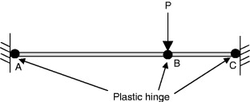

Photo 2: Plastic Hinge displayed on a beam where areas become plastic in order to bend (Rong, 2023)

3.2 Capacity Design
This design approach is critical for seismic resistance and ensures a structure remains safe while avoiding failure, this method employs several key areas such as establishing a strength hierarchy that involves columns to be stronger than beams known as the ‘Strong column-Weak Beam which ensures that beams yield first and prevents formation of a column sway mechanism (also known as a ‘soft storey’) that has historically led to multiple building collapses. Creating a favourable hierarchy of strength can offer a predictable and satisfactory response to seismic loading. Controlling energy dissipation in the structure can cause predetermined members to turn into ‘plastic hinges’ under severe inelastic deformation. This allows the members to accommodate the loading without the structure failing (Sujin S. George, 2012).

3.3 Structural Regularity & Symmetry
This method of design is critical in engineering to ensure uniform load distribution among structural elements during seismic events, when a structure is regular (characterised by uniform distribution of loads) it avoids the additional forces, eccentricities and excessive displacements that usually occur in irregular designed buildings due to changes in mass and stiffness. A structure is specifically classified as regular in elevation under Eurocode 8 (EC8) if it meets the following criteria:
- Continuous Resisting Systems – Lateral resisting systems such as frames and walls must be continuous from the foundation level to the roof level.
- Gradual Mass and Stiffness Distribution – Storey mass and stiffness must remain constant or be reduced only gradually from the base of the building upwards.
- Geometric Limits for Setbacks – Buildings with setbacks are subject to strict numeric threshold for them to maintain ‘regular’ classification under EC8.
Regularity and symmetry can provide predictable ductility, performance and avoid torsion in members while managing mass and stiffness (StruCalc, 2025) (SECED, 2026).

3.4 Lateral Load-Resisting Systems
These are structural configurations designed to withstand horizontal forces and utilised in absorbing forces generated by seismic activity. Load resisting systems are crucial to a structures stability and feature two types based on their performance goals such as conventional systems and high performance Self-Centring systems.
Conventional Systems – Standard systems used in modern building codes such as steel moment resisting frames, steel concentrically braced frames and concrete shear walls. These systems are designed to dissipate seismic energy through inelastic behaviour which means they are intended to sustain permanent damage like yielding, buckling or cracking to prevent the building from collapsing.
- Moment Resisting Frames – Allow controlled bending and rotation at joints.
- Shear Walls – Vertical elements that resist lateral forces.
- Braced Frames – Diagonal bracing introduced to reduce lateral displacements.
(StruCalc, 2025)

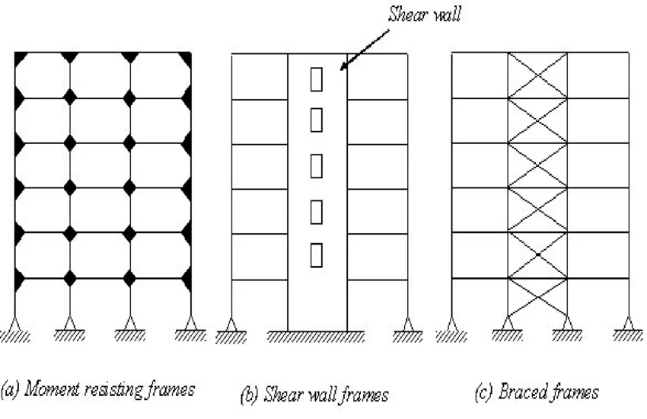
Photo 3: Conventional systems (Sohail, 2024)
Self-centring Systems – Modern system designed to minimize/eliminate structural damage that utilises gap opening mechanisms and post tensioning steel to allow the structure to soften elastically during seismic forces.
These systems are very important in protecting human life by reducing the risk of collapse to preserve ‘life safety’ all seismic design codes feature the primary concern being life safety. Self-centre systems limit residual drift which is horizontal displacement after seismic events which many lead to demolition or significant repairs (Chancellor, 2014) (gov.uk, 2015)
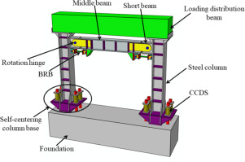

Photo 4: Self-Centring system (Yun, 2021)
3.5 Energy Dissipation Systems
These systems are designed to increase the seismic resilience and sustainability of structures by absorbing and dissipating energy induced by seismic events. These systems function by reducing the seismic forces exerted on structural members which minimises damage and extends the service life of the structure. There are several types of systems based on their mechanisms:
- Tuned Mass Dampers (TMDs) – These systems reduce motion by counteracting seismic forces very effectively, these are commonly utilised in skyscrapers.
- Friction Dampers – These systems feature controlled sliding friction between surfaces to provide consistent performance, often utilised in retrofits where space is limited.
- Viscous Dampers – Generate resistance through fluid viscosity providing predictable behaviour across different seismic intensities.
- Metallic Yielding Dampers – Absorb energy through inelastic deformation of steel elements.
- Viscoelastic Dampers – Combination of elasticity and viscous behaviour allowing to maintain stiffness while dissipating energy in flexible structures like skyscrapers.
(Al-Janabi, 2025) (Titirla, 2023) (DezignArk, 2020)
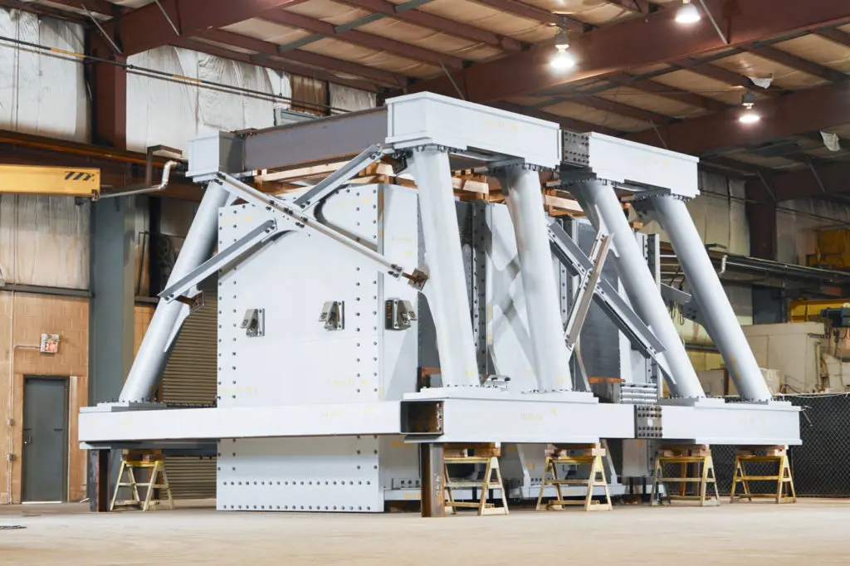

Photo 5: Tuned mass damper (Walters Group, 2022)

4. Architectural Considerations
To properly manage an effective design for a structure to withstand seismic loads it is very important to integrate building geometry, material selection and advanced technology to ensure structural integrity and user safety. The most efficient strategies for seismic design focus on influencing the buildings stability to withstand, absorb and recover from seismic forces. The following strategies can be:
4.1 Building Configuration & Geometry
Architectural design significantly influences how a building responds to ground movement.
- Symmetrical and Regular Shapes – Simple symmetrical designs such as squares or rectangles are preferred for their ability to distribute seismic forces evenly and reduce localised stress.
- Avoid Irregularities – Designers should avoid complex geometries such as re-entrant corners (L,T,U or H shaped plans) as they create ‘notch points’ where stress accumulates.
- Vertical Consistency – Sudden changes in a buildings height or floor plan (setbacks) should be avoided to prevent concentrated stress at certain levels.
(Harle, 2024) (Korkmaz, 2019) (Shareef, 2023)
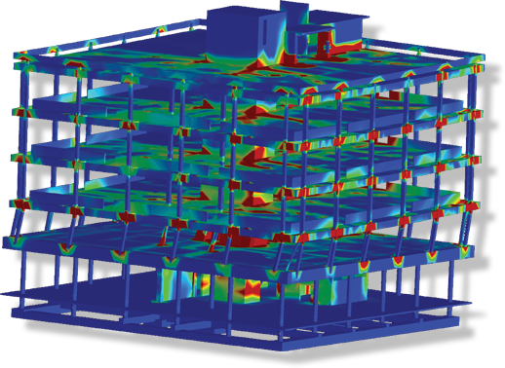

Photo 6: Extreme Loading seismic design (Extreme Loading, 2025)
4.2 Strategic Mass & Stiffness Distribution
Balancing the weight and rigidity of a structure is crucial to preventing collapse.
- Centre of Rigidity and Mass – The distance between a buildings centre of gravity and the centre of rigidity should be minimised to prevent torsional (twisting) effects.
- Lowered Centre of Gravity – The placement of heavier components such as mechanical equipment and storage lower in the structure can reduce the risk of the building overturning during seismic activity.
- Uniform Stiffness – Avoiding ‘soft stories’ which are levels with significantly less stiffness than those above, like open ground floor parking is essential for maintaining structural stability.
(Harle, 2024) (Korkmaz, 2019) (Shareef, 2023)
4.3 Implementation of Advanced Technologies
The incorporation of specialised devices to detach the building from ground motion and dissipate energy.
- Base Isolation – Involves placing the structure on flexible bearings at the foundation to allow the structure to move independently of the ground to reduce forces transmitted to the upper floors.
- Energy Dissipation Devices (Dampers) – Utilising tuned mass dampers and the like to absorb and counteract swaying from seismic energy.
(Harle, 2024) (Korkmaz, 2019) (Shareef, 2023)
4.4 Material & Structural System Selection
The choice of materials impacts a structures ductility and strength.
- Ductile Materials – Reinforced concrete and steel for their ability to deform without brittle failure, allowance for absorbing energy through controlled movement.
- Innovative Systems – Hybrid systems combining steel, concrete and timber such as Cross Laminated Timber offer high strength to weight ratios and natural damping qualities.
- Flexible Facades – Openings, facades and cladding can be designed with flexible joints and proper anchoring to accommodate structural movement without detaching and becoming dangerous.

4.5 Code Adherence & Design Code Requirements
Reviewing design codes in photos () outlines several main design code requirements focussing on ensuring seismic resilience of conventional and commercial buildings. The requirements focus on conceptual design, structural behaviours and methods used to calculate seismic forces.
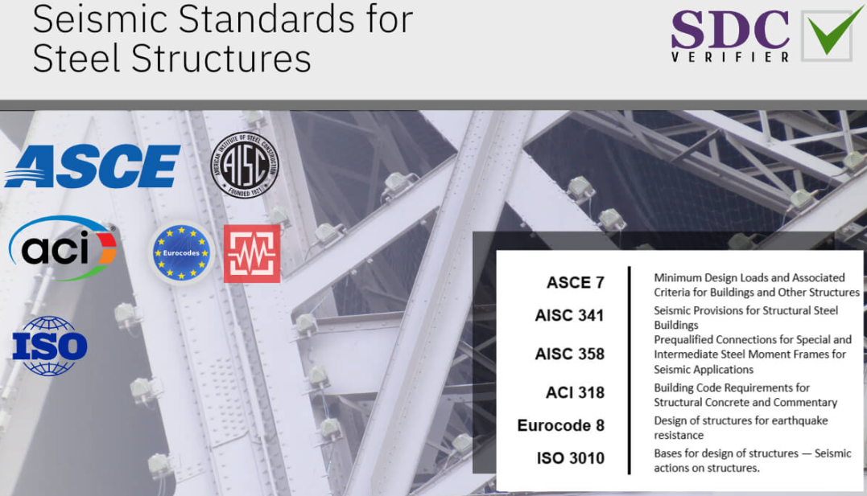
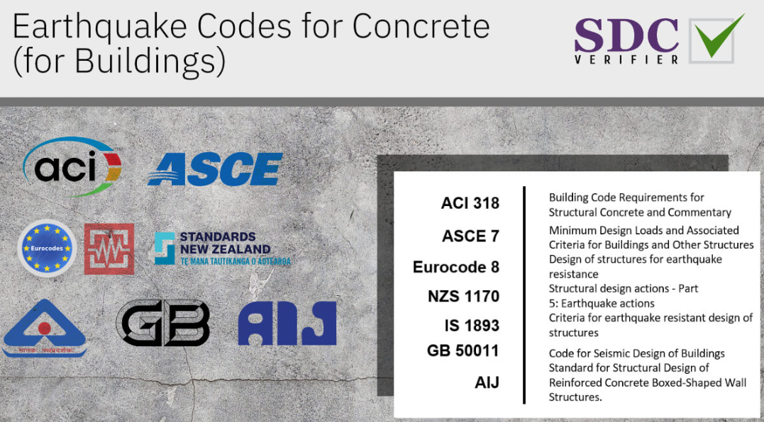
Photo 7: Earthquake codes for concrete (Shumak, 2023)

Photo 8: Earthquake codes for steel (Shumak, 2023)

4.5.1 Conceptual Design & Structural Regularity
International codes reinforce specific architectural and structural characteristics to ensure predictable performance during seismic events.
- Basic Principles – Codes recommend structural simplicity, uniformity and regularity in plan and elevation.
- Stability Requirements – Structures must have bi-directional, torsional resistance and stiffness, as well as diaphragmatic behaviour to ensure the structure moves as a cohesive unit.
- Foundations – All codes require adequate foundations to support the seismic resisting system.
4.5.2 Ductility & Detailing
All codes require structures to not be designed to remain purely elastic during major seismic events.
- Non-Linear Behaviour – Structures must be designed and detailed to provide enough ductility to dissipate energy in the non-linear range.
- Detailing for Energy Dissipation – Ductility achieved through specific structural detailing that allows the structure to undergo large deformations without collapsing.
- Response Modification – Codes provide reduction factors to transform elastic response spectra (Full seismic force) into design spectra (Reduced version of the elastic spectrum) based on the structural system, material and ductility class.
Other requirements such as classification and environmental factors should be considered, for example soil conditions that need to be tested and classes of importance for consequences of failure. There needs to be critical focus on analysis procedures depending on the structures characteristics including static analysis which focusses on the lateral force method. The dynamic analysis involves advanced methods such as linear time-history analysis using recorded seismic data. Some codes such as the Eurocode 8 allows non-linear static analysis providing they are properly substantiated (Shumak, 2023) (Santos, 2017) (Fu, 2018) (santos, 2020)

References
Al-Janabi, M. A. Q., 2025. Enhancing Structural Resilience for Sustainable Infrastructure. [Online]
Available at: https://www.mdpi.com/2071-1050/17/16/7314
[Accessed 15 04 2026].
Andrew O’Donnell, J. K., 2016. Ductility and Stiffness—What They Are and Why They Matter in an Earthquake. [Online]
Available at: https://www.verisk.com/blog/ductility-and-stiffness-what-they-are-and-why-they-matter-in-an-earthquake/
[Accessed 14 04 2026].
B1M, 2025. Bangkok’s Park Origin towers disaster. [Online]
Available at: https://www.instagram.com/reel/DH0iqUYMXa5/
[Accessed 16 04 2026].
Bachmann, H., 2003. Seismic Conceptual Design of Buildings – Basic principles for engineers. [Online]
Available at: chrome-extension://efaidnbmnnnibpcajpcglclefindmkaj/https://www.preventionweb.net/files/687_10092.pdf?startDownload=true
[Accessed 14 04 2026].
Chancellor, N. B., 2014. Self-Centering Seismic Lateral Force Resisting Systems. [Online]
Available at: https://www.mdpi.com/2075-5309/4/3/520
[Accessed 14 04 2026].
DezignArk, 2020. Base Isolation and Energy dissipative systems. [Online]
Available at: https://www.youtube.com/watch?v=4oIcuMi95x0&t=249s
[Accessed 15 04 2026].
Elide Nastri, A. P., 2025. Performance-Based Seismic Design. [Online]
Available at: https://www.mdpi.com/2076-3417/15/5/2254
[Accessed 09 04 2026].
Extreme Loading, 2025. What’s New With Extreme Loading for Structures:. [Online]
Available at: https://www.extremeloading.com/whatsnew/
[Accessed 16 04 2026].
Fu, F., 2018. Fundamentals of Tall Building Design. [Online]
Available at: https://www.sciencedirect.com/topics/engineering/design-spectrum#:~:text=The%20ability%20to%20deform%20plastically,Eurocode%208%20%5B9%5D).
[Accessed 16 04 2026].
gov.uk, 2015. Seismic Building Codes. [Online]
Available at: chrome-extension://efaidnbmnnnibpcajpcglclefindmkaj/https://assets.publishing.service.gov.uk/media/57a0897c40f0b652dd000242/EoD_HDYr3_59_November2015_Seismic_Building_Codes.pdf
[Accessed 14 04 2026].
Harle, S. M., 2024. Advancing seismic resilience: Focus on building design techniques. [Online]
Available at: https://www.sciencedirect.com/science/article/abs/pii/S2352012424005848
[Accessed 15 04 2026].
Jianhai Liang, Z. Y. H., 2025. Structural Analysis and Design Principles of Performance-Based Seismic Design (PBSD). [Online]
Available at: https://link.springer.com/rwe/10.1007/978-981-16-7408-2_44-1#:~:text=Abstract,earthquake%2C%20are%20discussed%20in%20details.
[Accessed 14 04 2026].
Jiro Takagi, A. W., 2019. Soil Dynamics and Earthquake Engineering. [Online]
Available at: https://www.sciencedirect.com/science/article/pii/S026772611730876X
[Accessed 09 04 2026].
KIMPUR, 2025. Earthquake Performance and Lightweight Structural Systems. [Online]
Available at: https://kimpur.com/en/earthquake-performance-and-lightweight-structural-systems-the-complementary-contribution-of-polyurethane-solutions/
[Accessed 14 04 2026].
Korkmaz, S. Z., 2019. Seismic Design Considerations for Architectural Design Aspects. [Online]
Available at: https://www.researchgate.net/publication/338251309_Seismic_Design_Considerations_for_Architectural_Design_Aspects
[Accessed 15 04 2026].
Rong, C., 2023. Engineering application of steel frame confined concrete column. [Online]
Available at: https://www.sciencedirect.com/topics/engineering/plastic-hinge
[Accessed 16 04 2026].
Santos, S. H. C., 2017. COMPARATIVE STUDY OF SOME SEISMIC CODES FOR DESIGN OF BUILDINGS. [Online]
Available at: chrome-extension://efaidnbmnnnibpcajpcglclefindmkaj/https://www.wcee.nicee.org/wcee/article/16WCEE/WCEE2017-942.pdf
[Accessed 16 04 2026].
santos, S. H. d. C., 2020. Comparative Study of International Major Codes for the Seismic Design of Buildings. [Online]
Available at: https://www.researchgate.net/publication/368658655_Comparative_Study_of_International_Major_Codes_for_the_Seismic_Design_of_Buildings
[Accessed 16 04 2026].
SECED, 2026. DESIGN AND ASSESSMENT OF SEISMIC BEHAVIOUR OF STRUCTURES IRREGULAR IN ELEVATION. [Online]
Available at: chrome-extension://efaidnbmnnnibpcajpcglclefindmkaj/https://seced.org.uk/images/newsletters/ID91_Carolina_Fonseca_Mojica.pdf
[Accessed 14 04 2026].
Shareef, S. S., 2023. Earthquake Consideration in Architectural Design: Guidelines for Architects. [Online]
Available at: https://www.mdpi.com/2071-1050/15/18/13760
[Accessed 15 04 2026].
Shumak, Y., 2023. Seismic Design: Codes, Standards, and Best Practices for Structures. [Online]
Available at: https://sdcverifier.com/articles/overview-of-seismic-codes-for-structural-engineering/
[Accessed 16 04 2026].
Sohail, M. T., 2024. Moment Resisting Frames, Shear walls, and Braced Frames. [Online]
Available at: https://www.researchgate.net/figure/1-Moment-Resisting-Frames-Shear-walls-and-Braced-Frames_fig3_308024223
[Accessed 16 04 2026].
StruCalc, 2025. Seismic Considerations in Structural Design. [Online]
Available at: https://strucalc.com/blog/learning/seismic-considerations-in-structural-design/#:~:text=Materials%20like%20reinforced%20concrete%20and,minimum%20requirements%20for%20seismic%20design.
[Accessed 14 04 2026].
Structural Engineering India, 2025. IMPORTANCE OF DUCTILITY. [Online]
Available at: https://www.sefindia.org/forum/files/importance_of_ductility_498.pdf
[Accessed 14 04 2026].
Sujin S. George, V. V., 2012. General Concepts of Capacity Based Design. [Online]
Available at: chrome-extension://efaidnbmnnnibpcajpcglclefindmkaj/https://www.ijitee.org/wp-content/uploads/papers/v1i2/B0191071212.pdf
[Accessed 14 04 2026].
Titirla, M. D., 2023. A State-of-the-Art Review of Passive Energy Dissipation Systems in Steel Braces. [Online]
Available at: https://www.mdpi.com/2075-5309/13/4/851
[Accessed 15 04 2026].
Walters Group, 2022. High Living Comfort with Tuned Mass Dampers. [Online]
Available at: https://www.waltersgroupinc.com/high-living-comfort-with-tuned-mass-dampers/
[Accessed 16 04 2026].
Yun, C., 2021. Study on seismic performance of prefabricated self-centering steel frame. [Online]
Available at: https://www.sciencedirect.com/science/article/abs/pii/S0143974X21001668
[Accessed 16 04 2026].

