BMIH4002
Food & Beverage Operations
Assignments 1, 2, 3
Module lead : Ffion Cumberpatch
STUDENT NAME :OANA GIRTU
STUDENT ID:2209481

Table of Contents
1 Part 1: Student Journal 3
1.1 Introduction 3
1.2 Significance of a Server in a Restaurant 3
1.3 A Comparison between Two Restaurants in Server Skills 3
1.4 Personal Reflection 4
1.5 Conclusion 4
2 Part 2: Restaurant Concept 5
3 Part 3: Menu Design 6
4 References 7

Part 1: Student Journal

Introduction
This essay is going to decipher how different restaurants are by noting the skills required for their servers. Since the restaurant industry is a popular place to engage for both professional and leisure reasons, I am familiar with how significant servers are for a restaurant's reputation. However, even though their importance everywhere is more or less the same, the skills required in a server may vary from restaurant to restaurant, which is why I aim to understand how different they can be and how diversified the sector is as a result. The companies I have chosen to compare are Old Stamp House and McDonald's.

Significance of a Server in a Restaurant
As I had noted before, a server is a very prominent career role in a restaurant, which is why companies in this sector have to make sure that the most talented and skilled servers are serving their business. To be more specific, a restaurant can cook the most delicious food, but it cannot add to a wonderful experience for customers without its servers, mostly because they provide exceptional customer service, create a friendly ambience with their interpersonal skills, and foster an interactive environment (Leung et al., 2020). Furthermore, the way they deliver the food to the table also makes an experience more memorable and satisfactory.

A Comparison between two Restaurants in Server Skills
The restaurants I have chosen are Old Stamp House and McDonald’s. I chose them for comparison because they belong to very different restaurant types, knowing how the Old Stamp House belongs to the fine dining category while McDonald’s is strictly about fast food. However, although these two restaurants are as different from each other as night and day, both of them hire servers, which is why the skills required for them can be compared and contrasted. Firstly, Old Stamp House claims that its servers have to be excellent at communication, be detail-oriented, and have exceptional customer service skills. On the other hand, the three most required server or crew member skills for McDonald's are the possession of physical strength, friendliness, and the capability to resolve conflicts. Hence, by observing these requirements, it can be claimed that the restaurants are very different from one another in these regards. To begin with, fine dining restaurants like Old Stamp House want servers who are detail-oriented because the menus they have are very complicated, complex in their nomenclature, and are ordered in significant amounts (Hwang et al., 2015). Besides that, the kind of customers that frequent these restaurants have to highlight their allergens because there is a large range of meals, and there is a possibility that they might consume food they are allergic to. Therefore, servers at Old Stamp House have to make sure these details stay in their mind when they convey the customers’ order. On the contrary, McDonald’s does not need such a skill because its menu is not as vast, and customers most probably do not encounter allergens while eating there. Another difference is how servers at Old Stamp House have to be excellent at communication, while those at McDonald's do not really need expertise in this and just need to be very friendly. This requirement highlights the restaurants’ natures. Old Stamp House is more modern and sophisticated, so the kind of customers it receives need an environment enriched with sophisticated conversation and servers that can understand their requirements. On the other hand, McDonald’s is more informal and livelier, which is why the chattier and friendlier its servers are, the better they will be at their jobs.

Personal Reflection
By noting the comparison that I just conducted between Old Stamp House and McDonald’s, I got a lot to learn. I have worked as a server once, but only for a short time, which is why I know how important they are for a restaurant's reputation. Since I love eating out, I also note the differences between the kinds of servers that I encounter in these different types, namely fine dining and fast food. However, conducting this comparative analysis made me learn more, and made me see that instead of relying on only one set of skills if one wants to become a server, it is vital to first know the kind of restaurant one wants to work in and then try to meet its requirements. Personally, I want to work as a server for a fine dining restaurant like Old Stamp House, so this comparative analysis made me realize that the skills I used in my old job might not come in handy for the job I want to pursue here.

Conclusion
In conclusion, it has been understood that restaurants, despite working in the same industry, are different from one another when their types and the food they serve are different. By comparing the fine dining company Old Stamp House and the fast-food chain McDonald’s, I realized how diversified the restaurant industry can be.

Part 2: Restaurant Concept
The restaurant would be an open-air venue near the seaside, and the primary dishes available would be seafood. The reason for this is that one of the most popular dishes in the UK is fish and chips (Wang and Huang, 2018). Therefore, this restaurant would also offer the dish that is in high demand for people, along with a lot of other dishes that would suit the taste of their guests. Moreover, from the statistical report on the consumption of seafood in the UK, it is analysed that the public of the UK is a big fan of seafood. In the year 2019, the sales of seafood faced a major downfall due to the world pandemic of Covid-19; nonetheless, as soon as the pandemic was over, the public again started consuming it in the same manner, if not more (Tyagi and Shah, 2021).
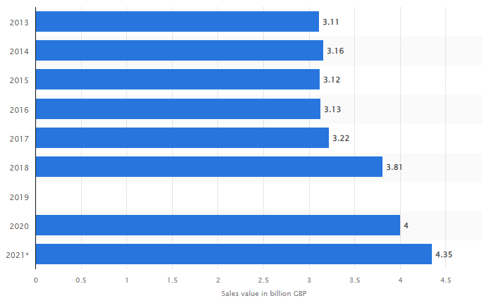
Figure 1: Annual retail sales value of seafood in the United Kingdom (UK) from 2013 to 2021(in billion GBP)
(Statista, 2023)
In the graph above, it is also elaborated that the retailers of seafood contribute a huge amount to the economy of the UK. This indicates that the target audience for this restaurant would be the group of people who prefer eating seafood over other dishes (Statista, 2023). In addition to this, the pricing of the items present on the menu would be competitive in the market; however, the taste and quality of foods, as well as services provided to the guest of the restaurant, would be extremely high. This factor of the business would make it unique in the industry. The reason for this would be that the prices of the items would be affordable for a family with a moderate financial background, along with the services of high standards. Furthermore, the restaurant would be highly conscious of including food that is vegan, vegetarian, gluten-free, sugar-free, and many other such options with the view to show respect to the life choices of everyone. This would be a high priority for the business the public of the UK is also very health conscious; therefore, it is essential for a restaurant in the UK to include healthy and nutritious options in their menu in order to enhance the experience of their customers (Sprake et al., 2018). Not only this, but the restaurant would also offer a wide range of variety in the starter, dessert and beverage options of the restaurant.

Part 3: Menu Design
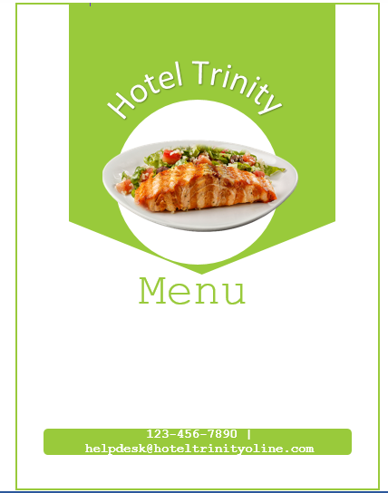
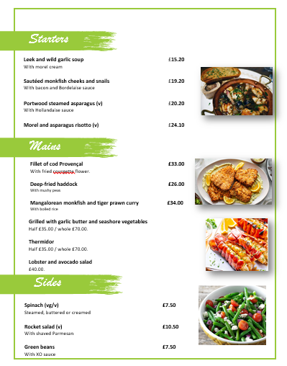
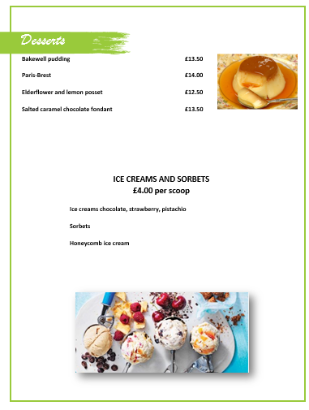
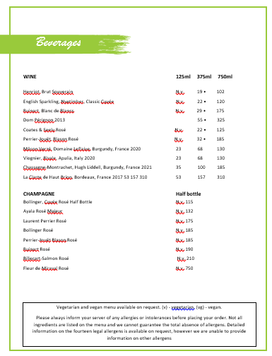

References
Hwang, J., Han, H. and Kim, S., 2015. How can employees engage customers? Application of social penetration theory to the full-service restaurant industry by gender. International Journal of Contemporary Hospitality Management, 27(6), pp.1117-1134.
Leung, X.Y., Josiam, B.M. and Moody, B.M., 2020. “I’d like to order with a server.” an experimental study of restaurant menu performance. Asia Pacific Journal of Tourism Research, 25(7), pp.766-779.
Sprake, E.F., Russell, J.M., Cecil, J.E., Cooper, R.J., Grabowski, P., Pourshahidi, L.K. and Barker, M.E., 2018. Dietary patterns of university students in the UK: a cross-sectional study. Nutrition Journal, 17, pp.1-17.
Statista 2023 Seafood: Annual retail sales value in the United Kingdom 2021, Statista. Available at: https://www.statista.com/statistics/510480/seafood-sales-value-united-kingdom-uk/ (Accessed: 19 May 2023).
Tyagi, A. and Shah, U., 2021. Modelling the direction and volume of trade flows in the global crisis, COVID-19. Journal of The Institution of Engineers (India): Series B, pp.1-7
Wang, C. and Huang, Y., 2018. “I Want to Know the Answer! Give Me Fish’n’Chips!”: The Impact of Curiosity on Indulgent Choice. Journal of Consumer Research, 44(5), pp.1052-1067.

