BA International Hotel Management
Financial Management for the Hotel Industry
BMIH5007
LEVEL 5
Student Name: Elena Boboc
Student ID: 2206217
Lecture Name: Tristan Hawkins

Declaration
I acknowledge the use of Grammarly (https://www.grammarly.com/) on 16 October 2024 to check spelling errors in my work. Grammarly did not require me to key in any prompt but only provided the document for spelling and grammar checks, and I chose what I wanted to change and what I wanted to dismiss from change among the issues it highlighted.
"I confirm that I have not used any AI tools in the research and creation of this assignment. I confirm that I have not presented any AI generated materials as my own work. I confirm I have copies of my drafts, notes, and other resources I used, which I may be asked to provide in evidence."
Executive Summary
The report compares the operational strategies and the financial outcomes of the Shangri-La Hotels and Premier Inn. This highlights their distinct approaches in the luxury and budget hospitality sectors. The Shangri-La, with its focus on affluent travelers, they face various challenges due to the higher operational costs and the narrower profit margins. This is especially in the luxury markets, where recovery post-pandemic has been slow. In contrast, Premier Inn, dominating the UK budget hotel market. Both brands prioritize sustainability and community engagement. Overall, the report demonstrates that how different market segments and the strategic focus areas drive the financial performance and growth of these two hotel chains. The recommendations for each brand focus on leveraging their strengths to adapt to evolving the market demands.

Table of Contents
1 Introduction 3
2 Total Revenue Comparison 3
2.1 Shangri-La Hotels 3
2.2 Primer Inn 4
2.3 Comparison 4
3 Market Positioning 4
3.1 Shangri-La Hotels 4
3.2 Primer Inn 4
3.3 Comparison 5
4 Growth Potential 5
4.1 Shangri-La Hotels 5
4.2 Primer Inn 6
4.3 Comparison 6
5 Financial Commitment to CSR 7
5.1 Shangri-La Hotels 7
5.2 Primer Inn 7
5.3 Comparison 7
6 Recommendation 8
6.1 Shangri-La Hotels 8
6.2 Primer Inn 8
7 Conclusion 9
8 Reference list 10

Introduction
Shangri-La Hotels and Premier Inn Hotels are two prominent players in the industry of hospitality (Ren, 2020). They cater the different segments of the market. Shangri-La operates in the luxury sector, while the Premier Inn is known for the budget accommodations. This report evaluates the financial management strategies of the both hotels by comparing the total revenue, their market position, growth potential and the financial commitment to the Corporate Social Responsibility.

Total Revenue Comparison

Shangri-La Hotels
Shangri-La Hotels, a prominent luxury hotel chain, which is based in the Hong Kong. It is recognized for offering the top-tier hospitality services (Snäll, 2023). Shangri-La is operating over the 100 hotels globally, the brand emphasizes the delivering the outstanding guest experiences in the prestigious locations (Shangri-la.com, 2024). The Shangri-La is celebrated for combining the Asian-inspired hospitality with the global luxury standards. In the year of 2022, the company reported the revenues of approximately $1,462.1 million, which reflecting the 17.8% rise compared to the 2021. This growth is largely due to the gradual rebound of the international tourism after the COVID-19 pandemic. With a strong foothold in these regions, the Shangri-La has successfully tapped into the revival of the high-end travel (Chen, 2021). However, despite this revenue increase, the company continues to face higher costs. This is especially in the operating expenses and the investments required to maintain the luxury services and the facilities. While the Shangri-La posted an EBITDA of about $174.4 million, it also reported a net loss of roughly $158.5 million. This highlights the challenges of fully overcoming the pandemic's effects.
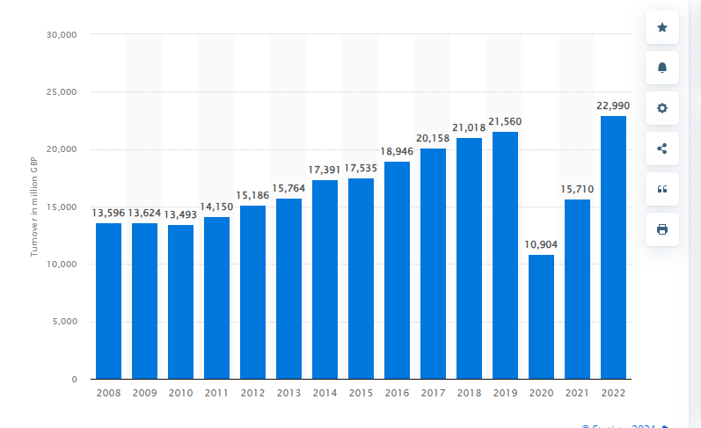
Figure 1- Turnover of hotel and similar accommodation businesses in the United Kingdom from 2008 to 2022
Source: (Statista, 2022)

Primer Inn
Premier Inn, which is a subsidiary of the Whitbread PLC, stands as the UK’s largest budget hotel chain. They offer affordable accommodations at over various locations (Adams, 2024). They serving the both business and leisure travellers. The Premier Inn is known for the competitive pricing and the high occupancy rates (Premier Inn, 2024). The company focuses on expanding its domestic footprint while also pursuing the international growth. This is especially in the markets such as Germany. In stark contrast to the previous years, Premier Inn saw an impressive 54% flow in the revenue. This reaching to the £2.6 billion in the year 2023. The pre-tax profits jumped from £58 million in the year of 2022 to £375 million in the year 2023. The company’s financial results have exceeded the pre-pandemic levels, which is driven by a resurgence in domestic demand and a recovery in the business travel. The mid-market segment, where the Premier Inn operates, which has shown strong resilience. This is particularly in the UK, where the chain holds a leading market position. The success of the Premier Inn’s is supported by the effective cost management and the streamlined operational model (Bas and Sivaprasad, 2022).
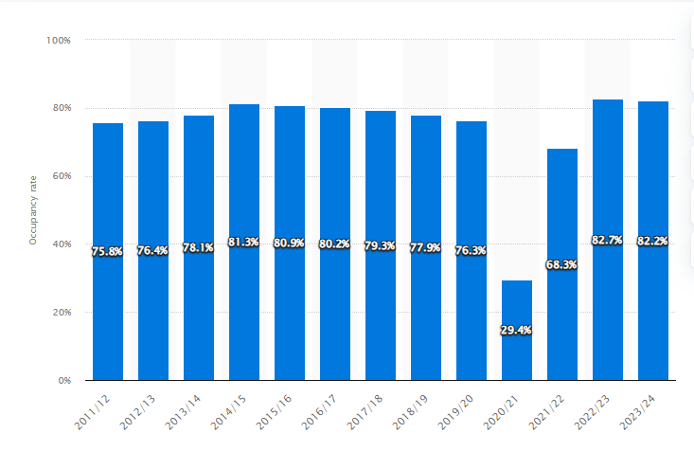
Figure 2- Occupancy rate of Premier Inn (Whitbread) hotel rooms in the United Kingdom and Ireland from 2011/12 to 2023/24
Source:(Statista, 2024)

Comparison
The differences between the Shangri-La hotel and Premier Inn underscore the contrasting of the operational strategies and the financial results (Wang et al., 2024). The Shangri-La faces challenges in sustaining profitability, largely due to the high costs, which is associated with luxury services, which result in slimmer profit margins, and the Premier Inn benefits from the more efficient cost structure and extensive operations. This enables it to generate more consistent profits. While Shangri-La’s revenue recovery has been slower, the Premier Inn has successfully capitalized on the rising demand for affordable accommodations in the UK. This contrast highlights how different market segments and business strategies can have a significant impact on financial outcomes in the hospitality sector.

Market Positioning

Shangri-La Hotels
Shangri-La Hotels occupies a prestigious place in the luxury hospitality sector. They cater primarily to the affluent clientele in Asia and the other global markets. The brand is synonymous with the elegance, outstanding service and the top-tier amenities. This making it a favoured choice for all the travellers, who are seeking the exclusive and the luxurious experiences. Shangri-La commands a substantial market share in the luxury segment, which is especially in the Asia, where it operates the numerous properties in key urban and the resort destinations (Chen, 2022). The chain primarily targets the high-net-worth individuals, business executives and the luxury travellers. Its customer base largely consists of the wealthy guests who desire the upscale accommodations and the premium services. The Shangri-La attracts guests celebrating the special events as well as the corporate travellers in need of the high-end meeting spaces and the personalized service (Zhu et al., 2020). Furthermore, the brand is increasingly appealing to the younger affluent travelers who value the experiential luxury and the cultural immersion.

Primer Inn
Premier Inn, by contrast, dominates the UK's budget hotel sector, they are serving as a wide and the varied customer base (George, 2021). The chain is well-known for offering the dependable and the affordable accommodations. Premier Inn's success in the mid-market is largely due to the focus on delivering value for the money, which makes it a favoured option for the budget-conscious travellers, families, and the business guests. The Premier Inn's strategic placement near major transport hubs and the city centers increases the appeal to leisure travellers (Matondolo, 2022). The family-friendly dining options and the spacious rooms draw in the families, while the reliable service and the comfortable stays cater to the business clientele. Renowned for the affordability, dependability and the value, the Premier Inn's marketing efforts highlight making the travel accessible to eth everyone.

Comparison
The market positioning of the both hotels such as Shangri-La Hotels and the Premier Inn Hotels highlights a stark difference between the luxury and budget accommodations (Tan, 2021). Shangri-La targets the affluent travellers, who are seeking the high-end, premium experiences, while the Premier Inn focuses on the cost-conscious customers looking for the value. In terms of the market share, Shangri-La holds the significant portion of the luxury hospitality sector. This is especially in the Asia, whereas the Premier Inn dominates the UK’s budget hotel market (Page and Connell, 2020). The Shangri-La primarily serves the high-net-worth individuals and the business professionals, whereas the Premier Inn attracts the families and the budget-conscious travellers. Shangri-La is perceived as a luxury brand known for the exceptional service and the social responsibility, while Premier Inn is recognized for the reliability, affordability and the accessibility.

Growth Potential

Shangri-La Hotels
Shangri-La Hotels possesses the significant growth potential, fueled by the resurgence of the global tourism and the rising demand for the luxury travel experiences (Hirslund, 2024). With a well-recognized brand and a strong presence in the key markets, which is particularly in the Asia and the Middle East, the Shangri-La is well-positioned to take the advantage of the various growth opportunities. Shangri-La can access a burgeoning customer base by entering the new geographical areas, which is especially in the Asia and Africa. Expanding the service offerings to include the wellness programs, luxury experiences and the personalized travel services can attract the wider clientele. The growing interest in the wellness tourism presents an opportunity for the Shangri-La to enhance the spa and the wellness services, appealing to the health-conscious travelers. Additionally, with a heightened emphasis on the sustainability within the hospitality industry, Shangri-La can strengthen the commitment to eco-friendly initiatives (Sinha and Fukey, 2020).

Primer Inn
Premier Inn Hotels demonstrate the significant growth potential, largely fueled by the rebound in the domestic tourism and the business travel in the UK (Fernandes, 2021). With a strong presence in the UK market, the hotel chain is strategically positioned to implement the various several key growth strategies. It can explore the opportunities for the expansion to underserved the areas, this is particularly in the suburban and regional markets. Increasing the presence in the popular travel destinations could boost the occupancy rates and the revenue. By investing in the technology and also enhancing the services, such as the mobile check-ins, the personalized guest experiences and also upgraded the dining options, the Premier Inn can better meet changing customer preferences. Additionally, enhancing the digital marketing strategies, this is particularly through the social media and the targeted advertising campaigns, can help to attract the broader audience.

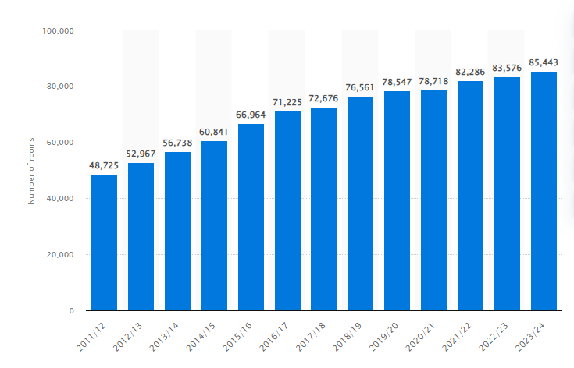
Figure 3- Number of Premier Inn (Whitbread) hotel rooms in the United Kingdom and Ireland from 2011/12 to 2023/24
Source: (Statista, 2024)

Comparison
The growth prospects for the both hotels Shangri-La Hotels and the Premier Inn Hotels illustrate the different strategies tailored to their respective market segments (Li, 2021). Shangri-La aims to penetrate the emerging luxury markets, while the Premier Inn seeks to reinforce the position in the UK budget sector. Both brands understand the significance of the geographic diversification. Shangri-La concentrates on providing the luxury and the personalized services to attract the affluent individuals (Maltese, 2020). The Premier Inn emphasizes the various operational efficiency and convenience for cost-conscious travelers. Both hotel chains are increasingly focusing on the sustainability, acknowledging the importance to today’s consumers. However, Shangri-La’s initiatives might revolve around enhancing the luxury experiences, whereas the Premier Inn’s strategies could center on implementing the cost-effective operational methods.

Financial Commitment to CSR

Shangri-La Hotels
Shangri-La Hotels have made the notable progress in the financial dedication to corporate the social responsibility initiatives (Su and Zabilski, 2022). This demonstrating the commitment to the sustainable practices and the community involvement. Their primary areas of emphasis include the substantial investments in the sustainable practices, which aimed at reducing the energy consumption and the waste. The group has launched the initiatives such as the water conservation efforts, the energy-efficient building designs and the integration of the renewable energy sources in many of the locations. The hotel group supports the educational and the empowerment initiatives by contributing both financially and through volunteer work.
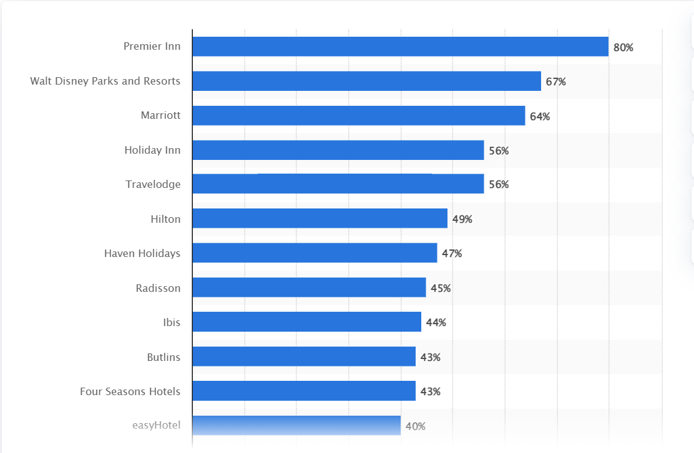
Figure 4- Most popular hotel brands among millennials in the United Kingdom in 2nd quarter of 2022
Source:(Statista, 2024)

Primer Inn
The company has made the various significant investments in the energy-efficient technologies, the waste reduction initiatives and the sustainable sourcing for the food and beverage operations (Espinosa et al., 2021). These actions are part of the larger strategy aimed at reducing the environmental impact and also promoting the eco-friendly practices within the hospitality industry. The Premier Inn is also dedicated to supporting the local communities through the various initiatives. The company engages in the charitable events, backs local charities and also encourages the staff participation in the community service activities.
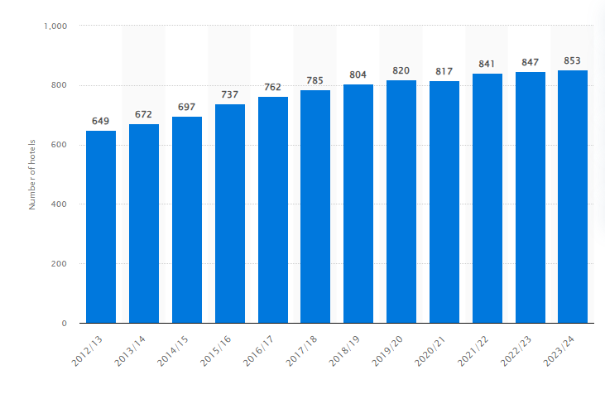
Figure 5- Number of Premier Inn (Whitbread) hotels in the United Kingdom and Ireland from 2012/13 to 2023/24
Source: (Statista, 2024)

Comparison
Both the hotel chains prioritize the sustainability, community involvement and the employee well-being. However, the Shangri-La emphasizes the luxury service sustainability and gives the various initiatives to a greater extent, while the Premier Inn concentrates more on the operational sustainability and the community support within the UK. While both companies engage with their local communities. The Shangri-La typically invests in the broader philanthropic efforts aligned with the global objectives, whereas the Premier Inn's initiatives are more localized and also tailored to meet the various specific community needs. Both brands acknowledge the significance of the employee welfare.

Recommendation

Shangri-La Hotels
- Given the increasing importance of the sustainability in the luxury market. The Shangri-La should further enhance the eco-friendly practices (Sinha and Fukey, 2020). This could involve investing in a green technologies, such as the solar energy systems and the waste reduction programs, as well as promoting the sustainability in the luxury offerings..
- To broaden the customer base, the Shangri-La should expand the services beyond the traditional luxury offerings. Introducing the wellness retreats, immersive cultural experiences and the personalized travel packages can attract the younger affluent travellers seeking the various unique experiences.
- Investing in the digital marketing strategies, which includes the social media campaigns and the influencer partnerships. This can help the Shangri-La reach a broader audience.

Primer Inn
- Premier Inn should capitalize on the success in the UK by exploring the various opportunities for the expansion in the underserved regions (Kandampully and Solnet, 2024).
- Premier Inn can further improve the guest experience by investing in the technology. Upgrades to the mobile check-in, the personalized booking systems and the smart room features can attract the tech-savvy travellers.
- Continuing to enhance sustainability initiatives, such as energy-efficient operations and waste reduction, can improve Premier Inn’s market positioning.

Conclusion
In conclusion, the report has highlighted the contrasting approaches to the financial management between the both hotels Shangri-La Hotels and the Premier Inn Hotels. While Shangri-La focuses on the premium services, the diverse revenue streams and the high CSR investment, Premier Inn leverages the budget model with the high occupancy rates and the cost-efficient practices. Both companies demonstrate the growth potential, but their strategies must align with the market positioning and the customer expectations.

Reference list
Adams, D., 2024. Management accounting for the hospitality, tourism and leisure industries: A strategic approach.
Bas, T. and Sivaprasad, S., 2022. An Exploratory Insight into the Impact of COVID-19 on the Travel and Tourism Sector: UK Evidence. Bas, T. & Sivaprasad, S.(2022). An exploratory insight into the impact of COVID-19 on the travel and tourism sector: UK evidence. In S. Karabulut (Ed.), Economic and Financial Analysis of Global and National Developments, pp.355-369.
Chen, F., 2021. Research on Design Strategies and Methods of Rural Hotels with Regional Characteristics (Doctoral dissertation, University of Hawai'i at Manoa).
Chen, X., 2022. Location Strategies of Multinational Hotel Groups in China: An Application of Game Theory (Doctoral dissertation, University of Plymouth).
Espinosa, R.V., Soto, M., Garcia, M.V. and Naranjo, J.E., 2021. Challenges of implementing cleaner production strategies in the food and beverage industry: literature review. Advances and Applications in Computer Science, Electronics and Industrial Engineering: Proceedings of CSEI 2020, pp.121-133.
Fernandes, F., 2021. Intercontinental Hotels Group-Time to Check-In (Master's thesis, Universidade NOVA de Lisboa (Portugal)).
George, R., 2021. Tourism and Hospitality Marketing Principles. In Marketing Tourism and Hospitality: Concepts and Cases (pp. 3-31). Cham: Springer International Publishing.
Hirslund, D., 2024. CONSTRUCTION, LABOR, AND LUXURY IN KATHMANDU'S POST-CONFLICT TOURISM ECONOMY. Insidious Capital: Frontlines of Value at the End of a Global Cycle, 35, p.151.
Kandampully, J. and Solnet, D., 2024. Service Management Principles for Hospitality & Tourism in the Age of Digital Technology.
Li, R., 2021. Hong Kong´ s Hospitality Sector: The Business Case for Quarantine Hotels: The Landmark Mandarin Oriental (Master's thesis, Universidade NOVA de Lisboa (Portugal)).
Maltese, D., 2020. Ecotourism development in Shangri-La, Yunnan province, China: the case of Tiger Leaping Gorge (Master's thesis, Norwegian University of Life Sciences, Ås).
Matondolo, M.P.M., 2022. Hotel choice attribute of business and leisure travellers in Cape Town (Doctoral dissertation, Cape Peninsula University of Technology).
Page, S.J. and Connell, J., 2020. Tourism accommodation and hospitality services. In Tourism (pp. 216-241). Routledge.
‌Premier Inn. (2024). Search results | Premier Inn. [online] Available at: https://www.premierinn.com/gb/en/search.html?gclid=CjwKCAjw9p24BhB_EiwA8ID5BqIuxP6xP-mgQc8H-oaIcDUP4_sWbwKfP0Jforr2Ih8p6ko-wjhwzRoCS5UQAvD_BwE&searchModel.searchTerm=London%2C+UK&VIEW=2&PLACEID=ChIJdd4hrwug2EcRmSrV3Vo6llI&cid=KNC_Brn_G_UK_AU_Eng_Brand-Destinations_Central-London_Null_Null&mckv=s_dc|pcrid|694425704592|kword|premier%20inn%20london|match|e|plid||pgrid|159417393119|ptaid|kwd [Accessed 10 Oct. 2024].
Ren, L., 2020. The Development of Hotel Management Contracts in China. In The Routledge Companion to International Hospitality Management (pp. 271-278). Routledge.
Shangri-la.com. (2024). Luxury 5 Star Hotel in London | The Shard | Shangri-La. [online] Available at: https://www.shangri-la.com/london/shangrila/ [Accessed 10 Oct. 2024].
Sinha, M. and Fukey, L.N., 2020. Circular Economy: Assessing a Progress of Resources Efficient Practices in Hotel Industry. In Circular Economy for the Management of Operations (pp. 89-117). CRC Press.
Sinha, M. and Fukey, L.N., 2020. Circular Economy: Assessing a Progress of Resources Efficient Practices in Hotel Industry. In Circular Economy for the Management of Operations (pp. 89-117). CRC Press.
Snäll, A., 2023. How Artificial Intelligence (AI) Can be Utilized for the Competitive Advantage of an International Luxury Hotel?.
Statista. (2022). Hotel business turnover 2022 | Statista. [online] Available at: https://www.statista.com/statistics/558099/hotel-business-turnover-uk-united-kingdom/ [Accessed 16 Oct. 2024].
‌Statista. (2024). Premier Inn hotel numbers UK and Ireland 2024 | Statista. [online] Available at: https://www.statista.com/statistics/739855/whitbread-premier-inn-hotels/ [Accessed 16 Oct. 2024].
Statista. (2024). Premier Inn hotel occupancy rates UK and Ireland 2024 | Statista. [online] Available at: https://www.statista.com/statistics/739831/premier-inn-hotel-occupancy-rates/ [Accessed 16 Oct. 2024].
‌Statista. (2024). Premier Inn hotel rooms UK and Ireland 2024 | Statista. [online] Available at: https://www.statista.com/statistics/629446/whitbread-premier-inn-hotel-rooms-united-kingdom-uk/ [Accessed 16 Oct. 2024].
Statista. (2024). Top hotel brands among UK millennials 2024 | Statista. [online] Available at: https://www.statista.com/statistics/951264/most-popular-hotel-brands-millennials-uk/ [Accessed 15 Oct. 2024].
Su, Z. and Zabilski, A., 2022. What is the relationship between quality of working life, work–life balance and quality of life?. Worldwide Hospitality and Tourism Themes, 14(3), pp.247-260.
Tan, Y.S., 2021. Harvesting a New Synergy: Exploring ‘Smart and Green’Hotels within the Context of the Irish Hospitality Industry.
Wang, L., Luo, X., Qiu, L., Xu, F. and Cui, X., 2024. Win by Hook or Crook? Self-Injecting Favorable Online Reviews to Fight Adjacent Rivals. Information Systems Research.
Zhu, Y., Zhu, P. and Zhang, Q., 2020. Research on the current situation and practice of the integration of national traditional horse racing festival and tourism. Design Engineering, pp.75-114.

‌

‌

‌

