Introduction.

“Perspective of Africa”; The show will be artist's rendition of different perspectives of Africa. It aims to contrast the ideas outsiders have of Africa versus the reality, through unassuming means the artists I have chosen create a deep and extended narrative through sometimes complex and often deceivingly simple designs. Each piece has been carefully chosen to suit today’s climate, a place where societies are more open to conversation, it is important that while the idea of equality is on everyone’s mind we use this opportunity to change the narrative and often ‘sorrowful’ attitude towards Africa as a whole. These reactions are often the case because the reactors have a “single story” (Chimamanda Ngozi Adichie) perspective of Africa. Because of this I believe it would create a powerful effect for people to be confronted by their thoughts on Africa directly beside the so much more Africa has to offer. Its ‘hidden beauty’ isn’t so hidden’ it’s just that nobody is looking or even trying to look.

I’ll be analysing work from ‘El Anatsui’, ‘Romauld Hazoumé’ and ‘Yinka Shonibare’, all whose work I’ve chosen because it provides an experienced portrayal of an outsiders attitude towards Africa.
Furthermore, I will be delving into the work of ‘Abdoulaye Konaté’ and ‘George Glavee’, their work will be unconventionally unique renditions of the beauty they see and experience in Africa.

Context. Artists and Artwork

The ‘perspective of Africa’ is often entirely dictated by politics and the media; The media often shifts to portray a single story and in the quest of effectivity they usually tell hard hitting and emotion inducing stories about Africa, from adverts of starving children who have never smiled or had fun before because they live in a derelict village and urgently need your support, to... well, nothing. The media constantly portrays Africa as this place of squalor and no appeal, with people who cannot/can barely provide for themselves and their family, they portray it as a place of no technological advancement with a population who have no future. Although many of you would like to think you have a different perspective, you probably don’t. Everything you see about Africa is dictated by the media, and the media has stereotyped the entire continent of Africa by giving the name ‘Africa’ negative connotations.
Politics play a similar role in the perspective of Africa; Mainly we see many governments using financial aid as a ‘get out of jail free’ card. They use this card to get their way and scam behind the guise of “We’re here to help”.

‘Yinka Shonibare’ is a London born Nigerian. “Shonibare’s work explores issues of race and class through the media of painting, sculpture, photography and film. Shonibare questions the meaning of cultural and national definitions..” (www.yinkashonibarembe.com/).
The main art installation which will be in the center of the gallery space will be ‘The Scramble for Africa’ by Yinka Shonibare. This important piece is a wooden table on an elevated platform surrounded by world leaders of yesteryear. In the center of the table is a map of Africa with the leaders carving out a piece for themselves. The creation is representative of the sharing of Africa amongst european leaders a deal finalised in the Berlin Conference of 1884-85. Although quite some time ago the artwork has similar relevance today. Its main focus highlights today’s political landscape with many first world countries using the facade of aide to blatantly steal resources from African countries in the public eye.

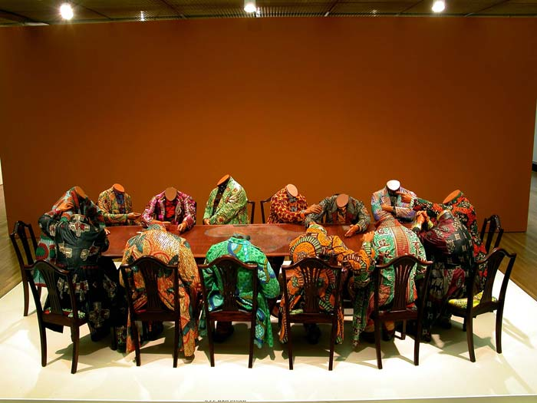

The second artist I have chosen is ‘El Anatsui’, whose artwork is important in how it turns a single story narrative of Africa on its head. “His work raises questions about ethnic identity by combining traditional African techniques and imagery with abstraction (which arguably is rooted within Western art).” (www.tate.org.uk/).
The next installation and easily the largest of the five would be the ‘Earth’s Skin’ by El Anatsui. Anatsui combined bottle caps, aluminium, tin and scraps in order to create this massive tapestry which makes his perspective on Africa clear, while some people look at the items he used to make this magnificent tapestry as rubbish, Anatsui sees the potential in everything, this vision is a critical idea in Africa which creates an unlimited list of possibilities for a continent that many see as having no prosperous future. Anatsui’s work is the perfect example of finding the beauty in the everyday.

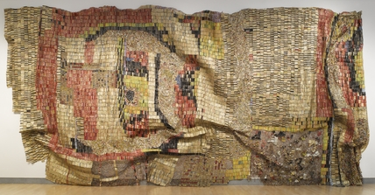

‘Romauld Hazoumé’ is the third artist I have selected; "Hazoumé’s practice deals with the social and political history of not just Benin, but of Africa and Africa’s dynamic, ever-changing role within the international art scene.” (www.aestheticamagazine.com).
Another large pivotal artwork will be the ‘Petrol Heads’ on a car by Romauld Hazoumé. His work forces some serious self analysation from Africans. He urges them to be aware of their and their countries’ identities as well as the value may it be hidden of each African country. His use of petrol heads to create masks highlights the importance of black gold (oil) in the identity of much of Africa. However the work does have a dual meaning, being part masks, in my perspective the work hides the other aspects of African identity portraying a single story view of Africa from the outside world as a continent good for resources and resources alone.
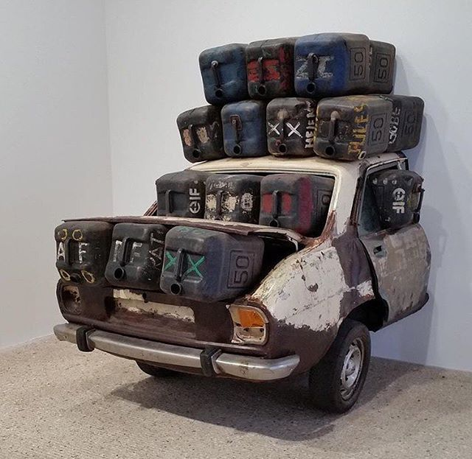

The fourth artist is ‘Abdoulaye Konaté’; “Work by Abdoulaye Konaté (b. 1953 Diré, Mali) primarily takes the form of textile-based installations that explore socio-political and environmental issues.” (www.blainsouthern.com/).
Konatae’s work is representative of Africa’s identity of vivid colours and bold textiles, his work resonates throughout the masses to notice their surroundings how beauty comes from the least expected things. My chosen work of Konaté’s is his “Symphonie en Couleur”, a trio of textile based artwork highlighting Mali’s textile background. His work is integral to Malian identity, it surely defines to us that he has a positive perspective of his homeland not tainted by their political and social reputation with Mali being publicly listed as a country receiving large amounts of aide from numerous sources. This contemporary artwork is the perfect example of Chimamanda Ngozi Adichie’s single story narrative, with the majority of the first work getting their information from unreliable online sources and news companies with agendas everybody has their one sided perspective. Konaté destroys those preconceived notions by creating stunning work that confuses people expecting devastated people from a country they only know to be in disaster.

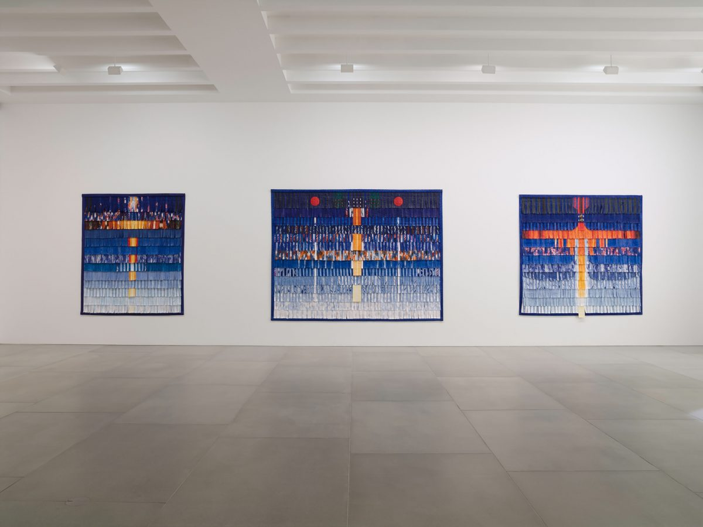

Finally my last artist: ‘George Glavee’; My step brother; Creates arts inspired by the colours and designs he sees around him in Ghana, he draws the colour and beauty from the seemingly mundane to the untrained eye, in order to create often abstract works of art with meanings up for interpretation. His work is relevant in the fact that it shows how two people can look at the same thing but not see it the same way, his art highlights the perspective and mindset of many Africans who can see the beauty even though it is often glanced over by the media. George’s artwork ‘ShadowPerson’ (bottom) and ‘Chaos’ (top) are abstract works purposely created to challenge the idea of first world beauty, his use of unsymmetric shapes in ‘Chaos’ as well his bold use of colours that don’t match of blend challenge the idea of perfection is beauty, it shows that there is beauty even in the flawed. That is his perception of Africa which he gained by living through many different stories, not by being fed a singular narrative he had no option but to believe. His second artwork ‘ShadowPerson’ is his direct call out to the darkness within each person. The person in the work is purposely gender ambiguous, they look like they have female features from afar but when approaching it seems to transform into more stern male features.

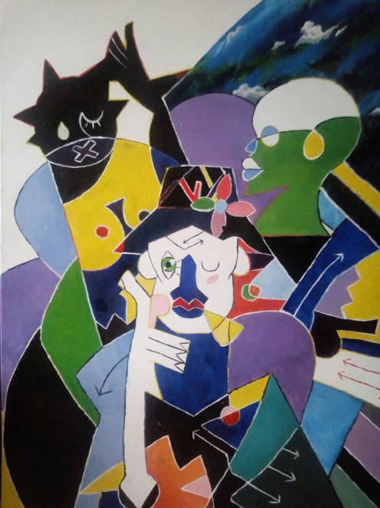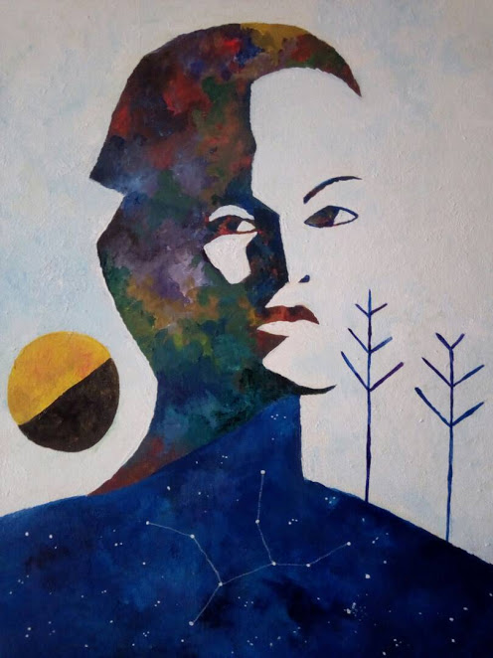

Bibliography
Biography, Yinka Shonibare MBE (RA). Available from: http://www.yinkashonibarembe.com/biography [Accessed: 3/3/18]
Blain Artists -, Blain Southern. Available from: https://www.blainsouthern.com/artists/abdoulaye-konaté [Accessed: 3/3/18]
Romuald Hazoumé, Aesthetica Magazine. Available from: http://www.aestheticamagazine.com/romuald-hazoume [Accessed: 3/3/18]
Tate Who is El Anatsui?, Tate. Tate. Available from: <span http://www.tate.org.uk/art/artists/el-anatsui-17306/who-is-el-anatsui [Accessed: 4/3/18]



