Exploring how atmospheric changes, particularly light and colour, are portrayed and perceived within art.
Corie-Beth Jones (p141854).
Surface Pattern Design for Interiors
Ainsley Hilliard
Table of Contents
List of illustrations: 2
Introduction: 3
Chapter 1: 4-14
Chapter 2: 15-22
Conclusion: 22-25
Bibliography: 26
Figure 1, Claude Monet – Impressionism Sunrise, 1872.
Figure 2, Claude Monet, Green Reflections, 1914-22.
Figure 3, Camille Pissarro – The Boulevard Montmartre at night, 1897.
Figure 4, Turner – Snowstorm, Steamboat off a harbours mouth, 1842.
Figure 5, Olafur Eliasson, Beauty, 1993.
Figure 6, Olafur Eliasson, Turner Colour experiments, 2014.
Figure 7, Crystal Beads, Hella Jongerius, 2017.
Introduction
Through the exploration of writers such as Maurice Merleau-Ponty and Juhani Pallasmaa we will explore the advantages of being multisensory creatures. How we are individuals who subjectively experience the beauty of the world dependent on how engaged we are with it, particularly engagement with our senses. As Juhani Pallasmaa (2005) expresses in his book Eyes of the skin, “A walk through the forest is invigorating and healing due to the constant interaction of all sense modalities… one’s sense of reality is strengthened and articulated by this constant interaction”, in relation to Pallasmaa’s theory we will explore artists of both the historical and contemporary period who endeavour in the journey to capture sensations, atmospherics and the complex relationship between colour and light.
Within Chapter one, an investigation is carried out into Historical Impressionist’s Claude Monet, Camille Pissarro, Paul Cezanne and Landscape artist Joseph M.W Turner, exploring their fascination with sensations, first-hand experience with the ever changing atmospherics of a landscape and mastery of en plein-air painting in order to understand how they embedded such sensational and impressionable qualities within their work. Through this analysis, unveiling how they allowed room for their viewer’s subjective imagination to take over whilst, in Chapter 2 we will explore contemporary Installation artists, Olafur Eliasson and Hella Jongerius and their fascination with the ideas established by the impressionists. Investigating their interactive and ever-shifting spaces predominately focused on the effect light has on colour and colour has on us, finally analysing how these contemporary advantages gift their viewers with a complete physical emersion.
Chapter 1
Sensate is to perceive the world through sense, and we are absolute sensate beings.
Through our eyes we see the world and instinctively this is mainly how we perceive things to be, but to participate in it, is to touch; to feel the surfaces of the objects around you, to smell the air even when there is no potent scent, to listen to the sounds echoing from every direction, to appreciate the change in the atmospherics - and in that moment consider how they make you feel.
(Having the ability to consciously use all of these senses makes us sensate beings.)

Polly Ullrich author of Beyond Touch: the body as perceptual tool (1999) introduces Maurice Merleau-Ponty, a French philosopher who frequently discussed the notion, and the significance of being active participants in the world, this being the idea of experiencing through the whole body.
“It is the totality of our body and its sense operations, rather than an over-riding and narrow cerebral activity that makes our ability to perceive and construct a world possible. Physical encounters such as handling and seeing are just as important as thinking. Our consciousness, our ability to perceive, comes from this integration of all our senses.” (Summer, 1999, 44)
As Merleau Ponty explains, we as humans have the ability to interact with our surroundings, to understand not just visually but multi-sensory, Juhani Pallasmaa (2005) explores the importance of touch and the idea that to really connect to the world we need more than just our eyes: “… touch is the sensory mode which integrates our experience of the world which that of ourselves… the dominance of the eyes and the suppression of our other senses tends to push us into detachment (Pallasmaa, 2005 11-19)… Pallasmaa encourages people to relish their ability be participatory, to be interactive, and to forbid them to rely on their sight alone to experience the world.
As both Pallasmaa and Ponty discuss, it is the importance of being engaged with our surroundings that ignite our emotional and physical responsiveness; take a memory for example, it is complex, more than a simple visual of the past, a memory could be involuntary triggered by a certain scent, a certain taste, an atmospheric change in the weather, all of which instantly evoke a feeling, a feeling you had once before, a feeling which stimulates a strong emotional awareness to a previous moment in your life. It is this ability to feel that makes us responsive to our surroundings and it is our physical senses that understand the world far more effectively than our eyes do, this is a result of active participation, a result of doing as opposed to looking.
It is important to understand how individual, subjective experience is represented in particular artworks, for example the way that historical artists such as Claud Monet, Paul Cezanne, Camille Pissarro, and Joseph M.W Turner all capture their subjective response to a motif through light, colour, the application of their paint and the movement of their brush, it is also interesting to see how others interpret this idea.
Pallasmaa: (2005) writes in regards to his own way of working “I wished to express the significance of the tactile sense of our experience and understanding of the world… In the experience of Art, a peculiar exchange takes place, I lend my emotions and associations to the space, and the space lends me its aura which entices and emancipates my perceptions and thoughts”. (Pallasmaa, 2005 12)
In Pallasmaa’s: (2005) circumstance he refers to his work with architecture and space, nonetheless he highlights the importance of the connection between an artist, and the sensation they revive from the motif they are studying, and thus the sensation they give back to their work.
It is by no surprise that Pallasmaa references French philosopher, Ponty within Eyes of the skin, “How would the painter or poet express anything other than their experience with the world? – Maurice Merleau Ponty” (Pallasmaa, 2005 14), as it is Ponty who identifies how the notion of sense and personal experience with the world is recognized in art through the Impressionist movement and in particular, artist Paul Cezanne’s works.
“Paul Cezanne, who engaged in a continual struggle to paint his skewed and
tactile landscapes during the last century, once commented, "…nature is on the inside." Cezanne meant that what we see outside awakens an echo inside us. Things in the world evoke an internal bodily equivalent. The artist is lucky to be able to give shape to that exchange. This
intersubjectivity, this intertwining with the physical world as a means
of conveying meaning, has always been an aspect of craft art” (Summer, 1999, 44)

Perhaps it is also useful to understand how Cezanne described his method of working which corresponds with how all impressionists work, Paul Smith (2005) Author of Impressionism Beneath the surface (1995) “… Cezanne put the matter most bluntly of all “… To paint after nature is not a matter of copying the objective world, its giving shape to your sensations.” (Smith, 1995, 22). As exhibited in Cezanne’s statement, “Sensation” is a term used just as commonly as the word “impression” throughout the impressionist movement.
According to Smith (1995), the impressionist’s captured a feeling, a moment in time through their works “They are impressionists in the sense that they render not the landscape, but the sensation produced in the landscape”. (Smith, 1995, 22)
Smith (1995) indicates, that to capture realistic detail was not the importance to impressionists, it was more to portray the feeling of being in that moment, to activate the sensation of all five senses, the movement and the factors of their surroundings that trigger an emotional response in themselves and their audience and this was done carefully through colour, light, and application. Artist Claud Monet took a subtle, gentle and luminous approach to colour and light (Fig. 1), while artist Camille Pissarro would use complimentary colours to portray the strong contrast in light and dark (Fig. 2)
Throughout the impressionist movement you see that the subject matter was rarely not that of a landscape, referencing Claude Monet, Belinda Thompson (2002) in Impressionism, Origins, Practice, and Reception “…for me a landscape does not exist in its own right, since its appearance changes at every moment. But its surroundings bring it to life, the air and the light, which vary continually, for me it is only the surrounding atmosphere which gives objects their real value” (Thomson, 2000, 249) For many impressionist’s like Monet, the observation of a landscape allowed endless possibilities for subjective outcome, the constant movement in colour and light produced the ultimate subject to allow their senses to flourish through their paintbrush.
Claude Monet (1872) the founder of the Impressionist movement was remembered chiefly for his en plein-air paintings, he, like many artists had a preferred way of working. Thomson (2002), compares him to a “…nature photographer… waiting and watching for advantageous light conditions”, (Thomson, 2000, 248) this corresponding with her previous statement regarding the impressionists nurturing preferred light and weather conditions.
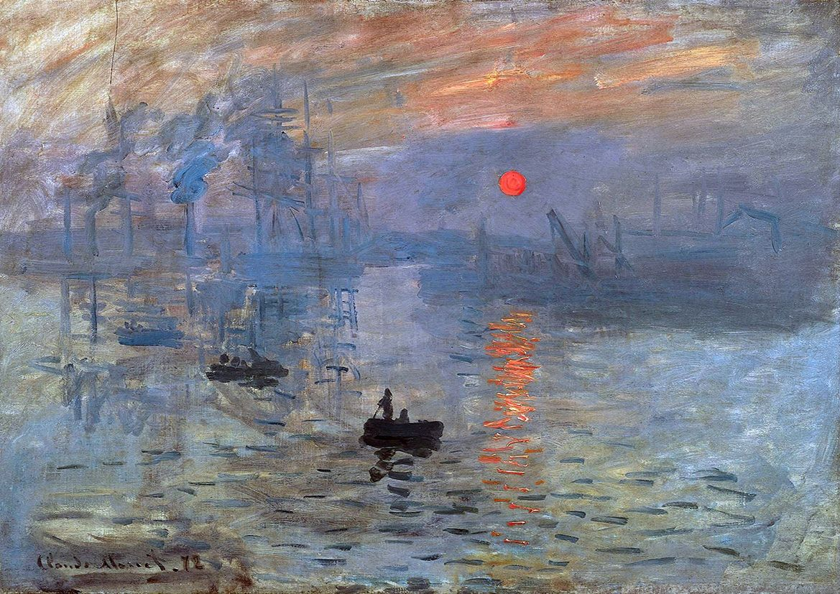
Figure 1, Claude Monet – Impressionism Sunrise, 1872.
Impressionism, Sunrise is one of Claude's most iconic works, a depiction of Port of Le Harve. As Smith (1995) informs us, it was this painting which was at the birth of impressionism "…Claude Monet showed Impressionism, Sunrise at an exhibition... which was the first of what we now know as the impressionism exhibitions" (Smith, 1995, 8), this meaning Impressionism Sunrise can be identified as the landscape that set an example for the many which followed as Smith (1995) follows on to explain…
"…Monet has succeeded in setting down the fleeting impression which his predecessors had neglected or considered impossible to render with the brush... No longer painting merely the immobile and permanent aspect of a landscape but also the fleeting appearances which the accidents of the atmosphere present to him, Monet transmits a singularly lively and striking sensation of the observed scene…" (Smith, 1995, 9)

Smith (1995) discusses how it was the technique used in this painting, which set the difference between Monet and previous landscape artists, whilst also establishing the foundation of the impressionist's signature style. It was this painting which noticeably paved Monet's way of working too.
Unlike Monet's previous depictions of landscapes which were generally quite realistic and flat, (for example his first landscape View from Rouelles 1858) Impressionism Sunrise possesses qualities of expression, movement, and change, from the application of Monet's paint, his brush strokes which are unblended, unpredictable, and uncontrolled much like his atmospheric influences.
Each element in Impressionism Sunrise, captures that of a moment, the way he has stippled his brush creating fluidity in the water and capturing the fragmentation of the sun's reflections, the way in which the pink and blue tones of his atmospherics are gentle, thus making the range of orange almost luminous next too the softer tones.
The way that Monet has painted the boats in the distance is in a muted and ghostly manner, each boat becoming darker in shade as they approach him, this is interesting as their scale and perspective inform us they are not that far away from one another, yet by doing this, Monet has actually captured the foggy atmosphere which is dominating the air and altering his sight beautifully. The same muted colours allow him to create emphasis on the saturation and warmth of the sun by pairing them with a bright vivid orange.
Impressionism, Sunrise possesses such a clear depiction of a sunrise, yet there are no distinctive qualities identifying a sense of particular location, resulting in this painting being a representation of harbors rather than that of this particular harbor in Musee Marmottan, Paris, thus leaving the landscape strongly subjective to his audience. Monet was renowned for painting the same motif over and over, alternating between different hours of the day, in different positions and light conditions.
In Paul Smith’s (1995) provides a quote from Monet himself explaining how he became interested in capturing change. …“I felt that is would not be trivial to study a single motif at different hours of the day and to note the effects of light which, from one hour to the next modified so noticeably the appearance and colouring” (Smith, 1995, 99) Perhaps a great example of this is the series of Waterlillies paintings that he created in his gardens at his home in Giverny as seen in Fig. 2.
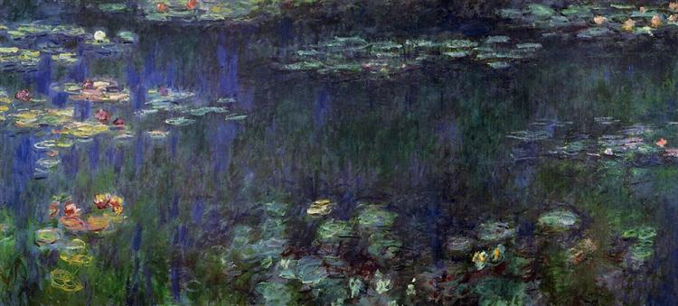
Figure 2, Claude Monet, Green Reflections, 1914-22.
Impressionists continually pushed their knowledge of scientific colour and light and used this understanding as the major influence in their works, Camille Pissarro an example of this, Paul Smith (1995) writes “Pissarro is attentive to the way that the local colour of an object is modified by the light falling upon it… and in many paintings Pissarro focuses on the way that complementary colours intensify one another’s hue” (Smith, 1995, 124).
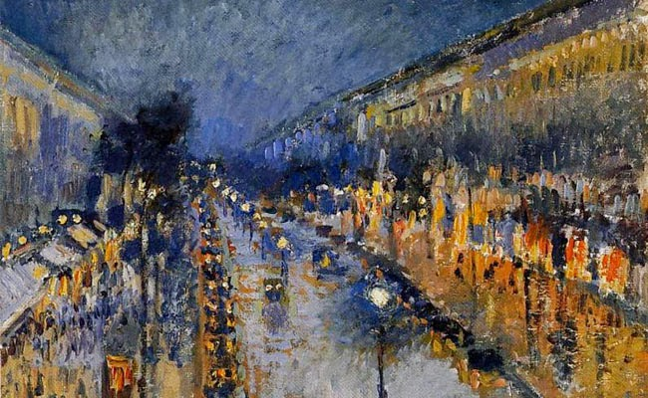
Figure 3, Camille Pissarro – The Boulevard Montmartre at night, 1897.
Smith (1995) follows on to explain how: “Pissarro’s vision was affected by science to the extent that the particular understanding of colour it gave him became bound up in what he saw” (Smith, 1995, 125) Pissarro’s perception of colour in the world is recognised through works such as “The Boulevard Montmartre at night 1897” (Fig. 3), the midnight painting which is completed with endless hues of the complimentary colours; blue and orange. It is evident how these colours effect one another, through the glare of the warm lit street lamps the blue hues change, in tone, in depth and in colour, the colour combination giving a strong emphasis on one another.
Through Pissarro’s work, much like every impressionist artist; you obtain a sense of the artist’s responsiveness. Not only through light and colour but through the unique application of their paint, the technique they use, the materials they work with and how these processes effect the consciousness of their viewers, Belinda Thomson’s (2000) book on Impressionism highlights the Positivists philosophy.
“Impressionism was subjective in two senses: it belonged to the consciousness of the individual who experienced It, but more importantly took a form unique to the individual having it” (Thomson, 2000, p21) the theory suggests that the subjective response of the viewer/ audience completes the work and thereby provides a unique experience based on their individual experiences.
Whilst discussing the notion of capturing the atmospheric sensations through painting, there is another important historical artist, commonly compared to that of an impressionist due to the way in which he worked, Joseph W.M Turner was a nineteenth-century French landscape painter.
Turner in fact, came before the impressionist movement - but what was the common ground between Turners work and that of an impressionist?
Sam Smile (2006) In ‘Light into Colour’ introduces Turner and discusses the key aspects of Turners methods “…with his increasingly sophisticated handling of medium, allowing light and colour to make a more decisive contribution to the overall impact of the image” (Turner and Hughes, 2006, 14) informed by the writings of Smiles and of Elizabeth Barker in her article Heilbrunn Timeline of Art history where she discusses Turners “…Atmospheric renderings…” and “…Interest in expressing grand emotions” (https://www.metmuseum.org/toah/hd/trnr/hd_trnr.htm) It is understood that it is Turners decision, and ability to capture the atmosphere through the exploration of how light alters colour that resonates with impressionists.
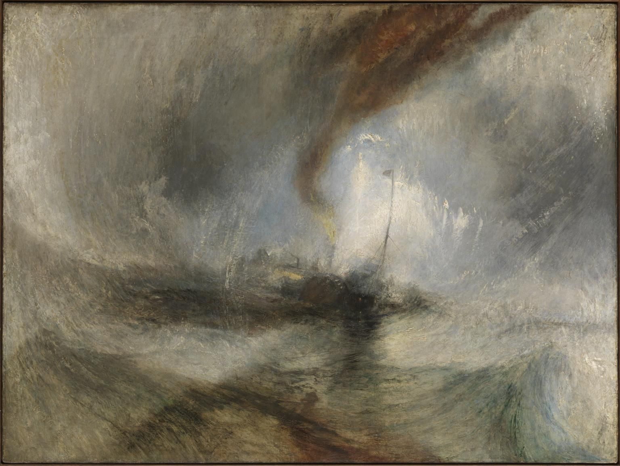
Figure 4, Turner – Snowstorm, Steamboat off a harbours mouth, 1842.
Smiles (2006) argues, “if there was one artist working in early nineteenth-century Britain who could have made a response to the atmospheric qualities of the West Country It was Turner” (Smiles, 2006, 12), this is particularly evident in work such as Snow storm, Steam boat off a harbours mouth (Fig. 4).
This painting was one of Turners late studies, and thus an absolute example of years of experience, working with oil paint, colour, light and capturing the complete essence of his scene.
Turner captures the moments in which a boat and its fishermen are completely obliterated by natural forces. The term harbours mouth in this title is important to note, it is almost as if Turner has created a living, breathing vortex, a being of the elements aggravated by man. The movement of Turners brush strokes creating both the air and the sea are almost like a work of choreography, dancing with one another to make a powerful force of destruction, as a result of this the boat is engulfed by the wind and submerged by the water.
The mood is depicted by colour in this painting, dark tones are depicted, and as dangerous as the waves themselves, the only streak of red and idea of warmth comes from the smoke leaving the dying boats engine. Sarah Monks (2010) author of Suffer a Sea-Change explains how even the single stroke of light has subjective meaning “…at its heart is a large flash of whitish paint which might represent the glaring light cast by the flare, or the spray of towering waves similar to those we see in the foreground, or indeed the ghost of a sail” (http://www.tate.org.uk/research/publications/tate-papers/14/suffer-a-sea-change-turner-painting-drowning) this single stroke of light, an individual experience for Turners viewers. Monks (2010) further entices us into the mind of Turner, exploring how he gripped his viewer through the structure of this particular work…
“In this painting, the characteristically circular composition of his late seascapes acts as an engine, forcefully propelling the painting’s effects out and into our space, so that Turner’s waves serve as both figures and vehicles for an aesthetic experience in which the image might enfold its viewer” (http://www.tate.org.uk/research/publications/tate-papers/14/suffer-a-sea-change-turner-painting-drowning)
That idea of a subjective experience is key in Monks quote, as she touches upon, it is the aggressiveness of Turners composition, his use of colour and of light - which force an impact into the viewers mind and depict what they are perceiving.
Chapter 2
It is wise to explore the ways in which contemporary artists work, particularly those who work within instillation, ambient lighting and colour, offering you an interactive experience for you mind, body and senses just as the historical artists such as Monet, Cezanne, Pissarro and Turner once did within their traditional methods.
Olafur Eliasson is a Danish instillation artist, who to entice his viewer explores atmospheric changes in his spaces, Michael Speaks author of Contemporary artist’s informs us “Eliasson’s artistic vocabulary is grounded in elemental but highly particular forces… gravity, erosion, turbulence, earth… light, colour, wind, heat, and especially water (Speaks, 2002, 54). Eliasson works with, and simulates qualities such as temperature, and ambient lighting within his instillation to amplify his viewer’s subjective experience.
Speaks (2002) introduces us to the thought-process behind the meticulous creations of Eliasson’s instillations, “Eliasson’s work is finally the aesthetic outgrowth of a deeply personal mode of being in the world” (Speaks, 2002, 93), this concept resonates with the writings of French philosopher Maurice Merleau-Ponty who was introduced on page 1, Speaks (2002) informs us on the influence Ponty has on Eliasson.
“Eliasson’s oeuvre is further infused by an early and continual regard for the phenomenological writings of Maurice Merleau-Ponty, with whom he shares a conviction that human experience, including perception, is embedded in a corporeal self… that reality is conditioned by a perceiver who is herself always responsive to unfolding circumstance… and the physical body is the very ground on which experience including our encounters with objects in the world, takes place”
(Speaks, 2002, 44)
Through his work, Eliasson drives the importance responsiveness, since to Eliasson the viewers experiencing his work are just as, if not more important than the work itself. In an interview recorded within Contemporary Artists Eliasson mentions “ Without the viewer the readings of the place could be endless… the readings and the experience are nailed down to one subjective condition; without the viewer there is, in a way nothing” (Speaks, 2002, 14)
His devotion to his viewers subjective experience is executed cleverly, before they experience the work, Eliasson offers it to them, “with his many titles that use the possessive pronoun ‘your’, Eliasson openly calls for an actively engaged spectator” (Speaks, 2002, 66) prematurely prompting and insuring their response system is actually reactive to the work around them and often there is a need of participation, for example this is perfectly displayed within a piece of work called Beauty 1993, Fig 5.
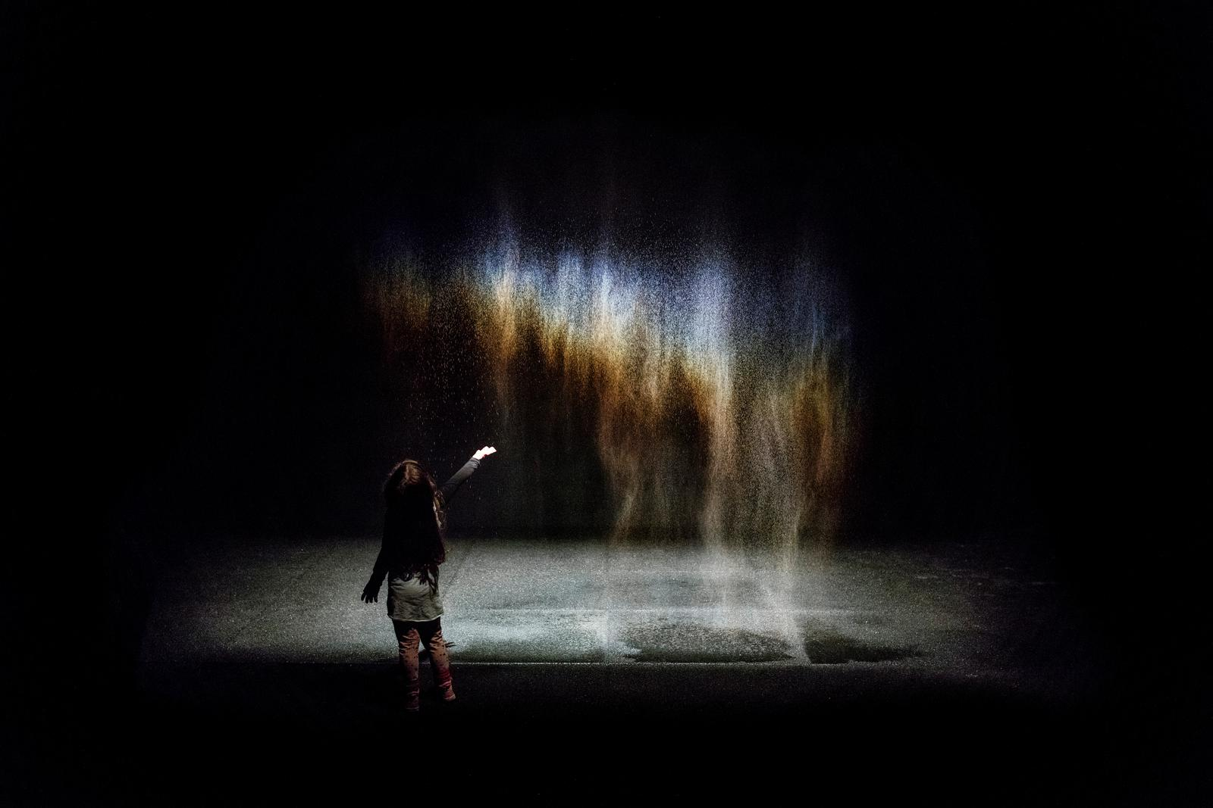
Figure 5, Olafur Eliasson, Beauty, 1993
Beauty is an instillation piece, a trickling curtain of water with a calculated light source projecting onto it, Eliasson explains the concept behind Beauty,
“If you’re located in the right spot, a spectral phenomenon similar to a rainbow occurs in the water drops, since the rainbow is obviously dependent on the angle between the water, the light and your eyes, if the light doesn’t go onto your eyes, there’s no rainbow… “
(Speaks, 2002, 22)
Beauty holds significant importance to Eliasson, as he states “for the first time it made it obvious for me that the spectator was the central issue” (Speaks, 2002, 22).
Eliasson’s atmospheric and sensational instillation works such as Beauty, Fig 5 has given life to both Ponty’s writings and the correspondence of his own beliefs. Michael Speaks (2002), suggests that through his work Eliasson forces his viewers to do that of which Ponty argued was so important to us as humans, “prompting us towards an extensive and intensive engagement with the world, an engagement that reawakens us to a fresh consideration of everyday life” (Speaks, 2002, 44) and Eliasson’s spaces which compel you to interact are significant to Ponty’s theory in regards to that, in the moment you enter Eliasson’s (your) instillation, you are faced with two decisions; to engage physically to the work and in return the piece offers you its full potential, or to simply admire with your eyes and fail to experience the possibilities.
Eliasson’s ultimate objective is that the viewer will take the same approach to the world as they do his work, as Speaks suggests, in his works he is “reminding the viewer that he or she is there, and that he or she is positioned in a certain place” (Speaks, 2002, 22) perhaps in the hope, that when the viewer leaves his exhibitions, they remain in the same state of awareness to the world around them.
Speaks earlier introduced us to the materials and qualities Eliasson works with, and clearly there are many components that Eliasson believes substantial when considering his viewers perspectives,
however it is his cooperative use of light and colour that are particularly interesting and occur frequently through his work, Olafur himself explains, “Colour doesn’t exist in itself, only when looked at. The fact that ‘colour’, uniquely only materializes when light bounces off it into our retina indicated that analyzing colours is in fact about analyzing ourselves”. (Speaks, 2002, 130) an example of Eliasson’s fascination with light and colour are showcased in the collection of his recent paintings that he created under the influence of William Turner, a French Landscape artist who is introduced on page 6.
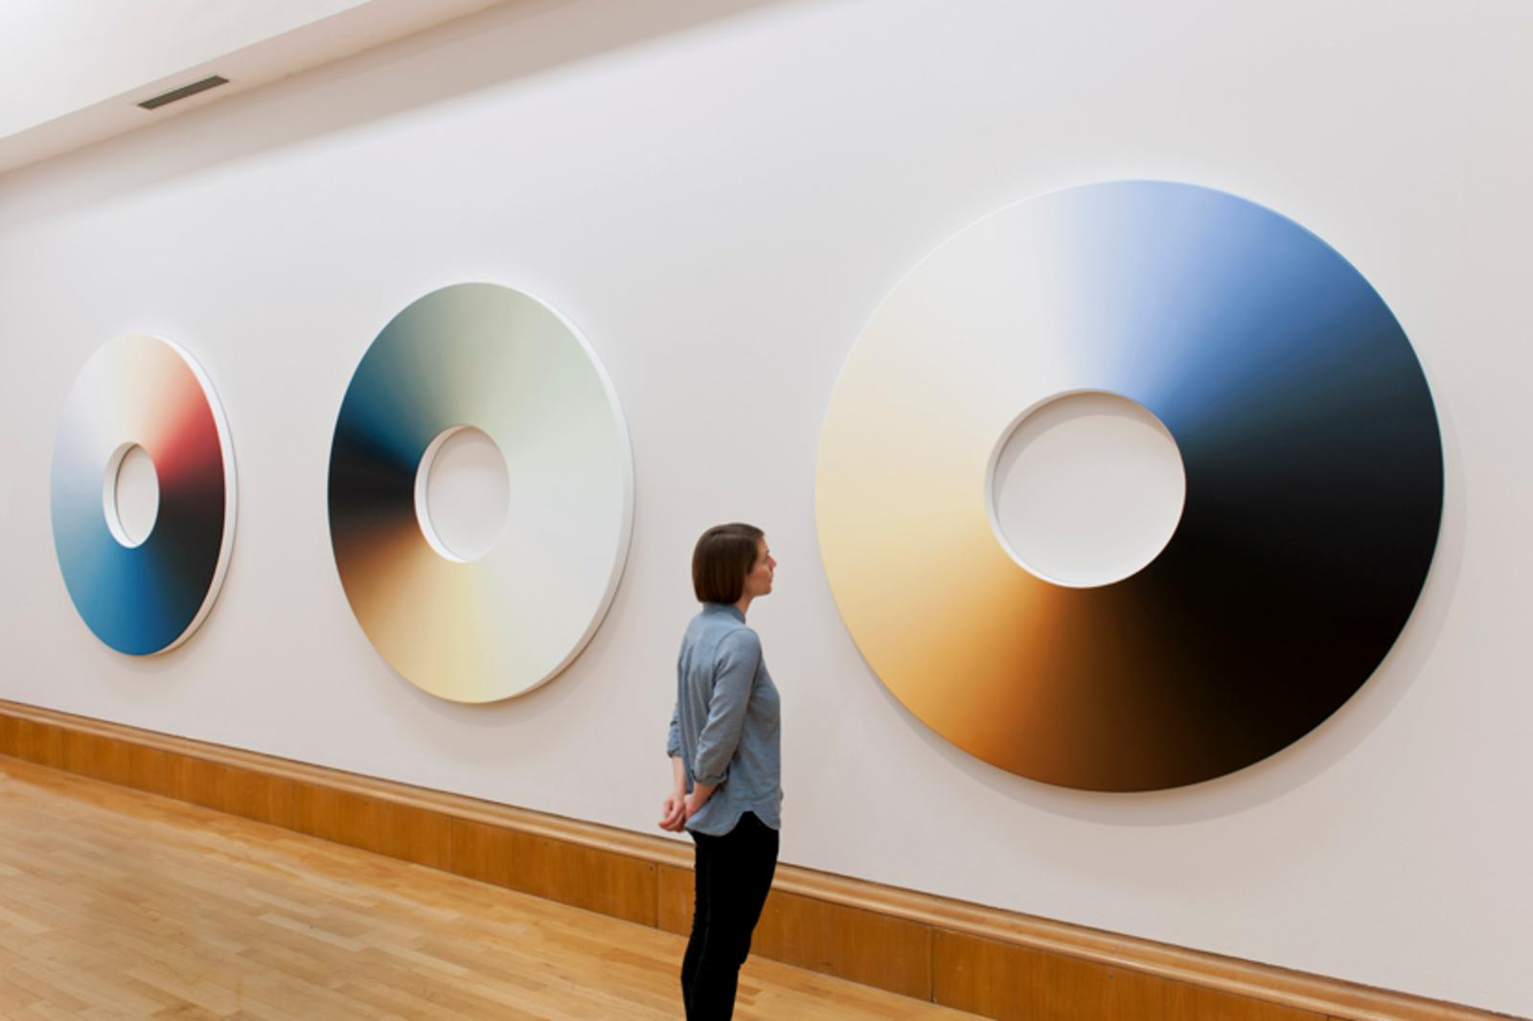
Figure 6, Olafur Eliasson, Turner Colour experiments, 2014
Whilst experimenting with colour and light, Turner has influence over Eliasson, as he explains in an interview conducted for his exhibition of ‘Turner Colour experiments’ located in the Tate Modern, “I have of course looked at who has been occupied with the ephemera of colour and of course Turner is one of the great protagonists when it comes to ephemera and atmosphere” (http://www.tate.org.uk/whats-on/tate-britain/display/olafur-eliasson-turner-colour-experiments) Eliasson ‘s fascination with Turners painting’s derive from the sensations and subjective experience one has whilst studying them, identifying that this was done primarily through colour and light he then creates a collection completely devoted to the pair.
Eliasson studied Turners work carefully, appreciating the way Turner created a subjective sensational atmosphere through colour and light, whilst also recognising the influence he has on contemporary artists like himself, he explains: “I have been particularly focused on the works in which turner radicalised his idea of ephemera, where It became abstract to the extent of you really had to work should you want to create a narrative, this idea of you being put to work, you had to look for something and after a while, one could argue that you are looking for ones self” (http://www.tate.org.uk/whats-on/tate-britain/display/olafur-eliasson-turner-colour-experiments), The same ideas correspond to Eliasson’s own works, such as his notion behind Beauty (Fig 5). The decision Eliasson makes to isolate the colour and light extracted from Turners work was done simplistically. Creating a seamless wheel devoted to the colours, Turner depicted every shade and hue altered by light in between. The arrange of colours are blended and conjoined, assuring seamless perfection, appearing almost endless, and although the landscape itself is absent, through Eliasson’s painstaking attention too the hues, colour temperatures, and how the luminosity of light effects them, individuals are still able to perceive the mood and sensations abstracted from Turners originals, thus identifying the sheer importance of sophisticated use of colour and light and the impact it has on the viewer.
Similar to Olafur Eliasson’s fascination with colour and light, Hella Jongerius is a Dutch designer who also aims to absorb and reveal the complex behaviour of the two. Throughout her work, Jongerius illuminates the effect in which light has on colour, this is important to understand due to the effect colour has on us, especially as colour is one of the most fundamental aspects within the design world. In particular, Jongerius’ 2017 exhibition titled “Breathing colour” demonstrates colour at its most ‘self’, the title Breathing colour is a perfect representation of her instillation, as she demonstrates the effects that atmospheric and surrounding elements such as light, form, and texture have on colour at different times of the day, thus allowing the colours to speak and breathe for themselves.
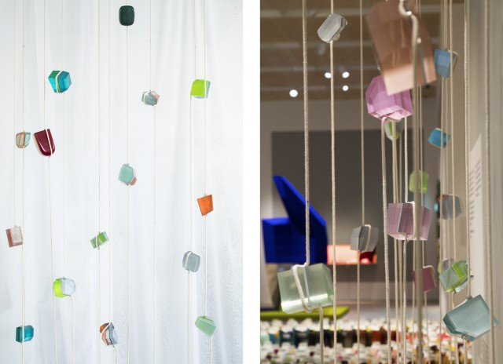
Figure 7, Crystal Beads, Hella Jongerius, 2017.
Crystal Beads is part of Jongerius 2017 exhibition Breathing Colour, created in order to demonstrate how objects absorb and reflect colour and light.
As Jongerius (2017) explores the relationship between light and its effect on colour, it is important to her that she addresses the complexity of light itself, “although we perceive light as colourless, in fact it contains every colour simultaneously, it is the unbroken form of colour” (Jongerius and Newson, 2017, 4) thus explaining why these two elements are so fundamental to one another’s existence, and within the demonstration of Crystal Beads where depending on the light striking them, reflect glimpses of colour. An uncountable array of hues possessing each corner of the every individual crystal, dependent on the ever-changing light conditions in the room, and demonstrating the endless possibilities which the colour possesses.
Similar to Eliassons Beauty (Fig 5) whilst experiencing Crystal Beads, the differing angles and positions that the viewer choose to embrace in, allow them to perceive a completely unique and subjective experience, this experience is completely dependent on how much interaction and engagement you offer Jongerius Piece.
As Breathing colour is a complete devotion to the ever-changing effects light has on colour, whether it is coming from the synthetic lighting Jongerius strategically positions or the constant shift of natural light and even the shadows created by the viewers themselves, these elements allow the room to breathe, showcasing the unpredictable experience unfolding to these objects, allowing the colour to live, to transform.
The objects of colour in this exhibition, Crystal Beads for example are eternally adapting to their surroundings, and each object holds infinite number of responses to the light projected onto them, out of both the objects and the colour’s control, thus if one chooses to actively engage with the objects of colour, they will be gifted a complete physical and subjective immersion, this is explained by Jongerius herself (2017)…
Throughout her exhibition Breathing Colour Jongerius emphasizes the importance that colour has on us, how in essence colour shapes the way we interact with our surroundings, whilst summarizing this exhibition she writes "The surface and colour of an object define how we interact with it, how we use it at first and over time. A sense of touch and feeling strongly influence the relationship between object and user (Jongerius and Newson, 2017, 30).
In discussion of Turners work (page 10), Eliasson’s uses the word ephemera, and In Breathing Colour, Jongerius perhaps helps us understand the extent of Eliassons description, “Colour is sometimes referred to as an illusion because it is temporary. At certain moments and under certain conditions colours acquire new tints and shades” (Jongerius and Newson, 2017, 11) she acquired this understanding through her own thorough experiments with colour, but also interestingly captures the entire notion behind what artists such as Monet, Cezanne, and Turner understood and delivered through their work too, that idea of ever changing colour as a result of the ever changing atmosphere.
Jongerius offers us a glimpse into the complexity of what she has discovered about colour, and in essence the many elements that alter it, thus allowing us to really understand why artist’s such as the impressionists chose to paint the same motif over and over again, because to Monet, his beautiful garden of Waterlillies (Fig 2) with its ever changing atmosphere, sensational experience and spectrum of colour, could never really be seen as the same motif after all.
Conclusion
Through the exploration of Maurice Ponty’s (1999) philosophy, the reality that we are beings who interact with the world using our physical multisensory advantages is brought to life, as Ponty (1999) reminds us, "…it is not what I think, but what I live through… We touch, and are touched in return (Summer, 1999, 44) Ponty directs us to the importance of experience, experience gifted through interaction and active participation in the world, he reminds his readers that you do not see the world simply through your eyes, but through touch and through engagement of all five senses, Ponty (1999) Introduced us into the likes of Historical Impressionist’s who painted feelings in response to the ever-changing atmosphere, not only recording the changes they saw, but the physical sensations they felt, and so cleverly did so in a way that was subjective to the sensations of the person viewing their finished landscape.
Exploring the works of artists such as Monet, Pissarro, Cezanne, and Turner, (who all worked oil on canvas), mastered the ability to embed a subjective, emotional experience in their paintings. A two-dimensional experience presented to the viewer to interpret in a way completely unique and personal to them.
Through the writings of Paul Smith, T.J Clark, and Belinda Thompson It is discovered that the impressionists were able to accomplish this through their vast understanding of light and colour, and how these two elements combined alter perceptions and implement a distinct yet entirely subjective mood.
For example how Turner’s work such as Steamboat (Fig 4) so clearly projects the frightening and daunting impression of a boat and its crew being destroyed by the natural elements, this is obvious. However the impression predominantly produced by the strokes of colour and light is experienced so much richer for an individual who open’s their own unique perspective to it, recalling their own experience at the shock of a cold ocean if they have one, the gruesome taste of salt water as it forcefully enters your mouth, the undefeatable strength of the waters current controlling your body’s movement, the smell of the smoke produced by overworked metal which is possibly experienced by the industrial factory’s overshadowing the city’s, in Turners lifetime and especially now. Depending on the viewer’s engagement with the world, all these sensations completely imaginable within their own subjectivity, thus rendering the piece of art an experience of their own.
The idea of capturing an atmospheric sensation through light and colour was explored furthermore within contemporary work. Within the journey of research conducted for contemporary installation artists such as Olafur Eliasson and Hella Jongerius. Jongerius not only introduces us to her own artistic focus, but perhaps leads us to a greater understanding of the impressionist’s eternal pursuit for atmospheric conditions, Within Breathing Colour Jongerius (2017) entices us with her descriptive analysis of the beauty and sensations within a mornings sunrise, “…As the sun gradually raises the warm shades of dawn recede and the colder morning air creates a crystal clear-glow. This sharper morning light brings intense and crisp colours and the world feels fresh from the glimmering dew” (Jongerius and Newson, 2017, 10) Jongerius (2017) helps summarise why the Impressionist’s consistently nurtured the transformation of elemental change, due to the endless shift in light and colour, thus the endless gift of sensational experience.
As uncovered throughout the examination of both Jongerius and Eliasson’s work within chapter 2, Although their working methods are completely unalike the impressionists - while the impressionists render their sensations two dimensionally through brush stokes and pigment and these contemporary artists create a complete interactive experience, simply generating a surface to allow the colour and light to make their own decisions, their ultimate values correspond beautifully, as we uncovered, It was after all Eliasson who created an entire collection based on Turners work - Turner colour experiments 2014 (Fig 6) and Jongerius (2017) who whilst describing the ambiance of the sunrise, uses Turner as an illustrational example and states “Turner knew how to paint the morning light” (Jongerius and Newson, 2017, 11).
Jongerius’s (2017) idea that colour shapes how we interact with objects/motifs Is undeniable as we have seen examples of this demonstrated effectively by Monet, Pissarro, Cezanne and Turner who all emphasized the importance that colour has on emitting sensations into their painted motifs. Taking inspiration from these historical artist’s Eliasson and Jongerius continue to explore colours potential within an atmospheric setting, and whilst It has been established Impressionist artist’s introduced the notion of sensation, mastered the effect light has on colour, unveiled the beauty in atmospheric change and execute this in a way that erupts a response in their viewers, It is however these contemporary artist’s that within their installation work allow for a dynamic interaction, offering their viewers a physical experience, and flawlessly demonstrating the effect and advantages that thoughtful awareness, touch and engagement hold in the world, as discussed within the analysis of works such as Eliasson’s Beauty 1993 (Fig 5) and Jongerius exhibition Breathing Colour 2017 (Fig 7).
Finally to concluded, it is with the advantages of modern day technology and methods such as light projection, that allow colour to live and ‘breathe’ through artists such as Eliasson’s and Jongerius’ work. These artists are continually pushing the foundations and ideas that the impressionist’s implemented, whilst allowing the colour and thus sensations to act for themselves, and surely within their installations, accomplishing a facility that shape a far more engaged audience within art, allowing for the ultimate subjective experience.
Bibliography
Barker, Elizabeth E. “Joseph Mallord William Turner (1775–1851).” In Heilbrunn Timeline of Art History. New York: The Metropolitan Museum of Art, 2000–.http://www.metmuseum.org/toah/hd/trnr/hd_trnr.htm, October 2004, (accessed 1 December)
Clark, T. (2017). The painting of modern life. New York: Knopf.
Monks, S '‘Suffer a Sea-Change’: Turner, Painting, Drowning', Tate Papers, no.14, Autumn 2010, http://www.tate.org.uk/research/publications/tate-papers/14/suffer-a-sea-change-turner-painting-drowning, accessed 2 December 2017.
Pallasmaa, J. (2005). The eyes of the skin. England: John Wiley & Sons.
Smith, P. and Smith, P. (1995). Beneath the surface. London: Weidenfeld & Nicolson.
Speaks, M. (2002). Olafur Eliasson - Contemporary Artists. Michigan: Phaidon.
Thomson, B. (2000). Impressionism. London: Thames & Hudson.
Turner, J. and Hughes, S. (2006). Light into colour. St Ives: Tate.
Ullrich, P. ''Beyond Touch: The Body as a Perceptual Tool," Fiberarts 26, No. 1
Warrell, I., Simpson, P., Crookham, A. and Moorby, N. (2012). Turner inspired. London: National Gallery.
http://www.tate.org.uk/art/artists/olafur-eliasson-5239
http://www.jongeriuslab.com/news
http://www.tate.org.uk/whats-on/tate-britain/display/olafur-eliasson-turner-colour-experiments turners work
http://olafureliasson.net/archive/artwork/WEK101824/beauty beauty
http://olafureliasson.net/archive/artwork/WEK101680/the-curious-garden -
file:///Users/katielloyd/Downloads/Hella%20Jongerius%20Tour%20Proposal.pdf - crystal beads

