

Programme: Master of Business Administration
Module: International Business Concepts
Module code: LCMB7034

Student Name: Md Ismail Hossan
Student ID: 2521543

Lecturer’s Name: Gladius Kulothungan

Work Count: 5232
Submission date: 13-08-2026

AI Acknowledgement
I would like to state that this assignment is my own work. All of the research, analysis, concepts, theories and frameworks are from my independent research. I used Google Scholar, academic journal, ResearchGate, SSRN, company websites and other websites/news to do my research. I did not use AI tools to generate content or analyse the concepts. But I used Grammarly for proofreading, grammar, spelling, and language corrections.

Table of Contents
Introduction 4
1. Organizational Classification and Global Strategy 5
1.1 Company Overview 5
1.2 Bartlett and Ghoshal Strategic Categorization 5
1.3 Significant Global Integration Requirements 6
1.4 Global Configuration and Competitive Advantage 6
2. Macro-Environmental Appraisal and Market Attractiveness 7
2.1 Host Country Analysis (PEST Framework Application) 8
2.1.1 Political Environment 8
2.1.2 Economic Environment 10
2.1.3 Legal Environment 12
2.1.4 Cultural Environment 14
2.2 Market Entry 15
2.2.1 OLI Analysis (John Dunning’s Eclectic Paradigm) 15
2.2.2 Market Attractiveness Assessment 18
3. Entry Mode Strategy and Strategic Synthesis 18
3.1 Historical Pattern Recognition 18
3.2 Strategic Fit&Justification 19
3.2.1 Suitability for Japan 19
3.2.2 Alternative Entry Mode 19
3.3 Recommendation 20
Conclusion 21
Section 2: Reflective Account 22
References 26

Introduction
International business is a field of study that deals with business activities, transactions, goods, services, and investments that extend beyond international geographical boundaries to meet business objectives (Blaszczyk, 2020). It allows organisations to synchronize strategic resources, streamline multi-country value chains and seize growth potential in different foreign markets. To explore such an international landscape in action, this report focuses on the particular case study of Primark, an international dominant, high volume, low margin fast-fashion retailer and what this means for its potential expansion in Japan, which it currently does not operate in. Based on the Bartlett and Ghoshal (1989) model, the study examines the organizational structure of Primark company and a detailed host country macro-environmental analysis is conducted on Japan using PEST model, and the study synthesizes the market attractiveness based on John Dunning's Eclectic (OLI) paradigm. Overall, the primary goal of this report is to critically examine the strategic positioning of Primark Limited, analyse the risks facing Primarks when entering the target market and develop an evidence-based market entry strategy for its proposed entry to the Japanese market.


Figure 1 Primark Logo; Source: (Primark, 2025)

1. Organizational Classification and Global Strategy

1.1 Company Overview
Primark was established in 1969 in Dublin, Ireland, as a business known as Penneys, and it continues to be known by its name today (Manly, 2022). It is a leading value and fast fashion global retailer known for its high-volume, low-margin clothing and homeware business (Ologunebi, 2023). The brand has been expanding throughout Europe and into the U.S. via the large stores and low prices. Importantly, at present, the firm has no operational presence in Japan and is thus an entirely new space for expansion.
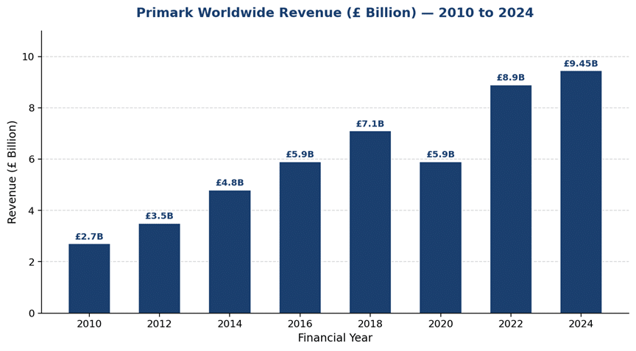
Figure 2 Revenue&Financial Performance of Primark; Source: (Soorya, 2026)

1.2 Bartlett and Ghoshal Strategic Categorization
The framework devised by Bartlett and Ghoshal (1989) divides multinational companies into four quadrants: international, global, multidomestic, and transnational. Primark follows an International Strategy the most, where some global standardization has been implemented with very little local market adaptation (Noris et al., 2025). The firm's strategy is to compete primarily by offering a low-cost, highly standardized retail format in different countries where its format may be appropriate for the markets.
Primark is not an ideal candidate for a multidomestic approach since it does not adapt the basic product offering extensively in each country where it is sold (Brammer, 2021). It is a business that heavily depends on scale, price, and a fairly homogenous retail concept across geographic and market areas.

1.3 Significant Global Integration Requirements
Primark is a centralized purchasing and long-lead sourcing matrix. This unified buying power is what enables them to maintain low per-unit costs and benefit consumers around the globe (Ivanov, 2025). A good comparison for this decision is to look at the competitor models. In contrast to companies like Inditex (Zara), which have agile nearshoring (Soares, 2024) to quickly change their product lines to suit local fashion micro-trends, Primark has highly standardized products around the world and uses a long-lead, centralized sourcing matrix. Primark pays in advance for standard products in bulk to ensure they can obtain the lowest unit cost in all global markets.

1.4 Global Configuration and Competitive Advantage
Primark's current geographical presence covers the UK, the Mainland part of Europe, the USA, and the Middle East, each of which makes a contribution to Primark's global value creation (DF News Desk, 2026).
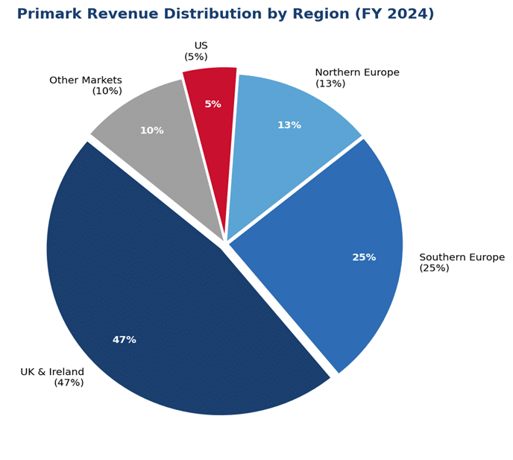
Figure 3 Primark’s Regional Revenue Breakdown (FY 2024); Source: (Soorya, 2026)
This geographic configuration is conducive to a number of important international strengths:
- Technological Leadership: According to Parashar (2021), Primark has adopted advanced logistics management systems and enterprise resource planning (ERP) software for accurate inventory monitoring. In addition, the company's upgraded digital click-and-collect system enables it to incentivize consumers to visit stores without investing in a broad e-commerce delivery service.
- Brand Equity: The Primark brand's global reputation is based upon the democratic nature of fashion, making it an extreme bargain for consumers (Thurnhofer, 2024). The visibility of the “Primark Cares” sustainability campaign also assures that the brand's reputation is safeguarded and that cheap garments can be ethically and sustainably sourced (Primark, 2025).
- Economies of Scale: The large square footage of retail stores and huge procurement orders from overseas suppliers to countries such as Bangladesh and China have an enormous impact on the cost of production per unit. Buying millions of identical t-shirts enhanced their unparalleled buying power.
- Vertical Integration and Supply Chain Control: Primark has strong control over its own value chain, which involves its in-house product design, procurement of contracts in manufacturing, and its complicated third-party logistics networks (Wang, 2023). However, by closely controlling the process from the factory floor to the retail shelf, the company is able to cut out the middleman profits and pass them on to the consumer.

2. Macro-Environmental Appraisal and Market Attractiveness
The section provides a detailed macro-environmental analysis of Japan to evaluate the structural suitability for Primark to operate in Japan. This analysis uses the PEST framework to dissect the conditions of the host country into separate political, economic, legal, and cultural realities. This base provides comprehensive risk assessments, and strategic business opportunities are clearly identified prior to capital investment.

2.1 Host Country Analysis (PEST Framework Application)
This analysis covers external environmental conditions in Japan that will affect the strategic viability of Primark's expansion as of mid-2026. The ability to analyse the interaction between regulations, economy, and cultural differences in Japan details that are crucial to translate country risk information into market entry information.
Political Environment
Economic Environment
Legal Environment
Cultural Environment
Figure 4 Host Country Analysis Framework; Source: Author

2.1.1 Political Environment
The Japanese parliamentary constitutional monarchy has long been a stable system, with a remarkably good institutional continuity and a good level of predictability and low risk in the corporate setting (D'Ambrogio, 2020). The overall political context is defined by the outstanding rule of law, low sovereign risk and policy predictability (Schweizer, 2024). Department of Foreign Affairs and Trade (2025) reported that the Japan-US alliance is the basis of Japan's foreign policy and national security, which underpin the geopolitical stability of the region.
Cabinet Secretariat of Japan (2021) has mobilized ministries to achieve a target of 120 trillion yen in inward FDI by 2030, with direct outreach initiatives to the Council for the Promotion of Foreign Direct Investment (FDI) to reduce non-tariff operational obstacles to FDI inflows.
Opportunities
- Pro-FDI Governance Reforms: Japan has implemented the Financial Services Agency's (FSA) revised Action Program for Corporate Governance Reform and is moving from defensive compliance with the corporate code to capital productivity and returns on equity (Buchanan and Deakin, 2025).
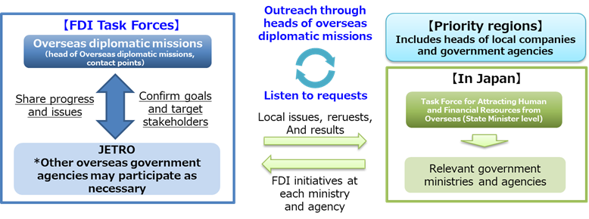
Figure 5 Overview of FDI Task Force; Source: (Ministry of Foreign Affairs of Japan, 2024)
For Primark, this represents a very real commercial opportunity because the regulatory impetus compels cash-rich local companies to sell off non-core property, releasing some of the best property in the city for commercial use. Moreover, by eliminating information asymmetries, the Tokyo Stock Exchange's requirements for the disclosure of financial information in English will enable foreign firms to enter Japan to buy properties and establish corporate ties with Japan's local firms with unprecedented speed and little transaction cost (Yamazaki, 2024).
- International Trade Liberalization: Salgado et al. (2025) noted that Japan's strategic approach to mega-regional trade agreements, such as the CPTPP and RCEP, that includes comprehensive and progressive agreements, is a strong cost-mitigation device. These schemes gradually reduced or completely removed import duties on major garment production centres in Asia (including Vietnam and Cambodia) and significantly reduced procurement costs (Miyajima, 2022). As a result, Primark can implement its global sourcing model, which is the backbone of its business, without the threat of punitive border taxes that threaten to compromise its price-leading advantage.
Risks
- East Asian Geopolitical Tensions: Geopolitical tensions and supply chain exposure across East Asia are a fundamental risk for all international operators in the region with regard to supply chain logistics (Hur and Yeo, 2024). The Taiwan Strait and East China Sea are also subject to regional posturing, which could result in abrupt shipping delays or rerouting requirements (Bukhari et al., 2024). Since Primark runs on strict inventory rotation deadlines and centralized buying is done on a long lead time (Primark, 2025), an extended stoppage at sea, even just a week, can lead to a stockout in their busiest stores, wreaking damage on the brand loyalty of their customers.
- Municipal Regulatory Hurdles: Federal political structures actively invite foreign capital, and in the cities, there are dense, localized city planning codes. The Large-Scale Retail Store Location Act requires local assessments of noise, waste management, and traffic congestion for retail developments larger than 1,000 square meters (Kim, 2020). This poses a major challenge for Primark's enormous model.
Political conditions are extremely favourable. The geopolitical shipping risks are manageable through proactive, diversified supply chain planning and the early provision of local legal planning to protect assets, with federal institutional stability providing excellent asset protection in the long-term.

2.1.2 Economic Environment
Japan's highly industrialised market economy is the world's fourth-largest economy (Morita, 2026), backed by highly sophisticated commercial infrastructure and dense transit connections. According to Jie (2026), the Bank of Japan has cut its growth forecast for the fiscal year 2026 to 0.5% from 1% and sharply raised its core inflation outlook to 2.8% from 1.9%. This recovery is largely due to a recovery in private consumption increased by 0.3% (Jie, 2026), indicating a reduction of structural deflationary mindsets as real household earnings continue to rise.
Key Strengths
- Highly Concentrated Consumer Markets: The Japanese consumer market is concentrated in large urban clusters, accounting for more than 37 million people in the Greater Tokyo area alone (Okata and Murayama, 2011). One of the advantages of this spatial density is that it generates a huge amount of retail traffic every day within walkable areas, such as Shinjuku and Shibuya. (Bramson, 2021). For Primark, this configuration maximises the economic value by enabling higher sales per square meter and the single central warehouse to efficiently replenish multiple high volume, urban location storefronts at low regional shipping expenses.
- Widespread Shift Toward Budget Optimization: Amoroso et al. (2026) stated that the local wage trend of the past few decades has fundamentally changed the psychology of consumers, leading to a new lifestyle pattern that is budget-oriented. This offers an excellent commercial opportunity for a value-fashion model. Japanese consumers are making the most of their discretionary spending (Chang et al., 2022), and the demand for value products and everyday wear has grown. The trend will provide a constant supply of shoppers seeking viable alternatives to more expensive domestic retail chains.
Economic Challenges
- Quality-Driven Margin Pressures: In May 2026, Japan's annual headline inflation rate is around 1.5% (Figure 6), due to the increase in raw materials costs and import energy price adjustments. This inflationary push is further exacerbated by currency fluctuations and a historically weak yen, which raise the prices of imported garments from around the world (Ye, 2024). Most importantly, the local market shows no compromise when it comes to quality standards, even at low prices, and expects flawless construction, perfect stitching, and immaculate store presentation. Thus, Primark has no room to reduce its production requirements in order to maintain profit margins without risking immediate loss of the local market (Primark, 2025).
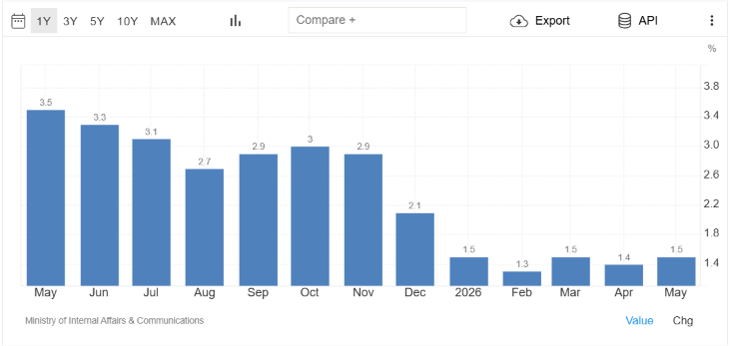
Figure 6 Japan Inflation Rate; Source: (Trading Economics, 2025)
- Demographic Squeezes on Labor and Target Markets: According to Yamane (2025), Japan is suffering from severe, ongoing demographic contraction with high levels of aging and low birth rates. Okamoto (2026) reported this change as a two-edged sword, making the key fashion and trendy consumer market smaller over time and seriously constricting the local retail workforce. This creates a labour shortage that increases local part-time wages and the cost of running a store (Okamoto, 2026), creating difficulties for discount retail spaces which rely on low overheads to operate.
Economic conditions are moderately favourable. Demographic shrinkage and consumer price optimization make for challenging operations, but strong urban traffic and a robust focus on consumer quality are counterbalanced by Primark's cost-leadership prowess.

2.1.3 Legal Environment
Japan has a civil law system, highly influenced by Europe, mostly by Germany and France (Sugimoto, 2021), but also incorporating aspects of the US constitutional and administrative law. It is highly structured, transparent, and strictly enforced, and requires absolute compliance across all operational layers. The legal climate has a direct impact on corporate structure, real estate renting, and import taxes for a foreign retailer.
Advantages Include
- Total Foreign Direct Investment Rights: Under the Foreign Exchange and Foreign Trade Act (FEFTA), 100% FDI is allowed in all commercial retail sectors in Japan (Ministry of Finance, 2025). This statutory protection enables Primark to avoid local equity splits and favour its narrow corporate profit margins.
- Elite Intellectual Property Safeguards: Japan has one of the world's strongest and most comprehensive intellectual property (IP) systems (Kahkesh, 2025), which has been established as a national policy of becoming an "IP Based Nation". The system is governed by the Japan Patent Office (JPO) and offers high-level legal protections to corporate trademarks (Kahkesh, 2025). This helps to reduce the chances of local fast fashion copycats taking away brand equity.
Challenges Include
- Strict Commercial Siting Legislation: Foreign brands have to contend with many restrictions under the Large-Scale Retail Store Location Act (Odagiri and Riethmuller, 2000). This law requires strict municipal evaluations of neighbourhood noise, urban traffic control, and the environment before the construction of retail store-fronts larger than 1,000 square meters (Odagiri and Riethmuller, 2000). This requirement is a huge barrier to project implementation as it falls upon long-lead retailers to invest significant upfront investment in local compliance processes.
- Complex Import Customs and Taxation: International Apparel Retailers are subjected to a very strict and detailed customs system in Japan. According to the JETRO (2025) report, the Japanese Consumption Tax is 10%, with a 2.2% local consumption tax rate. In Japan Customs, duties are calculated based on CIF value (Cost, Insurance, and Freight), which includes shipping and insurance costs, and which is actively taxed (Besusparienė and Bielskienė, 2023). In addition, the MFN tariff rates on imported garments are quite complex, varying between 8% and 15% based on specific fabric descriptions (Sykes, 2016).
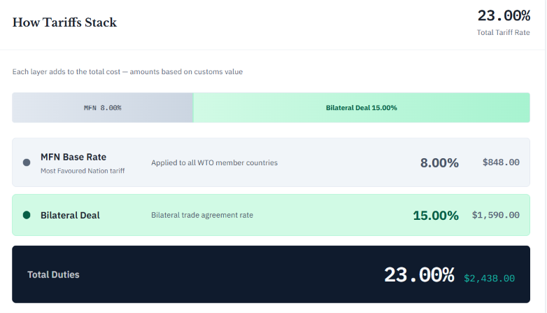
Figure 7 Tariff Calculation for Japan; Source: (Sykes, 2016)
Moreover, Japan's strict textile labelling requirements (JIS L 0001) and complicated electronic invoicing regulations by the National Tax Agency (NTA) have increased the administrative compliance burden for foreign companies (Esfahani et al., 2025).
Legal environment is neutral to favourable. Strict initial investment standards for large stores result in a degree of compliance that is significant; however, 100% FDI rights and corporate asset security make for a very safe business environment.

2.1.4 Cultural Environment
The Japanese fashion industry is highly cultural, influencing buyers' decisions and brand loyalty. To thrive in this market, it's essential to grasp the individual customer's psychological requirements.
Key Cultural Factors
- Overview of Consumer Psychology: On the cultural side, the group's harmony is respected, aesthetics are carefully presented, and the traditional Monozukuri culture (Kawamura, 2025), which focuses on precision and attention to detail, is highly valued. These values are extremely important in retailing, as a clean environment and a friendly staff are as important as the product itself, as are packaging materials.
- Quality vs. Value Balancing: According to Partner (2023), Japanese consumers put a huge emphasis on value but have no tolerance for product defects. Balancing the brand's reputation with the local expectations will be a challenge for Primark, which will have to put in place very careful quality controls to prevent even the tiniest of imperfections, such as loose threads or mismatched cuts, from taking its toll on the brand's reputation.
- Ethical and Sustainable Consumption: Though fashion continues to be a purchase for status in some of the more expensive shopping hot spots, a more practical and eco-conscious lifestyle choice is also emerging among the younger urban population (Nam and Kannan, 2020). As ethical purchasing becomes a trend, the transparent, eco-friendly practices of the “Primark Cares” initiative are a cultural must to gain consumer trust over the long haul.
The cultural environment is difficult and controllable. To weather a storm of consumer analysis, the quality control processes must be adapted to the local level.

2.2 Market Entry
The analytical framework indicates whether Primark has the ability to compensate for the inherent challenges of the retail market in Japan by utilizing its distinctive strengths.

2.2.1 OLI Analysis (John Dunning’s Eclectic Paradigm)
The eclectic approach by Dunning (1988) on the market entry strategy of internationalization of a firm is reliant on three major factors: ownership, location, and internalization advantages.
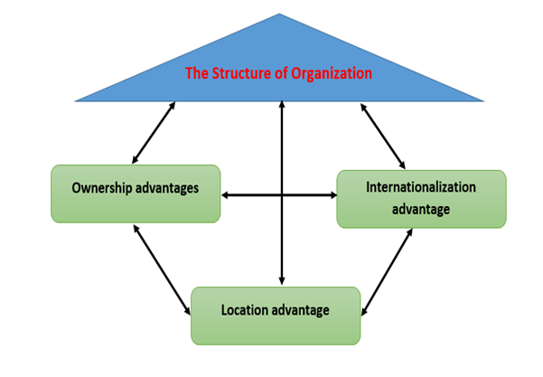
Figure 8 John Dunning’s Eclectic Paradigm; Source: (Rugman, 2023)
Ownership (O) Specific Advantages
Primark has a number of ownership-specific advantages that make it one of the larger tools in the Primark armoury for capturing initial market share, but they need to be able to produce efficiently whilst being able to meet local expectations.
- Brand Strength and Value Proposition: Primark is known the world over as a leader in democratic mass fast fashion (Blaszczyk, 2020). Its core strength of providing trendy clothing at very low price points directly targets the cost-conscious segments of the host markets (Hoskins, 2022).
- Centralized Enterprise Inventory Management: The company has an enterprise resource planning (ERP) system and centralized inventory management that ensures close control of the supply chain (Hoskins, 2022). It brings together huge quantities of procurement, making the cost of the products produced per unit less than that of domestic competitors can achieve.
- Intellectual Property and Global Licensing: Exclusive co-branding deals with global entertainment giants (Disney and Netflix) offer a design layer which resonates directly with pop culture consumer segments, with legal protection (Hoskins, 2022). Japan's zero-defect cultural norms add a small negative cost pressure that requires the firm to put a lot of effort into special quality-assurance testing to prevent product defect rejection.
Location (L) Advantages
Japan offers significant location advantages, making it an extremely attractive pull factor for a large international value retailer.
- Large and Highly Urbanized Customer Base: The host market has a large population density in the major commercial mega-regions such as Greater Tokyo and Osaka. This concentration of the population means there's a high daily foot traffic on the storefronts.
- Advanced Transit Infrastructure and Sourcing Proximity: World-class transport networks and deep Maritime Ports ensure predictable inventory distribution. Additionally, Japan's strategic location near Primark's main manufacturing hubs in China and Southeast Asia reduces transit times and enhances the efficiency of the supply chain.
- Pro-FDI Government Initiatives: Government policy encourages foreign investment by accelerating the process of corporate establishment and improving the corporate governance structure. But regulatory restrictions and fierce competition in prime urban locations are major issues that can slow the roll of physical stores under the Large-Scale Retail Store Location Act.
Internalisation (I) Advantages
Internalizing operations is the primary benefit of Primark expanding into Japan's market rather than relying on external market arms.
- Direct Control: Primark likes to maintain control of its vast physical storefronts (Cooijmans, 2023), interior designs, and day-to-day retail operations instead of licensing its brand or technology to other companies.
- Protection of Supply Chain Software and IP: Lower operational risk for IP leakage or unauthorized duplication of proprietary Logistics Software Systems.
- Elimination of Transactional Frictions: Internalization eliminates the middleman commission fee. This kind of operation helps to safeguard Primark's tight profit margins by passing on direct savings to the customer (Zekri, 2021). The OLI approach is, therefore, very pro-direct investment.

2.2.2 Market Attractiveness Assessment
Based on a critical synthesis of the macro-environmental forces and the OLI dimensions of the paradigm, Japan is a very profitable but also very complex environment for expansion. The host market's high-density urban population offers a huge commercial opportunity, while the growing trend for consumers to seek cost-cutting solutions aligns well with Primark's core scale benefits (Sierra-Sánchez, 2020). But the retailer will have to be able to conquer strict regulatory site laws and an adversarial zero-defect consumer culture to become profitable in the long-run. The overall market attractiveness is therefore rated as high attractiveness, high operational complexity, which means that it is necessary to have a direct and tightly controlled corporate strategy to enter the market.

3. Entry Mode Strategy and Strategic Synthesis

3.1 Historical Pattern Recognition
High control entry modes have always been a key attribute of Primark's international history. This helps to maintain its "value focus" operating model. The firm's major market entry strategy is the formation of wholly owned subsidiaries, which is achieved through Greenfield Investments and strategic Acquisitions (Ologunebi, 2023).
Traditionally, Primark has expanded beyond Ireland with stores in the UK since 1973 (Taylor, 2024), through organic growth. The firm expanded its presence rapidly in the 90s through to the early 2000s by making significant acquisitions in the retail portfolio (Taylor 2024). It was one of the many instances of the acquisition of over 41 Littlewoods storefronts in 2005 to obtain prime high street real estate.
Primark's wider expansion into Europe in the Spanish market in 2006 and its first market entry in the U.S. in 2015 involved the creation of large, directly owned stores from the ground up (Scott and Fridenson, 2021). With 100% equity ownership, the firm enjoys absolute ownership and strategic control over its complex global supply chain, high-volume inventory turnover, and low-cost pricing model, none of which will need to be handed over to third parties that have entered the franchise.
But in 2025, there was a really huge change in the business structure. It launched its 18th international market, Kuwait, with its first use of a Master Franchise Agreement in collaboration with the Alshaya Group (Alshaya Group 2025). This development has been observed to represent that it has been its historical anchor, but can contractually franchise when it enters commercially different and culturally different business environments.

3.2 Strategic Fit&Justification
The appropriateness of continued direct entry versus alternative partnership strategies must be carefully considered to establish strategic fit for Japan.

3.2.1 Suitability for Japan
- Advantages include: It allows for full control over store design, customer service and local marketing strategy, ensuring that the low-cost pricing model is protected from third-party royalties essential for the success of this strategy. Direct investment also demonstrates a strong commitment of the long-term investment in the Japanese market (Nam and Kannan, 2020). This reflects local business culture which has a strong emphasis on institutional trust, which led to the company being granted favourable retail leases from large municipal landlords. Logistically, direct control enables the development of the supply chain, and Primark will be able to connect its centralized warehouse in Asia directly to maritime ports across Japan, bypassing the need for a stopover.
- Disadvantages include: It takes a very high level of resources to run a completely greenfield operation, and it puts a heavy strain on corporate funds to pay for a top-tier real estate lease in high-traffic shopping areas such as Shibuya or Shinjuku. Moreover, it puts the company at the highest risk of financial and operational damages. For Primark, all of the localized compliance costs, such as the significant administrative expenses associated with Japan's Qualified Invoice System and the stringent textile labelling regulations (JIS L 0001), need to be absorbed, while all store sales-related expenses during the implementation phase must be covered (Esfahani et al., 2025).

3.2.2 Alternative Entry Mode
Another possible entry mode would be to enter with a Strategic Joint Venture (JV) in the form of a domestic Japanese retail company.
- Advantages include: A JV has faster market access through the partner's commercial property relationships, significantly accelerating the approvals process under the strict Large-Scale Retail Store Location Act (Elgarresta-Ugartemendia, 2025). It is a useful source of local knowledge, particularly on the intricacies of Japanese consumer psychology, and gives instant political legitimacy within municipal retail planning committees.
- Disadvantages include: A partnership structure takes much of the control away from the business and can be very troublesome in terms of strategic conflict over pricing cuts or marketing changes. More seriously, a joint venture implies significant IP dangers (Elgarresta-Ugartemendia, 2025), which places Primark's proprietary real-time stock supervision techniques and logistics software under threat of being copied by another party. The strategic risks are very high given Primark's dependence on technology and lack of margin.

3.3 Recommendation
This report suggests that Primark should have a gradual market entry approach with three phases to ensure that the risks are reduced structurally while maintaining its long-term goals:
Phase 1: Brand Anchor Realization: Open the first wholly owned flagship store in a high-density retail location in Tokyo, Shibuya, through targeted greenfield investment. During this stage, the emphasis is entirely on local brand building, refining quality assurance processes to meet the high-quality standards of the local consumer, and testing the results of the value proposition generated in the region.
Phase 2: Digital Integration and Logistics Optimization: Deploy a locally developed mobile app with a sophisticated stock check and digital click-and-collect system, similar to what has been done in the West. This digital layer will create immediate foot traffic in the flagship location, but without having to open up numerous storefronts. At the same time, centralize existing direct shipping routes from China and Bangladesh to the Port of Tokyo.
Phase 3: Controlled Geographical Expansion: Exploit the brand's proven identity with additional fully owned retail stores in commercial hubs of high traffic in Osaka and Nagoya in secondary urban mega-regions.

Conclusion
This detailed study indicates that Japan is one of the most promising countries for the potential expansion of Primark, but there is a need for careful timing of entry and a strong institutional control structure. The company’s wholly owned phased entry model effectively shields proprietary logistics software and maintains tight margins from being eroded by middlemen's fees. Although domestic regulations and consumer quality standards impose significant operational challenges, the nature of Primark's scale-driven price leadership will provide the brand with a very profitable and sustainable competitive edge in the Japanese fashion market.

Section 2: Reflective Account
This reflective account uses Gibbs Reflective Cycle (1998) to critically analyse the research’s analytical and developmental process used throughout this assignment.

Figure 9 Gibbs reflective Cycle; Source: (Galli and New, 2022)
Description
This report aimed to critically analyse the potential of Primark's international expansion into the Japanese retail market in terms of established international business frameworks. For the purposes of Section 1, I employed a multi-step research process, starting by applying the Bartlett and Ghoshal (1989) model to Primark's global corporate structure, which I determined to be an international strategy with selective standardization. I assessed Primark's track record of fully owned greenfield investments and developed a comprehensive, evidence-based market entry strategy to effectively manage the operational dynamics of a foreign market.
Feelings
The brief made me feel very overwhelmed, as I had just come to this assessment and had many high stakes set for myself. I was nervous when I was doing the initial outline because I knew that if I missed one of the requirements, I would not get any marks. I also faced difficulties in locating very targeted and recent information for the mid-2026 Japan macroeconomic indicators and textile tariffs.
When I started to combine information, I started to think very intellectually about how the low cost, long lead brand, Primark, could survive in Japan's "zero-defect" consumer culture. To get over the initial anxiety of the report I divided the report into more manageable, organized pieces. After I started to correlate what was happening in the real world with what I was learning in class, I got ever more confident and felt proud that I could produce a market overview that was more analytical than descriptive.
Evaluation
One very positive thing about this process of research was that the information about the operations of Primark as well as the commercial trends in Japan were authoritative and public, and were widely available. I was able to develop robust arguments for all of the macro-environmental domains through engaging with new industry frameworks and documents from government. In addition, structural frameworks such as the OLI paradigm gave a great tool for getting beyond description to making country data useful for market entry.
But there were many difficulties encountered during the process as well. The biggest challenge was keeping to the word limit and keeping the analysis level required for post graduate. When I first started drafting, I would describe quite a bit about the political history of Japan, and the statistics of its population, and how that impacted the supply chain of Primark, rather than evaluating the meaning behind these numbers. I had to be ruthless and cut work that was superficial summarizing and put in quantified impacts so every paragraph would relate to the corporate strategy.
Analysis
This assignment really helped me understand the importance of theories in international business, transforming it from a theoretical construct to a practical tool for companies. Using the Bartlett and Ghoshal model helped me to see that Primark's low-cost concept is based on replicating a 'standardised model' and that this is where they would have to restrict their movement to a multidomestic shift is highly unfeasible.
The PEST analysis demonstrated how various environmental factors continually overlap in ways such as Japan's sluggish wages directly supporting the consumer movement for smart budget management, and thus opening up a perfect opportunity for Primark's value proposition based on scale.
Also, the Dunning's OLI paradigm highlighted the need for a full ownership subsidiary for such an expansion. Primark is a thin-margin business where the only method to shield the slim margins is to cut out the middlemen by managing stores in-house.
Conclusion
This assignment has helped me greatly understand the choice one can make when entering the international market and the risk analysis of the countries. I've become more adept at the ability to combine highly variable and sometimes conflicting public information into meaningful corporate forecasts. The exercise was a good illustration of the fact that internationalization is not a size fits all affair, and that the strategic fit of the advantages in a company, and in the country of destination, is important.
For example, when I look at my work, I see that I have gotten better at being able to write objectively, and create a critical debate as opposed to just opinions. The process of navigating host country regulations is one that now appears to need early planning to secure a brand's long-term competitive advantages and localized compliance is an investment that needs to be made.
Action Plan
Based on the core research limitations identified in this task, I have created a structured action plan for my continued learning and to enhance my future performance in post graduate work:
Skills to Improve | Actions to Take | Timeline | Expected Outcome
Critical Evaluation&Analytical Depth | Actively eliminate descriptive summaries in early drafts, ensure every data point is immediately followed by a "strategic implication" sentence. | Week 1–3 of future modules | Higher marks for cognitive and intellectual skills by ensuring deep, analytical argumentation.
Advanced Sourcing of Academic Literature | Spend more time searching peer-reviewed international business journals | First half of the next research cycle | A broader, more authoritative reference profile exceeding 20+ high-quality academic sources.
Proactive Word Count Sizing Management | Write strictly to the allocated section word targets from day one, rather than over-writing descriptive text and relying on heavy post-draft editing. | Ongoing across all upcoming drafts | Smoother writing phases, better structural balance, and strict compliance with assessment parameters.

References
Alshaya Group (2025). Primark opens first Middle East store in Kuwait in partnership with Alshaya Group. [online] Alshaya.com. Available at: http://www.alshaya.com/english/media-centre/alshaya-news/primark-opens-first-middle-east-store-in-kuwait-in-partnership-with-alshaya-group/ [Accessed 13 July 2026].
Amoroso, D.L. and Ackaradejruangsri, P., 2026. Brand commitment as predecessor to the factors of continuance intention. Journal of Marketing Analytics, 14(1), pp.158-172.Section 1: Strategic Evaluation and Market Entry Analysis
Bartlett, C. and Ghoshal, S. (1991) Global Strategic Management: Impact on the New Frontiers of Strategy Research. Strategic Management Journal, 12, 5-16.
https://doi.org/10.1002/smj.4250120903
Besusparienė, E. and Bielskienė, M., 2023. Customs Valuation of Waste for Development of the Circular Economy. Management Theory and Studies for Rural Business and Infrastructure Development, 45(3), pp.221-232. https://doi.org/10.15544/mts.2023.22
Blaszczyk, R.L., 2020. Fashion as enterprise. European fashion.
Brammer, S., Nardella, G. and Surdu, I., 2021. Defining and deterring corporate social irresponsibility: embracing the institutional complexity of international business. Multinational Business Review, 29(3), pp.301-320. https://doi.org/10.1108/MBR-02-2021-0011
Bramson, A. and Hori, M., 2021, June. The best place in Tokyo for anything: Classifying stations by walkability to specific amenities. In Annual conference of the Japanese society for artificial intelligence (pp. 106-117). Cham: Springer International Publishing.
Buchanan, J. and Deakin, S., 2025. Has Japan's corporate governance reform reached a turning point? Some cautionary notes. In Reforming Capitalism, Going Digital and Green (pp. 13-30). Routledge. https://www.taylorfrancis.com/chapters/oa-edit/10.4324/9781003599623-2/japan-corporate-governance-reform-reached-turning-point-cautionary-notes-john-buchanan-simon-deakin
Bukhari, S.R.H., Khan, A.U., Haq, I.U. and Ullah, T., 2024. The geopolitical implications of Taiwan-China relations on regional security. Spry Contemporary Educational Practices, 3(1).
Cabinet Secretariat of Japan (2021). Action Plan of the Growth Strategy Action Plan of the Growth Strategy. [online] Government agency: Cabinet Secretariat of Japan . Available at: https://www.cas.go.jp/jp/seisaku/seicho/pdf/ap2021en.pdf [Accessed 12 July 2026].
Chang, W. L., Chen, L. M.,&Hashimoto, T. (2022). Cashless Japan: unlocking influential risk on mobile payment service. Information Systems Frontiers, 24(5), 1515-1528.
Cooijmans, M.P., 2023. Human rights and corporate social responsibility. In Applied human rights (pp. 247-276). Wageningen Academic. https://doi.org/10.3920/978-90-8686-943-5_15
D’Ambrogio, E. (2020). Japan’s Parliament and other political institutions | Think Tank | European Parliament. [online] Www.europarl.europa.eu. Available at: https://www.europarl.europa.eu/thinktank/en/document/EPRS_BRI(2020)651951 [Accessed 12 July 2026].
Department of Foreign Affairs and Trade (2025). Japan country brief. [online] Australian Government Department of Foreign Affairs and Trade. Available at: https://www.dfat.gov.au/geo/japan/japan-country-brief [Accessed 12 July 2026].
DF News Desk (2026). Primark targets youth market with new sub-brand, plans more Middle East stores. [online] Denim Focus. Available at: https://denimfocus.net/primark-targets-youth-market-with-new-sub-brand-plans-more-middle-east-stores/ [Accessed 12 July 2026].
Dunning, J.H. (1988) The Eclectic Paradigm of International Production: A Restatement and Some Possible Extensions. Journal of International Business Studies, 19, 1-31. http://dx.doi.org/10.1057/palgrave.jibs.8490372
Elgarresta-Ugartemendia, L., Chávez, M.M. and González-Eguía, N. (2025). Impact of joint venture on its partner company’s performance: A systematic literature review. [online] (3).
Esfahani, B. H., Li, R., Zhang, M., Eike, R., Etemadzadeh, M. and Song, G., 2025. Enhancing firefighter hoods: innovations, challenges, and future directions in PPE design. Textile Progress, 57(2), pp.73-116. https://doi.org/10.1080/00405167.2025.2528501
Galli, F. and New, C. (2022). Gibbs’ Cycle review. Emotions as a Part of the Cycle. E-Motion: Revista de Educación, Motricidad e Investigación, 19(19), pp.92–101.
Hoskins, T.E., 2022. The anti-capitalist book of fashion. Pluto Books.
Hur, A. and Yeo, A., 2024. Democratic ceilings: The long shadow of nationalist polarization in East Asia. Comparative Political Studies, 57(4), pp.584-612. https://doi.org/10.1177/00104140231178724
Ivanov, D., Tsipoulanidis, A. and Schönberger, J., 2025. Operations and supply chain strategy. In Global Supply Chain and Operations Management: A Decision-Oriented Introduction to the Creation of Value (pp. 97-134). Cham: Springer Nature Switzerland.
JETRO (2025). 3.6 Overview of consumption tax | Section 3. Taxes in Japan - Setting Up Business - Investing in Japan - Japan External Trade Organization. [online] ジェトロ. Available at: https://www.jetro.go.jp/en/invest/setting_up/section3/page6.html [Accessed 13 July 2026].
Jie, L.H. (2026). Japan’s economy grows at annualized 2.1% rate in first quarter, beating expectations. [online] CNBC. Available at: https://www.cnbc.com/2026/05/19/japan-first-quarter-gdp-economy-inflation-energy.html [Accessed 12 July 2026].
Kahkesh, V. (2025). Protecting IP ownership and rights in Japan: 8 Things employers need to know. [online] Rippling. Available at: https://www.rippling.com/blog/ip-ownership-in-japan [Accessed 13 July 2026].
Kawamura, Y., 2025. Fashioning Japanese Subcultures: Decentralization and Diversification as Neotribes. https://www.torrossa.com/it/resources/an/6031188
Kim, J., Potter, C. and Cho, A.R., 2020. Flexible Zoning and Mixed Use in Seoul, Korea: Planning Implications of Seoul’s Zoning Model. Architectural research, 22(4), pp.145-154.
Manly, S., 2022. An investigation from the perspective of employees as to whether Penney’s should introduce the concept of online selling or not (Doctoral dissertation, Dublin, National College of Ireland).
Ministry of Finance (2025). The Cabinet approved the Amendment of Cabinet Order on Inward Direct Investment. : Ministry of Finance. [online] Ministry of Finance. Available at: https://www.mof.go.jp/english/policy/international_policy/fdi/News_and_Communications/20250331134457.html [Accessed 13 July 2026].
Ministry of Foreign Affairs of Japan (2024). Foreign Direct Investment in Japan. [online] Ministry of Foreign Affairs of Japan. Available at: https://www.mofa.go.jp/policy/economy/japan/invest/index.html [Accessed 13 July 2026].
Miyajima, H., 2022. Corporate governance reform, and ownership, and control: Perspective from Japan. Asian Journal of Political Science, 30(3), pp.260-272. https://doi.org/10.1080/02185377.2022.2159177
Morita, L. (2026). Japan's Economic Prowess. Available at SSRN 6229238. https://dx.doi.org/10.2139/ssrn.6229238
Nam, H. and Kannan, P.K., 2020. Digital environment in global markets: cross-cultural implications for evolving customer journeys. Journal of International Marketing, 28(1), pp.28-47. https://doi.org/10.1177/1069031X19898767
Noris, A., Sabatini, N. and Cantoni, L., 2025. Strategic localization practices and glocalization dynamics: insights from the fashion industry. Humanities and Social Sciences Communications, 12(1), pp.1-10. https://doi.org/10.1057/s41599-025-05542-z
Odagiri, T. and Riethmuller, P. (2000). Japan’s Large Scale Retail Store Law: A cause of concern for food exporters? Agricultural Economics, [online] 22(1), pp.55–65.
Okamoto, A. (2026). Can Japan resist the demographic decline? The role of policy delays and prior announcements. Journal of Policy Modeling, p.107032.
Okata, J. and Murayama, A. (2011). Tokyo’s Urban Growth, Urban Form and Sustainability. cSUR-UT Series: Library for Sustainable Urban Regeneration, [online] pp.15–41.
Ologunebi, J. (2023). An analysis of customer retention strategies in e-commerce fashion business in the UK: A case study of Primark. [online] Social Science Research Network. .
Ologunebi, J., 2023. An analysis of customer retention strategies in e-commerce fashion business in the UK: A case study of Primark. Available at SSRN 4628521. https://dx.doi.org/10.2139/ssrn.4628521
Parashar, P. (2021). Retail Inventory Management in Fast Fashion. ResearchGate. [online]
Partner, S., 2023. Assembled in Japan: electrical goods and the making of the Japanese consumer. Univ of California Press.
Primark (2025). Shop Primark | Primark. [online] Www.primark.com. Available at: https://www.primark.com/en-gb [Accessed 13 July 2026].
Rugman (2023). International Production, International Production Management. [online] Www.civilserviceindia.com. Available at: https://www.civilserviceindia.com/subject/Management/notes/international-production.html [Accessed 13 July 2026].
Salgado, C.P., de Moraes, E.A. and Omura, H., 2025. Japan: Japanese Corporate Governance. In Corporate Governance in Capital Markets: Navigating Governance Systems of Publicly Traded Firms (pp. 87-124). Cham: Springer Nature Switzerland.
Schweizer, R. (2024). Japan: Country Profile. [online] Freedom House. Available at: https://freedomhouse.org/country/japan [Accessed 12 July 2026].
Scott, P. and Fridenson, P., 2021. Introduction: New perspectives on 20th-century European retailing. In New Perspectives on 20th Century European Retailing (pp. 1-18). Routledge. https://www.taylorfrancis.com/chapters/edit/10.4324/9781003138631-1/introduction-new-perspectives-20th-century-european-retailing-peter-scott-patrick-fridenson
Sierra-Sánchez, J. and Mañas-Viniegra, L., 2020. Social responsibility and sustainability of fast fashion retail companies in the textile sector. In Management and Inter/Intra Organizational Relationships in the Textile and Apparel Industry (pp. 303-324). IGI Global Scientific Publishing.
Soares, M.B., 2024. Enhancing Competitiveness and Differentiation Strategies in Integrated Supply Chain A Case Study of Fast Fashion (Master's thesis, Universidade de Coimbra (Portugal)).
soorya (2026). From Dublin to the World: The Rise and Rapid Growth of Primark. [online] Westford. Available at: https://www.mywestford.com/blog/from-dublin-to-the-world-the-rise-and-rapid-growth-of-primark/ [Accessed 13 July 2026].
Sugimoto, Y., 2021. An introduction to Japanese society. Cambridge University Press.
Sykes, A.O. (2016). Legal Aspects of Commercial Policy Rules. Handbook of commercial policy, pp.263–332.
Taylor, M. (2024). Derby: Primark’s first UK store was run on a “shoestring.” [online] 28 Sept. Available at: https://www.bbc.com/news/articles/c4g52w2g4ylo [Accessed 13 July 2026].
Thurnhofer, M. (2024). Primark uses StoreSpace® for supply chain efficiencies. [online] StoreSpace®. Available at: https://storespaceinsights.com/resources/case-studies/primark-uses-storespace-for-supply-chain-efficiencies/ [Accessed 12 July 2026].
Trading Economics (2025). Japan Inflation Rate. [online] Tradingeconomics.com. Available at: https://tradingeconomics.com/japan/inflation-cpi [Accessed 13 July 2026].
Wang, Z. (2023). The Reasons of Primark Brand Loyalty in The Post-Epidemic Era Based on Marketing Mix Theory. Highlights in Business, Economics and Management, 23, pp.590–596.
Yamane, L. (2025). Japan’s Economic Policy. Handbook of Japan's Foreign and Domestic Policies During the Decade of Abe, 225. https://www.taylorfrancis.com/chapters/edit/10.5117/9789048570317_CH14/japan-economic-policy-linus-yamane
Yamazaki, M. (2024). Tokyo bourse to make simultaneous English disclosure mandatory for top firms. Reuters. [online] 17 Jan. Available at: https://www.reuters.com/markets/asia/tokyo-bourse-make-simultaneous-english-disclosure-mandatory-top-firms-2024-01-17/ [Accessed 12 July 2026].
Ye, Z. (2024). The Causes and Impacts of the Depreciation of the Japanese Yen. Advances in Economics Management and Political Sciences, [online] 134(1), pp.155–160.
Zekri, H.B., 2021. Globalization and the fast fashion phenomenon: The impact upon labors, environment and the consumer behavior. MAS Journal of Applied Sciences, 6(3), pp.651-660.

