

Electrical and Electronic Engineering
Power Electronics & Drivers
Buthaina Al-jarrah
2020- 2021

Figure 1
Figure1 was taken from [1]

Table of Contents
1
Electrical and Electronic Engineering 1
Introduction 5
Task 1 6
Motor drives 6
Variable frequency drive 7
Motor drives Starters 8
Motor drives manufacturers 9
ABB motor drives 9
Siemens VFD 10
Allen Bradley 11
Danfoss 12
Rolling mill motor selection 14
Gantry Crane 16
Conveyor 18
Cutting machine 20
Pumps / Fans motor selection 22
Diode rectifier 23
Half wave rectifier circuit: 24
Full wave rectifier circuit: 25
Synchronous rectifier circuit 25
Thyristor rectifier 26
IGBTs rectification 27
Harmonics 28
• Harmonic heating 29
• Audible noise 29
• Vibration / forces 29
• Distortion of grid voltage 29
• Resonance effects 29
Harmonics sound level 29
Reducing the harmonics 30
Reducing the loads current 30
Filtering 31
Passive Harmonics filters 31
High pass filter 31
The bandpass filter 32
C type filter 32
Series filter 33
Active harmonics filter 33
Modifying the frequency response by filtering, use inductors or capacitors 34
6 pulse rectifier 35
6 pulse rectifier with capacitor 36
6 pulse rectifier with different capacitor value 37
12 pulse rectifier 38
12 pulse rectifier with capacitor 39
Conclusion 40
References 41

Figure 1 1
Figure 2 10
Figure 3 [7] 11
Figure 4 [8] 12
Figure 5 [10] 13
Figure 6 24
Figure 7 24
Figure 8 25
Figure 9 [30] 28
Figure 10 [35] 32
Figure 11 [35] 33
Figure 12 [35] 33
Figure 13 [35] 34
Figure 14 36
Figure 15 36
Figure 16 36
Figure 17 37
Figure 18 37
Figure 19 37
Figure 20 38
Figure 21 38
Figure 22 38
Figure 23 39
Figure 24 39
Figure 25 39
Figure 26 39
Figure 27 40
Figure 28 40
Figure 29 40

Table 1 7
Table 2 8
Table 3 13
Table 4 14
Table 5 15
Table 6 16
Table 7 16
Table 8 18
Table 9 19
Table 10 20
Table 11 20
Table 12 22
Table 13 23

Introduction

As part of L6 electrical and Electronic Engineering, I asked to write a report includes explanation of 2 task.
In task one, I am askes to refit five motor drives for a factory each motor with the given specifications. Firstly, I am going to give a brief description of the motor drives. Then, a different motor drives manufacturer will be listed. Furthermore, there will be selection of motor drive for each motor and choose the one that it is most fit the requirements.

In the second task, there will be explanation of how the diode, thyristors (SCRs) and IGBTs work for rectification for the incoming mains is used. Also, outlining the ways to reduce the harmonics and the effect of it on power and power factor. Furthermore, there will be a photos of the diode rectifier designing.

Task 1

Motor drives

The electronic mechanism that regulates the electrical energy supplied to a particular electrical motor is known as a motor drive. The motor drive regulates the speed and torque of the electric motor by feeding it electricity in variable quantities and at different speeds. In motor control systems such as elevators, motor drives can also control the ramp-up and ramp-down of a motor during stop and start sequences, minimizing mechanical tension.

Variable frequency drive
It is invaluable speed control, so the motor speed can ramp up and down. It can be used for AC or DC motor drives. Also, it changes the speed of the motor by varying the input voltage. [2]

Advantages | Disadvantages
It is more effective | Electromagnetic intrusion
Eas to start and stop | The length of the motor lead is limited
There is a noise reduction | The failure of the cable
The cost is low | Spikes in voltage
Control’s speed | The corona discharge
It does increase the power factor | Its was that staying still
It reduced harmonics | The failure in motor bearing
Easy to accelerate and decelerate
It can provide a communications feature
Table 1
Table 1 is about the advantages and disadvantages of the variable frequency drive which was taken from [3]

Motor drives Starters

It is an important solid device; it protects the AC electric motor from the damage that comes from sudden power that flow by limiting the large current flow that occurs when the motor turns on. It is cost effective option for speed application as well as torque control only while the engine is starting.

Advantages | Disadvantages
It's a quick full-speed acceleration. | It doesn’t suit the applications of controlling speed
It is easy to operate
It extends the life of motor and mechanical parts
Suits all types of induction motors
Motor starting duty is enhanced by decreasing the temperature rise in the stator winding and supply transformer.
Reduce the starting current to reach breakaway and keep the current back during acceleration to avoid mechanical and electrical damage to electrical equipment including generators, wires, transformers, and switchgear.
Table 2
Table 2 was taken from [4] and it is containing the advantages and disadvantages of the motor dives starter.

Motor drives manufacturers
- ABB
- Siemens
- Danfoss
- Allen Bradley

ABB motor drives
ABB is number one in the market as supplier of low voltage AC drives, and it has the widest range comparing with other manufacturers. The drives are available in the ABB manufacturers to meet the requirements of the chemical, oil gas industries. It also can be built to for even more complex requirements.
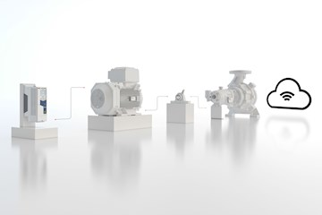
Figure 2
It was taken from [5]

Siemens VFD
Siemens is one of the world leaders in drives technology, it is improving the bar with Variable Frequency Drives that are specially engineered to meet the demands of today's HVAC systems. The increased emphasis on variable flow system energy efficiency has increased the need for simple-to-use and highly efficient variable frequency drives that minimize installation and maintenance costs while optimizing energy savings. [6]
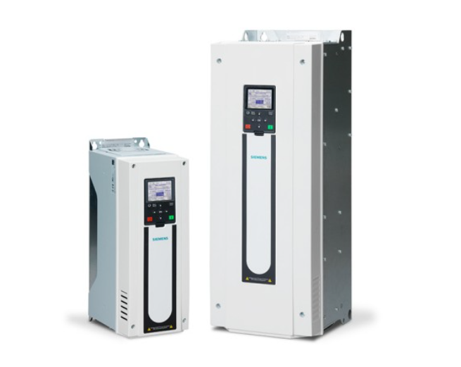
Figure 3 [7]

Allen Bradley
The 160 SSC Allen Bradley motor drives are used for 3 phase AC motors. They can be used for a wide range of application and programs. The drives have several features to guarantee high performance, such as a hinged finger guard that improves access to the line and load power terminals. They have a fault/ready panel. All the control functions of the 160 SSC Drives can be controlled from the control TB3 or the terminal block.
The drives have a fault indicator LED that illuminates whether there is a problem. There is also a "Ready" indicator LED that illuminates when the drives are ready to operate, and the DC bus is charged.
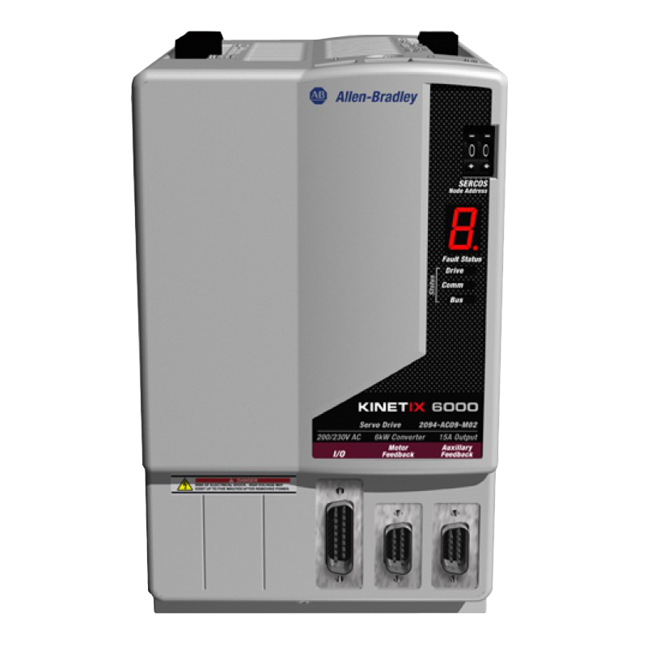
Figure 4 [8]

Danfoss
Danfoss is the world largest company for the variable speed drives for about 50 years. Their variable speed drives are VLT and VACON AC drives. [9]
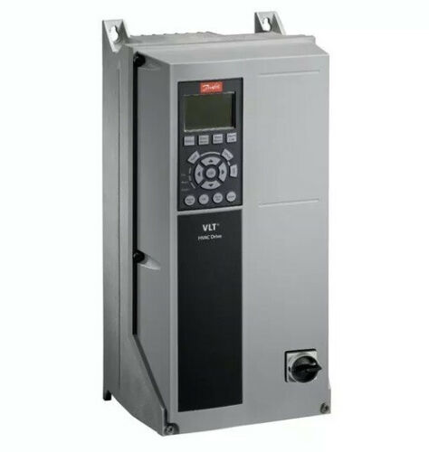
Figure 5 [10]

In this task the author required to change the motor drivers for factory, so there will be a selection of motors on specific specifications that required.

 | Motor 1 | Motor 2 | Motor 3 | Motor 4 | Motor 5
Power | 500 kW | 80 kW | 10 kW | 5 kW | 1 kW
Phases | 3 | 3 | 3 | 3 | 1
Voltage | 400 | 400 | 400 | 400 | 230
Required to be Reversible? | Yes | Yes | No | Yes | No
Variable speed required? | Yes | Yes | Yes | No | No
Quantity Installed | 5 | 10 | 23 | 17 | 127
Example Application | Rolling Mill | Gantry Crane | Conveyor | Cutting machine | Pumps / Fans
Table 3
Table 1 is giving all the specification that is needed in each motor that is going to be used.

Rolling mill motor selection
Power | 500 kW
Fase | 3
Voltage | 400
Quantity | 5
Table 4
Table 2 is the requirements.

Type | Invertek Optidrive E3 | Schneider AC Drives | ATV61QC50N4
Image | 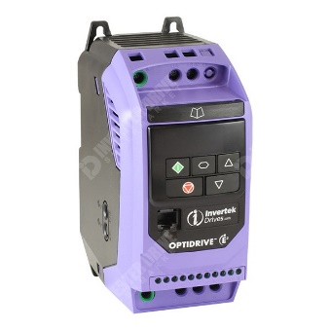 | 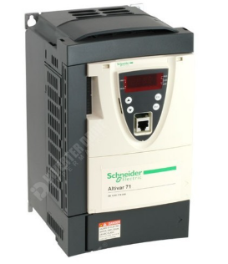 | 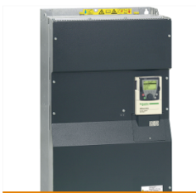
Phase | 3 phases | 3 phases | 3 phases
Input voltage | 200-240V | 380 - 480V | 380...480V
Frequency | 0-500Hz
Temperature
Power | 1.5kW | 0.5 - 500 kW | 500kW
Speed control range | 0-500Hz. |  | 50...60 Hz - 5...5 %
Current rating | 12.9A |  | 60 A for 480 V 3 phases 500 kW / 700 hp 876 A for 380 V 3 phases 500 kW / 700 hp
Dimensions | 83mm Wide x 123mm Deep x 173mm High | 180*232*170 | 1110mm*1150*337mm
Field bus communication type | RJ45 socket for Modbus RTU or CANopen communications over RS485.
IP Rating | Ip20 | IP21 | IP20
Features | -Improved automation capability for asynchronous and synchronous motors by open loop motor regulation combined with simplicity – this often occurs at low speeds, dynamic precision for start/stop applications.  -Expensive  - the communication card is easy to fit as cassette  -• Depending on the machine, this series has different mounting choices (vertical, horizontal, with the option to offset the control module when the drive is mounted on its side, side-by-side) |  | Motor phase break: motor Power removal: motor Thermal protection: motor
Price | £136.99 | £ 64.44
References | [11] | [12] | [13]
Table 5
Table 2 is a selection of motors for the roll mill. It is including 3 different motor drives which are the Invertek Optidrive E3, Schneider AC Drives and ATV61QC50N4. The ATV61QC50N is going to be chosen for the Roll Mill as a motor drive. This because it meets the requirements.

Gantry Crane
Power | 80 kW
Fase | 3
Voltage | 400
Quantity | 10
Table 6
Table 4 gives the requirements of the motor drive for the Gantry Crane.
Type | Siemens |  | Analogue DC driver
Name | G120P-90/35A | Unidrive HS30 | SL/X
Image | 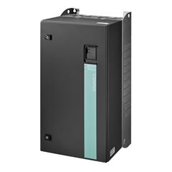 | 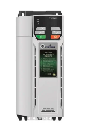 | 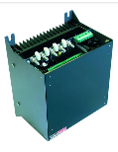
Phase | 3 phases | 3 phases | 3 phases
Input voltage | 400v |  | 240 - 480 VAC
Frequency | 47- 63Hz | 3,000 Hz | 50/60HZ
Temperature
Power | 90 kW | Min.: 250 W  Max.: 132,000 W | Max.: 145,000 W  Min.: 5,000 W
Speed control range
Current rating | 178 A |  | Max.: 330 A  Min.: 12 A
Dimensions | 410 x 915 x 416 mm
Field bus communication type | Modbus/RTU , RS485/USS , BACnet MS/TP , PROFIBUS (optional) , PROFINET (optional) , CANopen (optional)
IP Rating | IP55 | IP66
Features | Automatic restart | -Integrate directly into protection devices to meet safety requirements, increase uptime, and lower prices.  -HS30 has dual STO inputs for SIL3, PLe conformity, removing the requirement for additional safety modules.  -SI communications options allow for flexible system integration.  - easy to install and configure | - it is reliable and efficient to dc motors  -the SL/X has a built-in field weakener for extended speed range.
Price
References | [14] | [15] | [16]
Table 7
Table 5

Conveyor
Power |  | 10 kW
Fase |  | 3
Voltage |  | 400
Quantity |  | 23
Table 8
Table 6 again shows the requirements of the conveyor motor.
Type | Allen Bradley | DELTA AC drive | Danfoss
Name | 25B-D024N114 | VFD150A43A | Danfoss FC280
Image | 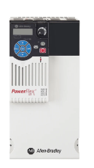 | 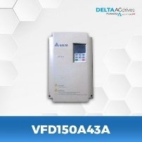 | 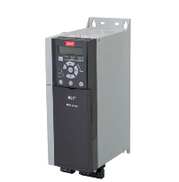
Phase | 3 phases | 3 phases | 3 phases
Input voltage | 400 V | 460V | 400V
Frequency | 500Hz | 0.1~400Hz | 0 → 500Hz
Temperature | -20 → +70°C | -25°C to +70°C; | 0 → +45 (Full Constant Output Current) °C, 0 → +55 (with Derating) °C
Power | 11kW | 15kW | 11kW
Speed control range
Current rating | 24 A | 32A | 18.4 (441 → 480 V) A, 22.1 (380 → 440 V) A
Dimensions | 260*130*212mm |  | 245*125*320mm
Field bus communication type | DeviceNet | RS-485 | Depend on the model: - Profibus  - Profinet with dual port  - Ethernet/IP with dual port  - CANopen  - Modbus RTU and FC Protocol are integrated as standard
IP Rating | IP20, IP30 |  | IP20
Features | Enhance Safety, Excellent Reliability, Flexible Control | This is the first generation of AC motors drive with great features including multi-function I/O terminal, V/f control and auto-torque/auto-slip compensation, built-in RS-485 serial interface (MODBUS) and digital keypad that can be connected to VFD with extended wire | -Easy and fast for installation  - it is flexible to meet any task  -
Price | £1,560.00 |  | £1,561.66
References | [17] | [18] | [19]
Table 9
Table 7 show different selection of motor drives for a conveyor and comparing them. Although the Danfoss FC280 is expensive, it was chosen because the specification meets all the requirements although the price is high.

Cutting machine
Power | 5 kW
Fase | 3
Voltage | 400
Quantity | 17
Table 10
Table 8 shows the requirement of the specification that is needed for controlling cutting machine motor.
Type | Allen Bradley |  | Altivar Machine
Name | PowerFlex 525 | WK600-0005-P3T | ATV320
Image | 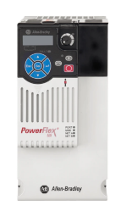 | 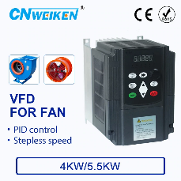 | 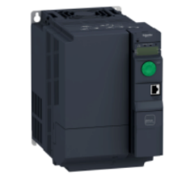
Phase | 3 phases | 3 phases | 3 phases
Input voltage | 400 V | 380V | 80...500 V (- 15...10 %)
Frequency | 500Hz | 0-500Hz | 50...60 Hz (- 5...5 %)
Temperature | -20 → +70°C | -10℃ to +50℃
Power | 5.5kW | 5.5KW/7.5HP | 5.5 kW for heavy duty
Speed control range |  | ±5% for 10 Hz above (SVC
Current rating | 13A | 13A | 20.7 A at 380 V for heavy duty 14.5 A at 500 V for heavy duty
Dimensions | 220*109*184mm | 170*126*168 | 150*232**232mm
Field bus communication type | DeviceNet
IP Rating | IP20, IP30 |  | Drive: thermal protection Drive: overcurrent between output phases and earth Drive: input phase breaks Drive: overheating protection Drive: short-circuit between motor phases
Features | Improved safety, high reliability, and control versatility
Price | £1,090.00 | ￡126.85 | £998.4
References | [20] | [21] | [22]
Table 11
Table 9 is comparing between 3 motor drives to control a cutting machine motor. The Allen Bradely PowerFlex 525 is hosen and that because the author found most the requirements needed. Also, because it is reliable, and it is safe.

Pumps / Fans motor selection
The motor will be using for Pump/ fan. the requirements are:
Power | 1 kW
Fase | 1
Voltage | 230
Quantity | 127

Type | Allen Bradley PowerFlex 523 Inverter Drive | Allen Bradley PowerFlex 4M Inverter Drive | Invertek Optidrive
Image | 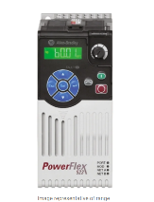 | 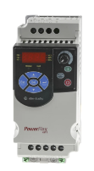 | 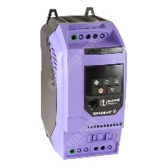
Phase | Single phase | Single phase | Single phase
Input voltage | 230 V ac | 230 V ac | 200-240V
Frequency |  | 400Hz | 50-60Hz
Temperature | -20 → +50°C | -10 → +50°C
Power | 0.4 kW | 0.75kW | 1.1kW
Current rating | 2.5 A | 4.2 A | Input: 14A  Output: 10.5
Dimensions | 72mm* 152mm* 172mm (W*L*D) | 72mm*172*136mm | 110mm Wide x 150mm Deep x 221mm High
Field bus communication type | RS485 | ModBus
IP Rating | IP20 | IP20 | IP20
Price | £215.00 | £203.00 | £237.93
References | [23] | [24] | [25]
Table 12
In the table there are 3 motor selections, which are the Allen Bradley Powerflex 523 Inverter Drive, Allen Bradley Powerflex 4M Inverter Drive and Invertek Optidrive. The invertek optidrive was chosen because the pump/ fan motor for the factory is requiring a 1kW and 230v, whereas the other 2 motors does not match the enquires.

Task 2

Diode rectifier
A semiconductor device that allows the current to flow in one direction. The diode needs a small voltage to operate it and it is depending on the type of the diode. For example, the turn-on voltage of a conventional silicon diode rectifier is about 0.6 volts. The turn on voltage of germanium diodes is around 0.2-0.3V, and the turn on voltage of silicon Schottky diodes is also around 0.2-0.3V.
The power diode and Schottky diode are best use for the power reflection application. Also, the small point contact diode, signal diode and Schottky diode can be used for the signal reflection. The advantage of the Schottky diode is that only requires a forward voltage of around 0.2 - 0.3volts for forward conduction which is useful when detecting small radio signal and for the power rectifier it reduces the power losses. [26]
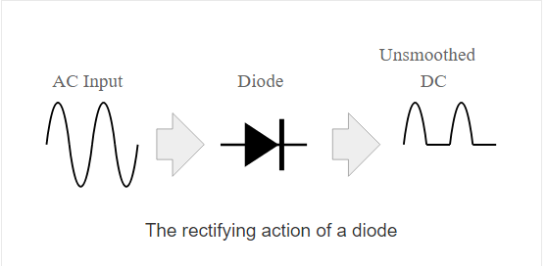
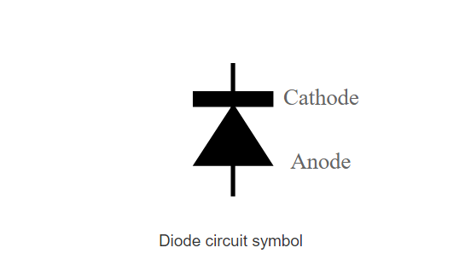
Figure 6
Figure 7
The are

There are a variety of diode rectifier circuit configurations that can be used. All various configurations each have their own set of benefits and disadvantages, making them suitable for a variety of applications which they are:

Half wave rectifier circuit:
This is the simplest form of using diode. When using one diode usually half of the cycle blocks and it will allow throughout the other half. The half wave rectifier circuit is used for detecting signal and level detection applications. [26]
Advantages | Disadvantages
Simple | The time between consecutive peaks of the rectified signal is higher.
 | Less effective
 | Difficult to achieve high levels ripple rejection.
Table 13

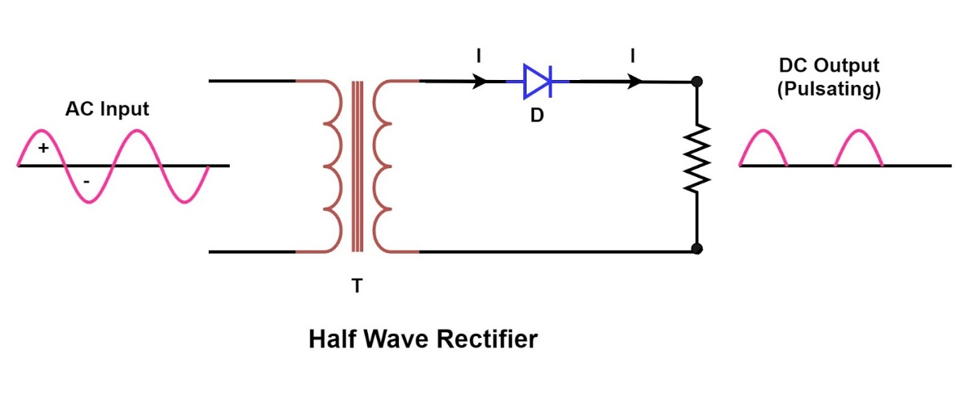
Figure 8
The figure 5 is taken from [27]

Full wave rectifier circuit:
Both halves of the waveform are used in this kind of rectifier circuit. This improves the efficiency of this type of rectifier, and since conduction occurs on both halves of the cycle, it becomes much smoother and more efficient. There are 2 types of full wave rectifier and they are:

- Two diode centre taped transformer full wave rectifier
- Bridge full rectifier circuit
[26]

Synchronous rectifier circuit
Instead of diodes, active components are used in synchronous or active rectifiers to provide switching. This eliminates diode errors and boosts performance levels greatly. [26]

Thyristor rectifier
A semiconductor and It consists of four layers of silicon in a P-N-P-N structure. It also known PN PN Devices. It has 3 terminals which are: Anode, Cathode, and gate. Also, it can be used for a wide range of application especially those who have a high voltage and current. [28] [29]

Advantages
Easy to use
Cheap to buy
It is able to handle the voltage and currents required for high power applications

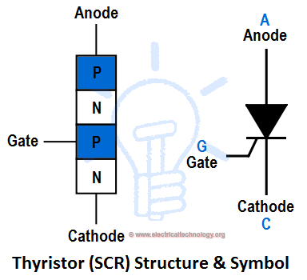
Figure 9 [30]

IGBTs rectification

The IGBT is a hybrid of bipolar and MOS technology. The best characteristics of bipolar transistors are combined with the voltage-controlled properties of MOSFETs. It can be used in wide range of applications in power electronics. It has three terminals and used to add voltage to a semiconductor. When it is in the off state it changes its properties to stop power flow and versa.
They are powered by a metal oxide semiconductor gate structure and are commonly used in applications such as welding, electric vehicles, air conditioners, trains, and uninterruptible power supplies. [31] [32]

Advantages
High efficiency
The frequency range extends far beyond 100 kHz.
Compact equipment design
Low switching losses

Harmonics
They are the changes in voltage and frequency waveforms. The harmonics caused by the nonlinear devices in the power system. The nonlinear device is where the current does not proportion to the applied voltage. Also, the harmonics attend to appear in some degree to all power systems. The harmonics generate additional radial flux elements, which result in additional harmonic heating Losses. The negative effects of harmonics are:

Harmonic heating
The frequencies of the harmonics current which multiples of fundamental frequency results a more losses. The conductor resistance will be increased with the frequency, this means additional losses. The effect known as skin effect.
The heating losses in the power cable, input transformer and all the components flow through, are caused by the network harmonics. The resistive heating of the core layer is caused by eddy currents circulating in ferromagnetic materials. [33]

Audible noise
The harmonics can cause increase in the noise level. That is why if the transformer is located in a resident area, the low noise level is required because the ear of the human is sensitive to a certain frequency, especially in range of 1-2 KHz.

Vibration / forces
It can also cause a vibration with noise. Vibration is primarily a motor-related problem (torque pulsations). It can also be observed on the grid line, but it normally has little noticeable effect other than potentially annoying noise.

Distortion of grid voltage
The harmonics generated by nonlinear devices cause voltage distortion on the grid. Poor networks (those with a low short circuit capacity) have higher voltage leakage. This maxim does not have wider validity, but it is true in most cases.

Resonance effects
In a resonance state, the system oscillates with greater magnitude than at other frequencies. The grid resonance is not risky until it is excited by a harmonic source where one of the harmonics coincides with the resonance (the frequency of harmonic component matches the resonance frequency of the grid). In such a case, higher harmonic distortion is to be expected.
The resonance effect depends on harmonics components magnitude and inherent system damping. Whenever the damping is low, the resonance condition is more dangerous.
[33]

That is why the harmonics unwanted in the electrical power field.

Harmonics sound level

When a transformer is turned on, it emits a certain amount of noise. The origin is a magnetic circuit, and it is referred to as characteristic humming. The effect of harmonics on noise must be studied in projects that use VFD transformers. It must distinguish between current and voltage harmonics. [34]

Reducing the harmonics

There are 3 ways to control the harmonics, they are:
- To reduce the harmonic current produced from the load.
- Filtering
- Modify the frequency response of the system by filters, inductors, or capacitors.

Reducing the loads current

Whilst an overexcited transformer can be restored to normal operation by reducing the applied voltage to the proper range, arcing devices and most electronic power converters are locked into their engineered characteristics.

One example is PWM drives, which charge the dc bus capacitor directly from the line without any deliberate impedance. Adding a line reactor or transformer in series reduces harmonics while still providing transient safety.

Also, to reduce the harmonics current in 3 phase system, the transformer connection can be used.

Filtering
There are different types of filters that used to protect the electrical equipment from destroyed power outputs caused by harmonics. The main types of the filtering are:
- Passive Harmonics filters
- Active Harmonics filters

Passive Harmonics filters
There are four types of the passive filters and they are:
- The high pass filter
- The bandpass filter
- The C type filter
- The series filter

High pass filter
Which is used to get rid off the high order harmonics and have flexible power over a large frequency spectrum. For the design three passive components is used which are:
- Resistor
- Capacitor
- Inductor
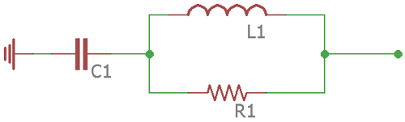
Figure 10 [35]

The bandpass filter
It is double tuned filter. It consists of 2 capacitor, 2 inductors and one resistor. This filter operates by integrating the parallel resonance of a regular bandpass filter with the series resonance of an inductor and a capacitor. [35]
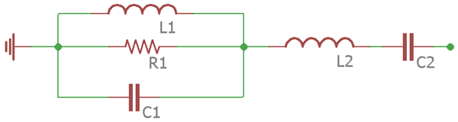
Figure 11 [35]

C type filter
This type is used for the low order of harmonics filtering. It has a less loss than the bandpass and the series filter.
It consists of 4 passive components and they are 2 capacitors, inductor and one resistor. [35]

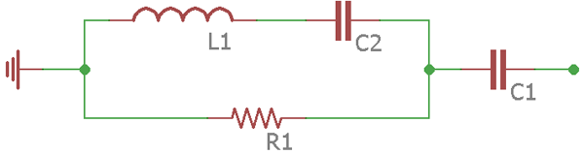
Figure 12 [35]

Series filter
This filter's construction is the most basic. In order, only three passive components – a single capacitor, inductor, and resistor – are included. This filter removes a single frequency.

Figure 13 [35]

Active harmonics filter
The active harmonics filter is easier to manage the power line harmonics with no need for the reactive power fundamental frequency dependencies.
The method of the Active harmonic filters is to use self-produced harmonic components and insert them into the power line, cancelling out the unwanted harmonics. Also, the active filter uses a semiconductor switch that needs power to operate.
There are various types of active filters available, each of which employs a different topology to remove harmonics in the power line. [35]

Modifying the frequency response by filtering, use inductors or capacitors

- Install a shunt filter. This not only removes a problematic harmonic current from the system, but it also totally alters the system response, usually (but not always) for the better.
- Adding a reactor to tune up the system. The bad resonances usually take please between the shunt power factor correction capacitors and the system inductance. The reactor should add between the capacitor and the supply system source. One approach is to directly connect a reactor to the capacitor in series to shift the circuit resonance without actually tuning the capacitor to create a filter. Another option is to have reactance in the sequence.
- Change the capacitor, this option the is cheapest.
- The capacitor can be to a location on the system with a different short-circuit impedance or higher losses. For industrial users, this is often not an alternative since the capacitor cannot be shifted far enough to create a difference.
- Simply remove the capacitor and accept the increased losses, reduced voltage, and power factor penalty. If theoretically possible, this is often the best economic option. [36]

The new technique of the VFD with harmonics reduction have designed to limit the overload capacities, the ability to run the motor above base speed is reduced, and a new method of minimizing input line harmonic currents without the inclusion of additional components is provided. [37]

6 pulse rectifier
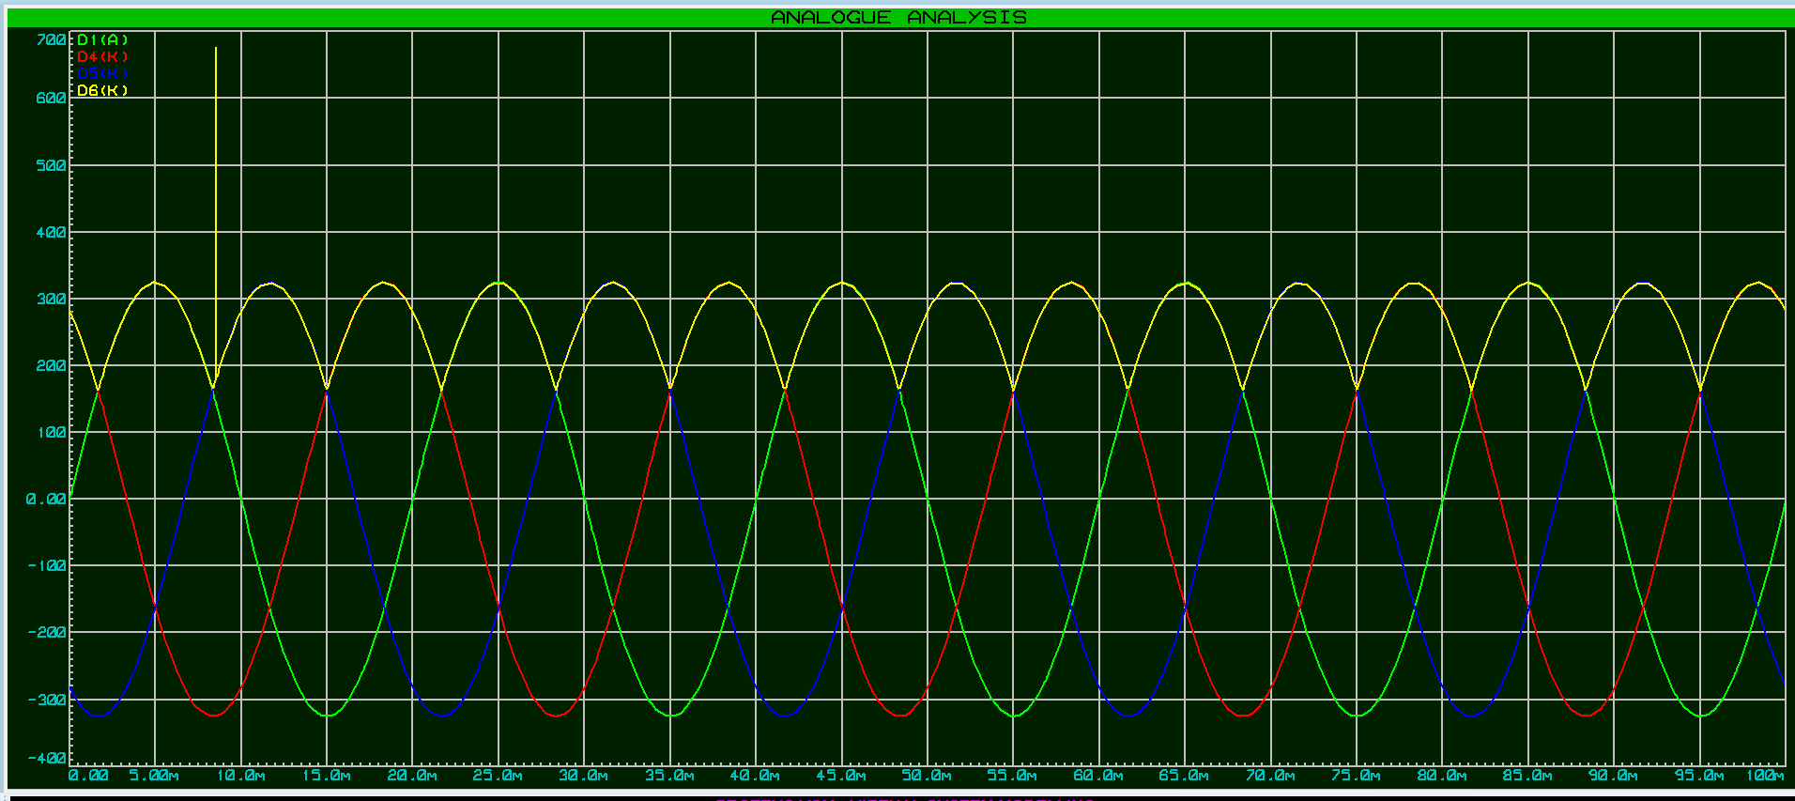
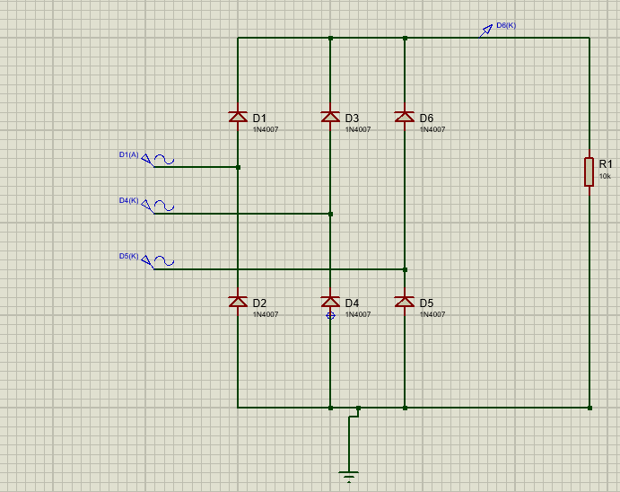
Figure 14
Figure 15
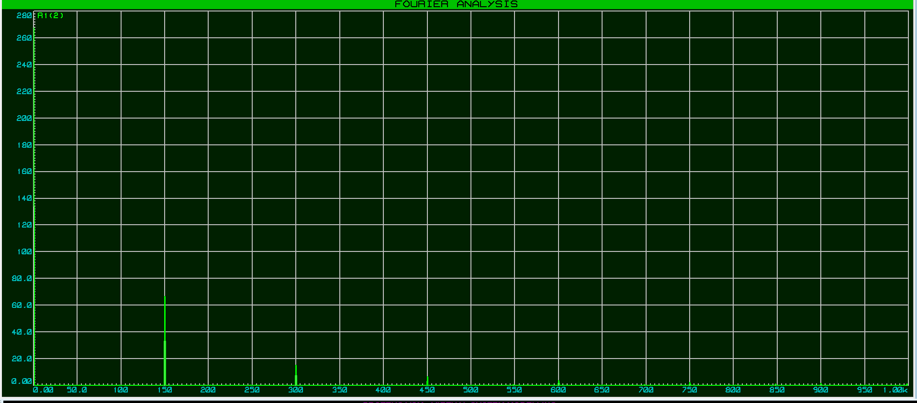
Figure 16
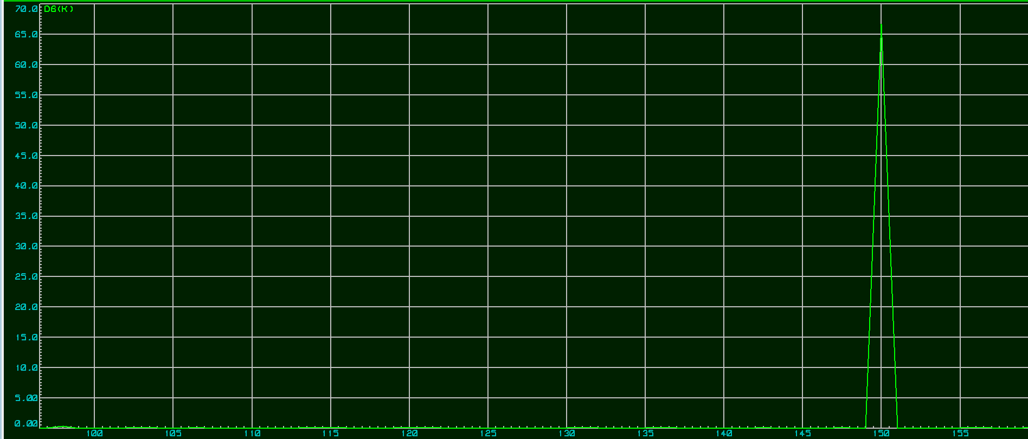
The figures above showing the 6-pulse diode rectifier that was designed using proteus.

6 pulse rectifier with capacitor

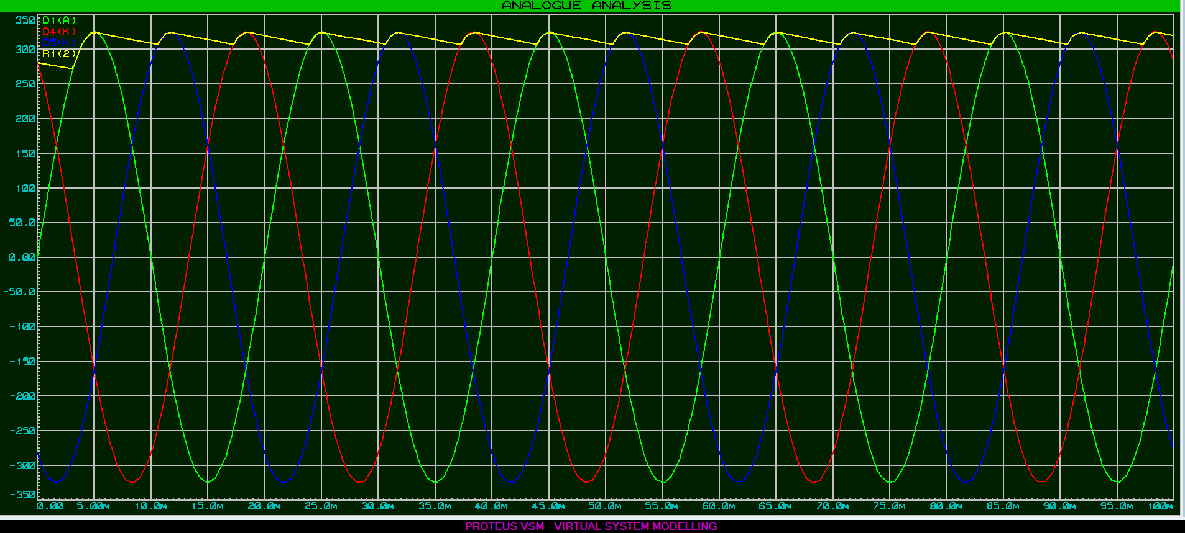
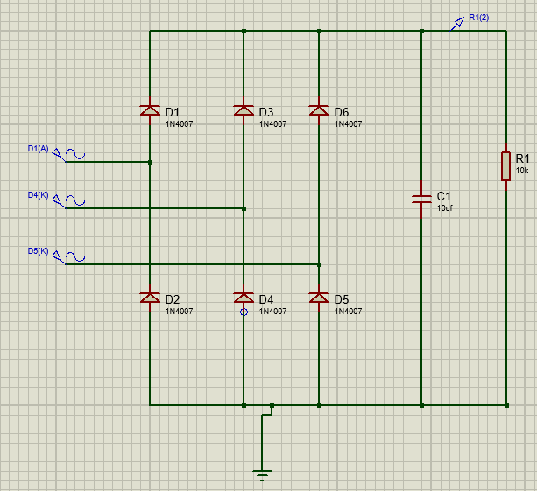
Figure 17
Figure 18

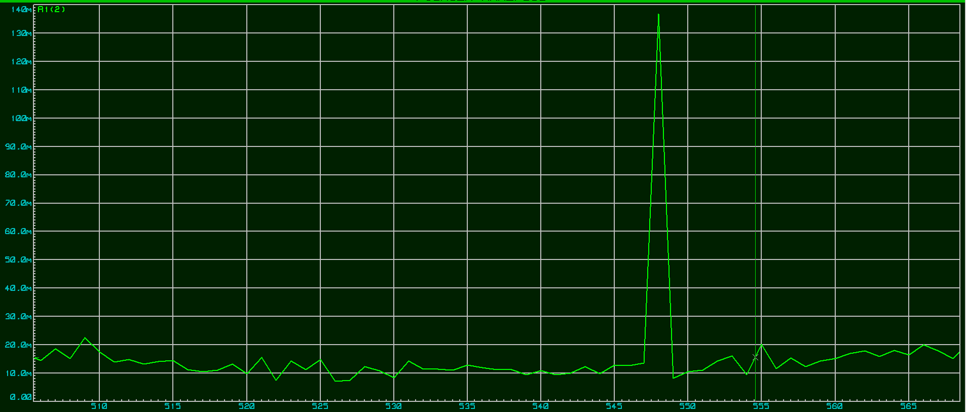
Figure 19
As shown in figure 10 the capacitor is added for modifying the frequency response. Whenever the capacitor value increases the less harmonics occurs and the line (ripple) gets more straight as shown in figures below (20- 22)

6 pulse rectifier with different capacitor value

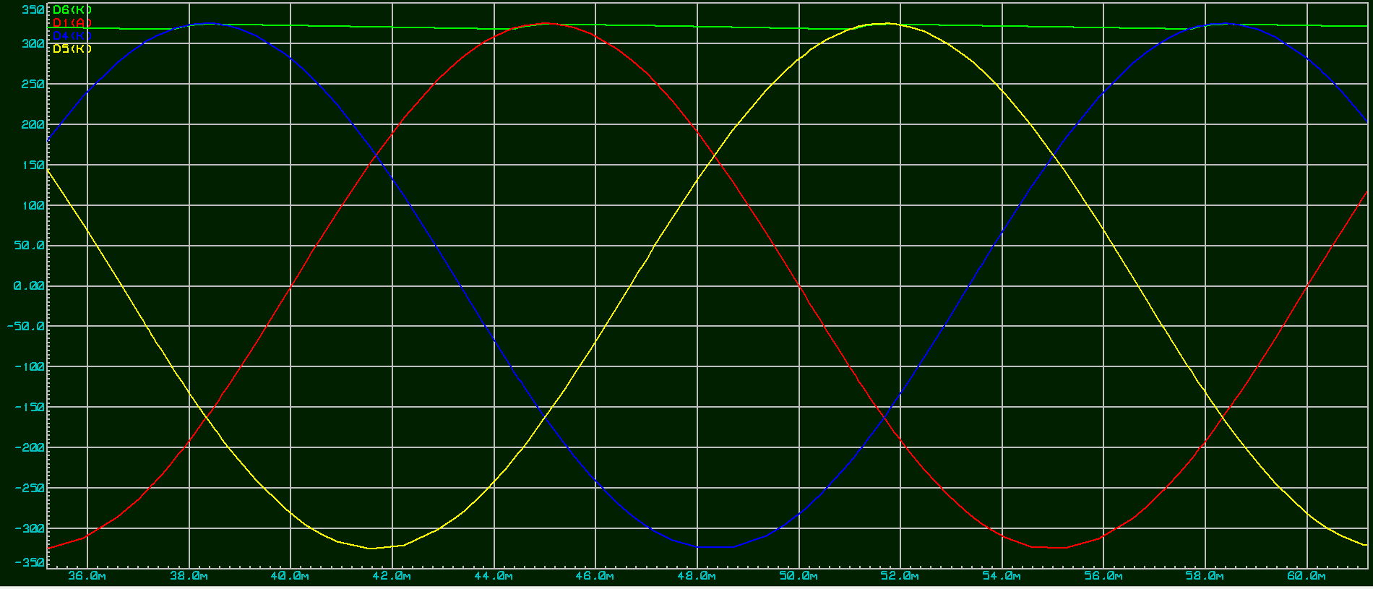
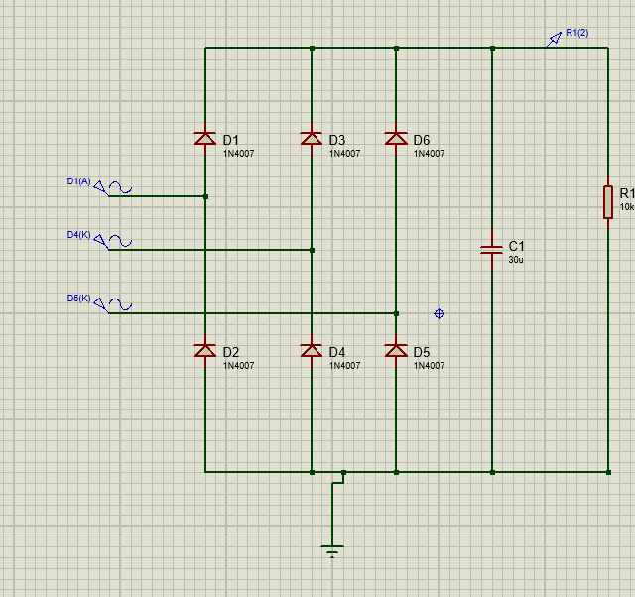
Figure 20
Figure 21

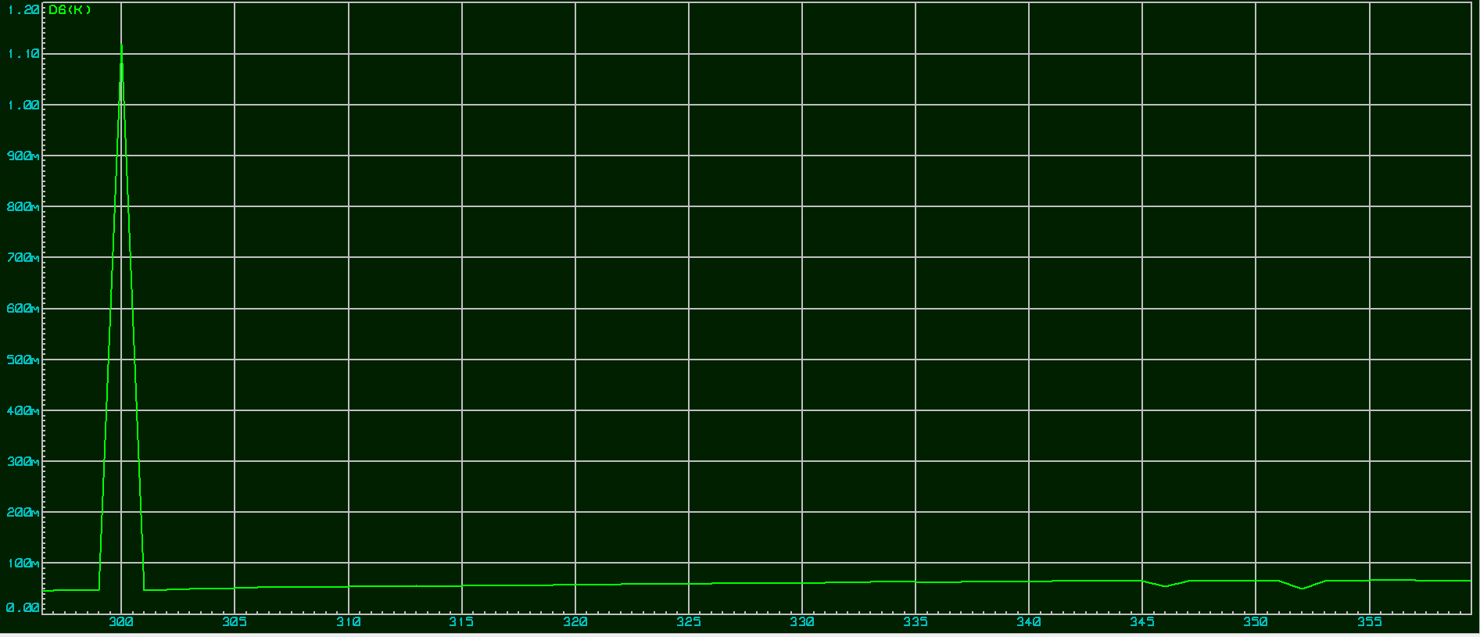
Figure 22
There is a difference that is noticed from changing the capacitor values is that the capacitor voltage get straight and the ripples reduce.

12 pulse rectifier

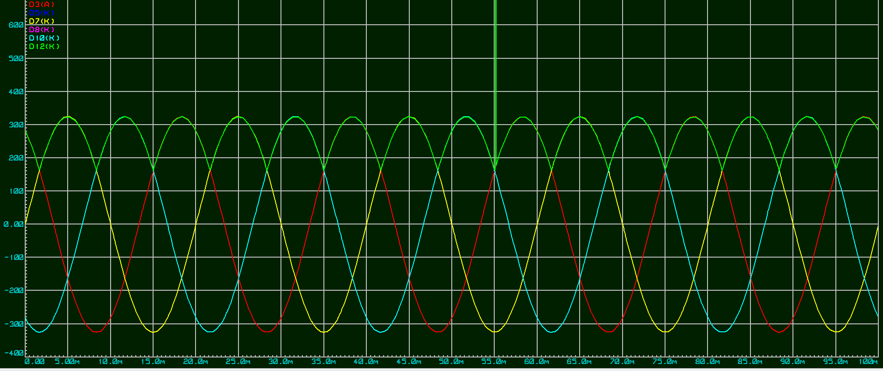
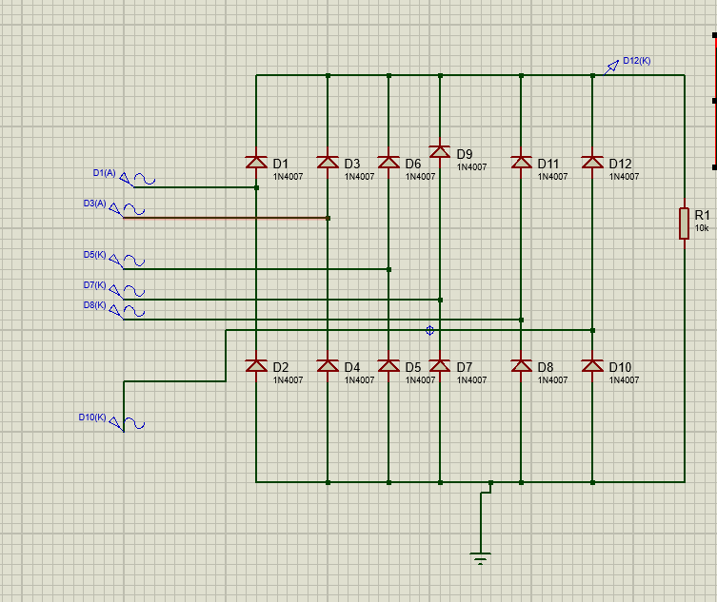
Figure 23
Figure 24
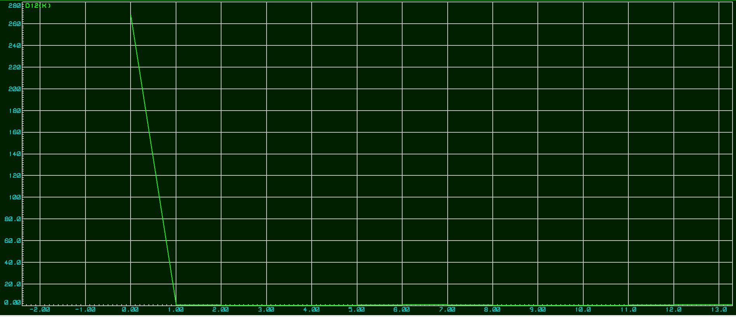
Figure 25
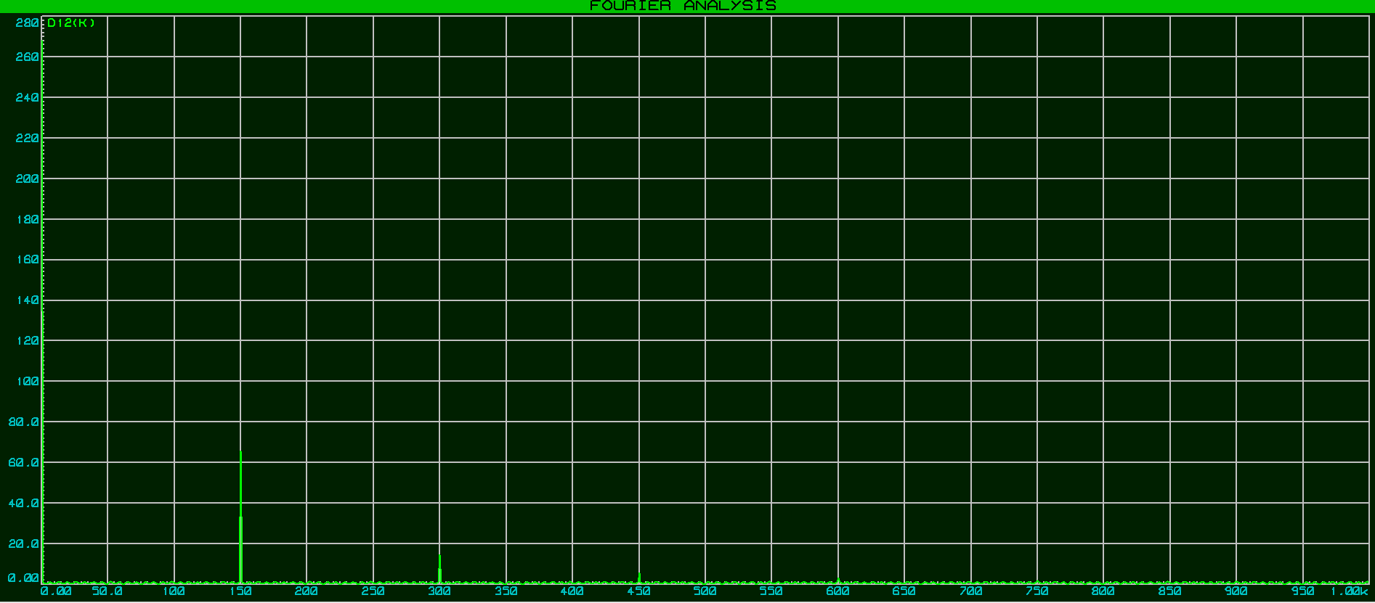
Figure 26

The figure above is showing the 12-pulse rectifier and they specify as very high-power rectifiers. They much better than the single- phase rectifier and the three- phase half wave rectifiers. It consisting from two six pulse circuit connecting in parallel.

12 pulse rectifier with capacitor

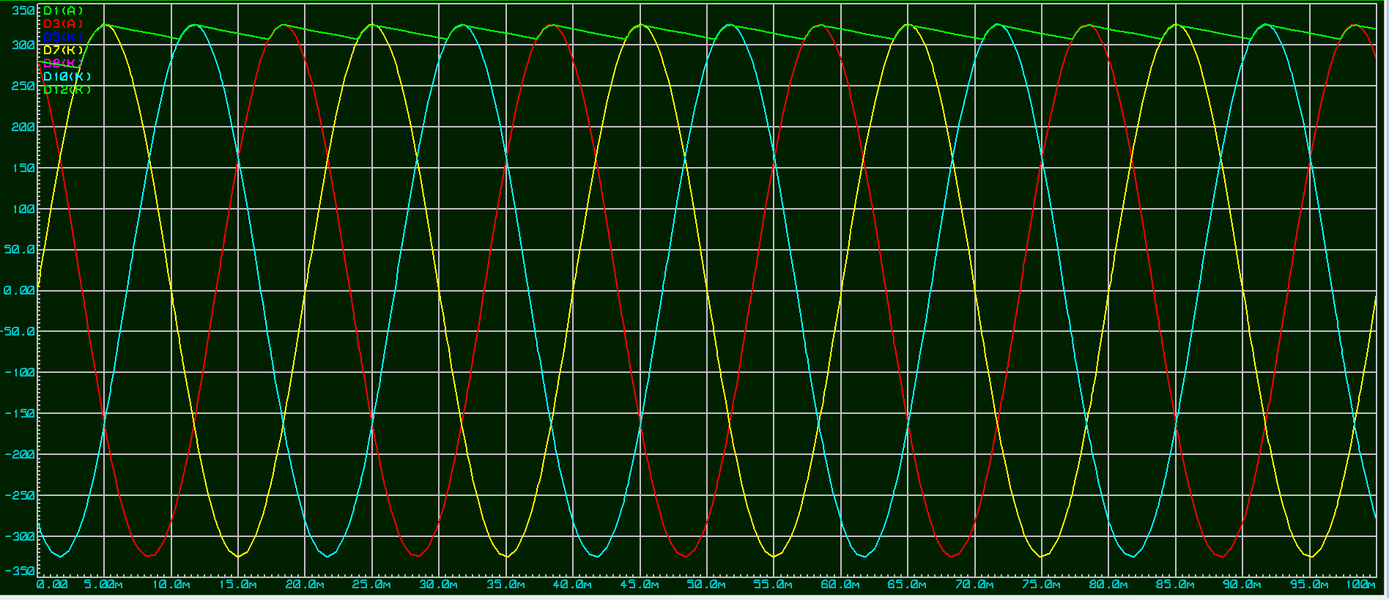
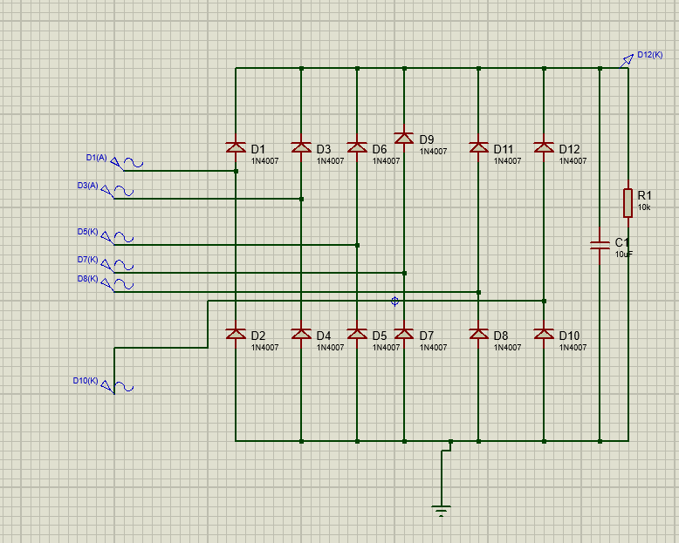
Figure 27
Figure 28
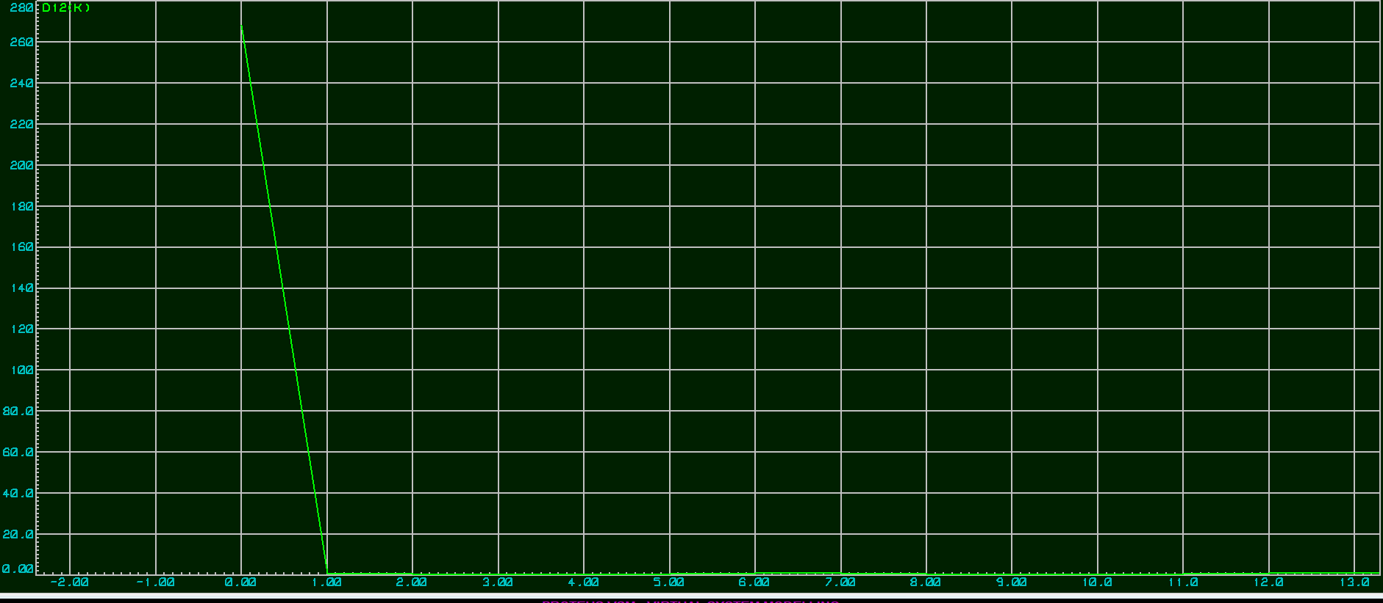
Figure 29
Same thing here by adding the capacitor the frequency response will be modified and ripples will be reduced.

Conclusion
This report is including 2 task that was required to solve. I would like to say that I enjoyed doing this assignment and it has added to my knowledge a lot.
In the first task, I was required to refit motor drives system for 5 five motors in a factory. Therefore, research was done for what is the variable speed drive and different motor drives manufacturers. Also, there is a three selection of motor drives for each motor and one of them will be choosing that meets the requirements.
Task 2 there is the differences between the diode, thyristor and the IGBTs rectifiers by explaining each of them. Furthermore, the affect f harmonics on power and power factor. In addition, how the harmonic noise can be reduce including in the report.

References

[1] | Chary Publications Pvt, 2021. [Online]. Available: https://www.electricalindia.in/power-electronics-in-smart-grid/. [Accessed 30 03 2021].
[2] | Quantum Controls Ltd., 2008- 2021. [Online]. Available: https://www.quantum-controls.co.uk/insights/faqs/what-are-the-differences-between-a-variable-frequency-drive-vfd-and-a-variable-speed-drive-vsd/. [Accessed 26 04 2021].
[3] | “www.ecstuff4u.com,” 2017-2018. [Online]. Available: https://www.ecstuff4u.com/2019/11/advantage-disadvantage-vfd.html. [Accessed 31 03 2021].
[4] | “ecstuff4u.com,” 2017- 2020. [Online]. Available: https://www.ecstuff4u.com/2019/11/advantage-disadvantage-soft-starter.html. [Accessed 31 03 2021].
[5] | “ABB,” [Online]. Available: https://library.e.abb.com/public/74cd9f5b736b7955c1257b130056f3ca/COG%20ATEX%20Drives%20and%20motors%200000037223%20Rev%20A_8.9_lowres.pdf. [Accessed 31 03 2021].
[6] | siemens , 2021. [Online]. Available: https://new.siemens.com/us/en/products/buildingtechnologies/hvac/variable-frequency-drives.html. [Accessed 255 04 2021].
[7] | siemens , 2021. [Online]. Available: https://new.siemens.com/us/en/products/buildingtechnologies/hvac/variable-frequency-drives/bt300-vfd.html. [Accessed 25 04 2021].
[8] | American PLC Store., 2010. [Online]. Available: https://www.americanplc.com/allen-bradley-2094-bc07-m05-m-a-kinetix-6000.html. [Accessed 25 04 2021].
[9] | [Online]. Available: https://www.danfoss.com/en/about-danfoss/our-businesses/drives/#:~:text=For%2050%20years%2C%20Danfoss%20Drives%20has%20been%20a,and%20experience%20within%20a%20wide%20range%20of%20industries.. [Accessed 04 2021].
[10] | ebay , 1995-2021. [Online]. Available: https://www.ebay.co.uk/itm/312952468192?chn=ps&norover=1&mkevt=1&mkrid=710-153316-527457-8&mkcid=2&itemid=312952468192&targetid=4584688615459475&device=c&mktype=&googleloc=&poi=&campaignid=398826061&mkgroupid=1297423980380978&rlsatarget=pla-45846886154594. [Accessed 25 04 2021].
[11] | Inverter Drive Supermarket, 2021. [Online]. Available: https://inverterdrive.com/group/AC-Inverter-Drives-230V/Invertek-Optidrive-E3-1-5W-1ph-3ph-IP20/. [Accessed 30 03 2021].
[12] | IndiaMART InterMESH ltd, 1996- 2021. [Online]. Available: https://www.indiamart.com/proddetail/three-phase-schneider-ac-drives-17655250833.html. [Accessed 30 03 2021].
[13] | Schneider Electric, 2021. [Online]. Available: https://www.se.com/uk/en/product/ATV61QC50N4/variable-speed-drive-atv61q---500kw---700hp---380...480v---ip20/. [Accessed 30 03 2021].
[14] | Siemens, 1996-2021. [Online]. Available: https://new.siemens.com/global/en/products/buildings/hvac/variable-speed-drives/g120p-bundle.html. [Accessed 30 03 2021].
[15] | “directindustry,” 2021. [Online]. Available: https://www.directindustry.com/prod/control-techniques/product-7177-1776439.html. [Accessed 30 03 2021].
[16] | directindustry., 2021. [Online]. Available: https://www.directindustry.com/prod/sprint-electric/product-15757-481307.html. [Accessed 30 03 2021].
[17] | “Allen bradely,” RS Component LTD , [Online]. Available: https://uk.rs-online.com/web/p/inverter-drives/8904339/. [Accessed 31 03 2021].
[18] | “deltaacdrives,” DELTA AC drives , 2021. [Online]. Available: https://deltaacdrives.com/delta-vfd150a43a/. [Accessed 31 03 2021].
[19] | RS COMPONENT LTD , 2021. [Online]. Available: https://uk.rs-online.com/web/p/inverter-drives/1250761/?cm_mmc=UK-PLA-DS3A-_-google-_-CSS_UK_EN_Automation_%26_Control_Gear_Whoop-_-Inverter+Drives_Whoop+(2)-_-1250761&matchtype=&aud-821594433763:pla-300344719413&gclid=EAIaIQobChMIx5GG-8Ha7wIVDc13Ch0WGgxq. [Accessed 31 03 2021].
[20] | RS COMPONENTS LTD , 2021. [Online]. Available: https://uk.rs-online.com/web/p/inverter-drives/8904332/. [Accessed 31 03 2021].
[21] | Aliexpress, 2010-2021. [Online]. Available: https://www.aliexpress.com/item/4000206442586.html. [Accessed 31 03 2021].
[22] | Premier Farnell Limited, 2021. [Online]. Available: https://uk.farnell.com/schneider-electric/atv320u55n4b/variable-speed-drive-3-ph-5-5kw/dp/2835229. [Accessed 31 03 2021].
[23] | RS Components LTD , [Online]. Available: https://uk.rs-online.com/web/p/inverter-drives/7934509/?cm_mmc=UK-PLA-DS3A-_-google-_-PLA_UK_EN_Automation_%26_Control_Gear_Whoop-_-Inverter+Drives_Whoop+(2)-_-7934509&matchtype=&aud-813230962291:pla-529873680712&gclid=EAIaIQobChMIrcuXxYrY7wIVPBoGAB1WPAmh. [Accessed 30 03 2021].
[24] | RS Components Ltd, 2021. [Online]. Available: https://uk.rs-online.com/web/p/inverter-drives/0447490/. [Accessed 30 03 2021].
[25] | Inverter Drive Supermarket , 2021. [Online]. Available: https://inverterdrive.com/group/AC-Inverter-Drives-230V/Invertek-ODE-3-220105-1F42-01/. [Accessed 30 03 2021].
[26] | 2021. [Online]. Available: https://www.electronics-notes.com/articles/analogue_circuits/diode-rectifiers/circuits-basics-primer.php. [Accessed 19 04 2021].
[27] | Electronics volt , 2021. [Online]. Available: https://sdvelectrical.blogspot.com/2020/05/single-phase-half-wave-rectifier-circuit-diagram-theory-and-application.html. [Accessed 19 04 2021].
[28] | 2021. [Online]. Available: https://www.electronics-notes.com/articles/electronic_components/scr/what-is-a-thyristor.php#:~:text=The%20thyristor%20or%20silicon%20controlled%20rectifier%2C%20SCR%20is,main%20current%20flows%20between%20the%20anode%20and%20cathode.. [Accessed 26 04 2021].
[29] | “engineeringe notes,” 2021. [Online]. Available: https://www.engineeringenotes.com/electrical-engineering/electric-motors/thyristor-control-of-electric-motors-electrical-engineering/36898. [Accessed 26 04 2021].
[30] | Electrical technology, 2021. [Online]. Available: https://www.electricaltechnology.org/2015/06/thyristor-silicon-controlled-rectifier-scr.html. [Accessed 04 2021].
[31] | 2021. [Online]. Available: https://www.ixyspower.com/images/literature/igbt_rectifiermodules.pdf. [Accessed 26 04 2021].
[32] | RS components LTD , 2021. [Online]. Available: https://uk.rs-online.com/web/c/semiconductors/discrete-semiconductors/igbts/?searchTerm=IGBTs. [Accessed 26 04 2021].
[33] | mb drive services, 2021. [Online]. Available: https://mb-drive-services.com/net_harm-introduction/. [Accessed 28 04 2021].
[34] | 2021. [Online]. Available: https://mb-drive-services.com/vfd-transformers-harmonics/. [Accessed 28 04 2021].
[35] | Circuit Digest., 2020. [Online]. Available: https://circuitdigest.com/tutorial/harmonic-filter-circuit-how-to-remove-harmonics-using-active-and-passive-harmonic-filters#:~:text=The%20main%20difference%20between%20these%20two%20types%20of,types%20of%20BJTs%2C%20IGBTs%2C%20MOSFETs%20and%20integrated%. [Accessed 30 04 2021].
[36] | EEP, 2021. [Online]. Available: https://electrical-engineering-portal.com/principles-for-controlling-harmonics. [Accessed 28 04 2021].
[37] | 3010 Highland Parkway Suite 325 , 2021. [Online]. Available: https://www.plantengineering.com/articles/reducing-harmonics-from-variable-frequency-hvac-drives/#:~:text=Reducing%20harmonic%20noise%20Recent%20advances%20in%20VFDs%20with,harmonic%20currents%20without%20the%20addition%20of%20extra%20components.. [Accessed 28 04 2021].

