Introducing the Modern Workplace

Structure & Culture- Assessment 1

STUDENT NAME: GEORGIANA ELENA PADURE
STUDENT NUMBER: 1813446
MODULE NAME: INTRODUCING THE MODERN WORKPLACE
LECTURER: HUSAM HELMI

Table of Contents
Introduction 3
Kellogg’s 3
Structure 4
Culture 6
Hofstede’s Cultural Dimensions 6
Power Distance 6
Individualism 7
Masculinity 7
Uncertainty Avoidance 7
Long Term Orientation 8
Indulgence 8
People 8
Performance 9
Recommendations 10
Conclusion 10
References 11

Introduction
Structure and culture are two important matters for any organisation to run operation in any country. An organizational structure refers how the activities of the organisation are directed from whom to whom and who reports to whom in order to achieve organizational objectives. There are many organizational structures can be seen to be used in different types of organisation. Functional organizational structure, matrix organizational structure, project structure etc. are few of the structures (Keith & Jones,2016). Organisational culture indicates underlying values, beliefs, assumptions, way of interacting among peers, way of treating employees that form the psychological environment of an organisation. Positiveness in the culture of an organisation is very necessary. It takes time to develop a good culture in an organisation. It is harder to change an existing culture of an organisation. Positive culture directs employees of an organisation to achieve the common goals of them of their organisation. In this write up, different types of organizational structure, organizational structure related to Kellogg’s and culture will be discussed on Kellogg’s. Hofstede’s cultural dimensions will be applied on the United Kingdom (UK). Before that a brief discussion about Kellogg’s will be done. Different theories like motivational theories will be applied on the Kellogg’s. Then a brief discussion regarding the management of performance will be done followed by few recommendations.

Kellogg’s
The company has been founded 113 years ago in 1906 by Will Keith Kellogg (Kellogg’s, 2019). The headquarter of it situated in Michigan of USA. The mission of the company is to share nutrition (Kellogg’s, 2019). It is operating business in food processing industry. Cereals, cookies, crackers, toaster pastries, cereal bars, fruit-flavored snacks, frozen waffles, vegetarian foods etc. are produced by the company. It has production unit in 18 countries and it is selling its product in 180 countries (Kellogg Company, 2019). Special K, Mini Wheats, Strawberry Krispies, Honey Nut Frosted Flakes and Pop Tarts, Eggo, Krave are its brands (Kellogg’s, 2019). The European head office of it is situated in Trafford, Great Manchester, UK. The largest factory of Kellogg’s is at the very same place. The American based multinational food processing company has around 32000 employees working for it in 180 countries to run its operations. In 2017, its total revenue was 12.92 billion dollars (Fortune, 2018). The operating income and net income of the company in the very same year were 1.94 and 1.26 billion dollars respectively (Fortune, 2018). It has subsidiary like Kashi, Keebler Company, Bear Naked Inc., and Rxbar. Steven Cahillane is the current Chairman and CEO of the Kellogg’s.

Structure
There are different types of business structures which we can notice in the business world. Sole proprietorship, partnership, public limited company and private limited company etc. are few popular business structures. In sole proprietorship, there is only one person who own the business and enjoy the profits of his or her business. He or she bears the liabilities solely. The owner may have few employees to help him or her in the business. (Keith & Jones,2016)
If several people come up and join together for business then that business will be called as a partnership business. There are legal bindings of number of members one partnership business can have. For general partnership business at least 2 and at most 20 members will be needed and allowed. For banking partnership business, the number of members’ limitation is 2 to 10.
The company business is two types. One is public limited company and the other one is private limited company. A public limited company should have at least 7 members and the highest number of members will be defined by the number of shares permitted. Such company can sell share among the general people for collecting capitals. On the other hand, a private limited company should have at least 2 members and at most 50 members. It can’t sell its shares to the general people but to its members only. Kellogg’s is operating as a public limited company which sells share to the general people and give them the portions of profits.
There are few types of organizational structure. Functional organizational structure, matrix organizational structure, project structure etc. are few organizational structures. Under functional organizational structure, an organisation has different departments like production department, marketing department, accounting department, human resource department etc. individual employees need to report to their superior boss. In matrix organizational structure, there are two bosses of an employee to report. One needs to report to his or her project manager and functional head simultaneously. Kellogg’s follow functional organizational structure to run business.
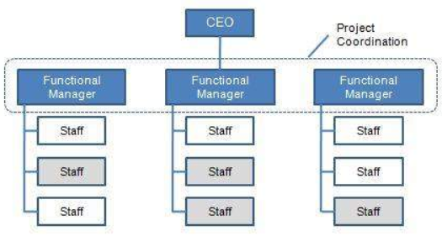
Figure: Functional Organisational Structure (Keith & Jones,2016)
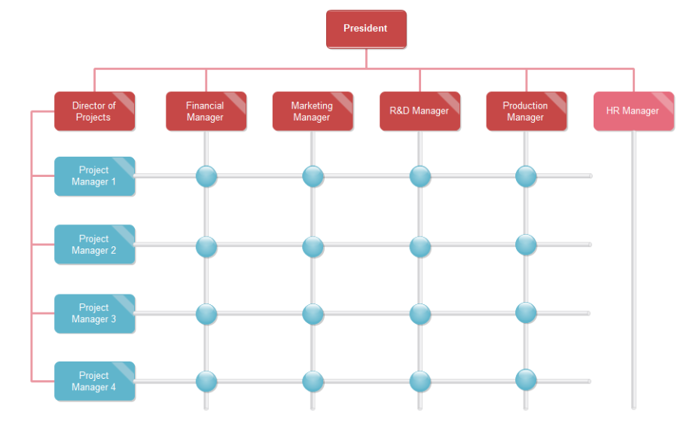
Figure: Matrix Organisational Structure (Keith & Jones,2016)

Culture
Organisational culture indicates underlying values, beliefs, assumptions, way of interacting among peers, way of treating employees that form the psychological environment of an organisation. Culture in organisations can be off two types. These are formal culture and informal culture. Formal culture refers the culture which is planned purposefully (Devid, 2008). As for example, the hierarchical structure of a company is the formal culture of it. Informal culture refers the interactions and connections among the humans of a company. Kellogg’s has both types of culture in its workplaces. There are hierarchical order and employees also interact among themselves apart from the organizational functions related works.
Employees of Kellogg’s are motivated by the company by appreciating their work, supporting them to come over their problems at work places, awarding monetary rewards etc. These motivates the employees of Kellogg’s to give their best output for the company. As a result, the company get better result. The Kellogg’s pay standard compensation to its workforce. This is very much needed to retain employees for long time. The Research & Development department of Kellogg’s is working relentlessly to innovate new products that can meet the demands better than the existing products meet and also brings profit. People from different country, different religion, male and female work in Kellogg’s. It has a diverse workforce. The leadership of this company is very fruitful as situational leadership theory has been followed in the company.

Hofstede’s Cultural Dimensions
Geert Hofstede developed this framework for cross-cultural communication. There are six dimensions of this model. These are applied on the UK and described below.

Power Distance
Power distance index refers the extent to which the less powerful employees or members of an institution or a family accept that power is equally distributed (Butler, Michael & Rose, 2011). A higher degree indicates that the upper section employees of a hierarchy holds more power than the lower section people of a hierarchy. In power distance index, UK’s score is 35 that indicates inequalities among the people should be reduced.
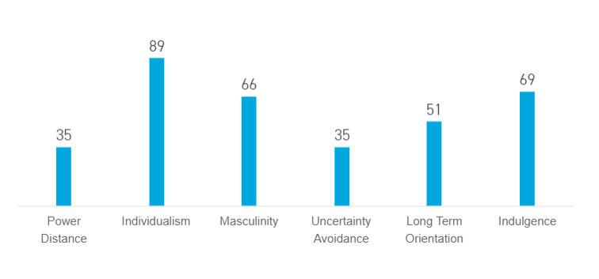
Figure: Cultural Dimensions’ result of UK (Hofstede Insights, 2019)

Individualism
The individualism index refers the degree to which people are integrated in a group of a society. The degree of interdependence is measured by this index of a society. The score of UK in this index is 89 which is the highest among all countries. This prove that British are most individualistic people in the world. They look after themselves only.

Masculinity
A high score (Masculine) on this dimension refers that competition, success and achievement will drive the society. A low score (Feminine) indicates that caring for others and quality of life are two dominant values in the society. Score of UK in this dimension is 66 which refers that it is a masculine society.

Uncertainty Avoidance
This dimension refers the extent to which people of a culture feel threatened by any unknown situation and form beliefs and institution to try to avoid these. The score of UK in this dimension is 35 that refers that the people of UK is happy to deal with uncertainities.

Long Term Orientation
This dimension refers how a society maintains links with its past at the time of dealing with present and future (Butler, Michael & Rose, 2011). UK’s core in this dimension is 51 by which no decision can’t be taken as it is an intermediary score.

Indulgence
This dimension indicates the extent to which people of a society try to control their desires and impulses. A weak control is called indulgence and strong control is called as restraints. A score of 69 of UK in this dimension refers that the people are indulgence.

People
People or employees that means the human resources are very important for any business organisation. People perform different types of activities to run the business operations in the right ways. They should be given importance by the company to get better output. The employees need to be motivated properly by their organisations. without motivation it is hard to get best efforts from the employees. (Armstrong, 2012)
Maslow’s Hierarch of Need theory is a motivational theory that can be applied practically. There are five steps of needs as per Maslow. The theory has been applied on Kellogg’s employees.
- Physiological Needs: In the first stage of needs, people feel need for food, home, cloth, water etc. The employees of Kellogg’s also feel the same. So, they want a job to meet these needs.
- Safety Needs: After fulfilling the physiological needs, like other people, Kellogg’s employees also feel the safety needs like security of job, safety of life at workplace etc.
- Social Needs: After meting the two needs, people feel social needs that means need for friendship, love etc. Kellogg’s employees want to have good relationship with the peers.
- Esteem Needs: In this stage, people feel need for self-esteem, power, recognition, prestige etc. Employees of Kellogg’s want to be appreciated for their performances. They want to be respected by their colleagues.
- Self-actualization need: this is the last step of the theory. Here, people feel the need for development and creativity. They want to use their full potential. Employees of Kellogg’s may feel the need to add something valuable which is unique to the company and help the business to get high positive outcome.

Performance
Performance management is a very crucial activity of a business organisation. It is very much necessary in order to keep business organisation in the right track. It helps to identify the errors and correct them. Kellogg’s also perform performance management to ensure its quality. The company at first sets standard of each task. Then, the performance management team compare the actual performance with the standards or benchmarks. If there is any negative gap be identified, then the corrective actions are taken as early as possible. If the performances of employees meet the standard, they are rewarded which motivates them to deliver their best efforts. For the unaccepted performers, company arranges training and workshops to make them better performer than they were in previous. (Butler, Michael & Rose, 2011)
Culture, people and structure helps the company to perform better. As there is both formal culture and informal culture in the company, the performance quality gets better. Employees have friendly and respectful relation with the colleagues. People working in Kellogg’s are very effective and efficient. Such employees can deliver very good performances which drives the company to satisfy the customers better. As a result, business run profitably. Employees are very much cooperative to their peers and customers. Functional organizational structure is followed in Kellogg’s. In this structure, for each type of performance, there is a separate department. Specialized departments perform the tasks they are specialized in. As a result, the performance of the company meets the expectations. In these ways, culture, people and structure help the company to perform better.

Recommendations
Few recommendations for Kellogg’s have been stated out below.
- Informal culture that exists in Kellogg’s should be restricted but not be prohibited. Informal culture is helpful but it will reduce productivity if the employees are too much practitioners of this culture.
- To meet the performance standards, regular training facilities should be organized for the employees. Before joining, the new employees will have to be heavily trained up to cope up with new environment and deliver good performances.
- Performance management process should be performed continually. If it is performed once or twice in a year, it will be late sometimes to identify errors.
- Employees should be given enough monetary motivations along with non-monetary motivations.

Conclusion
The write up was started with the definition and importance of structure and culture. Then, in different sections, different types of structure used in business, cultures etc. was discussed and applied on Kellogg’s which history was also included. Then, Hofstede’s Cultural Dimension theory was applied in UK which is the European Headquarter of Kellogg’s. Then, people and performance regarding Kellogg’s were discussed. The write up has been ended up with few recommendations.

References
Devid, P., (2008), Organizational behavior, London, Tomson press.
Kellogg’s, (2019). Serving New Beginnings — Where They’re Needed Most. [Online] Available at: https://www.kelloggs.com/en_US/who-we-are/our-workplace.html [Accessed on: 15-08-2019] D. Keith, W.N. Jones, 2016. “Organizational Behavior: Human Behavior At Work”.12th. McGrow Hill Companies
D. Keith, W.N. Jones, 2016. “Organizational Behavior: Human Behavior At Work”.12th. McGrow Hill Companies
Butler, Michael and Ed Rose (2011), Introduction to organisational behaviour. Chartered Institute of Personnel and Development.
Kellogg’s, (2019). Our Brands. [Online] Available at: https://www.kelloggs.com/en_US/our-brands.html [Accessed on: 15-08-2019]
Kellogg’s, (2019). A Historical Overview. [Online] Available at: http://www.kellogghistory.com/history.html [Accessed on: 15-08-2019]
Kellogg Company, (2019). Frequently Asked Question. [Online] Available at: http://newsroom.kelloggcompany.com/index.php?s=27540 [Accessed on: 15-08-2019]
Fortune, (2018). Fortune 500. [Online] Available at
: https://fortune.com/fortune500/kellogg [Accessed on: 15-08-2019]
Hofstede Insights, (2019). What about the UK? [Online] Available at: https://www.hofstede-insights.com/country/the-uk/ [Accessed on 16-08-2019]
Armstrong, M. (2012), A Handbook of Human Resource Management Practice, 9th Ed. London: Kogan Page Limited

