Marketing Essentials
(M4X01916_LON)
Assignment Part 1
Written by : Mihail Teofilov
Lecturer: Dale Clark

INTRODUCTION
Regarding the expand of the market and the huge wave of other competitors; we need to take care about the size of data needed daily by an organization or company.
In order to deal with the current market, employers and managers establishing and recreating marketing information system (MKIS) that can give an advantages so they can be reliable on the market and to continue their economic contribution.
With every fast growing market that is competitive, the amount of information needed daily by an organization is profound.
Researching the market Brown et al. (1994) confirm that the field of services trends to be down marketing related with less touch to the external factors comparing it to the producer business.
The marketing information system start and end with the following points:
- Gathering information from users to access information in future time ;
- Develops the data provided from internal and external sources ;
- Try to analyze the information and to be provided to the users in order to make a correct or right marketing decision ;
- Spread the marketing data to the managers as well so they can get to their marketing solutions ;

On his own words Kotler P. (2006), describes the marketing information system as a planned and strict procedure of collecting and receiving data, processing and storing it plus the right distribution of the collected figures to carry out the main functions of the management.

Also the marketing information systems are composed by equipment, people and processes to bring different kind, analyses, evaluate and distribute.

The majority of marketing information systems utilizes mainly internal data because this is easy to obtain, but research has shown that managers require mainly a external information on which to base their long-term decisions.

Internal data most of the time is related to the operational importance, whereas strategic decisions require more information on market trends, competitors’ strategies and economic and political fluctuations said Xu and Kaye (1995);

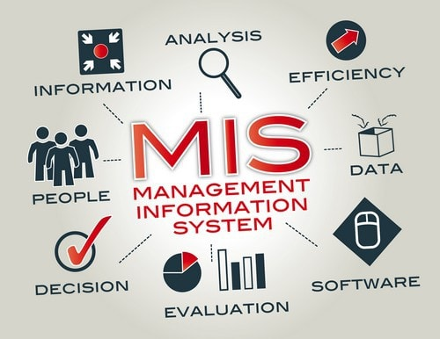

Components of the Marketing information systems:

- Marketing Control System / Marketing Intelligence system – The MIS system is used mainly to deal with the cost of a company or more straight to understand where they lost are going and how we can expand our market and our profit.

Talvien (1994, p.18) admitting that the MIS is used interchangeably. With all the external information from the MIS we can define problems, changes and opportunities from external sources and to create a new external environment.
- Marketing Planning System / Internal records of the information - Awareness of company performance and what could be improved in time. The managers that are working in the marketing sector could see records related with the sales, costs and inventories, cash flows and etc. A huge number of companies keep their internal records in order to create a statistics of the sales and other factors;
- Marketing Research System ;
- Marketing Decision Support System / (DSS) ;

Main roles of the Marketing information systems :

To improve the level of efficiency for the current company in current operations;

To collect the needed information regarding their customers and their needs as well;

To provide the gathered information to the management on a daily basis so they can follow the current trends and changes;

To analyze the sources that the data comes from both internal and external;

To facilitates the future marketing planning and to keep control;

Keep the marketing intelligence that will be able to achieve every future plans and researches;

The utilization of IT inside MKiS has become a key factor in an association's accomplishment of competitive ways of leeway and reaching the set goals.

Talvinen (1994, p.8) affirmed that "Overseeing promoting data by methods for IT has gotten one of the vital elements of effective marketing"

Differences between Marketing Information system and Marketing Research:

MKIS | Marketing Research (MR)
It`s related with the future plans of a company ; | MR giving more information about past plans ;
MKIS is constant process ; | One MR have an exact time and it`s not a continuous project ;
Get`s a popularity in 1960`s ; | MR start to be famous around 1950`s ;
Most of the processes are connected with using a PC or Internet connection; | To bring certain objective, marketing investigations is conducted ;
The primary role is to help to create and to take marketing decisions ; | MR is a irreplaceable and unique part of the MKIS ;
The marketing information system embrace a bigger data area ;

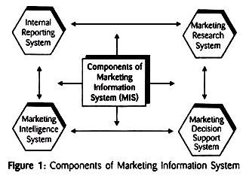

Definition of marketing research:

The manual process for taking any kind of information, recording and analyze so we can write it down and to be use to the marketing of goods and services.

Such research might be attempted by organizations or by business organizations or their offices to cut down the degree of advertising issues and to discover an adequate arrangement which grasps all examination exercises conveyed down in an association with the administration of promoting work.

Objectives of marketing research:

- Consider and define the current market regarding the product or the service that we would like to launch or improve ;
- What are the present trends and to figure out the main conditions of the market ;
- To be sure that their understand the SWOT and to think about future improvements in order to grow up ;
- Find out procedures and tactics to distribute the product to their chosen target ;
- Create a sales projection for a period for example 3,6,9 months and how we can flow on that level of sales ;
- Feedback is really important to every company so every kind of survey will be plus for the company development ;

Marketing Models:
- Theory that research a huge number of campaigns with the current guidance ;
- Utensils which create a good connection between the marketing managers and the following data in order to build better marketing decisions ;

We can define three different types of taking a marketing decision:

- Strategic decisions - are a main part of one-off situations. This part of decisions made are alarmed with deciding on the target , value and policies of the organization ;
- Control decisions - it`s deals with a huge number of policy issues. With that kind of model we would like to understand what is the efficiently and effectively source that is utilized and to understand how all operational units proceed.
- Operational decisions – related with the management and the marketing mix to the current organization. Here is coming the “specifics tasks by strategic planners and management” ;

In total all this models try to aims the level between the external and internal information and data in order to prove that the external source can be more relevant to the market.
We can get this trough a related MKIS to a different statistics types and use the Internet information as a tool to provide enough external data.

The important of “S” in the MKIS

MKIS helps to managers to understand the different point of view to the marketing movements and trends. The following may be in respect of price , product perfection , product development and promotions design.

CONCLUSION

At the moment most of MKIS are having their main source based on different types of surveys and analysis straight related and connected with the internal data that the customer provides. Regarding all that information no matter if it`s external or internal.

Information technology it`s not only about to help the harvesting of data and information but also to analyze and create a stable management regarding the structure that there are responsible for.

REFERENCES
Brown S., Fisk R., Bitner M. (1994), “The development of services marketing thought”, International Journal of Service Industry management 5(1) : p. 21 – 48 ;
Kotler, Philip; Keller, Kevin L. (2006). Marketing Management (12 Ed.). Pearson Education ;
Talvinen J. (1994), “Information systems in Marketing”, European Journal of Marketing 29 (1):p.8 – 26;
Xu X., Kaye GR (1995), “Building Marketing Intelligence systems for environment scanning” , Logistics In-formation marketing Management 8(2) : p. 22 – 29 ;

