
Strategic management
Adidas Competitive Advantage Strategies


November 1, 2018
Daniel Maharg
P149526

Table of Contents
1.0 Executive Summary 2
2.0 Introduction 3
2.1 Background of Organisation 3
2.2 Definitions of Major Concepts 4
3.0 Main Body 8
3.1 Implementation of Strategy 8
3.2 Advantages and Disadvantages 9
4.0 Conclusion 10
4.1 Recommendations 10
5.0 References 11

Table of Figures
Figure 2.1 Five Types of Business Level Strategies – Page 4
Figure 2.2 Porters Generic Strategies - Page 6

- Executive Summary
The purpose of this report is to identify and critically evaluate the competitive strategy Adidas utilise. This would include the strategy used by Adidas and the advantages and disadvantages that they may face when using that strategy.
Adidas is a sportswear and casualwear manufacturer and producer based in German that distributes its products worldwide and is one of the leaders within their market.
Within this report it was found that Adidas use a differentiation strategy for competitive advantage and do this by adding value to products and keeping competitive edge.
Some of the advantages of Adidas using this competitive strategy is building strong customer relationships and repeat purchases of products leading to the stimulation of economic growth. One disadvantage of this competitive advantage strategy is the repeat re-invention of products pushing away once loyal customers and losing customers to competitors within the market.
Some of the recommendations that were made to Adidas were to increase their use with celebrity collaborations / endorsements such as Kayne West. Another recommendation was to not over saturate their loyal customers with over-release of products that would lead to pushing customers away.

2.0 Introduction
This report will identify and critically evaluate the competitive strategy that Adidas have utilised. This would include recognising the advantages and the limitations of Adidas chosen strategy. This will be done by referring to the major concepts and linking this back to the organisation, Adidas.
2.1 Background of The Organisation
Adidas are a German manufacturer of athletic shoes and apparel such as sporting goods. Adidas sit top of the list of largest manufacturers of sportwear and second behind Nike in the world. Adidas products can be distinctively recognised by the three-stripe logo found on most of their products. The name Adidas is an abbreviation of the name of the founder Adolf (Adi) Dassler and their headquarters can be found in Herzogenaurach, Germany. The Dassler family started producing and manufacturing shoes after World War I. During the 1950s many football players were switching to Adidas boots because of their design leading to the company producing a line of sporting goods related to football, such as a range of footballs in 1963 (Lewis, 2016). After this success for many years Adidas were the most successful athletic shoes in the industry. Competition for Adidas increased during the 1970s with the introduction of newer firms such as Nike taking market share and furthermore 1978 Adi Dassler passed away and the company experienced a falling market share during 1980s. Although they are still a large organisation and a key player in the sports shoe market, their market share has dropped over the years. In 2004 Adidas acquired Valley Apparel Company, a US based company that held and distributed the licensing for outfitting more than 140 college teams in USA. Furthermore, Adidas announced they are purchasing the American shoemaker Reebok in 2005 allowing the company to compete more directly with Nike in the U.S (Flippo, 2018).
2.2 Definitions of Major Concepts
Business strategy can be seen as a set of guiding principles that when communicated and adopted into an organisation can generate a pattern and help with different decision-making processes (Watkins, 2007). Many different businesses and organisations struggle with strategy but realise that it is extremely important to have strategies. A strategy can be seen as the way that members of the organisation should make decisions and allocate resources in order to achieve objectives for the organisation. Strategy is the bridge between policy and the goals of the organisation. Strategy can refer to a complex web of thoughts, ideas, insights and goals that can provide insight and guidance in pursuit of particular ends of the organisational goals (Nickols, 2012).
Business level strategy looks at how a firm is going to try and compete within a specific industry. This can be quite a complex strategy because it differs from business to business what model they are going to use, and different organisations would have models that are unique to them. One solution is to consider the business-level strategy in terms of generic strategies. A Generic strategy is the general way of positioning a firm within an industry (BCCampus, n.d). The most common form of generic strategies is Porters Generic Strategies which will be used within this report.
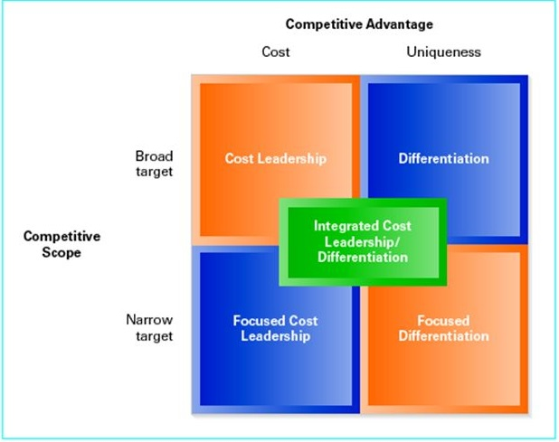

Figure 2.1 Five Types of Business Level Strategies (Cengage, 2015)

Cost leadership within figure 2.1 (Cengage, 2015) refers to the offering of the best price for the products. Cost leadership strategy considers the cost to produce and make the goods, transport and deliver them to the desired customers. Differentiation refers to when a product isn’t the least expensive of its type on the market, businesses would then need to find a way to differentiate themselves within that market. This would require the business to identify and make clear the benefits and the features of the product that makes it worth paying more than the cheaper competitors. Focused cost leadership strategy is where the organisation is trying to beat the competitors prices and would be focusing the marketing efforts in a specific way. Focussed differentiation can be compared to the differentiation stage but taking differentiation one step further. It finds the added value of the products that the organisation is offering then targets smaller markets. This type of focused differentiation would help a business define the small market niche where it would be profitable for the organisation and beneficial and would not be competing just on price. The final part of figure 2.1 is ‘integrated low cost/differentiation’, this business-level strategy combines aspects of low cost with differentiation and allows flexibility in both price and added value (Leonard, 2018).
Economic researcher Michael Porter examined the competitive behaviour patterns that comprise a successful business. Porter set out to uncover the ways in which companies would maintain their long-term advantages over their competitors in their industries. Through Porters work he generated ‘Porters Generic Strategies’. This model was used to show three interconnected concepts that most modern-day organisations use to develop key operating procedures and get a competitive edge within their market (Capism, 2015). Figure 2.2 depicts this model.
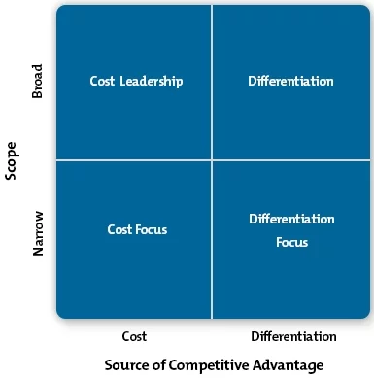

Figure 2.2 Porters Generic Strategies (MindTools, n.d.)
Porters generic strategies are ways of gaining a competitive edge or advantage over your competitors, this would therefore require the development of the edge that takes the sales away from your competitors and brings those sales to your organisation. Within the cost leadership strategy this would require increasing the profits by reducing the costs such as production and charge the industry average prices. Another way of following the cost leadership strategy is by increasing market share by charging lower prices for your products, this would lead to still making a reasonable amount of profit on products because the costs have been reduced. Cost leadership involves being the market leader in terms of cost (Thompson, 1984).
Differentiation involves an organisation trying to make their products different and more appealing to the products of their competitors. The way that an organisation would do this depends on the industry in which they operate and the products that the organisation offers themselves. These differences that an organisation would add to a product to try and increase the appeal on their products would be aspects such as improving and increasing the features, the functionality of the products, the durability of the products, and the support offered with a product e.g. the aftercare service with a product (Leinwand, 2016). For an organisation to implement these into their organisation they would require:
- good research, innovation and development teams
- The ability for the organisation to produce and maintain a high-quality product
- Effective level of sales and marketing

Focus strategies used by organisations concentrate on niche markets and by focusing and analysing that market understand and can deliver the needs of the customers within that market that will allow organisations to develop uniquely low cost or well specified products for that specific market. Because of the unique relationship that the organisation would serve their customers within this market the organisation would tend to build a strong brand loyalty amongst their customers, making their market segment a lot less attractive for competitors to try and edge. Focus strategies are a broad market strategy and would not be enough on their own, when an organisation selects a focus strategy they must then decide if they will pursue a cost leadership or differentiation when selecting focus strategies.

3.0 Main Body

The generic strategy that Adidas as an organisation uses is differentiation. Differentiation is a business strategy in which an organisation such as Adidas would attempt to gain a competitive advantage and edge over competitors by increasing the willingness and support from their customers. Adidas would use differentiation to gain a larger market share. Adidas are represented in a large amount of the professional sporting world including football shirt sponsorships, sports equipment and are even associated to certain athletes and celebrity endorsements, although these sponsorship deals with sporting teams and sports stars are common within the market that Adidas operates. Adidas has differentiated by offering top of the line fashion clothing lines and shoe brands and keep this competitive edge over competing brands such as Nike by tactically keeping prices lower in certain areas.

3.1 Implementation of The Strategy
Another form of competitive advantage and form of differentiation Adidas have shown is having celebrity collaboration/endorsement in the form of Kanye West. Adidas recognised the impact that having such an influential impact on society.

3.2 Advantages and Disadvantages
One of the advantages of the differentiation strategy type such as Adidas carrying out is entering into a niche market and building a strong customer relationship and encouraging repeat purchases from these customers (Leonard, 2018). Another advantage of differentiation strategy is the product variety it produces, firms such as Adidas would develop unique products to respond to customers preferences and increase customer satisfaction. Differentiation enhances creativity within an organisation and keeps organisations such as Adidas thinking of and releasing new products to try and keep themselves relevant. When competing with a differentiation strategy the organisation would always be looking to create unique products that satisfy customers demands. This production of better products would then lead to the stimulation of economic growth (Williams, 2018).
One of the disadvantages of the differentiation strategy is that organisations such as Adidas that keep re-inventing their products and changing their products attract loyal customers, but product differentiation within an organisation requires a large amount of market research to be carried out to understand the target customer. Sometimes these costs are then pushed onto the customer via increased product prices and can drive away certain customers. Another disadvantage to the differentiation strategy is that it is normally hard for organisations that are entering into a new market to differentiate those products, such as Adidas entering a new market and trying to differentiate new products that are new entrants into the market.

4.0 Conclusion
It is clear after looking and analysing Adidas competitive advantage and their strategy of competitive advantage, being differentiation, works best for them. As an organisation Adidas should be clear who their competitors are and keep differentiating their products at the same rate.
4.1 Recommendations
Adidas are fully utilising the full effects of a differentiation strategy and entering into niche markets such as the release of their Yeezy collaboration with Kanye West and entering the fashion industry. As this venture went so successfully for the organisation and for the competitive advantage it may be worth as an organisation to try and increase the amount of celebrity collaboration and endorsements as a whole the organisation has to try and increase their societal influence and stimulate the economic growth of Adidas.
Adidas should try to avoid re-inventing products at too quick of a rate. Although Adidas have a very loyal and happy customer base when releasing new products, this may change if there are large amounts of changes to frequently. For example of there are new releases that would appeal to a certain market to often it may push customers away as they would feel they are being taken advantage of, losing the competitive edge in the niche market.

5.0 References
BCCampus. (n.d.). Understanding Business-Level Strategy through “Generic Strategies”. Available: https://opentextbc.ca/strategicmanagement/chapter/understanding-business-level-strategy-through-generic-strategies/#return-footnote-139-1. Last accessed 22/11/2018.
Bhasin, H. (2017). Marketing strategy of Adidas. Available: https://www.marketing91.com/marketing-strategy-of-adidas/. Last accessed 22/11/2018.
Capism. (2015). An introduction to Porter’s Generic Strategies.Available: https://www.capsim.com/blog/an-introduction-to-porters-generic-strategies/. Last accessed 22/11/2018.
Flippo, H. (2018). A Brief History of Adidas. Available: https://www.thoughtco.com/quick-history-of-adidas-1444319. Last accessed 22/11/2018.
Ireland, R.D et al (2008). Understanding Business Strategy: Concepts. 2nd ed. California: South-Western College
Leonard, K. (2018). Five Types of Business-Level Strategies. Available: https://smallbusiness.chron.com/five-types-business-level-strategies-781.html. Last accessed 22/11/2018.
Leonard, K. (2018). Pros & Cons of Differentiation Strategy. Available: https://smallbusiness.chron.com/pros-cons-differentiation-strategy-21452.html. Last accessed 22/11/2018.
Leinwand, P. (2016). Your Whole Company Needs to Be Distinctive, Not Just Your Product. Available: https://hbr.org/2016/05/your-whole-company-needs-to-be-distinctive-not-just-your-product. Last accessed 22/11/2018.
Lewis, R. (2016). Adidas AG. Available: https://www.britannica.com/topic/Adidas-AG. Last accessed 22/11/2018.
MindTools. (n.d.). Porter's Generic Strategies. Available: https://www.mindtools.com/pages/article/newSTR_82.htm. Last accessed 22/11/2018
Nickols, F. (2012). Strategy: Definitions and Meaning. Available: https://www.nickols.us/strategy_definition.htm. Last accessed 22/11/2018.
Thompson, A.A Jr. (1984). Strategies for Staying Cost Competitive.Available: https://hbr.org/1984/01/strategies-for-staying-cost-competitive. Last accessed 22/11/2018.
Watkins, M.D. (2007). Demystifying Strategy: The What, Who, How, and Why. Available: https://hbr.org/2007/09/demystifying-strategy-the-what%20demystifying-strategy-the-what. Last accessed 22/11/2018.
Williams, J. (2018). Advantages and Disadvantages of Product Differentiation. Available: https://smallbusiness.chron.com/advantages-disadvantages-product-differentiation-66126.html. Last accessed 22/11/2018.

