UWTSD
WISA



Kinetic Energy Recovery
Alternative Propulsion Systems
ACHA5010

Daniel Jack Briggs
2312568
12/10/25

Contents
1 Introduction 1
1.1 Justification 1
1.2 Aims 1
1.3 Objectives 1
2 Dynamical Characteristics 2
3 WLTP Cycle 3
3.1 What is WLTP 3
3.2 WLTP Graphs 4
4 Tractive Braking 5
5 KERS 6
5.1 What is KERS 6
5.2 How does the Kinetic Energy Recovery System work? 6
5.3 What types of Kinetic Energy Recovery Systems are there? 7
5.4 KERS Assignment 8
6 System Operations and Assumptions Made 10
7 Conclusion 11
8 References and Research websites 13

Figure 1 (Show Myself on the Motorcycle) 2
Figure 2 (The WLTP Cycle) 3
Figure 3 (Forces On The Motorcycle For The WLTP Cycle) 4
Figure 4 (Tractive Force (N)) 4
Figure 5 (Tractive Power (W) Of The WLTP Cycle) 4
Figure 6 (Cumulative Tractive Braking And Energy Over The WLTP Cycle) 5
Figure 7 (Formula One Race Car) [Siemens.com. (2025).] 6
Figure 8 (Shows A Diagram Of KERS) [Azom.com. (2025).] 6
Figure 9 (Energy Recovery Systems) [Eltaweel, M. and Herfatmanesh, M.R. (2024).] 7
Figure 10 (Audi R18 e-tron quattro) [Formula1-dictionary.net. (2025).] 7
Figure 11 (Velocity With KERS Events) 8
Figure 12 (Kinetic Energy Recovered Returned to wheel) 9
Figure 13 (The Ducati Panigale S 1199) [Cycleworld.com. (2025).] 11
Figure 14 (The Damon Hypersport) [Webbikeworld.com. (2025).] 11
Figure 15 (The Kawasaki Ninja 7 Hybrid) [Motorcyclenews.com. (2025).] 12

Table 1 (Shows the motorcycle dynamics) 2
Table 2 (The Largest KERS Point) 8
Table 3 (Kinetic Energy Recovered Returned to wheel) 9

Introduction
This technical report will show a basic understanding of the WLTP cycle and KERS, with an application of the WLTP cycle and a theoretical application of the KERS on a motorcycle.

Justification
This technical report will show the understanding and application of the KERS using the WLTP cycle.

Objectives
To show a basic understanding of what the WLTP cycle is.
To select a suitable vehicle for the WLTP cycle.
To show a basic understanding of how to utilise the WLTP cycle works
To show a basic understanding of KERS.
To apply the KERS to a vehicle.

Dynamical Characteristics

The Vehicle I have chosen to use for the assignment is the Ducati Panigale S 1199 because I have some data on the motorcycle from the motorcycle dynamics lecture last year. The other reason is that the degree I am studying is motorcycle engineering.
Table 1 (Shows the motorcycle dynamics)
 | Measurements | SI Unit
Weight
Dry Weight of the Bike | 164.00 | Kg
Fuel, Oil, Coolant Weight | 18.31 | Kg
Other Weight | 4.94 | kg
Weight of Bike | 187.25 | Kg
Weight of Rider | 75.10 | Kg
Total Test Mass | 262.35 | Kg
Frontal Dimensions of the Motorcycle
Bike Hight | 1.100 | m
Rider Hight | 0.365 | m
Total Hight | 1.465 | m
Bike Width | 0.780 | m
Bike Lenth | 2.075 | m
seat Hight | 0.824 | m
Frontal Area | 0.9713 | m^2

Figure 1 (Show Myself on the Motorcycle)

WLTP Cycle

What is WLTP
The WLTP cycle stands for Worldwide Harmonised Light Vehicle Test Procedure. This is a global test designed to provide the most realistic and accurate measurements of fuel consumption and CO2 emissions for vehicles with internal combustion engines and hybrids. The test also measures electric range for electric and plug-in hybrid vehicles and pollution emissions for both petrol and diesel vehicles. The test is divided into four parts for a vehicle with different average speeds: Low (with a maximum speed of 56.5km/h); medium (with a maximum speed of 76.6km/h); high (with a maximum speed of 97.4km/h); and extra high (with a maximum speed of 131.3km/h). The test will also simulate more dynamic real-world driving conditions by incorporating acceleration, braking and stopping within the cycle. There are three categories for the cycle: Class 1 is for vehicles that have a ratio of rated power in W / kerb mass in kg <= 22; Class 2 is for vehicles that have ratio of rated power in W / kerb mass in kg > 22 but <= 34; and Class 3 is for vehicles that have ratio of rated power in W / kerb mass in kg > 34. The full cycle takes about 30 minutes and covers a total distance of 23.25km at a maximum speed of 131.3km/h with an average speed of 46.5km/h. [EuroCoc, (2020).] [Abarthcars.co.uk. (2017).]
The WLTP cycle was developed in a global effort between 2013 and 2014 and was implemented in September 2017 to replace the NEDC (New European Driving Cycle), which had been in use since the 1980s and was considered to be outdated. The WLTP was then made mandatory for all new vehicles manufactured and sold in the European Union to be tested and approved by the WLTP from September 2018.
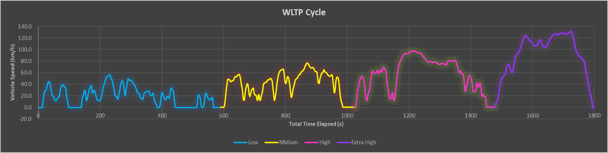
Figure 2 (The WLTP Cycle)

WLTP Graphs
For this assignment, the appropriate WLTP category that was chosen for the Ducati Panigale S 1199 was class three because the motorcycle can reach a top speed of 292km/h and a power-to-weight ratio of 143kw: 263.25kg. [Correia, A. (2005).]
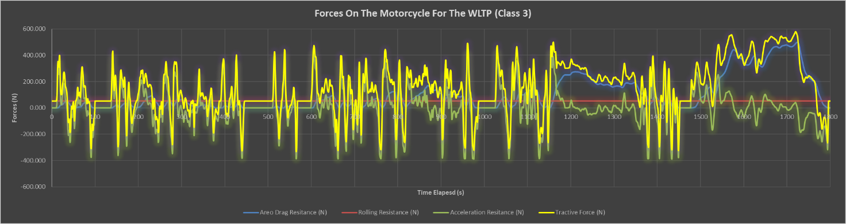
Figure 3 (Forces On The Motorcycle For The WLTP Cycle)
The graph above shows all of the forces acting on the motorcycle during the WLTP Cycle.
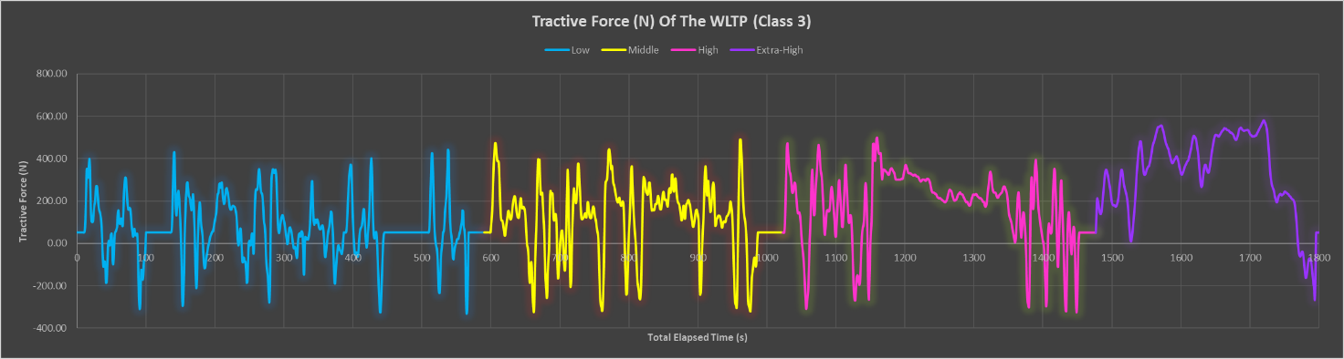
Figure 4 (Tractive Force (N))
The graph above shows the tractive forces of the motorcycle through all four stages of the WLTP cycle. The graph below shows the tractive power of the motorcycle through all four stages of the WLTP cycle.
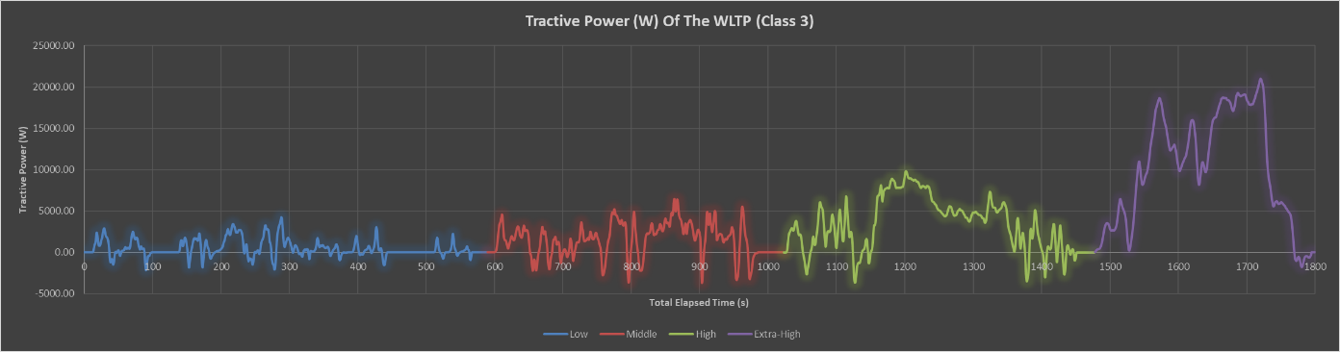
Figure 5 (Tractive Power (W) Of The WLTP Cycle)

Tractive Braking

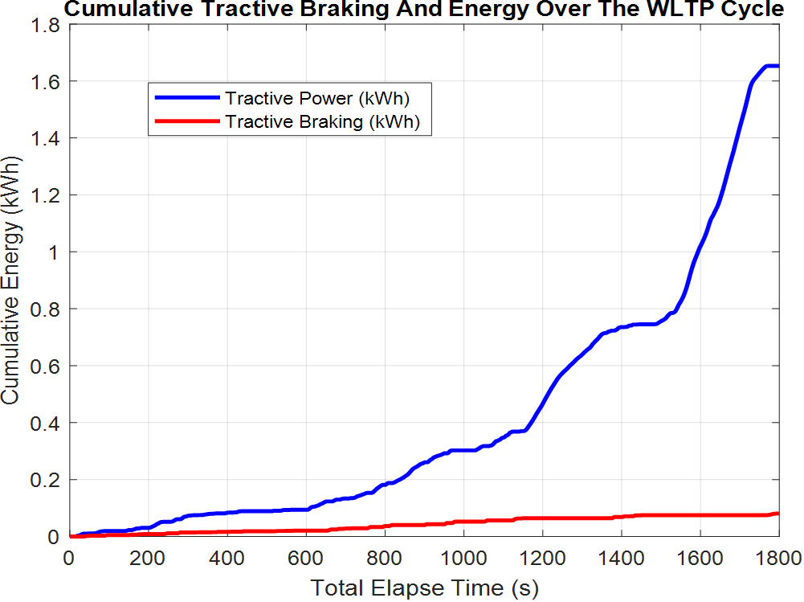
Figure 6 (Cumulative Tractive Braking And Energy Over The WLTP Cycle)

KERS

What is KERS
KERS stand for Kinetic Energy Recovery System, which is a system that collects and stores kinetic energy from a vehicle in motion. Without the system, the kinetic energy would be lost during braking. Kinetic Energy Recovery Systems have been used in Formula One since 2009 to provide the race cars with an acceleration boost up to 80 bhp and are now being used in modern electric and hybrid vehicles by improving fuel efficiency and range by sending energy back to the battery when the vehicle is slowing down. [Engineering, R. (2009).]
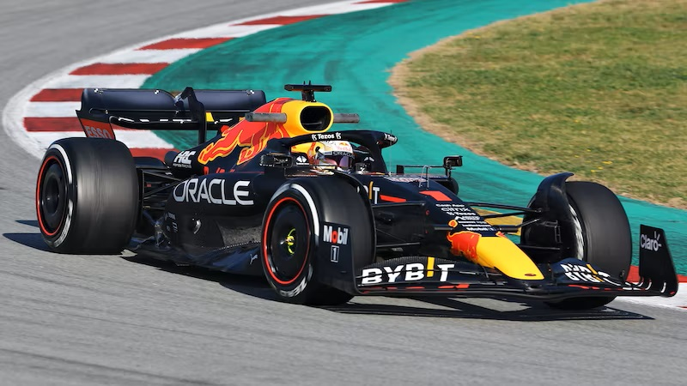
Figure 7 (Formula One Race Car) [Siemens.com. (2025).]

How does the Kinetic Energy Recovery System work?
Step one: When the vehicle is braking, the system captures the kinetic energy instead of letting the energy turn entirely to heat through the friction of the brakes.
Step two: The captured kinetic energy is then stored in an energy reservoir, such as a battery or a flywheel.
Step three: The driver can deploy the stored energy as an extra boost of power during acceleration.
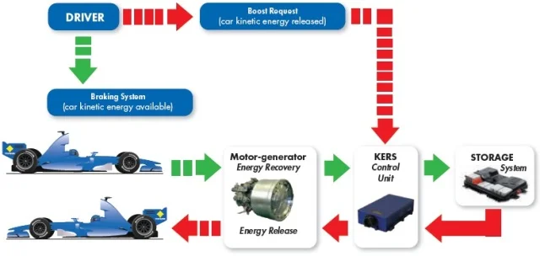
Figure 8 (Shows A Diagram Of KERS) [Azom.com. (2025).]

What types of Kinetic Energy Recovery Systems are there?
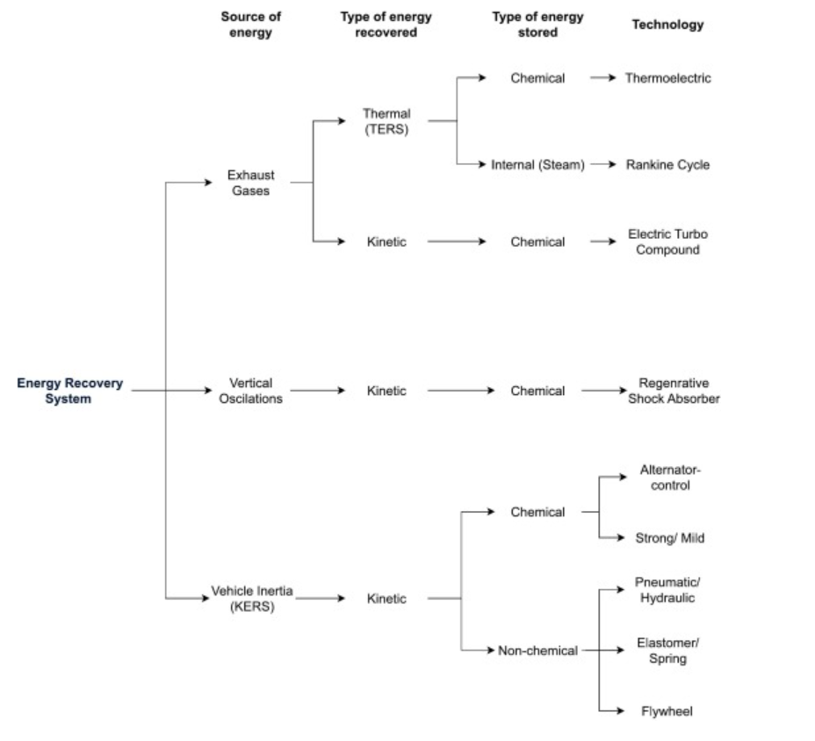
Figure 9 (Energy Recovery Systems) [Eltaweel, M. and Herfatmanesh, M.R. (2024).]
There are two types of Kinetic Energy Recovery Systems:
Electro-mechanical, by using a motor-generator to turn the kinetic energy into electrical energy, then storing the electrical energy in a high-voltage battery and then returning the electrical energy to the motor to provide power.
Mechanically, the system uses a high-speed flywheel to store kinetic energy during braking and releases the stored energy back during acceleration.
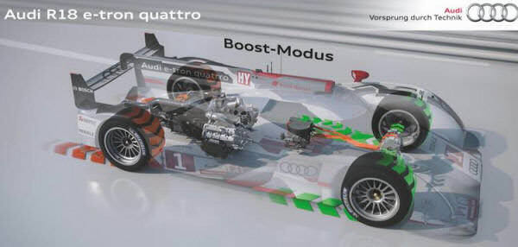
Figure 10 (Audi R18 e-tron quattro) [Formula1-dictionary.net. (2025).]

KERS Assignment
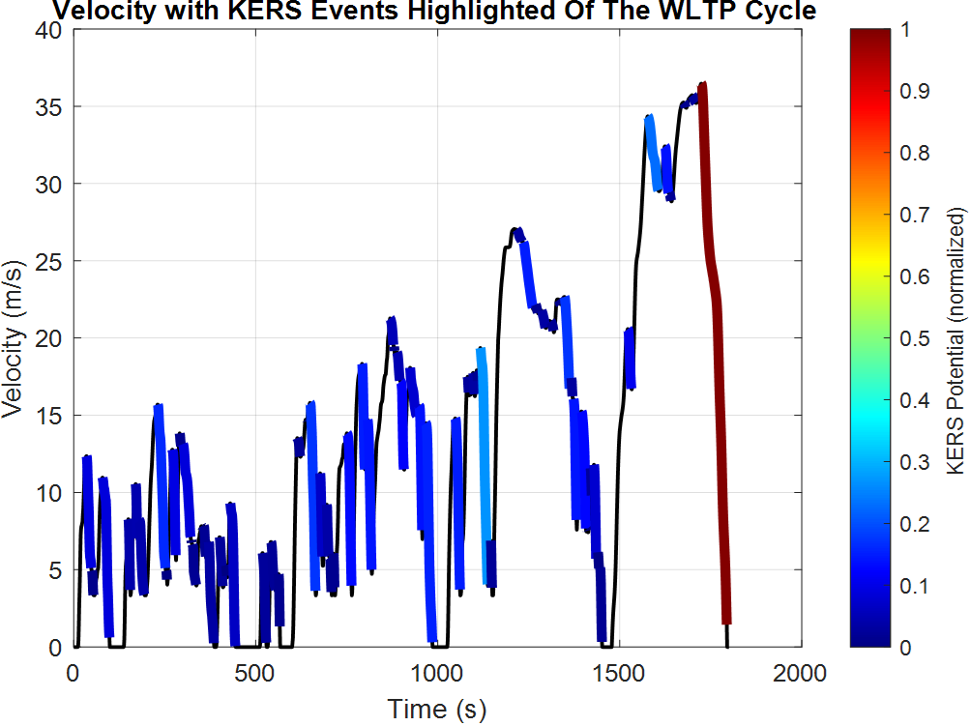
Figure 11 (Velocity With KERS Events)

Table 2 (The Largest KERS Point)
The largest KERS power input | 13.5kW
The largest KERS energy input | 0.220kWh
The energy storage requirements | 36.2kW

The figures in the table above were calculated on the Ducati Panigale S 1199 motorcycle's battery, this battery is a 12V, 8.6Ah Battery.
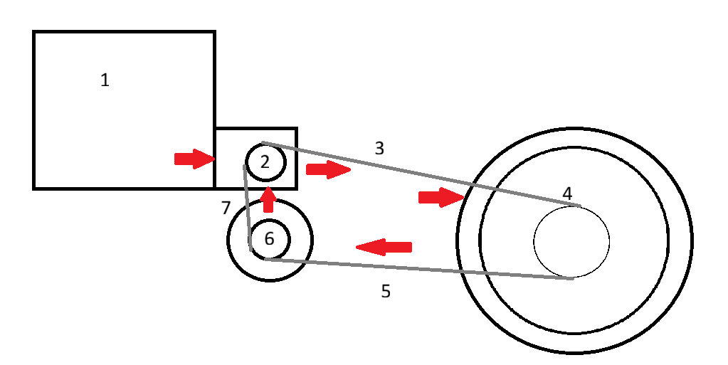
Figure 12 (Kinetic Energy Recovered Returned to wheel)
Using the calculations to determine the most suitable KERS for the motorcycle, a flywheel was chosen due to it having 90% efficiency; motorcycles don’t normally have Kinetic Energy Recovery Systems. The system was introduced into the chain loop, which would provide the largest amount of power back to the wheel.
Table 3 (Kinetic Energy Recovered Returned to wheel)
Stage | Motorcycle Part | Efficiency | Energy
1 | Engine/ Motor | 100% | 1000w
2 | Gearbox | 97.5% | 975w
3 | Chain | 97.5% | 950.6w
4 | Wheel | 90% | 855.6w
5 | Chain | 97.5% | 834.2w
6 | Flywheel | 90% | 750.8w
7 | Chain | 97.5% | 732w

System Operations and Assumptions Made and Rider Variations
The kinetic energy recovery system works by taking kinetic energy from the wheels during braking and returning it back to the wheels during acceleration, or it is turned into electricity and then stored in the battery, ready to be used in the engine/motor.
In this technical report, there were a couple of assumptions:
The first assumption made was in Table 3; this assumption was the starting energy figure that was used. 1000 W was used because it made calculating the energy drop easier.
The second assumption made was the positioning of the flywheel, because most motorcycles don’t have KERS in them.
The rider of the motorcycle will feel a slight gyration motion pushing forward when braking, which may also have an effect on the steering of the motorcycle due to the motorcycle's dynamics. When the rider accelerates, the motorcycle would theoretically pull off at a higher rate of speed, therefore putting a lot more force pushing against the rider than what the rider would normally feel without the Kinetic Energy Recovery System.

Conclusion
Looking at the data, I have come to the conclusion that a kinetic energy recovery system would not benefit motorcycles because the Ducati Panigale S 1199 is a powerful motorcycle and still does not have a high tractive braking energy and even with the energy recovery ratio being at 90 %, the energy recovered would be minimal and smaller motorcycles would produce even less recoverable kinetic energy.
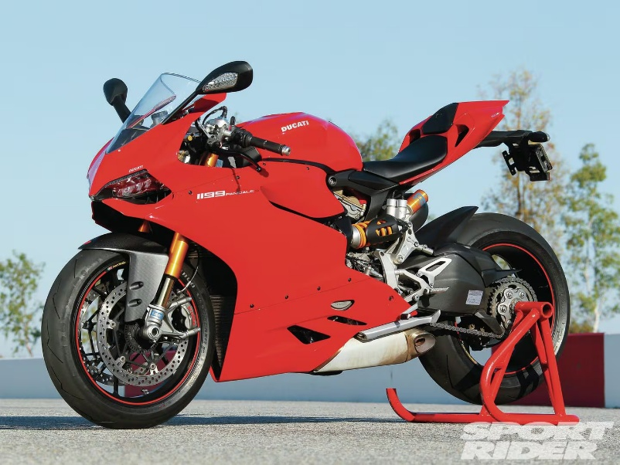
Figure 13 (The Ducati Panigale S 1199) [Cycleworld.com. (2025).]
On the other hand, if the motorcycle were an electric motorcycle, such as Damon Hypersport, then the Kinetic Energy Recovery System may provide an alternative role by recharging the battery system. By using the kinetic energy and transforming the energy into electrical energy, that energy can be stored in the battery and used to power the motor; however, this system has a 60 % efficiency ratio.
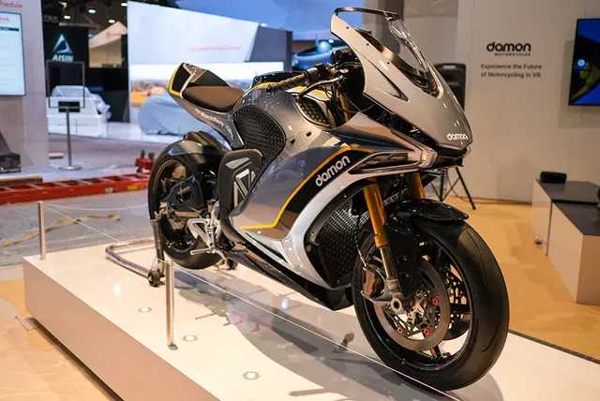
Figure 14 (The Damon Hypersport) [Webbikeworld.com. (2025).]
So, considering all of the advantages and disadvantages of the Kinetic Energy Recovery System, in my opinion, for internal combustion engine vehicles, the energy recovery system would not be beneficial to the motorcycle, but for the electric vehicle, the energy recovery system would allow motorcycles to potentially travel a further distance.
If the motorcycle were a hybrid, such as the Kawasaki Ninja 7 Hybrid, then the Kinetic Energy Recovery System could provide an increased range and acceleration to the motorcycle.
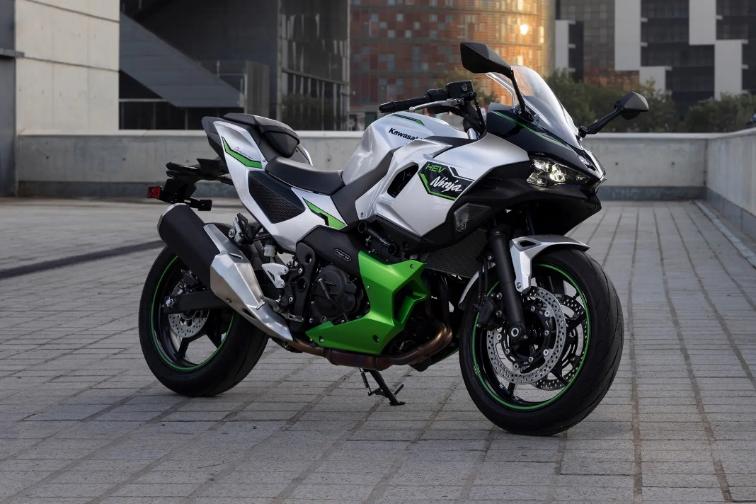
Figure 15 (The Kawasaki Ninja 7 Hybrid) [Motorcyclenews.com. (2025).]

References and Research websites

Abarthcars.co.uk. (2017). WLTP: new tests for fuel consumption and CO2 emissions | Abarth. [online] Available at: https://www.abarthcars.co.uk/certification-wltp.
Azarm, A., Esfahanian, M. and Hamidi, H. (2024). Development of an Innovative Flywheel-Based Brake Energy Recovery System for Enhanced Urban Fuel Efficiency in Passenger Cars. Automotive Science and Engineering, [online] 14(2), pp.4388–4406. doi: https://doi.org/10.22068/ase.2024.671
Azom.com. (2025). Available at: https://www.azom.com/images/Article_Images/ImageForArticle_9503(1).jpg
Correia, A. (2005). 2014 Ducati 1199S Panigale. [online] Motorcyclespecs.co.za. Available at: https://www.motorcyclespecs.co.za/model/ducati/ducati_1199s_panigale%2014.htm#google_vignette
Cycleworld.com. (2025). Available at: https://www.cycleworld.com/resizer/0Zy__29EKWDK9mzVYHMq1XI7RTE=/1440x0/smart/cloudfront-us-east-1.images.arcpublishing.com/octane/JGWLAS56AG2XOLUH2NTGXM45WM.jpg
Engineering, R. (2009). F1 Essentials: How KERS Works. [online] Racecar Engineering. Available at: https://www.racecar-engineering.com/articles/f1-essentials-how-kers-works/
Eltaweel, M. and Herfatmanesh, M.R. (2024). Enhancing vehicular performance with flywheel energy storage systems: Emerging technologies and applications. Journal of Energy Storage, 103, p.114386. doi: https://doi.org/10.1016/j.est.2024.114386
EuroCoc, (2020). WLTP cycle replaces NEDC | EuroCoc. [online] Available at: https://www.eurococ.eu/en/blog/wltp-cycle-replaces-nedc/
Formula1-dictionary.net. (2025). Available at: https://www.formula1-dictionary.net/Images/audi_r18_e_tron_quattro_boost_mode.jpg
Motorcyclenews.com. (2025). Available at: https://www.motorcyclenews.com/wp-images/219555/kawasaki-ninja-7-hybrid-01.jpg
Siemens.com. (2025). Available at: https://blogs.sw.siemens.com/wp-content/uploads/sites/2/2023/03/oracle-red-bull-racing.jpg
Sam (2011). Flywheel hybrid systems (KERS). [online] Racecar Engineering. Available at: https://www.racecar-engineering.com/articles/f1/flywheel-hybrid-systems-kers/
Webbikeworld.com. (2025). Available at: https://www.webbikeworld.com/wp-content/uploads/2020/01/Damon-Motorcycles-3.jpg

