University of Wales Trinity Saint David

School of Engineering


Electronic Ignition and Fuel Systems

Electrical Control Systems

ACHA4010

Aidan King

February-April 2022

Contents
1 Introduction 1
1.1 Aims 1
1.2 Objectives 1
2 Literature Review 2
3 Methodology 3
3.1 Test Equipment 3
3.2 Health and safety considerations 3
3.3 Procedure 3
4 Results and Analysis 5
4.1 Static ECU Pin Testing 5
4.2 Component Testing 9
4.3 Dynamic Testing 11
4.4 NTC2 Graphs 13
4.5 Wave Patterns 15
5 Discussion 24
6 Conclusion 26
7 References 27

Introduction

Aims
The main aim of this report is to provide an overview of the process of live testing on engine electrical control systems as well as give a detailed analysis of the results gained. Through this, the two engines tested will be compared with special regard given to how they can be improved.

Objectives
The advantages and disadvantages of live testing will be analysed as well as its uses within industry. The improvements made over the years of electrical control systems and live testing procedures will be discussed. The procedure used to obtain the results will be covered, as well as any important safety aspects. The results will then be analysed to provide an overview of different sensor operation at varying temperatures and phases. The two engines control systems tested will be directly compared, and one system will be chosen to discuss how it could be modified to increase the adaptability of the ignition and fuelling control.

Literature Review
Electrical control systems for fuelling and ignition have been developed rapidly to replace mechanical systems as they have increased accuracy and adaptability. Therefore making electrical control systems critical in reducing emissions, with benefits in drivability, increased performance and engine efficiency, however at the expense of greater cost and complexity. (Giorgio Rizzoni, Simona Onori, Matteo Rubagotti, 2009, p.191). On board diagnostics have also been required to monitor sensors or actuators that can effect emissions. And therefore, the ability to bring up an engine management light Is critical to maintain adaptability and therefore emission standards throughout a vehicles lifetime. (Giorgio Rizzoni, Simona Onori, Matteo Rubagotti, 2009, p.193)
Live testing is critical in the automotive industry not only for fault diagnosis, but for ensuring the continued adaptation of running parameters to continually meet emissions regulations. Due to increasingly tight standards for emission control, it has to be ensured that all parts of a fuel and ignition system are adaptable to changing conditions, from external environmental factors to wear on components.
Oscilloscopes and multi-meters are incredibly useful in the automotive industry, especially for fault diagnosis. Multi-meters are used for static testing and can measure resistance, voltage and current. Although incredibly accurate for static readings, signal patterns cannot be seen accurately. Hence, an oscilloscope is useful for dynamic testing to provide complete signal measurements. (Szabó. R, Gontean . A, Lie. J, 2010)
A digital oscilloscope has advantages over an analogue oscilloscope as it is capable of measuring signals much faster than an analogue system. A digital oscilloscopes can accurately measure higher frequency repeating signals, and any frequency within the oscilloscopes range can be displayed clearly. (Tekronix, 2008)
For accurate testing, consistent external factors are required. An important consideration for enclosed test spaces is ventilation as the heat given off by the engine must be removed to maintain a consistent air temperature and pressure. (Schuett and Peckham, 1986)

Methodology

Test Equipment
A multi-meter and a digital oscilloscope were used to obtain the results. A temperature probe, inserted into the oil dipstick hole was used to provide accurate engine temperatures. An exhaust gas extractor was used to remove exhaust gases while the engine was running.

Health and safety considerations
Firstly, personal protective equipment was worn at all times during the testing, in the form of a dust coat and safety steel top cap boots, as per the University workshop health and safety rules. Although guards were fitted around the auxiliary drive belts and other moving parts, care was taken to not get anything caught in the engine while it was running, hence all loose hair or articles of clothing were tidied out of the way. Moreover, care was also taken to not touch the exhaust or anything else that may be hot after the engine had been running.
Under COSHH SR14 guidelines for exhaust fumes, a tailpipe scavenge system is required, hence the exhaust gas extractor was fitted onto the end of the exhaust to remove harmful gases from the workshop. It was also ensured that the exhaust extractor duct was not damaged or cracked. On top of this proper ventilation of the workshop is required, of at least 10 air changes per hour. Respiratory equipment is not required with exhaust extraction and proper ventilation. (Health and Safety Executive, 2008a)
COSHH SR24 regulations also apply for the handling of petrol used in the engine. Moreover in case of any leaks from the engine, it is important for any spills to be cleaned up immediately. (Health and Safety Executive, 2008b)

Procedure
A multi-meter was used to measure the battery voltage as a comparator for voltage values taken. The multi-meter lead resistance was also taken. On the LE3 system, the voltage on each pin on the fuel ECU, Ignition ECU and amplifier was taken with the ignition off and repeated with the ignition on. This was repeated on the Motronic system, which has the fuel and ignition ECU as one unit unlike the LE3. This was done by securing the negative lead of the multi-meter onto a suitable earth with a crocodile clip. The positive lead was then used to probe each pin, therefore providing a potential voltage reading for each of the pins on both systems tested.
Using a multi-meter, individual components were then tested. On the LE3 system, the resistance values of the throttle switch, auxiliary air solenoid and all four injectors were taken using the workshop manual. On the Motronic system the resistance values of the throttle potentiometer, rotary idle valve, airflow sensor and all four injectors were also taken to be compared to the manufacturers values.
Using a digital oscilloscope, with a temperature probe down the oil dipstick hole, the voltage of NTC2 on the LE3 was taken in 10 degree Celsius increments from 20°C to 60°C, as well as the injection time in milli-seconds. The injection time on pin 3 was also taken for cold cranking. The resistance of NTC2 was taken at these temperature increments using a multi-meter.
Using the digital oscilloscope on the Motronic system, voltage values of NTC2 on pin 45 and injection time on pin 16 were taken in 10 degree increments from 20°C up to 80°C as well as injection time on cold cranking. Pin 4 (percentage opening of rotary idle valve), Pin 5 (tank vent valve), and pin 28 (Lambda) were also probed using the oscilloscope at the temperature intervals. NTC1 (air temperature sensor) voltage on pin 44 was also measured at 20°C and 80°C.
For both systems, scope patterns were taken, using the oscilloscope, for the primary ignition waveform, crankshaft sensor waveform, 12V supply, earth return, injection time at idle, under acceleration and under deacceleration. A secondary ignition waveform was also taken for both systems using an inductive pickup probe that goes around the HT leads. On the LE3 system, waveforms for the spark advance signal and the fuel ECU speed reference were taken. And lastly, on the Motronic system, waveforms for the rotary idle valve, lambda sensor, throttle potentiometer and air flow meter were taken.

Results and Analysis

Static ECU Pin Testing
Table 1 – LE3 system Static ECU tests, tested at 18°C, Multi-meter lead resistance 0.02Ω.
 | Pin |  | Voltage measured (V)
Unit | Number | Pin Description | Ignition off | Ignition on
Battery |  |  | 12.26 | 12.06
Amplifier | 1 | Ignition Primary | 0 | 11.74
 | 2 | Earth | 0 | 0.02
 | 3 | Supply | 0 | 11.75
 | 4 | Spark Advance Signal | 0 | 0.02
Fuel ECU | 1 | Ignition ECU Terminal 5 | 0 | 0.06
 | 2 | Supply | 0 | 11.81
 | 3 | Pulsed Side of Injectors | 0 | 0
 | 4 | Earth | 0 | 0.02
 | 5 | Earth | 0 | 0.03
 | 8 | Coolant temperature probe | 0 | 1.97
 | 10 | Ignition ECU Terminal 15 | 0 | 0.15
 | 12 | Supply | 0 | 11.88
 | 14 | Throttle Switch Terminal 3 | 0 | 4.99
 | 15 | Throttle Switch Terminal 6 | 0 | 0.02
Ignition ECU | 1 | Earth | 0 | 0.03
 | 2 | Octane Plug return | 0 | 0.03
 | 3 | Supply | 0 | 11.72
 | 5 | Fuel ECU Terminal 1 | 0 | 0.06
 | 6 | Throttle switch Terminal 2 | 0 | 0.02
 | 7 | Octane plug supply | 0 | 2.49
 | 8 | NTC2 supply | 0 | 0.95
 | 10 | NTC2 return | 0 | 0.03
 | 11 | Crankshaft position sensor | 0 | 0.03
 | 12 | Crankshaft position sensor | 0 | 0.06
 | 13 | Spark Advance signal to amplifier | 0 | 0.13
 | 14 | Throttle Switch Terminal 3 | 0 | 5
 | 15 | Fuel ECU Terminal 10 | 0 | 0.15

As seen in table 1, the battery voltage drops slightly with the ignition on as a small amount of electrical load is put on the battery. Amplifier Pin 3, Fuel ECU pin 2 and ignition ECU pin 3 are all switch live feeds from the ignition switch hence the 12v feed seen with the ignition on. Amplifier pin 2, fuel ECU pin 4 and 5 and ignition ECU pin 1 are all earths and therefore show almost 0 volts with the ignition on. The small amount of voltage seen on these earth pins represent the resistance between them and the multi-meter, including the lead resistance.
Amplifier pin 1 is connected to the ignition primary, negative side of the coil, hence has 12 V until the pin 1 is earthed. Pin 4 is the spark advance signal wire, hence no voltage is shown as the engine is not running, so there is no signal from the ignition ECU pin 13.
Voltage seen on Fuel ECU pins 1 and 10 mirror that of ignition ECU pins 5 and 15 respectively, as they are a speed reference to be provided to the fuel ECU. Negligible voltage is seen as the engine is not running so no square wave signal is present.
Pin 6 and pin 14 on the ignition ECU are two feeds for the throttle switch. When Pin 6 or pin 14 are earthed by the throttle switch it tell the ignition ECU whether the throttle is opened or closed. Hence, Pin 6 is currently earthed by the throttle switch as negligible voltage is shown, while pin 14 has 5V due to no connection to earth through the throttle switch, as would be expected with a close throttle.
Pin 12 and 11 are for the crank position inductive sensor, hence showing negligible voltage as the engine is not running. Pins 2 and 7 are a return and supply for the octane plug, hence showing 0.03V and 2.49V. This voltage relates to the resistance of the octane plug, and determines ignition advance or retardation for different octane fuels. Lastly, pins 8 and 10 are a supply and return for NTC2, hence showing 0.95V on pin 8, which varies depending on the NTC resistance, and 0V on pin 10 as it is an earth.
On the fuel ECU, Pin 3 is the switched side of the injectors which the fuel ECU will give an earth to complete the circuit, to fire the injectors at the right time when the engine is running. Pin 15 and 14 are to the throttle switch representing pin 6 and 14 on the ignition ECU respectively, hence showing mirrored voltages. Lastly Pin 8 is a supply to the coolant temperature probe which has a separate earth. Hence a voltage value of 1.97 volts is seen, relating to the NTC resistance.

Table 2 – Voltages on all ECU pins with ignition off and on
ECU Pin |  | Voltage Measured (V)
Number | Components | Ignition Off | Ignition On
 | Battery | 12.37 | 12.16
1 | Negative side of coil | 0 | 12.06
2 | Earth | 0 | 0.02
3 | Control Circuit for Fuel Pump | 0 | 12.02
4 | Pulsed Side of Rotary Idle Valve | 0 | 9.70
5 | Pulsed Side of Tank Vent Valve | 0 | 12.00
6 | 4WD ECU -A/T ECU – Fuel lamp | 0 | 11.30
7 | Load Signal output from air-flow meter | 0 | 0.30
10 | Earth | 0 | 0
12 | 5V Supply to air-flow meter and throttle potentiometer | 0 | 5.04
13 | Diagnostic Socket Supply | 0 | 10.09
14 | Earth | 0 | 0.02
16 | Pulsed side of injectors (1) | 0 | 12.00
17 | Pulsed side of injectors (2) | 0 | 12.00
18 | Permanent live (memory) | 12.37 | 12.01
19 | Earth | 0 | 0.02
22 | Engine warning light | 0 | 0.90
24 | Earth | 0 | 0.02
26 | Earth | 0 | 0.05
27 | Ignition coil Feed | 0 | 12.07
28 | Output from Lambda Sensor | 0 | 0.45
32 | Output to on board computer | 0 | 11.30
36 | Control circuit supply to auxiliaries and ECU | 12.04 | 0.29
37 | Supply to ECU and on board computer | 0 | 12.02
40 | Air Con | 0 | 0.05
41 | Air Con | 0 | 0.05
42 | Earth for manual transmission | 0 | 0.02
44 | Output From NTC 1 | 0 | 3.70
45 | Output From NTC 2 | 0 | 3.66
46 | Octane Plug input | 0 | 0.10
48 | Output from crankshaft sensor | 0 | 0.05
49 | Output from crankshaft senor | 0 | 0.09
53 | Output from TPS | 0 | 0.02
55 | Earth for diagnostic socket. | 0 | 11.00

Unlike the LE3 system, the Motronic system has on board diagnostics so therefore the ECU requires a permanent live feed to be able to retain fault codes in the memory. Hence pin 18 and pin 36 have a 12V supply with the ignition off.
Pins 2,10,14,19,24,26 and 42 are all earths and therefore have minimal voltage, any slight voltage shows any resistance between the pin being tested and the earth point of the negative multi-meter lead.
Pin 1 shows 12.06V until it is earthed to allow current to flow through the primary coil windings, and represents the primary waveform. Pins 16 and 17 also show 12v until they are earthed by the ECU when required, for the injectors to actuate. Pin 4 and 5 for the rotary idle valve and tank vent valve also work in the same way.
Pins 3,6,13, 27 and 32 are all 12V switched live feeds for their various components as can be seen in table 2. Hence all showing 0 volts with the ignition off where a feed isn’t required and 12 volts with the ignition on. Pin 12 is a 5V supply for the air flow meter and throttle potentiometer and works in the same way but provides a 5 volt feed rather than a 12 volt feed.
Pins 7, 28, 44, 45, 46, 48,49 and 53 are all signal inputs from various sensors to the ECU and hence all show 0 volts with the ignition off as there is no supply to any of the sensors, hence no returned signal voltage. With the ignition on they all show varying voltages, referring to their signals required for injection time and ignition timing, duration and advance when cranking occurs.

Component Testing
Table 3 – Components resistance tested compared to the manufacturers recommended values
Component | Pin No. | Manufacturer (Ω) | Measured(Ω)
Throttle switch | 2+18 | 0 | 0.03
 | 3+18 | ∞ | ∞
Auxiliary Air Valve |  | 40 | 45.8
Injector 1 |  | 15-17 | 15.7
Injector 2 |  | 15-17 | 15.7
Injector 3 |  | 15-17 | 15.7
Injector 4 |  | 15-17 | 15.7

The throttle switch tests showed 0.03 Ohms and open circuit for the two tests respectively. Although differing very slightly from 0 ohms, 0.03 ohms is negligible and can be attributed to the multi-meter lead resistance of 0.02 ohms and slight resistance in the switch. The Auxiliary air valve resistance reading is slightly out from the manufacturers specification. Although no tolerance was given, this may affect the results taken slightly. Lastly, all 4 injector resistances were within specification.
Table 4 – Resistance tests done on components compared to the manufacturers specifications on the Motronic system
Component | Pin No. | Manufacturer (Ω) | Measured(Ω)
Throttle potentiometer | 1+2 | 1900-2000 | 2000
 | 1+3 | 1000-2000 | 2580
Airflow Sensor | 4+2 | 8-2000 | 33.4
 | 4+3 | 1000-2000 | 560
Rotary Idle Valve |  | 8 | 8.4
Injector 1 |  | 15-17 | 16.6
Injector 2 |  | 15-17 | 16.5
Injector 3 |  | 15-17 | 16.5
Injector 4 |  | 15-17 | 16.5

As seen above in table 4, the throttle potentiometer resistance value measured between pins 1 and 2 were within manufacturers specifications from the manual, however the resistance value measured between pins 1 and 3 was significantly out of specification. This could have significant effect on how the ECU reads the throttle position. The air-flow meter resistance values were both within the manufacturers specifications, as were all four injectors. The rotary idle valve resistance value was 0.4 ohms away from the manufacturers specification, which will not have a significant effect on accurate operation, especially with a multi-meter lead resistance of 0.2 ohms considered.

Dynamic Testing
For both table 5 and table 6, NTC2 voltage and resistance for both systems is evaluated in section 4.4.
Table 5 – Dynamic Testing on the LE3 system of NTC2 resistance and voltage, and injection time at different engine temperatures.
Engine Temperature (°C) | Pin 8 (Ω) | Pin 8 (V) | Pin 3 (ms)
18 while Cranking |  |  | 63.5
20 | 1824 | 1.6 | 3.6
30 | 1058 | 1.1 | 3.2
40 | 780 | 0.9 | 3
50 | 526 | 0.7 | 2.8
60 | 387 | 0.5 | 2.7

Injection time on pin 3 at idle gets shorter as the temperature increases. At lower temperatures more fuel is required to maintain idle due to condensation and poor atomisation of fuel. (Fulcher, S. K., et al., 1995)
Table 6 – Motronic System testing done on ECU pins for NTC2, injection time, rotary idle valve, tank vent, lambda and NTC1 at different engine temperatures
Engine Temperature (°C) | Pin 45 (Ω) | Pin 45 (v) | Pin 16 (ms) | Pin 4 (%) | Pin 5 | Pin 28 | Pin 44 (V)
17.9 while Cranking |  |  | 28
20 | 1730 | 3.2 | 3.3 |  | off |  | 3.7
30 | 970 | 2.5 | 3.3 | 43 | off | switching
40 | 662 | 2.1 | 3 | 44 | off
50 | 398 | 1.5 | 3 | 44 | on
60 | 302 | 1.2 | 2.8 | 43 | on
70 | 245 | 1 | 3.3 | 44 | on
80 | 261 | 1.1 | 2.8 | 44 | on |  | 3.4

In table 6, Pin 16, the pulsed side of the injectors, shows a decreasing injection time with increasing engine temperature, as discussed above. Pin 4 shows the percentage opening of the rotary idle valve, and has very little change over varying engine temperatures. Pin 5 shows the tank vent valve opening between 40 and 50 degrees Celsius. The tank vent valve releases captured exhaust gases in the charcoal cannister to be burned off by the engine. This prevents the petrol tank from venting to atmosphere and contributing to emissions. (Frosina. E, et al. 2018) . Pin 28 shows the lambda sensor beginning to switch from 30°C. Lambda sensors need to be at least at roughly 400°C to accurately operate, hence will not operate for a while after a cold start until exhaust temperatures increase. As an important sensor for air/fuel ratio it is important that the lambda sensor gets to operating temperature as quickly as possible. (Zhang. M, et al, 2018) Lastly, Pin 44 (NTC1) was tested at 20 and 80 degrees, showing a decrease in voltage at operating temperature over a cold engine. Hence showing that the air temperature increased slightly throughout the test as the engine gave off heat to the surrounding environment.

NTC2 Graphs
Graph 1 – Resistance of coolant temperature sensor against engine temperature on the LE3 system

Graph 2 – Voltage of Pin 8 to coolant temperature sensor against engine temperature on the LE3 system

As can be seen above in graph 1 and 2, both the resistance and voltage of the temperature sensor on pin 8 was measured at different temperatures. By definition it is a negative temperature coefficient sensor hence, the resistance drops as temperature increases. (Turkani et al., 2018, p. 1). The voltage also decreases as due to ohms law, the voltage is a product of the resistance and the current (which remains constant). (Dietsche, K.-H. and Reif, K. 2018, p.97). Hence with less resistance, less potential difference is required to overcome it. The change in resistance and voltage is very linear, and is good for diagnosis as any anomalies would show up in these graphs. (Denton, 2006, p. 44).

Graph 3 – Resistance of coolant temperature sensor against engine temperature for the Motronic system

Graph 4 – Voltage on pin 45 to coolant temperature sensor against engine temperature on the Motronic system

As seen above in graph 3 and 4, both the resistance and voltage of NTC2 decrease with temperature as discussed above on the LE3 system. There is an anomaly at 70°C, where both the resistance and voltage dips further than expected. This is due to the thermostat opening at this temperature. (Zavaragh, et al., 2021)

Wave Patterns
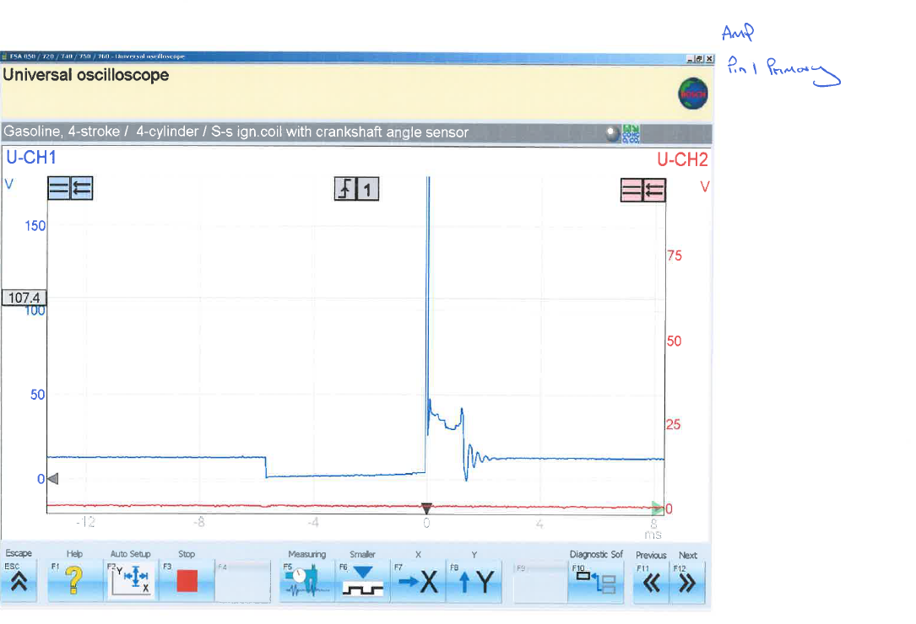
A
B
C
D
E

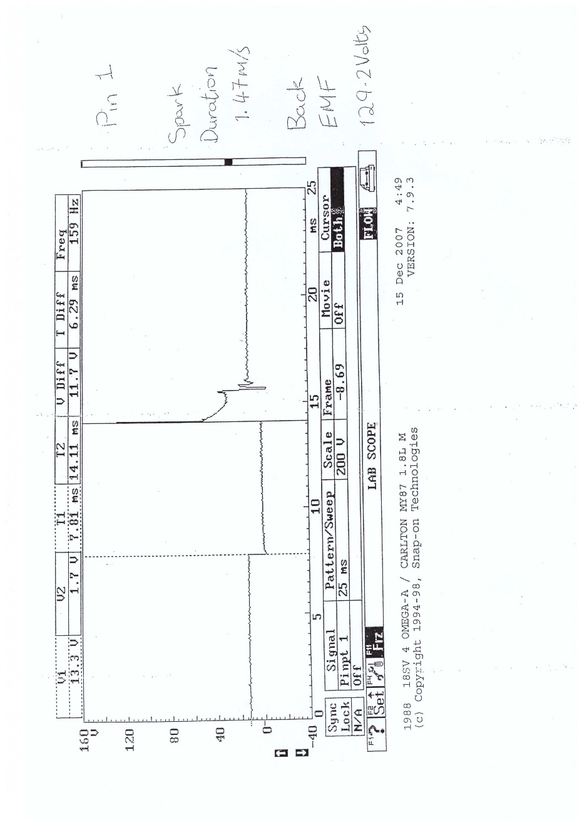
Figure 1 – Primary ignition waveform on the LE3 System
A
B
C
D
E
Figure 2 – Primary ignition waveform on the Motronic systems
The areas labelled ‘A’ in both figures 1 and 2 show a 12v constant voltage. The primary winding is then earthed by the ECU so current can flow in the area labelled ‘B’, where the dwell time occurs. This dwell time is controlled by the amplifier on the LE3, and the ECU on the Motronic, until enough current is built up in the primary coil. The primary winding is then suddenly earthed which results in voltage induction in the secondary winding as the magnetic field collapses. This is the exact point of ignition at point C. High voltage called back emf is seen at point C as high voltage is induced in both primary and secondary windings when the magnetic flux collapses. The spark duration is represented by ‘D’ and the voltage remains roughly constant as the spark is maintained. At point E there are several coil oscillations before returning to the constant 12V as represented by ‘A’. Fewer than 4 or 5 coil oscillations could point towards an issue within the coil. (Denton, 2006, p.55).
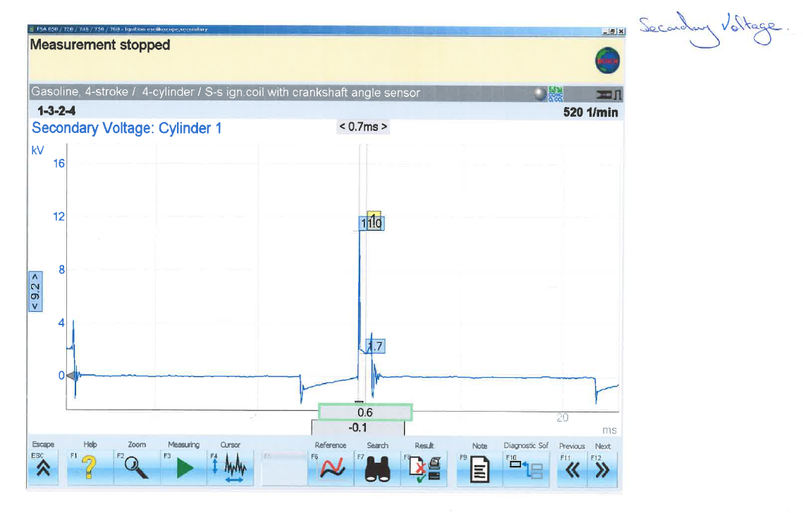
A
B
C
D
E

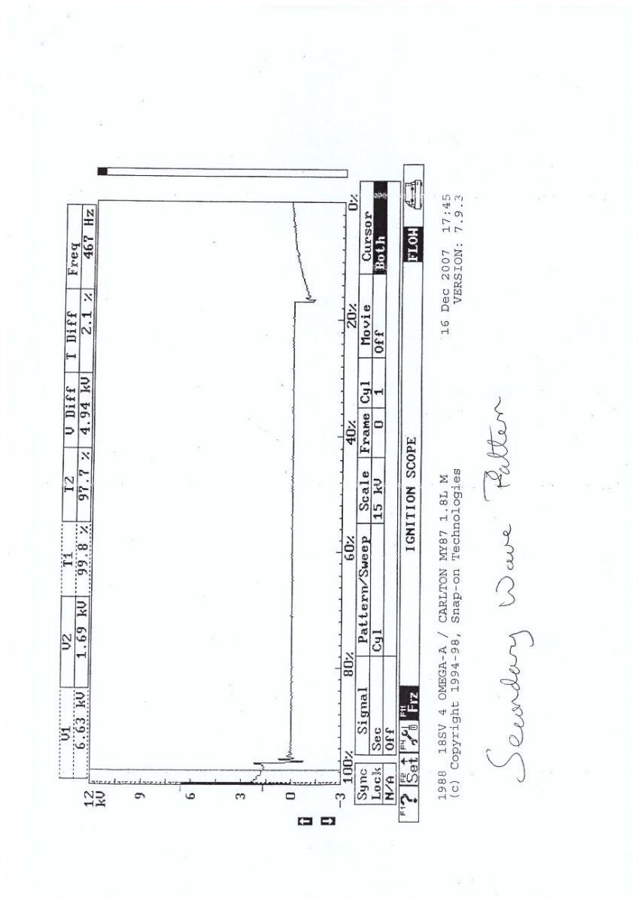
Figure 3 – Secondary ignition waveform on the LE3 System.
A
B
C
D
E
Figure 4 – Secondary ignition waveform on the Motronic System
As can be seen in the secondary ignition waveforms in figures 3 and 4, at point ‘A’ there is 0V, as there is no voltage induced in the secondary winding of the ignition coil . ‘B’ is the dwell time, where the magnetic field is being generated in the coil by the primary windings. Point C is the ignition voltage, showing the initial voltage required for a spark to be generated between the two spark plug electrodes. The value of this initial spike is dependent on the resistance of the air gap between the two electrodes. The area labelled D represents the spark duration, this voltage represents the potential difference required to maintain a spark. Point E is the coil oscillations that occur due to the energy left in the coils but is not enough to maintain a spark. (Denton, 2006, p.56) (Finch and Sutton, 1933).

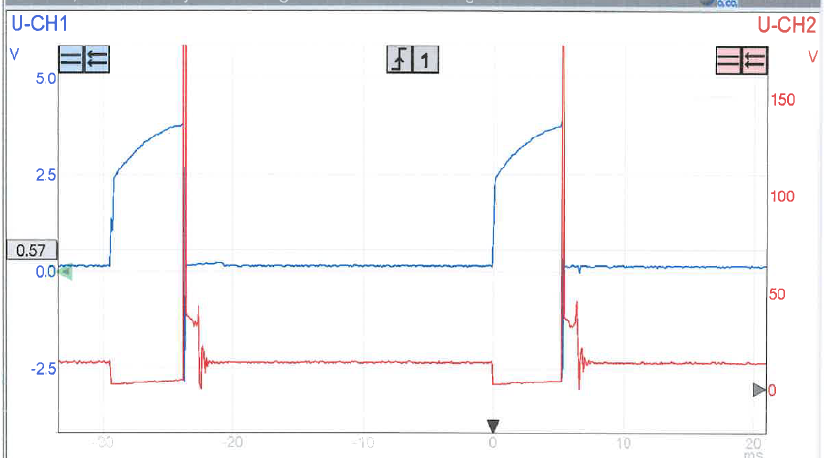

Figure 5 – LE3 system, Channel 1 – amplifier pin 4 spark advance signal, Channel 2 – amplifier pin 1 primary ignition waveform.
As can be seen in figure 5, the spark advance signal on pin 4 of the amplifier controls the dwell time and ignition timing.
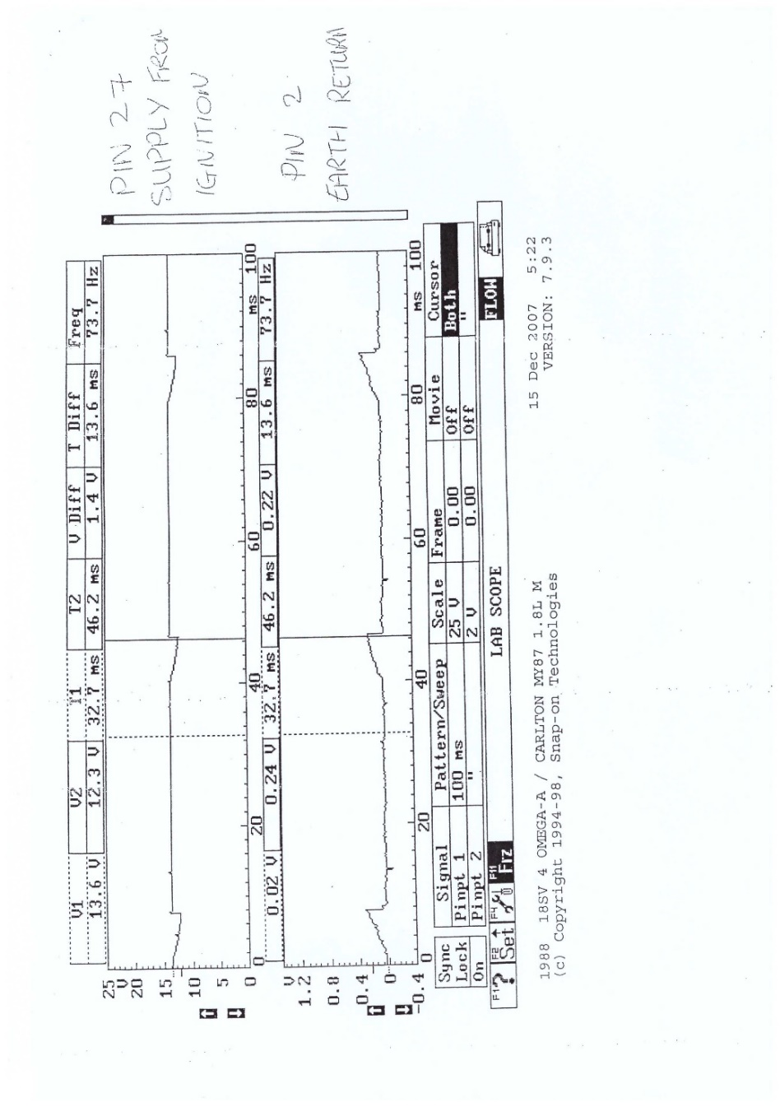
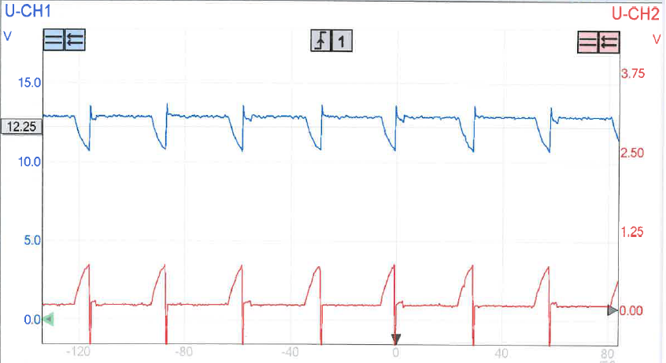
Figure 6 – LE3 amplifier pin 3 12V supply and pin 2 earth return
Figure 7 – Motronic system ECU ignition 12V supply and earth return.
As seen above in figure 6 and 7, the supply signal drops repeatedly due to the ignition coil putting electrical load on the battery. Hence, every time a spark is fired, the system voltage drops. This is mirrored on the earth signals as the massive voltage used to create the spark is earthed through the cylinder head and therefore the system earth will see an increase in voltage until it is dissipated.
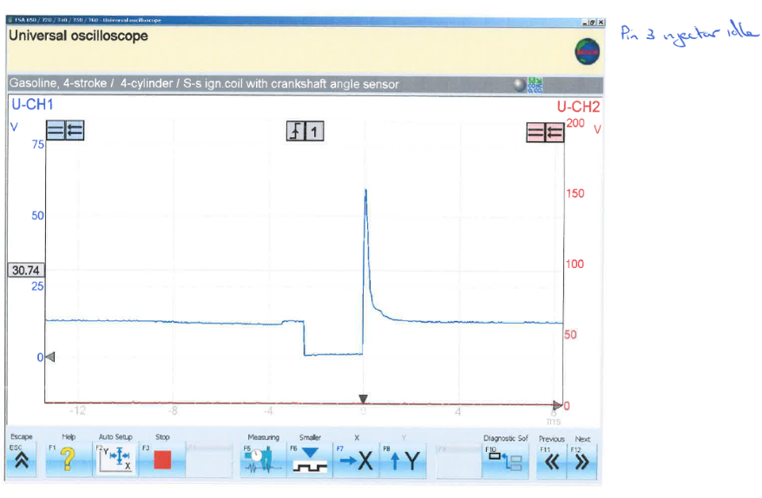
As can be seen in figures 8 and 9, the injection waveform is seen on both systems. At point ‘A’, 12 volts can be seen as there is a 12V feed from the ignition switch but no earth to complete the circuit. At point ‘B’ the injectors are earthed for a variable Injection time to control the air/fuel ratio. At point C, as the earth is switched off, the current stops and back EMF is induced in windings of the solenoid. Hence a spike in voltage is seen before returning to 12V.
Looking at figures 10 and 11, the frequency of injections and the injection time is clearly increased as the RPM increases. This is because a richer mixture is required to increase RPM. Moreover, as the throttle valve is opened, more air is drawn into the engine, hence more fuel is needed to maintain a rich air/fuel ratio for accelerating.
In figures 12 and 13, under deceleration, the injectors are not fired as no fuel is needed as the RPM drops. Once the RPM drops close to idle, fuel will then be injected again to maintain idle. (Wieclawski, et al., 2020)
A
B
C

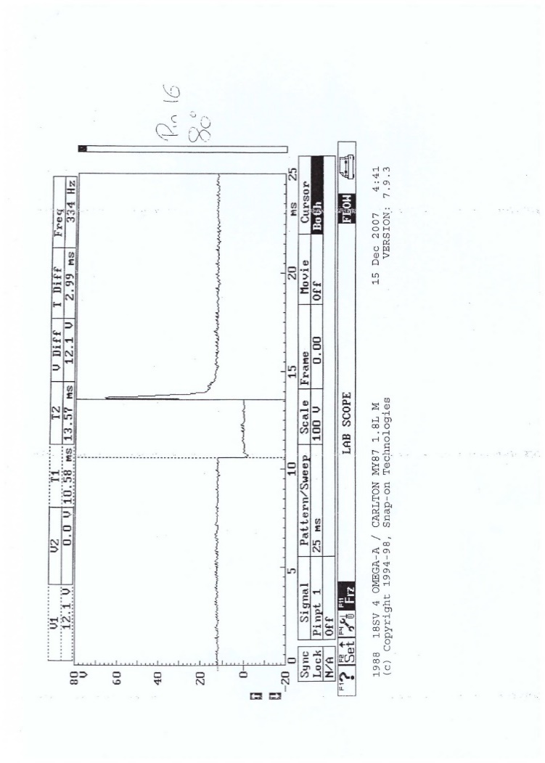
Figure 8 – LE3 pin 3 injection time at idle
A
B
C

Figure 8 – Motronic pin 16 injection time at idle at 80°C.
Figure 9 - LE3 pin 3 injection time under acceleration
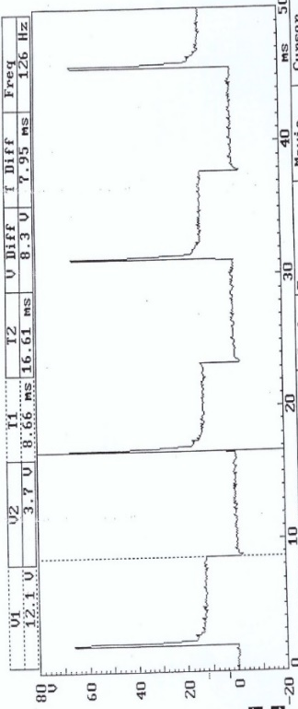
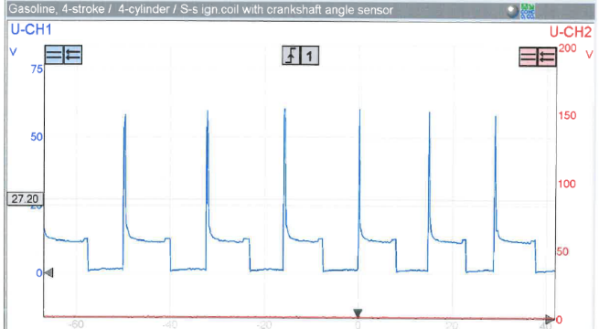
Figure 9 - Motronic pin 16 injection time at idle
Figure 10 – LE3 pin 3 injection time under acceleration
Figure 11 – LE3 pin 3 Injection time under acceleration
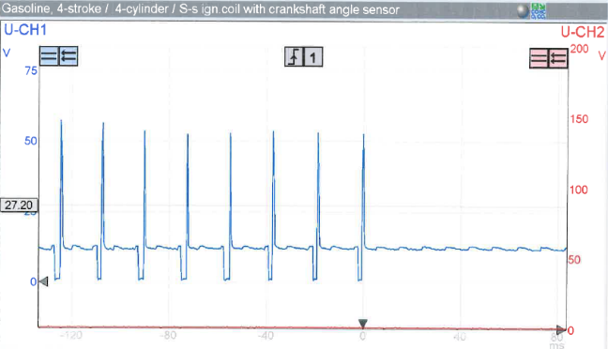

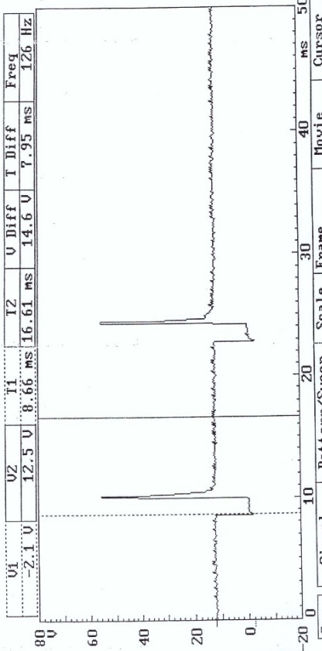

Figure 12 - LE3 pin 3 injection time under deacceleration

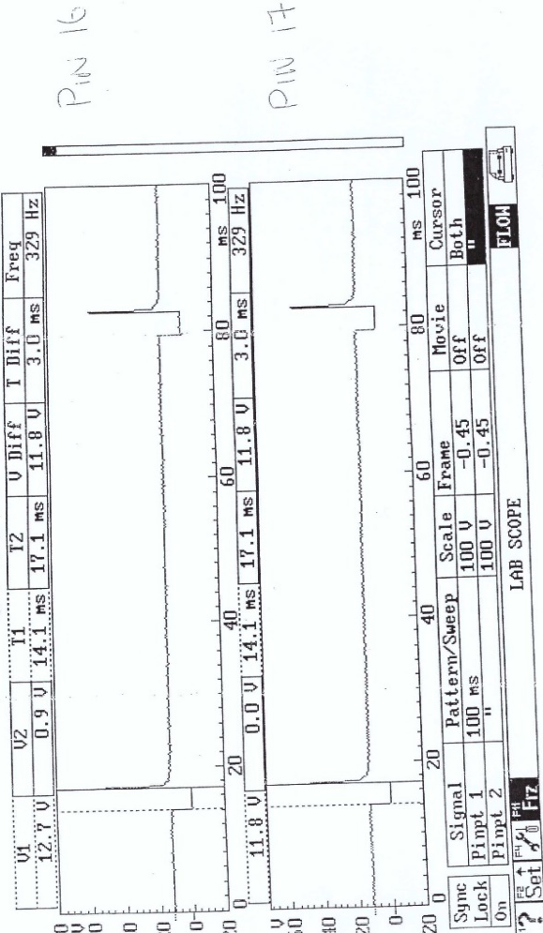
Figure 13 - Motronic pin 16 injection time under deacceleration

Figure 14 – Motronic pins 16 and 17 injection time.
As seen above in figure 14, there are two pins for the injectors. Unlike the LE3 system, the ECU controls the injectors in two pairs as a step towards sequential injection, for better control of the cylinders fuelling.

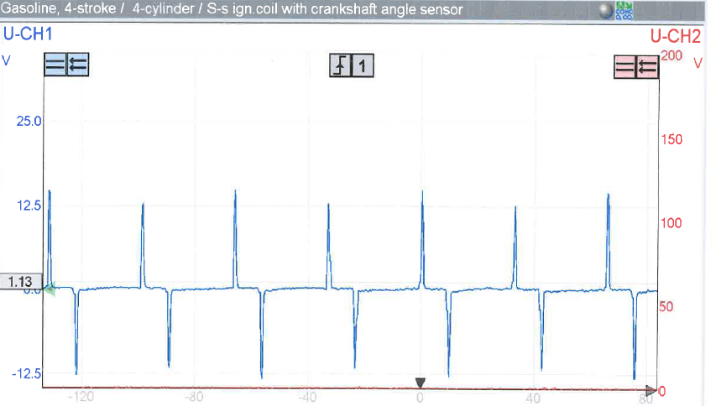

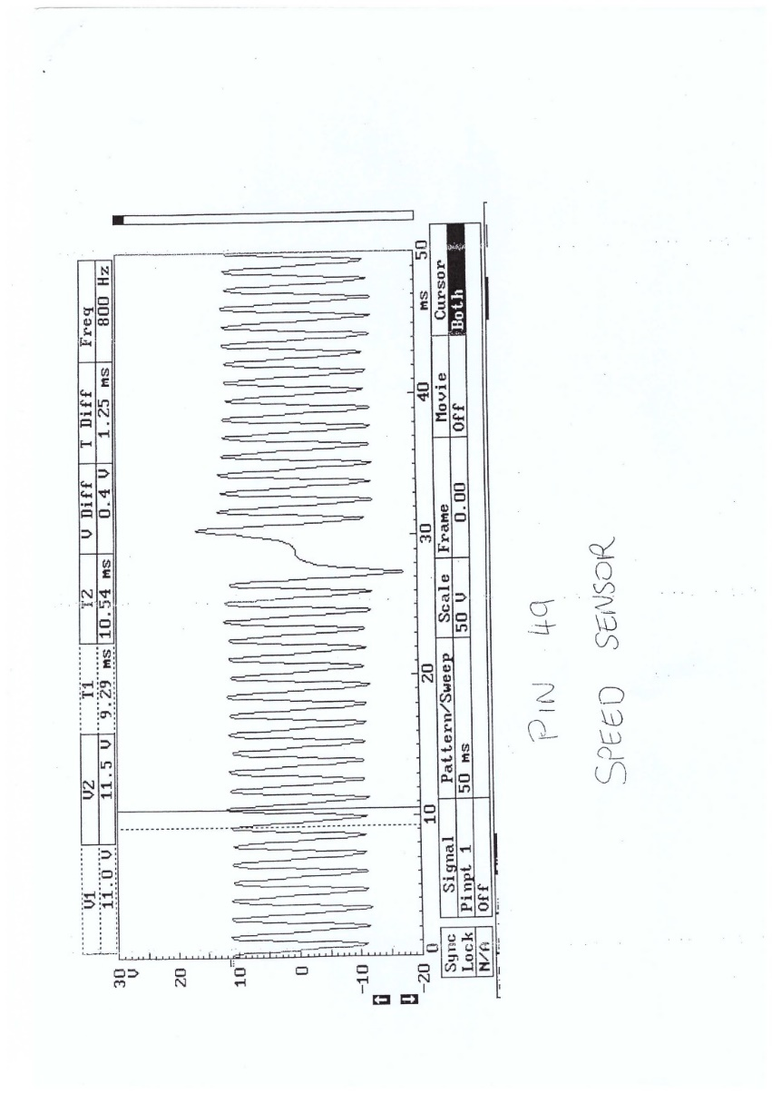
Figure 15 – LE3 System Crankshaft signal on pin 12 of the ignition ECU
A
Figure 16 – Motronic system crankshaft speed signal on pin 49
Figures 15 and 16 shows the analogue crankshaft signal from the crankshaft sensor on both systems. This signal tells the ECU the crankshaft position and speed so that ignition and injection timing can be controlled correctly. Point ‘A’ in figure 16 shows a missing tooth in the timing gear that would depict engine position for the ECU. While the frequency of the waveforms show the engine speed. (Ribbens and Rizzoni, 1989, p.1583)

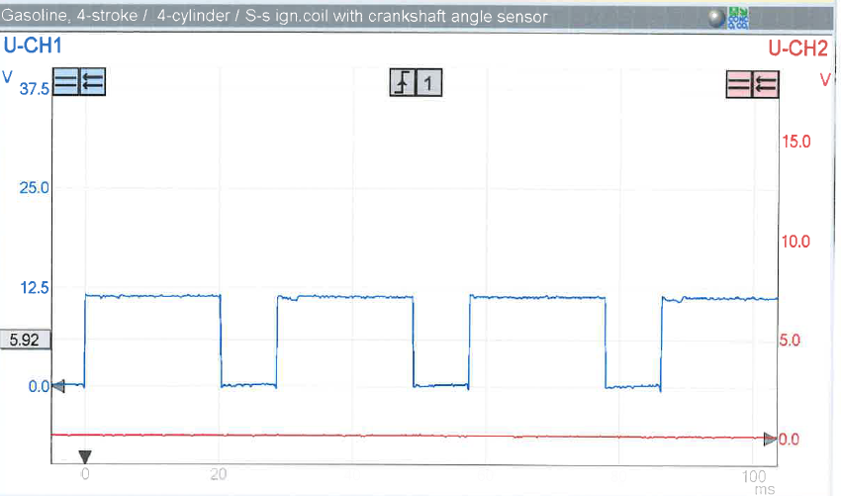

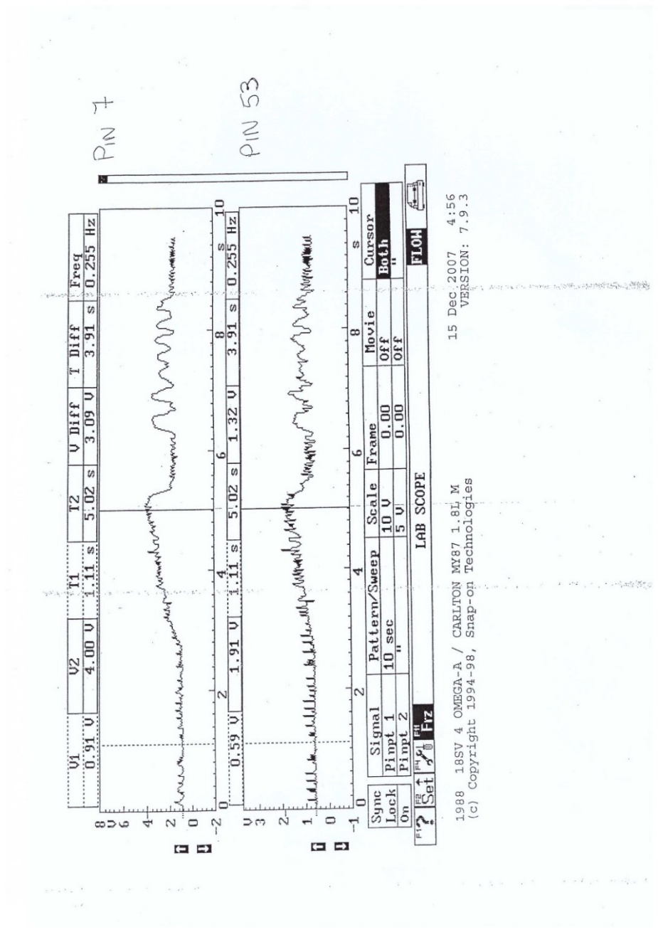
Figure 17 – LE3 Pin 5 fuel ecu speed reference
Figure 17, above, shows a square wave speed reference converted from the analogue signal from the crankshaft sensor by the ignition ECU.

Figure 18 – Motronic pin 7 (air flow meter output) and pin 53 (Throttle Potentiometer output) waveforms
The two waveforms in figure 18 show the pattern of the TPS output and air flow meter output with a blip of the throttle. As can be seen the throttle potentiometer waveform, the throttle is blipped, hence the voltage increases, before being released. This is mirrored on the air flow meter waveform, as the throttle valve opens, more air is drawn into the cylinder, hence more air is passed through the air flow meter. The following oscillations occur as the vane on the air flow meter and throttle valve return to their stops and bounce slightly until coming to rest.

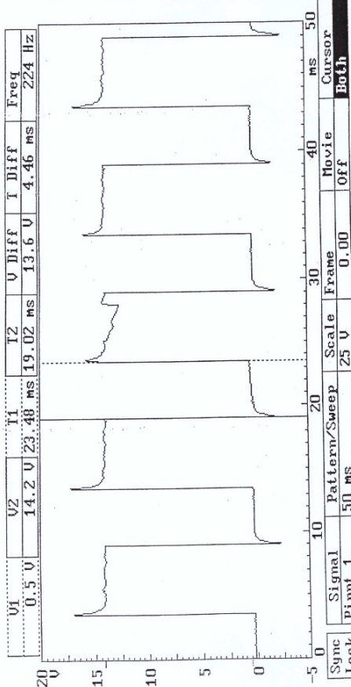

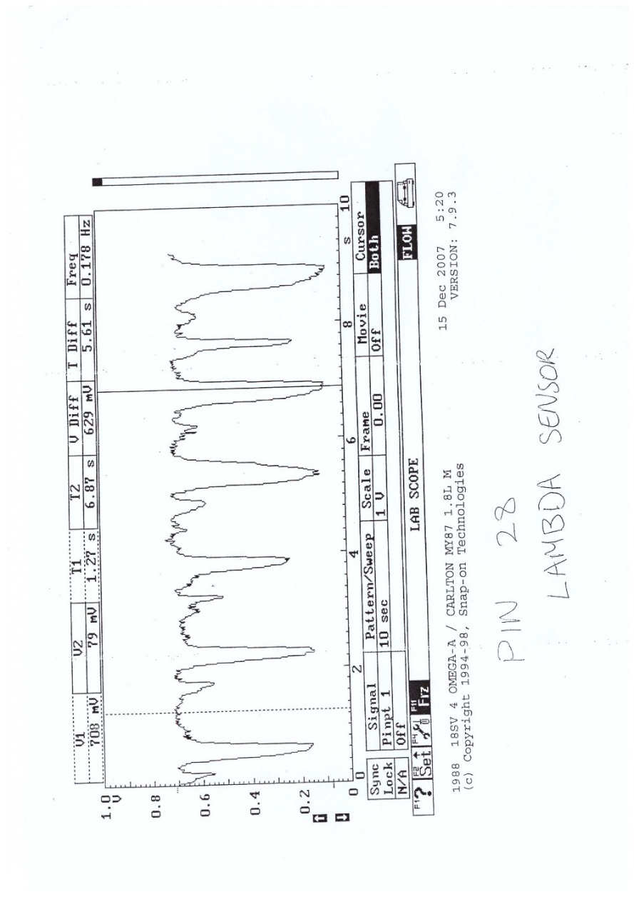
Figure 19 – Pin 4 Rotary Idle valve waveform at 80°C
The rotary idle valve is controlled by the ECU to maintain idle, this is achieved by turning the valve to control the air bypass past the throttle valve. As seen above in figure 19, the rotary idle valve is switched on and off in order to maintain base idle. (Denton, 2006, pp.53-54)

Figure 20 – Motronic pin 28, lambda sensor output.
In figure 20, the lambda sensor is switching as it detects the changes in oxygen content in the exhaust gases, therefore showing how rich or lean the engine is running. Lambda 1 represents a stochiometric mixture of 14.7:1 which is represented by 0.45V. Hence every part of the waveform above 0.45V shows a rich mixture, while everything below 0.45V shows a lean mixture. As can be seen the waveform goes up and down past lambda 1 as the injection time is altered to try and achieve the stochiometric mixture. (Riegel, et al., 2002)

Discussion
From an adaptability point of view, the LE3 is the weaker system compared to the Motronic, largely due to the lack of lambda control. Moreover, the Motronic system has one ECU integrated with ignition and fuelling control rather than separate ignition and fuel ECUs. This reduces delays that the LE3 experiences in the communication of engine speed between the ECUs. The Motronic system also has on board diagnostics which informs the user of any issues that could have a negative impact on adaptability, emissions, fuel consumption and component wear.
As the weaker system, the LE3 could be vastly improved, firstly by adding lambda control. The ability to measure oxygen content in the exhaust gases and therefore calculate the air/fuel ratio is critical for true adaptability of fuelling control. (Jones, et al, 1995) .
The LE3 uses an air flow meter to measure the amount of air intake into the engine. The air flow meter cannot accurately determine the difference between air density and velocity as the vane opens. Moreover, using a vane means there is a physical restrictor in the air intake system. The ECU also has to convert the vane opening reading into a mass value to determine the injection time for the correct air/fuel ratio. This takes time meaning that there will be a delay in any changes the ECU can make. The accuracy of an air flow meter can also be effected by gravity and vibrations. A mass air flow (MAF) sensor would be a suitable improvement as it directly measures the mass of the air being drawn into the engine, therefore the fuelling and ignition control can be quickly and accurately adapted to changing air density and temperatures. (Sumal, J., S., and Sauer. R, 1984)
Knock occurs when the air and fuel mixture in the combustion chamber detonates early. A knock sensor picks up the vibrations caused by knock and therefore the ECU can retard the ignition timing to avoid it. Meanwhile, when there is no knock detected, ignition timing can be advanced until knock begins to occur. (Ulsoy, A. G., Peng, H. and Cakmakci, M., 2012, pp.124-125) A knock sensor would be a good improvement to the LE3 system as it allows the ignition timing to run closer to the knock limit, this improves engine performance and efficiency as it allows the mixture more time to burn, for a more complete combustion process. (Kaji. K, et al.,1986) A knock sensor would therefore be a good improvement for improved adaptability of the ignition timing.
An ambient pressure sensor for adapting to changes in altitude would benefit the LE3. This would allow for the injection time to be altered to retain a good air/fuel ratio at differing altitudes and therefore air densities. (Martinez, 2022)
Lastly, the LE3 system could be improved greatly by having individual control over each cylinder by use of sequential injection. With the ECU having control over each injector individually, and therefore having much better control and accuracy of the air/fuel ratio. This finer control means that the fuelling can adapt more precisely to changes in external factors. (Kovalov and Plys, 2022)

Conclusion
As outlined in this report, the ability for a control system to be accurate and be able to adapt to external factors is critical. The merits of doing live testing was also expressed for proper diagnosis of faults. As the air temperature and pressure of the workshop was not able to be maintained constant, there may be a degree of inaccuracy in the results gained.
From the readings and waveforms taken, the operation of each component was explained and how well they can adapt to differing environments. The LE3 system is definitely the weaker of the two systems with regard to adaptability and accurate control, hence was chosen to suggest modifications to make it more adaptable. With use of the more modern developments discussed, the LE3 could have a much finer control over the ignition timing and injection time.

References
Denton, T. (2006) Advanced automotive fault diagnosis. 2nd ed. Amsterdam : Elsevier BH.
Dietsche, K.-H. and Reif, K. (2018) Bosch Automotive handbook. 10th edition, revised and extended. Karlsruhe: Robert Bosch GmbH.
Finch, G.I. and Sutton, R.W. (1933). The control of ignition-coil discharge characteristics. Proceedings of the Physical Society, 45(2), p.288-306
Frosina. E, et al. (2018) Evaporative emissions in a fuel tank of vehicles: numerical and experimental approaches, Energy Procedia, Volume 148, Pp. 1167-1174,
Fulcher, S. K., et al. (1995) The Effects of Fuel Atomization, Vaporization, and Mixing on the Cold-Start UHC Emissions of a Contemporary S.I. Engine with Intake-Manifold Injection. SAE Transactions, vol. 104, pp. 2345–65
Giorgio Rizzoni, Simona Onori, Matteo Rubagotti (2009) Diagnosis and Prognosis of Automotive Systems: motivations, history and some results, IFAC Proceedings Volumes, Volume 42, Issue 8, Pp 191-202
Health and Safety Executive (2008a) COSHH SR14: Vehicle exhaust fume
Health and Safety Executive (2008b) COSHH SR24: Storing chemical products
Jones. V. K., et al., (1995) Identification and Air-Fuel Ratio Control of a Spark Ignition Engine, IEEE Transactions on control systems technology, Vol 3, No 1, pp.14-21.
Kaji. K, et al. (1986) Development of Knock Sensor, SAE Transactions, vol. 95, pp. 315–323.
Kovalov. S., and Plys. S, (2022) Design of Control System for the Gas Engine With an Electronic Control Unit and Sequential Fuel Injection, Eastern-European Journal of Enterprise Technologies, pp. 96–104.
Martínez. J, et al. (2022) Effects of altitude in the performance of a spark ignition internal combustion engine, Materials Today: Proceedings, Volume 49, Part 1, Pages 72-78,
Patel. K.D, Subedar. D, Patel .F, (2022) Design and development of automotive catalytic converter using non-nobel catalyst for the reduction of exhaust emission: A review, Materials Today: Proceedings.
Ribbens, W. B., and G. Rizzoni., (1989) Applications of Precise Crankshaft Position Measurements for Engine Testing, Control and Diagnosis. SAE Transactions, vol. 98, pp. 1582–96,
Riegel. J., Neumann. H., Wiedenmann. H.M., (2002) Exhaust gas sensors for automotive emission control, Solid State Ionics, Volumes 152–153, Pp. 783-800
Schuett, J. A and Peckham. T. J, (1986) Advancements in Test Cell Design. SAE Transactions, vol. 95, pp. 912–23.
Sumal, J., S., and Sauer. R, (1984) Bosch Mass Air Flow Meter: Status and Further Aspects, SAE Transactions, vol. 93, pp. 812–21,
Szabó. R, Gontean . A, Lie. J, (2010) The Oscilloscope as a Digital Display, IFAC Proceedings Volumes, Volume 43, Issue 24, Pp 171-176,
Tektronix (2008) Oscilloscope Fundamentals, Accessed at: https://engineering.case.edu/lab/circuitslab/sites/engineering.case.edu.lab.circuitslab/files/docs/Oscilloscope_Fundamentals_-_Tektronix.pdf (Accessed on: 14/4/2022)
Turkani, V.S. et al. (2018) A carbon nanotube based NTC thermistor using additive print manufacturing processes, Sensors and Actuators A: Physical, 279, pp. 1–9.
Ulsoy, A. G., Peng, H. and Cakmakci, M. (2012) Automotive Control Systems, Cambridge: Cambridge University Press
Wiecławski. K, Maczak.J, and Szczurowski. K, (2020) Electric Current Waveform of the Injector as a Source of Diagnostic Information, Sensors 20, 4151.
Zavaragh. G. H., Kaleli. A., Solmus. I., Afshari. F, (2021) Experimental Analysis and Evaluation of Thermostats Effects on Engine Cooling System, Journal of Thermal Science, Vol. 30, pp. 540-550.
Zhang. M, et al, (2018) Effect of Al2O3-SiO2 substrate on gas-sensing properties of TiO2 based lambda sensor at high temperature, Ceramics International, Volume 44, Issue 3, Pp 3000-3004,

