

Mohammed Abdul Farhan P147765
Civil Engineering & Environmental Management
Geology and Soil Mechanics

Assignment 1
Laboratory Soil Work Experiment

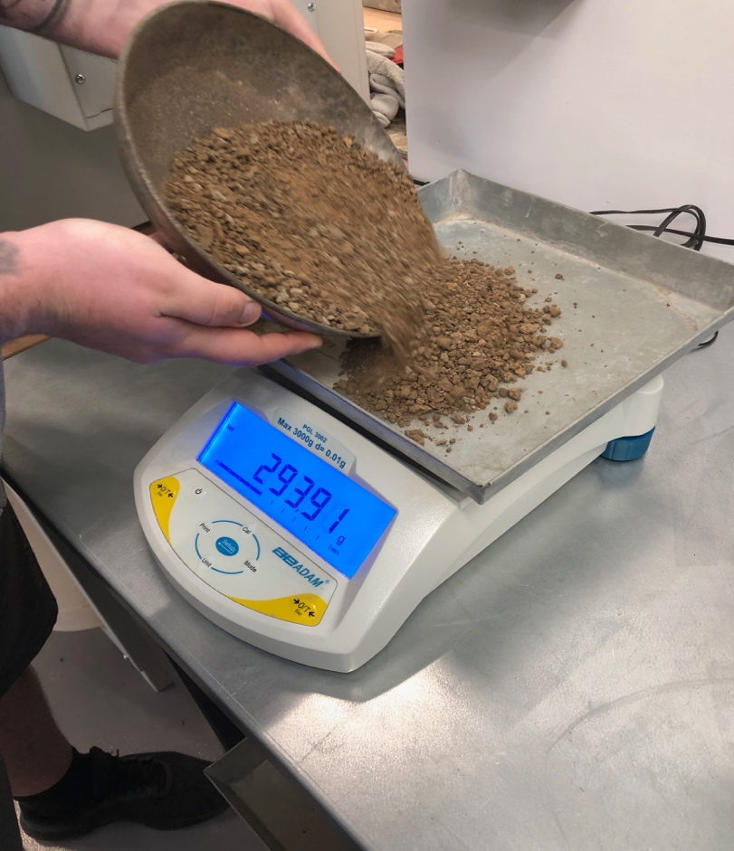

Lecturer- Allan Nantel
Geology & Soil Mechanics

Content

- Introduction………………………………………………3
1.1 Equipment…………………………………………………3
1.2 Safety Procedures……………………………………..3
- Methodology…………………………………………….4
2.1 Sieve Procedure…………………………………………4
2.2 Liquid & Plastic Procedure…………….…………..6
- Results and Analysis………………………………….8
3.1 Sieve Results………..……………………………………8
3.2 Plastic & Liquid Results(Atterberg limits)…..8
3.3 Liquid Limit Graph……………………………………..9
3.4 Sieve Analysis Graph………………………………....10
- Conclusion………………………………………………...11
4.1 Any Problems encountered/resolved….…….12

All photos and image are personal images used from the testing’s, no reference used due to it being an individual own write up of experiment.
All phots and images were taken on 19/03/2019 during experiment using personal mobile phone.

- - Introduction

This written report is outlining the stages and methodology used to do the following test; sieve analysis of soil, liquid and plastic limit determination using Atterberg Limits. There were several requirements and procedures to follow from the British Standards (BS410-1). The outcome from these tests is to identify the soil sample from high grades of sands to clay and to identify through the stages of different sieves and look at the weight using various methods which is to be explained further on. Once the sieve analysis has been completed we moved onto the plastic and liquid limit determination following the Atterberg Limits and looking more at the timings and how long it takes for the soil to form to its original position along with oven baking to determine moisture content after left in the oven for over 24 hours and taking precise readings.

1.1 – Equipment

- Scale pan
- 1kg Soil
- Set of 8 Sieves (including Pan)
- Vibration Control Machine
- Steel Lock bar with plastic locks
- Brushes
- Manual weight Scale (up to 10KG) + Electronic weight Scale (up to 3KG)
- Plastic sheets (to pour soil from sieve)
- Tin steel plates
- 7 plastic containers
- Clay, soil and water
- Metal mixing bowl, Spatula, Gauging Groove Tool
- Cassagrande Apparatus
- Baking oven

1.2 – Safety Procedure

It was essential that a skilled work technician was present in the workshop, this was mainly due to being supervised and if there were any unfortunate accidents. Signing a form to show who was in the workshop start and finish time was crucial to identify if anything went wrong who was there and at what time. Using the correct safety protection in the work place that the supervisor seemed necessary. Ensuring that yourself and others in the work shop are all safe whilst carrying out the test. Always being safe and responsible is key.

2.0 - Methodology

2.1 - Sieve Analysis Procedure

BS 410:1986 – this is the correct standard which is used for sieve analysis for soil testing and classification.
Sieving equipment, Sieving, Screening equipment, Test equipment, Particle size measurement, Holes, Size, Framed structures, Dimensions, Stacking, Marking, Wires, Cloth, Meshes, Sheet materials, Perforations, Acceptance inspection, Calibration, Maintenance, Screening (sizing). Firstly, the sample was taken and was put in equal quarters of the sample soil which was 250g of the 1kg and weighing it bit by bit until the correct amount was reached the 1000g (1kg). Both forms of weighing were used, firstly, it was crucial to use the manual scale and ensure that it was dead on the 1kg then for an even more accurate weight using the electronic scale and ensuring that it was reset to 0 with the scale span on there and pouring over the soil sample and gained an accurate weight.
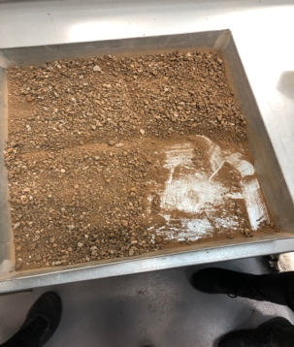
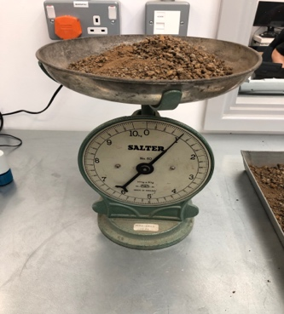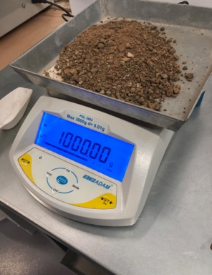
Once the weight has been measure, progression was made to move onto the Sieve containers. Making sure that the largest opening was on top which in this testing scenario was 4mm down to 80mic and the pan for the excess. It was vital that once taking the sieves off that someone was there to guide and ensure that none of the soil sample was left or dropped, as this would give an unfair reading to the testing. Therefore once we placed the sieve on top of the plastic sheet to remove into using a bristle brush and flipping over the sieve and brushing the excess left over as every soil sample grain makes a difference for the results. This part of the test was performed exactly the same for each of the set of sieves to obtain correct and accurate results. Once the first sieve sample was ready to be weighed, the sample was transferred from the plastic sheet onto a pan and reset the electronic scale so it was on 0000.00 with the empty pan and pouring the sample into the scale.
(Here are two images of the Sieve analysis containers which was used for this testing)
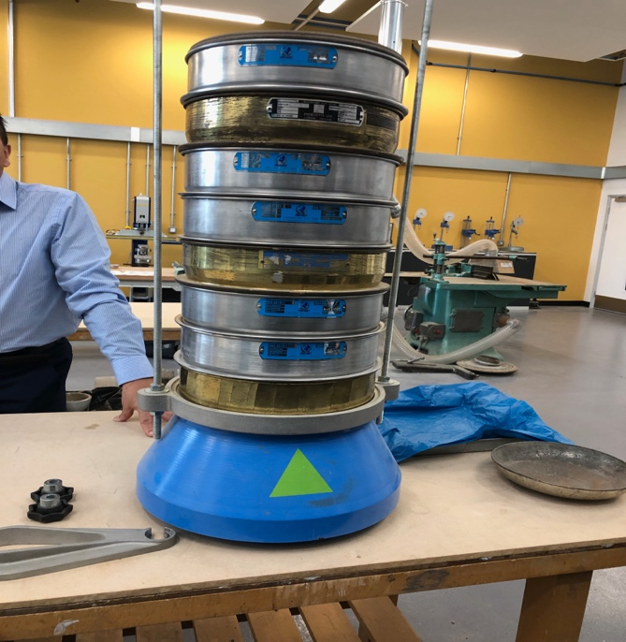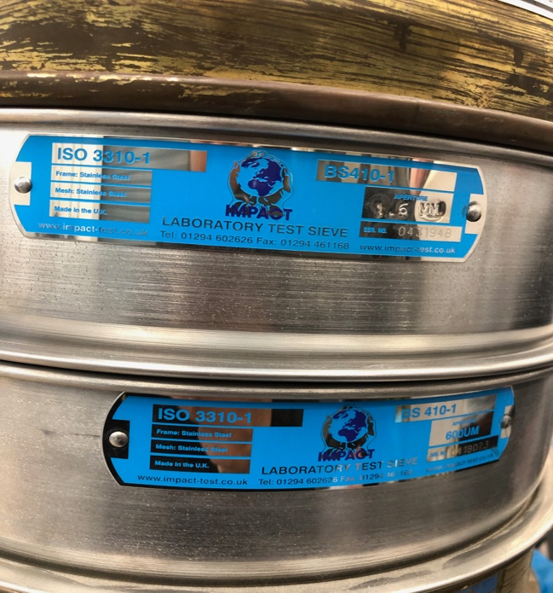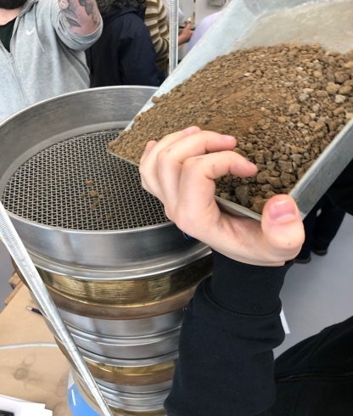

(Images represents different weights of soils from the sieve, Taken with phone 19/03/19)
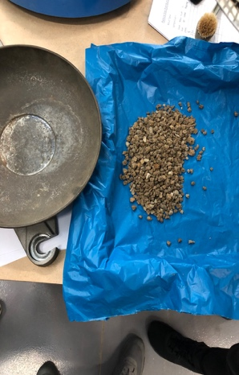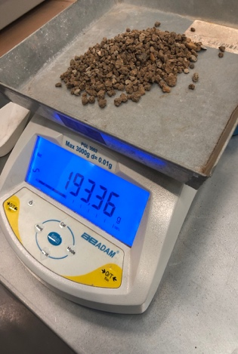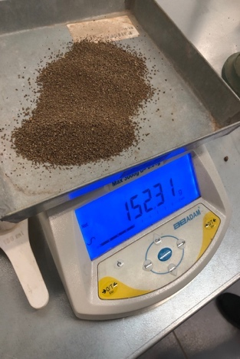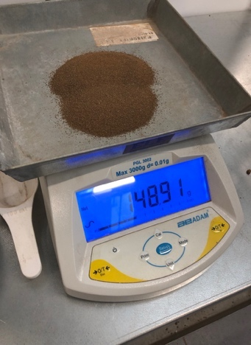
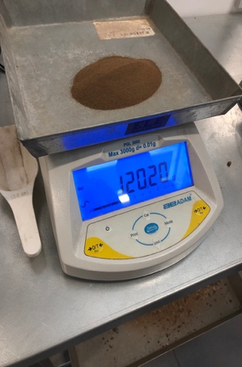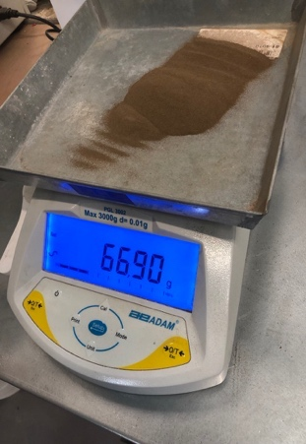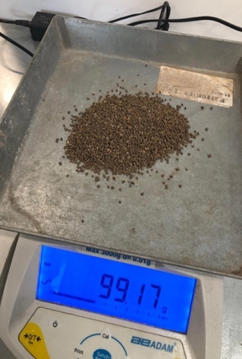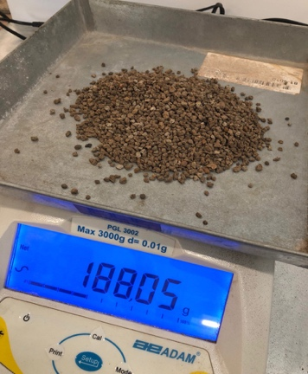
Above are the results image obtained from the different set of sieves which can be identified with 3.1 Sieve Table Results. As you can see the different grade of soil as it enters through different sieve sizes, from rocky sands to fine clay. Going back to saying any small sample change will result in the whole testing being irrelevant and void as this does not give accurate substantial results which was needed to understand the process and involvement within this soil sample. Once the results had been obtained it was then transferred into a table for reference.

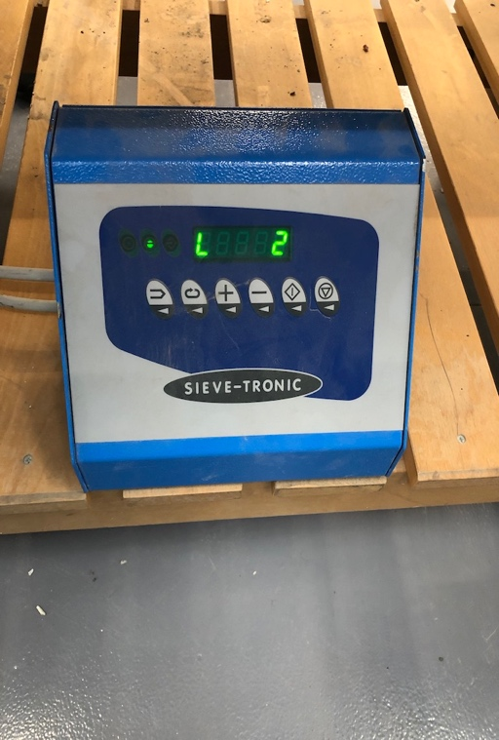
This Vibration control machine was used to vibrate the sieve machine and was set to a duration of 2 minutes to ensure the soil sample full passed through the sieves and into the correct grain sample. The machine has various settings and speed and it was important to make sure that the parameters of the machine was set to my specification for my testing. Before ensuring the machine was switched on, making sure that the lock bar was in place onto of the sieve just in case the sieves were not secure on their own.

2.2 - Liquid and Plastic Procedure (Atterberg Limits)
The Liquid procedure was very straight forward. Firstly, 4 containers are used and recorded their individual weight and once the weight had been recorded, Once this step was completed, placing a soil sample of around 250g into a metal mixing bowl and then mixing it thoroughly along with small samples of water around 1-2ml by stirring, kneading and chopping with a spatula. The mix will continue until a clay consistency will require around 30-35 drops of the Cassagrande apparatus to cause a groove gap closure of 12mm. However this consistency requirement is only trial and error only until the required consistency is reached. Once this step was completed, a sample from the mixture into the cup bowl, and ensuring it was fully flat and used a spatula to do this. Roughly the depth across the base which is aimed for 10mm and making sure there was no air bubbles to affect the sample. Return any excess soil to the mixing bowl. Use the gauging groove tool to cut a groove right through the sample to the lip of the cup base. Zero the drop counter on the cup apparatus. Life and drop the cup by turning the crank handle at a rate of around 2 turns per second and this was calculated as the number of blows and was done until two of the halves separated closed over a distance of 12mm which was made with the gauge tool. The number of blows was then recorded once the gap was closed to a full.
In addition, after this stage was done, remove a slice of the soil the width of the spatula from edge to edge across the sample cutting through the groove and this was then placed in the marked container which was the weight of wet soil and container together and a reading of weight taken. This was repeated for all 4 samples and gradually increasing moisture content slowly, to then reduce the number of blows to close the gap. The aim was to obtain samples that required above and below 25 drops to close the gap. The range was around 35-15. Finally, dry the four samples in the oven for a set time of 24 hours with right temperature and came back and weighed the dry sample and container together to determine the moisture. To calculate dry soil was to take the weight of the container from the weight of dry soil and container. Also, to calculate moisture content, divide the weight of moisture by weight of dry soil and times it by 100 to obtain the moisture content.
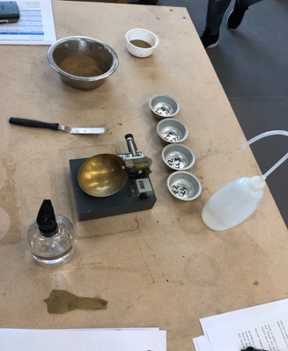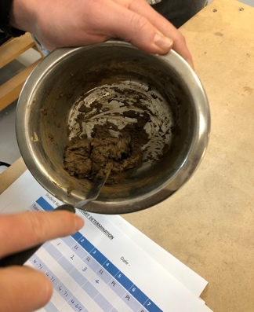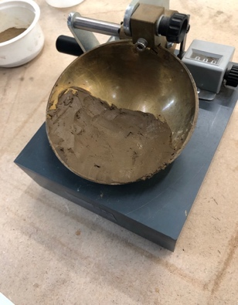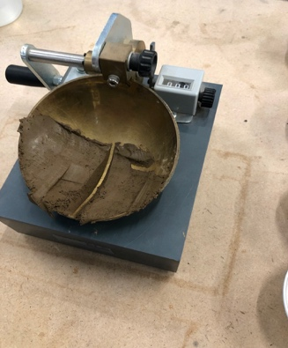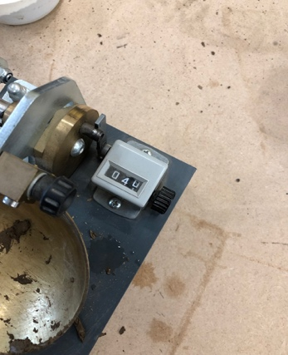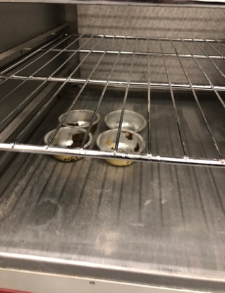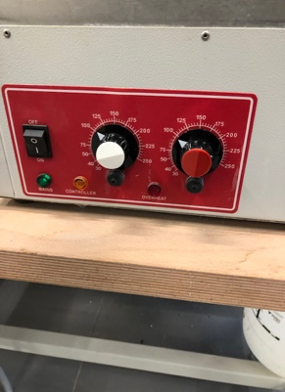
The plastic procedure which was done for this testing was fair steady and easy to follow. The test was to carry out the Atterberg Limits test with the available cohesive clay test sample. Firstly, same as the liquid process choose, mark and weigh 3 containers not 4 in this testing. Once the weight had been recorded in the table booklet which you can source from 3.2 - Plastic and Liquid Table Results Page 8. Thoroughly knead the clay sample and if needed mix with water or even dried clay to adjust the moisture content to required limits. Once the limits are met, mould a small ball of clay between the fingers and roll between the palms of the hands so that the warmth of the hand dries it slowly. So then when the slight cracks begin to appear on the surface, divide the ball into three equal sections roughly weighing 10g each and ensure they are fully separated. By measuring against the rod given, roll each ball into a thread on the glass plate of around 6mm in diameter. It is vital that the thread must be intact and also homogenous. Steadily applying pressure with the palm of the hands to reduce the diameter of the thread to around 3mm, this was repeated until the thread started to crumble at around the 3mm diameter mark. It was extremely important to maintain uniform rolling pressure throughout this was due crumbling being defined as shearing both longitudinally and transversally as it is rolled. Crumbling had to be down to the fact that the moisture reduction was rolling directly and losing its form, and not by mechanical breakdown due to the undue pressure from the hand. The plastic moisture content is reached once the crumbling point has taken place. After this process, gather all the crumbling soil and placed them in the container and took the reading when it was weighed and noted it down on the table the wet and soil container together. This process was repeated for all 3 samples. Then dry the 3 containers inside the oven and also left them for over 24 hours and came back and took the readings. Once it was fully dry, calculate the moisture content by weighing the container and dry soil together. Take the average of all 3 results and obtained the moisture content mean. This moisture content mean is the plastic limit moisture content indicator.
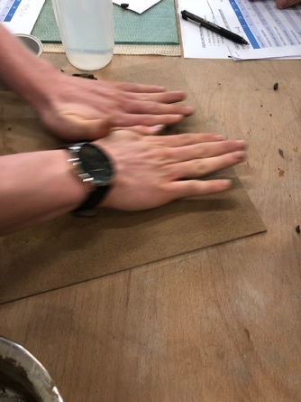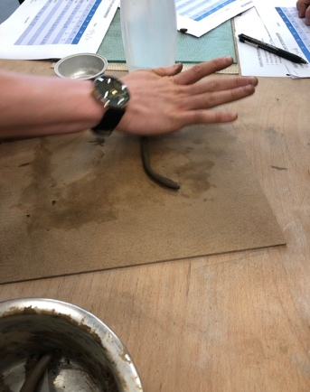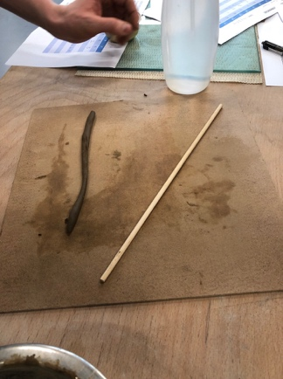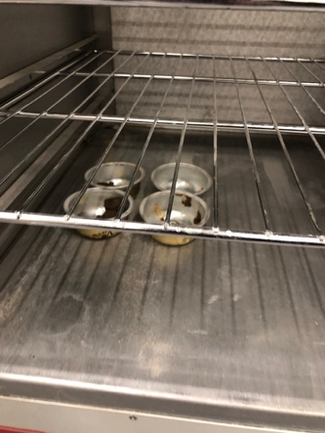
- - Results and Analysis

Overall the results obtained from the Sieve testing was very impressive due to the amount of the soil sample retained. Started with 1KG of soil, and once the sieve testing was underway and the vibration machine had started and finished for 2 minutes, the sieves for each sample was calculated and weighed. The soil retrieved was 99.873g which ensured that the sample was successful with only 0.127g loss.
The plastic and liquid was more to determine results and have a comparison and contrast between wet soils and dry soils, along with durations. Once the weight of. The dry soil and container was obtained after leaving the containers in the oven for 24 hours, the results were obtained to calculate the moisture content along with the weight of moisture. There were no blows to count for the plastic testing as this was more of a physical manual process rolling the soil samples until the breaking and shear points were reached.

3.1 - Sieve Results Table
Sieve Size (mm) |  | Mass (g) | % On Sieve | % Passing
4 mm |  | 193.35 | 19.335 | 80.665
2.36 mm |  | 188.06 | 18.806 | 61.859
1.6 mm |  | 99.15 | 9.915 | 51.944
600 um |  | 152.31 | 15.231 | 36.713
300 um |  | 148.91 | 14.891 | 21.822
160 mic |  | 120.20 | 12.02 | 9.802
80 mic |  | 66.90 | 6.69 | 3.112
Pan |  | 29.85 | 2.98 | 0.127
Total (1KG) | Difference  1,000-0.127= 99,873

From the 3.1 table of results, I have analysed that overall from the 1KG of soil used as part of the sieve testing, the difference left over is 0.127 and the retrieved soil was 99.873g.

3.2 - Plastic and Liquid Table Results
 | 1 | 2 | 3 | 4 | 5 | 6 | 7
Type of test | LL | LL | LL | LL | PL | PL | PL
Container Number | 1 | 2 | 3 | 4 | 1 | 2 | 3
Weight of wet soil + cont | 12.65 | 13.05 | 17.30 | 16.74 | 6.65 | 7.46 | 12.07
Weight of dry soil + cont | 10.52 | 10.57 | 14.06 | 13.71 | 6.36 | 6.85 | 10.41
Weight of container | 4.71 | 4.71 | 4.71 | 4.69 | 4.72 | 4.74 | 4.81
Weight of moisture | 2.13 | 2.48 | 3.24 | 3.03 | 0.29 | 0.61 | 2.29
Weight of dry soil | 5.81 | 5.86 | 9.35 | 9 | 1.64 | 2.11 | 5.6
Moisture content | 36.6 | 42.3 | 34.6 | 33.4 | 17.6 | 28.9 | 40.9
Number of blows | 26 | 16 | 40 | 58 | N/A | N/A | N/A
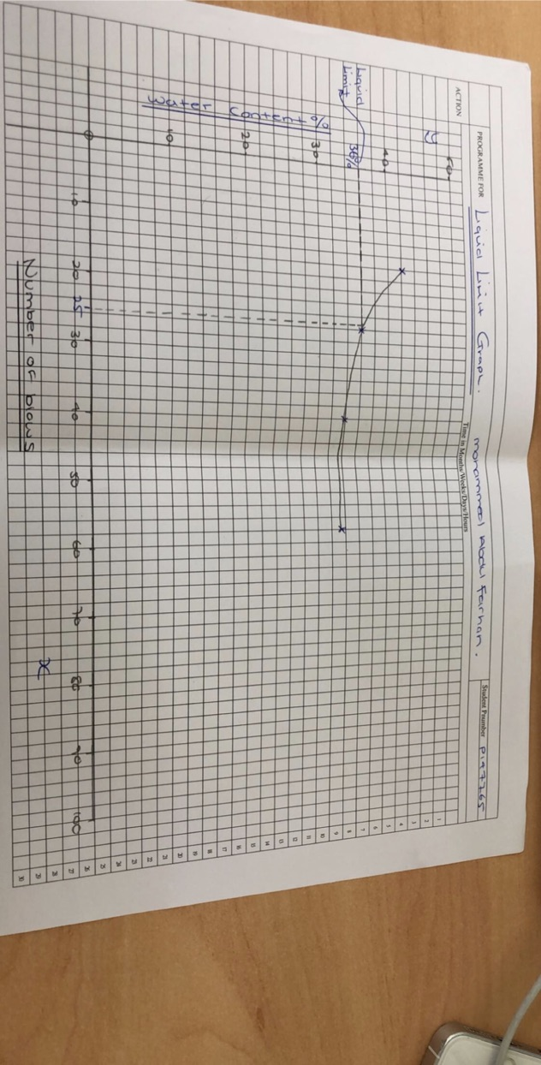

3.3 – Liquid Limit Graph

The graph identifies the amount of blows needed to calculate the liquid limit, in this scenario marking off at 25 blows gave me a reading of 36%.

Liquid Limit =36% (mark off 25 blows to water content)
Plastic Limit=29.13% (Average of all 4 moisture content)
Plasticity Index=6.87 (Plastic limit – liquid limit)
Soil Classification= ML or OL
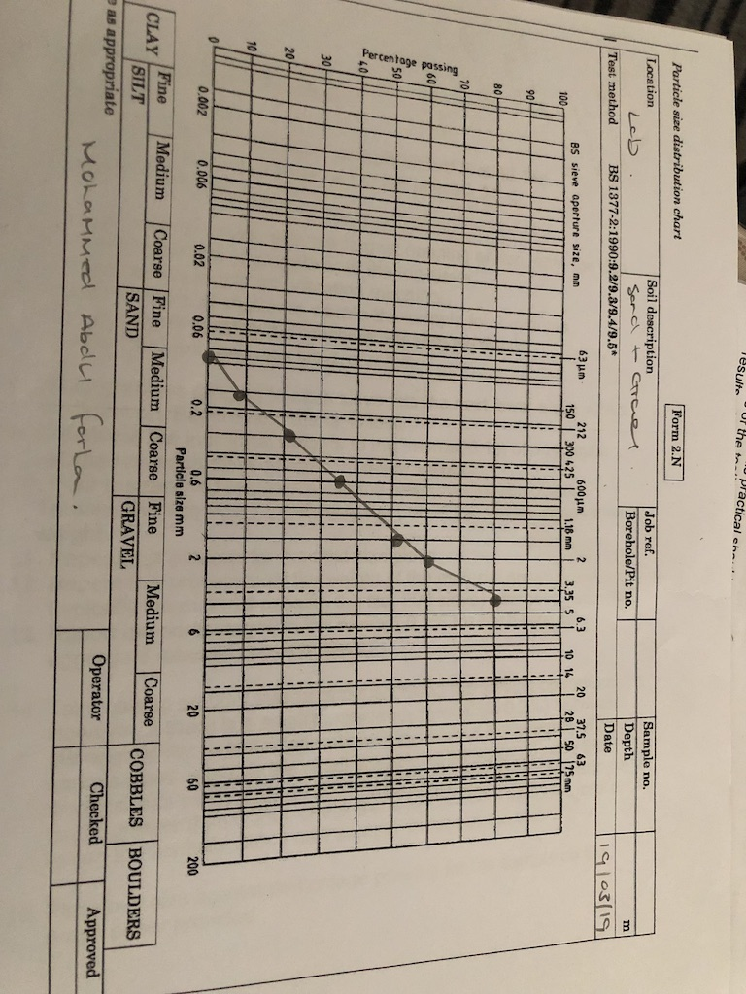

3.4 – Sieve Analysis graph

The representation of this graph illustrates the percentage of soil passing through each sieve apparatus. As the sieve size gets smaller less percentage escapes leaving more soil sample. With this representation you are able to identify where soil classification has its highest passing and its lowest.

- - Conclusion

Sieve analysis:

Question 1. From A civil engineering perspective and in consideration of the areas of soil mechanics studied to date, what is the purpose and value of this analysis method?

Answer. Sieve analysis is a very important process and experimental practice in civil engineering, the main aim is that it is used for finding particle size distribution of particular aggregate. Additionally for finding the fineness modulus of aggregate. Particle size distribution ensures the different sizes of aggregates and helps in classification for example either fine or coarse. The more fine the particle sizes are you able to determine the maximum amount of aggregates lying in one particular size of sieve of given total aggregate. The actual size of the aggregate is important as it has its influence in strength of concrete the desired size should be known to mix to get the correct and desired characteristic strength of concrete. To get better interpretations of sieve analysis graphs are always worth having a look at.

Atterberg Limits:

Question 1. What is the significance of the plastic limit for a soil?

Answer. The plastic limit significance of a soil is the measure of plasticity within soil. Plasticity index is the size of the range of water contents where the soil exhibits plastic properties. The Plasticity index is the difference between the liquid limit and plastic limit. Soils with a high plasticity index tend to be clay, those with a lower plasticity index normally are silt and finally those with a plasticity index of 0 have little or no silt or clay. The plastic limit determines the water content in percent at which a soil can no longer be deformed by rolling into 3.2mm. those limit of soil are very important property of fine grained soil and its value is used to classify fine grained soil and calculate activity of clays and toughness index of soil.

Question 2. What is the significance of the liquid limit for a soil?

Answer. The moisture content at which any increase in the moisture content will cause a plastic soil to behave as a liquid. The limit is defined as the moisture content, in percent, required to close a distance of 0.5 inches along the bottom of the groove after around 25 blows in the Cassagrande apparatus cup bowl. It is important as it shows the water content at which soil changes from a plastic to liquid behaviour, those limit of soil are very important property of fine grained soil and its value is used to classify fine grained soil and calculate activity of clays and toughness index of soil.

Question 3. How do these values relate to the stability of soil slopes?
Make reference to a reported example from archives.

Answer. The values shows the procedure of what happens with soil as it comes into contact with the inclined soil or rock slopes to withstand or undergo movement. A slope can be globally stable if the safety factor, computed along any potential sliding surface running from the top of the slope to its toe, it will always be larger than 1. The factors which influence the slope stability, shear strength of the soil, unit weight, embankment height, slope steepness and pore pressure within the actual soil. The stability is determined by the balance of shear stress and shear strength. The values shows the stability increasing from dry soils and the increasing number of blows to get the soil to compact together and you can understand and determine the type of soil which you are dealing with and whether it would be ideal for the structure in which you want to build. The wet soils shows me an increase in weight and this can be due to environmental factors.

4.1 Any Problems encountered/resolved

Whilst doing the experiment for both the sieve analysis and also the Atterberg limits, there wasn’t any problems which was encountered, this may be due to it being fairly straightforward procedure. As long as the procedure sheet which was made was followed, it would be hard to get any problems from the experiment.

Pictures are all personal images taken during the experiments using mobile phone, the date 19/03/2019 by Mohammed Abdul Farhan in IQ building Laboratory room. No references were needed.

