Student Name : Roman Ziga
Student Number : 1913284
Module Title : Effective Team Work and Communication
Assignment Title : Effective Team Work and Communication
Lecturer Name : Rita Ukachi-Lois

_______________________________________________________
University of Wales

Effective Team Work and Communication

Contents
Abstract 4
Introduction 5
Teamwork 6
How to manage teamwork effectively: 8
Communication 9
Importance of team communication: 10
Why communication is important: 11
Understand the skills for communication: 12
Conflict in communication: 14
Communication Theory: 15
Communication Model: 16
Written communication format 18
Recommendation 20
Conclusion 21
Bibliography 22
Appendix: 1 23

Abstract
It is crucial to consider many factors in doing projects in a team. To accomplish the project, it is important to work effectively. In working effectively in a team, it is essential to take consideration of many issues like what kind of communication mode needs to use and environment of the team. It is very crucial to have proper communication skills to run the team effectively. To run a team effectively there are many theories and models of communication that need to be considered. This whole assignment is based on the teamwork and communication and this will help to understand how teamwork works and what is the importance of communication in the teamwork and the ways to improve the efficiency of both teamwork and communication.

Introduction
What a person can do, can be done in seconds by a team. For this reason, to work efficiently it is important to form a team as more persons can work together to solve critical problems. As we will form teams then it is also important to work efficiently in the teams and for that, there are some tactics and elements to follow. And there is the crucial importance of communication to work smoothly in a team like briefing about the tasks that need to be performed by a teammate and there are some issues to be considered to have good communication in the team, and all this is thoroughly elaborated in this assignment.

Teamwork
Teamwork means a group of people work together to attain some predetermined goal and it will be a formal group (Frazer, 2009). In teamwork, various group members work together who are from different backgrounds and when they try to solve any particular problem Generally, we can focus on the study team, sports team, or corporate team where all the people in the group works with a specific problem to solve and they try each other to reach a common solution and they did it within a specific time.
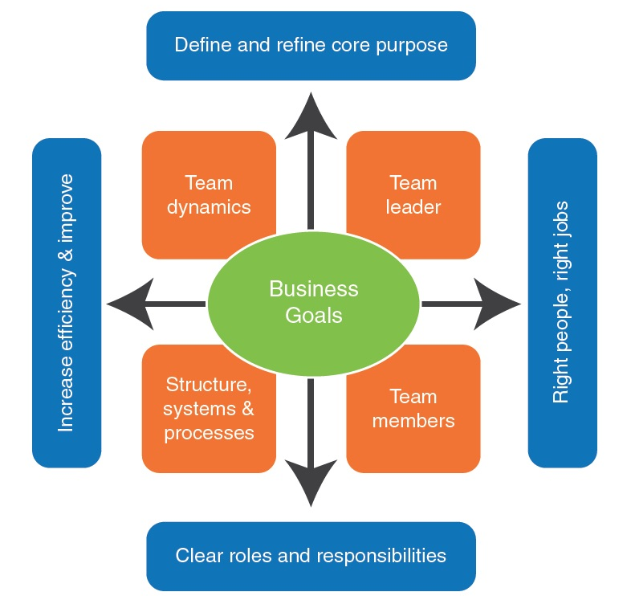
It is very crucial to operate effectively in teamwork to attain the desired outcome and it needs participation from every member and for making teamwork effective some issues are very important to consider and those are elucidated below-
Lead by example: It is very crucial to illustrate the mode of communication and how to work to participate in the problem solving to the members to make a team more effective. A team leader should ensure it in the team works to effectively attain the predetermined outcome of the teamwork.
Building trust and respect: It is very important to have trust in the team to work more efficiently where everyone can trust each other. This kind of environment should be built by the leader by taking some necessary steps and it is very crucial to attain the goal of teamwork.
Be social: By being social, performance can be enhanced in groups. The team members can pass some time with each other in the tea stall where they can gossip about some issues and this will create an understanding between them and it will help in the teamwork. For this reason, a leader should encourage team members to be more social.
Open discussion: There should be an environment of open discussions that will enhance the chance of giving opinions. If all the members of a team can give their opinions then all the members can brainstorm about the ideas and this will create the possibility of a better outcome and by this team, performance will enhance.
Specific role and responsibility: The team members and their roles and responsibility should be cleared from the beginning and this will help the members to work for a certain purpose.
Set the goal: A goal needs to be set for the members by a leader and this will help the team member to work more diligently to achieve that goal and it should a measurable one which has a specific time to achieve.
Appreciation of work: When a team member gets appreciation for his/her good performance then he/she tends to give better performance for the team and it should be ensured by a leader and other team members will also be inspired by this.
Feedback: Giving feedback is very crucial as by this a team member can know about his performance and according to the feedback, he/she can modify his/her working procedure or he/she can increase his/her work efficiency (Gordon, 2001).

How to manage teamwork effectively:
Teamwork must be efficient so that they can achieve the predetermined goal and for that, a leader needs to continuously push the team to work effectively and there are some steps which can be followed to manage team work more effectively and those are elucidated below-
- Clear objective: A team’s objective needs to be set at the very beginning and it will help them to work according to the objective requirement and time-bound should be added with the objective.
- Ground rule setting: For the meeting, there should have some effective rules like everyone needs to attend the meeting at a predetermined time rather they will be punished like the missed person will give a treat to the other members. In this way, time can be saved in a great deal.
- Proper communication: In a team, there should have proper communication among all the members of the team, and the leader, for example, the leader must know that what the members are doing and the way they are following to do so.
- Agree on goals: The goals of the team should be set by talking every team member's opinion and in this way, all the members will be motivated to the goal and will give their best performance to activate that goal.
- Clarification: A team leader should clarify all the terms to the teammates and with the members can do their assigned duty without any hindrance like if a teammate knows what he is doing and why he is doing then it will give him a better understanding of his value in the team.
- Meeting minutes: It is very important to take a record of all the activities of the meeting like what idea was proposed and what was the outcome and what decision was taken. And this will help the team in the future in following up.
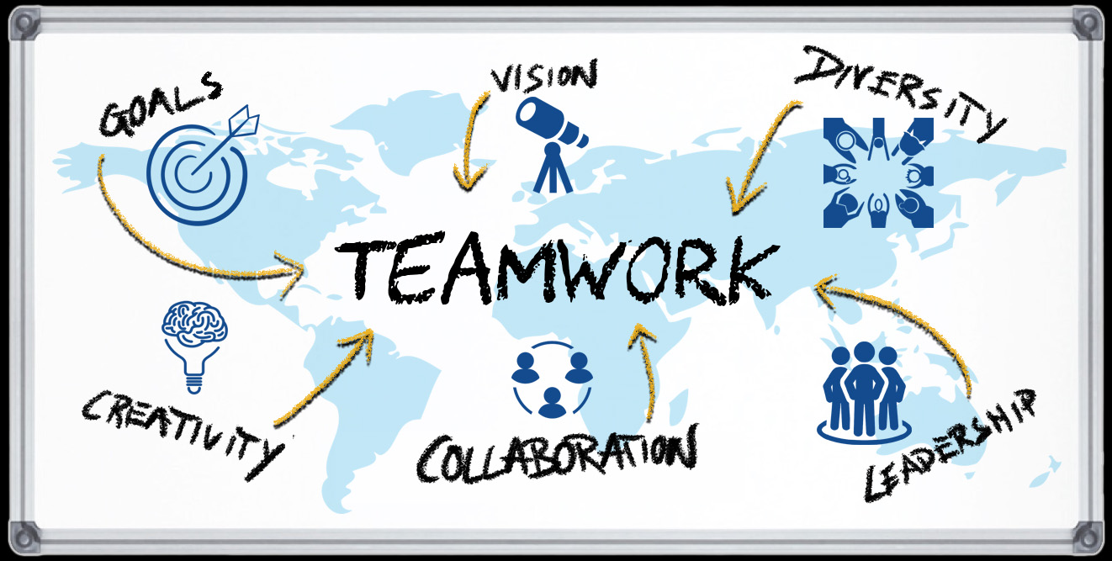
- Follow up: In teamwork, there should have the nature of following up like how much progress is happening and what goal is achieved and what is due. All the members need to accomplish his duty within the due time then the next assignment will be given to that group.

Communication
Communication is a process of transmitting information from one place to another place and it occurs between a minimum of two persons and there can be more than 2 persons like communications between the groups. There are different modes of communications like from one person to many persons is an example of team communication. To have a communication there must have some terms like a sender and a receiver.
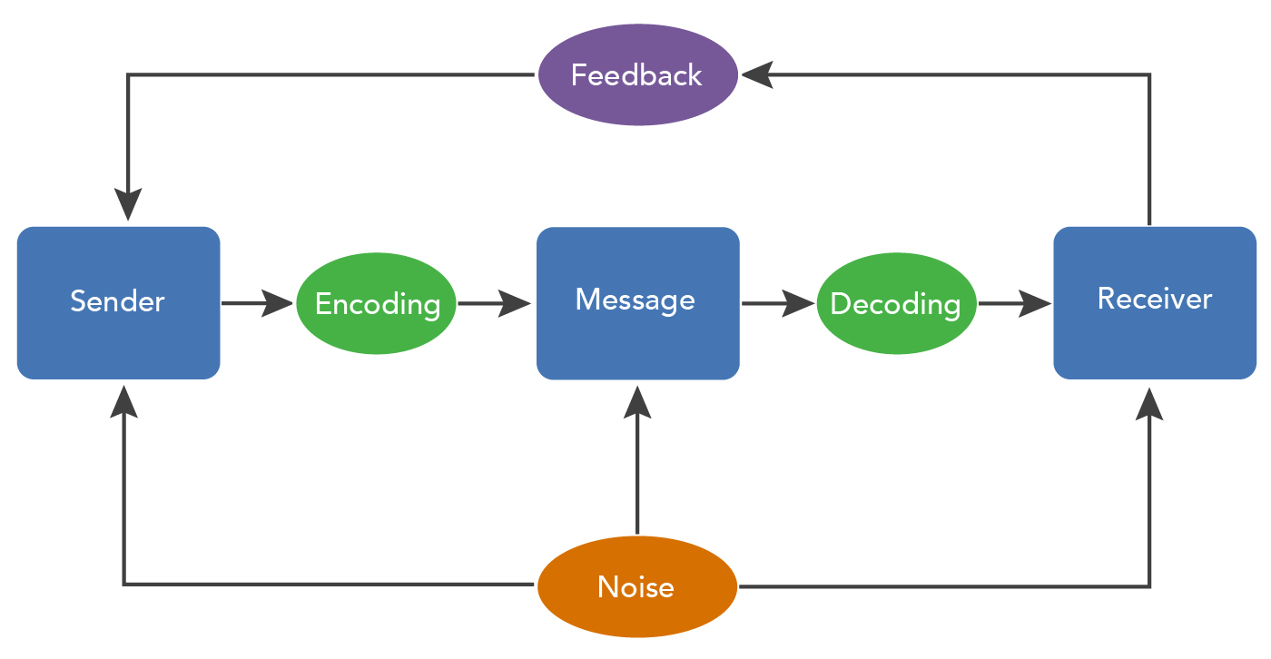

Importance of team communication:

On communications, there were many activities in the classroom and it is evident to be clear how important proper communication is to achieve the predetermined objectives. To accomplish a desirable target in a team it is very important to have proper communication between the team members otherwise it will be difficult to attain the goal within the due time.

In a team there may have many different experiences, some are negative and some are positive and these have their impact on the goal of the team. For example, sometimes it is seen that the assigned task to a team is not completed within the due time and it is maybe in the workplace but it happens for the lack of participation of the team members. It happens because other group members do not have that good communication skills.
It is very crucial to have a good relation among the team members to make proper communication. For example, Unilever Co. always tells their success story with their team members and this enhances the relationship between the team members as it inspires them (Cartwright, 2002).
As a result, efficient communication is very important for the teams to attain predetermined goals. Though it is very tough to have both efficient teamwork and communication in a team if both are absent then there is no possibility to get to the predetermined goal.

Why communication is important:
There are various reasons behind the importance of communications and those are elucidated below-
- Improving employee engagement: If there are proper communications then all the members will be easily engaged in the teamwork. Employees can know their duties properly and they can know what is their purpose in the team and this will engage them more in teamwork.
- Improves knowledge sharing: Every employee is from different backgrounds and they have different bits of knowledge about different fields and with proper communications, those will be shared among the employees and it will enhance the knowledge of the employees.
- Building trust: With proper communication, there will have a smooth conversation between the members and leaders, and all the employees will be able to share their opinions and this will increase the trust of the employees among themselves.
- Achieve the goals: If there is proper communication in the team then all the teammates will be ensured their duties properly and they will know what to do to accomplish their assigned job and this will facilitate the way of achieving the predetermined goal.

Understand the skills for communication:
Proper skills of communication help in many ways like it help others to know what is the information and why it is for. It is evident from the records that with good skills in communication, a person can achieve success in his/her career. In the USA, LinkedIn surveyed the most important soft skills to have in the corporate world and in that survey, communication was the topper of the chart.
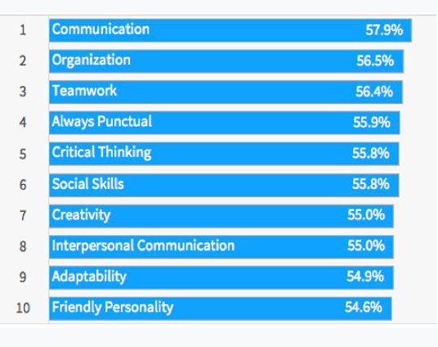
From this survey, it is evident that in this modern era, how important to have the skill of proper communication (Peters-Kühlinger, 2017).
Interpersonal communication needs to be enhanced to properly conduct the communication process efficiently and the techniques to do so are elucidated below-
- Active listener: To have good interpersonal communication the first most important thing to do is to listen actively to what the teammates or the leader are saying.
- Concise message: The message what is needed to be conveyed must be in a short but appropriate form so that everyone can easily understand the teammate's point of view and what the teammate is trying to say.
- Body language: Body language is the most crucial part of communications and if the body language is good then half the communication is already established. There are some techniques to have a better body contract like maintaining eye contact with the audience and using the gestures of the hand.
- Be confident: To have a confident voice is very helpful in communication as this attitude helps to convince the audience to listen to what the presenter is trying to communicate.

- Respectful: It is very important to respect the other group members as all the teammates are equal. For this all the teammates should give the chance of expressing their opinion, with this, there will establish two-way communication which is very important for effective communication.
- Presentable: If a teammate is presentable then it becomes easy for him to convince the other team members to listen to him diligently but it is hard to attain this skill but it can enhance communication skills profoundly.
- Correct medium use: It is a great skill to have as there are different modes of communication to choose from. For example, if a teacher wants to communicate with the students about the assignment then he/she can do this over email.

Conflict in communication:
As there are different types of members in a group from different backgrounds and they gave different perspectives so there may arise some conflicts among the team members and some common conflicts that arise in the teams are elucidated below-
- Wrong information pass: It is not possible for any team member to have all the needed information and if that person gives wrong information instead of the actual information then there will be some confusion related to that information and this will create conflict between the team members.
- Communication gap: If 2 teammates are assigned in a single task and one member does all the work without giving any feedback to the other member then there will be a communication gap as the 2 members should do that task together and for this conflict will arise.
- Lack of response: If teammates do not respond in time then the conflict can arise as any member can require help or something else anytime during the work time in a team.
- Communication style: If the style of communication is not chosen properly then the conflict can be arisen for example choosing an email to communicate a piece of information but don’t inform the other hand about the email.

Communication Theory:
There is some communication theory to improve the commutation in the team working and those are elucidated below-
- Critical theory: This theory explains the limitations of the communication process. In this theory, social and political discourse is emphasized and it tells that these terms can create problems as they may defend the norms of different persons. (International Communication Association, 1999).
- Information theory: According to this theory, all the relevant information should be given to all the teammates and there should not have any misconduct and this will enhance the effectiveness of the communication.
- Diffusion theory: This theory emphasized the new ideas that one team member expresses and how the social members relate to that new idea. This theory also tells that interpersonal communications and mass media can be used to share new ideas (McQuail, 2012).
- Groupware theory: According to this theory, all the team members can easily share their ideas and views with the other team members and discuss issues and can easily communicate with the other team members.
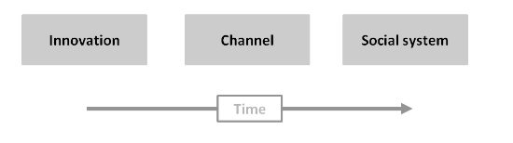

Communication Model:
There are some model of communication which are very helpful to increase the efficiency of an organization or teamwork and those are linear, interactive and transactional model of communication and these are elucidated below-
Linear model: In this model, if the information is provided properly then the feedback can be given otherwise there will be no feedback. In this model, there are different kinds and those are elucidated below-
- Lasswell model: In this model different acts of communication are described properly for example what was said and by whom, used mode of communication, and the destinations of the information. Moreover, the result of saying is also illustrated in this model. This model was 1st illustrated by Harold Lasswell (Smith, 2008).
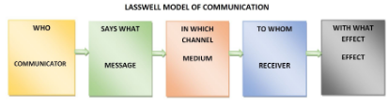
- Aristotle’s model: It is a one-way communication model where the speaker speaks for his audience and this model was illustrated by Aristotle. This model is completely based on the speaker.
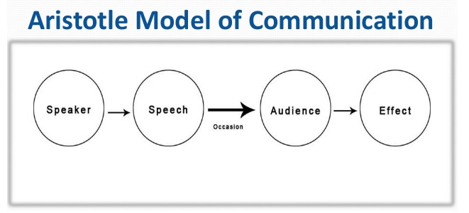
- Shannon Weaver model: This model is completely based on the sender and receiver and this tells how effective communication can be maintained between these two sides. This model also acknowledges the noise in the communication process which can create hindrance in the process and this was illustrated by Shannon Weaver who was a mathematician (Holden, 2006).

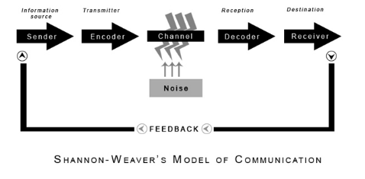
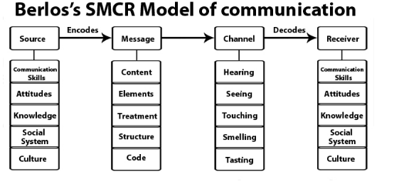
- Berlo’s S-M-C-R model: In this model of communication some elements are discussed like a source of the information, message, mode of the channel, and the receiver. In these elements, more sub-elements help the process to appropriately transfer the message from the source to the receiver with the help of encoding (Schulz, 2010).

Transactional model: In this model, only nonverbal feedbacks are discussed like body gesture and language. In this model, to effectively communicate both the sender and the receiver plays a crucial part. This theory is used in different social programs and cultural orientation.
Interactive model: In the transactional and in the interactive model, there are some similar things like both the models is in two may communication. This model is hugely used in internet platforms where the main focus is on sharing videos and news.

Written communication format
There are different types of written communication format which used in different organizations and the classroom activities and those are elucidated below appropriately-
- Business letter: This is one kind of letter which is used in the business industry. This letter used in communicating various company-related information with external and internal users. The structure and format of this letter should be very simple so that the user can understand the letter very easily. This type of letter expresses the issues which are compulsory to continue to conduct the nosiness smoothly.
- Email: In this modern world, for working smoothly and to conduct different communications in seconds, email is a must for every business sector and the digital format named email can help the organizations in communicating different information in seconds. With the help of email, a large amount of information can be communicated within a few seconds. This helps the teams to accomplish their goal in a short time as it saves time and this also reduces their workload.
- Business proposal: This is one kind of formal communication format and this is used by the seller of a product of an organization. Basically, with the help of this proposal, a seller tells or requests the buyer to get the product or service from the business organization. In this proposal, the product detail is mentioned like why the buyer should get, what kind of benefit the buyer will get from the product, what should be the pricing policy and many more issues regarding the product.
- Case study analysis: Case study analysis used by the teammates to solve any issues regarding the business. For the students, it is also important as with the help of this, they will be able to know the in and outs of the business. To conduct a case study among the teammates, cases different parts should be assigned to different members. There should have a checklist that will help to observe whether the teammates are doing their assigned job or not.

Recommendation
Some recommendations are given below-
- There should have a bonding among the team members and all the members need to trust each other.
- For a single project, enough time should be given to the team members to accomplished.
- There should be an environment of open discussion.
- All the teammate's views and ideas should be respected.

Conclusion
From this assignment, it is evident that proper communication is a must to have an effective and efficient team. It is a team effort that makes everything happens like projects in schools and colleges or projects in the corporate world. If the team gives its best performance then all the predetermined goals can be easily achieved. For this, it will be better to form a team with the members who have a good command over the communications skills and this will help the team to be more productive and accomplish desire goals.

Bibliography
Cartwright, R., 2002. Communication. Oxford, U.K.: Capstone Pub..
Frazer, R., 2009. Teamwork. New York: Simon Spotlight.
Gordon, D., 2001. Teamwork. Cincinnati, Ohio: South-Western Educational Pub..
Holden, S., 2006. Communication. Oxford: Macmillan Ed..
International Communication Association, 1999. Communication theory. Oxford: Oxford University Press.
McQuail, D., 2012. Mass communication theory. Los Angeles: Sage.
Peters-Kühlinger, G., 2017. Soft Skills. München: Haufe Lexware Verlag.
Schulz, P. J., 2010. Communication theory. London: SAGE.
Smith, L., 2008. Effective internal communication. London: Kogan Page.

