Student’s Name: Doru-Sorin Stavru
Student’s Number: 1922008
Module Title: Accounting Fundamentals (LCBB4001)

Assessment 2 - Resit

Module Lecturer’s Name: Widin Bongasu Sha'ven

Question 1
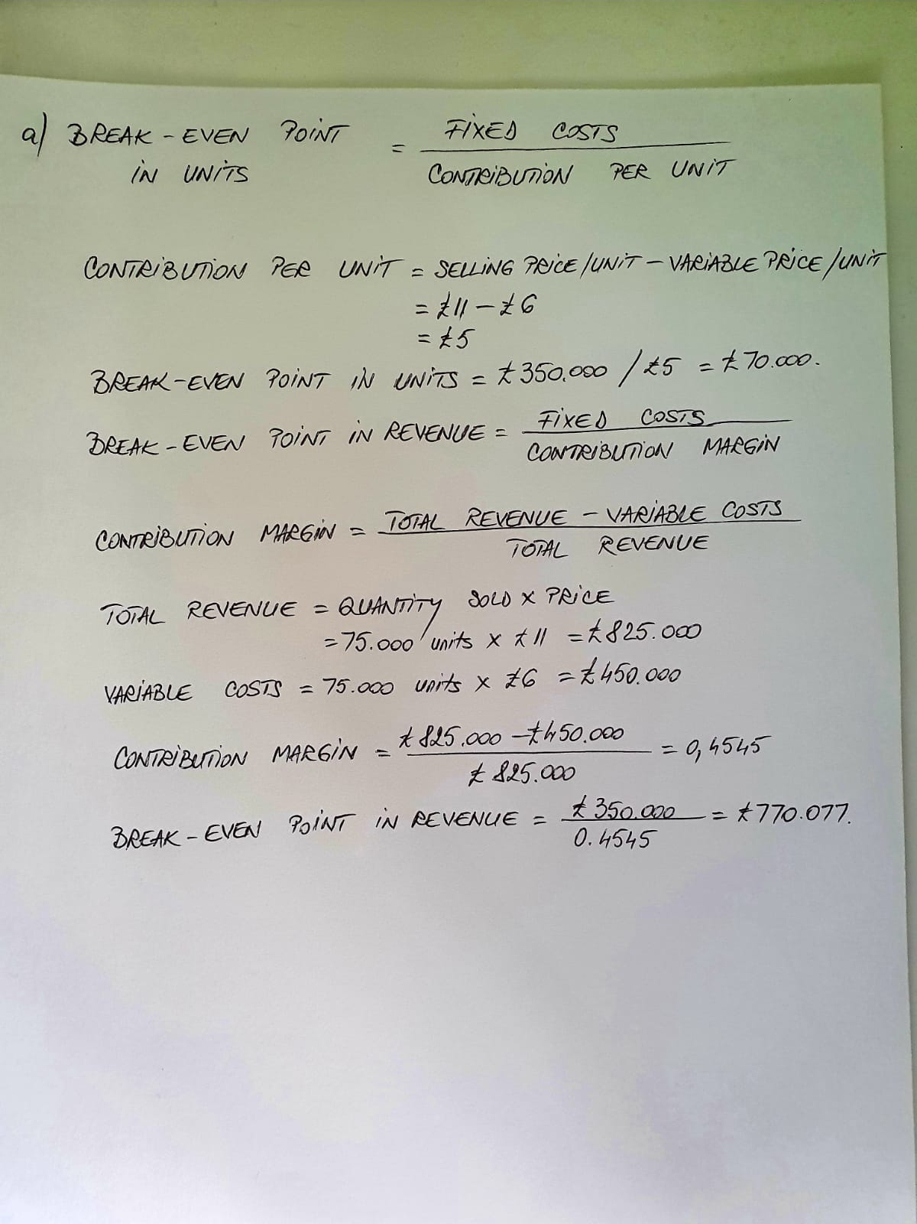

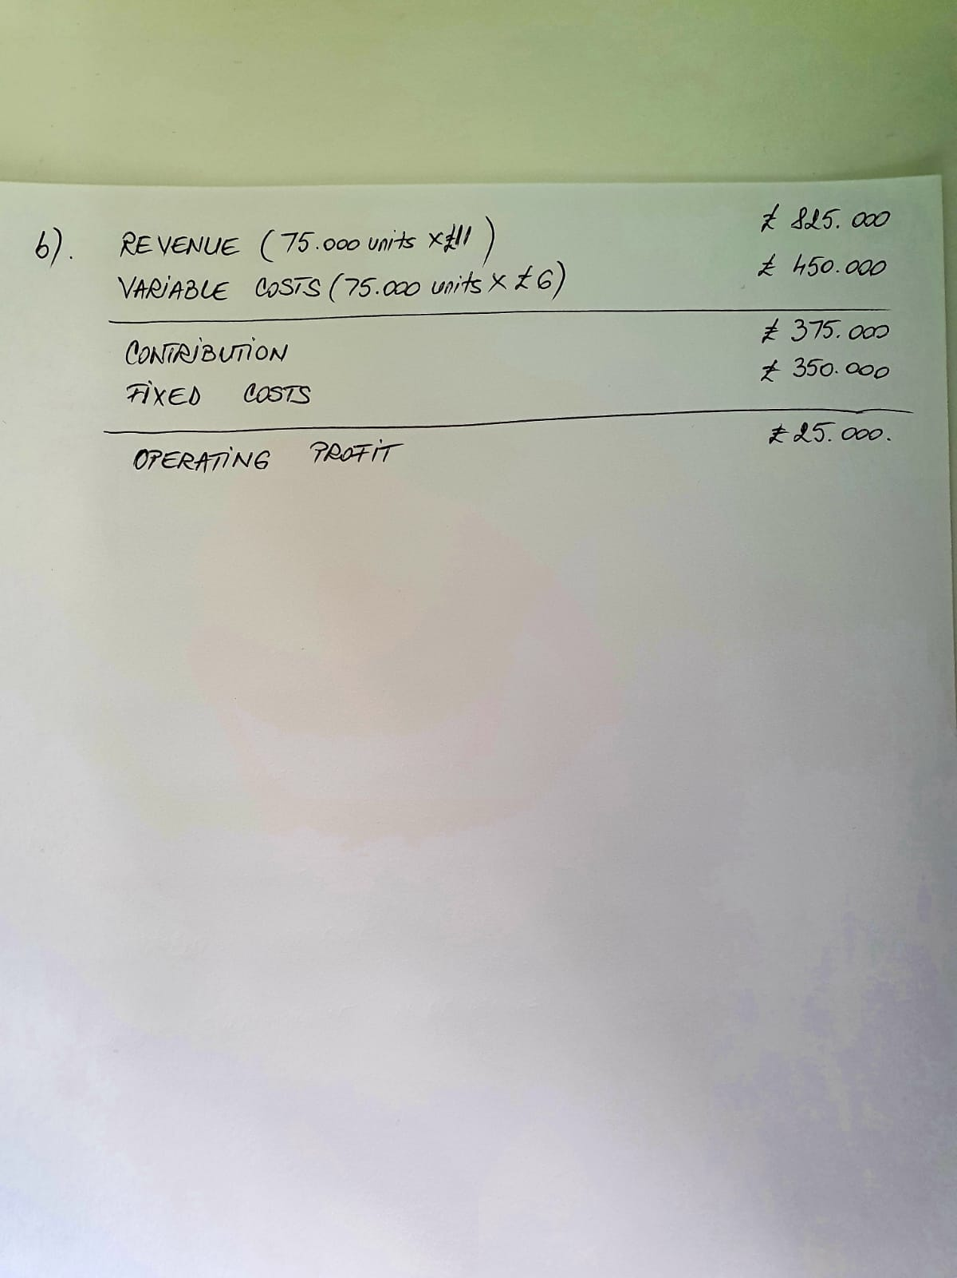

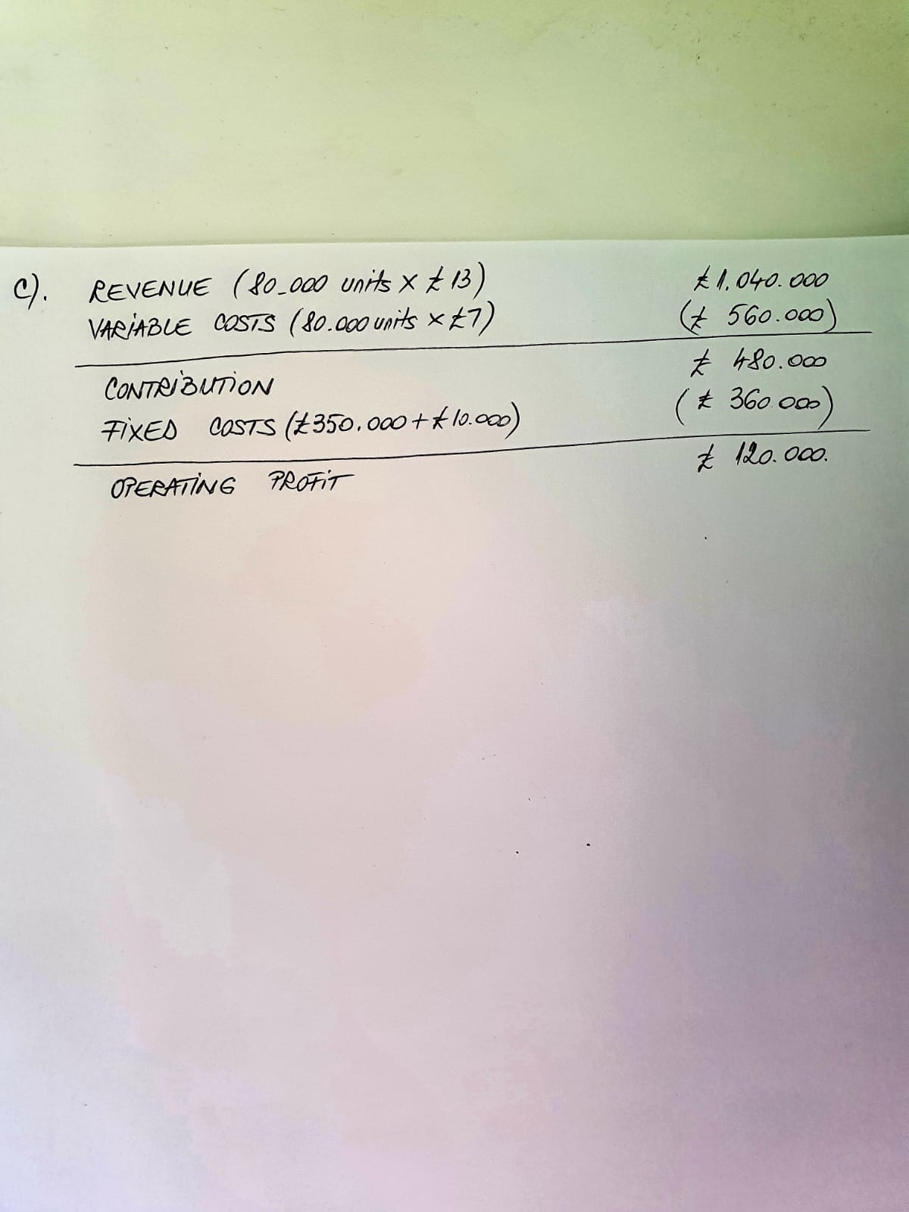

D. Break-even analysis is a valuable tool to examine the connection between fixed costs, variable costs and returns (Dalsted, P.H. Gutierrez and N.L., 1992).
The level of production is not associated directly with the fixed costs as they earned after the decision of entering into a business activity is made.
Also, the fixed costs are including the depreciation on equipment, interest costs, taxes, and general overhead expenses. Total fixed costs are the sum of the fixed costs (Dalsted, P.H. Gutierrez and N.L., 1992). The volume of output will change in direct connection with the variable costs. No mathematical formula can predict the future.
Question 2
- As per CIMA, 2005 the management accounting is the application of the principles of accounting and financial management to create, protect, preserve, and increase value for the stakeholders of for-profit and not-for-profit enterprises in the public and private sectors.
To supply accounting information, it is the principal purpose for use within an entity, however the information may be of interest to external parties such as banks, government, or credit rating agencies. Therefore, it is very related to financial accounting and there are many differences which can be differentiate between financial and management accounting.
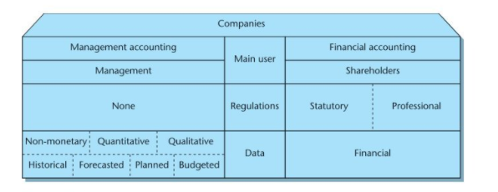
Figure 1. Management accounting versus financial accounting: main differences

- There are several techniques in order to archive the objectives of the management accounting such as planning, cost accounting, control, auditing, decision making and financial management.
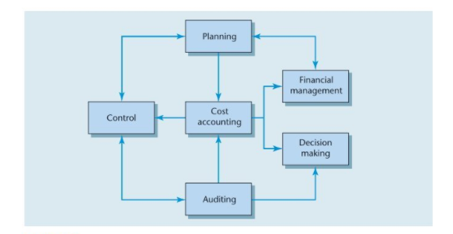
Figure 2 Management accounting: main functions
- Planning
The planning technique can be categorized into long-term and short-term planning.
Strategic planning or corporate planning is described as being the long-term planning. The senior management of the entity will prepare a strategic plan on long term and specific ways to archive the objectives. Also, will create a multidisciplined strategic planning team which will collect the data needed and will provide the relevant information to the team (Dyson, 2010).
The short-term planning is recognized as budgeting and is used for a certain period of the year.
- Decision Making
As per Dyson 2010 decision making is one of the most important function of the management accountants. And is requiring dealing with anticipated future costs and revenues which will include data that will not be included in a traditional accounting ledger system. The final decision will be taken by the managers themselves and should not be taken by the management accountants.

- Cost accounting
Cost accounting it is also considered being a key function of the management accounting and involves the collection of the ongoing costs and revenues of the entity’s as well as recording them in a double-entry book-keeping system. As per Dyson 2010 the calculation of the actual cost of services and products for the stock valuation, control and decision making it is part of cost accounting.

References

CIMA. (2005). Retrieved January 9th, 2021, from Official Terminology: https://r1.vlereader.com/Reader?ean=9780273723011#
Dalsted, P.H. Gutierrez and N.L. (1992). Economics. Retrieved January 9th, 2021, from Break-Even Method of Investment Analysis no. 3.759: https://mountainscholar.org/bitstream/handle/10217/193357/AEXT_ucsu2062237592004.pdf?sequence=1
Dyson, J. R. (2010). Accounting for non-accounting students. Retrieved January 9th, 2021, from https://r1.vlereader.com/Reader?ean=9780273723011#

