Name: Olivia Hall
Student Number: 2331705
Module: Changemakers: Creativity and Value Creation
Module code: BMHP5014
Lecturer: Raheela Shaikh
Assignment Title: Component 2: Written Assignment (Report)

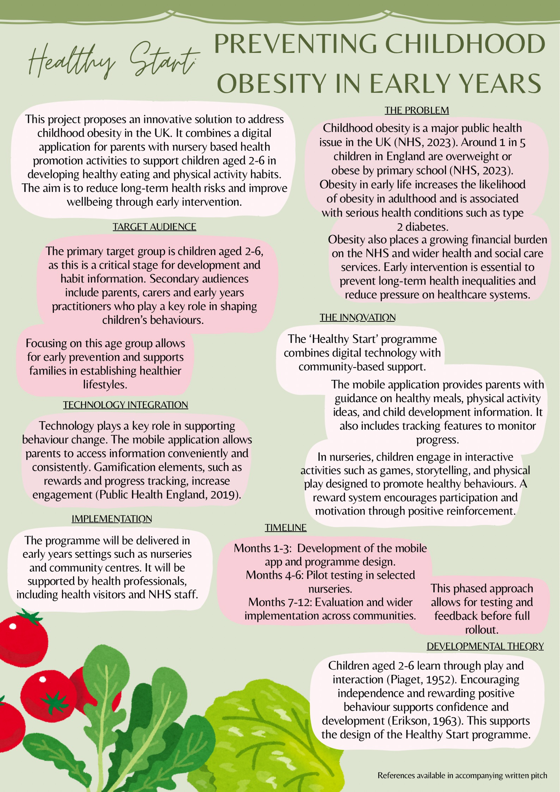

Healthy Start: Preventing Childhood Obesity Through Early Intervention

Childhood obesity is a growing public health issue in the United Kingdom, with increasing numbers of children becoming overweight before starting primary school. Around 1 in 5 children in England are overweight or obese by this stage (National Health Service, 2023). This is a significant concern because obesity in early life is strongly linked to obesity in adulthood and increases the risk of long-term health conditions such as type 2 diabetes and cardiovascular disease (Public Health England, 2017).

Obesity also places significant pressure on the National Health Service and wider health and social care services. Therefore, early intervention is essential to improve long-term health outcomes and reduce health inequalities (Department of Health and Social Care, 2020).

This pitch introduces Healthy Start, an innovative programme designed to prevent obesity in children aged 2–6 by combining digital technology with early years education. The aim is to support children and families in developing healthier habits from an early age.

The Healthy Start programme combines a mobile application for parents with structured activities delivered in nurseries and community settings. This approach recognises that both the home environment and early years settings play a key role in shaping children’s behaviours.

The mobile application provides parents with practical guidance on healthy eating, meal planning, and physical activity. It includes features such as reminders, progress tracking, and accessible educational content. This helps parents to make informed decisions and build healthier routines.

In nurseries, children take part in interactive activities such as games, storytelling, and physical play. These activities are designed to make learning about health fun and engaging. A reward system, including stickers and points, encourages participation and reinforces positive behaviour. This reflects behaviour change strategies commonly used in public health interventions (Public Health England, 2019).

The programme is supported by key developmental theories. Jean Piaget (1952) explains that children aged 2–6 are in the pre-operational stage, where they learn through play, interaction, and visual experiences. This supports the use of games and creative activities within the programme.

Similarly, Erik Erikson (1963) highlights that children at this stage are developing independence and confidence. Encouraging children to make choices and rewarding positive behaviour supports their emotional and social development. Using these theories ensures that the programme is developmentally appropriate and increases its effectiveness.

The Healthy Start programme will be delivered in early years settings such as nurseries and community centres. Early years practitioners will deliver activities as part of daily routines, supported by proper training.

Health visitors and professionals within the National Health Service will promote the programme and support families in using the app. Local councils and public health organisations will help to coordinate and fund the initiative.

A phased approach will be used, starting with a pilot programme in selected areas, followed by wider rollout based on evaluation outcomes. This allows for improvements to be made before national implementation.

Technology is central to the Healthy Start programme. The mobile app provides flexible and accessible support for parents, allowing them to engage with the programme at their convenience.

Features such as reminders, progress tracking, and personalised guidance support behaviour change. Gamification elements, such as rewards and achievements, increase motivation and engagement (Public Health England, 2019). All data will be managed in line with GDPR to ensure privacy and confidentiality.

The programme aims to improve children’s health and wellbeing by encouraging healthier eating and increased physical activity. In the short term, it will support families in making positive lifestyle changes. In the long term, it has the potential to reduce childhood obesity rates and associated health risks (National Health Service, 2023).

It will also help to reduce health inequalities by providing accessible support to a wide range of families (Department of Health and Social Care, 2020). By focusing on prevention, the programme can reduce demand on healthcare services and contribute to a more sustainable health system.

There are potential challenges to implementing the programme. Some families may not engage due to time constraints or lack of interest. To address this, the app will be designed to be simple, engaging, and easy to use. Support from health professionals will also encourage participation.

Funding may also be a challenge. However, collaboration with local authorities and public health organisations can support funding and long-term sustainability. Pilot programmes can show effectiveness and encourage further investment.

Digital exclusion is another consideration. Providing alternative resources, such as printed materials and face-to-face support, ensures that the programme stays inclusive.

The Healthy Start programme aligns with current UK public health policies that focus on prevention and early intervention. Government strategies emphasise the importance of tackling obesity and improving health outcomes from an early age (Public Health England, 2017).

The programme also reflects a shift towards integrated care, where services work together to improve outcomes (Department of Health and Social Care, 2020). By involving families, early years settings, and healthcare professionals, it adopts an integrated approach to health promotion.

In conclusion, childhood obesity stays a significant challenge in the United Kingdom and requires effective, innovative solutions. The Healthy Start programme offers a practical and evidence-based approach by combining digital technology with early years education.

By supporting children and families at an early stage, the programme has the potential to create lasting improvements in health and wellbeing. It is recommended that this initiative is piloted and expanded across the UK to support a healthier future generation.

References:
Department of Health and Social Care (2020) Childhood obesity: a plan for action. Available at: https://www.gov.uk/government/publications/childhood-obesity-a-plan-for-action (Accessed: 2 April 2026).

Erikson, E. (1963) Childhood and society. New York: Norton.

National Health Service (2023) Obesity. Available at: https://www.nhs.uk/conditions/obesity/ (Accessed: 2 April 2026).

Piaget, J. (1952) The origins of intelligence in children. New York: International Universities Press.

Public Health England (2017) Health matters: obesity and the food environment. Available at: https://www.gov.uk/government/collections/health-matters-public-health-issues (Accessed: 2 April 2026).

Public Health England (2019) All Our Health: behaviour change. Available at: https://www.gov.uk (Accessed: 2 April 2026).

World Health Organization (2021) Obesity and overweight. Available at: https://www.who.int (Accessed: 2 April 2026).

