Briefing Paper: Exploring Evidence Based Practice

What is Evidence Based Practice (AC 1.1)
Evidence based practice involves utilising management information to make informed decisions, that effectively support organisational strategies moving forward. People professionals have a significant role in contributing to organisational decision-making Taylor and Woodhams (2022, p. 115) states that ‘HR practitioners are central to decision making in organisations due to their involvement with employees and their experience in the organisation’. Therefore, those working within the people profession should develop their understanding and application of good quality evidence to effectively underpin sound decision making.

Evidence is available from various sources, in a world of information overwhelm it is crucial that any information gathered to use as evidence is reliable, accurate and comes from reputable sources. Having multiple perspectives provides a balanced view. A single source of information should not be used in isolation, CIPD (2024a) states that the following four sources of evidence should be considered: Scientific, Organisational, Expertise and Stakeholder.

It is worth noting that the availability of scientific literature within people practices is increasing, broadening the people professionals’ understanding of behaviour, for example the effect of feedback on employee performance. In contrast, organisational information is something managers may be more familiar or comfortable with, much of the data is already collated, for example, sickness absence data or feedback from exit interviews. However, the data must be complete, unbiased and accurate to be considered reliable. When tackling a new issue or developing a strategy it may require organisational data that has not previously been collated or considered. At this point analysing information from experts in a specific field within the organisation would add a depth to a particular perspective. Stakeholder evidence should not be overlooked as it can provide unique perspectives utilising sources of information from both internal and external viewpoints. These can include the community, customers and employees, which in turn broaden the scope of understanding.
Considering all aspects of the evidence available leads to a fuller insight to the current situation. Timing and age of the data collected is important, as outdated information can become irrelevant. However, caution should be applied when considering the latest fads, trends or gimmicks, as they pose risk. According to Barends, Rousseau and Briner (2014) ‘many pay little attention to the quality of the evidence’ thus leading to poor outcomes. Acknowledging a trend may have value if, the outcome of a formal pilot study on the subject matter is available, this could then be incorporated into the existing pool of reliable evidence for consideration.

Using inaccurate evidence is likely to result in the execution of ineffective organisational strategy. To increase the reliability of the evidence CIPD (2024a) outlines the six ways of reviewing the information gathered: Asking, Acquiring, Appraising, Aggregating, Applying and Assessing (Barends et al 2014). This enables the people professionals to ensure the evidence put forward has been methodically considered, critically evaluated and validated.

Overall, the importance of evidence-based practice for HR practice can be summed up by Waite et al (2021p. 47) as it ‘provides people professionals with the opportunity to support current and future HR Practice and achieve better decision making’.

Data Analysis (AC 1.2)
Collating vast amounts of evidence takes time, which can be a limitation, it can also become overwhelming without focus. Identifying and applying a systematic approach to data analysis supports effective decision making.

There are several tools available for people professionals to explore and understand the factors facing their organisations both internally and externally such as SWOT, Porters Five Forces and PEST. The latter can be explained to include two further factors PEST(LE). It is a tool that explores the external political, economic, social, technological, legal and environmental factors. Monmouthshire County Council are due to develop a new People Strategy, the table below provides a brief indication of the factors the council is currently facing.

Political | Local Government directly impacted upon by political changes, democratic changes to the organisational leadership and policy reforms
Economic | Budget cuts from central government and of the devolved budget held by Welsh Government. Monmouthshire County Council receives considerable Grant Funding, impacting on staff levels and retention.
Social | Lifestyle and career changing attitudes with increase in flexible working, average age demographic of the workforce 46 – 56, increase in flexible retirement requests.
Technology | Platforms for delivering professional development, online recruitment process and the use of AI during the recruitment processes
Legal | Recent changes in employment law with the Employment Rights Bill 2024 – 2025 will see further changes for Zero Hour Contract, Flexible Working, Statutory Sick Pay
Environmental | Monmouthshire is a rural location which brings challenges to the services provided by the organisation. Within the council corporate plan is an aim to be a zero-carbon county. The Transport and Travel Expenses Policy is under review.

It’s worth noting that tools such as PESTLE and SWOT reference one place in time, the analysis would need to be repeated to be relevant overtime. There is also a risk that HR Professionals may take the information gathered above at face value. CIPD (2024b) explains when using PESTLE ‘it is easy to use in sufficient data.’ The factors identified above require further analysis to be effectively used as a source of evidence to underpin the next People Strategy.

Organisations routinely collate people data within their organisation, e.g. absence rates, exit interviews, annual employee questionnaire, etc. CIPD (2024c) describe the people analytics as a nine-step process and consider it to be a significant insight to drive organisational change. CIPD has professional standards for people analytic specialists. It would be prudent for Monmouthshire County Council to carry out a thorough people analytics process, to recognise any problems that require addressing, or any opportunities that can be explored, as part of the next People Strategy.

Principles of Critical Thinking (AC 1.3)
When presented with data people professionals must be able to critically consider the information available and gain an understanding of it’s narrative to effectively apply it within the organisational decision-making process.

Critical Thinking involves asking questions, considering alternate viewpoints, thinking logically and being able to draw conclusions. Questions such as

Compare information
Are you considering like for like

People professions must avoid the pitfalls of taking information at face value, its crucial to be able to secure validity in the data and identify any potential bias from all involved in the discussions surrounding the problem or decision to be made. Triangulating the information, pulling all aspects together to reach a fully considered conclusion. Howlett (CIPD 2019) explains that in developing critical thinking techniques people professionals are able to construct logical sound arguments that contribute to collaborative decision making. Essentially having a seat at the table, having a voice in the meeting that is credible. Coburn (CIPD 2019) considers critical thinkers as having the ability draw conclusions, hold quality conversations, provides a persuasive argument that takes people with them.

Evidence Based Decision Making (AC1.4)

Barends (2014 p. 5) writes ‘Most management decisions are not based on the best available evidence. Instead, practitioners often prefer to make decisions rooted solely in their personal experience’. To overcome this, people practitioners are encouraged to develop their decision-making skills and utilise decision-making tools. There are a plethora of tools available, the majority of which offer a systematic approach involving a set of steps or actions to take, which include collating and interpreting information before concluding with an outcome, ‘the decision’.

Figure 1.1 Evidence Based Practice Process


Single or multiple
forms of evidence

Analytics

Insight and increased
awareness of the situation

Rational and
logical judgement

Decision
Waite Et al (2021) p. 47

The Chartered Management Institute (2024) explores the difference between problem solving and decision-making, stating that ‘decision making skills are used for planning and developing new strategies’. The type of tool selected is likely to be dependent on the problem or decision to be made, the type of organisation and the resources available. The CIM provide a 10 Step Checklist for decision making which recognises the need to reflect on factors that impact decision making such as uncertainty, applying analysis tools that fit the situation and biases. The CIM also advocate Data-driven decisions, both CIM tools support the evidence-based practice process as depicted by Waite et al (2021 p. 47) in Figure 1.1.

For the outcome (decision) to be effective, people professionals must acknowledge any limitations or barriers, for example when working in groups, there is a risk of going with the majority, or a ‘herd mentality’ making a rash or more radical decision than intended. Bias poses one of the biggest risks to effective decision making, people often find comfort in what’s already known and may seek out evidence to support their own perspective (confirmation bias). Senge’s Ladder of inference can be used by those making the decisions to prevent ‘bias from creeping in’. (CIM 2024)

There is also the bounded rationality impact, for example when facing extensive amounts of information presented in one business meeting, there is a risk that a rushed decision will be made, without a full understanding of the situation. De Bono’s Six Thinking Hats (Figure 1.2) may go some way to overcome these issues, especially when all decision makers are involved in the process. Considering six different perspectives, brings its own challenges, however, utilising the Blue Hat role as project manager is crucial. If executed well this tool provides a broader and deeper understanding of the situation and solutions should emerge.
Figure 1.2
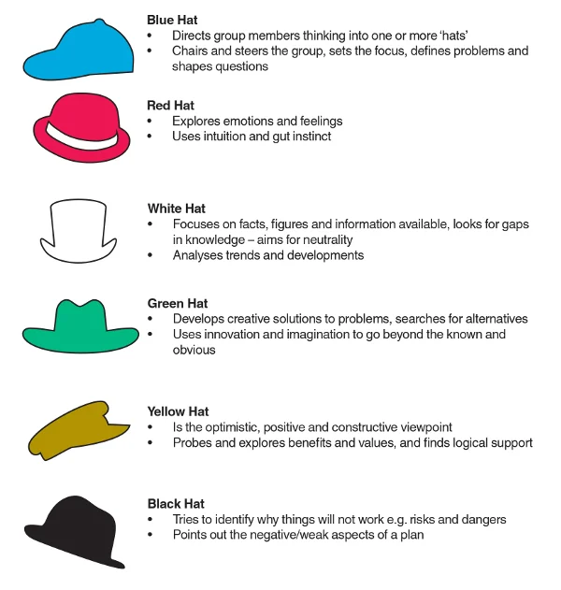

Ethical considerations (AC 1.5)
When making decisions, all involved in the process have a social responsibility to consider the ethical implications for both the internal organisation and the external stakeholders.

Very often people professionals set the moral tone for the organisation, this is often seen as establishing a company code of conduct, however, ethical decision making is much broader than this, it should form part of the company’s core values and culture. Organisations should be able to demonstrate ethical practices through systems and practice such as Recruitment, Pay Policies, Training and Development Programmes, conduct and discipline etc.

Having ethical perspectives requires people professionals to have an awareness of ethical perspectives. Waite et al (2021 p. 70) outlines the three main ethical perspectives as:
- Deontological Theory is based on justice, fairness and equity, ‘doing the right thing’.
- Teleology – Rightness is not an intrinsic property, dependant upon the goodness or badness of the consequences.
- Utilitarianism ‘doing the greatest good. To the greatest number of people’.

In applying CIPDs Eight Ethical Lenses (Fairness, Merit, Markets, Democracy, Wellbeing, Rights and Duties, Character and Handling Down) people professionals could ethically inform new strategies. Whilst each of the eight lenses do not identify what’s considered ‘right’ it does require decision makers to consider the appropriate direction the organisation should follow through each alternative perspective, allowing people professionals to take a deontological view.

Examples of Deontology and Utilitarianism as ethical considerations can be seen in Monmouthshire County Councils updated Summer Strategy 2022. Following COVID 19 the long-term strategy was updated. The values state their intent ‘We want to be a kind county where we do well by doing good things’. The vision statement included ‘Fairness: ...we will always try to treat everyone fairly and consistently.’ It also includes ‘Kindness: we will show kindness to all those we work with’.

It should be noted that CIPD’s people profession survey (2021) highlights the complex balance between what is ideal ethical practice and the actual practice. Actual ethical practice depends on the rapidly changing environment for the organisation, it’s employees and the community. If left unchecked this gap can cause considerable reputational damage externally and internally it may impact on retention of quality employees. Monmouthshire County Council’s success criteria may be seen in future staff turnover figures, staff absence rates, staff surveys and the number of grievances or customer complaints.

Ultimately, ethical decision making should be integral to evidence-based practice to inform moral decision making.

Measuring Performance (AC 3.1)
The success of an organisation depends on its performance, there several ways to measure performance both financial and non-financial and the type of key performance indicators depend on the business sector.

Using finance to measure an organisations performance can look at several aspects of the financial landscape. The private sector tends to focus on profit/loss, giving consideration to cash flow etc. The public sector specifically local government focus on financial statement analysis which is used to measure schools (in Wales) ability to provide value for money. Schools produce annual financial statements that allow monitoring of financial performance over time (horizontal analysis). For schools the key performance indicators focus on cost efficiency. Benchmarking expenditure on capitation, salaries and services to understand if the school provides value for money. However, it is important to measure like for like, schools of the same size and demographics to have an accurate comparison. Another key performance indicator for schools is the amount of school budget held per pupil, although this relies on the assumption that the higher the figure the better the provision, which may not be the case. With the complexities of school funding and performance measures, people professionals supporting schools very often include the testing of financial management skills in the Headteacher recruitment process. Although it should be acknowledged that pupil achievement is the most significant performance indicator for schools, which could be interpreted as a service delivery indicator. which is example of how financial indicators should not be used in isolation as a measure of performance of an organisation.

People professionals utilise non-financial performance measures. Hodkin (2023) identifies 22 metrics for measuring workforce planning which can be used to gain an insight into the effectiveness of planning and inform future developments in organisation strategy. Monmouthshire County Councils vision for Fairness and Kindness could be measured against workforce planning key performance indicators. If the organisation culture reflects the vision, there would be a basic expectation that low staff grievance rates would be measured over time. However, the grievance rate could be low due to other factors, including inaccurate data, staff awareness, staff confidence and the consistent application of the actual grievance process. Therefore, it’s important to take the data as an indication and explore further. Triangulating this information with other sources such as the annual staff survey outcomes, to establish an overall measure of performance. The CIPD 2021 case study Solving business problems with people analytics: Financial Times Understanding engagement to improve productivity, highlighted how engagements surveys were used as a measure of happy staff. Ultimately, individual key performance indicators should not be viewed in isolation as a measure of performance.

Impact of People Practices (AC 3.2)
The role of people professionals has evolved over time moving forward into strategic influence, being able to consider the wider aspects of people practices and the impact of people management on organisational objectives, values, culture and reputation. This is reflected in Taylors (2018) Three types of contribution, which reviews how people practice adds value by: delivering business objectives, providing excellent administrative service and acting as a champion for effective people management.

When considering the impact of people professionals on an organisation according to Taylor and Woodhams (2022 p. 135) ‘the final step in making good evidence-based decisions is to be able to evaluate the extent to which people management issues add value to an organisation using business indicators’. Key indicators for adding value to an organisation can be assessed using the organisations people analytics.

Return on Investment calculation (Return on investment (%) = (value of realised benefits – investment cost) / investment cost x 100) can be used to measure the success of a particular programme or initiative that has been rolled out at a significant cost to the organisation. CIPD (2023) considers measuring the effectiveness of a new learning and development programme as one of the most common to be analysed using ROI. However, there may be other factors at play which impact on the value of realised benefits, for this reason it is important not limit decision making to one source of evidence.

The Balanced Scorecard is an alternative method which encompasses both financial and operational measures. It incorporates four perspectives customer, internal, innovation and learning and financial. Kaplan and Norton (1992) suggest that this approach reduces the overload of information, focusing managers to a set number of measures.

Whichever method is chosen to suit an organisation, the measures allow people professionals to identify both strengths in the company and areas that require improvement. All organisations need to be adaptable to meet the challenges they face, knowing the workforce enables people professionals to ensure objectives are being achieved, place a value on people practices and inform future decision-making strategies.

Briefing Paper: Performance Review and Rewards Analysis
The company operates a quarterly 4% bonus scheme for those who reach outstanding in their performance review. Waite et al (2021) note that bonus schemes are popular with 62% of organisations utilising such schemes with varying degrees of success. Bonus schemes particularly those that are quarterly can create short term achievement targets.
Raw Data Considerations:
Caution should be applied when making comparisons based on percentages. The size of the departments impact on the percentage rates e.g. 30% of the Research Department equates to 3 members of staff while 30% of the Logistics Team is 6 members of staff. Therefore, individual departments shouldn’t be compared like for like.

Reliability of the data:
- One member of the Administration Department was assumed as absent in Quarter 2 as the data was missing.
- An anomaly has been identified in the salary structures within the Research and Development Team, specifically the Product team members of which two are under performing. This may be an error in the data, or it requires investigation.

It was worth noting that one member of the Research Team was underperforming in quarter 1, and was absent for quarter 2, in contrast the only other member of staff underperforming in quarter 1, went on and secured KPIs in quarter 2. This highlights the need to have further information such as sickness rates, training interventions or capability processes when making evidence-based decisions.

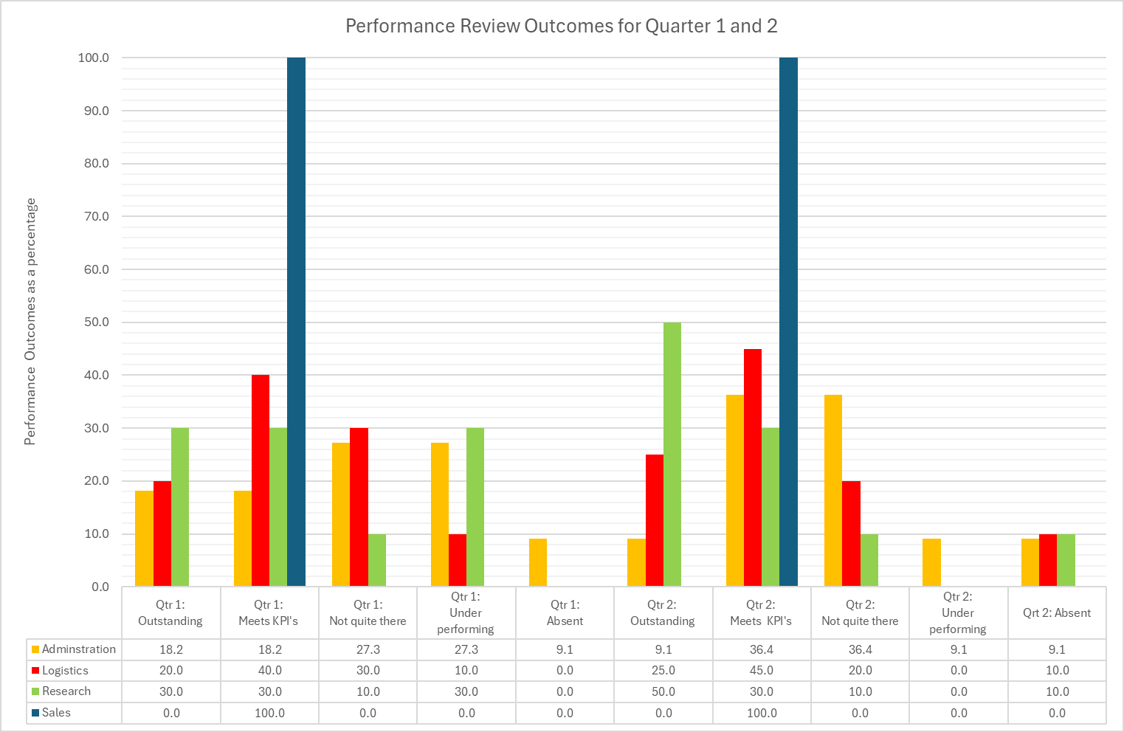
The performance for each department over quarter one and two, in percentages is depicted in Figure 2.1.
Figure 2.1

Reward Related Bonus structure
Quarter 1 and Quarter 2 bonuses are depicted in Figure 2.2 the data has been anonymised to comply with GDPR.

Team | Employee | Salary | Bonus Payment 1 | Bonus Payment 2 | Total Bonus
Administration Department | 1 | £31,500.00 | £420.00 |  | £420.00
Administration Department | 2 | £24,000.00 | £320.00 | £320.00 | £640.00
Logistics Department | 3 | £23,750.00 |  | £316.67 | £316.67
Logistics Department | 4 | £23,750.00 |  | £316.67 | £316.67
Logistics Department | 5 | £23,750.00 | £316.67 |  | £316.67
Logistics Department | 6 | £26,000.00 |  | £346.67 | £346.67
Logistics Department | 7 | £19,500.00 | £260.00 | £260.00 | £520.00
Logistics Department | 8 | £19,500.00 | £260.00 |  | £260.00
Logistics Department | 9 | £19,500.00 | £260.00 | £260.00 | £520.00
Research and Development | 10 | £32,500.00 | £433.33 | £433.33 | £866.67
Research and Development | 11 | £32,500.00 |  | £433.33 | £433.33
Research and Development | 12 | £29,500.00 |  | £393.33 | £393.33
Research and Development | 13 | £29,500.00 | £393.33 | £393.33 | £786.67
Research and Development | 14 | £29,500.00 | £393.33 | £393.33 | £786.67
 |  |  | £3,056.67 | £3,866.67 | £6,923.33
Figure 2.2
The logistics department are the largest in employee size and therefore noticeably have the larger share of all bonuses, Figure 2.3 shows the is a marked absence of the Sales Department.

Figure 2.3
Key findings
The data indicate that 11% of the workforce overall were consistent in achieving outstanding outcomes across both quarters. Overall quarter 2 did see an uplift in the number of employees achieving outstanding outcomes. The most striking themes from the data analysis is the outcomes from the Sales Department, all employees met the Key Performance Indicators, none were outstanding, therefore none received a bonus. Are the KPI’s set at the right level? Are they aligned to company goals? Not being able to achieve and subsequently not receiving bonuses will have a detrimental impact on the staff morale within each department, especially sales, which could be argued as the largest risk as their role directly impacts on revenue. There is the potential for staff turnover to rise. Sizable risk to lose the Return on investment in sales staff

Another significant finding is that none of the Managers achieved outstanding and two have underperformed over the combined period of quarter 1 and 2. This again may have a detrimental effect on morale, turn over of managers and potential increases of absenteeism. Considerations should be given to the effectiveness of the process, the ability of senior management to undertake reviews appropriately.

Recommendations
- Carry out a further study into staff performance and skill sets
This should include people analytics data over a longer period of time, consider focus groups and interviews to gain insights into each department. To gain a fuller understanding of the issues faced, identify any barriers to achieving KPIs. These activities can be done in house by people professionals, with cost being that of time taken.

- Carry out a systematic review into the Reward Related Bonus system.
This should include a review into what options are available to offer a complete reward package, are there other appropriate benefits or incentives that could compliment a bonus system, such as discount cards, access to leisure facilities, health care etc. This would need to be fully costed; however, this should be balanced against the potential loss of revenue as a result of staff leaving due to low morale and poor benefits and the cost to recruit and training staff.

Performance Review Survey
235 responses were received from the employees, unfortunately the response/ engagement rate is unknown as the total number of employees is not available. The survey does not identify employees in any way, which may indicate employees were confident to respond without fear of reprisals, therefore people professionals could assume the outcomes truly reflects employees’ views and experiences.

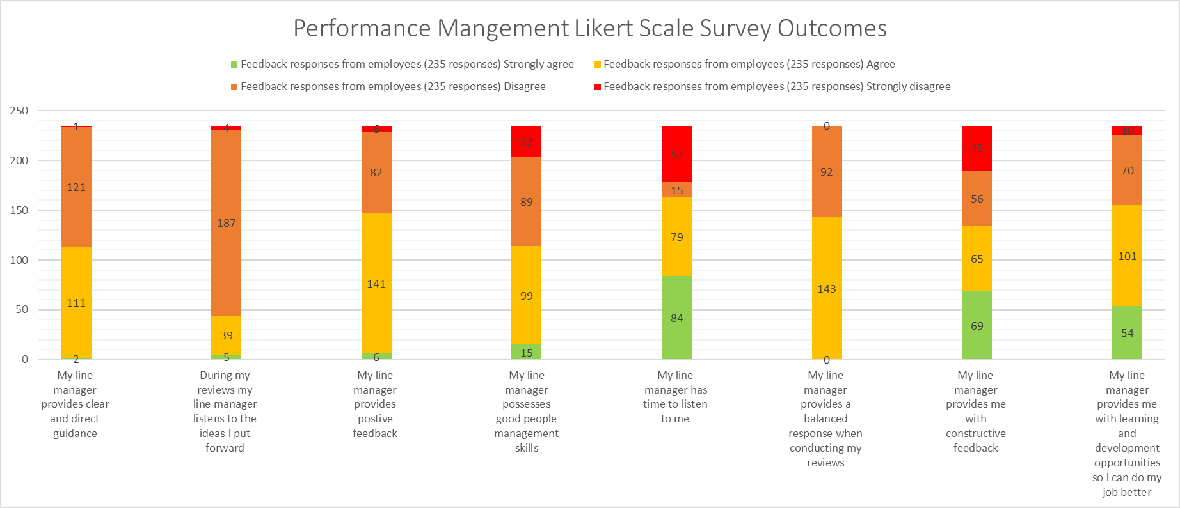
Figer 2.4

Findings from the Employee Survey:
Just over half of employees feel their line manager provides clear and direct guidance. Significantly 81% of employees feel their manager does not listen to their ideas. Suggesting the organisation is potentially reluctant to develop. Over 62% of employees feel their employer provides positive feedback, and just under half of employees feel their manager possess good people management skills, suggesting that most staff are comfortable with their line manager. Almost 70% feel their manager listens to them, 60% feel their manager provides a balanced response when conducting reviews, and almost 60% of employees feel their manager provides constructive feedback. This feedback suggests that while change may be resisted staff feel noticed and appreciated. Which is reinforce by 65% of employees feeling they are offered learning and development opportunities to ensure they can do a better job.

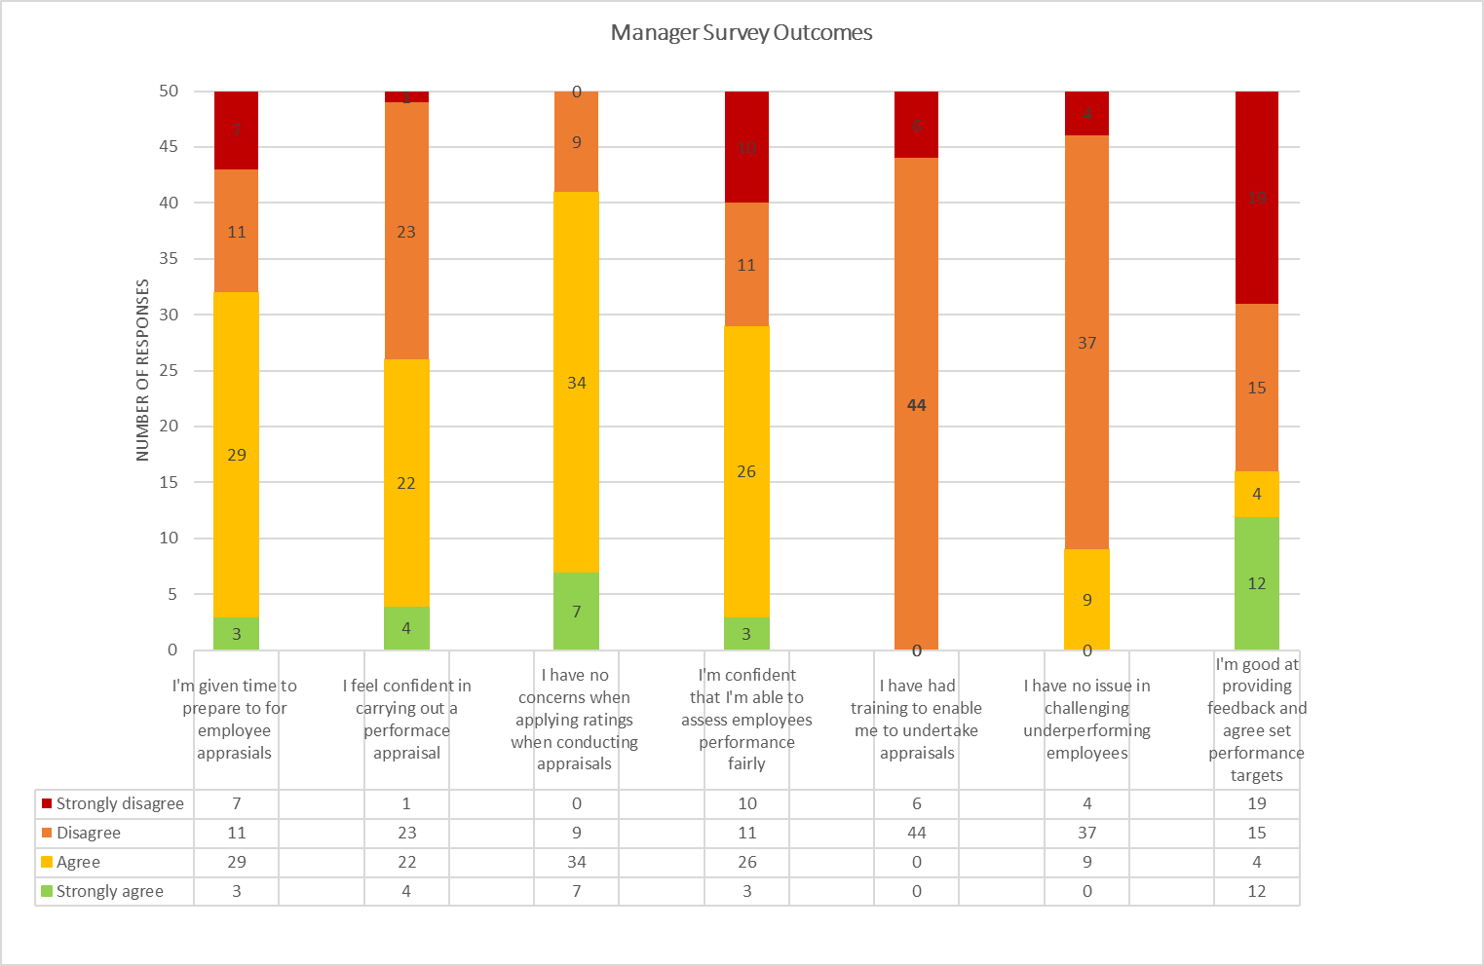
Figure 2.5
50 responses were received from managers unfortunately the response/ engagement rate is unknown as the total number of managers is not available. The survey does not identify managers in any way; therefore, people professionals could assume the outcomes truly reflects mangers views and experiences. The outcome of the survey is depicted in Figure 2.5.

Findings from the Managers Survey
The most significant finding relates to none of the managers having received training to undertake appraisals. And more concerning, 82% have no issues challenging underperforming employees. This may suggest that managers don’t seek guidance from people professionals when supporting underperforming employees and this may correlate with the absences identified in the earlier data. In contrast to the employee survey outcomes that they feel most managers feel they are not good at providing feedback and can’t agree set performance targets. This also contradicts mangers confidence in challenging underperformance.

Recommendations
- Provide all Managers and Corporate Managers Performance Management Training.
Ensure there is a specific focus on goal setting, goals and objectives must be SMART and align directly to company objectives, together with personal employee targets.
Aspects of the training should include learning from one another, developing ideas of others.
- Provide all employees with training on how to appraise their own performance.
This should include how goals are developed, considering your own performance, what went well, could do better if. If there are people professionals within the organisation that can deliver training, the cost is greatly reduced. A Train the Trainer Approach is also a consideration to keep costs down. Understanding and consistency of message will be key to the success of the new systems.

Bibliography

Barends, E., Rousseau, DM. and Briner RB. (2014). Evidence-Based Management: The Basic Principles. Centre for Evidence-Based Management. Available at:
https://cebma.org/assets/Uploads/Evidence-Based-Practice-The-Basic-Principles.pdf (Accessed: 15 November 2024)

CIPD (2015) Ethical decision-making: Eight perspectives on workplace dilemmas, CIPD: London
Available at: https://www.cipd.org/globalassets/media/knowledge/knowledge-hub/reports/ethical-decision-making-2015-eight-perspectives-on-workplace-dilemmas_tcm18-9564.pdf (Accessed: 15 November 2024)

CIPD (2016) In search of the best available evidence, CIPD: London
(Accessed: 15 November 2024)

CIPD (2021) Solving business problems with people analytics: Financial Times Case study on understanding engagement to improve productivity, CIPD: London
(Accessed: 20 November 2024)

CIPD (2023) People analytics: Guide for people professionals, CIPD: London
Available at:https://www.cipd.org/uk/knowledge/guides/analytics-practitioner-guide/
(Accessed: 17 November 2024)

CIPD (2024 a) Evidence-based practice for effective decision-making, CIPD: London
Available at: https://www.cipd.org/uk/knowledge/factsheets/evidence-based-practice-factsheet/
(Accessed: 17 November 2024)

CIPD (2024b) PESTLE analysis, CIPD: London Available at: https://www.cipd.org/uk/knowledge/factsheets/pestle-analysis-factsheet/
(Accessed: 17 November 2024)

CIPD (2024c) People Analytics, CIPD: London
Available at: https://www.cipd.org/uk/topics/people-analytics/
(Accessed: 15 November 2024)

CIPD (2024d) Ethical practice and the role of people professionals, CIPD: London
Available at: https://www.cipd.org/uk/knowledge/factsheets/ethics-role-hr-factsheet/
(Accessed: 15 November 2024)

CIPD Podcast 154: Critical thinking October 2019
Available at: https://soundcloud.com/cipd/podcast-154-critical-thinking
(Accessed: 20 November 2024)

Critical Thinking | HRM Handbook https://hrmhandbook.com/core/critical-thinking/ 2021
Accessed: 20 November 2024

Harvard Business Review: Kaplan, R., S. and Norton, D.,P. (1992) Available at: https://hbr.org/1992/01/the-balanced-scorecard-measures-that-drive-performance-2
Accessed: 20 November 2024

Hodkin.S. (2023) 22 metric for measuring workforce planning.
Available at: https://www.hibob.com/blog/measuring-workforce-planning/
(Accessed: 15 November 2024)

https://www.managers.org.uk/knowledge-and-insights/advice/top-models-for-effective-decisions/
(Accessed: 18 November 2024)

https://www.mindtools.com/aiplsat/how-to-make-decisions
(Accessed: 15 November 2024)

Monmouthshire County Council: Looking Ahead, Delivering Now (2022)
Available at: https://www.monmouthshire.gov.uk/our-coronavirus-strategy/
(Accessed: 16 November 2024)

https://mylocalschool.gov.wales/ accessed November
(Accessed: 16 November 2024)

Harvard business school online Business Insights Financial Statement Analysis: The Basics for Non-Accountants. Available at: https://online.hbs.edu/blog/post/financial-statement-analysis
(Accessed: 15 November 2024)

PM Insight, Inside information: How to unlock the power of your HR data, SD Worx
Available at: https://www.sdworx.co.uk/en-gb/events-and-webinars/power-hr-data
(Accessed: 14 November 2024)

Taylor, S. (2018) Resourcing and Talent Management CIPD: Kogan Page

Taylor, S. and Woodhams, C. (Eds) (2022) Studying Human Resource Management, A Guide to the Study, Context and Practice of HR, 3rd Ed, CIPD: Kogan Page

Taylor, S. and Woodhams, C. (Eds) (2022) Human Resource Management, People and Organisations, 3rd Ed, CIPD: Kogan Page

Waite, K., Beevers, K., Small, N., Tomlinson, K. and Hussain, S. (2021) People Practice A Complete Guide. CIPD: Kogan Page

Barends, E et al (2017) Managerial attitudes and perceived barriers regarding evidence-based practice: An international survey. Available at: https://doi.org/10.1371/journal.pone.0184594
Accessed 19 November 2024

