
Skills for the Workplace
Module Assignment Submission
Student Name: | Shanice Taylor
Student Number: | 2017374
Module No: | BMSK4006
Module Title: | Part 1 Business Plan

Statement of Confirmation of Authenticity
By the act of making this submission, the student declares that this is the work of the student named above. The work has not, in whole or in part, been knowingly presented elsewhere for assessment, or where assessment has been built on a previous assessment, this has been identified. Where materials have been used from other sources it has been properly acknowledged. If this statement is untrue, the student acknowledges that an assessment offence has been committed.
Attention is drawn to the plagiarism and unfair practice policies of both the University and of ILM.

Table of Contents
Title Page 3
Executive Summary 3
Business/Industry Overview 4
Operating Plan 5
Market Analysis and Competition 7
Sales and Marketing Plan 9
Financial Plan 11
Appendices and References 13

Title Page

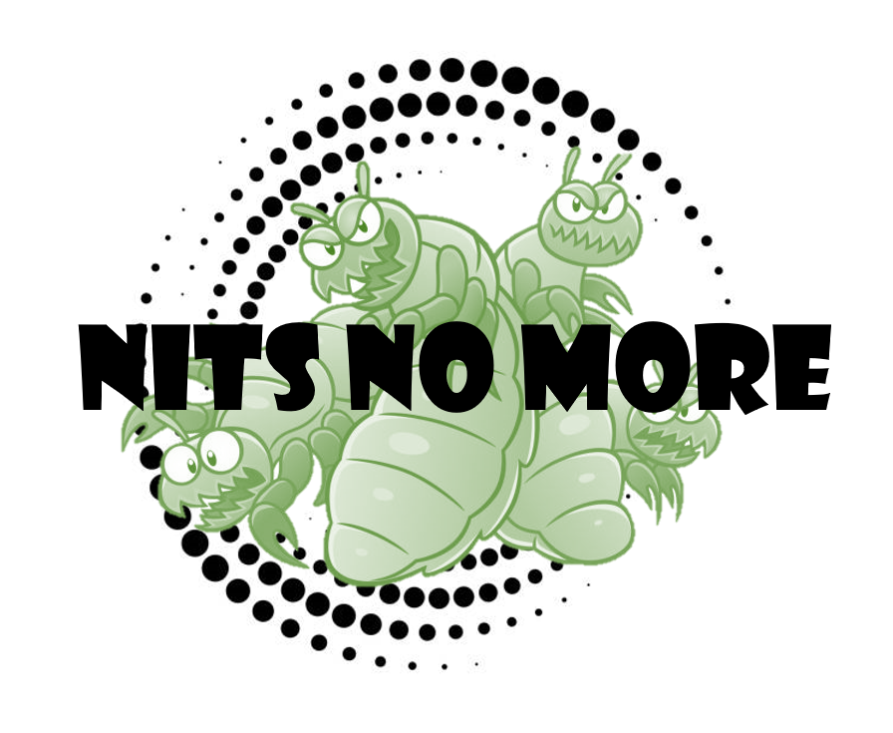

Above is my business logo which will be printed on all documentation released from my company.

Executive Summary

Although nit nurses are now extinct, nit infestations are still with us. I want to rid this world of nits. When the nit nurses were around, schools would hire them, parents would scramble for them, and nits would fear them. Since nit nurses abolishment in the 1980s and 1990s, parents have, again, become fearful of nits and there are more and more cases where children’s nit infestations are neglected. If nits are untreated, this is classed as a form of child abuse.

I will be a mobile nit nurse available Monday-Friday 7am-6pm and Saturday 10am-2pm. I will initially offer my services privately on a first come first served business to allow me to gather how great the need is for nit nursing. However, upon my research, I have found an increased need for nit nurses within schools.

According to a study, a third of parents in the UK will keep their children from school to tackle head lice infestations, regardless of government advice. Babs Young from Children and Young People’s Public Health stated that nits are not considered major health hazards by the government, but through her studies she has found that they have detrimental physical and psychological impacts on children and their families. She also states that “school nurses used to be in a position to take responsibility for prevention, identification and treatment, whilst nowadays the responsibilities lies with an uneducated parent,” (Voogd, 2011, pg. 109).

With Voogd’s research, I can see that nit nursing is something that is needed, and not wanted, by the British public.

Dr Adrian Raby, a Bupa General Practitioner, cited that children should still go to school with nits (2013, pg. 5). This, therefore, gives me the option to expand my business. I will advertise and offer my services to schools within the Cardiff area. This will entice parents, as it will not interrupt their busy lives and will be one less job for them to complete.

To make sure that my business plan can be achieved, I outlined SMART objectives to give me a wider look at how successful I can be (Doran, 1981, pg. 35). By the end of my first year as a nit nurse I would like to have worked in 20 schools across Cardiff. I will be proactive and make sure that my business is advertised within schools. This will help my business grow and thrive and, hopefully, reach a wider audience. Over the next 10 years I hope to have grown enough that I can expand further than Cardiff.

Business/Industry Overview

I will be a sole trader so will register with companies house to ensure that my business is legitimate. By registering as a sole trader, I will keep record’s of my business’s sales and expenses, send a self-assessment tax return every year to the HMRC, and pay income tax (www.gov.uk). Therefore, as a sole trader my personal and business finances will be amalgamated. An advantage of being a sole trader is that there is clearly defined ownership (Cerna, 2013, pg. 4).

I will have close relationships with my customers as a sole trader which will boost my reputation. A key to my business will be advertisement through word of mouth. By having close relationships with my customers they will be feel more at ease with me and not so concerned about me being around their children. However, as Cerna cites, being a sole trader you may have difficulties in obtaining larger contracts (2013, pg. 4). This is why it is key for me to hold business meetings with schools and have advertisement throughout the educational sector so that my business is more popular and will give me a higher return.

One disadvantage of being a sole trader is that my possibilities are limited by my available funds (Cerna, 2013, pg. 8). If I wanted to source more funds, I could be liable to pay more debts which could negatively affect my business. However, with this extensive business plan this disadvantage will not occur. My financial information will all be kept private and will only be registered annually. I will not have board meetings where we discuss my financial endeavours. Nonetheless, by having private finances I must hire an accountant to keep my affairs in order. The average accountant, according to Unbiased, can range from £60-£250 per month (www.unbiased.co.uk).

As a sole trader, I will be the owner of the business. I will have an assistant who will accompany me to my appointments. My assistant will be paid minimum wage, which in the UK is currently £8.91 for those aged over 23 (www.gov.uk).

Operating Plan

My business will be appointment based. My business hours will be from 7am-6pm Monday-Friday 7am-6pm and Saturday 10am-2pm. I will aim to keep my morning appointments for private customers, with a 9am-3pm slot for school hire. For the weeks that I am not hired by schools I will use this 6-hour slot for private home visits. My evening sessions will, again, be for private customers who were not available in the morning. I give myself something for my competitors to match by working 4 hours on a Saturday. This will be for customers who cannot make weekday appointments, again broadening my horizons and audiences. Each appointment will be around 30 minutes to ensure that the nits have been successfully extracted. My customers will be made aware that there may be the need for follow up appointments in extreme cases. I will also offer bundle packages to my customers so that if they do not want to attend the follow up appointment, that they have the option to continue the treatment at home.

As previously mentioned, I will begin with two members of staff – myself and an assistant. However, I aim to grow my business and have a clinic which will need to be staffed. My assistant’s salary will be based upon the UK governments national wage – this will be minimum wage as previously mentioned. This works out at £2102.56 before tax.

As it is just myself and an assistant, I can train them on the job. In the interview process I will ask personal questions and go into depth about the job to make sure that my assistant is prepared for the role they are going to be performing. In the future, I look to employ more staff so that I can be the Chief of Operations, with staff undertaking appointments.

Being a mobile business, I remove the need for rent. The only outgoing, with regards to location, is petrol. The current price for unleaded petrol is averaged at 124.2 p/litre. On average, it costs £40 to fill my cars tank up (Nissan Micra). If I am driving daily from appointment to appointment, I would most likely need to refuel on a weekly basis. This would result in a monthly deduction of £160. However, compared to rent and bills this deduction isn’t hefty at all.

With every appointment, I will make sure to pass on my business leaflets. I will be using Mark Edwards Printing Press. He will create my leaflets and also print them. Per 1000 brochures he charges £200. In the UK, you do not need a license to distribute leaflets if you are doing so in a building or in letterboxes. These will be the only places I will be distributing my leaflets. All documents will have a risk and safety clause stating that if allergies are not made aware when asked then I am not liable for any reactions. This will make sure that I am legally covered if anything were to happen to a child once they have undergone my services. The parents will also have to sign consent that they are happy to proceed with my services before every appointment.

In relation to advertisement, I will also have the printing company print my logo and details on my car. This will cost in the region of £1000.

Any staff and I will be DBS checked. DBS checks cost £44 per person. They need to be renewed every 3 years. With regards to this, I will need to notify the ICO as I will be withholding personal data for every customer. This will be for my records only.

To work with children, I will need Public Liability Insurance. According to AXA, the average UK annual PLI premium costs £119.37 (Lewis, 2021, pg. 7).

On a whole, there are many risks with my business. As mentioned, children could have allergic reactions to the treatments that I use. This is the main risk with my business.

I will not have a social media department, rather I will run any social media myself. I will have Instagram, Facebook and twitter pages advertising my business. In the modern day, social media is the best way to connect with customers. (Jones et al, 2015, pg. 611). Websites can be hard to navigate and cause confusion for many customers, that can lead them to end up taking their service elsewhere. The ‘Dot Com’ movement in the late 90’s early 2000’s era allowed larger companies to reach a mass audience. However, social media is much more accessible to customers and gives the option for instant communication between consumer and business (Abuhashesh, 2014, pg. 3). Customers want to be able to see reviews, and not a website where they can only attain information which has been provided by the business themselves (Abuhashesh, 2014, pg.3). Digital media has given us, as sole traders, the freedom to make free, social media pages that will reach audiences across the globe (Abuhashesh, 2014, pg. 3).

The only IT I will have will be a card reader for payments. This costs £29 from SumUp. Having a card reader makes me more accessible to the modern day world. I will use my current laptop to use Excel Spreadsheets and to arrange for stock to be ordered – this will then make my IT costs lower.

For stock control, orders will be made on a monthly basis as bulk from selected companies. The monthly orders will contain nit vacuums, nit combs, nit lotions, disposable towels, hair nets, disposable gloves, disposable aprons and filters. These facilities are the most modern available, with the nit vacuum only recently becoming available to nit nurses.

Market Analysis and Competition

My market is parents. There is a huge gap in the medical market for a nit nurse. Children will continue to infect each other for centuries. Ignoring head lice will only make it worse. It is important for children’s health that their lice are treated correctly. Home treatments are not always used properly, which leads to a reinfection. Nit nurses are trained professionals who know how to effectively delouse children.

Nit nursing also follows the general trend at current. People are focused on hygiene and how to better the world. Instead of having parents and pharmacies harming the environment by purchasing non-reusable nit combs and treatments that are not effective. I will use re-usable vacuums, and combs. My services will eradicate reinfections and ensure that the environment is also protected.

Social commerce is continuing to grow. This is why it is important for me to not only advertise via word of mouth, but to advertise online also. Hashtags are important in 2021. If I use a hashtag that directly relates to my business, such as #NitsNoMore, then I will be able to reach a larger audience and attract more customers.

Parents are willing to pay £10 a bottle for over the counter head lice treatments. I believe I can charge £25 per appointment. Parents will not have to repurchase head lice treatments due to them incorrectly treating the infestation. I will ensure that under my services the lice will be removed efficiently and effectively so that the parents do not always need to rebook with myself.

My main competitor is the NHS as they offer lice treatment under the NHS Ailment Scheme. The main threat is that their treatment is free. Customers would prefer to have a free service. Nevertheless, the NHS wait times are a huge disadvantage. Customers do not want to wait to receive the treatment, which is why my services are much more appealing. By having an appointment system my customers will know exactly when their children will be relieved of their infestations, instead of awaiting call backs from the NHS.

Additionally, a large competitor is pharmacies. They sell the products that I will be purchasing. Parents first point of contact is pharmacies, as nit nurses are not as popular in the modern day. This is why it is key for me to advertise my business through leaflets and word of mouth.

In allusion to this, the advantage that I have is being a familiar face. Customer loyalty is key to customer satisfaction (Parvez, 2009, pg. 33). Customer trust is important. This is what my competitors do not offer. My customers will know me and know my services, rather than attending appointments with the NHS or buying products from pharmacies which have “no face.” My customers will always feel appreciated. If customers feel you are making an investment in them, they made a similar investment in the provider (Morais et al, 2004, pg. 41).

To complete this competitor analysis I used Davidson’s model and researched information based on recorded data, observable data and opportunistic data (1997).

A good way to analyse an external factors that could impact your company is a PEST analysis. This was created by Professor Francis Aguilar (1967). See mine below:

Below is a SWOT analysis created to reflect my business plan and identify areas that I can improve on:

Sales and Marketing Plan

My target market is parents. These consumers will live in the Cardiff area, with average incomes. My services are not too expensive so will be available to all social classes.

The average parent does not enjoy treating their child for lice infestations, which is why my company will thrive.

Pricing is key to the marketing strategy as you need to take into account your competitors. You must take into consideration your customers perceived product value.

There are 3 pricing methods (Meissner, pg 23, 2010). The first is market penetration where you set low prices to attract customers and increase the price over time. The second is market skimming where the initial price is high to target a certain demographic, and then lowered to attract a larger audience after effectively hitting market targets. The final strategy is neutral pricing. This is where you match competitors’ prices so that customer is choosing quality over price. For my company, I believe market penetration will work best. My main competitors are the NHS, whose services are free. If I wanted to be successful, I cannot have services for free. My target market is not defined by income, so market skimming would also not be effective.

This why a market-based price will be used when pricing my services. Parents do not want to be charged excessive amounts for something that they can do at home. However, with my services I will be giving parents the time back after working long shifts that they may need to do other things. The average nit lotion is £12, plus combs etc. To effectively treat at home, it will cost parents in the region of £20. My services are only £5 more to have the treatment at home and correctly completed.

I will also use differential pricing. For instance, I would not charge a school the same as I would parents as I would then get no private business. I will also offer bundles (nit creams, combs etc) for discounted prices so that parents can purchase my products and use the treatment later.

I will have 2 income streams – private appointments and school appointments.

Following this extensive pricing analysis, I have decided to charge £25 per private appointment and £35 per school appointments (availability for 12 appointments per day within schools). This would mean schools will most likely need to book me for a week to ensure that all classes are treated. For schools I will charge £1500 per week. Although at first glance it is expensive, schools will be making an investment by purchasing my services. They won’t need my services for months following their bulk booking.

A budget is a plan that allows one to focus on their companies’ successes and finances. By budgeting you can establish an estimate of future income and evaluate business performance. My business ventures annual budget is as follows:

This budget factors in the below sales forecast:

Financial Plan

As seen above, my calculations estimate a profit of £41,732.63 annually. This is on the basis that I will be booked for the schooling year and have a maximum of 24 private clients weekly.

SET UP COSTS

CASHFLOW FORECAST
“No More Nits,” 5 Year Financial Cash Flow Forecast
YEAR | 2021 | 2022 | 2023 | 2024 | 2025
Income
Private Sales | 40,320 | 50,480 | 52,230 | 77,760 | 103, 680
School Sales | 45,000 | 47,500 | 48,000 | 49,000 | 49,500
Total Income | 85,320 | 97,980 | 100, 530 | 126, 760 | 153, 180
Expenses
Wages | 24,000 | 24,000 | 28,000 | 48,000 | 72,000
Transport | 2,160 | 1,940 | 1,740 | 1,740 | 3,420
Materials | 12, 365.26 | 12,085.26 | 12,085.26 | 12,085.26 | 12,085.26
Loan Repayments |  | 6,000 | 8,000 | 8,000 | 8,000
Legalities | 207.37 | 119.37 | 119.37 | 251.37 | 163.37
Total Expenses | 41, 732.63 | 44, 144.63 | 49, 944.63 | 70,076.63 | 95, 668.63
Inflow/Outflow | 127, 052.63 | 142, 124.63 | 150, 474.63 | 196, 836.63 | 248, 848.63
Opening Balance | 41,000 | 43, 587.37 | 97, 422.74 | 148, 008.11 | 204, 691. 48
Closing Balance | 43, 587.37 | 97, 422.74 | 148, 008.11 | 204, 691. 48 | 262, 202.85

My income considers my businesses growth. I hope that by 2025 I will be fully booked for 33 out of 39 of the school weeks. Charging £1500 per week, this equates to £49,500 per annum. My private sales will also improve. I will look to hire extra staff, meaning extra appointments. I estimate I could do 4x the work = 48 private appointments a day 6 days a week. I will also increase the pricing from £25 to £30. This means I would hit an annual inflow of £103,680 for private sales.
In my first couple of years as a sole trader, I will look at increasing sales than expanding the business. This means that I will keep the same assistant for 2 years, giving them a £4000 pay increase in the third year. In the fourth year I will begin expanding. I will increase my staff to 2 assistants, hence the increase in sales. The extra assistant can do extra private work when I am hired by schools. In my fifth year I want to have 3 employees. Again, increasing private appointments and allowing me to have a higher stream of income.
My materials were worked out via set up costs. In year 2 I will not need to purchase the vacuum comb or portable hair wash sink. The materials I will purchase will be the same for the next 5 years. In my 10-year plan I will have a clinic so will have varied outgoings as in 5 years I will be focused on my mobile opportunities.
Transport and travel decrease as my car insurance decreases. I am currently a new driver, so my insurance is high. However, I hope that by 2024 it will be in the region of £300. Additionally, by 2025 I am hoping to be more mobile and busier. This means that petrol will increase. I’ve factored in £60 per week for petrol equalling £3120 per annum.
If my company performs as well as I have worked out, then in the years following the 5-year plan I will look to open a clinic and hire many more staff.
PROFIT & LOSS STATEMENT

Appendices

CV for business owner

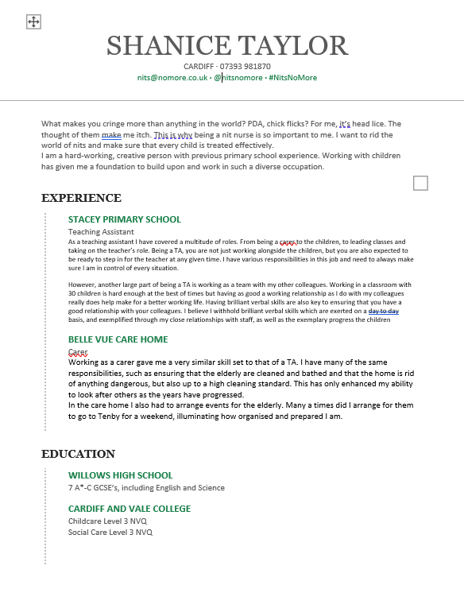

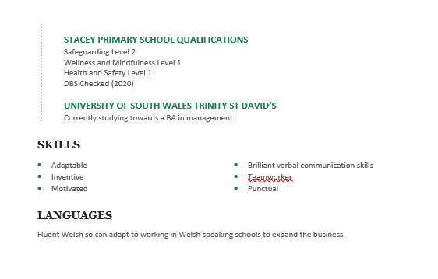

References

Abuhashesh, M. Y., (2014) ‘Integration of Social Media In Businesses,’ International Journal of Business and Social Science, Vol 5 No 8

Aguilar, F., (1967) Scanning the Business Environment, New York: MacMillan

Cerna, M. (2013) ‘Innovation for competitiveness,’ Journal for the Department of Finance and Accounting, Vol 11 no 306

Davidson, J,. (1997) Even More Offensive Marketing: An Exhilarating Action Guide to Winning in Business, London: Penguin Books Ltd

Doran, G. T. (1981) ‘There’s a S.M.A.R.T Way to Write Management’s Goals and Objectives,’ Management Review, Vol 70

Jones, N., Borgman, R., Ulusoy, Ebru., (2015) ‘Impact of social media on small businesses,’ Journal of Small Businesses and Enterprise Development, Vol 22 No. 4

Lewis, R., (2021) What is public liability insurance?, London: Entrepreneur Handbook

Meissner, J., (2010) ‘Basic Pricing Strategies and When to Use Them,’ Hamburg: Kuhne Logistics

Morais, D., Dorsch, M., Backman, S (2004) ‘Examining the Influence of Customer-Provider Investments on Loyalty,’ Journal of Travel Research, Vol 11, No 828

Parvez, N., (2009) ‘Impact of Service Quality, Trust and Customer Satisfaction on Customers Loyalty,’ ABAC Journal of Business Management, Vol. 29 No.1

Raby, A., (2013) ‘Head Lice,’ Journal of Children and Health Care

Voogd, Caroline, (2011) ‘Child Health: Is the tide about to turn?’ British Journal of School Nursing, Vol 6 No 3

www.gov.uk Accessed 2nd July 19:14

https://www.ons.gov.uk/economy/inflationandpriceindices/bulletins/consumerpriceinflation/may2021 Accessed 3rd July 15:23

www.unbiased.co.uk – Accessed 4th July 10:21

