

University of Wales Trinity Saint David
Master of Business Administration (MBA)
Module: International Business Concepts
Module Code: LCMB7034

International Business Report
South Korea’s Automotive Industry and BMW Korea’s Strategic Position

Lecturer: Dr Jean Wang

Student Name: Roshan Lal
Student ID: 2430265

Word Count: 5,173 words
Submission Deadline: 27th April 2026

AI use acknowledgement
Category | Tick
Research | No
Structure | No
Proofreading | No
Writing | No
Creative | No
Programming | No
None | No

I confirm that I have not presented any AI-generated text as my own work. I confirm I have copies of my drafts, notes, and other resources I used before and after the use of AI tools, which I may be asked to provide in evidence.
Table of Contents
1 Section 1: International Business Report 4
1.1 Introduction 4
1.2 Industry and Country Overview 4
1.2.1 Introduction to the South Korean Automotive Industry 4
1.2.2 Size, Scope and Economic Importance 5
1.2.3 Major Domestic and Multinational Firms 6
1.3 Porter’s Diamond Model of National Advantage 7
1.3.1 Factor Conditions 8
1.3.2 Demand Conditions 9
1.3.3 Related and Supporting Industries 9
1.3.4 Firm Strategy, Structure and Rivalry 10
1.3.5 Government Role 10
1.3.6 Chance Events 10
1.4 BMW Korea: Critical Evaluation of Success Factors 11
1.4.1 BMW Korea Overview and Strategic Position 11
1.4.2 Political and Governmental Factors 12
1.4.3 Economic Factors 13
1.4.4 Legal and Regulatory Factors 13
1.4.5 Cultural and Consumer Behaviour Factors 14
1.4.6 Technological and Environmental Factors 15
1.4.7 Competitive Forces and Market Attractiveness 15
1.4.8 BMW Korea Strategic Recommendations. 16
1.5 Conclusion 17
2 Section 2: Reflective Account Using Kolb’s Reflective Cycle 17
2.1 Concrete Experience 18
2.2 Reflective Observation 18
2.3 Abstract Conceptualisation 19
2.4 Active Experimentation 20
References 21

List of Figures
Figure 1 Trends in Korea Eco Friendly Vehicles (Invest Korea, 2025) 5
Figure 2 New Car Sales in 2025 by OEM (MarkLines, 2026) 6
Figure 3 Porters Diamond Model (Porter, 1990) 8
Figure 4 Imported Passenger Car Registration by Brand (Yonhap, 2026a) 11
Figure 5 Experiential Learning Cycle (Kolb, 1984) 18

List of Tables
Table 1 Relative Positioning of Key Automotive Firms in South Korea (author) 6
Table 2 CAGE Distance Analysis for BMW Korea (Ghemawat, 2001) 14
Table 3 Porter’s Five Forces Analysis of BMW Korea (Porter, 2008) 15

Section 1: International Business Report
An Analysis of South Korea’s Automotive Industry and BMW Korea’s Strategic Position

Introduction
South Korea is among the largest automotive economies in the world with a robust domestic manufacturing industry, developed supply chains, export potential and increased focus on policy on electric vehicles, batteries, autonomous driving and software-defined vehicles. South Korea manufactured some 4.1 million vehicles in 2025 with automobile exports of a record of US$72 billion, which shows that the industry is still of strategic value to the national income, employment and trade performance (Invest Korea, 2026).
This report critically evaluates competitiveness of the automotive industry in South Korea and assesses the future outlook of BMW Korea as a foreign multinational in this industry. The national automotive advantage of South Korea is evaluated with the help of the Diamond Model of Porter, and the opportunities and threats of BMW Korea are evaluated with the help of PESTLE, CAGE, institutional theory and competitive forces. BMW is a case in point as it led the imported car market in South Korea in 2025, marking the third year in a row (Yonhap, 2026a).
The report posits that South Korea is a good bet to BMW, yet it will succeed through localisation, compliance with regulations, battery transparency, after-sales credibility and distinction over Hyundai, Kia, Genesis, Tesla, Mercedes-Benz and BYD.

Industry and Country Overview

Introduction to the South Korean Automotive Industry
South Korea is a leading automotive producer and exporter of passenger cars, SUVs, electric cars (EVs), hybrids and automotive components in Asia and a significant global manufacturer of automotive products. The industry is directly related to other national industrial capabilities in batteries, semiconductors, steel, electronics, logistics and digital technology. This renders the automotive sector strategically significant as a manufacturing industry, as well as in the context of the South Korean move towards future mobility, such as EVs, autonomous driving and software-defined vehicles. In 2025, the automobile manufacturing in South Korea was around 4.1 million vehicles, marking the third year of consecutive production of over four million vehicles (Invest Korea, 2026).

Size, Scope and Economic Importance
The South Korean automotive sector is a big sector both locally and internationally. Invest Korea reports that domestic automobile sales grew by 3.3 percent on a year-on-year basis to 1.68 million vehicles in 2025, comprising approximately 1.36 million Korean-brand vehicles, and 320,000 imported vehicles (Invest Korea, 2026). In 2025, it also recorded record automobile exports of some US$72 billion, demonstrating the still significant role of the sector in national income, employment and trade performance (Invest Korea, 2026).
The industry is not only limited to vehicle assembly. It consists of domestic manufacturers, international importers, component vendors, EV battery manufacturers, logistics, companies and networks of charging infrastructure, after-sales services. South Korea is becoming significant in environmental-friendly cars as well. According to Invest Korea, South Korea is in the third position in the global electric vehicle export, ninth in plug-in hybrid export and fourth in hybrid vehicle export, as of 2024, underscoring its increasing prowess in future mobility (Invest Korea, 2025). This means that the industry is moving out of the traditional internal-combustion cars to electrification and new mobility technologies.
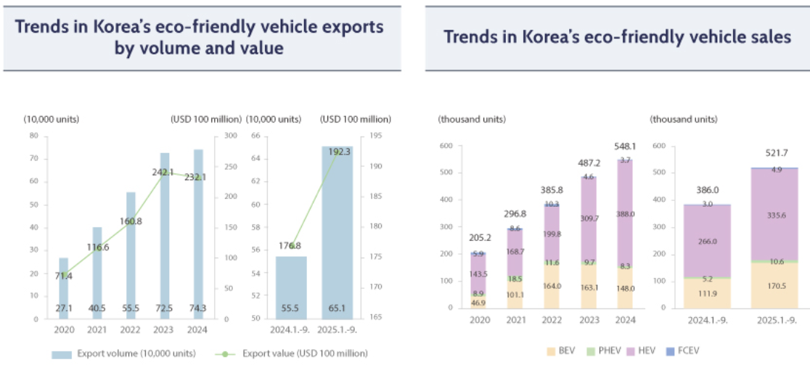
Figure 1 Trends in Korea Eco Friendly Vehicles (Invest Korea, 2025)
The economic significance of the industry is also reflected by the international size of the Korean companies. In 2025, Hyundai Motor sold about 4.1 million vehicles across the world, and Kia sold about 3.13 million vehicles (Hyundai Motor Company, 2026; MarkLines, 2026). In 2025, Hyundai sold 4,108,605 vehicles worldwide in retail, and nearly one million vehicles worldwide in the electrified category and 32 and 17 percent growth of hybrids and EVs respectively (Hyundai Motor Company, 2026). These numbers indicate that South Korea is a not only a production hub but also a complex home market and export location of electrified vehicles.
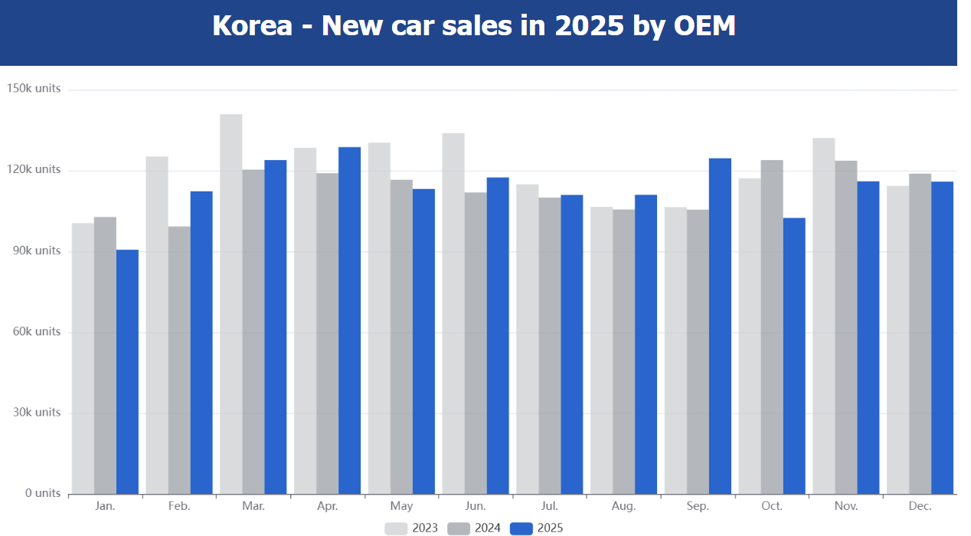
Figure 2 New Car Sales in 2025 by OEM (MarkLines, 2026)

Major Domestic and Multinational Firms
Domestically, Hyundai Motor Group (particularly Hyundai, Kia and Genesis) dominate the market. Hyundai and Kia are both fierce competitors in the mass-market cars, SUVs, hybrids and EVs, and Genesis is aimed at the high-end market. The strength of Hyundai Motor Group is in its scale, local brand loyalty, investment in research and development, and diversification of product range. According to MarkLines, Hyundai and Kia are the largest Korean auto-makers, whereas GM Korea, KG Mobility and Renault Korea are taking the lesser positions in the market (MarkLines, 2026).
Foreign MNCs are also significant, particularly the premium and EV segments. The registration of imported passenger cars was 307,377 units in 2025, which is 16.7 percent higher than the year before (Yonhap, 2026a). BMW is the best imported brand with 77,127 units then Mercedes-Benz with 68,467 units and Tesla with 59,916 units (Yonhap, 2026a). This demonstrates that BMW is very competitive in the premium imported cars market in South Korea.
Table 1 Relative Positioning of Key Automotive Firms in South Korea (author)
Company | Ownership / origin | Main segment | Strategic positioning | 2025 performance indicator
Hyundai | South Korea | Mass market, SUV, EV, hybrid | Domestic leader with broad product range and strong local loyalty | 4,108,605 global retail sales (Hyundai Motor Company, 2026)
Kia | South Korea | Mass market, SUV, MPV, EV | Strong design, family SUVs and electrification strategy | 3,130,014 global sales (MarkLines, 2026)
Genesis | South Korea | Premium | Korean luxury brand competing with BMW and Mercedes-Benz | Premium positioning supported by Hyundai Motor Group
BMW | Germany | Premium imported vehicles, EVs | Performance, luxury and premium German engineering | 77,127 imported sales; No.1 imported brand (Yonhap, 2026a)
Mercedes-Benz | Germany | Premium luxury | Luxury image, executive sedans and SUVs | 68,467 imported sales (Yonhap, 2026a)
Tesla | United States | EVs | Technology-led EV specialist | 59,916 imported sales (Yonhap, 2026a)
GM Korea | United States / Korea | Small cars, SUVs, exports | Export-oriented production and compact SUV focus | 462,310 global sales from Korean operations (MarkLines, 2026)
In general, the automotive sector of South Korea is very competitive and has international importance. Mass-market and export production is dominated by domestic companies, whereas foreign MNCs like BMW, Mercedes-Benz and Tesla are very competitive in the premium and EV segments. The high brand equity shown by BMW in the sale of imported vehicle has come at a time when the company is experiencing high competition with Mercedes-Benz, Tesla and Genesis. Thus, South Korea is a competitive and challenging motor vehicle market where technology, brand strength, localisation and quality of service are key success factors.

Porter’s Diamond Model of National Advantage
Porters Diamond Model describes the creation of national competitiveness by factor conditions, demand conditions, related and supporting industries, and firm strategy, structure and rivalry, where government and chance are other factors that can influence (Porter, 1990). Using the model in the case of South Korea, it can be seen that the automotive advantage of this country relies not on low labour costs but on high-level manufacturing, technology, innovation and coordination of industries.
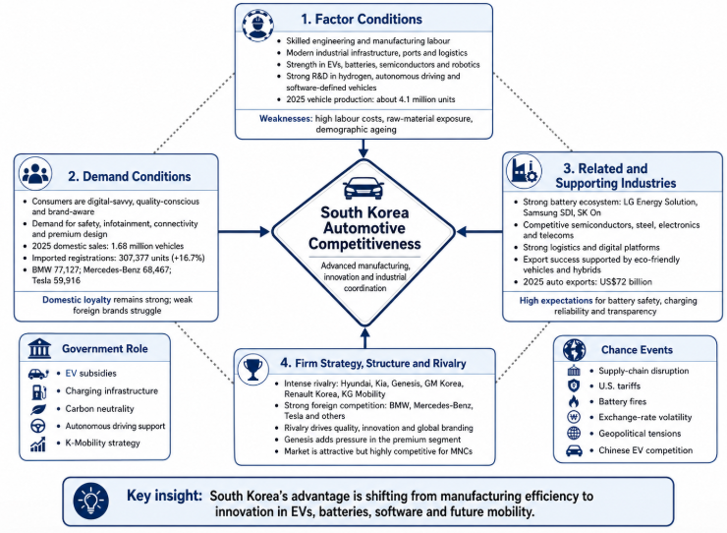
Figure 3 Porters Diamond Model (Porter, 1990)

Factor Conditions
South Korea possesses good advanced factor conditions favouring the production of automobiles. These consist of trained engineering workforce, modern industrial facilities, efficient ports, developed logistics and good research potential in electric automobiles, batteries, hydrogen, robotics, semiconductors and autonomous driving. In 2025, South Korea is projected to manufacture around 4.1 million vehicles, staying above four million units in the third year in a row (Invest Korea, 2026). This is an indication of its size and stability in its production base.
Low-cost labour is not, however, the key to competitiveness in South Korea. Technology, engineering quality, sophistication and innovation capacity of suppliers are its strength. These assets contribute to the shift towards EVs, hybrids and software-defined vehicles. Nevertheless, vulnerabilities remain. In the first quarter of 2026, U.S. tariffs and the disruption of the supply chain and the increase in the cost of steel, nickel, lithium and platinum led to a decrease in the operating profit of Hyundai Motor by 31 percent, which incurred approximately KRW 200 billion in additional costs (Kim and Lee, 2026). This indicates that factor advantages of South Korea are still vulnerable to the global pressure of raw materials.

Demand Conditions
South Korean consumers are digital savvy, quality and brand conscious. They demand high safety, infotainment, connectivity, EV performance and high design. This proves the point that Porter made that requiring domestic purchasers compel companies to innovate and modernize prior to competing on the global scale (Porter, 1990).
In 2025, the domestic vehicle sales grew by 3.3% year-on-year to 1.68 million units, comprising of 1.36 million Korean-brand and approximately 320,000 imported vehicles (Invest Korea, 2026). The number of imported passenger car registrations also increased 16.7 percent to 307,377 units, with BMW dominating the imported market at 77,127 units, then Mercedes-Benz (68,467), and Tesla (59,916) (Yonhap, 2026a). This indicates that Korean companies like Hyundai, Kia and Genesis, as well as luxury foreign brands like BMW, are supported by domestic demand.
Nonetheless, powerful domestic loyalty may limit weaker foreign rivals. Honda stated that it would no longer sell automobiles in South Korea by the end of 2026 due to alterations in global and South Korean automobile market along with necessity to focus corporate resources (Honda Motor Co., Ltd., 2026). Reuters also stated that Honda sold less than 2,000 vehicles in South Korea in 2025, which is more than 20% less than last year (Leussink and Goh, 2026). This implies that foreign companies require size, differentiation or excellent premium positioning to be successful.

Related and Supporting Industries
South Korea is also enjoying globally competitive supporting industries, such as batteries, semiconductors, steel, electronics, telecommunications, logistics and digital platforms. These sectors are becoming more significant as the modern vehicles rely on battery systems, sensors, software, connectivity and data-driven services. Battery companies like LG Energy Solution, Samsung SDI and SK On reinforce the EV ecosystem of South Korea and contribute to the development of mobility in the future.
This ecosystem has an economic significance that is apparent in terms of exports. In 2025, the automobile exports of South Korea hit an all-time high of US 72 billion which was facilitated by the high demand of eco-friendly cars and hybrids (Invest Korea, 2026). Yet, the same developed ecosystem generates more demands on transparency and safety. In 2026, South Korea fined Mercedes-Benz KRW 11.2 billion, or about US$7.61 million, because of falsifying information about battery suppliers of EVs (Reuters, 2026). In the case of BMW, this implies that competitiveness in Korea is not limited to premium branding, but also battery transparency, charging reliability and regulatory trust.

Firm Strategy, Structure and Rivalry
The automotive sector in South Korea is typified by a high degree of competition. The Hyundai Motor Group reigns supreme with Hyundai, Kia and Genesis, whereas GM Korea, Renault Korea, KG Mobility and foreign brands compete in respective segments. This competition has promoted the shift by Korean companies to design, quality, hybrids, EVs, and global branding as well as low-cost manufacturing.
This competition enhances national superiority since companies have to keep on advancing quality, technology and prices. But it also complicates the market of multinational companies. BMW also has to compete with Mercedes-Benz and Tesla, but also with Genesis, which enjoys the advantages of local knowledge, the support of Hyundai Motor Group, and the well-established after-sales networks. Thus, South Korea is a desirable destination to BMW, yet very competitive.

Government Role
The South Korean government promotes automotive competitiveness by subsidizing EVs, charging stations, carbon-neutrality policy, autonomous driving assistance and software-defined vehicle development. The 2025 EV subsidy reform provided better incentives to vehicles with better driving range and fast-charging capability, and manufacturers consider updating technology (Ministry of Environment, 2025). K-Mobility strategy aimed at EV transition, future vehicle parts, autonomous vehicles and software-defined vehicles were also reported by Invest Korea (Invest Korea, 2025). The policy of the government thus reinforces the innovation-based automotive advantage of South Korea.

Chance Events
Supply-chain disruption, U.S. tariffs, battery fires, exchange-rate volatility, geopolitical tensions and Chinese EV competition are all chance factors. The 2026 profit pressure of Hyundai indicates that external shocks can easily impact even competitive companies in the global arena (Kim and Lee, 2026). All in all, the South Korean automotive strength is great, yet it is moving away not only towards manufacturing efficiency but also to EVs, batteries, software and future mobility. This opens opportunities to BMW, and heightens demands on safety, charging, transparency and localisation.

BMW Korea: Critical Evaluation of Success Factors

BMW Korea Overview and Strategic Position
BMW is a German multinational automobile manufacturer that has a subsidiary in South Korea called BMW Korea. Its Korean business is centered on imported high quality vehicles, electric vehicles, after-sales services, logistics, charging infrastructure and premium customer experience. BMW Korea is a strategic market due to the fact that South Korea is a high-income, technologically advanced and brand-conscious market where premium imported cars have a high performance.
In 2025, BMW became the third consecutive year of the largest imported car brand in South Korea. The number of imported passenger cars had increased to 307,377 vehicles, which is 16.7 more than in 2024, and the sales of BMW amounted to 77,127 customers, followed by Mercedes-Benz (68,467) and Tesla (59,916) (Yonhap, 2026a). Hybrids took up 56.7% of the imported sales, and EVs took up 29.7% of the sales, indicating that electrified vehicles are now the focus of foreign manufacturers in Korea (Yonhap, 2026a).
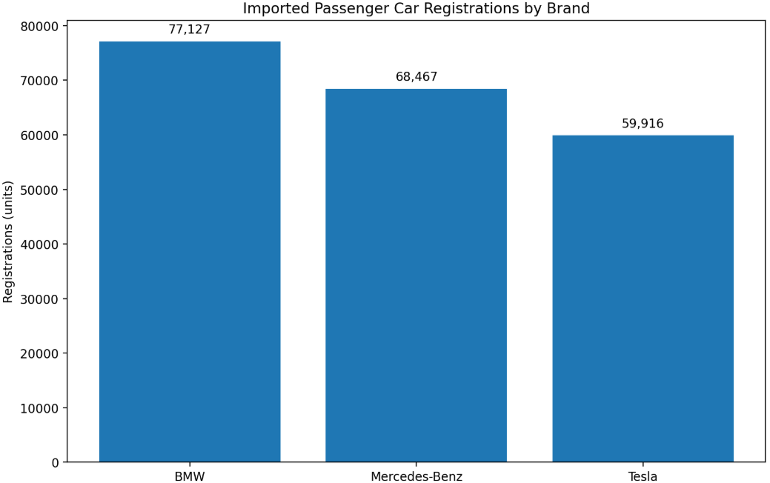
Figure 4 Imported Passenger Car Registration by Brand (Yonhap, 2026a)
BMW also continued to be strong globally. BMW Group reported that, in 2024, the BMW brand held the lead in the global premium segment, albeit with a 6.3% EBIT margin, which is below its target range of 810, partly due to delivery stops, reduced China demand and brake-system problems (BMW Group, 2025). Thus, BMW Korea enjoys the luxury of global reputation that BMW has in the market, yet cannot rest on its brand history. Korean customers evaluate BMW against Mercedes-Benz, Tesla, Genesis and more and more Chinese EV brands. The success of BMW is hinged on premium differentiation, EV credibility and high level of local responsiveness.

Political and Governmental Factors
BMW finds South Korea to be a politically stable and highly developed place. Future mobility, particularly EVs, charging infrastructure, battery safety and carbon neutrality are heavily promoted by government policy. The International Trade Administration (2025) estimated that by the end of 2025 EVs would be sold to 20 percent of all vehicles with the aid of subsidies, charging infrastructure and net-zero policy. It also reported that in 2025, South Korea had allocated more than US448 million towards charging infrastructure and that EV charging market had increased at a rate of 19 percent between 2020 and 2024 (International Trade Administration, 2025).
It is advantageous to BMW since EVs and plug-in hybrids demand is boosted with the help of the policy. BMW Korea has also invested locally to minimize the liability of foreignness which is the drawbacks that foreign firms experience because of the lack of familiarity, regulation and local competition (Zaheer, 1995). BMW Korea installed 3,030 EV chargers as of the end of 2025, the highest number of charging infrastructures in the imported car brands, and intended to install over 4,000 chargers in 2026 by installing over 900 more chargers (Lee, 2026).
There are however political and policy risks. EV subsidies are subject to change, and industrial policy can indirectly support domestic manufacturers like Hyundai, Kia and Genesis. There can also be more strict subsidy terms, battery disclosure or cost pressures as related to imports of EVs. Thus, BMW should not just be a foreign importer, but a permanent participant in the mobility ecosystem of the future of Korea.

Economic Factors
South Korea is a high-income country with urban customers who can purchase high-end imported cars. BMW enjoys the luxury cars, performance cars, corporate leasing, SUV, hybrids and EVs that have high demand. The fact that imported car registrations have been increasing by 16.7% in 2025 shows that the premium import market is still appealing despite the high competition (Yonhap, 2026a).
However, BMW Korea is exposed to economic risks. The exchange-rate movements can influence prices of imported vehicles, and inflation and interest rates can decrease the discretionary spending. There are also strong domestic substitutes of South Korean consumers. Genesis, as an example, will compete with BMW by providing high-quality design, familiarity with local brands and good service networks. Premium pricing should therefore be handled by BMW. In case the prices are excessive, customers can switch to Genesis, Tesla or Mercedes-Benz. When the prices are lowered excessively, BMW can undermine its luxury brand image. Value-based pricing approach is thus more appropriate as opposed to mere cost-plus pricing, since the up-market clientele pays based on performance, design, technology, service and brand position.

Legal and Regulatory Factors
The success of BMW in South Korea revolves around legal and regulatory matters. There are stringent regulations on the safety of vehicles, environmental regulations, consumer protection, advertising and competition. EV regulation has gained relevance especially following the issue of battery fires raised by the general population. In 2025, South Korea proposed a government-based EV battery certification system, which is compulsory safety labelling and more rigorous performance testing (International Trade Administration, 2025).
Compliance is important as demonstrated by the Mercedes-Benz case. The antitrust regulator of South Korea fined Mercedes-Benz KRW 11.2 billion, or around US7.61 million, on claims that it misled consumers with battery supplier details of its EVs (Reuters, 2026). This directly affects BMW. BMW should guarantee clear battery data, correct promotional assertions, recall, data protection of connected cars, readable warranty procedures, as well as good after-sales services.
Institutional theory states that companies need to ensure their legitimacy through adjustment to formal and informal institutions, including laws and regulations and consumer expectations and trust, respectively (North, 1990; Kostova and Zaheer, 1999). In the case of BMW, compliance is not merely a legal issue, but also a brand-protection problem. Customers who are premium expect assurance and trustworthiness; thus, any failure in transparency or safety would hurt the BMW brand more than it would hurt a cheaper one.

Cultural and Consumer Behaviour Factors
The consumers in South Korea are very brand conscious, technologically advanced and status conscious. This is advantageous to BMW since German engineering and luxury European brands have a high symbolic value. The sporty and performance-based image also contrasts BMW with Mercedes-Benz, which has a more traditional luxury positioning and Tesla, which is more focused on technology and the EV identity.
But, speed, convenience, digital services and after-sales responsiveness are also high expectations of Korean consumers. Bad online comments, safety issues or bad service may go viral. Foreign firms are also put under pressure due to domestic loyalty to Hyundai, Kia and Genesis. BMW has to hence localise the ownership experience and safeguard its world brand. This will involve the Korean language online platforms, rapid service reservations, transparent repair procedures, domestic finance options, dealer quality control and marketing to cultural relevance.
Table 2 CAGE Distance Analysis for BMW Korea (Ghemawat, 2001)
CAGE dimension | Impact on BMW Korea | Critical evaluation
Cultural distance | Moderate | BMW is foreign, but German engineering is admired. Premium branding fits Korea’s status-conscious consumer culture.
Administrative distance | Moderate to high | Regulations on EV batteries, safety, advertising and subsidies are strict. Compliance is essential for legitimacy.
Geographic distance | High | Vehicles are imported, creating logistics and cost challenges. BMW’s logistics and charging investment reduces this risk.
Economic distance | Low to moderate | South Korea is a high-income market, supporting premium pricing. However, exchange rates and household debt may affect demand.
The CAGE framework indicates that South Korea is a good place to invest in economically by BMW, yet the administrative and geographic distance demands that it localise and invest (Ghemawat, 2001).

Technological and Environmental Factors
South Korea is appealing due to its good EV infrastructure, battery capacity, digital connectivity and high-end consumers. The charging strategy of BMW Korea is thus a strategic one. BMW will eliminate range anxiety by installing 3,030 chargers by 2025 and aiming to install over 4,000 chargers by 2026 and enhance customer experience (Lee, 2026). In the first quarter of 2026, BMW Korea sold 2,913 electrified vehicles, 1,732 battery electric vehicles, and 1,181 plug-in hybrid vehicles, becoming the leading premium imported brand of electrified vehicle sales in the premium import segment of Korea (Choi, 2026).
The EV and plug-in hybrid strategy of BMW is also supported by environmental policy. The net-zero goal and EV subsidy system in South Korea will generate demand in less-emission vehicles. Nevertheless, the environmental expectations also put BMW under pressure to report on battery sourcing, recycling, lifecycle emissions and ESG commitments. Circularity and electrification are part of the global strategy of BMW, yet in Korea this needs to be seen by consumers and regulators.

Competitive Forces and Market Attractiveness
Porter’s Five Forces helps evaluate BMW Korea’s market attractiveness (Porter, 2008).
Table 3 Porter’s Five Forces Analysis of BMW Korea (Porter, 2008)
Force | Strength | Impact on BMW Korea
Rivalry among existing competitors | High | BMW competes with Mercedes-Benz, Tesla, Audi, Volvo, Lexus, Genesis and BYD. Differentiation and service quality are essential.
Threat of substitutes | Medium to high | Seoul has strong public transport, while mobility services, hybrids and EVs change ownership patterns.
Buyer power | High | Premium consumers have many alternatives and access to online reviews and comparison platforms.
Supplier power | Medium to high | Batteries, semiconductors and software are strategically important and can affect cost, supply and innovation.
Threat of new entrants | Medium | Traditional entry is difficult, but Chinese EV brands such as BYD can compete through price and battery strength.
The market is appealing but challenging. The move of Honda to stop selling automobiles in South Korea by the end of 2026 demonstrates that foreign car manufacturers lacking scale, high differentiation or premium positioning can suffer. In 2025, Honda sold less than 2,000 vehicles in South Korea, a decrease of over 20% compared to the year before (Leussink and Goh, 2026). BMW enjoys greater advantages than Honda due to the strength and scope of its premium brand but the example demonstrates that South Korea is not a market that foreign companies can easily enter.

BMW Korea Strategic Recommendations.
To begin with, BMW needs to increase the trust in EVs by being transparent. It must prominently feature battery suppliers, battery safety systems, warranty and recycling policies. This is in direct response to the pressure of Korean regulations and consumer anxiety following the recent EV battery scandals.
Second, BMW needs to enhance localisation. Korean consumers demand quick, online and trustworthy service. BMW ought to enhance Korean-language online services, service-reservation systems, financial products, customer-care responsiveness and dealer uniformity.
Third, BMW must keep building up charging and service networks. BMW ownership can be easier by having premium charging lounges and fast chargers in Seoul, Busan, Incheon and highway corridors to alleviate EV anxiety.
Fourth, BMW ought to protect premium differentiation against Genesis and Tesla. It must focus on German engineering, driving pleasure, M performance, design, luxury craftsmanship and premium EV technology.
Lastly, BMW ought to establish collaborations with Korean battery, software, charging and mobility companies. This would lessen foreign-ness, enhance domestic legitimacy and make BMW more central to the future mobility in South Korea.
Altogether, BMW Korea has good prospects in South Korea, yet its success will be based on the ability to balance global premium identity and local regulatory, technological and cultural adaptation.

Conclusion
The automotive sector in South Korea is considered to be competitive in the world due to the combination of new manufacturing capacity, challenging domestic markets, robust supporting industries, cutthroat competition plus active government policy. Porters Diamond reveals that the national advantage of South Korea is no longer founded on the efficient production of vehicles, but is gradually shifting towards EVs, batteries, software-defined vehicles, autonomous driving and future mobility. The strategic role of the sector in the national economy is attested by the US$72 billion of automobile exports that the country experienced in 2025.
In the case of BMW, South Korea is a very appealing, yet a very challenging market. The firm enjoys the advantage of high income earners, high demand of imported premium cars and government policy favors electrification. Its brand is popular locally as evidenced by the fact that BMW is the best imported brand in 2025 with 77,127 registrations. Yet, the market is also a risk, such as a strong competition with Hyundai, Genesis, Mercedes-Benz, Tesla and BYD; stringent regulation; battery-safety issues; exchange-rate risks; and high consumer expectations.
Thus, the future success of BMW Korea will be based on the ability to balance between the global integration and the local responsiveness. It needs to maintain the global high-end BMW brand and adjust to the Korean regulatory, technological and cultural demands. The best strategic path is to establish BMW Korea not merely as an importer of German luxury vehicles, but as a reliable high-end mobility firm that is a part of the EV and digital mobility ecosystem in South Korea.

Section 2: Reflective Account Using Kolb’s Reflective Cycle
The experiential learning cycle developed by Kolb describes the process of reflection in four steps, namely, concrete experience, reflective observation, abstract conceptualisation and active experimentation (Kolb, 1984). I applied this model to think about my research, analysis and report preparation of the automotive industry in South Korea and BMW Korea.
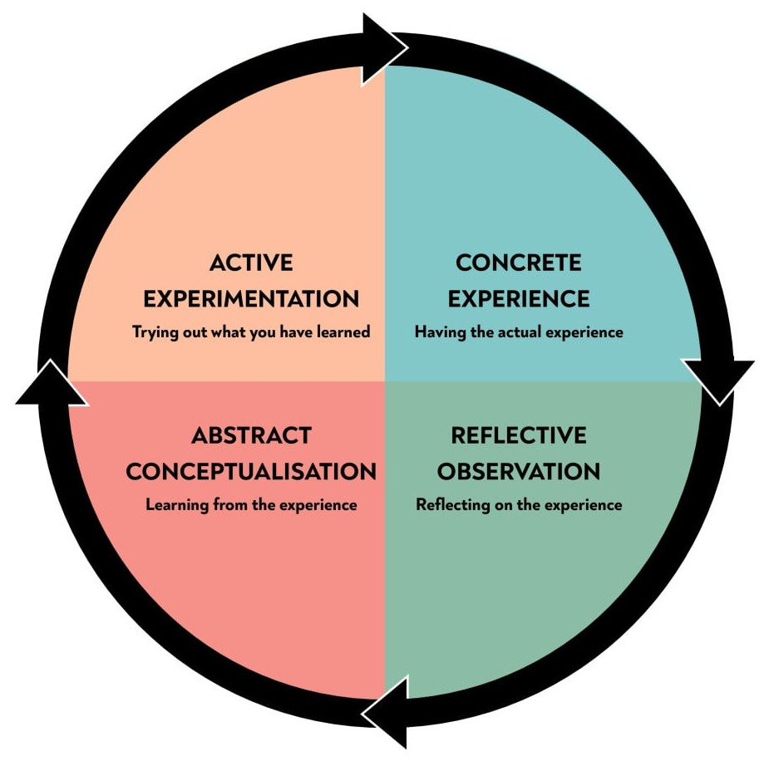
Figure 5 Experiential Learning Cycle (Kolb, 1984)

Concrete Experience
The initial phase is concrete experience which is the activity taken (Kolb, 1984). My experience was to choose South Korea as the country, automotive industry as the industry and BMW as the multinational company. I selected this issue as South Korea is a significant automotive economy, and BMW occupies a significant market in the imported high-end cars.
The assignment asked me to investigate the industry, analyze the national competitiveness of South Korea based on the Diamond Model by Porter and critically analyze the opportunities and threats of BMW Korea based on international business models. I collected academic, government, industry and company sources of evidence. They were Porters Diamond Model, Cage distance, institutional theory and Porters Five Forces, statistics on vehicle production, exports, imported car sales, EV infrastructure and performance of BMW.

Reflective Observation
The second level is reflective observation, in which the learner considers the occurrence of something in various ways (Kolb, 1984). Initially, I had a hard time doing it due to the fact that the automotive industry is expansive. It encompasses manufacturing, exports, batteries, EVs, software, infrastructure, regulation and consumer behaviour. First, I was inclined to add more general information about South Korea and BMW. I however realised that a Level 7 report should be analytical and not predominantly descriptive.
One of the challenges was how to determine the most relevant evidence. The statistics of production and exports in South Korea assisted in demonstrating the economic significance of the industry, but they were not sufficient in themselves. I had to justify why such figures were important to competitiveness and the strategy of BMW. In the same vein, BMW was also the market leader in the imported vehicles sales, which also came in handy, yet I needed to consider whether the company could maintain this success in the market as compared to its rivals like Mercedes-Benz, Tesla, Genesis and BYD.
The application of multiple frameworks aided my thinking. Porters Diamond was applicable in the analysis of national competitiveness whereas PESTLE and CAGE were applied to evaluate the external environment of BMW Korea. The institutional theory particularly came in handy since it revealed that the success of BMW is not solely based on the sale of high-quality vehicles, but also on the attainment of legitimacy as a result of compliance, transparency and customer trust.

Abstract Conceptualisation
Abstract conceptualisation is the third stage, during which the learner connects the experience with theory and broader learning (Kolb, 1984). This assessment helped me to gain a better idea of how one can apply the international business theory to a case in reality. I found out that structures are best applied critically but not mechanically. Indicatively, Porters Diamond cannot merely be a listing of the factors conditions, demand conditions and supporting industries. It must describe the interaction of these factors to produce national advantage.
This mattered as automotive competitiveness of South Korea is not founded primarily on low-cost labour. Rather, it has an upper hand in skilled labour, sophisticated suppliers, technology, consumer demandingness and government assistance in mobility in the future. This enabled me to realize that national competitiveness is dynamic and can change to include manufacturing efficiency or innovation ability.
I also got to know that attractiveness in the market does not necessarily mean that a multinational company will succeed. BMW would find South Korea appealing since it is a rich, technologically sophisticated and open market to high-end imported cars. But it is also hard since consumers are demanding, regulation is stringent and competition is stiff. This is associated with the idea of the liability of foreignness where foreign companies are disadvantaged over the domestic companies due to lack of familiarity, institutional disparities and domestic rivalry (Zaheer, 1995). Thus, BMW has to adjust to the expectations of the Koreans and retain its international high-end status.
The study also enhanced my knowledge of the institutional theory. North (1990) suggests that economic behaviour is influenced by institutions in the form of formal and informal rules. Formal institutions in the case of BMW Korea are EV safety regulations, consumer protection laws, whereas there are informal institutions that are customer expectations regarding reliability, prompt service, and brand trust. This demonstrated to me that compliance and reputation are not merely legal issues, but also strategic.

Active Experimentation
The last one is active experimentation where the learner reflects on how he will apply the learning in future (Kolb, 1984). In case I was doing a similar assignment in the future, I would start by developing a research matrix. This would assist me in sorting out the sources based on theme like industry size, competitiveness, regulation, consumer behaviour and company strategy. It would also assist me in avoiding repetition and make sure that every source is relevant to the argument.
I would also take more time to correlate academic theory with the existing market evidence. The most powerful analysis that I learned in this report is the one that relates theory and data. As an example, CAGE distance will be more significant when related to the necessity of BMW to be localised, charged, and trusted in after-sales. In the same way, the Five Forces as presented by Porter is more fortified when there is evidence of real competitors.
To manage my time better in future work, I will write the reference list as I write, not at the end. This will assist in making sure that there are correct Harvard referencing and less chance of omitting sources. On the whole, the reflective cycle by Kolb assisted me in gaining insight into my learning process. The evaluation has helped me enhance my skills in independent research, the use of global business models, an evaluation of complicated evidence and sound judgements.

References
BMW Group (2025) BMW Group Report 2024. Available at: https://www.bmwgroup.com/en/report/2024/index.html (Accessed: 26 April 2026).
Choi, Y. (2026) ‘BMW Korea tops imported electrified vehicle sales in Q1, driven by i5’, The Asia Business Daily, 7 April. Available at: https://www.asiae.co.kr/en/article/2026040710154185954 (Accessed: 26 April 2026).
Ghemawat, P. (2001) ‘Distance still matters: The hard reality of global expansion’, Harvard Business Review, 79(8), pp. 137-147.
Honda Motor Co., Ltd. (2026) Honda to discontinue automobile sales in South Korea. Available at: https://global.honda/en/newsroom/news/2026/4260423beng.html (Accessed: 26 April 2026).
Hyundai Motor Company (2026) Hyundai Motor reports 2025 global retail sales results. Available at: https://www.hyundai.com/worldwide/en/newsroom/detail/hyundai-motor-reports-2025-global-retail-sales-results-0000001111 (Accessed: 26 April 2026).
International Organization of Motor Vehicle Manufacturers (OICA) (2026) Production statistics. Available at: https://oica.net/production-statistics/ (Accessed: 26 April 2026).
International Trade Administration (2025) South Korea electric vehicles EV market. Available at: https://www.trade.gov/market-intelligence/south-korea-electric-vehicles-ev-market (Accessed: 26 April 2026).
Invest Korea (2025) Korea’s Future Mobility Industry: Advancing through Ecosystem Development and Global Competitiveness. Available at: https://www.investkorea.org/ik-en/bbs/i-5025/detail.do?ntt_sn=490814 (Accessed: 26 April 2026).
Invest Korea (2026) S. Korea’s auto exports hit record USD 72 bn in 2025. Available at: https://www.investkorea.org/ik-en/bbs/i-5073/detail.do?ntt_sn=493173 (Accessed: 26 April 2026).
Kim, H. and Lee, J. (2026) ‘Hyundai Motor posts Q1 profit drop, warns growing business headwind’, Reuters, 23 April. Available at: https://www.reuters.com/business/autos-transportation/hyundai-motor-reports-31-drop-q1-operating-profit-meets-forecasts-2026-04-23/ (Accessed: 26 April 2026).
Kolb, D.A. (1984) Experiential Learning: Experience as the Source of Learning and Development. Englewood Cliffs: Prentice-Hall.
Kostova, T. and Zaheer, S. (1999) ‘Organizational legitimacy under conditions of complexity: The case of the multinational enterprise’, Academy of Management Review, 24(1), pp. 64-81.
Lee, S. (2026) ‘BMW Korea surpasses 3,000 electric vehicle chargers installed nationwide’, The Asia Business Daily, 29 January. Available at: https://www.asiae.co.kr/en/article/2026012909585268073 (Accessed: 26 April 2026).
Leussink, D. and Goh, B. (2026) ‘Honda to halt South Korea car sales, highlighting strain across Asian markets’, Reuters, 23 April. Available at: https://www.reuters.com/world/asia-pacific/japans-honda-stop-selling-cars-south-korea-end-2026-2026-04-23/ (Accessed: 26 April 2026).
MarkLines (2026) Korea: new car sales in 2025 by OEM. Available at: https://www.marklines.com/en/statistics/flash_sales/automotive-sales-in-korea-by-month-2025 (Accessed: 26 April 2026).
Ministry of Environment (2025) 2025 Electric Vehicle Purchase Subsidy Reform. Available at: https://www.me.go.kr/eng/web/board/read.do%3Bjsessionid%3D7jQufQEJmWMz1LkyfA7cROGqeV1gnGalgv5I1WhB.mehome1?boardCategoryId=&boardId=1718350&boardMasterId=522&decorator=&maxIndexPages=10&maxPageItems=10&menuId=461&orgCd=&pagerOffset=120&searchKey=&searchValue= (Accessed: 26 April 2026).
North, D.C. (1990) Institutions, Institutional Change and Economic Performance. Cambridge: Cambridge University Press.
Porter, M.E. (1990) The Competitive Advantage of Nations. New York: Free Press.
Porter, M.E. (2008) ‘The five competitive forces that shape strategy’, Harvard Business Review, 86(1), pp. 78-93.
Reuters (2026) ‘South Korea fines Mercedes $7.6 million over misleading EV battery information’, Reuters, 10 March. Available at: https://www.reuters.com/sustainability/boards-policy-regulation/south-korea-fines-mercedes-76-mln-over-misleading-ev-battery-information-2026-03-10/ (Accessed: 26 April 2026).
Yonhap (2026a) ‘Imported car sales jump nearly 17 pct in 2025; BMW tops list for 3rd year’, Yonhap News Agency, 6 January. Available at: https://en.yna.co.kr/view/AEN20260106004500320 (Accessed: 26 April 2026).
Zaheer, S. (1995) ‘Overcoming the liability of foreignness’, Academy of Management Journal, 38(2), pp. 341-363.

