Name: Alice Samuel

Student Number: P149875

Course: Illustration

Title: The Exploration of “Monsters” in Media and Literature

Word Count: 2168

Tutor: Louise Burston

In today’s society where the unease of war and terrorism is at its peak, our civilization’s morality is beginning to be questioned. What divides the unprincipled individuals from those with good intent? And is there really a definitive line, or is there more to the question of what makes a monster?
The question has been explored throughout history, from fairytales and myths to modern psychoanalytical studies, but there are so many variations that it is difficult to tell which is the most accurate depiction.

Dictionary definitions are as follows:

- A large, ugly, and frightening imaginary creature.
- An inhumanly cruel or wicked person.
(Oxford Dictionary, 1995)

Both stereotypes are usually the first answers that come to mind, but perhaps there is no real definition, and that with our ever-changing society our views of monsters are adapting with it. But, why now? What is influencing us so much? This is what I intend to explore in my dissertation.

Literature

My first keyword that I will explore is Literature. How have “monsters” been represented in early works such as myths and fairytales?
Fairytales have always been stories that teach us valuable life lessons, whether they be in the forms of Greek mythology, short stories or fables; although some storylines would be considered more eccentric in today’s society, they all have a universal understanding. But how have these critically acclaimed childhood stories changed for our modern audiences? Original fairytales could include issues of murder, deception, rape and cannibalism, and were considered warnings to make children behave compared to their innocent and modern mainstream counterparts such as the storylines in Disney© movies. For example many see the message of ‘Hansel and Gretel’ (Brothers Grimm, 1812) as a warning to not venture off, but the original story was based upon a darker time in its history: the great famine of 1315-17.
Now the most obvious answer to the question ‘who is the “monster” in this tale?’ would usually receive the answer of the Witch. But maybe we should stop and think for a moment about the actions of the parents, who abandoned their children in the middle of a forest to starve in order to save themselves. Although the Witch’s intentions are more barbaric in the sense that she willingly plans to cook the children (whereas the mother and father felt that there was no other way to survive), should we not also question the parents’ decision a little more too? Why should we only punish the witch for what she intends to do when the parents’ abandonment would also assuredly end in the children’s death?
Is it our fear of the unknown, and of the supernatural that makes us place more blame on the Witch’s character? But then why are the human’s actions more justified? It is always easier to place blame on something that we do not quite understand, and perhaps they use supernatural characters to hide the underlying threats that we humans pose upon others of our species to make us feel better about our decisions, assuring ourselves that they are for the greater good.
Morality is not only questioned in storylines as early as childhood, but they are also explored in higher forms of literature.
Folkloric creatures have always been known to embody our social anxieties, whether they are characters that must be understood or, most commonly, vanquished. Some creatures appear as more technologically advanced beings, and this especially applies to the story of ‘Frankenstein’ (Shelley, 1818), as scientific developments were the technological advancements of their time. But the story’s themes also challenged the morals of religion, and anything that could signify a huge change was suppressed.
Frankenstein is a Byronic creation, and his creature, an unholy abomination. Although he is made from human parts, the resurrected man challenges the morals of religion by Dr. Frankenstein trying to emulate God.
Lord Byron whom challenged Mary Shelley to a writing competition, helped to influence the famous story. When overhearing a conversation between Byron and her husband Percy Shelley, the intellectual stimulation conjured visions of ‘[…] a pale student of unhallowed arts kneeling beside the thing he had put together. I saw the hideous phantasm of a man stretched out, and then, on the working of some powerful engine, show signs of life, and stir with and uneasy, half-vital motion.’ She goes on to say ‘Frightful must it be; for supremely frightful would be the effect of any human endeavor to mock the stupendous mechanism of the Creator of the world.’ (Shelley, p.9, 1818).
This concern with “playing God” only adds to the creature’s inability to be seen as human, and more an entity that embodies the fears of religious and scientific anxiety of the time.
These dreams became the catalyst for the acclaimed novel ‘Frankenstein, or the Modern Prometheus’ (Shelley, 1818).

Psychology

Frankenstein’s themes have always been a dominant piece of literature to appear in psychoanalytical texts, particularly those of Sigmund Freud and his theory of the “monster” and the super-ego.
The “super-ego” is described as ‘the human sense of guilt and conscience.’ (Bartleby.com, n.d.) Dr. Frankenstein’s guilt is established from his inability to comprehend his violent and immoral actions when planning the process of reviving the body, and this grows throughout the book by means of the “monster’s” actions as punishment for creating him. This only enforces the feeling of anxiety of society and pushes the psychological studies of the “super-ego”. Not only do his actions reflect the apprehension of his actions, but also his surroundings are described a filthy and unhealthy, almost mirroring his mentally frantic and manic desires to play God. His state of mind can be shown when he is thought to be doing the right thing by saying "A new species would bless me as its creator and source; many happy and excellent natures would owe their being to me. I might in process of time renew life where death had apparently devoted the body to corruption". This shows his desire for power and greed for knowledge. Could it be that he simply wants power over the control of death and immortality, or could it be something more oppressive, such as the greed for knowledge being a burden upon those who follow science more than religion?

After the “monster’s” creation, its overpowering presence is used as a metaphor to represent Freud’s theory of the “super-ego” and the development of anxiety through the loss of love, control and above all, one’s own soul. After all, we all fear what we cannot see or understand, and perhaps this fear of revealing ones inner “monster” is truly one of the greatest fears of all.

Media

From a classic novel to a modern form of art; the appearances of supernatural entities and unknown creatures in literature only spurned on the desire for visual stimulation, and when films were developed this allowed viewers to be shocked and thrilled by the horrors of famous characters, especially the “Universal Monsters”.
Released between 1931 and 1954, Universal released a total of six monster movies that are still renowned today.
The question now is, are the plotlines and character depictions still relevant?
Hollywood motifs have drastically changed over the last few decades with political and social movements influencing new storylines, and technological advancements allowing filmmakers to play with different elements of mise en scène, to influence the audience’s reactions towards particular characters.
These can best be explored through looking at the comparisons between movies of their time and “monster” movies now.
Take ‘King Kong’ (1933) for example compared to the 2005 remake by director Peter Jackson. Considered a ‘ground-breaking film’ (Jottedlines.com, 2012), the story contained a number of classic Hollywood motifs that paved the way for many of the films we know today, whether it be characters, plots, cinematography or sound and colour.
For example, let’s take a look at the posters made to advertise the films.

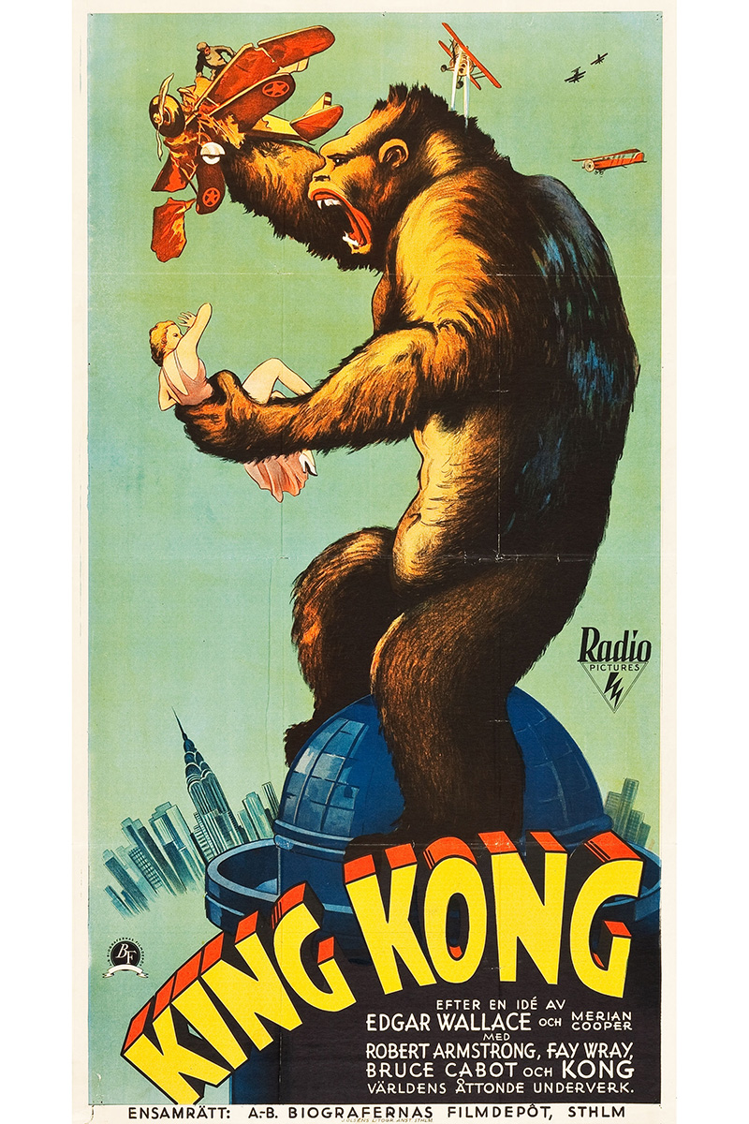
(At The Movies, n.d)

The first picture is that of the 1933 film directed by Merian C. Cooper and Ernest B. Schoedsack. There are several variations of the advertisement, but all depict the same humungous ape gripping a defenseless female while he predictably destroys all that is around him.

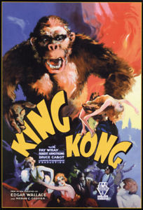

The bold and bright reds symbolize the danger surrounded around Kong, while the humans are running, fainting or being destroyed. His monstrous size forces us to remember that he is no ordinary beast, but something unnatural, unlike the real apes that are far smaller and less threatening to the eye; in other words, very similar to us.
We then take a look at Jackson’s posters for the film, and there is already a significant difference between them:

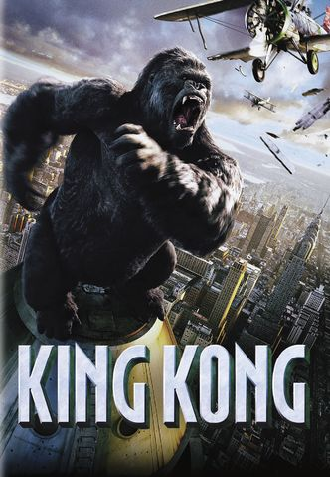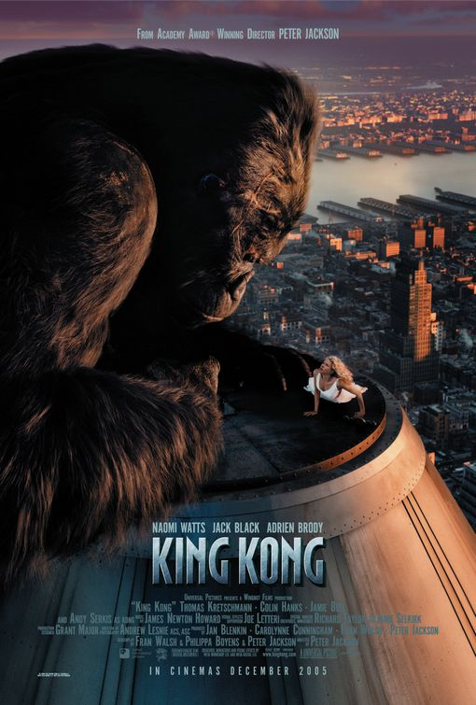
(The Ant Farm, 2006)

We can instantly see the differences between the new and the old. Despite Kong destroying the airplane in the first poster, the high-angle shot symbolizes his loss of power nearing the end of the film. Could it be that it wants us to feel less threatened and add to his character? Or could it be foreboding his imminent demise by making him appear smaller? If we were looking up at him, it would signify an ominous triumph, however the second poster shows no sign of this. With a dominant orange hue, it softens the image and provides it with a feeling of calm and care. Kong is not holding on to a fainting Ann, nor is anyone running from the beast, instead they look at each other with an almost heartfelt gaze.
Kong is a primitive creature, although he is seen as being all devoid of real emotions and thought, Peter Jackson explores this more in his 2005 remake of the same name by taking a fine comb through the relationship between both the leading lady Ann Darrow and Kong.
Another film that looks at the relationship between an otherworldly creature and a human is Guillermo Del Toro’s ‘The Shape of Water’ (The Shape of Water, 2017). It’s the story of a mute woman who falls in love with an ‘elemental god from a river’ (Painter, 2017). In an interview with KUTV’s Ryan Painter, Del Toro explained that ‘[…] there is an empathy for “the other” in the early Universal monster movies, that is almost completely absent of modern genre. What is the Shape of Water? … It’s its own thing.’ The film covers a range of topics from race, sex, gay rights and disability, all while set in a decade thought to be a time of the “ideal America”, but as Del Toro states, ‘[…] It was a very divisive time, a time of toxic masculinity… gender discrimination, race discrimination, riots, Cold War… it’s a mirror, but also a torturous time to go back because a lot of people when they crystalize the idea of the ideal America, the great America, it’s that time but it’s not the real time. Sort of a cookie cutter, cleaned up version of that era, but it was not that way, and I wanted to show that today is then, and then is today, and the only thing that Jesus, Buddha, the Beatles agreed on was that all you need is love, and let’s talk about it without fear, with as much heart as we can and as much intelligence as we can.’ (Painter, 2017).
Unlike Jack Arnold’s film ‘The Creature from the Black Lagoon’ (The Creature from the Black Lagoon, 1954) whose story was set not long before that of ‘The Shape of Water’, the story of Eliza and her creature is one of understanding and love, and our acceptance of those who are different. In the 1954 film, the creature follows the similar plot patterns to Kong: The damsel is taken by an in-human beast, where she must be saved by the dashing male hero, only then to be killed or disappear. In some fairytales, the beast can transform, however when they do, it is always into an attractive human. The creature in the ‘The Shape of Water’ does not do that. He is who he is and can not be changed physically. As Del Toro expresses: ‘[…] not only are they capable of violence, but they are also capable of feeling and of love.’

Conclusion

It is clear that the term “monster” is a difficult one to pinpoint. They have been shaped by religion, anxiety and history, and we have developed numerous definitions of the term. What I want to know is how the media has truly changed our views on that particular label, from early children’s literature to now, and how we perceive certain characters in films. What qualifies as our equivalent of a scary “monster” to the 1950s classic creatures? I will continue to look more in-depth at authors such as Mary Shelley and Bram Stoker, thinkers like Sigmund Freud, Bruno Bettelheim and Roland Barthes and also the viewpoints of highly acknowledged film critics to see their view on how the film industry’s design can shape our perceptions.

The question I shall explore is:

‘How is the term “monster” characterized in media and literature?’

References
Websites:
Anon, (2018). [online] Available at: https://en.oxforddictionaries.com/definition/monster [Accessed 18 Apr. 2018].
Chen, M. (2018). The Other & The Failure of Philosophy. [online] New Narratives. Available at: https://newnarratives.wordpress.com/issue-2-the-other/essays/the-other-the-failure-of-philosophy/ [Accessed 28 Apr. 2018].
Painter, R. (2017). Empathy for the Other: Guillermo del Toro talks 'The Shape of Water'. [online] KUTV. Available at: http://kutv.com/news/entertainment/empathy-for-the-other-guillermo-del-toro-talks-the-shape-of-water [Accessed 1 May 2018].
Ebert, R. (2002). King Kong Movie Review & Film Summary (1933) | Roger Ebert. [online] Rogerebert.com. Available at: https://www.rogerebert.com/reviews/great-movie-king-kong-1933 [Accessed 1 May 2018].
Ebert, R. (2005). King Kong Movie Review & Film Summary (2005) | Roger Ebert. [online] Rogerebert.com. Available at: https://www.rogerebert.com/reviews/king-kong-2005 [Accessed 2 May 2018].
Altschuler, G. (2016). Monsters. [online] Psychology Today. Available at: https://www.psychologytoday.com/us/blog/is-america/201611/monsters [Accessed 2 May 2018].
Bartleby.com. (n.d.). The Monster within Us: Freud and Frankenstein Essay | Bartleby. [online] Available at: https://www.bartleby.com/essay/The-Monster-within-Us-Freud-and-Frankenstein-FKC29X4ZTJ [Accessed 3 May 2018].
Encyclopedia Britannica. (2018). Roland Barthes | Biography & Facts. [online] Available at: https://www.britannica.com/biography/Roland-Gerard-Barthes [Accessed 3 May 2018].
Encyclopedia Britannica. (n.d.). Bruno Bettelheim | American psychologist. [online] Available at: https://www.britannica.com/biography/Bruno-Bettelheim [Accessed 3 May 2018].
University of Cambridge. (2015). What is a monster?. [online] Available at: http://www.cam.ac.uk/research/discussion/what-is-a-monster [Accessed 3 May 2018].
Ellis, L. (2018). My Monster Boyfriend. [video] Available at: https://www.youtube.com/watch?v=YesMWAxqJ60&feature=youtu.be [Accessed 3 May 2018].
At The Movies (n.d.). King Kong (1933). [image] Available at: https://www.atthemovies.co.uk/gallery/484-king-kong-1933 [Accessed 5 May 2018].
Cherry, K. (2017). The Importace of the Superego in Psychology. [online] Verywell Mind. Available at: https://www.verywellmind.com/what-is-the-superego-2795876 [Accessed 5 May 2018].
Bangerter, A. (2003). Freud and the Monster. [online] Public.asu.edu. Available at: http://www.public.asu.edu/~hiroshi/eng400/frankenstein/project/student/bangerteressay.html [Accessed 5 May 2018].
Jacobson, S. (2013). Sigmund Freud's Main Theories in Psychoanalysis: A Quick Summary. [online] Harley Therapy™ Blog. Available at: https://www.harleytherapy.co.uk/counselling/freuds-main-theories-psychoanalysis.htm [Accessed 5 May 2018].
Jottedlines.com. (2012). King Kong (1933): An Analysis | Jotted Lines. [online] Available at: http://jottedlines.com/media-studies/king-kong-1933-an-analysis/ [Accessed 6 May 2018].
Gaines, J. and Bingham, M. (n.d.). A History of Classic Monsters: Frankenstein’s Creature | Librarypoint. [online] Librarypoint.org. Available at: http://www.librarypoint.org/history_of_classic_monsters_frankensteins_creature [Accessed 6 May 2018].
Mahara, A. (2014). Top 10 Fairy Tale Monsters. [online] Top 10 outstanding List. Available at: http://www.elist10.com/top-10-fairy-tale-monsters/ [Accessed 6 May 2018].
Ogden, V. (2014). The Shocking True Stories Behind Your Favorite Classic Fairy Tales. [online] HuffPost. Available at: https://www.huffingtonpost.com/valerie-ogden/fairy-tale-true-story_b_6102602.html [Accessed 6 May 2018].
Wonder, P. (2004). Race, Gender and Terror: The Primitive in 1950s Horror Films. [online] Genders 1998-2013. Available at: https://www.colorado.edu/gendersarchive1998-2013/2004/12/01/race-gender-and-terror-primitive-1950s-horror-films [Accessed 7 May 2018].
Spitz, E. (2015). The Irresistible Psychology of Fairy Tales. [online] The New Republic. Available at: https://newrepublic.com/article/126582/irresistible-psychology-fairy-tales [Accessed 7 May 2018].
Edmundson, M. (2007). Relgion and Faith - Sigmund Freud - Atheism. [online] Nytimes.com. Available at: https://www.nytimes.com/2007/09/09/magazine/09wwln-lede-t.html [Accessed 7 May 2018].
Gunderman, R. (2018). What Mary Shelley's Frankenstein teaches us about the need for mothers. [online] The Conversation. Available at: http://theconversation.com/what-mary-shelleys-frankenstein-teaches-us-about-the-need-for-mothers-94789 [Accessed 8 May 2018].

Films:
King Kong. (2005). [DVD] Directed by P. Jackson. New Zealand: Universal Pictures.
The Bride of Frankenstein. (1935). [film] Directed by J. Whale. California: Universal Pictures.

Images:
King Kong (2005). (2006). [image] Available at: http://www.impawards.com/2005/king_kong_ver6.html [Accessed 8 May 2018].
King Kong Wiki. (n.d.). [image] Available at: http://skull-island.wikia.com/wiki/File:King-Kong-Movie-Poster-1-.jpeg [Accessed 8 May 2018].

Books:
Barthes, R. (1991). Mythologies. 25th ed. United States of America: Noonday, pp.50-52.
Fahy, T. (2012). The philosophy of horror. 1st ed. Lexington, Ky.: University Press of Kentucky, pp.14-30.
Lebeau, V. (2005). Lost angels. 1st ed. London: Taylor & Francis e-Library, pp.11-31.
Lehr, S. (2001). Beauty, Brains, and Brawn: The Construction of Gender in Children's Literature. Heinemann.
Newman, K. and Marriott, J. (2006). Horror!. 2nd ed. London: Carlton Books.
Shelley, M. (1818). Frankenstein or, The Modern Prometheus. 100th ed. London: Penguin Classics.
Shildrick, M. (2002). Embodying the monster. 1st ed. London [u.a.]: SAGE Publ., pp.9-27.
Tudor, A. (1991). Monsters and mad scientists. Oxford: Blackwell, pp.81-157.
Watson, D. (2009). Horror screenwriting. Studio City, Calif.: Michael Wiese Productions, pp.1-36.

