Nicholas Drake
What is Civilization
Museum Review: Harold Jones Exhibit
Does Ancient Egypt truly have a place in southwest Wales? Carmarthenshire Museum is a museum that is supposed to focus on the people of Carmarthenshire and its people. Its current seasonal exhibit features the collection of one Harold Jones and plaques showing his history. Harold Jones is an illustrator and archaeologist focusing on Ancient Egypt.
Although born in Yorkshire, Harold Jones had a strong connection to Carmarthen, being raised there and educated in the Carmarthen school of art. He got a scholarship for London’s Royal College of Art in 1902, before eventually having to move to Egypt for his health. There he worked alongside archaeologists as an illustrator in Egypt, drawing various artefacts and tombs before eventually gaining the skills to run his own excavations. Harold was one of the key figures that lead to the identification of Tutankhamun’s tomb. After Harold’s return to Carmarthen and death, many of his artworks and personal collection from Egypt were donated to the Carmarthenshire Museum.
While the exhibit does portray plaques about Harold Jones around the walls, much of the focus is drawn to his collection of Egyptian objects in the centre of the room.
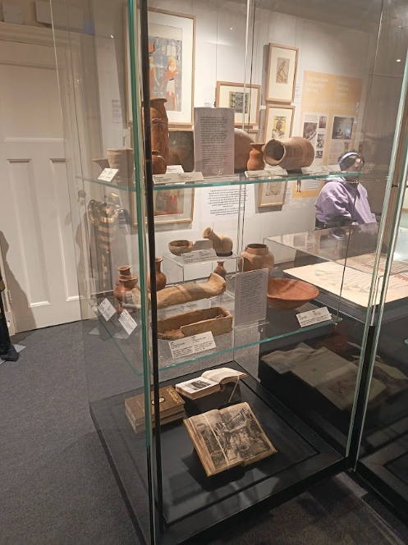Picture of one of the Display cases
There are 5 display cases in the centre of the room filled with oddities of Harold Jones’ personal collection. These, however grand looking, have no connection with Carmarthen. The 7 plaques about Harold jones hidden on the walls, one of which is seen in the top right of the image, are not hidden, but draw less attention than the colourful and ancient items in the middle of the room. This does pose a problem that the exhibit is seen less for Harold, as more attention from a casual museum explorer is drawn to the items in the centre than the signs on the walls. This could be seen as counterintuitive to the exhibit, as the purpose of the exhibit is to show Harold Jones; a man rooted in Carmarthenshire. That is the ultimate purpose of the Carmarthenshire Museum, as a local museum must show the history and pride of the county.
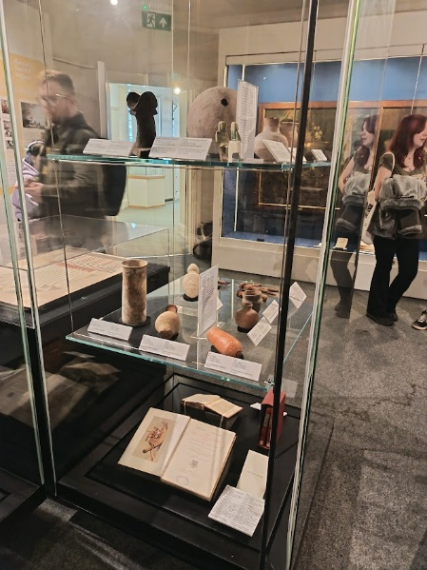Picture of another display case
The artefacts of the exhibit are also arranged in a certain way, with more visually catching artefacts—such as the Egyptian headrest with its strange shape and the large vase with a hole—on the bottom, and objects considered less visually appealing—like the books—on the bottom shelf. While this leads to a more pleasing display that a casual goer might enjoy, the problem is that the figurines and headrests on the top of the display at eye level draw the eyes more than the books on the lower levels, making it less likely that a viewer would not look down or notice fully all the artefacts. If the less appealing artefacts were on eye level, they would be noticed and viewed more, while a visually appealing artefact would already make people look down to view. Although it would lead to a less eye-catching design, it would draw attention towards more objects in the exhibit.
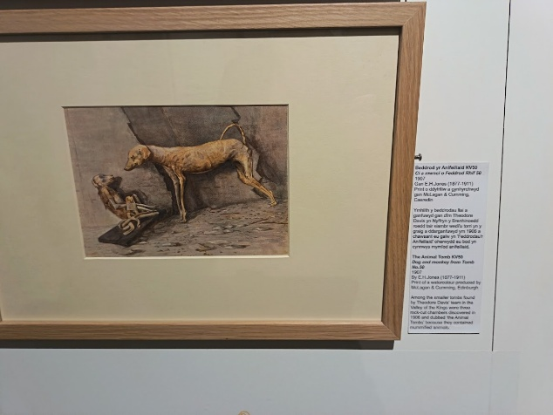
The paintings of Harold Jones throughout the walls are greatly displayed. Many of Harold Jone’s framed illustrations are hung up throughout the walls of the exhibit room. They appeared to be hung from left of the door to around the wall in a chronological manner, which fits with the order of the plaques around the room. Each illustration is given a smaller plaque to describe what the context behind each was, as well as the name, date, and obvious illustrator.
Interactive displays are a great way to stimulate the mind of the museum goer by making them use more of their senses and engage further within the topic. The exhibit’s interactive displays are a great touch but perhaps could be off topic. There are 3 “interactable” activities with each positive and negative characteristics. First is the build a mummy, which requires the participant to but the sewn organs into the human body, or back into the bins. This idea is fun and attracts especially younger children, but it lacks a deeper connection to Carmarthen or Harold jones other than just being about Ancient Egypt. The second are these paper books detailing the collection among other things. Although this provides very important and detailed information, the design is not appealing enough for most casual museum enjoyers to read fully. The third interactable thing is not in the exhibition room itself, rather at the bottom of the stairs. There is a large tablet with access to puzzles and even a quiz involving Harold Jones. This would probably be the best out of the three, but its location makes it hard to find in relation to the far away exhibit up the stairs and around the hall. These three together do make fine ways to interact with and understand the museum.
Overall, the Carmarthenshire Museum’s exhibit about Harold jones was deeply insightful, but lacked a high level of connection to Carmarthenshire. Although much of the museum could have been shifted to further broaden the academic aspect of the museum, the casual expectations are more than exceeded to fit the purpose of the exhibit in showing what the people of Carmarthenshire can find and do.

