Lab - Building a Simple Network
Topology
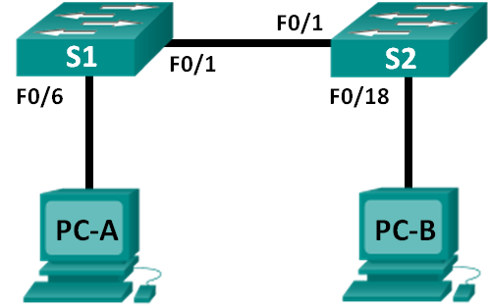
Addressing Table
Device | Interface | IP Address | Subnet Mask
PC-A | NIC | 192.168.1.10 | 255.255.255.0
PC-B | NIC | 192.168.1.11 | 255.255.255.0
Objectives
Part 1: Set Up the Network Topology (Ethernet only)
Part 2: Configure PC Hosts
Part 3: Configure and Verify Basic Switch Settings
Background / Scenario
Networks are constructed of three major components: hosts, switches, and routers. In this lab, you will build a simple network with two hosts and two switches. You will also configure basic settings including hostname, local passwords, and login banner. Use show commands to display the running configuration, IOS version, and interface status. Use the copy command to save device configurations.
You will apply IP addressing for this lab to the PCs to enable communication between these two devices. Use the ping utility to verify connectivity.
Note: The switches used are Cisco Catalyst 2960s with Cisco IOS Release 15.0(2) (lanbasek9 image). Other switches and Cisco IOS versions can be used. Depending on the model and Cisco IOS version, the commands available and output produced might vary from what is shown in the labs.
Note: Make sure that the switches have been erased and have no startup configurations. Refer to Appendix A for the procedure to initialize and reload a switch.
Required Resources
- 2 Switches (Cisco 2960 with Cisco IOS Release 15.0(2) lanbasek9 image or comparable)
- 2 PCs (Windows 7 or 8 with terminal emulation program, such as Tera Term)
- Console cables to configure the Cisco IOS devices via the console ports
- Ethernet cables as shown in the topology
- Set Up the Network Topology (Ethernet only)
In Part 1, you will cable the devices together according to the network topology.
  - Power on the devices.
Power on all devices in the topology. The switches do not have a power switch; they will power on as soon as you plug in the power cord.
  - Connect the two switches.
Connect one end of an Ethernet cable to F0/1 on S1 and the other end of the cable to F0/1 on S2. You should see the lights for F0/1 on both switches turn amber and then green. This indicates that the switches have been connected correctly.
  - Connect the PCs to their respective switches.
    - Connect one end of the second Ethernet cable to the NIC port on PC-A. Connect the other end of the cable to F0/6 on S1. After connecting the PC to the switch, you should see the light for F0/6 turn amber and then green, indicating that PC-A has been connected correctly.
    - Connect one end of the last Ethernet cable to the NIC port on PC-B. Connect the other end of the cable to F0/18 on S2. After connecting the PC to the switch, you should see the light for F0/18 turn amber and then green, indicating that the PC-B has been connected correctly.
  - Visually inspect network connections.
After cabling the network devices, take a moment to carefully verify the connections to minimize the time required to troubleshoot network connectivity issues later.
- Configure PC Hosts
  - Configure static IP address information on the PCs.
    - Click the Windows Start icon and then select Control Panel.
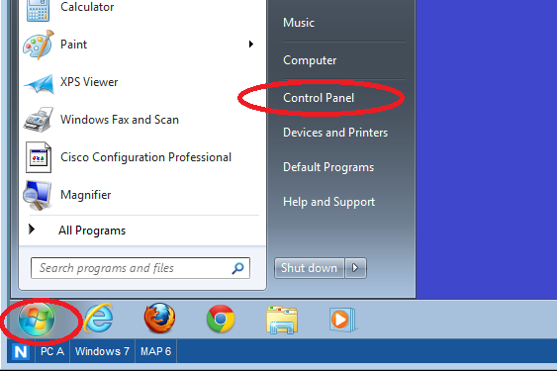
    - In the Network and Internet section, click the View network status and tasks link.
Note: If the Control Panel displays a list of icons, click the drop-down option next to the View by: and change this option to display by Category.
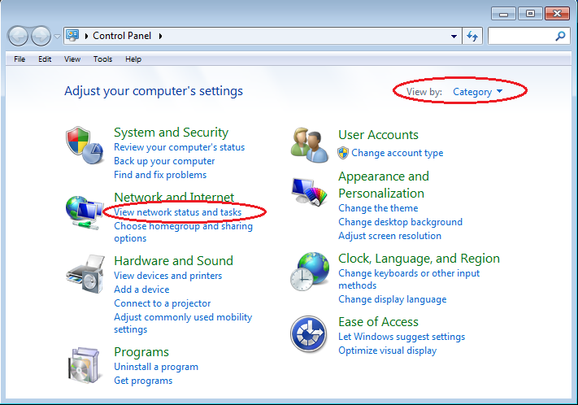
    - In the left pane of the Network and Sharing Center window, click the Change adapter settings link.
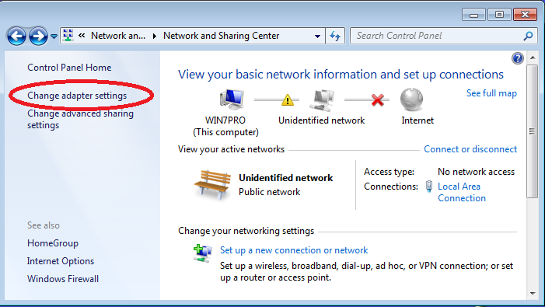

    - The Network Connections window displays the available interfaces on the PC. Right-click the Local Area Connection interface and select Properties.
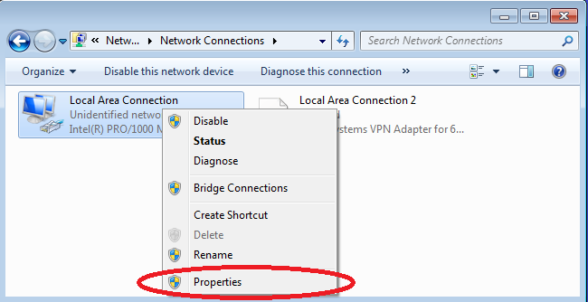
    - Select the Internet Protocol Version 4 (TCP/IPv4) option and then click Properties.
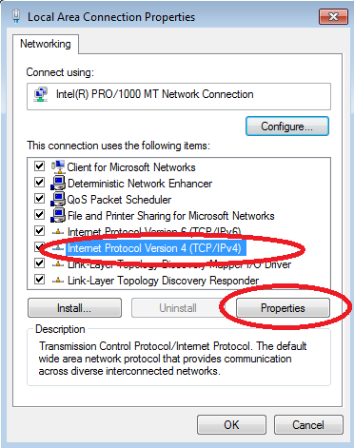
Note: You can also double-click Internet Protocol Version 4 (TCP/IPv4) to display the Properties window.
    - Click the Use the following IP address radio button to manually enter an IP address, subnet mask, and default gateway.
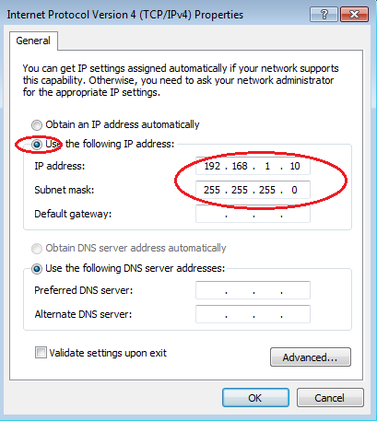
Note: In the above example, the IP address and subnet mask have been entered for PC-A. The default gateway has not been entered, because there is no router attached to the network. Refer to the Addressing Table on page 1 for PC-B’s IP address information.
    - After all the IP information has been entered, click OK. Click OK on the Local Area Connection Properties window to assign the IP address to the LAN adapter.
    - Repeat the previous steps to enter the IP address information for PC-B.
  - Verify PC settings and connectivity.
Use the command prompt (cmd.exe) window to verify the PC settings and connectivity.
    - From PC-A, click the Windows Start icon, type cmd in the Search programs and files box, and then press Enter.
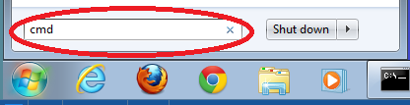

    - The cmd.exe window is where you can enter commands directly to the PC and view the results of those commands. Verify your PC settings by using the ipconfig /all command. This command displays the PC hostname and the IPv4 address information.
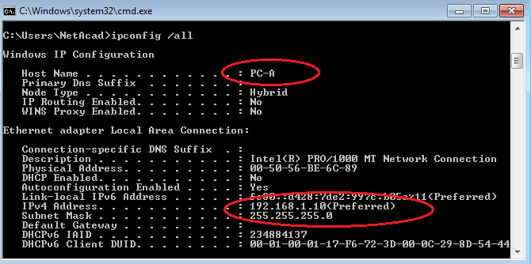
    - Type ping 192.168.1.11 and press Enter.
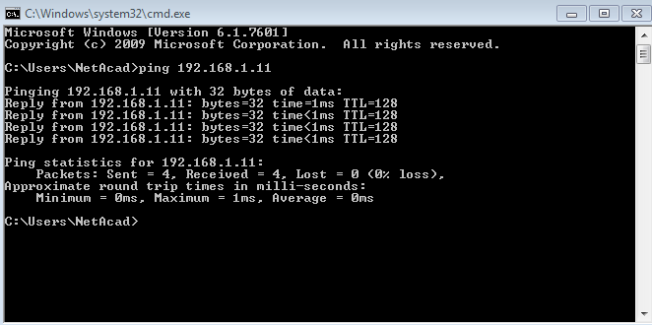
Were the ping results successful? ______________________
If not, troubleshoot as necessary.
Note: If you did not get a reply from PC-B, try to ping PC-B again. If you still do not get a reply from PC-B, try to ping PC-A from PC-B. If you are unable to get a reply from the remote PC, then have your instructor help you troubleshoot the problem.
- Configure and Verify Basic Switch Settings
  - Console into the switch.
Using Tera Term, establish a console connection to the switch from PC-A.
  - Enter privileged EXEC mode.
You can access all switch commands in privileged EXEC mode. The privileged EXEC command set includes those commands contained in user EXEC mode, as well as the configure command through which access to the remaining command modes are gained. Enter privileged EXEC mode by entering the enable command.
Switch> enable
Switch#
The prompt changed from Switch> to Switch# which indicates privileged EXEC mode.
  - Enter configuration mode.
Use the configuration terminal command to enter configuration mode.
Switch# configure terminal
Enter configuration commands, one per line. End with CNTL/Z.
Switch(config)#
The prompt changed to reflect global configuration mode.
  - Give the switch a name.
Use the hostname command to change the switch name to S1.
Switch(config)# hostname S1
S1(config)#
  - Prevent unwanted DNS lookups.
To prevent the switch from attempting to translate incorrectly entered commands as though they were hostnames, disable the Domain Name System (DNS) lookup.
S1(config)# no ip domain-lookup
S1(config)#
  - Enter local passwords.
To prevent unauthorized access to the switch, passwords must be configured.
S1(config)# enable secret class
S1(config)# line con 0
S1(config-line)# password cisco
S1(config-line)# login
S1(config-line)# exit
S1(config)#
  - Enter a login MOTD banner.
A login banner, known as the message of the day (MOTD) banner, should be configured to warn anyone accessing the switch that unauthorized access will not be tolerated.
The banner motd command requires the use of delimiters to identify the content of the banner message. The delimiting character can be any character as long as it does not occur in the message. For this reason, symbols, such as the #, are often used.

S1(config)# banner motd #
Enter TEXT message. End with the character '#'.
Unauthorized access is strictly prohibited and prosecuted to the full extent of the law. #
S1(config)# exit
S1#
  - Save the configuration.
Use the copy command to save the running configuration to the startup file on non-volatile random access memory (NVRAM).
S1# copy running-config startup-config
Destination filename [startup-config]? [Enter]
Building configuration...
[OK]
S1#
  - Display the current configuration.
The show running-config command displays the entire running configuration, one page at a time. Use the spacebar to advance paging. The commands configured in Steps 1 – 8 are highlighted below.
S1# show running-config
Building configuration...

Current configuration : 1409 bytes
!
! Last configuration change at 03:49:17 UTC Mon Mar 1 1993
!
version 15.0
no service pad
service timestamps debug datetime msec
service timestamps log datetime msec
no service password-encryption
!
hostname S1
!
boot-start-marker
boot-end-marker
!
enable secret 4 06YFDUHH61wAE/kLkDq9BGho1QM5EnRtoyr8cHAUg.2
!
no aaa new-model
system mtu routing 1500
!
!
no ip domain-lookup
!

<output omitted>

!
banner motd ^C
Unauthorized access is strictly prohibited and prosecuted to the full extent of the law. ^C
!
line con 0
password cisco
login
line vty 0 4
login
line vty 5 15
login
!
end

S1#
  - Display the IOS version and other useful switch information.
Use the show version command to display the IOS version that the switch is running, along with other useful information. Again, you will need to use the spacebar to advance through the displayed information.
S1# show version
Cisco IOS Software, C2960 Software (C2960-LANBASEK9-M), Version 15.0(2)SE, RELEASE SOFTWARE (fc1)
Technical Support: http://www.cisco.com/techsupport
Copyright (c) 1986-2012 by Cisco Systems, Inc.
Compiled Sat 28-Jul-12 00:29 by prod_rel_team

ROM: Bootstrap program is C2960 boot loader
BOOTLDR: C2960 Boot Loader (C2960-HBOOT-M) Version 12.2(53r)SEY3, RELEASE SOFTWARE (fc1)

S1 uptime is 1 hour, 38 minutes
System returned to ROM by power-on
System image file is "flash:/c2960-lanbasek9-mz.150-2.SE.bin"

This product contains cryptographic features and is subject to United
States and local country laws governing import, export, transfer and
use. Delivery of Cisco cryptographic products does not imply
third-party authority to import, export, distribute or use encryption.
Importers, exporters, distributors and users are responsible for
compliance with U.S. and local country laws. By using this product you
agree to comply with applicable laws and regulations. If you are unable
to comply with U.S. and local laws, return this product immediately.

A summary of U.S. laws governing Cisco cryptographic products may be found at:
http://www.cisco.com/wwl/export/crypto/tool/stqrg.html

If you require further assistance please contact us by sending email to
export@cisco.com.

cisco WS-C2960-24TT-L (PowerPC405) processor (revision R0) with 65536K bytes of memory.
Processor board ID FCQ1628Y5LE
Last reset from power-on
1 Virtual Ethernet interface
24 FastEthernet interfaces
2 Gigabit Ethernet interfaces
The password-recovery mechanism is enabled.

64K bytes of flash-simulated non-volatile configuration memory.
Base ethernet MAC Address : 0C:D9:96:E2:3D:00
Motherboard assembly number : 73-12600-06
Power supply part number : 341-0097-03
Motherboard serial number : FCQ16270N5G
Power supply serial number : DCA1616884D
Model revision number : R0
Motherboard revision number : A0
Model number : WS-C2960-24TT-L
System serial number : FCQ1628Y5LE
Top Assembly Part Number : 800-32797-02
Top Assembly Revision Number : A0
Version ID : V11
CLEI Code Number : COM3L00BRF
Hardware Board Revision Number : 0x0A

Switch Ports Model SW Version SW Image
------ ----- ----- ---------- ----------
* 1 26 WS-C2960-24TT-L 15.0(2)SE C2960-LANBASEK9-M

Configuration register is 0xF
S1#
  - Display the status of the connected interfaces on the switch.
To check the status of the connected interfaces, use the show ip interface brief command. Press the spacebar to advance to the end of the list.
S1# show ip interface brief
Interface IP-Address OK? Method Status Protocol
Vlan1 unassigned YES unset up up
FastEthernet0/1 unassigned YES unset up up
FastEthernet0/2 unassigned YES unset down down
FastEthernet0/3 unassigned YES unset down down
FastEthernet0/4 unassigned YES unset down down
FastEthernet0/5 unassigned YES unset down down
FastEthernet0/6 unassigned YES unset up up
FastEthernet0/7 unassigned YES unset down down
FastEthernet0/8 unassigned YES unset down down
FastEthernet0/9 unassigned YES unset down down
FastEthernet0/10 unassigned YES unset down down
FastEthernet0/11 unassigned YES unset down down
FastEthernet0/12 unassigned YES unset down down
FastEthernet0/13 unassigned YES unset down down
FastEthernet0/14 unassigned YES unset down down
FastEthernet0/15 unassigned YES unset down down
FastEthernet0/16 unassigned YES unset down down
FastEthernet0/17 unassigned YES unset down down
FastEthernet0/18 unassigned YES unset down down
FastEthernet0/19 unassigned YES unset down down
FastEthernet0/20 unassigned YES unset down down
FastEthernet0/21 unassigned YES unset down down
FastEthernet0/22 unassigned YES unset down down
FastEthernet0/23 unassigned YES unset down down
FastEthernet0/24 unassigned YES unset down down
GigabitEthernet0/1 unassigned YES unset down down
GigabitEthernet0/2 unassigned YES unset down down
S1#
  - Repeat Steps 1 to 12 to configure switch S2.
The only difference for this step is to change the hostname to S2.
  - Record the interface status for the following interfaces.
Interface | S1 |  | S2
Interface | Status | Protocol | Status | Protocol
F0/1 | Up | Up | Up | Up
F0/6 | Down | Down | Down | Down
F0/18 | Down | Down | Down | Down
VLAN 1 | Down | Down | Down | Down
Why are some FastEthernet ports on the switches are up and others are down?

The reason why the ‘FastEthernet ports on the switches are up and other are down, is simply because they are in use and plugged in this is the reason for why they are up.
The reason why they are down is because they are not active, they are not currently being used now.

What could prevent a ping from being sent between the PCs?
Incorrect IP address
Note: It may be necessary to disable the PC firewall to ping between PCs.
Appendix A: Initializing and Reloading a Switch
  - Connect to the switch.
Console into the switch and enter privileged EXEC mode.
Switch> enable
Switch#
  - Determine if there have been any virtual local-area networks (VLANs) created.
Use the show flash command to determine if any VLANs have been created on the switch.
Switch# show flash

Directory of flash:/

2 -rwx 1919 Mar 1 1993 00:06:33 +00:00 private-config.text
3 -rwx 1632 Mar 1 1993 00:06:33 +00:00 config.text
4 -rwx 13336 Mar 1 1993 00:06:33 +00:00 multiple-fs
5 -rwx 11607161 Mar 1 1993 02:37:06 +00:00 c2960-lanbasek9-mz.150-2.SE.bin
6 -rwx 616 Mar 1 1993 00:07:13 +00:00 vlan.dat

32514048 bytes total (20886528 bytes free)
Switch#
  - Delete the VLAN file.
    - If the vlan.dat file was found in flash, then delete this file.
Switch# delete vlan.dat
Delete filename [vlan.dat]?
You will be prompted to verify the file name. At this point, you can change the file name or just press Enter if you have entered the name correctly.
    - When you are prompted to delete this file, press Enter to confirm the deletion. (Pressing any other key will abort the deletion.)
Delete flash:/vlan.dat? [confirm]
Switch#
  - Erase the startup configuration file.
Use the erase startup-config command to erase the startup configuration file from NVRAM. When you are prompted to remove the configuration file, press Enter to confirm the erase. (Pressing any other key will abort the operation.)
Switch# erase startup-config
Erasing the nvram filesystem will remove all configuration files! Continue? [confirm]
[OK]
Erase of nvram: complete
Switch#
  - Reload the switch.
Reload the switch to remove any old configuration information from memory. When you are prompted to reload the switch, press Enter to proceed with the reload. (Pressing any other key will abort the reload.)
Switch# reload
Proceed with reload? [confirm]
Note: You may receive a prompt to save the running configuration prior to reloading the switch. Type no and press Enter.
System configuration has been modified. Save? [yes/no]: no
  - Bypass the initial configuration dialog.
After the switch reloads, you should see a prompt to enter the initial configuration dialog. Type no at the prompt and press Enter.
Would you like to enter the initial configuration dialog? [yes/no]: no
Switch>

Reflection (Max word count 200):
Write your reflection based on what you learned from this activity. This could include operation of Switch, configs and testing network connectivity.

Overall, I think this activity went great I was able to use my previous knowledge when dealing with packet tracer the benefit of me having this prior knowledge allowed me to understand what I was doing when setting up ‘Switches’ and being able to configure this.

A new thing that I was able to learn, and I found great was the ‘MOTD’ banner also known as the ‘Message of the day’ this is great to implement in because it can warn or speak to the user who is trying to enter the switch, another great tool that I learnt was the secret password tool, I think this is great for security because this can prevent unwanted configuration of the switch, I also learn the ‘Show flash’ feature I always wondered how to see the content of flash memory and to preview the used space and available space.

I think this was a great activity, it is good to get the fundamentals of setting up a simple network and is great for new people and great for people like me with prior knowledge to be able to reflect and remember these great tools.

Lab - Building a Switch and Router Network
Topology

Addressing Table
Device | Interface | IP Address | Subnet Mask | Default Gateway
R1 | G0/0 | 192.168.0.1 | 255.255.255.0 | N/A
R1 | G0/1 | 192.168.1.1 | 255.255.255.0 | N/A
PC-A | NIC | 192.168.1.3 | 255.255.255.0 | 192.168.1.1
PC-B | NIC | 192.168.0.3 | 255.255.255.0 | 192.168.0.1
Objectives
Part 1: Set Up the Topology and Initialize Devices
Part 2: Configure Devices and Verify Connectivity
Part 3: Display Device Information
Background / Scenario
This is a comprehensive lab to review previously covered IOS commands. In this lab, you will cable the equipment as shown in the topology diagram. You will then configure the devices to match the addressing table. After the configurations have been saved, you will verify your configurations by testing for network connectivity.
After the devices have been configured and network connectivity has been verified, you will use IOS commands to retrieve information from the devices to answer questions about your network equipment.
This lab provides minimal assistance with the actual commands necessary to configure the router. Test your knowledge by trying to configure the devices without referring to the content or previous activities.
Note: The routers used with CCNA hands-on labs are Cisco 1941 Integrated Services Routers (ISRs) with Cisco IOS Release 15.2(4)M3 (universalk9 image). The switches used are Cisco Catalyst 2960s with Cisco IOS Release 15.0(2) (lanbasek9 image). Other routers, switches, and Cisco IOS versions can be used. Depending on the model and Cisco IOS version, the commands available and output produced might vary from what is shown in the labs. Refer to the Router Interface Summary Table at the end of this lab for the correct interface identifiers.
Note: Ensure that the routers and switches have been erased and have no startup configurations. Consult with your instructor for the procedure to initialize and reload a router and switch.
Required Resources
- 1 Router (Cisco 1941 with Cisco IOS Release 15.2(4)M3 universal image or comparable)
- 1 Switch (Cisco 2960 with Cisco IOS Release 15.0(2) lanbasek9 image or comparable)
- 2 PCs (Windows 7 or 8 with terminal emulation program, such as Tera Term)
- Console cables to configure the Cisco IOS devices via the console ports
- Ethernet cables as shown in the topology
Note: The Gigabit Ethernet interfaces on Cisco 1941 routers are autosensing and an Ethernet straight-through cable may be used between the router and PC-B. If using another model Cisco router, it may be necessary to use an Ethernet crossover cable.
- Set Up Topology and Initialize Devices
  - Cable the network as shown in the topology.
    - Attach the devices shown in the topology diagram, and cable, as necessary.
    - Power on all the devices in the topology.
  - Initialize and reload the router and switch.
If configuration files were previously saved on the router and switch, initialize and reload these devices back to their basic configurations.
- Configure Devices and Verify Connectivity
In Part 2, you will set up the network topology and configure basic settings, such as the interface IP addresses, device access, and passwords. Refer to the Topology and Addressing Table at the beginning of this lab for device names and address information.
  - Assign static IP information to the PC interfaces.
    - Configure the IP address, subnet mask, and default gateway settings on PC-A.
    - Configure the IP address, subnet mask, and default gateway settings on PC-B.
    - Ping PC-B from a command prompt window on PC-A.
Why were the pings not successful?
_The pings where not successful due to the router not being configured.
  - Configure the router.
    - Console into the router and enable privileged EXEC mode.
    - Enter configuration mode.
    - Assign a device name to the router.
    - Disable DNS lookup to prevent the router from attempting to translate incorrectly entered commands as though they were host names.
    - Assign class as the privileged EXEC encrypted password.
    - Assign cisco as the console password and enable login.
    - Assign cisco as the VTY password and enable login.
    - Encrypt the clear text passwords.
    - Create a banner that warns anyone accessing the device that unauthorized access is prohibited.
    - Configure and activate both interfaces on the router.
    - Configure an interface description for each interface indicating which device is connected to it.
    - Save the running configuration to the startup configuration file.
    - Set the clock on the router.
Note: Use the question mark (?) to help with the correct sequence of parameters needed to execute this command.
    - Ping PC-B from a command prompt window on PC-A.
Were the pings successful? Why?
_____________________Yes the pings went through, the way I got this to happen is by pinging the ‘IP’ addresses correctly and it translated pings going back and for, with no packets lost
_____________________________
- Display Device Information
In Part 3, you will use show commands to retrieve information from the router and switch.
  - Retrieve hardware and software information from the network devices.
    - Use the show version command to answer the following questions about the router.
What is the name of the IOS image that the router is running?
___ Cisco IOS Software, C2900 Software (C2900-UNIVERSALK9-M)____
How much DRAM memory does the router have?
________64 bits_____________
How much NVRAM memory does the router have?
________225k bytes ______________
How much Flash memory does the router have?
________ 249856K_______________
    - Use the show version command to answer the following questions about the switch.
What is the name of the IOS image that the switch is running?
_________ Cisco IOS Software, C2960 Software (C2960-LANBASE-M)_____________
How much dynamic random access memory (DRAM) does the switch have?
____________________________________________________________________________________
How much nonvolatile random-access memory (NVRAM) does the switch have?
______________ 63488K bytes _______________
What is the model number of the switch?
_______________ WS-C2960-24TT____________________________________

  - Display the routing table on the router.
Use the show ip route command on the router to answer the following questions.
What code is used in the routing table to indicate a directly connected network? C and L
How many route entries are coded with a C code in the routing table? 2
What interface types are associated to the C coded routes?
____________Gigabit Ethernet connections________________________________
  - Display interface information on the router.
Use the show interface g0/1 to answer the following questions.
What is the operational status of the G0/1 interface?
___________________________Up (Connected)_______________________________________________
What is the Media Access Control (MAC) address of the G0/1 interface?
______________________ 0001.c97b.e102___________________________________
How is the Internet address displayed in this command?
____________________ 192.168.1.1/24________________________________
  - Display a summary list of the interfaces on the router and switch.
There are several commands that can be used to verify an interface configuration. One of the most useful of these is the show ip interface brief command. The command output displays a summary list of the interfaces on the device and provides immediate feedback to the status of each interface.
    - Enter the show ip interface brief command on the router.
R1# show ip interface brief
Interface IP-Address OK? Method Status Protocol
Embedded-Service-Engine0/0 unassigned YES unset administratively down down
GigabitEthernet0/0 192.168.0.1 YES manual up up
GigabitEthernet0/1 192.168.1.1 YES manual up up
Serial0/0/0 unassigned YES unset administratively down down
Serial0/0/1 unassigned YES unset administratively down down
R1#
    - Enter the show ip interface brief command on the switch.
Switch# show ip interface brief
Interface IP-Address OK? Method Status Protocol
Vlan1 unassigned YES manual up up
FastEthernet0/1 unassigned YES unset down down
FastEthernet0/2 unassigned YES unset down down
FastEthernet0/3 unassigned YES unset down down
FastEthernet0/4 unassigned YES unset down down
FastEthernet0/5 unassigned YES unset up up
FastEthernet0/6 unassigned YES unset up up
FastEthernet0/7 unassigned YES unset down down
FastEthernet0/8 unassigned YES unset down down
FastEthernet0/9 unassigned YES unset down down
FastEthernet0/10 unassigned YES unset down down
FastEthernet0/11 unassigned YES unset down down
FastEthernet0/12 unassigned YES unset down down
FastEthernet0/13 unassigned YES unset down down
FastEthernet0/14 unassigned YES unset down down
FastEthernet0/15 unassigned YES unset down down
FastEthernet0/16 unassigned YES unset down down
FastEthernet0/17 unassigned YES unset down down
FastEthernet0/18 unassigned YES unset down down
FastEthernet0/19 unassigned YES unset down down
FastEthernet0/20 unassigned YES unset down down
FastEthernet0/21 unassigned YES unset down down
FastEthernet0/22 unassigned YES unset down down
FastEthernet0/23 unassigned YES unset down down
FastEthernet0/24 unassigned YES unset down down
GigabitEthernet0/1 unassigned YES unset down down
GigabitEthernet0/2 unassigned YES unset down down
Switch#
Reflection
  - If the G0/1 interface showed administratively down, what interface configuration command would you use to turn the interface up?
__________________________duplex half________________
  - What would happen if you had incorrectly configured interface G0/1 on the router with an IP address of 192.168.1.2?
It would not send the correct packets
  - Explain the operation of a Router and a Switch.
The operation of a Switch is simply designed to be able to connect computers, this could be one or many computers within a network.
The operation of a Router is like the Switch in some ways that it connects things to a network, but a router will connect multiple networks together.

Lab: IPv4, Subnetting, VLSM and IPv6 Addressing

- Understanding IPv4 and IPv6 addressing (word count 1000)
This part of lab worksheet require you research and write a report on “Features of IPv6”. You may discuss but not limited to structure, address types, advanced functionalities and security.

Table of Contents

Introduction: …………………………………………………………………

History: ……………………………………………………………………….

What is the difference between IPv4 & IPv6: …………………………..

Structure: ……………………………………………………………………..

Address Types: ………………………………………………………………

Advanced functionalities: ………………………………………………….

Security: ……………………………………………………………………….

References: …………………………………………………………………...

Introduction

Today’s age not many people have a good understanding of what an IPv6 means or what it even is, this reports overall topic will be based on the different “Features of IPv6” different types of features such as the structure of the IPv6 Addressing and the different Address Types there are currently are present, advanced functionalities will also be touched on and talked in detail and finally the security aspect of the IPv6 addressing along side this the comparison between IPv6 vs IPv4 will be a topic that would be talk about in detail throughout the different contents.

History

In this section a simple background will be given to give the reader an understanding of how these IP’s came about and why they are so important to use in this modern age of technology.
Let’s start off with talking about the background and history of IPv4, this was created in the 1970s as the first major version of internet protocol. IPv4 allows numbers to map to physical devices and build a logical method for traffic to route from one number to another. [1]

Next topic to discuss is what is IPv6, this is the most recent version of the Internet Protocol (IP), the communications protocol that provides an identification and location system for computers that are on a network and routes traffic across the internet. [2] This was created in the month of December 1998 the overall creation of this was to replace the use of IPv4 due to the massive benefits it had compared to IPv4 that will be discussed in more detail later in the report.

What is the difference between IPv4 & IPv6?

The word most famously known as ‘IP’ stands for ‘Internet Protocol’, this is a numerical label which is assigned to each unique device this could be your broad brand for example as long as it is connected to the computer network that uses the IP for communication, these are binary numbers that can then be sorted as text for humans to be able to understand. [3]

The difference between the two different types of IP addresses is very simple, IPv4 is a 32-bit numeric address this is then written in a decimal as four numbers separated by periods, and the more modern IP address the IPv6 is a 128 bit and due to this will give IPv6’s the ability to allocate almost unlimited addresses to all the divides in the world for years to come. A reason why IPv6 is better and more suitable for todays age is that it is a more efficient way of routing, IPv4 has no way to be able to distinguish the delay sensitive packets from bulk data transfers the reason why this would cause an issue is because it would take a lot of work to be able to work around this issue meaning a lot man hours that could be used on something else, this could then put some companies behind their competitor because of this and would just cause delays.

Another reason why IPv6 is overall better than IPv4 is that, with IPv6 they have got a ‘Stateless address’ autoconfiguration the benefits behind this is it will allow for easier network administration. With IPv4 their installs where much more complicated because they don’t have the automation that IPv6 has when setting up this can then cause the user into confusion when doing the installs for the router and when they needed to do address assignment.

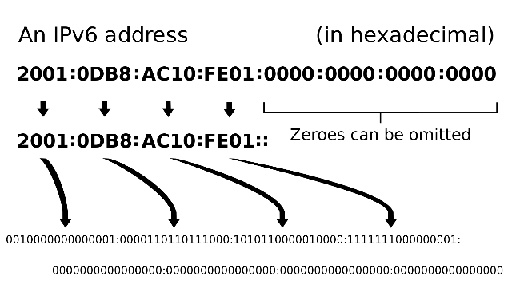
IPv6 address representation into its binary form [3] IPv4 address representation into its binary form
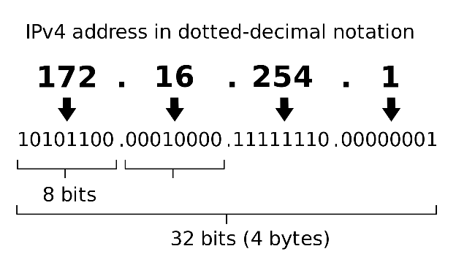

Above you can clearly see the difference between the two different protocols as displayed above, the image to the left as labels IPv6 has much more bits compared to the other protocol as displayed on the right, this is to give a better visual representation of the two different protocols and this is also a way to show the size difference between the two.

Structure

In this section the structure types of the two different protocols will be discussed in detail, firstly the IPv6 structure will be discusses then moving onto the structure of the IPv4.

An IPv6 address is made of 128 bits and this is then divided into eight 16-bits blocks. Each block is then converted into 4-digit Hexadecimal numbers separated by colon symbols. Below is an example given to display 128 bits addressing shown in a binary format that has been divided into eight 16-bits blocks. [4]

IPv6 address in binary format [4]

Address Types

In this section the different address types for both IPv6 & IPv4 will be discusses briefly. As previously mentioned IPv6 addresses are 128-bits long and are identifier for individual interfaces and sets of interfaces. IPv6 addresses of all types are assigned to interfaces, this means they are not assigned to hosts or routers. The reasoning behind this is because each interface belongs to a single node, any of that certain node’s interfaces unicast address can be used as an identifier. [5]

Overall there are 3 different types of addresses for IPv6
- Unicast addresses identify a single interface.
- Anycast addresses identify a set of interfaces
- Multicast addresses identify a group of interfaces

Advanced functionalities

The different types of features will be discussed in this section, the first feature is ‘Larger Address Space’ IPv6 uses 4 times more bits to address a device on the internet. This much of extra bits can provide a massive amount of different combinations of addresses. This address can then accumulate the aggressive requirement of address allotment for almost everything in this world. [6]

Other features include
- Simplified header
- End-to-end Connectivity (causes some limitations involved like firewall)
- Auto-configuration
- Faster Forwarding/Routing
- IPSec
And many more other features that make IPv6 what it is today, and this gives it the reasoning behind why it is better to use than its successor IPv4.

Security

Security is a massive aspect in everything we do we got to make sure everything is secure as possible, IPsec is an optional add-on but is mandatory IPv6 as previously mentioned in the section above, this is an payload encryption and a packet authentication, this must be implemented manually and it needs to be configured and used with a security key exchange. [7]

Different types of packet encryption
- Authentication Header
- Encapsulating Security Payload
- IPsec Modes (Tunnel & Transport mode)
And many more of other features that would support the security of IPv6

References

[1] | History behind IPv4: https://icannwiki.org/IPv4. [Online].
[2] | History behind IPv6: https://en.wikipedia.org/wiki/IP_address, “IP_address,” [Online].
[3] | Difference between IPv4 & IPv6: https://en.wikipedia.org/wiki/IPv6. [Online].
[4] | IPv6 image: https://www.tutorialspoint.com/ipv6/ipv6_address_types.htm. [Online]. Available:  IPv4 image: https://www.tutorialspoint.com/ipv6/ipv6_address_types.htm.  Binary image: https://www.tutorialspoint.com/ipv6/ipv6_address_types.htm.
[5] | https://docs.oracle.com/cd/E19455-01/806-0916/6ja8539be/index.html, 2010. [Online]. Available: https://docs.oracle.com/cd/E19455-01/806-0916/6ja8539be/index.html.
[6] | https://www.tutorialspoint.com/ipv6/ipv6_features.htm, 2019. [Online]. Available: https://www.tutorialspoint.com/ipv6/ipv6_features.htm.
[7] | http://ipv6now.com.au/primers/IPv6PacketSecurity.php, 2019. [Online]. Available: http://ipv6now.com.au/primers/IPv6PacketSecurity.php.

- Subnetting and VLSM

NOTE: To complete this part you would need full understanding of Lab 10 to 14.



Using the Network address 172.16.2.0/24, VLSM the network to support the following requirements:
Subnet A: 16 hosts
Subnet B: 2000 hosts
Subnet C: 6 hosts
Subnet D: 500 hosts
Subnet E: 60 hosts
Subnet F: 180 hosts and Serial links between routers

Table 1
Subnet | Network Address | Subnet mask | First Address | Last Address | Broadcast Address
B | 172.16.2.0 | 255.255.248.0 | 172.16.2.1 | 172.16.9.254 | 172.16.9.255
D | 172.16.10.0 | 255.255.254.0 | 172.16.10.1 | 172.16.11.254 | 172.16.11.255
F | 172.16.12.0 | 255.255.255.0 | 172.16.12.1 | 172.16.12.178 | 172.16.12.179
E | 172.16.12.180 | 255.255.255.192 | 172.16.12.181 | 172.16.12.242 | 172.16.12.243
A | 172.16.12.244 | 255.255.255.226 | 172.16.12.245 | 172.16.13.2 | 172.16.13.3
C | 172.16.13.20 | 255.255.255.248 | 172.16.13.21 | 172.16.13.26 | 172.16.13.27
R1 | 172.16.13.28 | 255.255.255.252 | 172.16.13.29 | 172.16.13.30 | 172.16.13.30
R2 | 172.16.13.32 | 255.255.255.252 | 172.16.13.33 | 172.16.13.34 | 172.16.13.34
R3 | 172.16.13.36 | 255.255.255.252 | 172.16.13.37 | 172.16.13.38 | 172.16.13.36

Lab - Accessing Network Devices with SSH
Topology
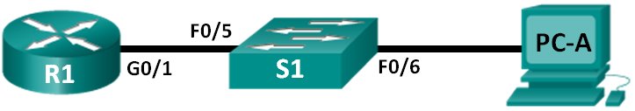
Addressing Table
Device | Interface | IP Address | Subnet Mask | Default Gateway
R1 | G0/1 | 192.168.1.1 | 255.255.255.0 | N/A
S1 | VLAN 1 | 192.168.1.11 | 255.255.255.0 | 192.168.1.1
PC-A | NIC | 192.168.1.3 | 255.255.255.0 | 192.168.1.1
Objectives
Part 1: Configure Basic Device Settings
Part 2: Configure Basic Security Measures on the Router and Switch
Part 3: Configure the Router for SSH Access
Part 4: Configure the Switch for SSH Access
Part 5: SSH from the CLI on the Switch
Background / Scenario
In the past, Telnet was the most common network protocol used to remotely configure network devices. Telnet does not encrypt the information between the client and server. This allows a network sniffer to intercept passwords and configuration information.
Secure Shell (SSH) is a network protocol that establishes a secure terminal emulation connection to a router or other networking device. SSH encrypts all information that passes over the network link and provides authentication of the remote computer. SSH is rapidly replacing Telnet as the remote login tool of choice for network professionals. SSH is most often used to log in to a remote device and execute commands; however, it can also transfer files using the associated Secure FTP (SFTP) or Secure Copy (SCP) protocols.
The network devices that are communicating must be configured to support SSH in order for SSH to function. In this lab, you will enable the SSH server on a router and then connect to that router using a PC with an SSH client installed. On a local network, the connection is normally made using Ethernet and IP.
Note: The routers used with CCNA hands-on labs are Cisco 1941 Integrated Services Routers (ISRs) with Cisco IOS Release 15.2(4)M3 (universalk9 image). The switches used are Cisco Catalyst 2960s with Cisco IOS Release 15.0(2) (lanbasek9 image). Other routers, switches, and Cisco IOS versions can be used. Depending on the model and Cisco IOS version, the commands available and the output produced might vary from what is shown in the labs. Refer to the Router Interface Summary Table at the end of this lab for the correct interface identifiers.
Note: Make sure that the routers and switches have been erased and have no startup configurations. If you are unsure, contact your instructor.
Required Resources
- 1 Router (Cisco 1941 with Cisco IOS Release 15.2(4)M3 universal image or comparable)
- 1 Switch (Cisco 2960 with Cisco IOS Release 15.0(2) lanbasek9 image or comparable)
- 1 PC (Windows 7 or 8 with terminal emulation program, such as Tera Term, and Wireshark installed)
- Console cables to configure the Cisco IOS devices via the console ports
- Ethernet cables as shown in the topology
- Configure Basic Device Settings
In Part 1, you will set up the network topology and configure basic settings, such as the interface IP addresses, device access, and passwords on the router.
  - Cable the network as shown in the topology.
  - Initialize and reload the router and switch.
  - Configure the router.
    - Console into the router and enable privileged EXEC mode.
    - Enter configuration mode.
    - Disable DNS lookup to prevent the router from attempting to translate incorrectly entered commands as though they were host names.
    - Assign class as the privileged EXEC encrypted password.
    - Assign cisco as the console password and enable login.
    - Assign cisco as the VTY password and enable login.
    - Encrypt the plaintext passwords.
    - Create a banner that will warn anyone accessing the device that unauthorized access is prohibited.
    - Configure and activate the G0/1 interface on the router using the information contained in the Addressing Table.
    - Save the running configuration to the startup configuration file.
  - Configure PC-A.
    - Configure PC-A with an IP address and subnet mask.
    - Configure a default gateway for PC-A.
  - Verify network connectivity.
Ping R1 from PC-A. If the ping fails, troubleshoot the connection.

- Configure Basic Security Measures on the Router
  - Encrypt the clear text passwords.
R1(config)# service password-encryption
  - Strengthen passwords.
An administrator should ensure that passwords meet the standard guidelines for strong passwords. These guidelines could include combining letters, numbers and special characters in the password and setting a minimum length.
Note: Best practice guidelines require the use of strong passwords, such as those shown here, in a production environment. However, the other labs in this course use the cisco and class passwords for ease in performing the labs.
    - Change the privileged EXEC encrypted password to meet guidelines.
R1(config)# enable secret Enablep@55
    - Require that a minimum of 10 characters be used for all passwords.
R1(config)# security passwords min-length 10
  - Secure the console and VTY lines.
    - You can set the router to log out of a connection that has been idle for a specified time. If a network administrator was logged into a networking device and was suddenly called away, this command automatically logs the user out after the specified time. The following commands cause the line to log out after five minutes of inactivity.
R1(config)# line console 0
R1(config-line)# exec-timeout 5 0
R1(config-line)# line vty 0 4
R1(config-line)# exec-timeout 5 0
R1(config-line)# exit
R1(config)#
    - The following command impedes brute force login attempts. The router blocks login attempts for 30 seconds if someone fails two attempts within 120 seconds. This timer is set especially low for the purpose of this lab.
R1(config)# login block-for 30 attempts 2 within 120
What does the 2 within 120 mean in the above command?
___If you have 2 failed attempts within 2 minutes which is 120 seconds, it will block the login access
What does the block-for 30 mean in the above command?
___f the login access is blocked the router will wait for 30 seconds before allowing login access.
  - Verify that all unused ports are disabled.
Router ports are disabled by default, but it is always prudent to verify that all unused ports are in an administratively down state. This can be quickly checked by issuing the show ip interface brief command. Any unused ports that are not in an administratively down state should be disabled using the shutdown command in interface configuration mode.

R1# show ip interface brief
Interface IP-Address OK? Method Status Protocol
Embedded-Service-Engine0/0 unassigned YES NVRAM administratively down down
GigabitEthernet0/0 unassigned YES NVRAM administratively down down
GigabitEthernet0/1 192.168.1.1 YES manual up up
Serial0/0/0 unassigned YES NVRAM administratively down down
Serial0/0/1 unassigned YES NVRAM administratively down down

- Configure the Router for SSH Access
Using Telnet to connect to a network device is a security risk because all information is transmitted in a clear text format. SSH encrypts the session data and provides device authentication, which is why SSH is recommended for remote connections. In Part 2, you will configure the router to accept SSH connections over the VTY lines.
  - Configure device authentication.
The device name and domain are used as part of the crypto key when it is generated. Therefore, these names must be entered prior to issuing the crypto key command.
    - Configure the domain for the device.
R1(config)# ip domain-name ccna-lab.com
  - Configure the encryption key method.
R1(config)# crypto key generate rsa modulus 1024
The name for the keys will be: R1.ccna-lab.com

% The key modulus size is 1024 bits
% Generating 1024 bit RSA keys, keys will be non-exportable...
[OK] (elapsed time was 1 seconds)

R1(config)#
*Jan 28 21:09:29.867: %SSH-5-ENABLED: SSH 1.99 has been enabled
  - Configure a local database username.
R1(config)# username admin privilege 15 secret adminpass
Note: A privilege level of 15 gives the user administrator rights.
  - Enable SSH on the VTY lines.
    - Enable Telnet and SSH on the inbound VTY lines using the transport input command.
R1(config)# line vty 0 4
R1(config-line)# transport input telnet ssh
    - Change the login method to use the local database for user verification.
R1(config-line)# login local
R1(config-line)# end
R1#
  - Save the running configuration to the startup configuration file.
R1# copy running-config startup-config
Destination filename [startup-config]?
Building configuration...
[OK]
R1#
  - Establish an SSH connection to the router.
    - Start Tera Term from PC-A.
    - Use Tera Term to telnet to R1.
Does R1 accept the Telnet connection? Explain.
______R1 does not accept the connection, this is due to telnet being disable with the SSH command ____________________
Use Tera Term, establish an SSH session to R1. Use the username admin and password adminpass. You should be able to establish an SSH session with R1.
Does R1 accept the SSH connection? __Yes___
    - Intentionally mistype the user and password information to see if login access is blocked after two attempts.
What happened after you failed to login the second time?
__________It will disconnect the connection to the router ‘R1’ you cannot try again for 30 seconds _________________________________________________________________________
    - From your console session on the router, issue the show login command to view the login status. In the example below, the show login command was issued within the 30 second login blocking period and shows that the router is in Quiet-Mode. The router will not accept any login attempts for 14 more seconds.

R1# show login
A default login delay of 1 second is applied.
No Quiet-Mode access list has been configured.

Router enabled to watch for login Attacks.
If more than 2 login failures occur in 120 seconds or less,
logins will be disabled for 30 seconds.

Router presently in Quiet-Mode.
Will remain in Quiet-Mode for 14 seconds.
Denying logins from all sources.
R1#
    - After the 30 seconds has expired, SSH to R1 again and login using the SSHadmin username and Admin1p@55 for the password.
After you successfully logged in, what was displayed? ______The login banner___________
    - Enter privileged EXEC mode and use Enablep@55 for the password.
If you mistype this password, are you disconnected from your SSH session after two failed attempts within 120 seconds? Explain.
______________________By doing this will not disconnect you because it is just a login block it stops the users from entering if 2 attempts have failed, as previously explained above. ____________________
    - Issue the show running-config command at the privileged EXEC prompt to view the security settings you have applied.

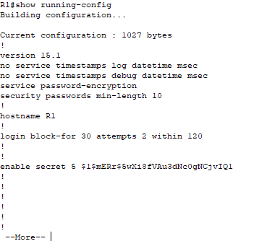
- Configure the Switch for SSH Access
In Part 3, you will configure the switch in the topology to accept SSH connections. After the switch has been configured, establish an SSH session using Tera Term.
  - Configure the basic settings on the switch.
    - Console into the switch and enable privileged EXEC mode.
    - Enter configuration mode.
    - Disable DNS lookup to prevent the router from attempting to translate incorrectly entered commands as though they were host names.
    - Assign class as the privileged EXEC encrypted password.
    - Assign cisco as the console password and enable login.
    - Assign cisco as the VTY password and enable login.
    - Encrypt the plain text passwords.
    - Create a banner that will warn anyone accessing the device that unauthorized access is prohibited.
    - Configure and activate the VLAN 1 interface on the switch according to the Addressing Table.
    - Save the running configuration to the startup configuration file.
  - Configure the switch for SSH connectivity.
Use the same commands that you used to configure SSH on the router in Part 2 to configure SSH for the switch.
    - Configure the device name as listed in the Addressing Table.
    - Configure the domain for the device.
S1(config)# ip domain-name ccna-lab.com
    - Configure the encryption key method.
S1(config)# crypto key generate rsa modulus 1024
    - Configure a local database username.
S1(config)# username admin privilege 15 secret adminpass
    - Enable Telnet and SSH on the VTY lines.
S1(config)# line vty 0 15
S1(config-line)# transport input telnet ssh
    - Change the login method to use the local database for user verification.
S1(config-line)# login local
S1(config-line)# end
  - Establish an SSH connection to the switch.
Start Tera Term from PC-A, and then SSH to the SVI interface on S1.
Are you able to establish an SSH session with the switch?
_______________________Yes____________________________________________
- SSH From the CLI on the Switch
The SSH client is built into the Cisco IOS and can be run from the CLI. In Part 4, you will SSH to the router from the CLI on the switch.
  - View the parameters available for the Cisco IOS SSH client.
Use the question mark (?) to display the parameter options available with the ssh command.
S1# ssh ?
-c Select encryption algorithm
-l Log in using this user name
-m Select HMAC algorithm
-o Specify options
-p Connect to this port
-v Specify SSH Protocol Version
-vrf Specify vrf name
WORD IP address or hostname of a remote system
  - SSH to R1 from S1.
    - You must use the –l admin option when you SSH to R1. This allows you to log in as user admin. When prompted, enter adminpass for the password.
S1# ssh -l admin 192.168.1.1
Password:
***********************************************
Warning: Unauthorized Access is Prohibited!
***********************************************

R1#
    - You can return to S1 without closing the SSH session to R1 by pressing Ctrl+Shift+6. Release the Ctrl+Shift+6 keys and press x. The switch privileged EXEC prompt displays.
R1#
S1#
    - To return to the SSH session on R1, press Enter on a blank CLI line. You may need to press Enter a second time to see the router CLI prompt.
S1#
[Resuming connection 1 to 192.168.1.1 ... ]

R1#
    - To end the SSH session on R1, type exit at the router prompt.
R1# exit

[Connection to 192.168.1.1 closed by foreign host]
S1#

What versions of SSH are supported from the CLI?
_________________Doesn’t state the versions that are supported. ______________________________
______________________________

How would you provide multiple users, each with their own username, access to a network device?
__________The way you would go about doing this is by adding each user’s correct credentials to a database such as their user name and password. _____________________

Reflection (max 800 words):
Write a research report comparing various Encryption standards, e.g AES, SHA, DES, RSA.

Table of Contents

Introduction: ……………………………………………………………….

History: ………………………………………………………………………

AES: ………………………………………………………………………….

SHA: ………………………………………………………………………….

DES: ………………………………………………………………………….

RSA: …………………………………………………………………………

References: …………………………………………………………………

Introduction
Encryption is a very important part of technology today, it is very important for us to be able to know what needs encryption this is so we can help prevent unauthorized access. Every single bit of our data needs to be secured down to every file on our computer, there are many different types of cryptographic methods that can be used in order to ensure the safety of our data. This report will be discussing the history of encryption to be able to get a better insight on the background of these standards and the follow up by comparing four different types of encryption methods that are available today.

History

Encryption has been around for many years, it was first used in 600 BC by the ancient Spartans, they wouldn’t have the type of methods we use today because they wouldn’t have the technology that is present in the modern age, the way they would have worked around this is by a method called ‘Scytale’ they would use this to send secret messages during a battle.[1]

AES

AES this is the first standard that will be discussed in this report, this stands for ‘Advance Encryption Standard’ this is an algorithm that was developed in 1998 by someone called Joan Daemen and Vincent Rijmen, which is a symmetric key block cipher [2]. AES algorithm can support any combination of data such as 128 bits and keys lengths of 128, and 256 bits. The algorithm is the referred to as AES-128, AES-192, or finally AED-256, they will be called this depending on the key length. [2]
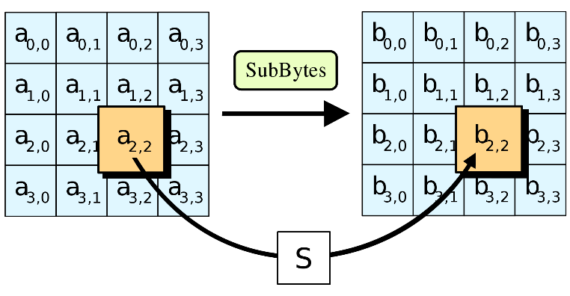
To the left is an image that was taken of the AES Wikipedia page, this simply displays what this Encryption standard does, in this example it is called ‘The SubBytes step’ and it is one of many different types this standard takes to encrypt data, they take each byte of state that is in the array and then it is replaced with a ‘SubByte’. [3]

SHA

The next standard of encryption that will be discussed in a standard called ‘SHA’ this stands for ‘Secure Hash Algorithm’, this is a cryptographic hash function which takes an input and then it produces a 160 bit hash value known as a message digest, [4] hashes are also used for passwords for example when a password gets encrypted it will then become a hash value this is used mostly everywhere when it comes to users inputting their personal details.

There have been many different developments of ‘SHA’ such as SHA-1, SHA-2 and SHA-3 it has thought that they have brought out these new developments of different hash algorithms to make it more secure each time. All major web browser vendors ceased acceptance of SHA-1 SSL certificates in 2017. Amsterdam and Google announced they had performed a collision attack against SHA-1, publishing two dissimilar PDF files which produced the same SHA-1 hash [5], this is bad for security because every hash needs to be completely different.

DES

DES stands for Data Encryption Standard, this is the third encryption standard that will be discussed in this report, this is another algorithm that’s is used to be able to encrypt electronic data, the key length used for this type of standard is 56 bits, due to the short length means that it would be very hard for an attacker to be able to use a brute-force attack against this, there are so many possibilities of different keys and this would take a decade to be able to find the correct key for an attacker to be able to follow through with a successful brute force attack and by the time they have done so a lot of the data would have been changed, moved and updated. This standard was developed in the 1970s making it one of the earlier standards created.

This standard first came from a design by a man called Horst Feistel and this then was developed by the company called IBM where it was then officially published in 1977 by no other than the United States and this is what made it an FIPS meaning an ‘Federal Information Processing Standard’. Another advantage of this is that the Encryption and decryption takes the same algorithm. Only that the function needs to be reversed and the key should be taken in opposite order. This is very convenient for software and hardware requirements. [6]

RSA

The final standard that will be discussed in this report is ‘RSA’, this stands for ‘Rivest-Shamir-Adleman’ this is an algorithm used by modern computers to be able to encrypt and decrypt messages [7]. This is a good algorithm to be able to keep users safe they would do this via complex mathematics, and due to how complex this becomes makes it a hard algorithm to be able to crack since it involves factorization of prime numbers which are difficult to be able to factorize. [8]

References
[1] | Gemalto.com, 18 April 2016. [Online]. Available: https://www.gemalto.com/review/Pages/a-brief-history-of-encryption.aspx.
[2] | S. L. Mohammed Nazeh Abdul Wahid, 22 June 2018. [Online]. Available: https://symbiosisonlinepublishing.com/computer-science-technology/computerscience-information-technology32.php.
[3] | wikipedia, 29 November 2019. [Online]. Available: https://en.wikipedia.org/wiki/Advanced_Encryption_Standard.
[4] | wikipedia, 2 Decmeber 2019. [Online]. Available: https://en.wikipedia.org/wiki/SHA-1.
[5] | Wikipedia, 4 December 2019. [Online]. Available: https://en.wikipedia.org/wiki/SHA-1.
[6] | A. Noushad, 5 April 2015. [Online]. Available: https://www.quora.com/What-are-the-advantages-and-disadvantages-of-DES.
[7] | Wikipedia, 28 November 2019. [Online]. Available: https://simple.wikipedia.org/wiki/RSA_algorithm.
[8] | Online.tutor, 6 April 2019. [Online]. Available: https://www.coursehero.com/file/p1tk10o/Advantages-and-disadvantages-of-RSA-Algorithm-There-are-advantages-and/.

Lab – Understanding Ethernet Cable Standards
Topology
Addressing Table
Device | Interface | IP Address | Subnet Mask | Default Gateway
PC-A | NIC | 192.168.10.1 | 255.255.255.0 | N/A
PC-B | NIC | 192.168.10.2 | 255.255.255.0 | N/A
Objectives
Part 1: Analyze Ethernet Cabling Standards and Pinouts
Part 2: Build an Ethernet Crossover Cable
Part 3: Test an Ethernet Crossover Cable
Background / Scenario
In this lab, you will build and terminate an Ethernet crossover cable and test it by connecting two PCs together and pinging between them. You will first analyze the Telecommunications Industry Association/Electronic Industries Association (TIA/EIA) 568-A and 568-B standards and how they apply to Ethernet cables. You will then construct an Ethernet crossover cable and test it. Finally, you will use the cable you just constructed to connect two PCs together and test it by pinging between them.
Note: With autosensing capabilities available on many devices, such as the Cisco 1941 Integrated Services Router (ISR) switch, you may see straight-through cables connecting like devices.
Required Resources
- One length of cable, either Category 5 or 5e. Cable length should be 0.6 to 0.9m (2 to 3 ft.)
- 2 RJ-45 connectors
- RJ-45 crimping tool
- Wire cutter
- Wire stripper
- Ethernet cable tester (optional)
- 2 PCs (Windows 7 or 8)
- Analyze Ethernet Cabling Standards and Pinouts
The TIA/EIA has specified unshielded twisted pair (UTP) cabling standards for use in LAN cabling environments. TIA/EIA 568-A and 568-B stipulates the commercial cabling standards for LAN installations; these are the standards most commonly used in LAN cabling for organizations and they determine which color wire is used on each pin.
With a crossover cable, the second and third pairs on the RJ-45 connector at one end of the cable are reversed at the other end, which reverses the send and receive pairs. The cable pinouts are the 568-A standard on one end and the 568-B standard on the other end. Crossover cables are normally used to connect hubs to hubs or switches to switches, but they can also be used to directly connect two hosts to create a simple network.
Reflection:
Write a research report (Max word count 600) on Cat 5e and 6 Ethernet cable standards.

Table of contents

Introduction: …………………………………………………………………

History: ……………………………………………………………………….

Cat 5e: ……………………………………………………………………......

6 Ethernet Cable Standards: ……………………………………………..

References: …………………………………………………………………

Introduction
Ethernet cables are something that are used every single day, in this report ethernet cables will be discussed in detail to give you an understanding of where they came from and what different types of ethernet cables are out there, some people would assume that it is one wire and it plugs into the back of their device they wish to use it with but it is much more than that.

History
Ethernet cables first came around in the 80’s this is when they were commercially introduced, and they weren’t standardized until 3 years later in 1983 and this is called ‘IEEE 802.3’. These ethernet cables are used in ‘local area networks’ or better known as ‘LAN’ an explain of where this would be used is a small office area, the original 10BASE5 Ethernet cables uses a coaxial cable as a shared medium but you will find that the modern ethernet cables use ‘Twisted pair’ or ‘Fiber optic’ is the more commonly known.

Cat 5e
Category 5e cable or better known as ‘CAT 5e’ is a variant of ‘CAT 5’. This cable standard provides performance of up to 100 MHz and is suitable for most varieties of Ethernet over twisted pair to 1000BASE-T (Gigabit Ethernet). [1]
The specification of category 5 cable was defining in ANSI/TIA/EIA-568-A, with clarification in TSB-95. These documents specify performance characteristics and test requirements for frequencies up to 100 MHz. [1]
The cable is available in both standard and solid conductor forms. The stranded form is more flexible and withstands more bending without breaking. [1] Patch cables are also another standard that is used here.
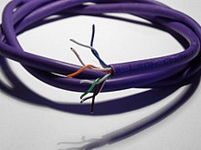
To the right you can see and image that is displaying what a ‘Twisted Pair’ looks like, this cabling is type of writing in which two conductors of a single circuit are twisted together for4 the purpose of being able to improve electromagnetic compatibility. [2]

6 Ethernet Cable Standards

Onto the next topic of the report, ‘6 Ethernet Cable Standards’ will be discussed, there are 6 different types of ethernet standards, they will be discussed briefly one by one on their different attributes.
Cat-3 is the first one, this is a unshielded cable and only goes up to 10 Mbps and the maximum bandwidth is only 16 MHz so nowhere near as powerful and the other different standards. Cat-5 cable is also unshielded and is similar compared to the previous cable, but this has a maximum bandwidth of 100 MHz a lot more than Cat-3 cable.
Moving onto the next cable is the Cat-5e cable, this is the enhanced version of the previous cable ‘Cat-5’, this can go up to 1 Gbps ‘Maximum Transmission Speec‘ they are pretty much the same the only difference is that Cat-5e cables are built under strict standards in order to reduce cross talk issues. [3]
Moving onto the both ‘Cat-6’ and ‘Cat-6a’ cables once again they are similar there are a couple of different things between the two cables such as ‘Cat-6’ cables are exposed to high frequencies, but quite low in Cat-6a.
Moving onto the Cat-7 and Cat-8, Cat-7 is the newest widely available Ethernet technology, and support higher bandwidths and significantly faster transmissions speeds than Cat-6 cables. Cat-8 are still in development but they are said to be faster than Cat-7, they are said to be released into the market soon. [4]

References

[1] | Wikipedia, 2 Novemeber 2019. [Online]. Available: https://en.wikipedia.org/wiki/Category_5_cable.
[2] | Wikipedia, 10 December 2019. [Online]. Available: https://en.wikipedia.org/wiki/Twisted_pair.
[3] | E. CABLES, 12 December 2019. [Online]. Available: https://www.elandcables.com/the-cable-lab/faqs/faq-what-are-the-ethernet-standards.
[4] | E. Cables. [Online]. Available: https://www.elandcables.com/the-cable-lab/faqs/faq-what-are-the-ethernet-standards. [Accessed 2019 December 08].

  - Analyze diagrams and tables for the TIA/EIA 568-A standard Ethernet cable.
The following table and diagrams display the color scheme and pinouts, as well as the function of the four pairs of wires used for the 568-A standard.
Note: In LAN installations using 100Base-T (100 Mb/s), only two pairs out of the four are used.
568-A 10/100/1000Base-TX Ethernet
Pin Number | Pair Number | Wire Color | 10Base-T Signal  100Base-TX Signal | 1000Base-T Signal
1 | 2 | White/Green | Transmit | BI_DA+
2 | 2 | Green | Transmit | BI_DA-
3 | 3 | White/Orange | Receive | BI_DB+
4 | 1 | Blue | Not Used | BI_DC+
5 | 1 | White/Blue | Not Used | BI_DC-
6 | 3 | Orange | Receive | BI_DB-
7 | 4 | White/Brown | Not Used | BI_DD+
8 | 4 | Brown | Not Used | BI_DD-

The following diagrams display how the wire color and pinouts align with an RJ-45 jack for the 568-A standard.
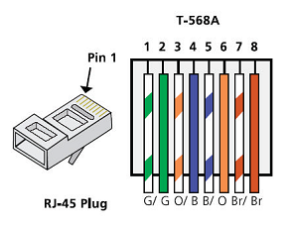
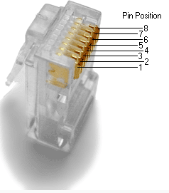
  - Analyze diagrams and tables for the TIA/EIA 568-B standard Ethernet cable.
The following table and diagram display the color scheme and pinouts for the 568-B standard.
568-B 10/100/1000-BaseTX Ethernet
Pin Number | Pair Number | Wire Color | 10Base-T Signal  100Base-TX Signal | 1000Base-T Signal
1 | 2 | White/Orange | Transmit | BI_DA+
2 | 2 | Orange | Transmit | BI_DA-
3 | 3 | White/Green | Receive | BI_DB+
4 | 1 | Blue | Not Used | BI_DC+
5 | 1 | White/Blue | Not Used | BI_DC-
6 | 3 | Green | Receive | BI_DB-
7 | 4 | White/Brown | Not Used | BI_DD+
8 | 4 | Brown | Not Used | BI_DD-
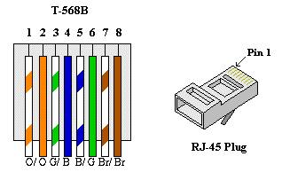

- Build an Ethernet Crossover Cable
A crossover cable has the second and third pairs on the RJ-45 connector at one end, reversed at the other end (refer to the table in Part 1, Step 2). The cable pinouts are the 568-A standard on one end and the 568-B standard on the other end. The two following diagrams illustrate this concept.
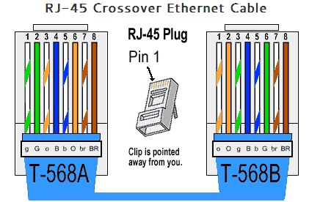
  - Build and terminate a TIA/EIA 568-A cable end.
    - Determine the cable length required. (Your instructor will let you know the cable length you should make.)
Note: If you were making a cable in a production environment, the general guideline is to add another 12 in. (30.48 cm) to the length.
    - Cut off a piece of cable to the desired length and using your wire stripper, remove 5.08 cm (2 in.) of the cable jacket from both ends.
    - Hold the four pairs of twisted cables tightly where the jacket was cut away. Reorganize the cable pairs into the order of the 568-A wiring standard. Refer to the diagrams, if necessary. Take as much care as possible to maintain the twists in the cable; this provides noise cancellation.
    - Flatten, straighten, and line up the wires using your thumb and forefinger.
    - Ensure that the cable wires are still in the correct order for the 568-A standard. Using your wire cutters, trim the four pairs in a straight line to within 1.25 to 1.9 cm (1/2 to 3/4 in.).
    - Place an RJ-45 connector on the end of your cable, with the prong on the underside pointing downward. Firmly insert the wires into the RJ-45 connector. All wires should be seen at the end of the connector in their proper positions. If the wires are not extending to the end of the connector, take the cable out, rearrange the wires as necessary, and reinsert the wires back into the RJ-45 connector.
    - If everything is correct, insert the RJ-45 connector with cable into the crimper. Crimp down hard enough to force the contacts on the RJ-45 connector through the insulation on the wires, thus completing the conducting path. See the following diagram for an example.
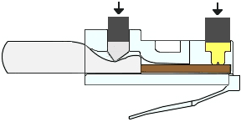
  - Build and terminate a TIA/EIA 568-B cable end.
Repeat steps 1a to 1g using the 568-B color wiring scheme for the other end.
- Test an Ethernet Crossover Cable
  - Test the cable.
Many cable testers will test for length and mapping of wires. If the cable tester has a wire map feature, it verifies which pins on one end of the cable are connected to which pins on the other end.
If your instructor has a cable tester, test the crossover cable for functionality. If it fails, check with your instructor first as to whether you should re-cable the ends and re-test.
  - Connect two PCs together via NICs using your Ethernet crossover cable.
    - Working with a lab partner, set your PC to one of the IP addresses shown in the Addressing Table (see page 1). For example, if your PC is PC-A, your IP address should be set to 192.168.10.1 with a 24-bit subnet mask. You partner’s IP address should be 192.168.10.2. The default gateway address can be left empty.
    - Using the crossover cable you made, connect the two PCs together via their NICs.
    - On the PC-A command prompt, ping the PC-B IP address.
Note: The Windows firewall may have to be temporarily disabled for pings to be successful. If the firewall is disabled, make sure you re-enable it at the conclusion of this lab.
    - Repeat the process and ping from PC-B to PC-A.
Assuming IP addressing and firewall are not issues, your pings should be successful if the cables were properly made.
Reflection
  - Which part of making cables did you find the most difficult?
________The most difficult part when assembling the cable was putting the wires into the RJ 45 connector, this was personally the most challenge part of this task, this is due to me getting mixed up with the orders of the wires causing confusion. _________

  - Why do you have to learn how to make a cable if you can easily buy pre-made cables?
__________It is very useful for a person to understand and learn how to make a cable because not all of the time will shops be open for you to be able to buy a pre-made one, or you may live far away from any type of shop so having this understanding will allow you to know how to create and build your own wire when it is needed. ________________

