Key Worker Handbook-
Transition in the Early Years

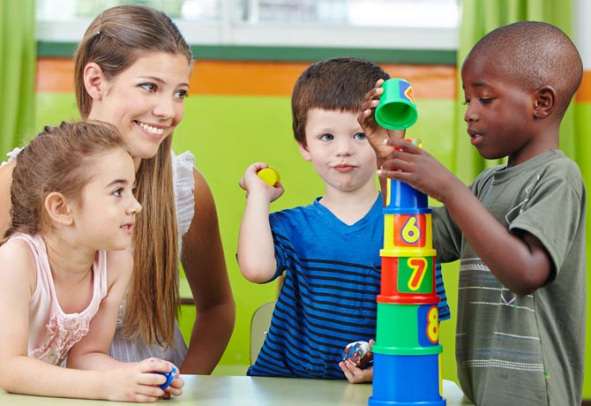(Source: Dr.Dina.ca, 2018)

Contents
Introduction
What is transition?........................................................................................3

The Role of the Adult
How can adults help to facilitate positive transitions?...................................4

The Needs of the Child
How can new experiences be dealt with?.....................................................6

Partnerships
How can strong relationships be developed?.............................................10

Interventions
What activities are there to support?..........................................................12

Conclusion
What are the proposed outcomes?.............................................................13

References................................................................................................14

Introduction- What is transition?
The purpose of this handbook is to provide support and guidance to all Early Years practitioners who are involved in the transitional process that supports children and their families. It will provide advice and information about how everyone involved can deal with these new changes effectively, always keeping the child at the center.

A child’s life can be very busy, even more so as they start to grow up and begin the different stages of their lives. Change is inevitable, however, learning about a child’s development can help us to understand how children acknowledge transition.

When a child starts school for the first time, it is a milestone event for young children that can have a definite effect on their development. However much this can be an exciting change for a child to experience, it can also become a time of uncertainty as they need to get used to their new surroundings and daily procedures (Early Years Matters, 2018). Research highlights, that many children who first begin school experience a big culture shock (Brostrom, S 2007). Any change to a child’s life is something that will take time to get used to (Dunlop and Fabian, 2007, p.4).

Bronfenbrenner (1979) interprets a child starting school as an environmental transition. A child’s immediate setting is with their family and a school setting is their second enriching connection. This necessitates adjustments in order to bring out a child’s identity, relationships and character.

For smooth transitions to come into action, it must depend on the commitment from all professionals to advance positive communication links. It is important that young children experience consistency when transitioning between settings. There must be a shared approach from everyone who is involved in the child’s life (Oxfordshire County Council, 2017).

The Role of the Adult- How can adults help to facilitate positive transitions?

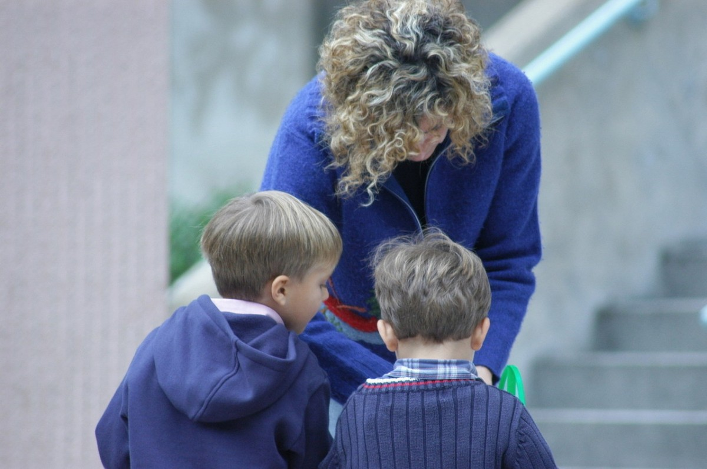(Source: Early Years Careers, 2018)
The role of the adult is crucial when ensuring that transitions run smoothly.
It is important that each key person that is already involved with the child provides a summary statement about the individual in preparation for their transition. A child moving from a nursery setting would need this provided to the keyworker in the child’s new reception class. This should indicate the level that the child is working at and any interests or needs that the child has. If the child has any additional needs, then the transition process will need a more precise plan put into place. The keyworker in reception may have to communicate with multi agency professionals in order to provide the most effective care for the individual.
All practitioners should ensure that children feel secure, included and valued. No child should feel excluded or disadvantaged. Article 5 of the United Nations Convention on the Rights of the Child states that all parents and carers must provide guidance and direction as the child grows up so that their rights can be fully enjoyed. This must be carried out in a process that recognises the child’s growing limitation to making their own choices (UNICEF, no date).
It is important for parents, carers and other professionals to work together to ensure that the transition process is effective and consistent. Significant adults must act responsibly to enable children to achieve their full potential. By adults embracing this, children can be fully supported. Children benefit from having a secure base and all practitioners involved with children must have a very good understanding of the child’s life and their background.
Children develop at different rates, so the relationships children form constructs all the stages of their development. The more positive the relationship, the better the child’s development will be.
For any parent it can be a difficult time when leaving their child in the care of someone else. Therefore, effective communication is crucial as it enables the parent to be involved in the child’s learning. It is a chance for any concerns to be addressed and for the parents to seek advice from the practitioner if needed (Early Years Careers, 2018).
The role of the keyworker during transition is very important. The ability to build a close relationship is essential so that children feel connected which can help them to develop a sense of belonging. Children need a lot of reassurance and comfort from adults, even more so when experiencing change.
When a child begins school, they are separated from their main caregiver and are in a position where they need to build new relationships with unfamiliar adults (Early Childhood Learning & Knowledge Centre, 2018). The keyworker needs to respond consistently to a child’s needs for them to build a trusting relationship. The keyworker’s role is to be a familiar figure who acts as a point of contact for parents. It is important that a positive relationship is built with the parents as well as the child (Early Years Matters, 2018).
Observing children is such an important part of the keyworkers role as it supports the understanding of what they can do, what they are interested in and what they already know. (Smidt, 2015, p.11) writes about a book called ‘Dibs in Search of Self’ written by a theorist called Virginia Axline. She followed the progress of a 5-year-old boy named Dibs who was described by his school setting as being ‘defective’. She observed him during play and started to understand his likes, dislikes, abilities, fears and dreams. Axline was trained to closely observe children who displayed signs of behaviour that was described as ‘strange’ or ‘unacceptable’. Throughout her book she explained that by observing the child through play, she was able to understand what frightened him and what caused him to be such a nervous child. During one of the sessions, Dibs was playing with a toy soldier. He called the soldier ‘Papa’ and kept knocking him down to the floor. Observations enable practitioners to pick up on things about a child’s life that may not be noticed straight away.
It is important for practitioners to plan activities that children are interested in to further their development and to observe them when doing so. Observations capture a child’s abilities and talents. Observing what children choose to do highlights what their interests are and who and what they enjoy playing with. This provides the adult with reliable information that is needed to gain an overall understanding about the child. It can help to accurately plan a child’s next steps to learning. Discussing this with all adults involved with the child can provide a starting point for a holistic approach to ensure that the child is always central to what is being planned for their development (Early Years Matters, 2018).

The Needs of the Child- How can new experiences be dealt with?
Every child is unique, and it is vital that this is recognised. During transitions, children can be sensitive especially those with additional learning needs. The child’s experiences must be consistent, and they need to include all aspects of a child’s holistic development.
A child’s response and strategies they use to cope with transition are regularly associated with their development stage. When a child is adjusting to a new environment, they will show signs of strong emotions. These may include distress, fear or excitement. Children may express these emotions by kicking, crying or rolling on the floor (Early Childhood Learning & Knowledge Centre, 2018).
By using a developmental approach, this can offer extensive leverage to understand the different types of behaviour that a child demonstrates during transitions (Sroufe, 1995, p.3).
A child’s right to play is fundamental for their development. Article 31 of the UNCRC states that all children have the right to have fun in any way that they want to. They should be able to participate in cultural activities that are inclusive (Children and Young People’s Commissioner Scotland 2018).
McLeod (2018) provides useful information about Erik Erikson’s theory. His theory is about the psychosocial development which is highlighted by eight important stages. During each stage, the individual experiences a situation that could have either a positive or negative affect on their personality development. He explains that if each stage of an individual's life is completed correctly, then this will result in a healthy personality which is able to solve later issues or problems in their life. However, if a stage in an individual's life is completed unsuccessfully, then this can result in an unhealthier sense of self. Below is a diagram of the eight stages of development in Erikson’s theory.

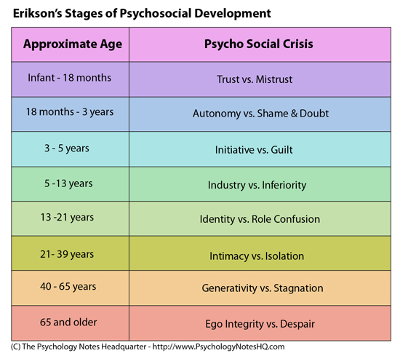

(Source: The Psychology Notes Headquarter, No date)
By the time a child begins reception they will be 4 years old. Based on this diagram, they will be at stage three, where they experience ‘Initiative vs. Guilt’. Bee (1992) describes this time as being when a young child displays signs of different actions and behaviours that adults may describe as being aggressive.
McLeod (2018) explains that during this time, children experience more interaction regularly with the other children in their class. The most important stage in this is play as it gives the children chances to explore their interpersonal skills through creating activities. Children will start to make up their own games and join in activities with others. If children are given this opportunity, then they will feel secure when mixing with other individuals and will be able to make their own decisions. However, if the child is regularly criticized or controlled then they can develop a sense of guilt. This could lead to them feeling like a nuisance to others and it can cause them to lack self-initiative.
Kolar (2018) suggests that young children must be given the chance to make their own choices and act upon them. It is essential that in the classroom, children can initiate their own activities. If they are unable to do this then they will be associating self-directed behaviour as a punishment. A segment of a child’s day must be available for children to choose their own activities freely. Children need to be encouraged to take risks and without the opportunity to do this they will become frustrated by activities in a sense where they feel that they are completing them poorly. Practitioners must accept mistakes that children make when trying out new activities on their own. If they break something or make a mess then the adult must show the child how to fix, correct or clean it instead of punishing them. By doing this, young children will feel confident in attempting new activities on their own.
A child’s learning environment plays a big part in this. The setting needs to encourage a shared endeavor for children to be provided with memorable times in small groups which can help them build new friendships. Children benefit from using familiar resources and experiences to help them build a sense of security. When children have successfully adapted to their new environment then they will become more responsive to new challenges. A child’s core skills need to be taught in fun ways that they can enjoy. This provides children with a deeper understanding of the world around them. Areas such as role play, small world, sand and water are activities that encourage child lead learning experiences (Teach Early Years, 2018).
During transitions, children need to be well supported through any difficulties and challenges that they may face. They need to feel that you believe in them and that in return, they can believe in you. If a child experiences early trauma then this can result in an unhealthy form of flexibility which can have an impact on a child’s brain development. A child may become frightened, distrustful and ambivalent. It is expected for children to show some of these behaviours when experiencing any transition, but certain individuals may display this behaviour more intensely and for a much longer period. (Goldschmied and Jackson, 1994) explain that a child may not understand why they are at school. Their only explanation is that they have been left by their primary caregiver who they are totally dependent on. This can result in them experiencing very high levels of anxiety.
(O’Connor, 2018, p.2) explores John Bowlby’s attachment theory about how a child’s early experiences can affect their long-term well-being in their later life as an adult. A child needs to feel safe, secure and protected and this is how an attachment bond is formed. Children pick up responses from adults that trigger their brains and to do this effectively, they need to have the people who are closest to them right by their side. Even when they are babies, they are always active at ensuring that they are getting the attention they need. When a child is seeking attention, they want to attract the behaviour of their caregivers. This can produce a brain chemical called oxytocin which can reduce stress. Children need to rely on the response from adults to help soothe their stress and to send positive messages to their brain by engaging in positive experiences to incorporate a feeling of security. A child who is securely attached, feels that they are loved, and this is all down to the response from the adults they have around them.
Children remember times when they feel scared or insecure and they keep a memory of the adults in their life who make the situation better for them. This helps them to deal with the times when they feel upset or angry because they put trust in the adult to help them feel better again. These are important feelings that help the child to take risks and to want to explore the world around them because they know that they have someone there who cares. This is a relationship that is built on love and sensitivity that will help a child to build their self-confidence.
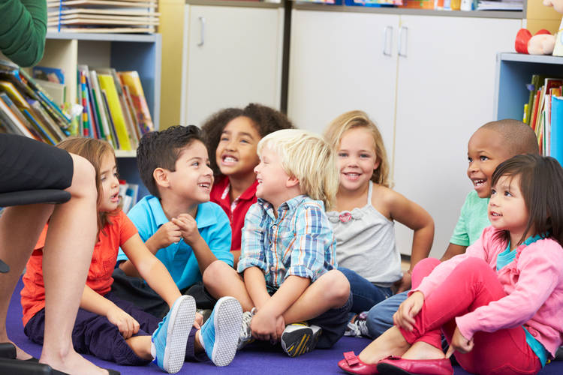
(Source: Zero To Three, 2018)

Partnerships- How can strong relationships be developed?
(Margetts, K, 2004) declares that the performance and quality of the transitional process all depends on the communication and team work between all the people involved with the child.
As mentioned previously, the keyworker will develop a strong relationship with the child and their family. In return, the family must also feel like they have a strong relationship with the child’s keyworker. A child’s family will feel like they are going through the transition themselves. They will feel sad and anxious just like the child, so it is vital that the practitioner regularly communicates with them to ensure that they feel secure. This can be done through regular meetings, a home school book, information packs about the classroom and the new school setting. This will create a positive relationship so that the children and parents can both feel comfortable and at ease during the transition.
If the child has additional learning needs or there is an involvement from social services, then the transition process will need even more care and attention. Working with multi-agencies can provide a very particular contribution to support an individual and their family to help with the improvement of a child’s life outcomes (Every Child Matters, 2005). Depending on a child’s personal circumstances, a practitioner may need to work in partnership with professionals such as; Social Services, Medical Experts, Mental Health Services or possibly the Police.
If a practitioner is concerned about a child’s development progress, then there are several professionals that can also offer their support. Practitioners can communicate with multi- agencies such as the Educational Psychologist, School Nurse and Speech and Language Therapist. The keyworker would arrange a meeting with one of these outside professionals depending on the child’s individual needs, they would then come into the school setting and assess the child. Following on from this, they are then able to feedback to the keyworker about their observation and put an action plan in place to support the child’s needs. The parents of the child are always informed in every step taken and are always present during the meetings.
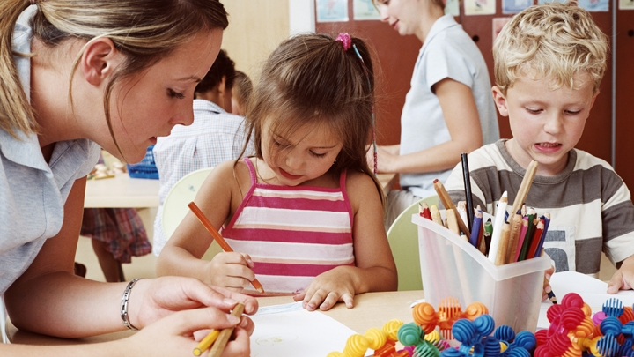
(Source: Encyclopedia on Early Childhood Development, 2017)

Interventions- What activities are there to support?
Prior to children beginning reception, families should be invited to a school visit where they can look around the school setting and the child’s new classroom. Arranging ‘Meet the Teacher’ sessions and providing welcome packs are also beneficial ways to provide parents and carers with information about key dates and the school setting procedures. This is a chance for any concerns to be addressed. Home visits and small group play dates are also very helpful during the transition process. ‘Stay and Play’ sessions are a good idea as the children can mix with each other and start to get used to their environment. This is a laid-back approach that also allows the keyworker to begin to get to know the child. The practitioner may also visit the children in their nursery setting. This is to help the child get used to the keyworkers unfamiliar face.
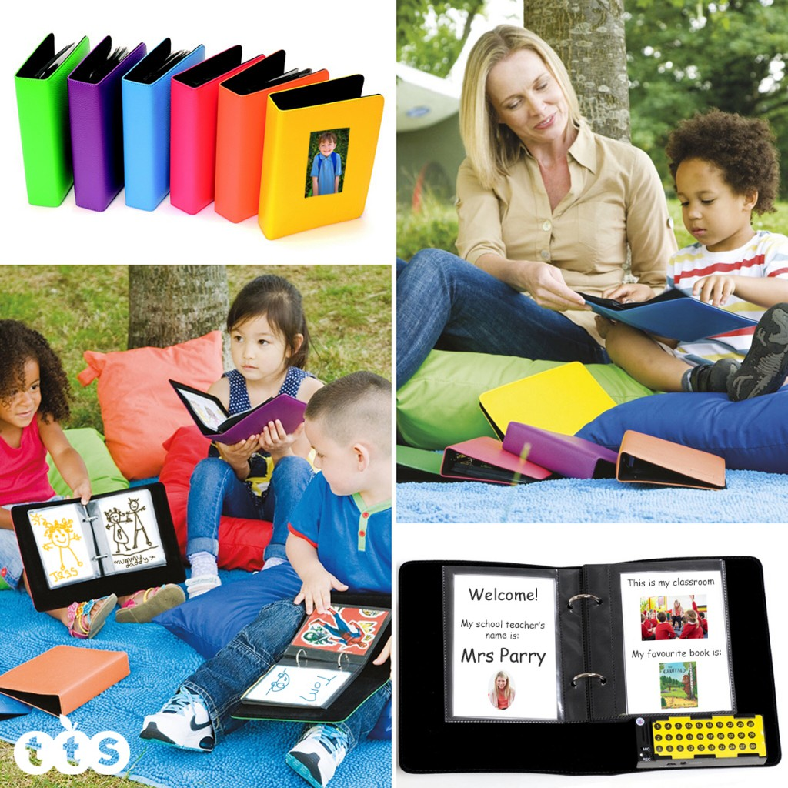
When children begin reception, they will begin the induction process, this will depend on the settings policy. During the first week, children may come in for the mornings and then the second week they will stay in the afternoons. Some school settings begin the children gradually which means small groups of children may join the class each day. Other settings start all the children straight away, whichever process is used, the child must respond well and feel at ease.

(Source: tts, 2018)
Conclusion- What are the proposed outcomes?
Children who have adapted well to the transition process will continue to build on their confidence and resilience. They will respond better to gradual change and not see it as being such a large hurdle in their life. The more confident a child is, the quicker they will find it easier to settle into their new school. However, if a child is more disadvantaged then this will take a lot longer as they are more vulnerable.
Within the first few weeks of the transition, a child’s progress is likely to regress, this is not uncommon. The children need time to adapt to their new environment and the new adults in their life.
(Achievement for All, no date) explains that if the four key principles of the Foundation Phase are kept in mind, then this can help during the planning process of supporting children going through transitions.
- The Unique Child- Every child is different; some children will need a lot more support in order to make the transition successful.
- Positive Relationships- Adults must all work together and understand the impact that the transition will have on the child. Working in partnership is the key process.
- Enabling Environments- They must be similar in terms of provision and expectations.
- Children Learn in Different Ways and at Different Rates- The child’s holistic needs must be considered around all aspects of learning.
Our main goal is for all children to appear settled in their new environment. They should be able to respond well to their keyworker and other adults around them and their independence and confidence should grow stronger every day. By working together, this transitional process that children will experience can be as stress free as possible.
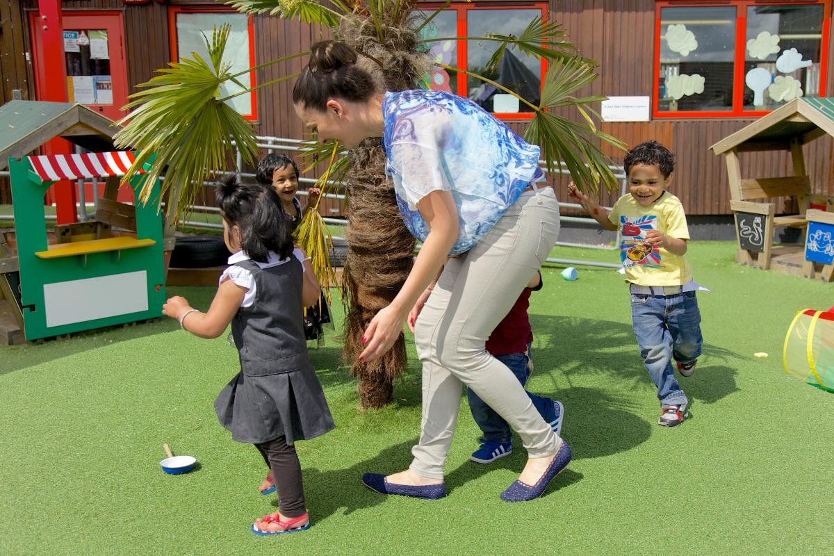 (Source: Pre-School Learning Alliance, 2017)
References
Achievement for All (No date) Successful Transitions in Early Years. Available at: https://afaeducation.org/blog/successful-transitions-in-early-years/successful-transitions-in-early-years/ (Accessed: 3rd December 2018)
Bee, H. L. (1992). The developing child. London: HarperCollins.
Bronfenbrenner, U. (1979) The Ecology of Human Development, Annals of Child Development. Cambridge: Harvard University Press.
Brostrum , S (2004) Communication and continuity in the transition from kindergarten to school. In Fabian, H and Dunlop, W (Eds) Transition in the Early Years. London: Routledge Falmer.
Children and Young People’s Commissioner Scotland (2018) Article 31. Available at: https://www.cypcs.org.uk/rights/uncrcarticles/article-31 (Accessed: 27th November 2018)
Early Childhood Learning & Knowledge Centre (2018) Supporting Transitions: Using Child Development as a Guide. Available at: https://eclkc.ohs.acf.hhs.gov/publication/supporting-transitions-using-child-development-guide (Accessed: 22nd November 2018).
Every Child Matters (2005) Multi-agency working. Available at: http://www.wokingham.gov.uk/EasysiteWeb/getresource.axd?AssetID=75433&. (Accessed: 29th November 2018).
Early Years Matters (2018) Key Person & Attachment. Available at: http://www.earlyyearsmatters.co.uk/eyfs/positive-relationships/key-person-attachment/ (Accessed: 21st November 2018).
Early Years Matters (2018) Observation, Assessment and Planning. Available at: http://www.earlyyearsmatters.co.uk/eyfs/a-unique-child/planning/ (Accessed: 22nd November).
Early Years Matters (2018) Transition: The Journey. Available at: http://www.earlyyearsmatters.co.uk/eyfs/positive-relationships/transitions/ (Accessed: 20th November 2018).
Fabian, H. and Dunlop, A.-W. (2007) Informing Transitions in the Early Years: Research, Policy and Practice. Maidenhead: McGraw-Hill Education.
Goldschmied, E. and Jackson, S. (1994) People Under Three: young children in day care. London: Routledge.
Kolar, R. (2018) How to Apply Erikson’s Theory in Instruction. Available at: https://www.theclassroom.com/apply-eriksons-theory-instruction-8400675.html (Accessed: 27th November 2018)
Margetts, K (2004) Planning Transition Programmes. In Fabian H, and Dunlop, W (Eds) Transitions in the Early Years: London: Routledge Falmer
McLeod, S (2018) Erik Erikson's Stages of Psychosocial Development. Available at: https://www.simplypsychology.org/simplypsychology.org-Erik-Erikson.pdf (Accessed: 26th November 2018)
O’Connor, A (2018) Understanding Transition in the Early Years- Supporting Change through Attachment and Resilience (2nd Ed) New York: Routledge.
Oxfordshire County Council (2017) Smooth Transitions in the Early Years: A Good Practice Guide. Available at: https://search3.openobjects.com/mediamanager/triborough/directory/files/eytransitionpack.pdf (Accessed: 21st November 2018).
Smidt, S. (2015) Observing Young Children: The Role of Observation and Assessment in Early Childhood Settings. (2nd Ed). London: Routledge.
Sroufe, L (1995) Emotional Development: The Organization of Emotional Life in the Early Years. US: Cambridge University Press.
Teach Early Years (2018) Supporting Transitions in the Early Years. Available at: https://www.teachearlyyears.com/a-unique-child/view/supporting-transitions-in-the-early-years (Accessed: 1st December 2018)
UNICEF (No date) A Summary of the UN Convention on the Rights of the Child. Available at: https://www.unicef.org.uk/wp-content/uploads/2010/05/UNCRC_summary-1.pdf (Accessed: 21st November 2018).

