
Skills for the Workplace
Module Assignment Submission
Student Name: | Jenna Stabler
Student Number: | 2107303
Module No: | BMSK4006
Module Title: | Part 1 Business Plan

Statement of Confirmation of Authenticity
By the act of making this submission, the student declares that this is the work of the student named above. The work has not, in whole or in part, been knowingly presented elsewhere for assessment, or where assessment has been built on a previous assessment, this has been identified. Where materials have been used from other sources it has been properly acknowledged. If this statement is untrue, the student acknowledges that an assessment offence has been committed.
Attention is drawn to the plagiarism and unfair practice policies of both the University and of ILM.

Table of Contents
Title Page 3
Executive Summary 4
Business/Industry Overview 5
Market Analysis and Competition 5
Sales and Marketing Plan 9
Product or Service Offerings 9
Pricing Strategy 9
Sales and Distribution 9
Advertising and Promotion 9
Ownership and Management Plan 10
Operating Plan 10
Financial Plan 10
Appendices 10

Title Page

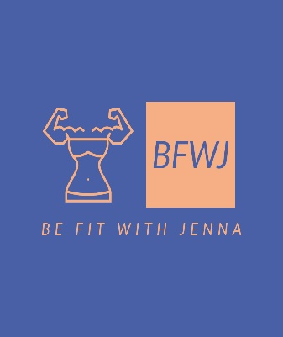

“Empowering Women Through Fitness”

Business Plan for Be Fit with Jenna

15/7/22

Location: Singleton Park

07736900037

BefitwithJenna@yahoo.co.uk

www.Befitwithjenna.co.uk - Facebook

@BefitwithJenna Instagram

Executive Summary

My name is Jenna and I am a Sole trader business for personal training. My vision for the future is to Empower Women, Encourage Women and Support Women in making changes in their lives to become more active, healthier and happier. I am passionate about using fitness to empower women. I adore gathering exceptional women and assisting them in rediscovering the joy of working out and the value of making time for oneself after spending so many years putting other people before themselves.

My classes will be available from 1/1/2023. I am a Women’s only personal trainer, fully qualified with my level 3 personal training qualification. I offer safe, adaptable, and efficient exercises that include both outdoor and virtual activities, enabling my female clients to leave feeling more self-assured and energetic. I am looking to sell my products to Women of all ages. Lockdown was tough for many but I saw it as an opportunity so in September 2021 I decided to take the leap and complete my personal training. I wish to pursue my passion of assisting women in feeling their best selves via physical activity. I will be holding 2 outdoor HIIT classes a week and 2 strength and conditioning classes online a week.

Be Fit with Jenna Virtual programme

This programme focuses on strength training. Strength training is often overlooked by females as they are convinced that sweaty cardio is more effective and that they will end up bulking if they lift weights. By following this programme for just 4 weeks you will start to feel and see many benefits both physically and mentally and realise its importance for your vitality and longevity.

Be Fit with Jenna Outdoor Classes

All of my face to face classes are conducted in the great outdoors (singleton park). They involve weighted and body weight movements and will focus on working the full body. Come and feel motivated and train with like-minded local ladies and leave feeling energised.

I am friendly, knowledgeable, and quick to respond to customers this will build a reputation for my service. My main focus are my customers I want them to feel cared for and that I am assisting them in meeting their needs when they attend my classes. I am passionate about my fitness and I want to be able to give something back to my clients. I am trustworthy and my prices will be at a reasonable price and easy bookable via Instagram. I will be offering monthly cost of just £30 for all my classes or £5 a class.

My competitive advantage is that there are no outdoor classes for women only within the Swansea area. Yes there are many personal trainers out there but not offering what I am. I believe there is a niche in the market for my business.

I have estimated that I will need £829 as a starting point for my business. After all cash outflows I will take £1413 a month. My closing cash position estimates I will take £28,214 before tax after 12 months of operating providing my projected sales and the costs of goods and services are as predicted. With the personal training industry expected to grow by around 18% in 2022, I believe my business has potential to be very successful and profitable.

Business/Industry Overview

The UK personal training market expanded gradually between 2011 and 2020 before experiencing a sharp decline in 2021. on account of the Covid 19 epidemic. Notably, the market for personal trainers decreased by almost 25% in 2021. However, it is expected that the business will grow by around 18% in 2022. The personal training market is expected to grow during the next five years. New trends in personal training are continuously appearing as the fitness industry changes. Due to people's growing interest in controlling their health, personal training is still on the rise. With obesity at an all-time high, there will be a rise in the need for personal trainers.

I am a Women’s only personal trainer who offers both group and one-on-one sessions. My main goal is to build a community of like-minded women who are encouraging, supporting, and empowered by others. I work outside, in nature, not in a gym. All of my in-person lessons take place outside, in nearby parks, gardens, and beaches. But because I am aware of how hectic life can be, I also provide twice-weekly virtual sessions that you can attend live from the comfort of your home or catch up on at a time that is more suitable for you. As a single parent myself I know how difficult it can be to find time to train and to prioritise yourself. I will be targeting my classes at Women only from all ages. Whether you are a stay at home mum or retired and just want to keep fit. When you sign up to Be Fit with Jenna, you will experience more than just a fitness class, you will have entry to the amazing community of women via a private WhatsApp group, as well as access to nutritional information, group challenges and direct support and accountability from myself. With more and more people wanting to get fit and healthy, given the advantages of outdoor fitness training for both physical and mental health, the demand for these sessions is hardly surprising.

My vision for the future is to Empower Women, Encourage Women and Support Women in making changes in their lives to become more active, healthier and happier.

With the personal training industry becoming more and more popular this means that there are lots of competitors out there. To beat my competition, I must do a great deal of marketing. I will be expanding on this within the next section.
I will be targeting my market to Women only of all ages and my prices will be at a lower cost of just £30 a month for all classes or clients can purchase a class for only £5. This gives them the option to book if they have other commitments like different work pattens. For all my clients first class I will be offering them a free pass to my class at no cost so that they can come and see what I am offering.

Market Analysis and Competition
There are many competitors out there especially within the personal training industry. There are currently 21, 879 registered personal training businesses within the UK.
I am targeting my market at Women only from all ages with HIIT training and strength and conditioning. I believe there is a niche for women to be able to train with their babies/toddlers outside. My outside class can only hold a maximum of 30 people due to the permit that I have in place. However for my online classes there is no limit as I will be live through a video call these classes will be recorded for those who can’t make it so they can do it at a more convenient time.
I will need to get people interested in me and my business. I will be using personal training testimonials and client success stories to show off my capabilities. People will be able to relate to this kind of marketing and it is a brilliant way of demonstrating my passion and knowledge to prospective clients. Inspiring positivity and motivation in people will not only encourage them to train but to train with me. I will also be using social media to market my business as I believe this is the most effective way to get clients to see what I offer and appeal to them.
I have completed a SWOT analysis to help me identify issues that could potentially impact my business and competitors.

Strengths  - Qualified as Level 3 personal trainer 2021  - Completed an advance sports nutrition course 2021  - Highly competent with HIIT been attending classes for 5 years  - Completed first Aid training 11/7/22 red cross certificate for 3 years  - Keen interest in circuit training and strength and conditioning | Weakness  - Inexperienced in personal training completed in 2021  - Limited experience with marketing or sales  - Age could be a factor 35 when others trainers maybe younger and fitter  - Accustomed to working in a team. Training clients 1 on 1 could be an adjustment
Opportunities  - Undertake a CPD course in strength and conditioning to further my expertise  - Enrol on a marketing and sales course  - Background in holistic fitness, means I’m well rounded for clients  - Age means I’m a clearer choice for older clients  - Make use of mentoring schemes available | Threats  - More experienced trainers that offer the same  - Limited to 30 clients outdoors  - Weather can have an impact on my outdoor classes  - Clientele is very broad and I have limited experience with aerobic exercise

After some research I haven’t found any women’s only Personal training sessions outside in the Swansea area. I have found a business called SOFit and they offer boot camp style training outdoors so this would be a competitor but offering different style training, they also offer online classes 20 live online classes. They are offering an 8 week plan for £39 with a saving of 20%. There are also some outdoor yoga classes available on Swansea beach. Other competitors I have would be online. I follow a PT called Courtney Black and her style of training is very similar to myself. But I will be doing this in Swansea and she is based in Essex and online only. There are a few gyms that offer women’s only classes but they are based in a gym, some of the gyms that offer this are: LC2, YMCA, The Gym Group Swansea, JD Gyms, the fitness studios and Jack2akinggym. These would be my competitors also but as I am offering outdoor classes I feel that my business opportunity will be successful and that there is a niche in the market for my business Be fit with Jenna.
I have completed a PEST analysis that identify external factors that could affect my business.

Government can introduce new Health and Safety Regulations.
Government can introduce new laws like national living wage.

Some individuals may not have access to computer, Leaflets to hand out.
Wealth of people.

Instagram booking system for people to book classes. Could be down.
Some people may not have internet access.

Cost of living disposable income going up people will have less money to spend on PT Instructor
Recession.

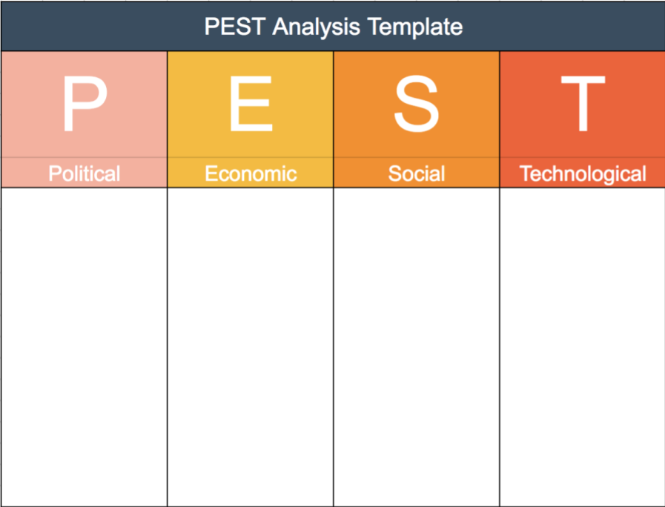

The marketing process that begins with segmenting the market into more manageable divisions is what I will now be looking at for my company's segmentation, targeting, and positioning. It will be easier for me to decide which market segments to target and which have the greatest potential if I look at many segments. Long-term, attractive target markets will result in increased sales and profits. That's advantageous for my gain and loss.
Segmenting my consumer base based on shared characteristics will enable me to create more useful solutions for their problems. Instead of buying generic products made to appeal to everyone, consumers opt for products that are customised to their requirements and relevant to those demands. It's an essential component of marketing theory. My segmentation chart is shown below. I have chosen to focus on new mothers, working women, retired women, and a gathering place for women to make friendships and socialize.

Sales and Marketing Plan

The 7P’s to Marketing

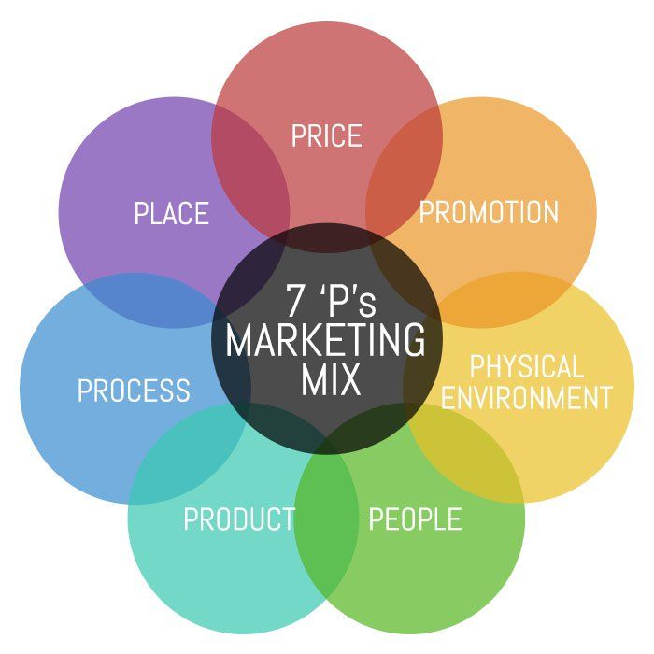
- Price – I will be offering my clients a £30 a month access to all four of my weekly classes as well as access to nutritional information, group challenges and direct
- support and accountability from myself. But if my clients wish to pay for individual classes at a time they can do so for just £5 a class.
- Product – I offer safe, adaptable, and efficient exercises that include both outdoor and virtual activities.
- Promotion – The main way I am going to promote my brand is through social media. I believe this is the way forward given that social media is so popular. I will be able to share stories of my classes to encourage clients to signup with me.
- Place – My outdoor classes will take place in Singleton park as outdoor training has become more and more popular with lots of benefits. My live/ recorded classes will be via teams so that clients can train in the comfort of their own home.
- People – I wish to pursue my passion of assisting women in feeling their best selves via physical activity. I have always been customer focused all my previous jobs have always been with customers. I am friendly, knowledgeable, and quick to respond to customers this will build a reputation for my service. My main focus are my customers I want them to feel cared for and that I am assisting them in meeting their needs when they attend my lessons. I am passionate about my fitness and I want to be able to give something back to my clients.
- Process – The process of Be Fit with Jenna includes providing virtual and outdoor classes, Registering new customers and providing membership deals as I am offering
- a monthly fee of just £30. My main agenda is to provide quality services through better processes as per the needs of my customers.
- Physical Evidence – This will be provided by my clients and their progress and experience shared by them. I will be sharing success stories to help build my business.

Product or Service Offerings

I am a women-only personal trainer that provides effective, adaptive exercises that can be done both outside and online. My main objective is to create a group of like-minded women who are supportive, empowering, and encouraging.

Be Fit with Jenna Virtual programme

This programme focuses on strength training. Strength training is often overlooked by females as they are convinced that sweaty cardio is more effective and that they will end up bulking if they lift weights. By following this programme for just 4 weeks you will start to feel and see many benefits both physically and mentally and realise its importance for your vitality and longevity.

Be Fit with Jenna Outdoor Classes

All of my face to face classes are conducted in the great outdoors (Singleton Park). They involve weighted and body weight movements and will focus on working the full body. Come and feel motivated and train with like-minded local ladies and leave feeling energised.

What makes my classes different?
There are many benefits to training outdoors I believe that the fresh air and sunlight additionally, it delivers essential vitamin D, which is crucial considering the large percentage of vitamin D-deficient individuals in the UK. There are two key benefits of utilising an outside area instead of a gym. First off, just using the gym can incur high rental fees for PT’s. Before you break even, you must put in a specific number of hours. Second, HIIT (high intensity interval exercise), which can be done anywhere, is becoming more and more popular.
Numerous studies have shown how HIIT can improve your metabolic rate for hours after working out. Even more than running and weight training, several researchers have discovered that HIIT enhances your metabolism after exercise.

What will I offer to my clients that my competitors will not?
As a level 3 certified personal trainer, I offer safe, adaptable, and efficient exercises that include both outdoor and virtual activities, enabling my female clients to leave feeling more self-assured and energetic. They will soon experience a sense of empowerment and inspiration that will motivate them to make great life choices and lead more active, healthy, and joyful lives.

Pricing Strategy

I will be offering my customers an unlimited class pass and a monthly cost of just £30 a month. They will be able to attend all 4 of my weekly classes included in this price. For those who don’t wish to pay a monthly fee and have a busy schedule or work commitments, I will be offering a class pass of just £5 for a class. Although this is not a guaranteed commitment by my clients I do feel that it gives some women the opportunity to book when they can and it will be beneficial to some of my customer’s.
I will be marketing my business Be Fit with Jenna on social media. Instagram will be how my clients can sign up or book a class it is a simple way of booking and an easy way for myself to see any notifications with automatic reminders and its free. My customers can pay directly on my Instagram page if they follow the link at the top of my page. This will direct them to input their card details and save for future payments.

Sales Forecast

As my outdoor classes can only hold 30 people due to the permit I have my sales estimation is as follows:
Service 1 is based on my monthly paying customers
4 sessions a week at £30 monthly fee =£120
£120 cost X 4 = £480 per month divide 4 = 120
120 clients x £30 per month = £3600 a month income

Service 2 is based on my class pass customer of £5 a class
I am basing these sales on that if I have 6 customers purchase these passes a week my sales forecast are as follows:
£5 x 6 = £30
30 x 5 =£150 a month
Evidence of my sales assumptions will be in my appendix.

Budget and timeline

I will still be working part time as a Casino Manger to start off as this income of £1000 a month will help me start my business off. With my salary from my work, Universal credit and child benefit that I receive my annual income is £16,896 this Is a massive help for me to achieve my goal of having my own personal training business Be fit with Jenna. After my personal expenses are paid I am left with £4,992.
I have estimated that I will need a start-up loan of £1000 to help me with equipment for my classes such as weights and dumbbells. I am asking all my customers to bring their own matt and water bottle as this is another expense I do not have to have. I will need to have insurance for my Be fit with Jenna business and after some research this will cost me £9 a month. I will also need a permit to hold my outdoor classes and this I have estimated to be £480 a month. I will be using my personal mobile for my business and this will cost me £60 a month. The only other expense I have is vehicle running cost which I have estimated being £280 a month. My starting point for my business after all my cash out-flows is £829. With my monthly wage of £416 left over and my starting point sum of £829 this leaves me with a budget of £1245. I believe I am able to set my business up on that budget. I am planning on staring my business up in January 2023 this will give me enough time to plan and prepare.

Advertising and Promotion

I firmly believe that social media has fundamentally altered how people exercise outdoors. Going outside is highly valued on Instagram, and this could spread. Therefore, I'll promote Be Fit with Jenna via social media. All new customers will receive a free pass class as part of my promotion strategy so they can try my class and learn more about what I have to offer. My Instagram page will offer booking options for this. Additionally, I'll use customer testimonials and success stories to advertise my company. As more people use social media, I'll use it to promote my company by posting live footage of my outdoor classes so that potential clients can see what I'm all about. Once I have established a customer base I will be thinking about selling water bottles with my logo and training hoodies and vests to help promote my business but this will be further down the year.

Ownership and Management Plan
Be fit with Jenna is a Sole trader business for personal training. I will be working by myself to help empower Women, Encourage Women and Support Women in making changes in their lives to become more active, healthier and happier. I am a fully qualified with my level 3 personal training qualification. I offer safe, adaptable, and efficient exercises that include both outdoor and virtual activities, enabling my female clients to leave feeling more self-assured and energetic. I have completed my level 3 in first aid training as well as a course on advanced sports nutrition. I am incredibly skilled in HIIT training, circuit training, strength training, and conditioning. I will be in charge of my own finances and how I wish to run my business

Operating Plan

I will run my Be fit with Jenna company from my house for my online classes and from Singleton Park for my outdoor class. I'll need a permit that can only accommodate 30 persons for this. Through the council, I have made a request for this. I'll be asking my customers to bring an exercise mat. Dumbbells and kettlebells will be among the equipment I provide to help me with my classes. As it is more economical, I will store these in my garage. I have a start-up loan in place to help me purchase these.

As a personal trainer I have a legal duty of care to my clients to reduce the likelihood of an accident occurring. If a client is injured I can be liable. Therefore, before any physical activity can start, I have to complete a number of forms and have their signatures from new clients. With the use of these forms, I will be able to create a training programme for my customers that will reduce their risk of injury and my potential liability. The key legal forms a PT should have include:
- Disclaimer form
- Physical Activity Readiness Questionnaire
- Fitness assessment form
- Emergency contact details form
- Client-trainer service agreement
- Online forms
- Insurance

Financial Plan

To help start my Be fit with Jenna personal training business up I will need a start-up loan of £1000. This will help me with costs for equipment and my initial payment for insurance and permit for my outdoor classes. As I have previously mentioned I will still be working my other part time job to contribute to this. I have estimated that after I have paid all my personal expenses and with my personal wage I have £416 disposable income a month and £4992 a year. This will help with the start-up of my business. I plan to repay a monthly payment of £84 towards the start-up loan over a 12 month period. My main source of revenue is the revenue I make from training clients. I do plan to expand this by selling t-shirts, hoodies and water bottles with my logo on after I have established a customer base.
I am going to be using Social media to advertise my business as this is free and no additional cost to me. I have estimated that it will cost me £489 for my permit and insurance, as I am going to be working on my own this is the only cost I have to get me started. My cash flow forecast shows I will need £829 as a starting point for my business. By selling my 2 services service 1 - monthly payment and service 2 - class pass payment I have estimated that my total sales value will be £3750 a month. After all cash outflows I will take £1413 a month. My closing cash position estimates I will take £28,214 before tax providing my projected sales and the costs of goods and services are as predicted. I understand with the current climate and cost of living is rising this may change.

Evidence of my cashflow forecast is in my appendix.

Risk Analysis

I am aware that there may be certain possible hazards when a new business is launched. As a result, I have made sure that I carry liability insurance. I shall abide by GDPR rules regarding customer personal information. Health and safety of my clients are my top priorities. With each customer, I will fill out a risk assessment form to make sure I'm doing everything I can to prevent, get rid of, or limit risks. I will also be mindful of a tax bill at the end of the year and ensure I have enough to pay.

Appendices

Cash-Flow-Forecast-Start-Up-Loans.xlsx

https://swansea.gov.uk/applyforeventoncouncilland

https://www.instagram.com/befit_withjenna/

https://www.simplybusiness.co.uk/cs/welcome/public-liability-insurance/?gclid=2c3460b10a071b0c8bcf02612730c9bf&gclsrc=3p.ds&&?mkt_medium=ppc&mkt_source=bing&msclkid=2c3460b10a071b0c8bcf02612730c9bf&utm_source=bing&utm_medium=cpc&utm_campaign=CORE%20-%20PL-G11613752811&utm_term=public%20liability%20insurance&utm_content=PL%20-%20Generic

Jenna Stabler
19 Clos San Pedr Cockett SA2 0FX
Jennastabler@yahoo.co.uk 07736900037

Personal Statement
A Polite, enthusiastic and well-presented individual who is looking for a position that is customer service based. I am currently employed at Grosvenor Casino as a Gaming Manager. I am responsible for the smooth running of the Casino. Ensuring all team members are fully trained and adhere to all company policies and procedures. Customer service is something that I take very seriously and strive to ensure that everyone that visits the casino enjoys their experience.
I have been in the gaming industry since 2008 and began my career as a dealer. I have held various positions of dealer, inspector and pit assistant.
Key Skills
- Outstanding interpersonal and Communication Skills - Using different method of communicating to my team members.
- Computer Literate – using different systems in my current employment
- Customer Service- My whole work experience I have always worked with customer focused job roles.
- Cash Handling
- Mental Arithmetic
- Calm under pressure
- Friendly and outgoing personality
- Focused approach to problem solving, with the ability to prioritise tasks and manage time effectively
- Ability to understand and act on assigned tasks and work on my own initiative when needed
- Quick learner, keen to learn new skills and build on existing experience.
- Level 3 personal training
- Level 3 First Aid

Work Experience
Grosvenor Casino July 2014 – Present
I am Currently employed at Grosvenor Casino Swansea as a Casino Manager. My duties include all aspects of the running of the gaming floor and the smooth running of the Casino. Ensuring that customer Service is delivered

Aspers Casino October 2008 -2014
Aspers Casino Stratford as an inspector/pit boss. I have held various gaming position within the company. My duties include all aspects of the running of the gaming floor and to supervise all of the games that we offer. On a nightly basis I am in control of the break list of 70-80 staff and have achieved “rising star” awards for my contribution to the business.
XL Airways April 2006-September 2008
Cabin Crew
In this position I was responsible for ensuring all customers had a comfortable flight, serving hot and cold food and beverages, ensuring company grooming policies were upheld and providing exceptional customer service.

Travel City Direct. October 2005-2006
Telesales Operator
I was responsible for answering incoming calls and ensuring excellent customer service. Providing customers with quotes on holidays for the best price meeting their budget.

Education
Tycoch College. 2004-2006
BTEC National Diploma in Travel and Tourism.

Ysgol Gyfun Gwyr 1997-2004
Secondary school. G.C.S.E
References
Mr Steven Bailey
Aspers Casino
312 The Loft

Montifichet Road
London
E20 1ET
Mrs Katy Graham
15-16 Highstreet
Swansea
Sa1 1LT
Jenna Stabler
Jennastabler@yahoo.co.uk

References

Bitner, M. J. and Booms, H. (1981). Marketing Strategies and Organization

B Finch (2013)

Davidson (1997)

D Anderson (2003)

McCarthy, E. J. (1964). Basic Marketing.

WA Sahlman - 1997

