MBA Marketing Dissertation
LCMB7020 MOHAMMED SHOEB
2214606



Module Title : Dissertation
Module Code : LCMB7020
Course : MBA Marketing
Dissertation Topic: The impact of digital marketing practices on
consumer behaviour of UK University students:
an analysis of Lyst
Lecturer : Ms Tushara Balendran
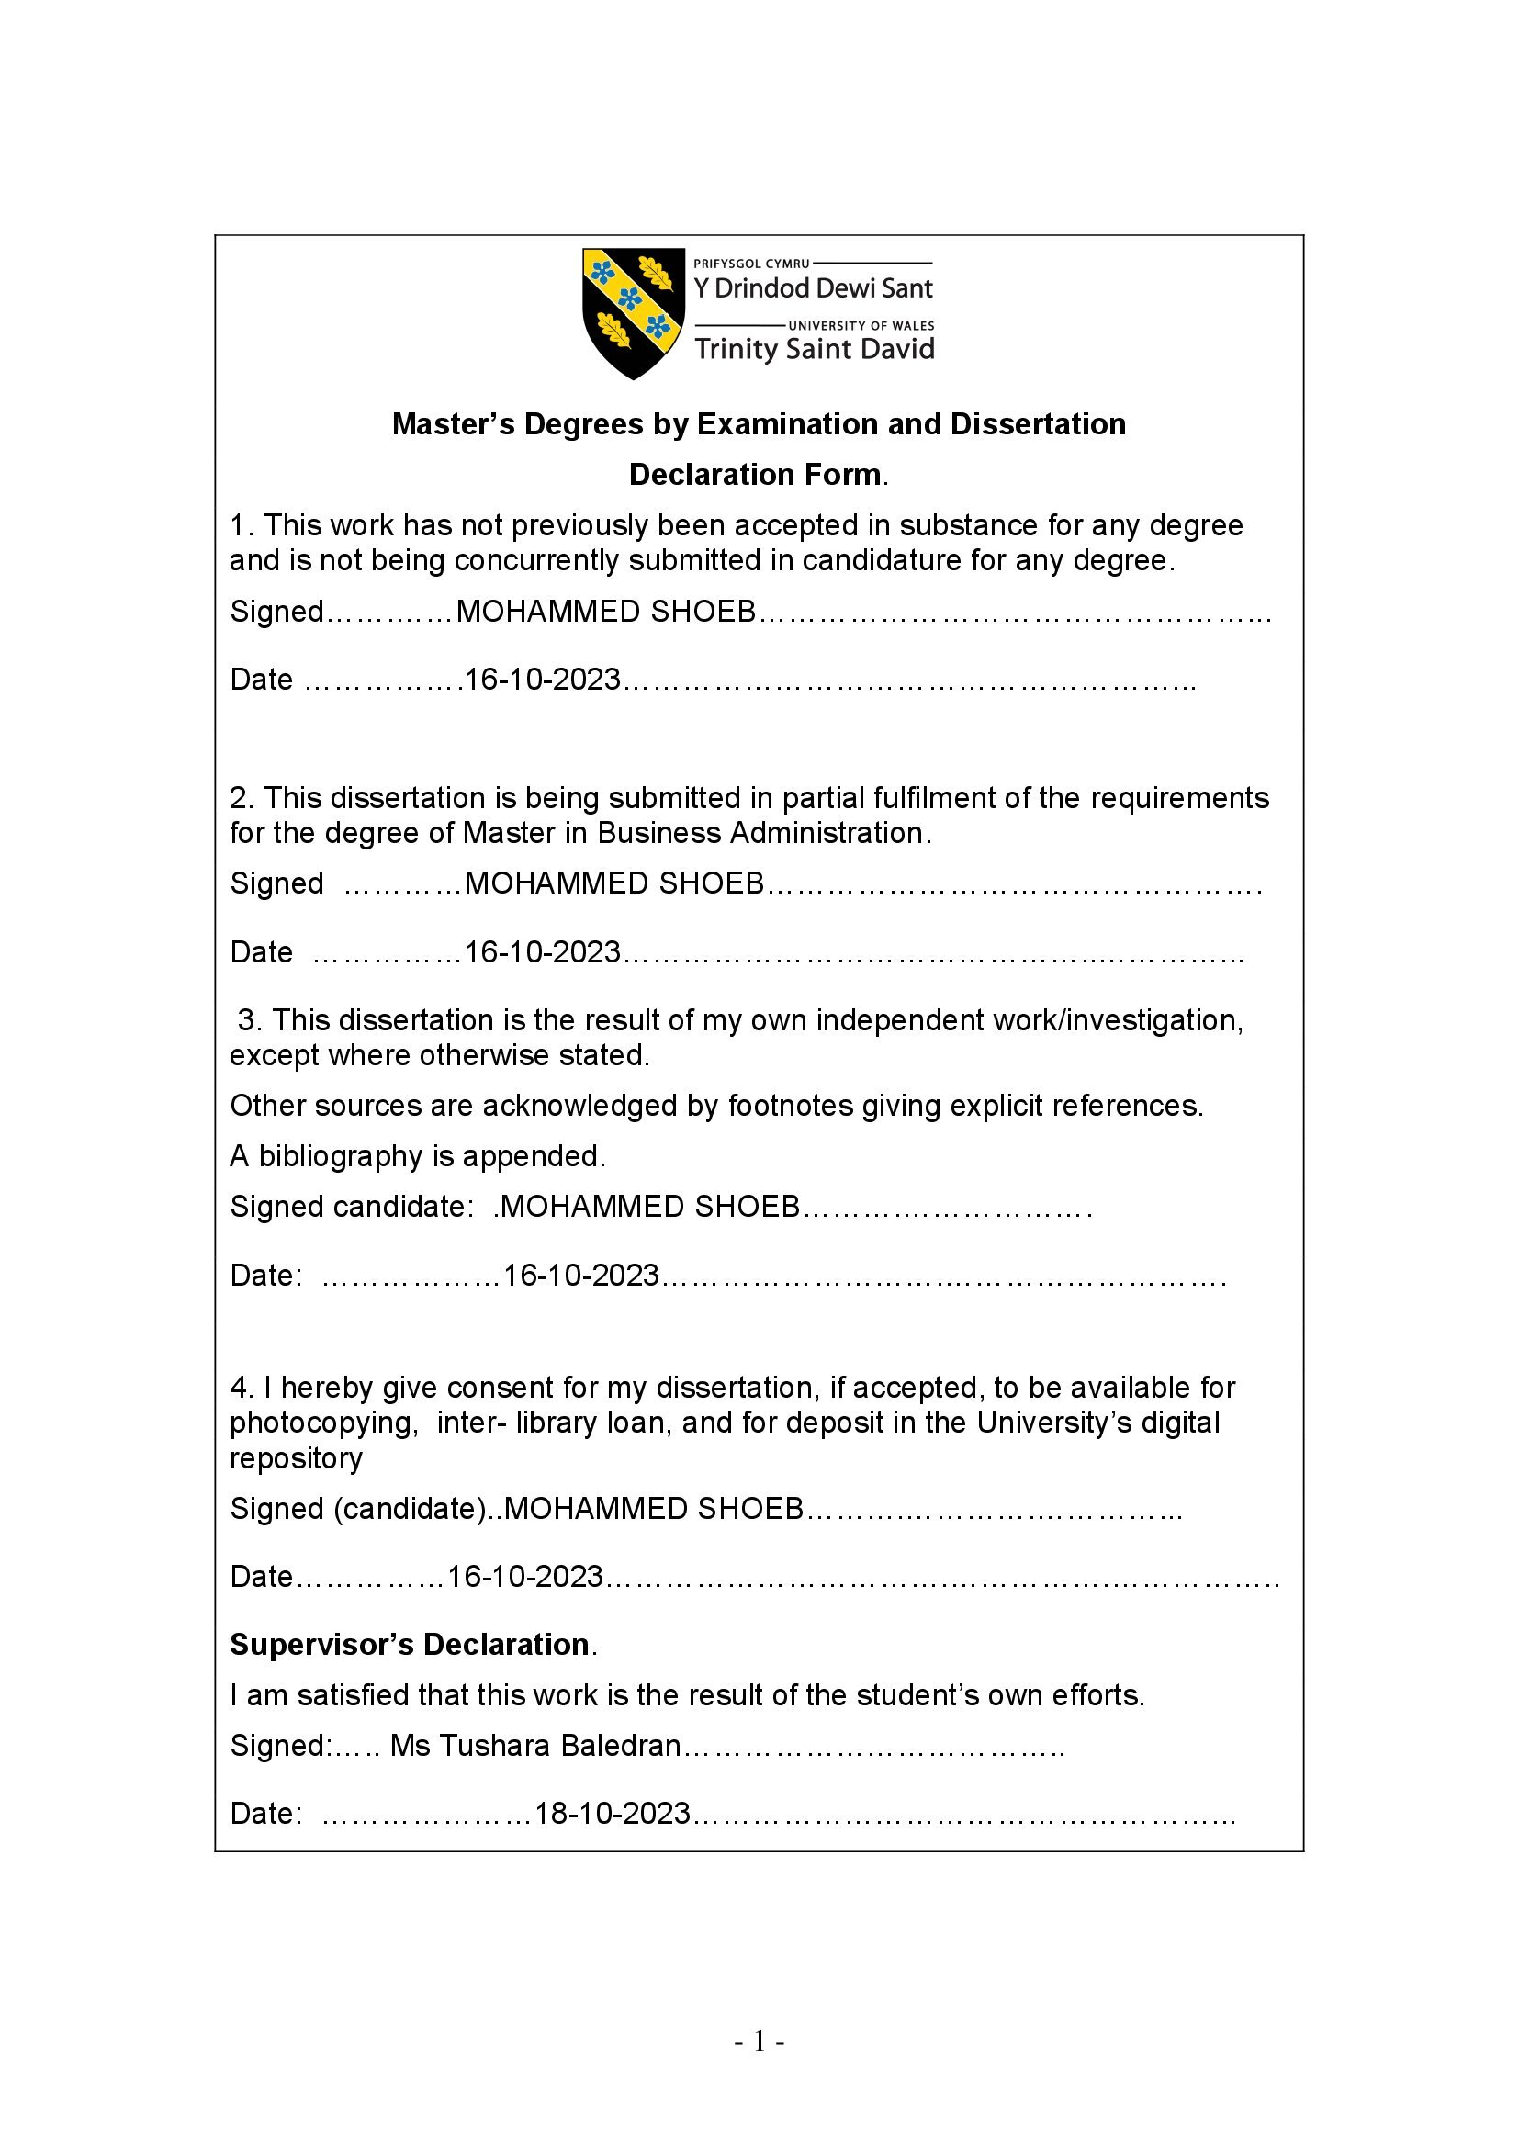
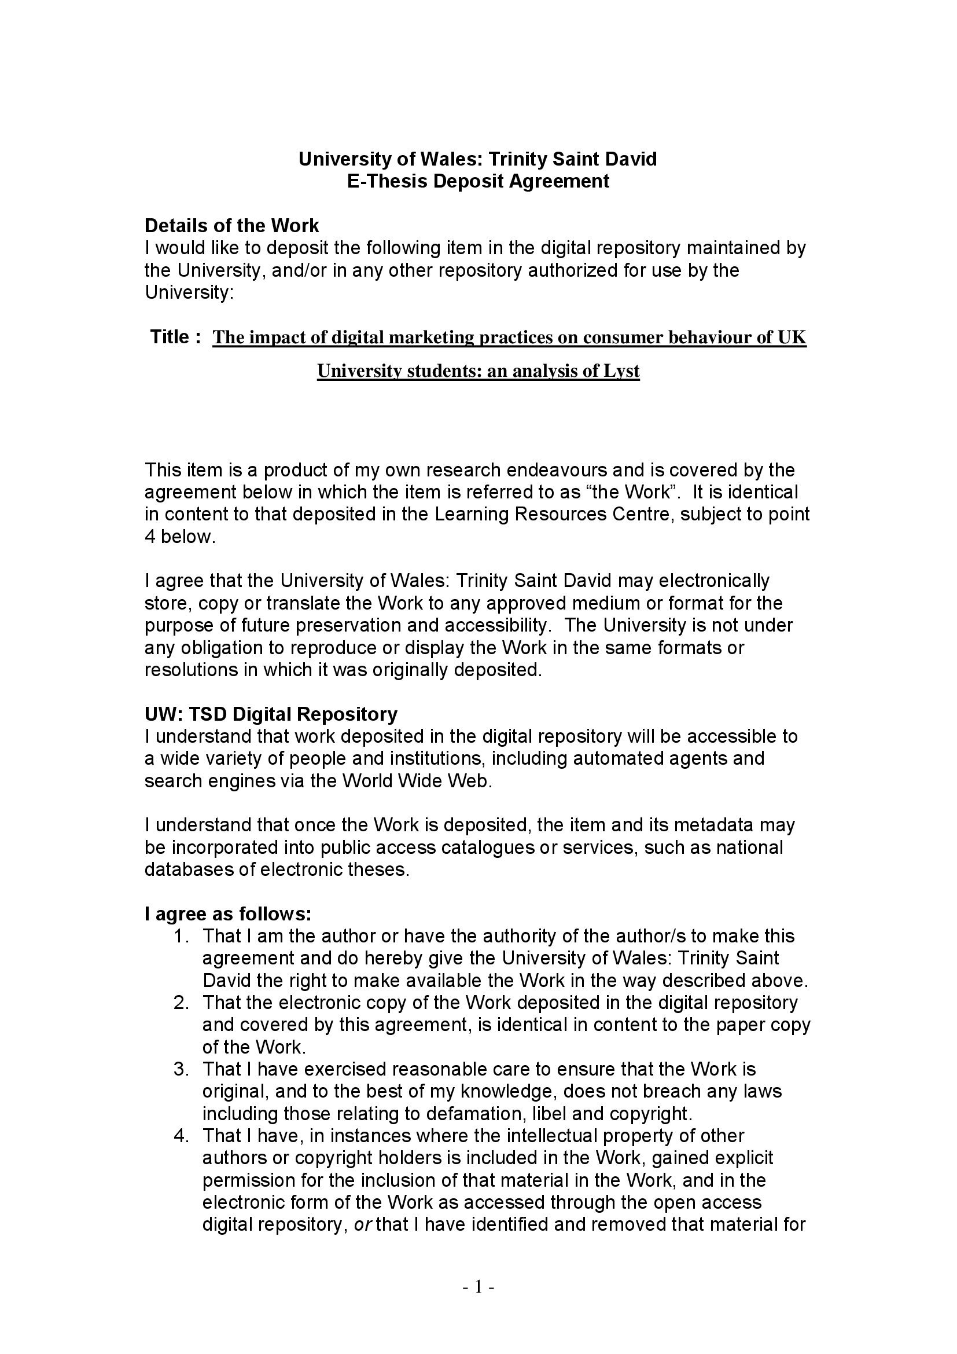
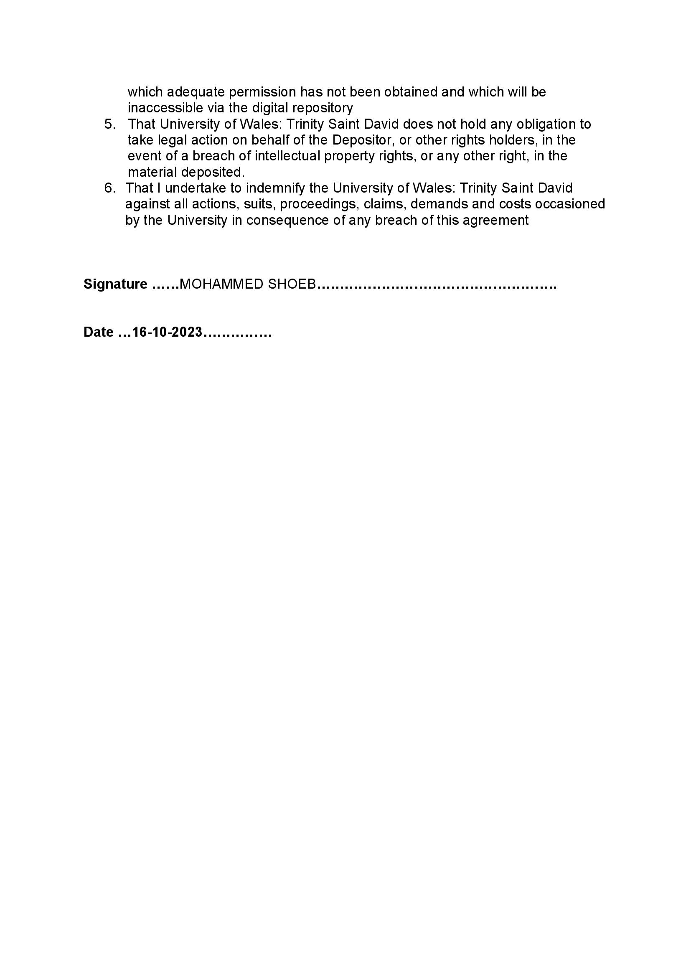

Abstract
The research has been executed with the aim to evaluate“the impact of digital marketing practices on consumer behaviour among university students in the UK in general for the prominent fashion startups in the country, as well as evaluate the same for Lyst”. The next chapter conducts a detailed literature review to provide readers with a better understanding of the subject through past research. The literature review also demonstrates that these businesses benefit from social media, influencer marketing, data analytics, and personalisation to raise brand awareness and engage their target audience even as they navigate challenges such as limited resources, intense competition, and quickly evolving technology.The section on research methodology detailed the approaches and how well they applied to the study. The researcher employed positivism as their research philosophy in addition to a deductive research approach and a descriptive study design. The research has been conducted with the collection of primary data reflecting survey of students from the UK universities. The quantitative analysis of the research proved that the digital strategies that Lyst introduced over the times has increased the customer loyalty levels as well as positively impacted their engagement patterns. The findings of the study further made it evident that the practices of using social media platforms for communication, influencer marketing, mobile applications and most importantly the personalised recommendations have helped in increasing the purchase level of the students by changing their shopping decisions and experience. The last chapter provided an overall conclusion of the study along with providing recommendations for improving Lyst's digital marketing practises' effects on UK university students' purchasing behaviours.

Table of Contents
Chapter 1: Introduction 5
1.1 Introduction and Research Background 5
1.2 Research Rationale 6
1.3 Research Aim 8
1.4 Research Objectives 8
1.5 Research Questions 8
1.6 Structure of the Dissertation 8
Chapter 2: Literature Review 10
2.1 Introduction 10
2.1.1 Definitions of digital marketing and consumer behaviour 10
2.1.2 Contrasting information about digital marketing and consumer behaviour from different authors 10
2.1.3 The possible answer to the research objectives/questions stated 11
2.2 Digital marketing practices and strategies incorporated by the UK-based fashion startup 11
2.3 The challenges and opportunities faced by UK-based fashion startups while implementing digital marketing practices and strategies 13
2.4 The impact of digital marketing practices adopted by Lyst on consumer behaviour of university students in the UK 15
2.5 Theoretical framework 18
2.6 Literature gap 23
2.7 Summary 24
Chapter 3: Research Methodology 26
3.1 Introduction 26
3.2 Purpose of the study 26
3.3 Research Philosophy 27
3.4 Research Approach 28
3.5Research Strategies 29
3.6 Research Choices 29
3.7 Time horizon 31
3.8 Data Collection and Sampling Method 31
3.9 Data Analysis Method 33
3.10 Ethical Considerations 34
3.11 Summary 35
Chapter 4: Analysis of data 36
4.1 Introduction 36
4.2 Survey graphical analysis 36
4.3 Survey inferential analysis 44
4.4 Discussion 50
4.5 Summary 52
Chapter 5: Conclusion and Recommendations 53
5.1 Conclusion 53
5.2 Linking with the objectives 53
5.3 Limitations of primary research 56
5.4 Recommendations 56
5.5 Future scope 57
References 58
Appendix: Survey questionnaire 65

List of tables
“Table 1: Result of correlation” 45
“Table 2: Summary result of regression model” 46
“Table 3: Anova” 47
“Table 4: Coefficient results" 48

List of figures
Figure 1: Honeycomb model. Source: (Ronquillo et al., 2019) 21
Figure 2: RACE model. Source: (Chaffey and Smith, 2022) 22
Figure 3: Research onion. Source: (Saunders et al., 2019) 26
Figure 4: Engagement span with Lyst Company 36
Figure 5: Increase in customer engagement with Lyst for digital marketing 37
Figure 6: Influence of direct communication through social advertisements on student participation 38
Figure 7: Impact of two-way communication system 39
Figure 8: Impact of influencer marketing and user-generated content on student engagement 40
Figure 9: Purchase made through mobile applications 41
Figure 10: Smooth browsing through mobile apps 41
Figure 11: Influence of personalisation strategy 42
Figure 12: Tailored advertisements 43
Figure 13: Influencing purchases through interesting narrations 44

Chapter 1: Introduction

1.1 Introduction and Research Background
Digital marketing has become a key factor in driving customer engagement and purchase behaviour in the ever-evolving corporate landscape (Vidili, 2021). In this regard, an important consideration is the different digital marketing techniques that have significantly altered the fashion business, which is renowned for its agility and trend sensitivity. Thus, utilising Lyst as a fascinating case study, this research tries to examine the complex interaction between digital marketing tactics and customer preferences among UK university students in fashion businesses situated in the UK. In this regard, it is important to note that social media advertising and influencer marketing are two of the key models that Lyst UK uses. These models have been thoroughly discussed in the literature section.
The wide range of digital marketing initiatives, such as influencer partnerships, content strategies, SEO tactics, social media campaigns, and personalised email approaches, may have a big impact on customers' purchase decisions, brand loyalty, and overall satisfaction in the purchasing journey of a consumer (Sudha and Sheena, 2017). Notably, it is important for entrepreneurs to remember that knowing the most effective digital marketing strategies is especially crucial in the dynamic world of fashion startups, where resources are scarce, and competition is severe.The consumer behaviour of UK university students is significantly impacted by digital marketing strategies. These procedures include a wide range of online marketing techniques, including paid advertising, influencer marketing, social media marketing, email marketing, and content marketing. Universities reach a larger audience of potential students due to digital marketing methods (Pandeyet al., 2020). The institution and its programmes are made known to students through tailored marketing and content. This had an impact on their decision to think about attending university. Frequently, college students utilise the internet to research their options.
Universities highlight their services, such as degree programmes, campus amenities, teacher biographies, and student testimonials, through the use of digital marketing. Students' views and decisions are shaped by this knowledge (Sundströmet al., 2019).Digital marketing enables personalised communications and suggestions based on a student's preferences, prior interactions, and online activity. Customised offerings and content help students feel appreciated and are more inclined to interact with a certain university. Direct communication between institutions and potential students is made possible through social media marketing and email marketing (Vidili, 2021). Universities give updates, respond to inquiries, and promote a feeling of community, all of which serve as strong selling points for prospective students. Universities frequently work with former students who have a large following on social media platforms or influencers who are students. These opinion leaders offer sincere perspectives and testimonies regarding their time in college, which have an impact on other students' choices.
This study is in a unique position to provide insightful information for improving Lyst's strategies as well as for other fashion startups facing comparable difficulties because it is set against the backdrop of the globally significant UK fashion industry with its varied buyer spectrum, especially university goers in the UK, and digital proclivity (Gornostaeva, 2023). Evidently, startups aiming for prominence in the extremely competitive fashion industry must consider the fundamental implications of the delicate relationship between digital marketing strategies, the preferences of these students, their perceptions of brands, and their decisions while making a purchase. A fascinating backdrop for this study is Lyst, a noteworthy fashion business with headquarters in the UK. Within the context of the digital ecosystem, where marketing strategies and consumer behaviour are intricately intertwined and have a significant influence, this company operates as an innovative platform that combines fashion items from various brands and stores (Rathore, 2018). Therefore, this study uses Lyst as a case study and conducts a thorough analysis of the company in order to understand the specific digital marketing strategies used by the firm and the effects those strategies had on the behaviour of the university students in the nation.

1.2 Research Rationale
By utilising Lyst as a case study and taking into account its relevance to modern company success, this research seeks to evaluate the impact of digital marketing by fashion startups on customer behaviour among university goers in the UK. The fashion sector, which is known for its quick changes and resonance with society's trends, has undergone massive changes sparked by the use of internet marketing methods (Kingsnorth, 2022). Nevertheless, despite the widespread use of these tactics, there is a major knowledge gap about how they intricately interact with consumer behaviour, especially among Gen Zs and millennials, particularly when considering startups that are hampered by a lack of funding and fierce competition. By revealing the relationship between digital marketing strategies and consumer behaviour, this research aims to close this gap. As a result, the body of knowledge must be enriched, and fashion entrepreneurs must have access to valuable information to help them improve their strategies.
The fashion industry in the UK, which is notable for its influence on the world stage and tech-savvy customer base, which includes most of today’s university students, provides an engaging setting for this research. Understanding how digital marketing techniques influence consumer choices and create impressions of brands is crucial given that customers are increasingly looking to digital platforms for fashion inspiration and purchase decisions (Nurfadila and Riyanto, 2020). The underlying rationale for this research comes from the realisation that, despite digital marketing's vital status, a thorough grasp of the effects it really has on the consumer behaviour of university goers is still elusive. Students are guided easily and clearly through the application process through digital marketing. Students are encouraged to advance in their academic careers by using clear calls to action and online application forms. After they've applied, students are kept updated about university activities, opportunities, and resources through the use of digital marketing.
Universities also get student input through digital marketing, which they then utilise to enhance their offerings to students as well as their programmes and services. In a competitive marketplace, effective digital marketing makes institutions stand out and influence students to pick one over another (Sundströmet al., 2019).Universities employ digital marketing to advertise scholarships, chances for financial assistance, and tuition reductions. This has a big impact on students' selections because picking a university is frequently influenced by financial concerns. Today's students are more aware than ever of social and environmental challenges (Pandeyet al., 2020). Universities utilise digital marketing to emphasise their dedication to diversity, sustainability, and social responsibility, all of which are ideals that some students share.Furthermore, the research also examines Lyst's digital marketing tactics and their results in an effort to derive lessons that may be applied by businesses facing identical obstacles. Besides, it should be possible to shed light on previously unrecognised aspects of the startup environment by analysing the difficulties faced and possibilities discovered during the use of these tactics. Eventually, the study hopes to provide emerging fashion brands with the knowledge and skills necessary to use digital marketing as a powerful tool for connecting with customers, building brand loyalty, and obtaining an advantage in the rapidly changing fashion industry.

1.3 Research Aim
The primary purpose of the research is to assess the impact of digital marketing practices on consumer behaviour among university students in the UK in general for the prominent fashion startups in the country, as well as evaluate the same for Lyst.

1.4 Research Objectives
Given the principal research aim, it can be segregated into key objectives to address the aim. Hence, the specific research objectives are -
- To investigate the digital marketing practices and strategies incorporated by the UK-based fashion startup
- To explore the challenges and opportunities faced by UK-based fashion startups while implementing digital marketing practices and strategies
- To analyse the impact of digital marketing practices adopted by Lyst on consumer behaviour of university students in the UK

1.5 Research Questions
The research objectives can be formulated into corresponding research questions, whose answers must clarify the main purpose of the research.
RQ1. What are the digital marketing practices and strategies incorporated by the UK-based fashion startup?
RQ2. What are the challenges and opportunities faced by UK-based fashion startups while implementing digital marketing practices and strategies?
RQ3. How is the impact of digital marketing practices adopted by Lyst on the consumer behaviour of university students in the UK?

1.6 Structure of the Dissertation
This chapter serves as an introduction to the study by providing an outline of its background history, primary goals, and purpose. It introduces the main research questions and provides an explanation of the rationale for the study, both of which were developed with a set of goals in mind. A thorough literature review is conducted in the next chapter to help readers better understand the topic through earlier studies. The methods for gathering data, chosen method of analysing them, and addressing ethical issues are all covered in detail in the third chapter. The findings of thematic analysis and how they relate to each theme and pattern are covered in the next chapter. The results of this analysis are presented in chapter five as the final research conclusion, along with practical suggestions for UK fashion entrepreneurs and approaches to upcoming difficulties.

Chapter 2: Literature Review

2.1 Introduction
The literature section provides theoretical proof, which makes it simpler for the student to finish the research completely. The study's literature review also examines how customer behaviour among UK university students has been impacted by digital marketing strategies at UK-based fashion startups. The relevance of the digital marketing practices and techniques used by Lyst, the UK-based fashion startup, is also examined in the study's literature section. The research also looks at the potential and problems faced by UK-based fashion entrepreneurs when using digital marketing practices and tactics.

2.1.1 Definitions of digital marketing and consumer behaviour
Utilising online platforms to market companies, goods, or services requires using data-driven insights to customise marketing tactics and increase engagement and conversion (Rathnayaka, 2018). On this note, it is specifically understood that this flexible strategy of digital marketing incorporates several techniques such as content production, search engine optimisation, and social media marketing and may be tailored to consumers' shifting buying patterns. Likewise, the study of consumer behaviour examines the complex psychological, social, and economic factors that affect people's purchasing choices (Sudha and Sheena, 2017). In this regard, this research offers marketers crucial information that they can use to create more effective campaigns and improve customer experiences. Hence, it can also be understood that real-time data from digital platforms allows for the distribution of personalised content, encouraging deeper brand-customer interactions and informed decision-making. This shows how digital marketing and consumer behaviour work collectively. Nevertheless, in the ever-evolving digital world, this combination optimises marketing efforts and fosters a customer-centric mindset.

2.1.2 Contrasting information about digital marketing and consumer behaviour from different authors
According to one group of authors, the focus of digital marketing is largely on using online platforms to promote brand engagement and sales through tailored tactics based on insights into customer tastes (Vieira et al., 2019). As per the authors of a contrary viewpoint, consumer preferences are more complex and are impacted by a wide range of psychological, social, and cultural aspects in addition to online interactions (Szmigin and Piacentini, 2018). Notably, this difference in emphasis suggests that understanding a wider range of consumer motivations may be necessary for digital marketing to be effective. It also draws attention to the fact that consumer behaviour is a complex synthesis of both online and offline factors, necessitating a comprehensive strategy for effective marketing campaigns.

2.1.3 The possible answer to the research objectives/questions stated
In order to examine their brand promotion techniques, this research delves into the digital marketing environment of a fashion business with headquarters in the UK. The potential and problems experienced during the integration of digital marketing practices are revealed by conducting surveys and interviews with the potential stakeholders involved. Moreover, the research carefully examines how Lyst's digital marketing strategies have an impact on the purchasing habits of UK university students. The information gathered allows for a deeper comprehension of the startup's strategy and gives insight on the interaction between digital marketing, consumer behaviour, and the fashion industry.

2.2 Digital marketing practices and strategies incorporated by the UK-based fashion startup
According to Kalbaska and Cantoni (2019), startups are aggressively presenting their wide selection of items on social media marketing channels, including Instagram, Facebook, Twitter, and Pinterest. The fashion startups are forging connections with their audience by sharing eye-catching images and interesting material. In addition to that, fashion startups are working with fashion influencers to use their credibility and reach in order to market their products to a larger audience. As demonstrated by Muniesa and Giménez (2020), fashion startups improve the user experience by enabling users to buy straight from their posts using Instagram Shopping and Facebook Buy capabilities. A variety of digital marketing techniques and methods are now being used by the fashion startup situated in the UK to successfully reach its target market and build a credible online presence. The startup has a vibrant fashion blog that covers the newest trends, styling advice, and business insights as part of its content marketing initiatives.
As per the consideration of Noris et al. (2021), the start-up establishes itself as an authoritative voice within the fashion sector by continuously putting out good pieces. In addition to this, the firm creates interesting video material, including lookbooks, lessons, and behind-the-scenes footage. This approach not only draws viewers' attention to websites like YouTube and TikTok, but it also offers a more engaging brand experience. As opined by Kalbaska and Cantoni (2019), fashion startups are painstakingly optimising their websites for relevant fashion-related keywords in the area of search engine optimisation (SEO). Through this strategy, businesses visibility in search engine results is enhanced, making it easier for potential buyers to locate their items. Building and maintaining an email list while routinely sending newsletters with information on new arrivals, current specials, and exclusive deals are all part of the startup's email marketing plan. The business increases engagement and conversion rates by customising these emails based on individual consumer preferences and browsing behaviour. In the UK, startups collaborate with fashion influencers who share their brand identities in the field of influencer marketing. These influencers provide genuine content that communicates with their followers in an effective way and increases traffic to the startup's website.
Furthermore, as per Liu et al. (2017), these startups' social media presence goes beyond simply serving as a display for their product offerings. User-generated content (UGC) is effectively used by these companies in their marketing initiatives, which encourage customers to post pictures of their outfits from the corresponding fashion brands using certain relevant hashtags on various social media platforms. Likewise, through this strategy, these firms have been able to successfully foster a sense of community among their users, transform them into brand ambassadors, and start a chain reaction of natural brand promotion.
According to the study of Silva et al. (2020), although these businesses have had success with influencer marketing, email marketing, and social media, they may still benefit from improving their data analytics procedures. Given the reality that, through their company websites and social media platforms, these businesses must efficiently be able to gather user data, some of these startups still fail to make the most of this useful data. Notably, the ability to create a more individualised shopping experience is something that all these firms can do with the help of more thorough research of client behaviour and preferences towards the corresponding brands.
Additionally, as per the views of Rizvanović et al. (2023), in order to reduce their overdependence on social media networks, these companies should think about diversifying their digital marketing channels. Although these platforms have huge audiences, changes to the algorithms or policies can have a big influence on reach and exposure. Importantly, UK-based fashion startups may widen their digital marketing horizons and tap into new client categories by investigating developing platforms, making more efficient content marketing investments, and seeking partnerships with websites and blogs that are specifically focused on fast fashion and upcoming trends.

2.3 The challenges and opportunities faced by UK-based fashion startups while implementing digital marketing practices and strategies
As illustrated by Nobile et al. (2021), when using digital marketing practices and tactics to establish themselves in the competitive fashion sector, fashion startups face a combination of chances and obstacles. The UK fashion market is crowded with both well-known names and new businesses. According to Muniesa and Giménez (2020), it might be difficult to stand out and attract attention in a crowded field. Budget constraints limit the reach of digital marketing initiatives and limit the amount that can be spent on paid advertising, influencer partnerships, and cutting-edge technology. The algorithms of social networking sites and search engines are often updated. It takes time and continual monitoring to keep up with these developments and adjust strategy accordingly. Consumer preferences and behaviours change quickly, so businesses must constantly adapt their tactics and keep up with the latest trends.
According to Olins (2017), fashion entrepreneurs in the UK have several difficulties when putting their digital marketing plans into practice. On this note, it is crucial to mention that gaining momentum and creating a unique brand identity is a challenging undertaking in business due to the fierce rivalry being pushed by well-known companies and an increasing number of startups. Moreover, for marketing and sales to be successful, choosing the correct target market is essential. However, as per the views of Aakko and Niinimäki (2018), startups frequently struggle since they have limited access to thoroughly analysed consumer data. Furthermore, another important challenge that has been substantial is working within limited financial constraints, which increases the complexity, prevents major expenditures in digital marketing efforts, and results in lower visibility and engagement in comparison to more established rivals.
As suggested by Muangmee (2021), another challenge is creating brand recognition and credibility from the start because it is difficult to win over customers to a new brand over alternatives that are already well-known. Additionally, it is quite evident that smaller teams with fewer resources are overwhelmed by the need for constant adaptation due to the rapidly changing technological world. Besides, creating eye-catching, compelling, and unique content and updating it constantly with new posts is essential for the success of digital marketing, which presents additional difficulties for startups due to their lack of resources and limited time. Nevertheless, it has been argued in several pieces of literature that fashion entrepreneurs must use smart tactics, utilise affordable marketing strategies, and capitalise on their individuality to overcome these challenges and establish themselves in the fiercely competitive industry.
Following the analysis by Dumitriu et al. (2019), fashion business owners, especially among UK startups, have a wealth of chances, with the help of digital marketing, to succeed in an extreme rivalry in the fashion sector. Startups may reach out to existing audiences, establish credibility, and boost brand awareness to improve sales by partnering with top or emerging influencers and fashion bloggers. Certainly, Instagram, Facebook, Twitter, and now Thread are mostly used as key social media platforms that provide entrepreneurs with affordable ways to engage with their target market and develop a devoted client base, promoting organic development and the possibility of viral marketing. Furthermore, these startups may obtain insightful knowledge about consumer purchasing habits by utilising customisation and the implementation of data analytics. There is no doubt that this knowledge helps them better focus their marketing efforts and communications on their target market.
Moreover, as per Jutkowitz (2017), fashion companies may build emotional connections with customers by embracing content marketing and storytelling, which helps them stand out from the competition while reinforcing their brand values, recognition, reputation, and storylines. Importantly, with the help of digital marketing and e-commerce integration, entrepreneurs may reach clients all over the world without the use of physical storefronts, and mobile commerce offers the chance to interact with customers over smartphones, increasing accessibility and ease (Mowat, 2018). Additionally, a startup's exposure in search engine results is increased by concentrating on search engine optimisation (SEO), which makes it simpler for prospective clients to access their goods and services online as per their convenience, anytime they want (Bertels, 2019). Nonetheless, the literature discussion in this regard makes it evident that the concerned fashion business owners in the UK may find a core, build a solid web presence, and stimulate economic growth by effectively using these digital marketing opportunities.
While there is potential for fashion entrepreneurs in the UK, there are also important things to keep in mind. In this regard, it is crucial to note that these startups must carefully consider their strategies rather than relying just on platforms and methods, because doing so may come up to be unproductive in certain situations. Notably, according to Gustavsson et al. (2018), these emerging fashion brands must carefully select influencers who are consistent with their brand's image and values because an overabundance of them may result in higher costs and less effect. Additionally, companies run the danger of abrupt algorithm changes, which may also harm organic reach and engagement if they rely too heavily on a limited number of social media sites. Moreover, ad fatigue or boredom from seeing the same advertisements very frequently is a problem since bombarding customers with advertisements may make them less sensitive, which can harm how they perceive a company.
As per Edwards (2018), another important consideration is that these startups must adhere to data protection laws and be open with their audience since the collection and use of consumer data for targeting generates privacy and security issues. Nonetheless, given that people's attention spans are so limited in the digital era, entrepreneurs must constantly innovate to keep people intrigued and engaged by putting out concise and captivating information. Henceforth, fashion entrepreneurs may better navigate the world of digital marketing and create a long-term online presence by identifying and responding to the opinions put forward in the literature.

2.4 The impact of digital marketing practices adopted by Lyst on consumer behaviour of university students in the UK
Influencer marketing and social media advertising are two of the key business models used by Lyst UK. According to Chaffey and Ellis-Chadwick (2019), direct communication with Lyst's audience is made possible through the company's active participation on a number of social media platforms, including Instagram, Facebook, and Twitter, which are also popular among university students in the country. Moreover, in order to build brand loyalty and repeat business, the company establishes a two-way communication channel with its users by sharing eye-catching visual material, outfit ideas, and special deals, which today’s young adults are massively influenced by. Likewise, by creating interesting and shareable content that entices users to spread the word, the firm also makes use of viral marketing to increase brand reach and recognition naturally.
Furthermore, as viewed by Martínez-López et al. (2020), user-generated content and influencer marketing are two strategies Lyst uses well to connect with their audience. The company displays the style choices of well-known fashion influencers and celebrities by featuring their brilliantly chosen collections. Given the fact that university students, during their stage of growing up, are very much moved and motivated by public figures, this strategic model is also extremely crucial. Moreover, by encouraging these students to follow the newest trends and base their purchases on the advice of influencers, this method not only increases platform traffic but also motivates this young generation to follow the influencers' suggestions. Additionally, the company is able to create a sense of community and authenticity around the brand because of the use of user-generated content, which fosters credibility and trust among potential customers.
On this note, as per the views of Topalova (2021), it is significant to mention the advantages and disadvantages of these two key digital marketing strategic models. Influencer marketing benefits from unbiased endorsements that are genuine and trustworthy; their loyal fan bases increase brand visibility and engagement; and careful influencer selection matches the target audience among the university students of the UK for Lyst for directed exposure. Nevertheless, there are disadvantages to this tactic, such as the potential high costs of working with well-known influencers, difficulties in sustaining oversight of merchandise presentation, and the possibility of authenticity problems that may erode consumer trust if collaborations turn out to be untrue. On the other hand, according to Nash (2019), in addition to having a chance to display fashion apparel visually on platforms such as Instagram, Twitter, and Facebook and the perks of measurable results through in-depth analytics for campaign effectiveness assessment, the strategic model of social media advertising offers a number of other benefits. These include the capacity to attain targeted reach by connecting with specific demographics, interests, and behaviours. However, the risks that social media advertising poses for audience disengagement due to ad fatigue, the fierce competition for the attention of the target audience, and the potential interference from ad blocks used by some users are some of the obstacles.
Apart from these two key digital marketing models, following the research by Kingsnorth (2022), personalisation is another vital strategy for tech marketing that Lyst uses. The company customises the content of its website and emails to each user's unique interests and online surfing habits through the collection and analysis of user data. The whole shopping experience is improved by the firm's curation of individualised fashion recommendations for today’s university goers, as they are upfront about being stylish and elegant at the university campus, which raises the possibility that these pupils may discover goods that suit their particular purposes and desires. Because customers believe that the platform understands and values them, this degree of personalised service promotes exclusivity and increases client loyalty.
As per Muhamad and Aryanto (2022), as the effect of mobile devices on consumer behaviour among this section of the population increased, Lyst made adjustments to its platform to support mobile commerce. In order to accommodate the constantly on the go lifestyle of students in the UK, mobile apps and adaptable website designs offer smooth browsing and purchasing experiences on smartphones and tablets. There is no doubt about the fact that they find it extremely convenient to browse fashion trends and make purchases from the fingertips of their hands, therefore, this mobile-first strategy has greatly contributed to increasing sales and user engagement for this company.
As claimed by bin Abdul Lasi et al. (2021), remarketing and behavioural retargeting strategies are used by Lyst to re-engage potential students who have expressed interest in particular items but have not made a purchase. This way, the brand reminds consumers of their product choices and entices them to come back to finish their purchases by delivering tailored advertisements across several web platforms. As per the annual reports of many companies of this sort, which are among fashion startups, it has been shown that due to the fact that consumers are more inclined to make a purchase after being reminded of their original interest, this strategic approach improves conversion rates and increases revenue.
Furthermore, as suggested by Zaka and Al Juboori (2023), the creation of captivating and interesting narratives about vogue trends, celebrity style, and up-and-coming designers is another key component of Lyst's content marketing approach. There is no doubt about the fact that Gen Zs are substantially addicted to the intriguing contents available on social media. Notably, by producing information in an editorial style, this company establishes itself as a reliable and knowledgeable source in the fashion sector. Nonetheless, the platform's content engages the students and keeps them coming back for smart, trendy, and catchy fashion material, in addition to attracting a vast number of potential purchasers from organic search through SEO optimisation. Since consumers are more emotionally linked to Lyst's beliefs and vision due to their minute storytelling strategy, brand loyalty has certainly increased.
On this note, Chaffey and Ellis-Chadwick (2019) mention that it is crucial to mention that the digital marketing strategies used by Lyst have had a significant influence on the customer behaviour of university students in the UK, impacting their choice-making and perception of the company as a whole. It is most notable to mention that the company has greatly increased brand recognition and reach because of its strong social media presence and emphasis on viral marketing. Likewise, by creating interesting content and shareable articles, the firm has been able to increase brand awareness among these university goers outside of its current clientele, therefore bringing in more students and strengthening its position in the market. Furthermore, user-generated content and influencer marketing have both been shown to be successful in boosting purchase intent in the past few years. Thus, when these young adults see influencers, they respect recommending goods or are motivated by UGC featuring actual individuals sporting Lyst's clothing items, they are more inclined to make an investment in that particular product. No wonder that increased conversion rates and increased platform sales are both results of this influencer-driven strategy.
As per Kim et al. (2021), Lyst's brand identity has been bolstered, and the platform has become a recognised authority in the fashion sector, due in large part to content marketing and storytelling. This company has established trust, especially among university students and its other audience, by offering informative and timely fashion materials. Therefore, it has become a go-to source for fashion trends and inspiration. Besides, Lyst's customer experience among students has been improved by means of personalisation and data-driven marketing. Furthermore, these students feel cherished when businesses provide them with specific fashion advice, which boosts engagement and loyalty. Most precisely, a sense of community and trust is fostered through the platform's active participation on social media, along with user-generated content, which further increases brand loyalty. Apart from that, the company has taken advantage of the expanding mobile shopping trend by optimising for mobile commerce. As a result of these university goers being more willing to explore and buy from Lyst while on the go due to the convenience of mobile shopping, online sales have increased, and the total income of the firm has increased quickly as well.

2.5 Theoretical framework
Technology Acceptance Model
This conceptual underpinning has become a popular theoretical framework for analysing consumer behaviour with regard to embracing new technologies (Acheampong et al., 2017). TAM may assist in the analysis of customers' attitudes and views regarding the platform's features and personalisation initiatives in the context of Lyst's broad digital marketing practices. Moreover, according to this framework, the perceived value and usability of a technology have a big impact on a person's decision to embrace it (Revythi and Tselios, 2019). Furthermore, researchers may utilise this understanding to analyse how customers' views, intentions, and actual platform usage are impacted by Lyst's personalised suggestions, user-friendly interface, and simple mobile shopping. Hence, it can be assumed that this paradigm should provide insight into the elements that influence Lyst users' engagement and loyalty, which in turn affect their purchasing patterns.
The Consumer Decision Process Model
The steps that customers go through when making purchase decisions are described in this theoretical model, often known as the buyer decision process or customer journey. Five steps make up this paradigm, which are issue recognition, information search, alternative evaluation, purchasing choice, and post-purchase evaluation (Ozarslan and Eren, 2018). Hence, applying this model to the context of Lyst's digital marketing strategies must assist academics in comprehending how the website's marketing, influencer referrals, and personalised recommendations affect customers' choice-making processes for a longer period of time than expected. Moreover, researchers can pinpoint key areas where the firm's digital marketing methods have a substantial influence on customer behaviour by examining each stage of the consumer decision-making process (Kurdi et al., 2022). Nonetheless, this approach also enables an evaluation of the elements that encourage brand loyalty and repeat purchases, which are two significant concerns for the company.
Social Identity Theory
According to this ideology, an individual's sense of self is influenced by their affiliation with particular social circles. On this note, it is relevant to note that the application of this theory to Lyst's usage of influencer marketing and user-generated content in the context of digital marketing allows for analysis (Vazquez et al., 2021). Moreover, with the aid of this framework, it is easier to comprehend how customers' social identities and self-concepts are affected when they identify with the fashion trends and styles that Lyst and the influencers the company works with are promoting. Furthermore, understanding how customers interact with the firm's ideas and goods may be done by applying concepts from social identity theory (Prentice et al., 2019). Customers' needs for social acceptance and a sense of belonging are what drive this behaviour. Likewise, in order to boost brand loyalty and advocacy, this brand can establish a sense of community and belonging by drawing on users' social identities, which in turn aligns with the theoretical underpinning discussed above.
Consumer Behaviour Theory
The marketing strategy for the brand is heavily influenced by consumer behaviour theory, which also affects customer decision making at every step, and therefore the relevance of this theory in this regard arises. Lyst UK learns crucial information about the factors influencing the fashion choices of their target audience by exploring these theoretical models, including the buyer decision process and the theory of planned behaviour, as also mentioned earlier. Moreover, to find the most effective message and positioning for their goods, the business has to have a thorough understanding of aspects such as attitudes, beliefs, and perceptions (Chang and Watchravesringkan, 2018). Furthermore, the company is better able to develop pertinent and relatable marketing campaigns that connect with their wide range of clientele by fully appreciating the influence of social, cultural, and psychological factors on consumer behaviour (Wiederhold and Martinez, 2018). Additionally, by using this concept, the brand should be able to optimise the customer experience from the moment they first learn about a product to the moment they are satisfied with it, resulting in effortless interactions and increased customer loyalty. In addition to bolstering the marketing initiatives of the company, this increased understanding of consumer behaviour also enables the startup to quickly respond to changing market dynamics, consumer preferences, and emerging trends. As a result, the firm must be better able to sustainably grow and succeed in the fiercely competitive fashion sector.
Honeycomb Model
Seven building components make up Doole and Lowe's Honeycomb model, which represents many facets of digital marketing interaction (Ronquillo et al., 2019). This refers to how universities display themselves online through their websites, social media accounts, and branding in the context of UK university students. Students are drawn to powerful, attractive online identities. The Honeycomb approach assists academic institutions in comprehending and influencing the purchasing habits of UK university students. Universities influence students' opinions and enrolment decisions by actively controlling their online identities, participating in discussions, and cultivating connections.
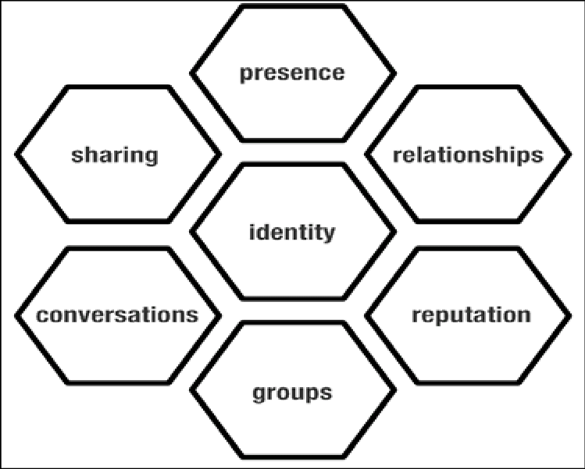
Figure 1: Honeycomb model. Source: (Ronquillo et al., 2019)
A conceptual framework used in network defence and information security initiatives is called the Honeycomb Model (Zhang et al., 2020). It divides security measures into seven interconnected levels, each representing a distinct facet of security and having the form of a honeycomb. Physical security, employee security, operational security, communication security, network security, computer security, and information security are examples of these levels. The Honeycomb Model's benefit is in its comprehensive approach, which makes sure that many aspects of security are covered in detail. Its intricacy is a drawback, too, since it is difficult for smaller organisations to implement and manage properly without significant resources and knowledge. For example, Lyst has been found to be implementing the mentioned model with the intention of maintaining their brand image with the help of social platforms. In addition to this, it can be stated that the company can develop a platform that provide the opportunity to the people to connect through online meetings, emails and phone calls thereby developing the social media image. This implies an understanding that the honeycomb model can be thereby stated to manage the relationships between networks that improve the social media engagement. However, concerning disadvantages, it can be said that this model is found to be expensive for organisations and it needs a system of quality control (Wang, 2019).
RACE Model
Race Model is a marketing strategy that asissts organisations in developing a public relations plan increase their investment returns and improve the overall brand image in the market.Smart Insights created the RACE model (Reach, Act, Convert, Engage) as a framework to assist companies in developing and implementing their digital marketing campaigns (Chaffey and Smith, 2022). The RACE model offers institutions an organised method for influencing the purchasing decisions of university students. Universities might determine whether students choose their school by efficiently reaching out to them, assisting them in making decisions, and keeping their interest.
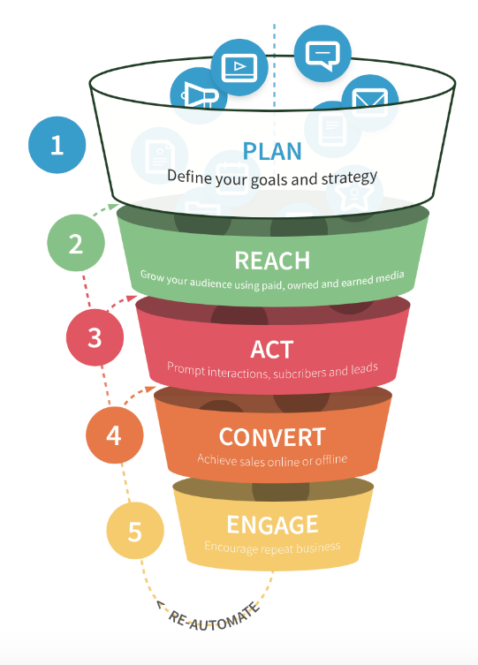
Figure 2: RACE model. Source: (Chaffey and Smith, 2022)
According to the RACE Model, "Reach" refers to drawing in a large audience, "Act" urges people to do a certain action, "Convert" attempts to convert leads into customers, and "Engage" promotes continued interactions with clients. The RACE Model's benefit is its crystal-clear structure, which aids organisations in methodically planning and carrying out digital marketing initiatives. As emerged, the Race model can be effectively used by Lyst in the current business scenario. It can make an approach to the target customers with a lucrative offer. In the next stage, by fulfulling the requirement of the customers, the company can be potentially capable of coverting the customer for full time thereby increasing customer loyalty and engage them with the platform with the inclusion of new contents (Sestino et al., 2021). In this context, it can be mentioned that the concerned model is effective enough in driving the customer engagement levels of the organisations through the social media platforms. However, it oversimplifies the intricacies of consumer behaviour and market dynamics, and its efficacy depends on how well the data are collected and how well the system can adjust to shifting patterns.Only provide examples of Lyst in relation to the Race model.
Comparison
Similarities | Differences
- The RACE and Honeycomb models both offer systematic methods for comprehending and putting into practice digital marketing strategy (Chaffey and Ellis-Chadwick, 2019).  - Both models stress how crucial it is to comprehend and interact with the consumer.  - Both models acknowledge the value of establishing and sustaining connections with stakeholders or consumers (Zhang et al., 2020). | - The digital marketing funnel is the main emphasis of the RACE model (Chaffey and Ellis-Chadwick, 2019). With an emphasis on conversion, it offers a step-by-step manual for guiding prospects through this funnel.  - The Honeycomb model emphasises seven components or elements of digital marketing interaction for a more comprehensive perspective (Zhang et al., 2020). It offers a more comprehensive viewpoint on the different ways that businesses interact with their audience.

2.6 Literature gap
Despite the notable success of fashion startups in the UK using digital marketing techniques to build brand awareness and encourage customer engagement, there is a gap in the body of knowledge regarding the particular opportunities and challenges they face with regard to data analytics and marketing channel diversification. More precisely, an in-depth study on how entrepreneurs may utilise data analytics to efficiently get deeper insights into customer behaviour and preferences is lacking, despite the fact that current research emphasises the efficacy of social media, user-generated content, and personalised email advertising. Likewise, the scarcity of studies examining how virtual reality technology interacts with consumer decision-making procedures when it comes to buying luxury goods may represent a gap in the literature. In addition, methods and best practices for extending the use of marketing channels beyond the most common tools, social media, and influencer marketing in general, are not empirically well explored in the literature currently in existence. Another important gap in the literature arises from the fact that the existing study on the effects of digital marketing tactics on the behaviour of UK university students may be lacking in thorough long-term insights, and its concentration on certain platforms or trends may make it difficult to gain a comprehensive picture of changing consumer preferences and behaviours among today's young adults or university goers. Hence, for fashion startups to maximise their potential for sustainable growth in the highly competitive fashion industry and to establish their status as leaders in the digital era, it is essential that they comprehend these factors.

2.7 Summary
Fashion start-ups in the UK have had great success engaging consumers and building their brands using the effective application of digital marketing. User-generated content, social media, and targeted email marketing campaigns have all been expertly combined by these firms to increase their visibility. However, there is still room for development, notably in data analytics and broadening the marketing mix, which would further bolster their status as leading UK-based fashion entrepreneurs in the digital era. Moreover, the literature discussion also reveals that these firms may benefit from social media, influencer marketing, data analytics, and personalisation to increase brand recognition and engage their target audience even while they deal with obstacles such as tight budgets, fierce competition, and rapidly changing technology. It is essential to emphasise a critical approach to digital marketing that highlights innovation, data security, and agility if a firm wants to stay competitive in the ever evolving fashion industry. Henceforth, it can be deduced from the discussion that fashion startups situated in the UK may optimise their digital marketing strategies and succeed in the digital world by being aware of and responding to these possibilities and difficulties.
The fashion e-commerce site Lyst is a notable illustration of the profound influence that digital marketing strategies have on customer behaviour among university goers in the UK. Two key strategic models such as influencer marketing and social media interaction, are specifically mentioned in the literature, along with their advantages and disadvantages. Apart from that, more vital digital marketing strategies such as using individualised interactions, mobile commerce optimisation, content marketing, and smart remarketing, are mentioned, with the help of which this company has successfully changed preferences among the students, increased their purchase intent, and promoted brand loyalty. Moreover, this brand has established itself as a dominant force in the fashion e-commerce industry by implementing innovative and creative digital marketing methods. This has helped the company build stronger relationships with the students and promote long-term company success.
In order to examine the influence of Lyst's digital marketing strategies on the choices of university students, this literature review suggests four theoretical frameworks that are directly applicable to the topic of research. For analysing user perceptions of the firm's digital platform and customisation initiatives, the company uses the Technology Acceptance Model (TAM). In contrast, Social Identity Theory is used to investigate how user-generated information and influencers affect how consumers see themselves and their social identities. Apart from these two, understanding the phases of customers' decision-making processes impacted by Lyst's marketing methods required the use of both the Consumer Decision Process Model and the Consumer Behaviour Theory. Henceforth, it can be extracted from the comprehension of the overall discussion that these frameworks may be used by academics to develop a thorough understanding of the underlying dynamics of consumer behaviour in reaction to Lyst's digital marketing endeavours. This knowledge can be extremely helpful for other fashion startups looking to improve their digital strategy.

Chapter 3: Research Methodology

3.1 Introduction
The thorough step-by-step procedures selected for carrying out this research are described in detail for the readers in this chapter. The systematic approach and methods that researchers use to carry out studies, collect data, analyse information, and come to findings in a structured and organised manner are referred to as research methodology (Davidavičienė, 2018).The research onion serves as the primary guidance for the research approach. The research philosophy, research methodology, research design, the approach to research, research choices, and the techniques for gathering and analysing data are the major layers of this research onion. All the previously mentioned phases are methodically explored in this chapter, and the appropriate choices for this study subject are justified as a result. An overview of the whole chapter and a discussion of crucial ethical issues to keep in mind when this study is conducted are provided in the summary.
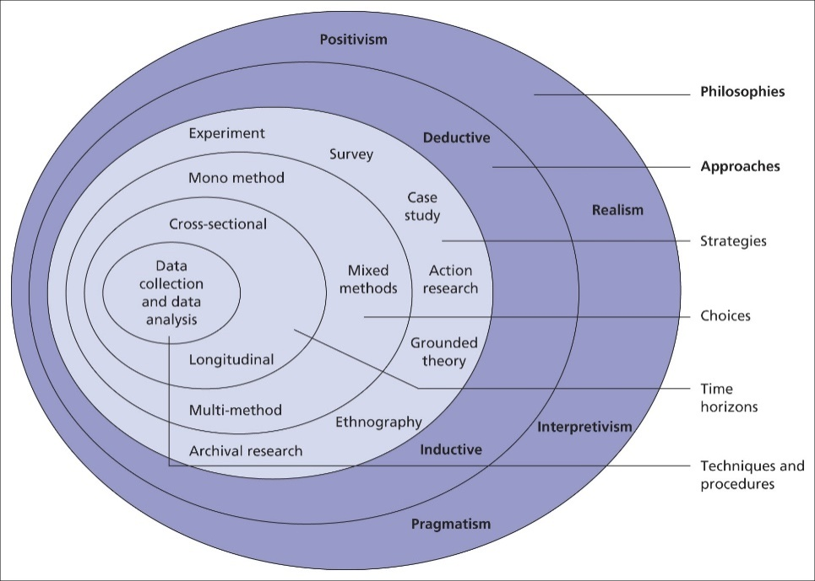
Figure 3: Research onion. Source: (Saunders et al., 2019)

3.2 Purpose of the study
The major emphasis of the study's research purpose is the achievement of the objectives that the researcher put forth in the first chapter. The goal of the study is to advance the field of study now under consideration utilising technology ideas, thoughts, and concepts (Melnikovas, 2018). One of the goals of the study will be to help the researcher define the research issue and fully understand the findings so that the study can be completed properly and on schedule. The study examines the justification for the study's design and how the data it yielded would help the researcher describe the kind of study that was carried out.The main objective of this study is to evaluate the impact that digital marketing strategies have on consumer behaviour among university students in the UK, both across Lyst and other well-known fashion startups in the nation.
The Research Onion Model is a thorough framework for research methodology that directs the planning and execution of research undertakings (Saunders et al., 2019). It is made up of several layers, each of which represents a particular step in the research process and resembles the layers of an onion. Philosophical views like positivism and interpretivism are among the outer layers that influence the overall research methodology. It includes research approaches, options for data-gathering methods, sample tactics, and procedures for data processing. With this methodology, researchers are encouraged to approach these levels methodically, beginning with their philosophical foundations and gradually refining their research design. It ensures that research initiatives are methodologically sound, conceptually sound, and well-structured.

3.3 Research Philosophy
The several research philosophies that are presented in Saunders' Research Onion enhance the research process.The collection of premises that serve as a framework for the study and provide the researcher direction is referred to as research philosophy in the methodology portion of the paper (Saunders et al., 2019). The research philosophy is the term used by academics to refer to the collection of rules that fundamentally outline how the data for the current study is gathered and evaluated. Realism looks for underlying truths, whereas positivism places more emphasis on quantitative results and empirical evidence. In order to solve problems effectively, pragmatism combines a variety of methodologies with interpretivism to move through subjective understanding. Nonetheless, the depth of the study, the methodology, and the views are all improved by this outermost yet core layer of the research onion.
Positivism is a research philosophy that emphasises the use of measures and measurable elements while the researcher collects data from a neutral viewpoint. As a result, this study takes positivism as its guiding philosophy in accordance with the research questions. According to positivism, knowledge is derived through actual observations and scientific methods, emphasising objectivity, careful data collection, and quantitative analysis to reveal underlying patterns or principles (Park et al., 2020). Moreover, the study investigates observable phenomena and causal relationships between digital marketing practices and customer behaviour within this framework. The goal of this research strategy is to use organised scientific methods to provide reliable and impartial results. Likewise, the research seeks to offer insightful information on the influence of digital marketing on customer preferences within Lyst's market by adopting a rigorous approach incorporating primary and secondary data. The combination of secondary research and survey data improves the result's validity and reliability, adding to the body of information pertaining to online marketing and customer behaviour in the fashion industry. Henceforth, this chosen research philosophy absolutely aligns with the entire research plan.

3.4 Research Approach
As it presents a compelling case for data collection and a thorough explanation of how it will be accomplished, the study's research approach is typically regarded as crucial (Woiceshyn and Daellenbach, 2018). Deductive, inductive, and abductive research approaches are located on the second-last outer layers of the research onion model, and collectively they make up a range of methodological options (Melnikovas, 2018). Starting with broad ideas and examining hypotheses in specific circumstances, the deductive approach examines general propositions. In contrast, the inductive approach starts with specific observations and leads to the distillation of general models or ideas. The abductive approach, meanwhile, focuses on figuring out the best way to explain observed occurrences. Notably, these methodological paths provide value to the research project by providing a variety of avenues for the collection, study, and interpretation of data, which in turn increases the scope and depth of an academic inquiry. Importantly, the deductive approach is therefore the recommended research approach for the current investigation since it is suitable for assessing particular hypotheses based on accepted ideas and prior research (Woiceshyn and Daellenbach, 2018). Moreover, the statistical program SPSS is prepared to do an inferential analysis, carrying out this deductive research approach goes hand in hand with this analytical method. The inductive approach, in contrast, relies on careful observation to generate broad paradigms, whereas the abductive technique looks for the best feasible explanation for actual events. Therefore, the suitability of the deductive approach in this regard is quite evident. Nevertheless, intellectual pursuit is enhanced by these diverse avenues, which increase the dimension of coverage for a research topic.

3.5Research Strategies
The procedure by which the researcher is able to choose the strategy that helps with the timely completion of the research is known as the research design of the study (Iovino and Tsitsianis, 2020). The research design's implications also assist in the interpretation of high-quality data, enabling the researcher to evaluate supporting data and finish the study. The research design of the study is built upon the approach used to incorporate the instruments and steps necessary for the investigation. Exploratory, descriptive, and explanatory research designs are the three main categories. The research design layer of the research onion includes descriptive research design, which describes subject traits and trends without examining causation, exploratory research design, which delves into unexplored areas to develop hypotheses, and explanatory research, which is focused on revealing causal links within accepted theories (Iovino and Tsitsianis, 2020). Thus, these three types of research designs enrich the methodological depth of the study.
On this note, it is important to note that a realistic depiction of Lyst's digital marketing strategies and how they affect customer behaviour is achieved for this study through the use of a descriptive research design. This enables a thorough study of the research topics, concentrating on the presentation and analysis of phenomena rather than causal links. It does this by utilising quantitative data from surveys and even broader data insights from secondary sources of study (Nardi, 2018). Furthermore, this design effectively summarises and interprets the data that has been collected using methods such as surveys, observations, and existing sources, supported by strategies involving statistical analysis and content analysis. This broadens the scope of the research to embrace online marketing and consumer behaviour within the context of Lyst's fashion business.

3.6 Research Choices
This research on the UK-based fashion company Lyst should employ a combination of quantitative research choices because of their ability to produce complete insights when used to examine the effects of digital marketing practices on customer behaviour. A mono method has been chosen for this study. Broader sample sizes are frequently used in quantitative research, which enhances the generalizability of results to a broader population (Davidavičienė, 2018). This is especially helpful for drawing conclusions about more general patterns or populations. Rigid statistical analysis is performed on quantitative data, allowing the researcher to find patterns, connections, and correlations between variables. However, the depth and richness of data that qualitative research offers are lacking in quantitative studies. The complexity of human behaviour and experiences is not well captured. Quantitative research is regimented, making it unsuitable for developing hypotheses or investigating novel, unexpected events.
Moreover, the study makes use of well-known theories and earlier research to carefully examine certain hypotheses, and it also makes use of statistical tools like SPSS for inferential analysis (Mertleret al., 2021). With the use of a methodical framework, this methodology offers the opportunity for empirical data analysis and observation. Most importantly, the correct blend of quantitative survey data and secondary research insights is used to accurately represent Lyst's digital marketing practices and their impact on customer tastes. Moreover, the descriptive research design was chosen to match the quantitative character of the original study (Basias and Pollalis, 2018). Notably, this method works well for exposing patterns and traits without getting too deep into cause-and-effect interactions. The positivism research school of thought supports the methodological decision by emphasising empirical observations, quantitative analysis, and objectivity, which is in line with the study's goal of identifying causal links between the field of digital marketing and consumer behaviour. This research approach is well-positioned to produce trustworthy and impartial findings that add to the body of knowledge already present in the interconnected areas of digital marketing, consumer preferences, and the fashion industry. Hence, it is vividly clear that the research must be supported by quantitative research choices for both primary survey data and secondary study data.
One benefit of quantitative research is its capacity to produce numerical data that can be objectively and quickly statistically analysed. This information frequently makes it possible to generalise to broader groups, improving the external validity of findings. It is effective in finding patterns and correlations in huge datasets and testing hypotheses. Quantitative research does have drawbacks, though. It understates complicated events while ignoring valuable contextual data (Nikpour, 2017). Common quantitative techniques like surveys and experiments might be prone to respondent bias or lack ecological validity. In-depth comprehension of participant viewpoints or examination of unexpected factors might be constrained by the rigid framework of quantitative research, necessitating additional qualitative research for a comprehensive perspective.
Primary data are real facts that were obtained for a specific study directly from the source (Iovino and Tsitsianis, 2020). This data is directly gathered by the researcher, who then modifies it to fit the needs of the study. Primary data that has been gathered directly from sources has benefits like high relevance and accuracy to a certain research subject. It gives researchers control over data gathering techniques, enabling customisation, and guaranteeing it satisfies the study's goals. However, gathering it takes time and money, and if not done carefully, there is a chance of bias. In this research, the selection of the primary data has assisted the researcher in conducting the survey as real facts from human participants have been gathered. Secondary data is information that has been obtained, examined, and published by writers for purposes other than the current research or study. Secondary data that is gathered from already-existing sources saves money and time. It gives access to vast datasets and historical context and helps in the development of the discussion of the literature review. However, it could not precisely match the needs of the research, resulting in limits in relevance or accuracy. Researchers have less control over the accuracy, collecting procedures, and other biases in the original source of the data. Therefore, the decision between primary and secondary data depends on the goals of the research and the resources that are accessible.

3.7 Time horizon
Epidemiology, the social sciences, and market research are just a few examples of the many disciplines that employ a time horizon as a form of research methodology. The study used a cross-sectional methodology, in which information is gathered from a sample or population at one moment in time or over a brief period of time. The cross-sectional technique used in this study provides a snapshot of the population or sample at a particular time, as opposed to longitudinal studies, which entail data gathering at many time periods to examine changes over time.

3.8 Data Collection and Sampling Method
The process of selecting a subset or a representative piece of a larger population or dataset is known as sampling in statistics and research methodology. Sampling is used to acquire data, infer things about the population, or come to conclusions about it based on the traits shown in the chosen sample. The sample size for this study is 50. 50 people were participated in this study for conducting the survey. In a research or data analysis environment, sample type refers to the category or categorization of a sample (Schermann et al., 2018). Subsets of a broader population or dataset are called samples and are chosen for research or analysis. The study aims and the type of data being gathered both influence the sample types in a significant way. Every person or thing in a population has an equal probability of being chosen for inclusion in a sample when using the random sampling technique in research. By ensuring that the sample is representative of the entire population, this method reduces the likelihood of bias and enables the generalisation of results.
Random sampling has several benefits, including being unbiased and fair, lowering the possibility of researcher bias, and improving the external validity of study results (Davidavičienė, 2018). However, its drawbacks include practical difficulties in putting it into practice, particularly in large or difficult-to-reach populations, and the potential for some people or things to be overlooked by accident, lowering the sample's comprehensiveness. A survey with 10 closed-ended questions on digital marketing strategies taken up by the company and how users perceive how they affect consumer behaviour has been used to collect primary data. To make it easy for participants to participate and to collect data quickly to ease the research process, this questionnaire has been made available online.
Data collection is one of the most important components, and it is included in the methodology chapter since it discusses the methods for getting data from various sources (Nikpour, 2017). The two basic categories of sources used to obtain data are primary data and secondary data. This research opts for a survey to collect primary data for proceeding with the research. Primary data is defined as authentic information that was gathered directly from the source for a particular study (Basias and Pollalis, 2018). The researcher collects this information directly and it is adjusted to meet the objectives of the study. One approach for gathering primary data is through surveying. The researcher used a survey in this study to create a collection of questions or structured prompts to get data and views from participants.
Due to the fact that managers and workers at Lyst have a thorough awareness of the company's digital marketing tactics and how they affect customer behaviour, they in particular have been targeted for the data gathering process using a random sampling method. 50 people participated in this study to provide a representative sample. Besides, in order to give a more comprehensive background for understanding digital marketing practices within the fashion sector and their effects on consumer behaviour, secondary research has also been carried out. Data that has been gathered, analysed, and published by authors for purposes other than the present research or inquiry is referred to as secondary data. Secondary data has been used in the literature portion of the study. This research has drawn from a variety of sources, such as journal articles, books, and news reports for collecting secondary data.
The decision between primary and secondary research relies on the study's objectives and available resources. Both methods have advantages and limitations. Primary research produces unique data that is suited to the specific study objectives and offers a distinctive viewpoint on the subject (Basias and Pollalis, 2018). Primary research yields data that is directly related to the study topic and goals, assuring high relevance. However, compared to using already available secondary data, undertaking primary research is costly as well as time-consuming. Since existing data sources are easily accessible, secondary research is frequently more affordable than primary research (Davidavičienė, 2018). It saves time since current data is analysed right away rather than requiring researchers to gather new data. However, secondary data might be of varying quality and accuracy, and researchers have little influence over the data-gathering procedure. The ability to answer research questions is limited since the available facts do not perfectly match the specific study objectives.

3.9 Data Analysis Method
In order to arrive at conclusions that are essential to the study's goals and research objectives, the data is exposed to logical and analytical reasoning, as well as data analysis techniques (Nikpour, 2017). After data has been collected, a dual strategy involving descriptive and inferential statistical analysis has been used for thorough evaluation. The thorough summary and interpretation of survey results have been part of the descriptive analysis, which also makes use of a variety of metrics, including frequencies, percentages, and averages. Moreover, this aspect of the analysis must shed light on Lyst's adopted digital marketing tactics and their apparent impact on consumer behaviour. Furthermore, research-derived hypotheses have been examined in parallel with inferential analysis. With the use of statistical techniques, this approach employs rigorous hypothesis testing to provide deeper insights and support findings (Schermann et al., 2018).
Data patterns were examined throughout the research process to find important information that helped to successfully complete the study. The survey respondents' opinions on the questions were carefully examined. The responses were then subjected to descriptive and inferential analysis using the SPSS software in order to support the survey respondents' perspectives.Thus, by combining these many methods, it is possible to gain a thorough understanding of the complex interactions that digital marketing strategies have with customer behaviour in the context of Lyst and the dynamics of the fashion sector. In addition to that, the value of this study is greatly increased by the use of this SPSS statistical tool, which also makes it simpler to do both descriptive and inferential analysis.

3.10 Ethical Considerations
The behaviour of researchers and the planning of their studies are underpinned by a well-established set of guidelines and regulations known as ethical concerns in research (Luu, 2017). The implementation of the study was done in compliance with moral standards. The inclusion of ethical issues as a prominent part of this study was made possible by adherence to academic institution guidelines and more general qualitative research standards. The uttermost ethical requirements for this study are to uphold the highest level of integrity and to protect participants' rights and welfare. The research carefully abides by the fundamental rules to ensure ethical behaviour. Moreover, participant information on the purpose, methods, and possible dangers of the research has been thoroughly provided in order to get informed consent. Likewise, prior to involvement, obtaining informed consent and emphasising voluntary participation have been prioritised.
The use of actual people in this study has raised concerns that it may have been very unethical. The study's purpose, goals, and objectives, as well as its data management procedure and other information, have all been explained to all survey participants in advance. A participant in the survey was not forced to take part in the study either physically or psychologically. The researcher treated each subject fairly, gave them all the benefit of the doubt, and respected their right to privacy. Furthermore, by carefully removing or making identifiable information anonymous, the privacy and anonymity of participants have been protected. Notably, taking data protection steps ensures that information is stored securely and that only authorised researchers have access to it. Participants are allowed to stop participating at any time without facing any consequences, which promotes non-coercion and voluntary participation (Luu, 2017).
The research has been conducted with a foundation of respect, minimising any pain and appreciating participants' well-being. The study was ethically conducted without seeking any participants' personal information, and it did not contain any incorrect information. To prevent plagiarism, the researcher correctly cited all secondary sources used in the study's literature section. The references to secondary sources in the literature section are correct, valid, and contain the correct DOI and ISBN numbers. In addition to that, the researcher promises that all data will be erased after publication and institutional approval. For the sake of this study's ethical considerations, participants have given their informed permission. They are also provided with a withdrawal option and have their responses kept secret. Clearly, the study respects participants' rights, upholds the integrity of the research, and guarantees the accuracy of its results by rigidly following these ethical guidelines.

3.11 Summary
The methodologies and how well they applied to the study were described in the section on research methodology. Along with a deductive research approach and a descriptive research design, the researcher used positivism as their research philosophy. The researcher additionally focused on data collection and analysis in order to conduct the study and get results that helped advance the study's topic. The examination of the effects of digital marketing strategies on consumer behaviour among UK university students was the main topic of the discussion of a detailed study methodology. The layers of methodology that the inquiry was directed by were underlined by Saunders' framework for the research onion. This section presents a thorough defence of the selected research philosophy, research approach, and research design.It was determined that using positivism and a deductive approach, together with surveys as the primary source of data, was appropriate. Through the use of a descriptive research design, deeper causal insights were presented. Along with this, ethical concerns highlighted the importance of permission, confidentiality, cultural sensitivity, and openness. In addition, the descriptive and inferential analyses carried out with SPSS software provided beneficial outcomes. This thorough and organised technique ensures rigorous research with practical applications.

Chapter 4: Analysis of data

4.1 Introduction
Data analysis is one of the significant stages in the research process that provides a scope to the researcher to understand the topic of the research. In addition, it is the stage where the researchers obtain data from the chosen research sources that reflects the current or actual scenario related to the research reflecting the dependence on relevant information. In this context, the current chapter of the research has analysed the data obtained in a detailed manner with the help of quantitative methods as the data has been gathered with the help of surveys. Descriptive or graphical analysis has been integrated where the responses of the participants have been evaluated with the depiction of the graphs. Furthermore, inferential analysis has also been incorporated that has further validated the responses of the participants and improved the authenticity of this study. However, a discussion of the primary and the secondary data findings has been incorporated which as well has further developed the connection between major findings of this research.

4.2 Survey graphical analysis
Question 1: For how long have you been engaged with Lyst as a customer?
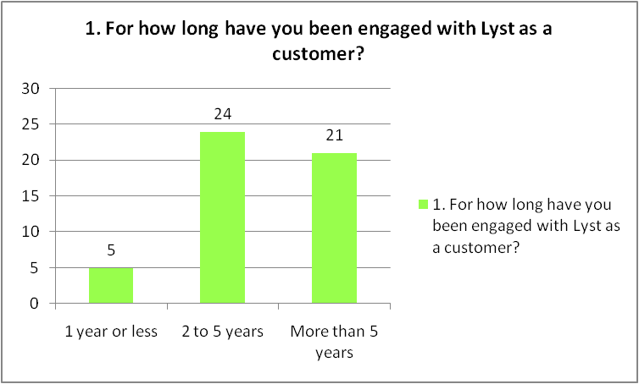
Figure 4: Engagement span with Lyst Company
(Source: Self-created)
As per the responses of the university students, it has been found that the majority of them have been engaged with the company as a customer for 2 to 5 years depicting 24 responses. Furthermore, 21 responses reflected having an engagement of more than 5 years with the company and only 5 students have been found to be engaged with the company for 1 year and less. This implies that a maximum number of university students have been making purchases from the company for a longer time reflecting their positive dependence on the organisation.
Question 2: Do you agree that the digital marketing practices of Lyst have increased the engagement of the customers who are UK university students?
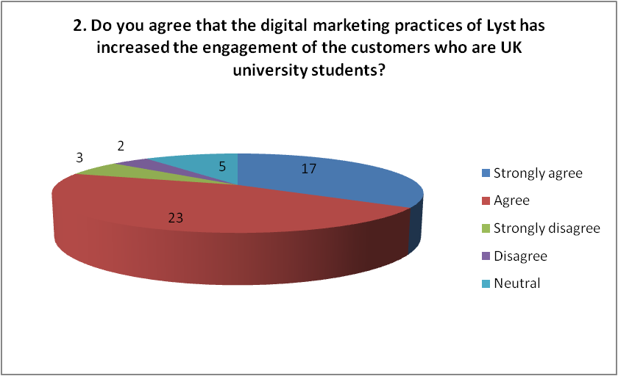
Figure 5: Increase in customer engagement with Lyst for digital marketing
(Source: Self-created)
From this specific question onwards, the students have been provided with “five-point scale questions” which are also known as “likert scale questions”. The employees have been provided with five choices or options reflecting “Strongly agree, agree, neutral, strongly disagree and disagree” as showcased in the above figure. Concerning the agreement of the students with respect to the influence of digital marketing practices in increasing their responses or not, it can be stated that the UK university students have been highly driven by the digital marketing practices of the company which further increased their engagement.
Question 3: How far do you agree that direct communication through social media advertising has increased active participation of university students?
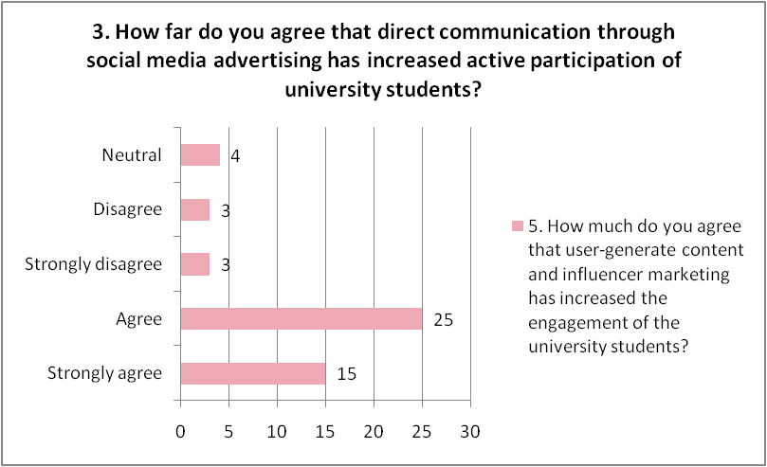
Figure 6: Influence of direct communication through social advertisements on student participation
(Source: Self-created)
In this survey, question regarding whether direct communication has increased the participation of the students from the Universities in the UK have been asked to the employees reflecting the usage of the social platforms. With respect to the positive responses provided by the participants depicting 40 agreement answers, it has been found that the direct communication maintained by the organisation with the help of social media advertisements have potentially helped in increasing the participation of the students. Furthermore, it can be mentioned that the usage of the social platforms such as facebook, twitter and instagram gas been useful for the company as it helped in influencing the university to connect with the company and make purchases.
Question 4: Do you agree that two-way communication channels influenced the university students with the eye-catching visual materials, special deals and outfit ideas?
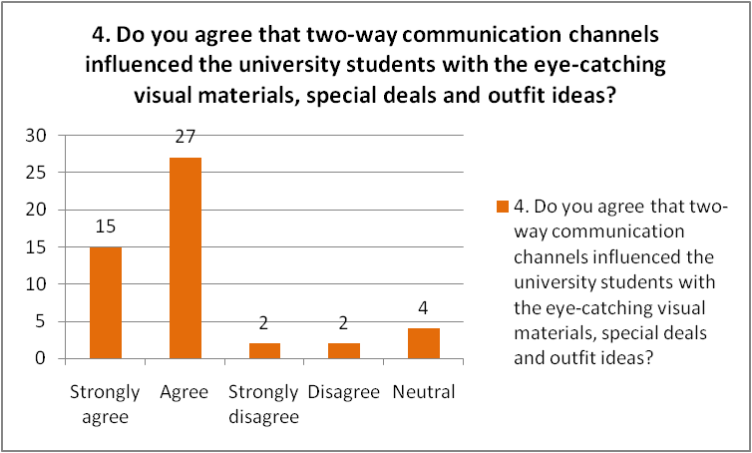
Figure 7: Impact of two-way communication system
(Source: Self-created)
Upon further analysis of the response of the students with respect to whether the two-way communication channels have actually influenced the students with the outfit ideas, eye-catching visual materials and the special deals or not, it has been found that most of the responses have been positive. This explains that the strategy of developing two-way communication with the students has actually been effective in driving the attention of the students and making them engage with the company. However, this practice has helped in positively influencing the consumer behaviour in the market.
Question 5: How much do you agree that user-generated content and influencer marketing has increased the engagement of the university students?
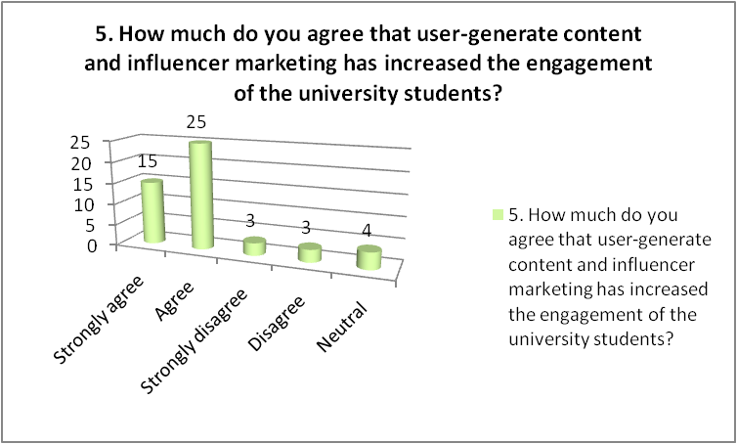
Figure 8: Impact of influencer marketing and user-generated content on student engagement
(Source: Self-created)
The employees have been further asked if they agree with the fact that the user-generated content along with the influencer marketing have increased the involvement of the students of the university or not. Following the positive agreement responses of the participants depicting a total of 40, the survey question implied an understanding that the usage of influencer marketing as well as the development of user-generated content has significantly helped the students in further engaging with the company and making their purchases.
Question 6: Do you think that the introduction of the mobile applications further made it convenient for the students to make purchases?
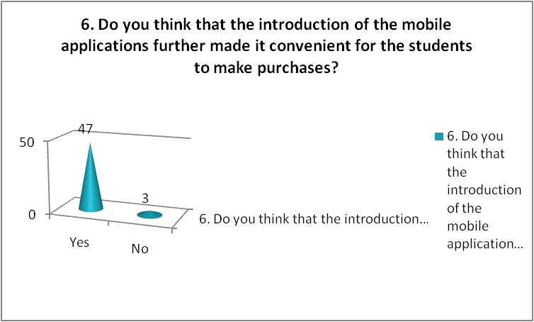
Figure 9: Purchase made through mobile applications
(Source: Self-created)
The students have been further asked if they think that the mobile application introduction has made it convenient for them to make purchases from the company or not. Gaining positive responses from 47 students, it can be stated that it has been easy and convenient for university students to purchase products from the company with the usage of the mobile apps.
Question 7: How far do you agree that mobile apps offers smooth browsing facilities to the students and enhance purchase experience?
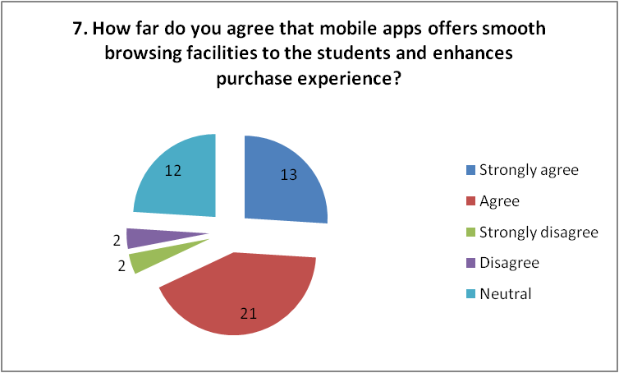
Figure 10: Smooth browsing through mobile apps
(Source: Self-created)
Further, considering the question of mobile application usage, the participants have been asked if they agree with the fact that mobile applications of the company has enabled the students to browse products in a smooth way that furtehr influenced their purchase experience or not. In this respect, considering tha majority of the responses, it can be stated that smooth browsing of the products offered by the organisation has significantly helped the students in making purchases by making specific choices and has improved their shopping experience. Thus, it can be stated that inclusion of mobile applications has been beneficial for the company.
Question 8: How far do you agree that personalisation strategy used by the company as per each user's interest through emails and SEO has increased customer purchases?
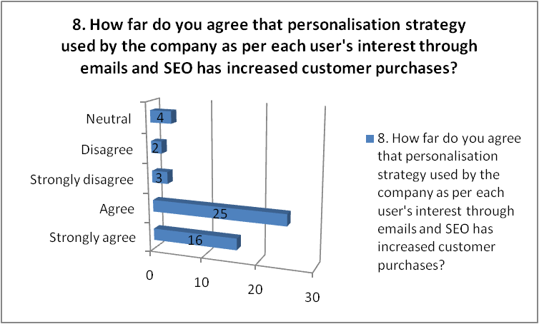
Figure 11: Influence of personalisation strategy
(Source: Self-created)
Referring to the other likert scale question, the students have been asked regarding their agreement with the question if the personalisation strategy has increase the purchases of them or not reflecting the effectiveness of SEO marketing and content customisation as per user’s interest or not. In this respect, considering the positive responses of the students of university depicting most of the agreement responses of 41, it can be stated that the customised or personalisation strategy where the organisation sends emails to the customer as per their choice has also helped in increasing the positive engagement of the customers.
Question 9: Do you agree that tailored advertisements through web platforms make it easy for the students to make purchases?
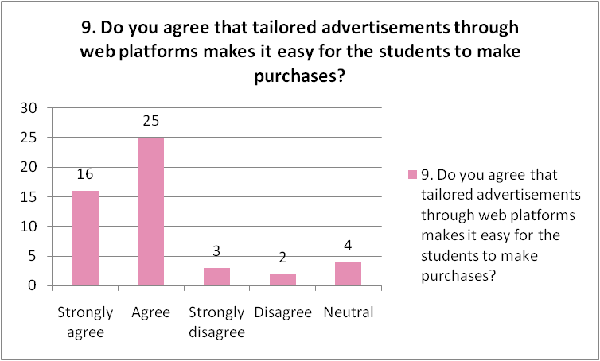
Figure 12: Tailored advertisements
(Source: Self-created)
Upon further questionning, the students hve been asked if the tailored advertisments made by the company with the help of the web platforms have helped them in making purchases in an easier manner or not. In this context, going by the responses, it has been evident that a maximum number of students have provided positive responses reflecting a total of 41 responses. This indicates an understanding that the tailored ads given by the company through social platforms have significantly made the purchase process easy for the students. However, it proves that the digital marketing strategies adopted by the concerned organisation have been effective in influencing the purchase habits of the students.
Question 10: How far do you agree that creation of interesting and captative narrations of fashion trends influence purchases of the students?
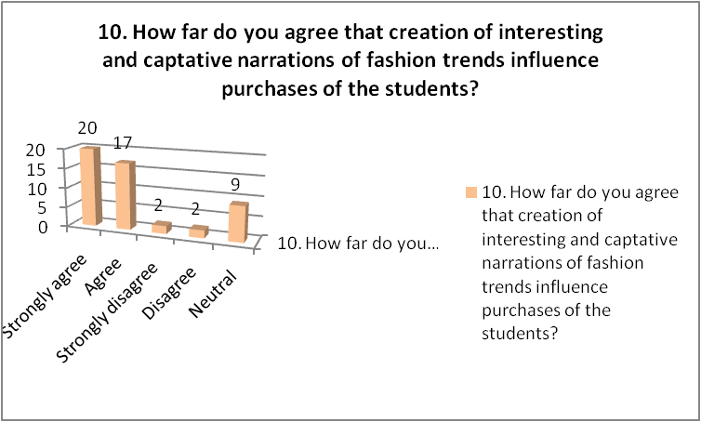
Figure 13: Influencing purchases through interesting narrations
(Source: Self-created)
With reference to the final question, based on the responses provided by the students, it hass been found that the captivating and interesting narrations that the organisation provided to the customers regarding the celebrity styles and future fashion designs have positievely helped in changing the purchase behaviour of the customers. In short, it has influenced the customers in making purchases from the company reflecting the effectiveness of the digital marketing approaches.

4.3 Survey inferential analysis
Results for the research have been also derived with the help of the inferential analysis which has further validated the responses given by the employees. Tests such as correlation and regression have been included which has helped in gaining better understanding regarding the phenomenon or the variables of the study. The scientifically developed models have potentially helped in understanding the effectiveness of the digital marketing practices of Lyst in driving the attention and engagement of the students from the UK University.
Correlation
This particular test has been developed in this study which has evaluated the bond between the “dependent and independent variable”. It has further assimilated the magnitude that the variables share with each other thereby considering more than one variable. It reflects on the patterns incorporated within a dataset thereby addressing the relationships formed between the elements included in it. Concerning the current study, this test has analysed the association amongst the variables. It has also evaluated whether the variables linearly covary with each other or not.
“Correlations
 |  | Increasein engagement ofuniversitystudent | Directcommunicationthroughsocialmedia | Twowaycommunicationchannels | Influencermarketingandusergeneratecontent | Personalisationstrategy
Increasein engagement ofuniversitystudent | Pearson Correlation | 1 | .992** | .984** | .987** | .995**
Increasein engagement ofuniversitystudent | Sig. (2-tailed) |  | .001 | .002 | .002 | .000
Increasein engagement ofuniversitystudent | N | 5 | 5 | 5 | 5 | 5
Directcommunicationthroughsocialmedia | Pearson Correlation | .992** | 1 | .996** | .998** | .998**
Directcommunicationthroughsocialmedia | Sig. (2-tailed) | .001 |  | .000 | .000 | .000
Directcommunicationthroughsocialmedia | N | 5 | 5 | 5 | 5 | 5
Twowaycommunicationchannels | Pearson Correlation | .984** | .996** | 1 | .999** | .996**
Twowaycommunicationchannels | Sig. (2-tailed) | .002 | .000 |  | .000 | .000
Twowaycommunicationchannels | N | 5 | 5 | 5 | 5 | 5
Influencermarketingandusergeneratecontent | Pearson Correlation | .987** | .998** | .999** | 1 | .998**
Influencermarketingandusergeneratecontent | Sig. (2-tailed) | .002 | .000 | .000 |  | .000
Influencermarketingandusergeneratecontent | N | 5 | 5 | 5 | 5 | 5
Personalisationstrategy | Pearson Correlation | .995** | .998** | .996** | .998** | 1
Personalisationstrategy | Sig. (2-tailed) | .000 | .000 | .000 | .000
Personalisationstrategy | N | 5 | 5 | 5 | 5 | 5
**. Correlation is significant at the 0.01 level (2-tailed)”.
“Table 1: Result of correlation”
(Source: Self-created)
In the above table, correlation of “pearson’s bivariate” has been developed which has reflected on the bond shared by the variables of the study. In this case, the “dependent variable” chosen has been the “increase in the engagement level of the University students” and the ‘independent variables” which links with the dependent one is “personalisation strategy, user-generated content and influencer marketing, two-way communication channels, direct communication with social advertisement”. The evaluation of the bond has been identified with the help of the “significance level” which has been showcased with the “Sig (2-tailed)” column. For the concerned study, the total number of observations has been 5 as denoted by N. Any value of the variable higher than .005 has been acknowledged as “statistically significant”.
Regarding the present test results, it has emerged from table 1 that the “independent variables” have been significant with the depiction of the values less than the criterion value. As reflected, the values of the variables such as “direct communication through social media, personalisation strategy, two-way communication systes and influencer marketing and user-generated content” have been .001, .000, .002 and .002 respectively. This depicts that the variable in the table has a lower value than 5% or .005 and hence can be termed to be “statistically significant”. Based on this result, it can be further stated that the “independent variables” of the dataset shares a linear bond with the “dependent variable”.
In addition to this, focusing on the values of the variables, it has been found that the numbers have been potentially lower than 5% which signifies the high magnitude of the variables. This indicates that the digital marketing practices or strategies that Lyst has incorporated has significantly benefited the company in driving the attention of the young customers who happened to be the students of the University in the UK as well as increasing their engagement with the same. The result of this model has further provided help for the development of the regression model.
Regression
Regression can be stated to be an advanced level of statistical model that happens to test the bon between variables thereby considering two or more variables. This test provides an opportunity to the researcher to explain, predict and measure the bond between the chosen variable sets. It has further helped in the development of the general conclusion based on the results. It has evaluated if the considered variable interdependent as well the percentage to which the “dependent variable” is predicted by the other group. In this respect, the regression analysis has been incorprated considering the variables of “personalisation strategy, influencer marketing and user-content generation and direct communication with social media platforms”.

“Model Summary
Model | R | R Square | Adjusted R Square | Std. Error of the Estimate
1 | 1.000ª | 1.000 | .999 | .22822
a. Predictors: (Constant), Influencermarketingandusergeneratecontent, Personalisationstrategy, Directcommunicationthroughsocialmedia”
“Table 2: Summary result of regression model”
(Source: Self-created)
With reference to the current study, a linear regression model has been carried out as the correlation results proved of linear bond between the variables of the dataset. “A multiple linear regression” has been developed which has assessed the quality of prediction outcome related with the “dependent variable” As depicted in table 2, “R column” is considered to be the ‘multiple coefficient correlation” of the model, which is the measurement for the “prediction quality of the dependent variable of the dataset”. For this particular study, the value has been found to be 1.000 which depicts 100% prediction outcome of the “dependent variable”. On the other hand, the “R square column” has also reflected a value of 1.000 or 100%, which is the variance proportion in the “dependent variable” and defined or explained by the “independent variable”. Thus, in an overall basis, it can be stated that the engagement of the University students have been highly predicted by the chosen factors which are the digital marketing strategies of Lyst.
“ANOVAª
Model |  | Sum of Squares | df | Mean Square | F | Sig.
1 | Regression | 355.948 | 3 | 118.649 | 2278.067 | .015^{b}
1 | Residual | .052 | 1 | .052
1 | Total | 356.000 | 4
a. Dependent Variable: Increaseinengagementofuniversitystudent
b. Predictors: (Constant), Influencermarketingandusergeneratecontent, Personalisationstrategy, Directcommunicationthroughsocialmedia”
“Table 3: Anova”
(Source: Self-created)
In this model, the analysis regarding the appropriateness of the model to identify the relationship between the variables has been tested. Concerning this criteria, the test of Anova has been included which has not only assessed whether the model has been a perfect fit for the dataset but also its effectiveness in drawing results that reflect positive relationship between the selected variable category of this research. The assessment has been done based on the equation established followed by the F ratio. The equation is represented as “F (3, 1) = 2278.067, p<.0005”. Depending on this ratio or the equation, it has been found that the p value has been .0005 which proves that the model has been a perfect fit for assessing the bond between the variables. Moreover, as showcased in the table 3, the “significance value” has been found to be .015 which is also less than 5%. Thus, the Anova model proved that the variables such as “personalisation strategy, content generation, influencer marketing as well as social media advertisements” have positively influenced the engagement of the University students in the UK.
“Coefficientsª
Model |  | Unstandardized Coefficients |  | Standardised Coefficients | t | Sig. | 95.0% Confidence Interval for B
 |  | B | Std. Error | Beta | t | Sig. | Lower Bound | Upper Bound
1 | (Constant) | 1.354 | .169 |  | 8.021 | .079 | -.791 | 3.499
1 | Directcommunicationthroughsocialmedia | .875 | .194 | .939 | 4.512 | .139 | -1.589 | 3.339
1 | Personalisationstrategy | 1.875 | .194 | 2.012 | 9.668 | .066 | -.589 | 4.339
1 | Influencermarketingandusergeneratecontent | -1.885 | .222 | -1.958 | -8.485 | .075 | -4.709 | .938
a. Dependent Variable: Increaseinengagementofuniversitystudent”
“Table 4: Coefficient results"
(Source: Self-created)
The correlation test has been carried out with the consideration of “95% of confidence level”. This specific test has evaluated whether the valuse of the “unstandardised coefficients” has been equal to zero or not. In this context, the variables are stated to be “significant on a statistical basis”, only when p< .05. Further, the values have been related with the significance levels as well to justify the significance of the same. Additionally, the significance of each variable has been evaluated based on the beta values when the other “independent variables” have been assumed to stay constant. As depicted in table 4, the beta value of “direct communication through social media” has been .875 which can be stated to be a higher value than 0. This implies that the variable has a positive impact on the dependent factor. In this context, the significance value of the same variable has been found to be .139 which is also less than 5%. Therefore, it can be stated that the practice of direct communication maintained by Lyst through the platforms such as Instagram, facebook and twitter has influenced customers in further engagement.
On the other hand, the beta value of personalisation strategy has been higher reflecting 1.875 along with the “significance value” of .066 when the other two variables have been constant. In other words, it can be stated that the “significance value” of this variable has been less compared to the others which reflects higher influence of this strategy or practice on the engagement levels. Furthermore, as per the table, the influencer marketing has been found to depict a negative beta value, however, a lower “significance value” of .075. This explains that out of all the variables, it has been the customisation practice of the company through the mobile applications which has potentially drawn the attention of the students from the UK universities. Moreover, based on the result and the learnings, it can also be stated that social media engagement of the company has also influenced as with an increase in the same, the customer engagement has also increased. However, the customer involvement has been comparatively less with respect to influencer marketing compared to the customisation strategy.

4.4 Discussion
The responses provided by the students from the universities of UK have reflected on an understanding that there has been a positive impact of the digital marketing strategies and practices of the company and the engagement of the students with the company for making purchases. It has been further observed that the students have been engaged with the company for a longer period of time depicting the potential of the organisation in retaining customers and increasing the customer loyalty levels. The responses provided by the students have reflected on an understanding that the digital transformation of Lyst has significantly increased the level of interaction and engagement of the students reflecting a positive effect of the digital operations on the customer’s mind.
In this area of discussion, it has been noticed that the digital business model followed by the organisation has positively attracted the customers in the UK market depicting the basic dependence on digital marketing. The students stated that the practice of maintaining a direct communication by the company with the usage of the social platforms such as Twitter, Instagram and Facebook have significantly increased the active participation of the students from the universities. In this regard, relating the responses with the opinion made by Chaffey and Ellis-Chadwick (2019), it can be stated that the company has become popular to the customers or the students with the help of these platforms as the students have been majorly active in the social media platforms compared to the other kinds of digital channels. Furthermore, relating the answers of the students stating that the two-way communication system developed by the company through the social platforms has been an additional factor that influenced the participation of the students.
In a broader way, it has been observed that the company has been capable in developing contents that are eye-catching, creative and benefits the needs of the students in the market through the social media platforms. In addition to this, the option of sharing the contents and showcasing the support or positive response of the customers along with the options of commenting regarding the positives and negatives of the same have further helped in developing communication between the customers and the company which has helped in increasing the customer loyalty and brand image in the competitive market. Furthermore, it has emerged from the responses of the students that the development of the mobile application has been one of the significant strategies that also contributed to the increase in the customer engagement levels.
Connecting with the views of Muhamad and Aryanto (2022), the concerned organisation has matched the expectations of the students in the UK with the introduction of the mobile apps designed in a way that offers smooth browsing and easy purchase system. The convenience of browsing the new products as well as products of personal choice with simple mobile applications has been found to be highly motivating the students to engage with the company. Furthermore, as each and every student has a smartphone, it has been easier for the company to reach to the indoor of every household which has further assisted in increasing the level of participation. It has also contributed to increasing the sales of the company. Also, it can be stated that the tailored advertisments that the company provided to the customers have been found to improve the shopping experiences and benefited the company with increased customer engagement levels.On the other hand, it has been evident from the survey findings that the customisation strategy developed by the brand has been one of the most significant factors that have driven the customer participation in huge numbers.
Considering the views of Kingsnorth (2022) and aligning the same with the responses of the UK students, it can be mentioned that the offerings made by the company with respect to each user’s unique choice and preference and informing them through the content of the websites as well as emails has helped in providing seamless shopping experience to the customers. The personalised fashion recommendations provided by the company to the students have been found to be highly effective in drawing their attention. Moreover, this strategy has potentially assisted the organisation in increasing the purchase level of the students as well thereby positively impacting their purchase habits and decisions. The “influencer marketing as well as the user-generated contents” has also been found to positively impact the engagement. As per the secondary findings, it can be stated that the effectiveness of these strategies or practices has been comparatively less as getting hold of well-known influencers in the market has been expensive.
In this context, following the statistical results of the research as well, it has been found that the mentioned digital marketing practices of the firm has been positively influencing the customer’s level of engagement reflecting the positive bond shared between the digital marketing strategies of Lyst and the engagement of the students. In this respect, based on the regression results, it has been found that although most of the practices have influenced the engagement, yet, it has been the customisation strategy which has mostly motivated the customers to participate with the company and make purchases. Therefore, considering both the findings such as primary and secondary, the research reflects that the student participation or engagement with Lyst has positively changed over time with the development of the digital marketing strategies by the organisation.

4.5 Summary
The chapter of the research summarises the findings from the survey conducted with the students at the UK universities with the help of descriptive and statistical evaluation. The chapter reflects on the understanding that the digital marketing approaches taken by the fashion brand Lyst such as customisation, user-generated contents, mobile applications, two ways communication, direct communication, social media usage, influencer marketing have helped in changing the purchase habits of the students. However, the customisation strategy, mobile applications and the social media advertisement approaches have been found to positively motivate the students to engage with the company for making purchases.

Chapter 5: Conclusion and Recommendations

5.1 Conclusion
The vast array of digital marketing initiatives, including influencer alliances, content strategies, SEO techniques, social media campaigns, and personalised email strategies, have had a significant impact on customers' purchase decisions, brand loyalty, and overall satisfaction in the consumer's buying journey. In the constantly changing business landscape, digital marketing has emerged as a critical role in influencing consumer involvement and purchasing behaviour. The behaviour and perception of university students in the UK have been dramatically changed by Lyst's digital marketing methods. Their robust user-generated content, influencer marketing, and social media presence have increased brand awareness and reach. A mobile-first strategy has enhanced convenience and sales while fostering trust and brand loyalty through content marketing and personalisation. Lyst has become well-known in the fashion business among college students as a result of its extensive digital marketing initiatives.
The organization's use of a digital business strategy has drawn clients in the UK market favourably, demonstrating the fundamental reliance on digital marketing. The company's use of social media platforms like Twitter, Instagram, and Facebook to maintain direct touch with customers, according to the students, has greatly boosted the number of university students who actively participate in the programme. Through the use of social media platforms, the business has proven adept at creating materials that are appealing, original, and helpful to the market's demands for students. In addition, the ability to share content, highlight customer support or positive feedback, as well as the option to comment on both the positives and negatives of the same, have further aided in the development of communication between customers and the business, increasing both customer loyalty and brand image in the competitive marketplace.

5.2 Linking with the objectives
- The digital marketing practices and strategies incorporated by the UK-based fashion startup
Fashion startups in the UK have been actively promoting their wide range of products on social media platforms including Instagram, Facebook, Twitter, and Pinterest. They build relationships with their target audience by disseminating eye-catching visuals and interesting material. Collaborations with fashion influencers have been a popular tactic to benefit from their credibility and increase the reach of their products. By enabling direct purchases using tools such as Instagram Shopping and Facebook Buy, these firms improve the customer experience. As part of their content marketing strategies, they also run active fashion blogs that cover the newest trends, styling advice, and business insights. Delivering quality information on a regular basis aid in the development of authority in the fashion industry. On websites like YouTube and TikTok, video material is used to captivate viewers, such as look books and behind-the-scenes footage.
Startups in the fashion industry understand the value of SEO tactics to increase their websites' exposure in search engine results for relevant fashion-related keywords. In order to establish and maintain strong client connections, email marketing is essential. Startups tailor their emails to customers' interests and browsing patterns to boost engagement and conversion rates. As they provide honest content that connects with their followers and increases traffic to the startup's website, collaborations with fashion influencers are an important part of their influencer marketing approach. Social media networks efficiently monetize user-generated content by allowing users to share outfit images with the appropriate hashtags. This tactic promotes a feeling of community, converts consumers into brand evangelists, and results in natural brand promotion.
- The challenges and opportunities faced by UK-based fashion startups while implementing digital marketing practices and strategies
When implementing digital marketing techniques, fashion startups in the competitive UK fashion sector encounter both possibilities and obstacles. Standing out in a competitive sector where several startups and well-known businesses compete for attention has been a huge task. The scope of digital marketing activities, including paid advertising and influencer relationships, is constrained by financial restrictions. It takes constant effort and monitoring to stay on top of the ever-changing social media and search engine algorithms. It has also been crucial to adjust to swiftly changing customer tastes and behaviours. For effective marketing and sales, choosing the correct target market has been essential, yet startups frequently lack access to thorough consumer data. Visibility and engagement are reduced in comparison to more established rivals due to budgetary constraints.
It has been challenging to establish brand awareness and credibility from the beginning, and smaller teams with fewer resources find it challenging to stay up with the rapidly changing technology world. The effectiveness of digital marketing depends on the creation of appealing and consistent content, which can be difficult for startups due to time and resource constraints. However, online marketing may help fashion businesses be successful. They have reached their current audiences, established trust, and increased brand recognition by collaborating with influencers and fashion bloggers. Despite the difficulties faced by UK fashion startups in the cutthroat industry, they have much potential to flourish through efficient digital marketing techniques, so long as they properly traverse the digital environment and consistently adapt to shifting trends and customer behaviour.
- The impact of digital marketing practices adopted by Lyst on consumer behaviour of university students in the UK
Lyst UK uses a diverse approach to digital marketing to attract college students and build a solid reputation in the cutthroat fashion industry. On sites such as Instagram, Facebook, and Twitter, which are well-liked by young adults, they use influencer marketing and social media advertising to speak directly to their audience. They establish a two-way communication channel with students and promote brand loyalty by offering aesthetically engaging material, wardrobe suggestions, and promotional offers. Utilising viral marketing strategies expands brand awareness and reach naturally. Lyst's main marketing techniques include influencer marketing and user-generated content. They include famous people and fashion icons, reflecting the tastes of college students who are inspired by popular personalities. By encouraging students to follow trends and make purchases based on suggestions from influencers, this strategy not only increases platform traffic but also fosters a feeling of community and authenticity. These tactics do, however, have benefits and drawbacks. Influencer marketing provides sincere endorsements and improved visibility, but it has also been expensive and has problems with authenticity.
Social media advertising offers visible exposure and quantifiable outcomes, but it also runs the danger of audience apathy and ad blockers being used. Personalisation, which adapts website content and communications to specific user interests and behaviours, is another crucial Lyst tactic. This improves the buying experience for college students and encourages loyalty and exclusivity. With mobile applications and flexible website designs for smooth browsing and shopping on smartphones and tablets, Lyst's mobile-first strategy fits the on-the-go lifestyle of students. Sales and user engagement have both improved as a result of this strategy. Strategies like behavioural retargeting and remarketing aid in re-engaging prospective consumers who have expressed interest but have not yet completed a purchase. Conversion rates and revenue rise when consumers are reminded of their product preferences through targeted advertisements. By luring students with compelling narratives about trends, celebrity fashions, and up-and-coming designers, content marketing and storytelling position Lyst as an authority in the fashion industry. Due to the students' increased emotional ties to Lyst's principles and mission, this technique increases brand loyalty.

5.3 Limitations of primary research
The current research has incorporated primary research to develop an understanding regarding the digital marketing efficiency of Lyst in engaging the students from UK universities. In this regard, it can be mentioned that there are certain limitations of the method. It has been difficult for the researcher to address if the responses given by the participants have been biased or not which has been one of the major limitations. In addition, a small sample size of 50 participants has been considered which barely reflects the engagement behaviour of the UK university students. However, the primary data restricted the researcher in gathering information from the point of view of the students through the survey thereby impacting an analysis from the broader aspect through interview of the company managers.

5.4 Recommendations
Lyst should think about regularly expanding its influencer pool to make sure that the influencers are in tune with the always-changing tastes and values of the student audience. This will help to increase the impact of digital marketing strategies on the purchasing decisions of UK university students. The business can also look at micro-influencers who appeal to certain university communities and are more regionally focused and approachable. Lyst should also engage in innovative data analytics to learn more about student preferences and behaviours, enabling the creation of even more individualised material and product suggestions. In order to stay ahead of the curve and keep up a fresh and current presence, the organisation should also research new social media platforms and trends that are well-liked by students. Students who are constantly on the go will benefit from a more streamlined purchasing procedure due to the addition of new features and user-friendly interfaces, which will also boost conversion rates and brand loyalty.
Lyst should concentrate on building a sense of involvement and community among college students. This may be accomplished by promoting more user-generated material, such as challenges or competitions in the fashion industry where students can actively engage and display their personal style while utilising Lyst's services. Growing the company's online community will build brand loyalty and encourage students to talk about the brand on their own. In addition, Lyst should frequently solicit input from its student audience and promptly address any comments or ideas they make on social media. By showcasing their appreciation for student feedback, the business may forge closer ties with their target market and modify their tactics in light of relevant information.

5.5 Future scope
In this study, UK university students' consumer behaviour is examined in relation to digital marketing strategies. The majority of the information utilised to support the study's conclusions came from the replies of 50 survey participants. There were not enough participants for the survey to produce meaningful findings. More survey respondents as well as secondary data from books, journals, and other online publications can be used in future studies on the analysis of the influence of Lyst's digital marketing practises on the consumer behaviour of university students in the UK.

References
Aakko, M. and Niinimäki, K., 2018. Fashion designers as entrepreneurs: Challenges and advantages of micro-size companies. Fashion Practice, 10(3), pp.354-380.
Acheampong, P., Zhiwen, L., Antwi, H.A., Otoo, A.A.A., Mensah, W.G. and Sarpong, P.B., 2017. Hybridizing an extended technology readiness index with technology acceptance model (TAM) to predict e-payment adoption in Ghana. American Journal of Multidisciplinary Research, 5(2).
Basias, N. and Pollalis, Y., 2018. Quantitative and qualitative research in business & technology: Justifying a suitable research methodology. Review of Integrative Business and Economics Research, 7, pp.91-105.
Bertels, H.M., 2019. Startup on a budget: Winning new customers without breaking the bank. The CASE Journal, 15(2), pp.109-130.
bin Abdul Lasi, M., Halabi, K.N.M., Jantan, A.H. and Azahari, M.H., 2021. Marketing technologies and its effect towards online purchasing behaviour of fashion consumers in malaysia. Review of International Geographical Education Online, 11(12), pp.908-916.
Chaffey, D. and Ellis-Chadwick, F., 2019. Digital marketing. Pearson uk.
Chaffey, D. and Smith, P.R., 2022. Digital marketing excellence: planning, optimizing and integrating online marketing. Taylor & Francis.
Chang, H.J. and Watchravesringkan, K.T., 2018. Who are sustainably minded apparel shoppers? An investigation to the influencing factors of sustainable apparel consumption. International Journal of Retail & Distribution Management, 46(2), pp.148-162.
Davidavičienė, V., 2018. Research methodology: An introduction. Modernizing the Academic Teaching and Research Environment: Methodologies and Cases in Business Research, pp.1-23.
Dumitriu, D., Militaru, G., Deselnicu, D.C., Niculescu, A. and Popescu, M.A.M., 2019. A perspective over modern SMEs: Managing brand equity, growth and sustainability through digital marketing tools and techniques. Sustainability, 11(7), p.2111.
Edwards, L., 2018. Data protection: Enter the general data protection regulation. Law, Policy and the Internet (Hart Publishing, 2018).
Gornostaeva, G., 2023. The development of digital commerce in the fashion industry: The typology of emerging designers in London. Technological Forecasting and Social Change, 186, p.122122.
Gustavsson, A.S., Suleman Nasir, A. and Ishonova, S., 2018. Towards a world of influencers: Exploring the relationship building dimensions of Influencer Marketing.
Iovino, F. and Tsitsianis, N., 2020. The methodology of the research. In Changes in European energy markets (pp. 79-95). Emerald Publishing Limited.
Jutkowitz, A., 2017. The strategic storyteller: content marketing in the age of the educated consumer. John Wiley & Sons.
Kalbaska, N. and Cantoni, L., 2019. Digital fashion competences: Market practices and needs. In Business Models and ICT Technologies for the Fashion Supply Chain: Proceedings of IT4Fashion 2017 and IT4Fashion 2018 7 (pp. 125-135). Springer International Publishing.
Kim, N.L., Woo, H. and Ramkumar, B., 2021. The role of product history in consumer response to online second-hand clothing retail service based on circular fashion. Journal of Retailing and Consumer Services, 60, p.102457.
Kingsnorth, S., 2022. Digital marketing strategy: an integrated approach to online marketing. Kogan Page Publishers.
Kurdi, B., Alshurideh, M., Akour, I., Alzoubi, H., Obeidat, B. and Alhamad, A., 2022. The role of digital marketing channels on consumer buying decisions through eWOM in the Jordanian markets. International Journal of Data and Network Science, 6(4), pp.1175-1186.
Liu, X., Burns, A.C. and Hou, Y., 2017. An investigation of brand-related user-generated content on Twitter. Journal of Advertising, 46(2), pp.236-247.
Luu, T.T., 2017. CSR and organizational citizenship behavior for the environment in hotel industry: The moderating roles of corporate entrepreneurship and employee attachment style. International Journal of Contemporary Hospitality Management, 29(11), pp.2867-2900.
Martínez-López, F.J., Anaya-Sánchez, R., Fernández Giordano, M. and Lopez-Lopez, D., 2020. Behind influencer marketing: key marketing decisions and their effects on followers’ responses. Journal of Marketing Management, 36(7-8), pp.579-607.
Melnikovas, A., 2018. Towards an Explicit Research Methodology: Adapting Research Onion Model for Futures Studies. Journal of futures Studies, 23(2).
Mertler, C.A., Vannatta, R.A. and LaVenia, K.N., 2021. Advanced and multivariate statistical methods: Practical application and interpretation. Routledge.
Mowat, J., 2018. Video marketing strategy: harness the power of online video to drive brand growth. Kogan Page Publishers.
Muangmee, C., 2021. Effects of Facebook advertising on sustainable brand loyalty and growth: case of Thai start-up businesses. Transnational Corporations Review, pp.1-12.
Muhamad, S.R. and Aryanto, R., 2022. Validation and Development Strategy for Fashion Business: An Action Research Study on Euvoria.
Muniesa, R.L. and Giménez, C.G., 2020. The importance of the loyalty of fashion brands through digital marketing. Journal of Spatial and Organizational Dynamics, 8(3), pp.230-243.
Nardi, P.M., 2018. Doing survey research: A guide to quantitative methods. Routledge.
Nash, J., 2019. Exploring how social media platforms influence fashion consumer decisions in the UK retail sector. Journal of Fashion Marketing and Management: An International Journal, 23(1), pp.82-103.
Nikpour, A., 2017. The impact of organizational culture on organizational performance: The mediating role of employee’s organizational commitment. International Journal of Organizational Leadership, 6, pp.65-72.
Nobile, T.H., Noris, A., Kalbaska, N. and Cantoni, L., 2021. A review of digital fashion research: before and beyond communication and marketing. International journal of fashion design, technology and education, 14(3), pp.293-301.
Noris, A., Nobile, T.H., Kalbaska, N. and Cantoni, L., 2021. Digital fashion: A systematic literature review. A perspective on marketing and communication. Journal of Global Fashion Marketing, 12(1), pp.32-46.
Nurfadila, S. and Riyanto, S., 2020. Impact of Influencers in Consumer Decision-Making: The Fashion Industry. Interdisciplinary journal on law, social sciences and humanities, 1(2), pp.1-13.
Olins, W., 2017. The new guide to identity: How to create and sustain change through managing identity. Routledge.
Ozarslan, S. and Eren, P.E., 2018. MobileCDP: A mobile framework for the consumer decision process. Information Systems Frontiers, 20, pp.803-824.
Pandey, N., Nayal, P. and Rathore, A.S., 2020. Digital marketing for B2B organizations: structured literature review and future research directions. Journal of Business & Industrial Marketing, 35(7), pp.1191-1204.
Park, Y.S., Konge, L. and Artino, A.R., 2020. The positivism paradigm of research. Academic medicine, 95(5), pp.690-694.
Prentice, C., Han, X.Y., Hua, L.L. and Hu, L., 2019. The influence of identity-driven customer engagement on purchase intention. Journal of Retailing and Consumer Services, 47, pp.339-347.
Rathnayaka, U., 2018. Role of digital marketing in retail fashion industry: A synthesis of the theory and the practice. Journal of Accounting & Marketing, 7(02).
Rathore, B., 2018. The Fashion Paradox: Deciphering the Relationship between Consumer Behaviour and Evolving Marketing Trends. Eduzone: International Peer Reviewed/Refereed Multidisciplinary Journal, 7(2), pp.61-71.
Revythi, A. and Tselios, N., 2019. Extension of technology acceptance model by using system usability scale to assess behavioral intention to use e-learning. Education and Information technologies, 24, pp.2341-2355.
Rizvanović, B., Zutshi, A., Grilo, A. and Nodehi, T., 2023. Linking the potentials of extended digital marketing impact and start-up growth: Developing a macro-dynamic framework of start-up growth drivers supported by digital marketing. Technological Forecasting and Social Change, 186, p.122128.
Ronquillo, D.C., Vengal, A. and Trivedi, N., 2019. Signatures of magnetic-field-driven quantum phase transitions in the entanglement entropy and spin dynamics of the Kitaev honeycomb model. Physical Review B, 99(14), p.140413.
Saunders, N. K., Lewis, P., and Thornhill, A., 2019. Research Methods for Business Students, 8th Edn. London: Pearson Education.
Schermann, G., Cito, J., Leitner, P., Zdun, U. and Gall, H.C., 2018. We’re doing it live: A multi-method empirical study on continuous experimentation. Information and Software Technology, 99, pp.41-57.
Sestino, A., Prete, M.I., Piper, L. and Guido, G., 2021. The future of online marketing strategies and digital tools: new challenges and contributions to RACE framework. International Journal of Electronic Trade.
Silva, E.S., Hassani, H. and Madsen, D.Ø., 2020. Big Data in fashion: transforming the retail sector. Journal of Business Strategy, 41(4), pp.21-27.
Sudha, M. and Sheena, K., 2017. Impact of influencers in consumer decision process: the fashion industry. SCMS Journal of Indian Management, 14(3), pp.14-30.
Sudha, M. and Sheena, K., 2017. Impact of influencers in consumer decision process: the fashion industry. SCMS Journal of Indian Management, 14(3), pp.14-30.
Sundström, M., Hjelm-Lidholm, S. and Radon, A., 2019. Clicking the boredom away–Exploring impulse fashion buying behavior online. Journal of Retailing and Consumer Services, 47, pp.150-156.
Szmigin, I. and Piacentini, M., 2018. Consumer behaviour. Oxford University Press.
Topalova, N., 2021. The impact of marketing through Instagram influencers on consumer behavior in the fashion industry: comparison of Millennials and Generation Z in Russia. Geneva Business School: Geneva.
Vazquez, D., Cheung, J., Nguyen, B., Dennis, C. and Kent, A., 2021. Examining the influence of user-generated content on the fashion consumer online experience. Journal of Fashion Marketing and Management: An International Journal, 25(3), pp.528-547.
Vidili, I., 2021. Customer experience: The new competitive advantage for companies that want their customer at the center of their business. In Handbook of Research on User Experience in Web 2.0 Technologies and Its Impact on Universities and Businesses (pp. 183-209). IGI Global.
Vieira, V.A., de Almeida, M.I.S., Agnihotri, R., da Silva, N.S.D.A.C. and Arunachalam, S., 2019. In pursuit of an effective B2B digital marketing strategy in an emerging market. Journal of the Academy of Marketing Science, 47, pp.1085-1108.
Wang, Z., 2019. Recent advances in novel metallic honeycomb structure. Composites Part B: Engineering, 166, pp.731-741.
Wiederhold, M. and Martinez, L.F., 2018. Ethical consumer behaviour in Germany: The attitude‐behaviour gap in the green apparel industry. International journal of consumer studies, 42(4), pp.419-429.
Woiceshyn, J. and Daellenbach, U., 2018. Evaluating inductive vs deductive research in management studies: Implications for authors, editors, and reviewers. Qualitative research in organizations and management: An International Journal, 13(2), pp.183-195.
Zaka, K. and Al Juboori, M.M.S., 2023. The Impact of Generation-Z on International Branding Strategy: An Analysis of Startup Fashion Brands: What are the possible challenges and advantages faced by startup fashion brands in adapting to the Gen-Z effect in their international branding strategies?.
Zhang, S.S., Batista, C.D. and Halász, G.B., 2020. Toward Kitaev'ssixteenfold way in a honeycomb lattice model. Physical Review Research, 2(2), p.023334.

Appendix: Survey questionnaire
Question 1: For how long have you been engaged with Lyst as a customer?
- 1 years or less
- 2 to 5 years
- More than 5 years
Question 2: Do you agree that the digital marketing practices of Lyst have increased the engagement of the customers who are UK university students?
- Agree
- Strongly agree
- Neutral
- Disagree
- Strongly disagree
Question 3: How far do you agree that direct communication through social media advertising has increased active participation of university students?
- Agree
- Strongly agree
- Neutral
- Disagree
- Strongly disagree
Question 4: Do you agree that two-way communication channels influenced the university students with the eye-catching visual materials, special deals and outfit ideas?
- Agree
- Strongly agree
- Neutral
- Disagree
- Strongly disagree
Question 5: How much do you agree that user-generated content and influencer marketing has increased the engagement of the university students?
- Agree
- Strongly agree
- Neutral
- Disagree
- Strongly disagree
Question 6: Do you think that the introduction of the mobile applications further made it convenient for the students to make purchases?
- Yes
- No
Question 7: Question 7: How far do you agree that mobile apps offers smooth browsing facilities to the students and enhance purchase experience?
- Agree
- Strongly agree
- Neutral
- Disagree
- Strongly disagree
Question 8: How far do you agree that personalisation strategy used by the company as per each user's interest through emails and SEO has increased customer purchases?
- Agree
- Strongly agree
- Neutral
- Disagree
- Strongly disagree
Question 9: Do you agree that tailored advertisements through web platforms make it easy for the students to make purchases?
- Agree
- Strongly agree
- Neutral
- Disagree
- Strongly disagree
Question 10: How far do you agree that creation of interesting and captative narrations of fashion trends influence purchases of the students?
- Agree
- Strongly agree
- Neutral
- Disagree
- Strongly disagree

