JENNIFER GRACE OGBUOGU-PHILLIP 1910035

CLASS: BMSW4001 ACE

LECTURER: MR KALAM

INTRODUCTION:
I’m writing this reflective report on my academic study to explore what I have started in this module, reflect and analyse the good and bad parts of it and to identify what needs to be worked on for future references. In this report, I’ll be introducing reflective models such as ‘Kolb’s’, which states that a person can’t just learn by observing and reading but also by being actively involved in practical ways so they can reach their fullest potential in education. ‘Honey and Mumford’ model stems from ‘Kolb’s’ model but focuses on four types of learning styles/preferences that every student falls in. I’ll be specifically focusing on and reflecting with ‘John Gibbs’ model which emphasizes on thinking about the experiences that has happened in a situation, activity or event and how they have come together to create where I currently stand. From this report, I expect to write a detailed and analyzed personal development plan that will majorly showcase my weakness, strengths and how to overcome my limitations.

John Gibbs Model:
This model was structured in 1988 to show the strong relation between learning and experience. It enables you to learn from the past in order to make the right decisions in the future. It involves six stages:
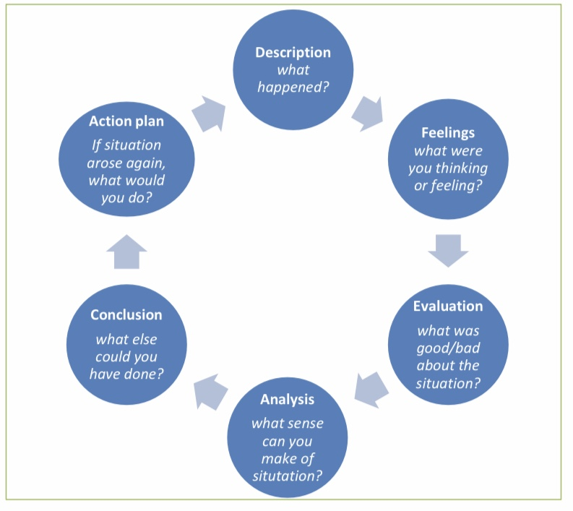
Dye, V. (2011) ‘Reflection, Reflection, Reflection. I’m thinking all the time, why do I need a theory or model of reflection?’, in McGregor, D. and Cartwright, L. (ed.) Developing Reflective Practice: A guide for beginning teachers. Maidenhead: McGraw-Hill Education (pp. 217-234).

This is the model I’ll be using for my reflective report because it is the clearest and most precise. It also allows me to thoroughly express and explain my experience and findings as a learner.

DESCRIPTION:

Employability skills
Learning how to study
CV’s, cover letters, application forms etc.
Academic skills.

Employability skills: Within my two terms of studying this module, I’ve learnt about employability and I now possess most of the skills that every job career strongly requires of. I’ve also mastered the ability to work with others, understand their perspectives and come to a sensible conclusion, communicate effectively and lead others well. This has indirectly advanced my presentation skills, which helps me to be able to impact others and present myself well in an audience.

Learning how to study: In this module within first and second term, I’ve learnt how to study and manage my time well as time is a very important aspect of life which must be spent and used wisely e.g. studying for the right amount of hours at the right time, submitting essays on time, being punctual to lectures etc. I have also been able to easily adapt to the teaching methods being taught to me, which has provided me with great guidelines in how to study effectively e.g. using resources given to me to do research, prioritizing what needs to be completed first, how to write and structure an essay well etc.

CV’s, Cover letters, Applications forms: This module has gone the extra mile to educate me about how to have an outstanding report (cv, cover letter, application form). This also adds benefit to my outside life of university and my future. CV’s, cover letter and application forms play a massive role in your representation to the business world so it is crucial to have correct ones. I felt eager to learn about this, as I had known the importance of it but wasn’t able to write them accurately so it being taught has helped me tremendously. This topic provided a lot of insight regarding how to present well and write professional and standardized CV’s, cover letters etc. Curriculum Vitae (CV’S) are used for job applications; employers want to see whom they are employing so from the CV’s they can access information such as your education, accomplishments, life experience etc. Cover letters are letters that provide extra information on your skills and experiences, it is usually sent alongside CV’s while application forms are forms used to collect relevant and required information from the applicant, many jobs and educational institutions use application forms.

Academic skills: These are skills I’ve learnt in first term and second term. These are skills needed in order to thrive well in academic field. Learning this topic has helped me to become more of an efficient student as I can add this skill to every aspect of my life specifically in academics. It has also helped me to write better, speak clearer and present well. This topic has taught me how to think critically, to overview, write academically etc.

FEELINGS:

I felt very satisfied and content about these topics and skills gained as it has helped me grow in my knowledge and abilities in the area of academic and employability skills. The topics mentioned above, are the ones that have had an effective impact in my academic life at university especially. ‘Employability skills’ has emphasized the importance of possessing skills that will enable me to be employed. Previously, I lacked the knowledge of how to be employable, how to answer interview questions, how to ask questions in different situations etc but being taught this topic has helped me in these areas. In learning how to study, I didn’t know how to study effectively, I didn’t know how to assign enough time to specific task but after learning this topic of ‘knowing how to study’, I’m confident in how to study to my fullest potential. Before I came to university, I didn’t know how to write cv’s, cover letters and fill in application forms, I also didn’t have enough experience and knowledge to write them in an outstanding way but this topic has brought me to a higher level all-round in gaining more experience, how to write a cv, cover letter etc successfully. ‘Academic skills’ has helped me to improve majorly in my writing and reading/comprehension skills. My standard and quality of academic skills has changed for the better, before I didn’t know how to present myself appropriately and gather relevant information needed for given research but now I do know how to do such things and much more.

ANALYSIS:

Employability skills is vital because the job market and career you’re pursuing is competitive. Employers seek for people who can perform tasks in different places and adapt quickly. When you have employability skills you are able to thrive well in any given situation or task because you understand the basics, without the skills you will lack what it takes to stand out and do well especially in employment e.g. organizational skills, technology use, team-work etc.

Knowing how to study is one of the most crucial skills every student must have. Without this, you will struggle to do well in exams, write essays efficiently and effectively, revise well etc. Knowing how to study helps you to make progress in your academics e.g. by attending lectures, asking for lecturer’s help if needed, practicing how to write essays, reading recommended textbooks etc.

CV’s, cover letters and application forms enable you to showcase why and how you stand out, why you are worthy of being chosen for the job, position or career you are seeking for. It is a must that you know how to write them in a way that will catch the eye of the employer/recruiter. CV’s also help in getting to know yourself more as you are indirectly reflecting on who you are and what you’ve done/achieved e.g. your skills, medals, experience etc.

Academic skills are essential as they help students to be efficient in learning and studying. It helps you to exercise your speaking, writing and listening abilities, which is needed in every aspect of your life. As you practice it, unknowingly or knowingly you get better at it and it indirectly boosts up your confidence and increases your knowledge e.g. studying for an exam indirectly you are learning how to read and write in English more which also improves your vocabulary, writing and essay or watching an educational video etc.

EVALUATION:

These topics taught have been drastically effective but it doesn’t disregard the fact that I have strengths and weaknesses in them. My strengths in employability skills are that I can work well with others and present myself well while my weakness is that I can lack the ability to manage resources which can also mean I can’t be fully relied on sometimes. In learning how to study, I struggle with not being distracted easily and devoting time to specifically finish a given task. I procrastinate sometimes and rely on myself too much that I can bypass the act of asking for help when needed while in my strength, I can study and work to my full potential, write essays to a good standard and do research effectively. I have great strengths in writing CV’s, cover letters and filling in application forms. I can write exhaustively and bring together good information but I lack experience, which is something I’m working on. Lastly, I can struggle in speaking clearly and slowly to the level of people’s understanding while academically, I can write and read well.

SUMMARY AND CONCLUSION:

I’m in a place of progression, understanding and learning more. My journey started In October (first term) 2019 and I’m currently in April (second term) 2020. I’ve learnt a lot of things that has aided to my growth as a person but one thing that I have that has always stood with me is to ‘always ask for help when needed’, do the best you can do and always work at your fullest potential. The lecturers, textbook, classmates, online resources etc are there for a reason. A mistake I made was to carry the burden of stress and misunderstanding alone meanwhile things can be explained and smoothened out to my level of understanding. The set up of the university and they way the modules were taught exceeded my expectations, which I’m happy about; I was also able to adapt quickly and grow accordingly. In third term (June 2020), I aim to work harder, communicate better and be ready to learn.

In conclusion, this reflective journal writing has helped me to understand myself more and go deeper in my ability to learn. I’ve been able to critically and analytically think, create and improve my capability to develop as an academic student in university. This reflection has helped me to identify better ways to improve myself as a leader, which doesn’t just affect my academics, but my whole life, which is needed.

REFERENCES:

n.d. 4 Models Of Reflection – Core Concepts For Reflective Thinking. [online] Available at:
<https://www.open.edu/openlearn/ocw/mod/oucontent/view.php?id=51386&section=4> [Accessed 2020].

n.d. Gibbs' Reflective Cycle | The University Of Edinburgh. [online] Available at: <https://www.ed.ac.uk/reflection/reflectors-toolkit/reflecting-on-experience/gibbs-reflective-cycle> [Accessed 2020].

n.d. Kolb's Learning Styles And Experiential Learning Cycle .... [online] Available at: <https://www.simplypsychology.org/learning-kolb.html> [Accessed 2020].

n.d. Important Employability Skills For Workplace Success. [online] Available at: <https://www.thebalancecareers.com/employability-skills-list-and-examples-4143571> [Accessed 2020].

n.d. Employability Skills | Skillsyouneed. [online] Available at: <https://www.skillsyouneed.com/general/employability-skills.html> [Accessed 2020].

n.d. How To Study Effectively: 12 Secrets For Success | Oxford .... [online] Available at: <https://www.oxfordlearning.com/how-to-study-effectively/> [Accessed 2020].
n.d. A Guide To Cvs, Cover Letters And Application Forms. [online] Available at: <https://info.lse.ac.uk/current-students/careers/Assets/Documents/application-and-cv-brochure.pdf> [Accessed 2020].

n.d. Academic Skills - Social Skill Builder. [online] Available at: <http://www.socialskillbuilder.com/choosing-the-right-software/academic-skills/> [Accessed 2020].

n.d. A Guide To Cvs, Cover Letters And Application Forms. [online] Available at: <https://info.lse.ac.uk/current-students/careers/Assets/Documents/application-and-cv-brochure.pdf> [Accessed 2020].

APPENDIX:

PDP PLAN ON ‘WHAT AREAS I NEED TO IMPROVE AND HOW I’D IMPROVE IN THESE SKILLS.

Skills | Why is it crucial? | My plan to progress | Materials used to help me progress | Review Date on progress.
Communication | It makes a way for information and people to come together, which creates growth and builds your understanding and knowledge in different things. | In order for my communication to improve I aim to speak a little bit slower and clearer so that the information I’m transmitting is fully understood. | I will think and articulate what is in my mind before I voice out.  I will watch more videos and observe how my ‘role models’ in communication speak.  I will be patient. | 3 months
Employability  Skills | It helps you to work well with others and thrive well in the workplace. It enables you to stand out and achieve many things. | I will always take interest in what others are saying and contributing around me.  I will continuously work on developing myself as an individual. | Recommended textbooks and videos regarding these skills.  Feedback on how to improve from my friends, classmates, lecturers etc. | 6 months.
Academic skills | They help you to achieve your targets more easily and do well in your academics. | I will read and write more.  Watch more educational videos.  Seek help and advice in areas I’m struggling in. | Textbooks, blogs, people’s personal revelations and experiences regarding academic skills. | 4 months.
Problem solving skills | Without this skill, it would be impossible to solve problems and overcome them. We encounter problems everyday and we need to skills to tackle any type of problem. It helps you to work efficiently with others. | Practice problem solving in different areas at least three times a week.  I will analyze the decisions I’m making and why.  I will be intentional about the way I solve situations or problem crisis I find myself in. | Textbooks. | 3 months.
Leadership | It is needed daily and our lives depend on it as we make decisions which affect others and ourselves. Leadership builds connection, provides adaptability and freedom which in needed in the workplace. | I will ask for feedback after I’ve been told to lead or take control in something.  I will observe my ‘role models’ in leadership.  I will read more books because readers have the ability to lead. | Textbooks, feedback from my role models, films, videos etc. | 5 months.
Motivation | It increases the productivity of an individual, which is needed in order to work at the best of your abilities. | I will encourage myself to do better and congratulate myself when needed.  I will observe people realistically doing better or know more than me. | My achievements  Videos, books, people’s experiences, findings etc. | 2 months.
Creativity | This skill helps in problem solving and builds up confidence in self, which enables you to work well with others in any environment. | I will look at things from different perspectives and see how I can attempt it.  Practice how to be creative with different things. | Videos, magazines, creators achievements, advice etc. | 5 months.

IN-CLASS EXCERISE:



