George-Catalin Ciufu
Student 2232975
E-portfolio report
Learning in the Digital Era – BMPL4007/BMPS4009

Table of Contents

Task 1 – Written summary 2
Task 2 – Mind map 3
Task 3 – Presentation 4
Task 4 – Reflection 5
Reference list 6

Task 1 – Written summary
As university is much different than the other types of education, new students might find themselves much more independent than in the other cycles of education, therefore skills like time management and organization need to be developed early in order to ensure success. In other words, students manage themselves. Therefore, self-efficacy is the most important trait that can be brought into higher education (Cotrell, 2019).
For a student preparing for higher education, it is essential to be able to study effectively mastering the basics of it, such as learning how to focus on the tasks at hand by being engaged, understanding the importance of spaced learning and the benefits of it, making the most of lecture notes and creating summaries and introducing a routine for accomplishing tasks (The University of Edinburgh, 2022).
Based on the fact that studying in higher education prepares students for a future career, in the digital age, developing digital skills becomes a must as many jobs will be highly based on them. Still, they are instrumental in day-to-day life as well. Students must be able to use various devices, such as computers and phones, to find information on the internet, how to stay safe online, and how to communicate using multiple tools, including emails and social media (National Career Service, n.d.).
Finally, at the core of the whole preparation for higher education sits the ability to produce original work, which, if done successfully, can help students bring their learning into real life, using it on topics and themes that, as a result, will help to get a deeper understanding of the learning done over the lectures, understand its importance and eases the way it can communicate it to other individuals (Pitchford,2021).
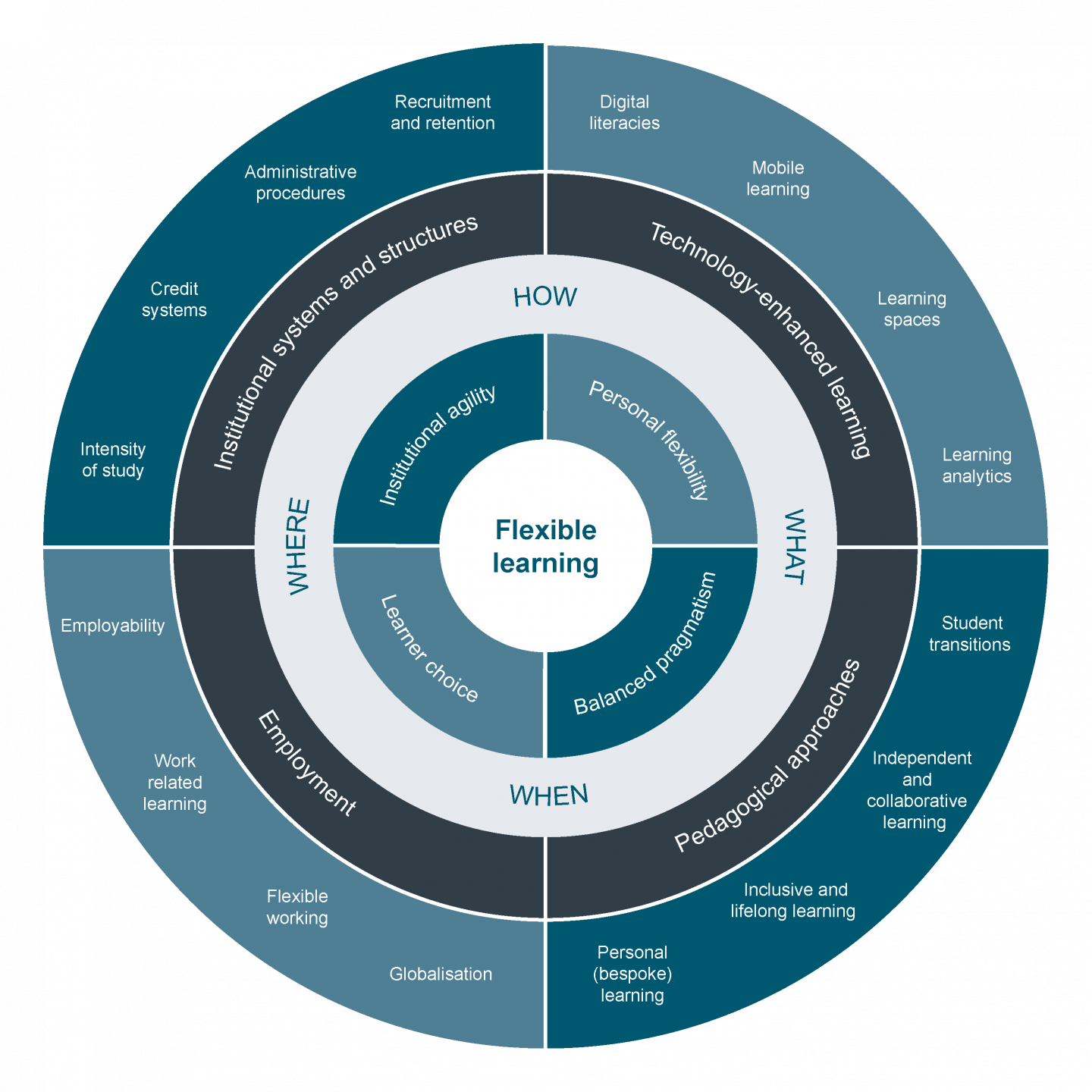
285 words

Photo (Advance HE, n.d.)

Task 2 – Mind map
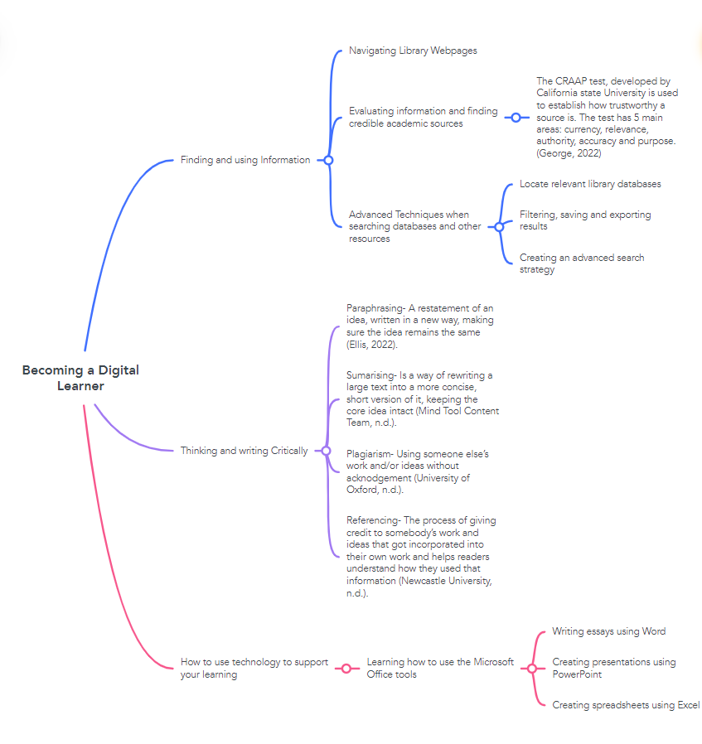

Task 3 – Presentation
Please follow this link to view my presentation: Presentation George Ciufu.mp4

Task 4 – Reflection
WHAT?
The decision to start studying Law and Legal Practice came from finding out that the legal profession has become more accessible over the recent years and represents a fulfilling and financially rewarding career (University of Law, 2022). Given that I always thought I could be a great lawyer, given the nature of my personality and my people skills, I decided to apply.
In the first week of learning, I was presented with many resources and online tools that I needed to use to ensure my academic success in this course. I found that learning about how Moodle and Office 365 work takes some time. Therefore, I spent a reasonable amount of time exploring their functions and capabilities.

SO WHAT?
After getting to grips with the resources and the online learning ecosystem, I started working on my first assignments. The process felt incredibly scary, especially as I have never done it before.
Writing the assignments was slow initially, and much research had to be done as I needed clarification on various essay aspects. Smith (2021) states that essays are much different from school on the undergraduate level, and it is essential to know how to begin and how to find your way around completing the task. However, it is much trickier to do so without experience in undergraduate work. With that in mind, my process was to gather as many resources as possible and filter through them, compiling them into one piece of information. After many trials and errors, I got better and better, concluding that the only way to improve is by practicing and finding your unique process.

NOW WHAT?
I have learned from this process that, regardless of how intimidating a task is, it is always achievable if enough effort is put into it. I developed much confidence during my work over my first assignments, and now I have my writing and research process that will help me throughout my academic journey.

324 words

Reference list

AdvanceHE (No Date), Flexible Learning in Higher Education, Available at: https://www.advance-he.ac.uk/teaching-and-learning/flexible-learning (Accessed on: 5th March 2023)
Cottrell, S (2019), The Study Skills Handbook, 5th Edition, Bloomsbury Academic, London
Ellis, M (2022), How to Paraphrase (Without Plagiarizing a Thing), Available at: https://www.grammarly.com/blog/paraphrase/ (Accessed on: 4th of March 2023)
George, T (2022), Applying the CRAAP Test & Evaluating Sources, Available at: https://www.scribbr.co.uk/working-sources/craap-test-explained/ (Accessed on: 5th March 2023)
Indeed Editorial Team, (2023), Team Player: Definitions and Examples, Available at: https://uk.indeed.com/career-advice/career-development/team-player (Accessed on: 6th March 2023)
Mind Tools Content Team, (No Date), How to Paraphrase and Summarize Work, Available at: https://www.mindtools.com/axggxkv/paraphrasing-and-summarizing (Accessed on: 4th March 2023)
National Career Service, (No Date), Digital skills to help your career, Available at: https://nationalcareers.service.gov.uk/careers-advice/build-foundation-digital-skills-to-help-your-career (Accessed on: 3rd March 2023)
Newcastle University, (No Date), Referencing, Available at: https://www.ncl.ac.uk/academic-skills-kit/good-academic-practice/referencing/#:~:text=Referencing%20is%20how%20you%20acknowledge,your%20own%20ideas%20and%20arguments (Accessed on: 4th March 2023)
Pitchford, A (2021), Developing authentic learning in universities: benefits and challenges, Available at: https://blogs.bath.ac.uk/clt/2021/01/20/developing-authentic-learning-in-universities-benefits-and-challenges/ (Accessed on: 4th March 2023)
Psychology Today Staff, (No Date), Identity, Available at: https://www.psychologytoday.com/gb/basics/identity (Accessed on: 6th March 2023)
Silbert, D, (No Date), 5 qualities of a great team player, Available at: https://www.predictiveindex.com/blog/team-player/#:~:text=What%20does%20it%20mean%20to%20be%20a%20great%20team%20player,the%20good%20of%20the%20team. (Accessed on: 6th March 2023)
Smith, J (2021), How to Write an essay, Available at: https://www.prospects.ac.uk/applying-for-university/university-life/how-to-write-an-essay (Accessed on: 4th March 2023)
The University of Edinburgh, (No Date), Effective studying, Available at: https://www.ed.ac.uk/institute-academic-development/study-hub/learning-resources/studying (Accessed on: 3rd March 2023)
The University of Law (2022), Four reasons why a career in law is leading the way, Available at: https://www.law.ac.uk/about/press-releases/four-reasons-why-a-career-in-law-is-leading-the-way/#:~:text=Competitive%20Salary,of%20%C2%A342%2C250%20per%20year (Accessed on: 5th March 2023)
University of Oxford, (No Date), Plagiarism, Available at: https://www.ox.ac.uk/students/academic/guidance/skills/plagiarism (Accessed on: 5th March 2023)

