[Name: Ross Pullin]
[Student Number: 0851963
[WORKSHEET 2 -- TESTING (Parking Fee Calculator)]
A:
print("Welcome to the Car Park")
print("Vehicle types:")
print("Car")
print("Motorcycle")
print("Van")
vehicle = input("Enter your vehicle type: ")
if vehicle == "Car":
rate = 2.50
max_fee = 15.00
elif vehicle == "Motorcycle":
rate = 1.00
max_fee = 6.00
elif vehicle == "Van":
rate = 4.00
max_fee = 25.00
else:
print("Invalid vehicle type.")
exit()
hours = input("Enter number of hours parked: ")
if not hours.isdigit():
print("Please enter a whole number for hours.")
exit()
hours = int(hours)
if hours <= 0:
print("Hours must be more than 0.")
exit()
# Calculate fee
fee = hours * rate
if fee > max_fee:
fee = max_fee
print("You need to pay: £" + str(fee))

B – Extended code

print("Welcome to the Car Park")

print("Vehicle types:")
print("Car")
print("Motorcycle")
print("Van")

vehicle = input("Enter your vehicle type: ")

if vehicle == "Car":
pass
elif vehicle == "Motorcycle":
pass
elif vehicle == "Van":
pass
else:
print("Invalid vehicle type.")
exit()

day = input("Is it a Weekday or Weekend? ")

if day != "Weekday" and day != "Weekend":
print("Invalid day type.")
exit()

hours = input("Enter number of hours parked: ")

try:
hours = float(hours)

except:
print("Invalid number of hours.")
exit()

if hours <= 0:
print("Hours must be more than 0.")
exit()

if day == "weekday":
if vehicle == "Car":
rate = 2.50
max_fee = 15.00
elif vehicle == "Motorcycle":
rate = 1.00
max_fee = 6.00
else:
rate = 4.00
max_fee = 25.00
else:
if vehicle == "Car":
rate = 3.00
max_fee = 15.00
elif vehicle == "Motorcycle":
rate = 1.20
max_fee = 6.00
else:
rate = 4.80
max_fee = 25.00

fee = hours * rate

if fee > max_fee:
fee = max_fee

print("You need to pay: £" + str(round(fee, 2)))

[Code Testing]
For each test below, run your code and enter the values provided. Provide a screenshot of what happened when the programme ran. Did the programme behave correctly or did it do something unexpected? Fill in a box for each test below. You should present 12 separate boxes, 1 for each test. (Note: the first box is provided as a template)
Test the following values for your calculator:
- 2 hours parking with a car on weekday
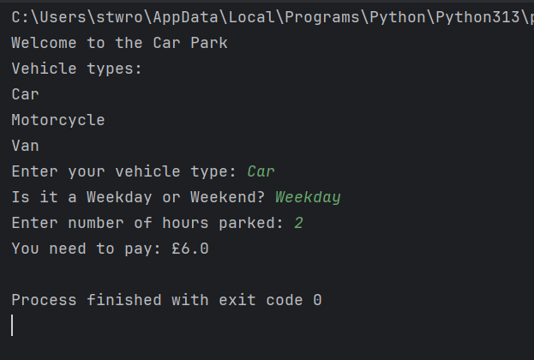
- 0.5 hours parking with a motorcycle on weekday
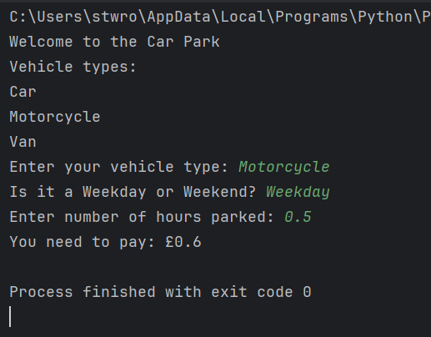

- 8 hours parking with a van on weekend
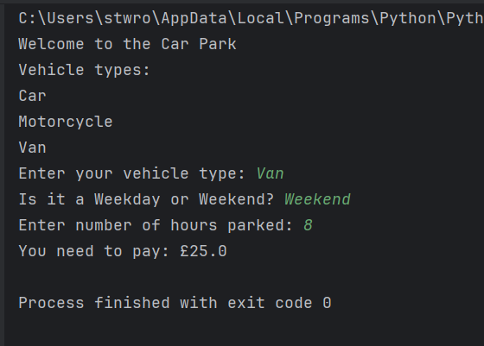
- 0.25 hours parking with a car (short stay outlier)
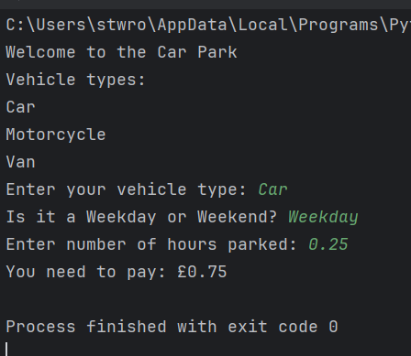
- 100 hours parking with a motorcycle (long stay outlier)
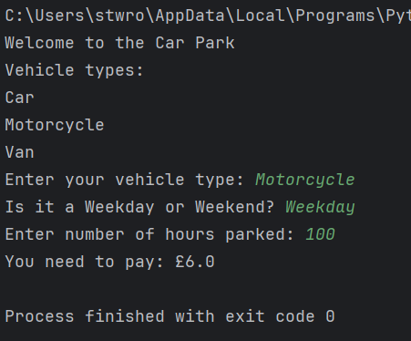

- 24 hours parking with a van on weekday
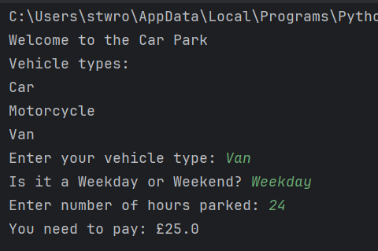
- 72 hours parking with a car on weekend
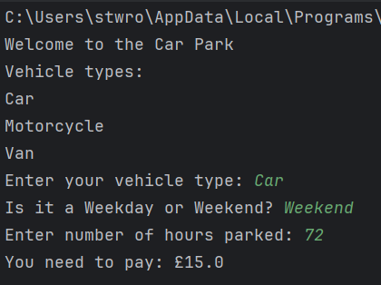
- -2 hours parking with any vehicle
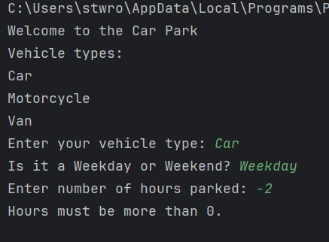

- Enter an outlier value, click "n", then enter another outlier value
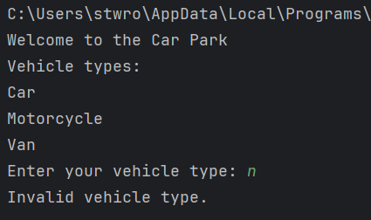
- Suitable "normal" parking duration for your chosen 4th vehicle

- Suitable out of range parking duration for your chosen 4th vehicle

- Test your menu -- what happens if you enter "5" for vehicle type?

For each test provide screenshots(s) of output: and answer the following questions
- Result: Did the program behave as expected ie syntactically and logically correct? YES/NO
If NO, what problems were encountered and why? Suggest how things could be improved.

YES – Codes and A and B acted as normal.

No - when I tried to implement the short stay Long stay – I couldn’t get this to work. Did not attempt to add a 5th vehicle.

