
APPENDIX GA36b

LEVEL 5 ASSESSMENT SPECIFICATION

Student name: |  | Student ID number:
Programme:
Module: | Network Operating Systems and Services
Module code: | ACCA5023 | Contribution to Overall Module Assessment (%): | 50%
Lecturer: | Md Abrar Jahin Almazi Bipon | Internal Verifier: | Dr Sana Jokhio
Assignment Title: | Research, build, and deploy a Virtualised Enterprise network | Word count (or equivalent): | 2500 Words equivalent
Submission deadline: | 02/04/2026  14:00 | Return date of provisional marks & written feedback: | 02/05/2026
Submission method: | All written assessments, where practical and possible, must be submitted via Turnitin unless otherwise instructed by the Lecturer. (Please DO NOT put this assessment specification into Turnitin or it will match many similarities with other students’ submissions.)  Alternative submission method (if applicable):  Late submission of the assessment will result in a late penalty mark:  Work which is submitted up to 1 week late will be capped at 40% for the first attempt and will be awarded a mark of 0% for re-assessment. Late submission penalties may be lifted only if there is an approved extenuating circumstances claim.  Work submitted more than 1 week late will be considered as a non-submission and will not be marked. The work may be considered as a submission for reassessment if offered by an Examining Board or if there is an approved extenuating circumstances claim.
Academic honesty / referencing: | Academic honesty is required. In the main body of your submission you must give credit to authors on whose research and ideas your work is based. Append to your submission a reference list that indicates the books, articles, etc. that you have used, cited or quoted in order to complete this assessment.

Module Learning Outcomes
(from module syllabus)
Apply a systematic understanding of network operating system environments to deploy, manage and maintain critical network services and resources.
Analyse a given network to produce suitable security audit/disaster recovery strategy.

TASK DESCRIPTION

Use of Generative AI in Assessment
(Lecturer to indicate Yes or Not against each element)

RESEARCH | For this assessment, you can use Generative AI to support you in research and data analysis. | Yes ☒  No ☐
STRUCTURE | For this assessment, you can use Generative AI to support you in structuring your submission, including creating a draft argument structure, identifying parts and headings, etc. | Yes ☒  No ☐
PROOFREADING | For this assessment, you can use Generative AI to check your own text/creation for grammatical and syntactical mistakes, including getting suggestions to rephrase your work. | Yes ☒  No ☐
WRITING | For this assessment, you can use Generative AI to create text for submission. | Yes ☐  No ☒
CREATIVE | For this assessment, you can use Generative AI to create creative materials, such as images. | Yes ☒  No ☐
PROGRAMING | For this assessment, you can use Generative AI to create and check code. | Yes ☒  No ☐
NONE | For this assessment, you are not allowed to use any type of Generative AI support. This includes research support, structure support, writing/proofreading support and creative support. | ☐

Important Notes:

Each tasks have varying word lengths specified for them; it is important that you keep to the word length specified for each assessment at all times on the following grounds:
• To encourage succinct and clear writing.
• To ensure equity between all the students doing that particular assessment.

If the specified word limit for an assessment has been exceeded, the following penalties would normally apply. The penalty cannot take the work into the fail category.

• Up to 10% above the word limit – No deduction off final mark
• Between 10% and 25% above the word limit – Deduction of 5 marks off final mark, or reduce the mark to the capped mark, whichever is the lesser penalty.

For example,

For an undergraduate student achieving a final mark of 44%, the mark would be reduced to the capped mark of 40%; whereas for an undergraduate student achieving a final mark of 49%, the mark would be reduced to 44%.

• Between 25% and 50% above the word limit – Deduction of 10 marks off final mark, or reduce the mark to the capped mark, whichever is the lesser penalty.

For example, for an undergraduate student achieving a final mark of 47%, the mark would be reduced to the capped mark of 40%; whereas for an undergraduate student achieving a final mark of 55%, the mark would be reduced to 45%.

• 50% or more over length – Maximum mark of capped mark

A failure to meet the word limit (or minimum word limit if a range is given) may result in lower marks based on the quality of the work because the work may not include the necessary information required for the assessment to meet the stated learning outcomes.

The feedback on the assessment should explicitly mention any mark deduction and the reason for it.

This coursework’s deadlines and deliverables:
Task | Deliverables | Deadline
Task 1 | Research Report (1000 Words) | TBA @ 1500 HRS
Task 2 | Technical Documentation (1250 Words equivalent) | TBA @ 1500 HRS
Task 3 | Personal & Technical Reflection (250 Words) | TBA @ 1500 HRS
Submit Task 1, 2 and 3 as one Single Document. Technical Documentation must contain Screenshots with Timestamp, IP Details and other configuration details as required/ necessary.

Briefing

This is an Individual Task. This assessment comprises of both research and practical implementation. This task continues to the next coursework as well.
- Research work:
  - Use appropriate referencing style to in-text cite your research work.
  - Try to review recent academic/ industry credible literatures and reflect on your understanding on the concepts covering the areas requested by summarizing the topics given and writing critical appraisals.
  - Don’t answer the research questions “what is what”.

- Practical work: Complete the task and document it with necessary screenshots.

You are required to research and build/ deploy a Virtualised network. Choice of virtualization completely depends on you. However, consider the availability of the resources before deciding your implementation. Requesting a new resource may affect your submission deadline. It is always recommended to know the availability of resources before deciding the infrastructure.

Scenario
Assume, you have been hired as an IT Tech by a Multinational Corporation called NOSSLONDON2026. NOSSLONDON2026 operates currently at two locations: Birmingham and London. You are asked to do research and implement the network as given in the topology.

Topology (For Coursework 1)

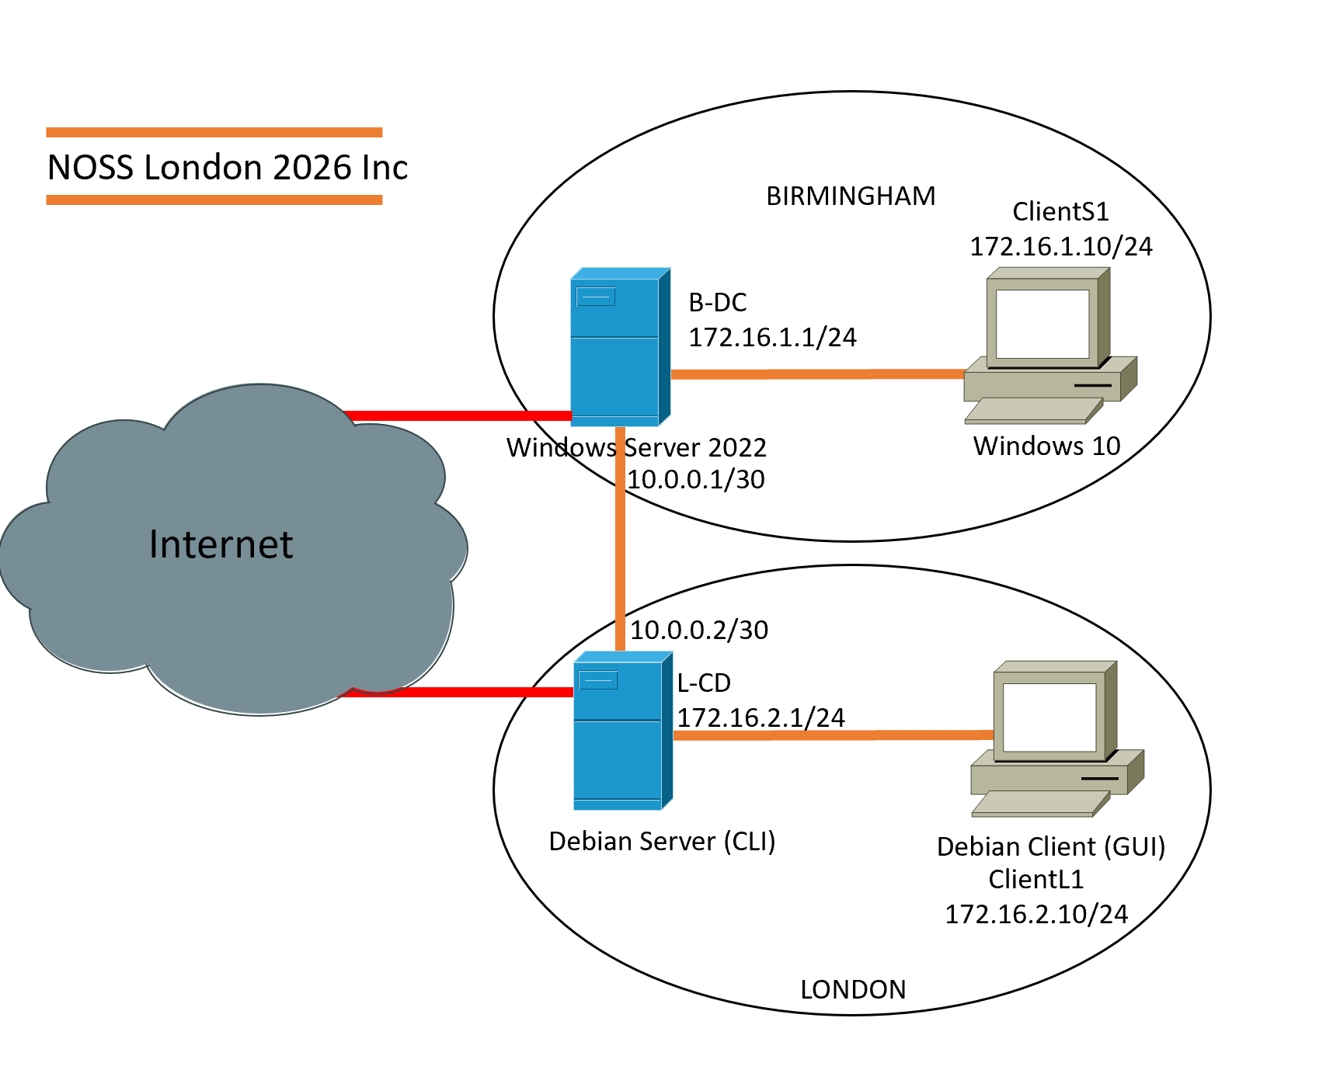

Topology Enhanced (For Coursework 2)
You won’t deploy this topology for your Coursework 1 – This is provided to you to help you for planning purposes.

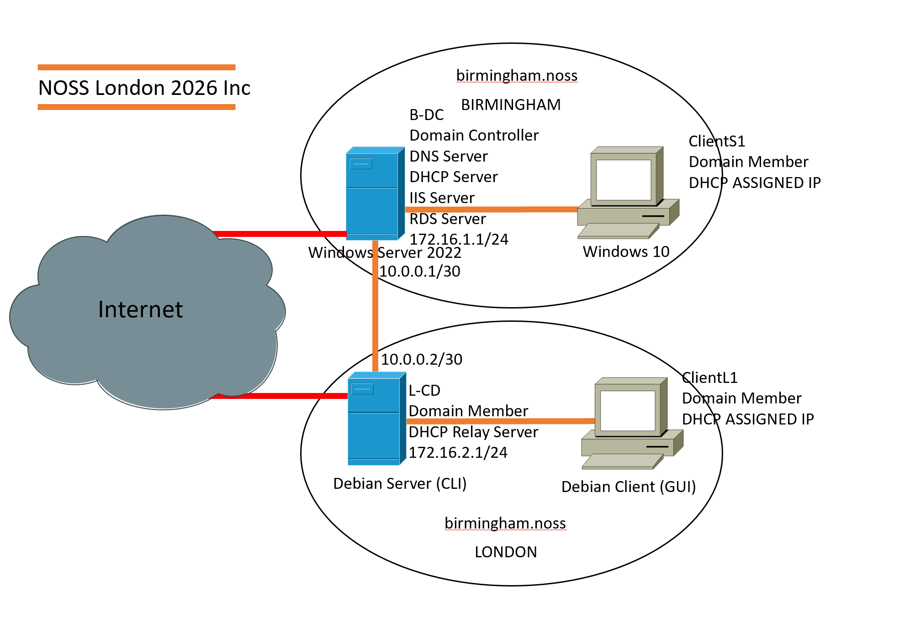

Critical Details
Windows Server: Standard Desktop Version
System Configuration: -: Language: English US, Time Format: London UK
Username: Administrator
Password: NotebooK@123

Debian Server: CLI
Username: localadmin
Password: NotebooK@123

Complete the following tasks:
- Research on the given topics
- Build and Deploy a virtual network based on the above topology

Task 1

Word Limit: 1000 words

Deliverables
- Report: Research– 40 Marks Maximum

Do a research addressing the following
- Research on Hypervisor: (Maximum: 250 Words)
  - Summarize your understanding of hypervisor types (Type 1 and Type 2) and their architectures
  - Reflect on which hypervisor type is suitable for this topology (e.g., hosting the Windows Server 2022 and Debian Server) based on features, hardware requirements, advantages, scalability, security, and compatibility.
Consider Enhanced Topology as well!!!
  - Justify your choice by considering the domain environment (BIRMINGHAM.ACCA) and the need to support both Windows and Debian clients, including specific hardware constraints or security needs in the topology.

- Research on IP Addressing: (Maximum: 250 Words)
Refer to your Group Activity during one of your lectures asking you to discuss in a group about
- How does data get from one computer to another on the Internet and what is the role of IP addresses in the transmission of data on the Internet?
- How do you think routers and switches work on the Internet to facilitate the flow of data between different networks?

  - Based on the above Group Activity, reflect your understanding on IP Addressing with appropriate and adequate in-text citations.
    - Explore how IP Addressing contributes to the functionality and effectiveness of the network.
    - You need to address the structure, format, and representation of IPv4, IPv6 addressing, concept of subnetting, efficient utilization of IP addresses.
    - Include diagrams and examples of IP Addressing concepts and their practical applications.

- Research on Routing: (Maximum: 250 Words)
  - Summarize your understanding of routing protocols, focusing on their purpose, how they operate, and the differences between static and dynamic routing.
  - Reflect on which routing approach suits the topology’s setup, considering the Debian Server’s role as a DHCP Relay and the Windows Server’s connectivity.

- Research on Network Services: (Maximum: 250 Words)
  - Summarize your understanding of VPNs, DHCP, Active Directory Domain Services (AD DS), and Certificate Authorities, focusing on their key features and best practices

Note: As stated above, you are not expected to answer “what is what”. Review recent academic/ industry credible literatures and reflect on your understanding on the above concepts by summarizing and writing critical appraisals. Appropriately in-text cite your work.

Task 2

Word Limit: 1250 words equivalent

Deliverables
- Report: Technical Documentation – 50 Marks Maximum

  - Choose your Hypervisor: Based on the above research, justify with concreate evidence and strong statements that influenced your choice of hypervisor to complete this network. Consider the fact that you will be continuing this topology to manage different network services in Coursework 2.
For below Tasks:
Note: The timestamp must prove that the task was done on a regular basis rather than a last minute work to be considered as excellent work.
Note: Without Timestamp in the screenshots submitted for task 2.2, “Time Management, Planning, Exercise of personal responsibility and decision-making, complete tasks and procedures” will be marked Zero.
  - Download and Setup:
    - Download the chosen Hypervisor and Server, Client Operating Systems for the relevant Sources. Evidence for downloading from relevant/ appropriate resources will be considered as exceptional work.
    - Deploy your network as per the given topology. The setup needs to be taken screenshots with Timestamp
  - Configure IP Addressing
    - Appropriate IP addressing
Fail – No IP Addressing configured
Marginal Fail – Wrong IP Address Configuration
Satisfactory - Good Work: IP Address Configured – However used the IP addresses given in the Topology Diagram.
Very Good – Exceptional: IP Address Configured – Used VLSM IP Addressing Scheme to calculate and assign your own IP Addressing Scheme.
The above topology gives network address for the networks. However, it is up to you to use the same network or a different network/ IP Addressing Scheme. Designing your own IP Addressing scheme for the network will be considered as exceptional work.
  - Test and Troubleshoot
You need to achieve the following:
    - Perform Connectivity tests
Outcome 1: Successful connectivity within same networks.
Outcome 2: Unsuccessful connectivity within different networks.

Task 3

Word Limit: 250 words

Deliverables
- Report: Reflection – 10 Marks Maximum

  - Reflect on the following
    - Write a Technical reflection covering network deployment and testing.
Hint:
Throughout Task 2, reflect on any issues/ challenges during deployment and testing. (like IP Address conflicts, DNS resolutions, firewall configurations etc.)
Document with necessary evidence on how you diagnosed and troubleshooted any issues systematically (if occurred).
    - Write your Personal Reflection

Marking Scheme
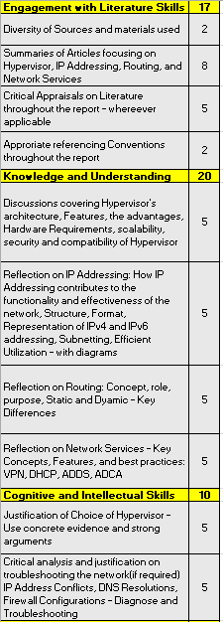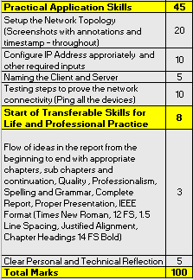

GUIDANCE FOR Students IN THE COMPLETION OF TASKS

NOTE: The guidance offered below is linked to the five generic assessment criteria overleaf.

- Engagement with Literature Skills
Your work must be informed and supported by scholarly material that is relevant to and focused on the task(s) set. You should provide evidence that you have accessed an appropriate range of sources, which may be academic, governmental and industrial; these sources may include academic journal articles, textbooks, current news articles, organisational documents, and websites. You should consider the credibility of your sources; academic journals are normally highly credible sources while websites require careful consideration/selection and should be used sparingly. Any sources you use should be current and up-to-date, mostly published within the last five years or so, though seminal/important works in the field may be older. You must provide evidence of your research/own reading throughout your work, using a suitable referencing system, including in-text citations in the main body of your work and a reference list at the end of your work.

Guidance specific to this assessment: Detailed information is given above

- Knowledge and Understanding Skills
At level 5, you should be able to demonstrate: sound knowledge and critical understanding of the well-established concepts and principles of the subject area and the way in which those principles have developed; knowledge of the main methods of enquiry in the discipline. Knowledge relates to the facts, information and skills you have acquired through your learning. You demonstrate your understanding by interpreting the meaning of the facts and information (knowledge). This means that you need to select and include in your work the concepts, techniques, models, theories, etc. appropriate to the task(s) set. You should be able to explain the theories, concepts, etc. meaningfully to show your understanding. Your mark/grade will also depend upon the extent to which you demonstrate your knowledge and understanding.

Guidance specific to this assessment: Detailed information is given above

- Cognitive and Intellectual Skills
You should be able to critically analyse information, and propose solutions to problems arising from that analysis, including the critical evaluation of the appropriateness of different approaches to solving problems. Your work must contain evidence of logical, analytical thinking, evaluation and synthesis. For example, to examine and break information down into parts, make inferences, compile, compare and contrast information. This means not just describing what! But also justifying: Why? How? When? Who? Where? At what cost? At all times, you must provide justification/evidence for your arguments and judgements. Evidence that you have reflected upon the ideas of others within the subject area is crucial to you providing a reasoned and informed debate within your work. Furthermore, you should provide evidence that you are able to make sound judgements and convincing arguments using data and concepts, with an understanding of the limits of knowledge, and how this influences analyses and interpretations. Sound, valid conclusions are necessary and must be derived from the content of your work. Where relevant, alternative solutions and recommendations may be proposed.

Guidance specific to this assessment: Detailed information is given above

- Practical Skills
At level 5, you should be able to use/deploy a range of established techniques within the discipline, and apply underlying concepts and principles outside the context in which they were first studied, including, where appropriate, the application of those principles in an employment context. You should be able to demonstrate how the subject-related concepts and ideas relate to real world situations and/or a particular context. How do they work in practice? You will deploy models, methods, techniques, and/or theories, in that context, to assess current situations, perhaps to formulate plans or solutions to solve problems, or to create artefacts, some of which may be creative. This is likely to involve, for instance, the use of real world artefacts, examples and cases, the application of a model within an organisation and/or benchmarking one theory or organisation against others based on stated criteria. You should show awareness of the limitations of concepts and theories when applied in particular contexts.

Guidance specific to this assessment: Detailed information is given above

- Transferable Skills for Life and Professional Practice
Your work must provide evidence of the qualities and transferable skills necessary for employment requiring the exercise of personal responsibility and decision-making. This includes demonstrating: professional development to advance existing skills and acquire new competences that will enable you to assume significant responsibility within organisations; that you can initiate and complete tasks and procedures, whether individually and/or collaboratively; that you can use appropriate media to effectively communicate information, arguments and analysis in a variety of forms to specialist and non-specialist audiences; fluency of expression; clarity and effectiveness in presentation and organisation. Work should be coherent and well-structured in presentation and organisation.

Guidance specific to this assessment: Detailed information is given above

Student FEEDBACK FORM

This section details the extent to which the assessment criteria are demonstrated by you, which in turn determines your mark. The marks available for each category of skill are shown. Lecturers will use the space provided to comment on the achievement of the task(s), including those areas in which you have performed well and areas that would benefit from development/improvement.

Generic Assessment Criteria | Marks available | Marks  awarded
1. Engagement with Literature Skills  . | 17
2. Knowledge and Understanding Skills | 20
3. Cognitive and Intellectual Skills | 10
4. Practical Application Skills | 45
5. Transferable Skills for Life and Professional Practice | 8

Assessment Mark (Assessment marks are subject to ratification at the Exam Board. These comments and marks are to give feedback on module work and are for guidance only until they are confirmed. ) | Late Submission Penalties (tick if appropriate) |  | %
 | Up to 1 week late (40% Max) |  | %
 | Over 1 week late (0%) |  | %

GENERIC ASSESSMENT CRITERIA

Level 5
In accordance with the Framework for Higher Education Qualifications, at the end of Level 5 students will be expected to have developed sound knowledge and critical understanding of the well-established concepts and principles in their field of study, and of the way in which those principles have developed. They will have learned to apply those concepts and principles more widely outside the context in which they were first studied, including, where appropriate, the application of those principles in an employment context. They will have knowledge of the main methods of enquiry in the subject area, and ability to evaluate critically different approaches to problem solving. They will possess an understanding of the limits of their knowledge, and how this influences their analyses and interpretations. They will be able to use a range of established techniques to initiate and undertake critical analysis of information, and to propose solutions to problems arising from that analysis. They will be able to effectively communicate information, arguments and analysis in a variety of forms to specialist and non-specialist audiences, and deploy key techniques of the discipline effectively. They will be able to undertake further training, develop existing skills and acquire new competences that will enable them to assume significant responsibility within organisations. They will have the qualities and transferable skills necessary for employment requiring the exercise of personal responsibility and decision-making.

Level 5 | FAIL | MARGINAL FAIL | SATISFACTORY  (3rd / Pass) | GOOD  (2.2 / Pass) | VERY GOOD  (2.1 / Merit) | EXCELLENT  (1st / Distinction) | EXCEPTIONAL  (1st / Distinction)
Category | 0-29% | 30-39% | 40-49% | 50-59% | 60-69% | 70-84% | 85-100%
Engagement with literature (including reading, referencing,  academic conventions and  academic honesty) | Little or no evidence of reading and/or reliance on inappropriate sources.  Views and findings mostly unsupported and non-authoritative.  Referencing conventions used incoherently or largely absent. | Poor engagement with essential reading. No evidence of wider reading. Reliance on inappropriate sources, and/or indiscriminate use of sources. Heavily reliant on information gained through class contact. Inconsistent and weak use of referencing. | Engagement with a limited range of mostly relevant and credible sources. Some omissions and minor errors.  Referencing conventions evident though not always applied accurately or consistently. | Engagement with an appropriate range of literature, including sources retrieved independently. Some over-reliance on texts. Referencing may show minor inaccuracies or inconsistencies. | Engagement with a wide range of literature, including sources retrieved independently.  Selection of relevant and credible sources. Very good use of referencing, with no/very few inaccuracies or inconsistencies. | Engagement with an extensive range of relevant and credible literature. Consistently accurate application of referencing. | Exceptional engagement with an extensive range of relevant and credible literature. High-level referencing skills consistently applied.
Knowledge and understanding (Sound knowledge and critical understanding of the well-established concepts and principles in their field of study; knowledge of the main methods of enquiry in the discipline.) | Major gaps in knowledge with unsatisfactory, uncritical understanding of the subject matter. Much irrelevant material. Substantial inaccuracies. Significantly flawed understanding of the main methods of enquiry in the discipline. | Fragmentary knowledge, with only superficial critical understanding. Some significant inaccuracies and/or irrelevant material. Incomplete or partially flawed understanding of the main methods of enquiry in the discipline. | Limited but adequate knowledge and critical understanding of the well-established concepts and principles within the subject area, with a few gaps in the selection of material. A narrow critical understanding of the main methods of enquiry. | Knowledge is reasonably detailed and accurate. A good critical understanding of the well-established concepts and principles and the main methods of enquiry, with minor gaps in the selection of material. | Knowledge is reasonably extensive. Exhibits very competent critical understanding of the well-established concepts and principles of the subject and the main methods of enquiry. Breadth and depth of knowledge. | Excellent, detailed knowledge and highly critical understanding of the well-established concepts and principles of the subject and the main methods of enquiry. | Exceptionally detailed knowledge and outstanding critical understanding of the well-established concepts and principles of the subject and the main methods of enquiry. May go beyond established theories.
Cognitive and intellectual skills  (Critical evaluation and analysis of concepts and principles; argument and judgement; the limits of their knowledge, and how this influences their analyses and interpretations.) | Wholly or almost wholly descriptive work. Little or no critical evaluation and analysis of concepts and principles.  Failure to develop arguments, leading to illogical or invalid judgements. Unsubstantiated generalisations or opinion, made without use of any credible evidence. | Largely descriptive work, with superficial use of critical evaluation and analysis of concepts and principles. Weak development of arguments and judgements. Information accepted uncritically, uses generalised statements made with scant evidence and unsubstantiated opinions. Ideas sometimes illogical and contradictory. | Limited attempt at critical evaluation and analysis of concepts and principles, tending towards description.  Some evidence to support arguments and judgements but these may be underdeveloped, with a little inconsistency / mis-interpretation or failure to fully recognise limits of knowledge. | Some critical evaluation and analysis of concepts and principles, though descriptive in parts.  An emerging awareness the limits of their knowledge and ability to use evidence to support the argument though with some tendency to assert/state opinion rather than argue on the basis of reason and evidence.  Mostly valid arguments and logical judgements. | Sound critical evaluation and analysis of concepts. Is selective in the range of evidence used and synthesises rather than describes. Ability to devise arguments that show awareness of different stances, and use evidence convincingly, to support appropriate and valid judgements. | Excellent critical evaluation and analysis of concepts and principles leading to logical, evidence-based, reasoned arguments and judgements. Explicit recognition of other stances and a strong awareness of the limits of their knowledge.  A capacity for independent thought and ability to ‘see beyond the question’, suggesting some grasp of the broader field and wider concepts. | Outstanding critical evaluation and analysis of concepts and principles. Uses evidence exceptionally well to connect ideas, and support highly logical and persuasive, arguments and judgements. Evidence of independent thought and ability to ‘see beyond the question’, suggesting a clear grasp of the broader field and wider concepts. Perceptive recognition of the limits of their knowledge, and how this influences their analyses and interpretations.
Practical skills  (Apply underlying concepts and principles more widely outside the context in which they were first studied; use a range of established techniques; propose solutions to problems arising from analysis.) | Limited or no use of established methods, materials, tools and/or techniques.  Little or no appreciation of the context of the application.  Limited understanding of the application of theory to practice or making appropriate links between the two.  Very weak problem-solving skills outside the context in which they were first studied. | Rudimentary application of established methods, materials, tools and/or techniques but without consideration and competence. Flawed appreciation of the context of the application.  Weak understanding of the application of theory to practice, with only occasional evidence of making appropriate links between the two. Weak problem-solving skills outside the context in which they were first studied. | An adequate awareness and mostly appropriate application of established methods, materials, tools and/or techniques.  Basic appreciation of the context of the application. Theoretical knowledge and understanding applied in practice, but not always making logical links between the two.  Can identify problems and propose basic solutions outside the context in which they were first studied. | A good and appropriate application of established methods, materials, tools and/or techniques.  Clear appreciation of the context of the application. Mainly consistent, accurate and logical application of theory to practice, making appropriate links between the two.  Can identify problems and propose mostly appropriate solutions outside the context in which they were first studied. | A very good application of a range of established methods, materials, tools and/or techniques.  Very good consideration of the context of the application, with perceptive insights. Consistent, accurate and logical application of theory to practice, making appropriate links between the two. Can identify problems and propose appropriate solutions outside the context in which they were first studied.  Evidence of some creativity. | An advanced application of a range of established methods, materials, tools and/or techniques.  The context of the application is well considered, and insightful.  Consistent, accurate and logical application of theory to practice, making well-developed links between the two. Can identify problems and propose excellent, creative solutions outside the context in which they were first studied. | Exceptional levels of application and deployment skills using established methods, materials, tools and/or techniques. Consistent, accurate and logical application of theory to practice, making highly developed links between the two. Can identify routine and non-routine problems and propose quite sophisticated, creative solutions outside the context in which they were first studied.
Transferable skills for life and professional practice  (Effectively communicate in a variety of forms  to specialist and non-specialist audiences; the qualities and transferable skills necessary for employment requiring the exercise of personal responsibility and decision-making.) | Communication medium is inappropriate or misapplied.  Work is poorly structured, disorganised and/or confusingly expressed. Very weak use of language and/or very inappropriate style. Failure to work effectively as part of a group. Little or no evidence of the skills for employment requiring the exercise of personal responsibility and decision-making. | Communication medium is poorly designed and/or not suitable for the audience.  Work is poorly presented in a disjointed manner. It is loosely, and at times incoherently, structured, with information and ideas often poorly expressed. Weak use of language and/or inappropriate style. Flawed approach to group work, meeting only partial obligations to others. Limited evidence of the skills for employment requiring the exercise of personal responsibility and decision-making. | Can communicate in a suitable medium for the audience but with some room for improvement.  Mostly ordered presentation and structure in which relevant ideas / concepts are reasonably expressed. Work may lack coherence in places. Can work as part of a group, meeting most obligations to others but perhaps with limited involvement in group activities.  Demonstrates the basic skills for employment requiring the exercise of personal responsibility and decision-making, with some areas of minor weakness. | Can communicate effectively in a suitable medium for the audience, but may have minor errors.  Mostly coherent, organised work, in a suitable structure and is for the most part clearly expressed. Can work effectively independently and/or as part of a team, with clear contribution to group activities.  Demonstrates the skills for employment requiring the exercise of personal responsibility and decision-making, with some areas of strength and some of minor weakness. | Can communicate well, confidently and consistently in a suitable medium for the audience.  Work is coherent, fluent, well-structured and organised. Can work very well autonomously and/or as part of a team, with very good contribution to group activities.  Demonstrates very good skills for employment requiring the exercise of personal responsibility and decision-making, with just occasional minor weakness. | Can communicate professionally confidently and consistently in a suitable medium for the audience.  Work is coherent, very fluent and is presented proficiently. Can work autonomously with initiative. Where relevant can work professionally within a team, showing leadership skills as appropriate, and meeting obligations. Demonstrates excellent skills for employment requiring the exercise of personal responsibility and decision-making and an appetite for further development. | Can communicate with an exceptionally high level of professionalism, highly suitable for the audience.  Work is exceptionally coherent, very fluent and is presented professionally. Can work exceptionally well within a team, showing leadership skills. Demonstrates exceptional skills for employment requiring the exercise of personal responsibility and decision-making and an appetite for further development.

THIS DOCUMENT IS ALSO AVAILABLE IN WELSH

