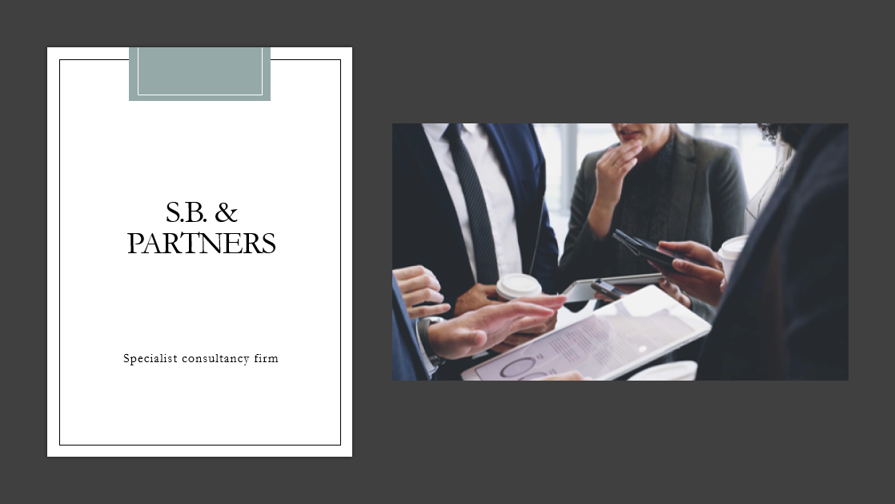
Trump International hotel & tower New York
Guest complaints: INADEQUATE CUSTOMER SERVICE

Syeda Shabna begum
2126655

Organisational consultancy
Bmih6005

Jaliya de silva
Word count: 6,085

Date delivered to client: The date the report will be delivered to the client will be on the 12/11/24.

Executive summary:
This report is focused on the customer service issues related to the Trump International Hotel and Tower New York. This report aims to investigate the underlying issues contributing to inadequate customer service at the Trump International Hotel & Tower New York. To effectively analyse the problem this report will utilise established frameworks such as PESTLE, SWOT, and TOWS. The PESTLE analysis will help understand the external factors influencing customer service quality (Makos, 2024), while the SWOT analysis will identify the internal strengths and weaknesses of businesses in addressing these issues (Peterdy, 2024). Finally, the TOWS matrix will assist in developing strategic options that leverage strengths and opportunities to mitigate weaknesses and threats (Visual Paradigm, 2024).
The S.B & Partnering Specialists Consulting firm will assist the Trump International Hotel and Tower New York in improving the quality and efficiency of their operations, developing effective strategies, employee training, increase revenue creation and profitability, and improving the guest experience. Hospitality consulting is essential as the hospitality industry is extremely competitive, expert advice can help restaurants, hotels, and other hospitality businesses overcome the numerous challenges they face when attracting customers (Barten, 2024).
The Trump International Hotel and Tower New York is owned by Donald Trump a luxury 52 storey hotel located in Central Park, New York. Opened in 1997 and noticed for being the only Forbes 5-Star, AAA 5-diamond hotel in New York. The Trump International hotel and Tower New York offers high end amenities and services to its guests attracting tourists and business travellers. Trump International Hotel & Tower New York amenities include:
- The Trump Spa & Fitness Centre spans 6,000 square feet
- 55-foot heated indoor saltwater pool.
- Jean-Georges, two Michelin starred restaurants,
- Casual dining venue
- Bar and more……
Upon analysis the issue identified by the hotel is the inadequate customer service received by guests from the front desk staff, which can be evident from the guest reviews posted on online platforms. Looking at the reviews from a couple of platforms such as Booking.com and Trip advisor the most evident complaint continuously cropping up was the bad experience guests received from the front of house team. To overcome and resolve the issue this report will look at the importance of feedback, reputation, income and scope.
The PESTEL analysis is a strategic framework used to assess a company’s operating environment. Using the PESTEL framework will help understand the external factors influencing customer service quality. Followed by the SWOT analysis and the TOWS analysis.
The SWOT analysis will identify the internal strengths and weaknesses of the Trump International Hotel & Tower New York. The TOWS (Threats, Opportunities, Weaknesses, Strengths) analysis expands on the SWOT approach which allows to consider plans for both internal and external sectors.
Identifying the issue there are several recommendations and change management strategies to implement to help overcome the issue. Hoteliers may improve their customer service in several ways (Alemar, 2024). To overcome bad customer service at the Trump International Hotel and Tower New York, several recommendations can be implemented:
- Staff training and development programs
- Feedback mechanisms
- Communication and more…….
The Trump International hotel and Tower New York have received a few negative reviews on trip advisor and the booking.com site and to address these bad customer service reviews and facilitate a seamless transition, several change management strategies can be implemented:
- Training programs
- Leadership involvement
- Clear communication
- Crisis management plan
- Reviewing feedback
To review and measure the impacts and success rates of the change management strategies implemented at the Trump International Hotel and Tower New York, will be done by conducting regular surveys and conducting feedback from the guest. Also, by tracking the KPI’s to determine customer service effectiveness.
Providing an excellent customer service experience has various real-world implications for the businesses performance and the company is perceived by the public. Good customer service always helps keep the customers; this is what keeps the customers returning for more purchases. Retaining customers enhances revenue, and it also far cheaper to keep existing customers rather than to acquire a new one (intuit mailchimp, 2024). Good customer service showcases a brand’s dependability. Reliable service fosters confidence and loyalty. As reputation grows so will the revenue (Pitman training, 2024). Providing good customer service can result in satisfied customer who are more inclined to promote the company to others (ixion, 2024).
A proposed action plan outlining the problem, solution, desired outcome, the time scale and the planned budget has been put together for the Trump International hotel and Tower New York to overcome this issue.

Contents Page:

Executive Summary………………………………………………………………………2-4
Introduction……………………………………………………………………………….....6
Trump International Hotel & Tower New York………………………………………….6-7
S.B & Partnering Specialist Consultancy Firm…………………………………………..8
Analysis………………………………………………………………………………………8
Feedback………………………………………………………………………………….8-9
Reputation………………………………………………………………………………..9-11
Income………………………………………………………………………………………11
Sope…………………………………………………………………………………………11
PESTEL…………………………………………………………………………………11-13
SWOT……………………………………………………………………………………13-15
TOWS……………………………………………………………………………………15-16
Recommendations and Change Management………………………………………16-19
Change management………………………………………………………………….19-21
Benefits of Implementing strategies …………………………………………………….22
Cost………………………………………………………………...……………………22-23
Action Plan………………………………………………………………………………23-24
Conclusion………………………………………………………………………………24-25
References…………………………………………………………………………...…26-36

Introduction:
In today’s competitive market, customer service quality significantly impacts a business’s reputation and success (Daoust, 2021). Unfortunately, many establishments face challenges related to dirty environments and subpar service, leading to customer dissatisfaction and potential loss of clients (Asif, 2023). This report aims to investigate the underlying issues contributing to inadequate customer service at the Trump International Hotel & Tower New York. To effectively analyse the problem this report will utilise established frameworks such as PESTLE, SWOT, and TOWS. The PESTLE analysis will help understand the external factors influencing customer service quality (Makos, 2024), while the SWOT analysis will identify the internal strengths and weaknesses of businesses in addressing these issues (Peterdy, 2024). Finally, the TOWS matrix will assist in developing strategic options that leverage strengths and opportunities to mitigate weaknesses and threats (Visual Paradigm, 2024).

Trump International Hotel & Tower New York:
This report is focused on the Trump International Hotel & Tower New York which is a 52-storey luxury hotel located at the corner of Central Park West and 61st Street. 1 Central Park W, New York, NY 10023, USA, opened in 1997 and continues to receive excellent reviews on all fronts, most notably for being the only Forbes Five-Star, AAA Five-Diamond hotel in New York with a Five-Star, Five-Diamond restaurant (The Trump Organisation, 2024). This iconic skyscraper stands out with its striking design and offers breathtaking views of central Park and the Manhattan skyline. The hotel’s 176 rooms feature elegantly appointed rooms and suites and are outfitted with a variety of modern conveniences including 55-inch televisions, Blu-ray players, and more. Many of the rooms and suites come with kitchenettes, and all have marble baths. The beds have Serta’s signature Trump mattresses and cultural stunning views (Telegraph, 2024). Guests can enjoy world-class amenities, including a full-service spa, fine dining options, and a fitness centre. The property is also known for its exceptional service and attention to detail, making it a popular choice for both business and leisure travellers. Additionally, its prime location provides easy access to some of New York City’s most famous attractions, shopping districts, and cultural landmarks.

Trump International Hotel & Tower New York amenities include:
- The Trump Spa & Fitness Centre spans 6,000 square feet
- 55-foot heated indoor saltwater pool.
- Jean-Georges, two Michelin starred restaurants,
- Casual dining venue
- Bar
- Business centre
- House car
The hotel’s rooms vary in size according to accommodation, which include 35 superior and deluxe guest rooms, including some of the nicest suites in New York City 12 junior suites and 99 executive one-bedroom suites, and 30 two-bedroom rooms. The standard guest room and luxury superior room is a well-appointed 440 square feet, with floor to ceiling windows. The spacious deluxe room has a floor space of 460 square feet. The hotels suites are spacious, featuring a luxurious king-size bed, with a floor space of 460 square feet, The executive suites are 700 square feet. The Park View suite has a very spacious 700 square feet also offering a separate living room (Trump International Hotel & Tower New York, 2024).
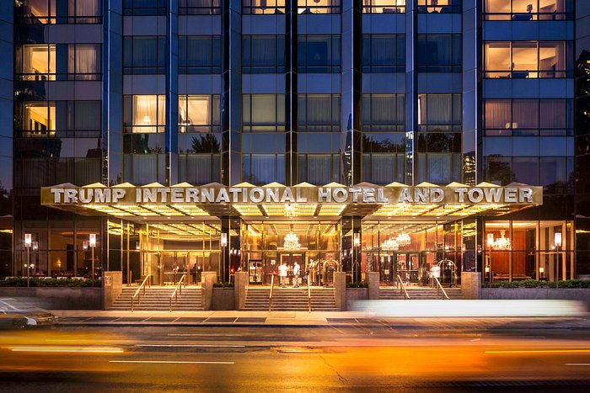
(Tripadvisor, 2024).
S.B. & Partners Specialist Consultancy firm:
S.B. & Partners Consultancy firm is a consultancy firm that specialises in helping businesses overcome issues and entails providing professional advice to investors or individuals interested in entering the hospitality industry, as well as assisting independent hotels or resorts that are already in operation (International Hotel Consulting Services, 2024). The ultimate aim of S.B Partnering Specialist consultancy is to assist hospitality firms in improving the quality and efficiency of their operations, developing effective strategies, employee training, increase revenue creation and profitability, and improving the guest experience. Hospitality consulting is essential as the hospitality industry is extremely competitive, expert advice can help restaurants, hotels, and other hospitality businesses overcome the numerous challenges they face when attracting customers (Barten, 2024).

Analysis:
The issue identified by the hotel is the inadequate customer service received by guests from the front desk staff, which can be evident from the guest reviews posted on online platforms. Looking at the reviews from a couple of platforms such as Booking.com and Trip advisor the most evident complaint continuously cropping up was the bad experience guests received from the front of house team. Numerous guest comments reported on Booking.com reviews complaining about staff attitude, being very unpolite (Booking.com, 2024). A recent review from July 2024 on Tripadvisor was from a very dissatisfied guest complained about how incredibly rude the staff were, another reviewed the front desk staff seemed miserable and flustered, rating customer service at zero. Many guests who reviewed on these platforms felt upset and disappointed (Tripadvisor, 2024). The front desk staff are the cause of the issue which has aroused at the hotel resulting in negative reviews and dissatisfied guests.

Feedback:
Feedback is crucial for hotels, managing online reputation and addressing negative feedback promptly is crucial for hotels to maintain their competitiveness and appeal to guests. Guest feedback may help hotels track trends over time and evaluate how they’re impacting the service they deliver to customers (Shubham, 2024).
Negative reviews can significantly impact a hotel in several ways:
- Reputation Damage: Negative feedback can tarnish a hotel’s reputation, making potential guests hesitant to book a stay. Many travellers rely on reviews to make their decisions, and consistently poor ratings can deter them.
- Decreased Bookings: If a hotel receives a high volume of negative reviews, it may experience a drop in bookings. Guests often prefer establishments with better ratings, leading to reduced occupancy rates (Customer alliance, 2024).
- Financial Loss: Fewer bookings can result in lower revenue, which can affect the hotel’s overall financial health. This can hinder the ability to invest in improvements or maintain quality standards (Viqal, 2024).
- Increased Marketing Costs: Hotels may need to spend more on marketing and promotions to counteract negative perceptions and attract guests, which means increased operational costs (Khalil, 2023).
- Staff Morale: Negative reviews can also affect staff morale, as employees may feel demotivated if they perceive that their efforts are not appreciated or recognised by guests.
- Opportunity for Improvement: On a positive note, negative reviews can provide valuable feedback that hotels can use to identify areas for improvement and enhance guest experiences (Guest Ban, 2024).

Reputation:
Inadequate customer service from hotel staff can significantly affect a hotels reputation in several ways:
- Guest Dissatisfaction: Poor service can lead to a negative for guests, resulting in dissatisfaction that they may share in reviews or other people.
- Negative Reviews: Guests who experience inadequate service are likely to leave negative reviews online, which can prevent potential guests from choosing that hotel (Whittaker Systems, 2022).
- Word-of-Mouth Impact: Guests may share their experiences with friends and family leading to negative word-of-mouth publicity that will affect the hotel’s reputation.
- Loss of Repeat Business: Guests who receive poor service are less likely to return, resulting in lost repeat business, which is also crucial for a hotels success.
- Brand Image: A hotel’s brand image can suffer significantly if it becomes known for poor customer service, making it difficult to attract new guest and retain existing ones.
- Employee Morale: Inadequate service can also affect staff morale, as employees may feel overwhelmed or unsupported, leading to a cycle of poor service.

If a hotel has few unfavourable ratings, avoiding an additional negative review can be critical. For many hotels, their immaculate reputation is a significant selling feature.
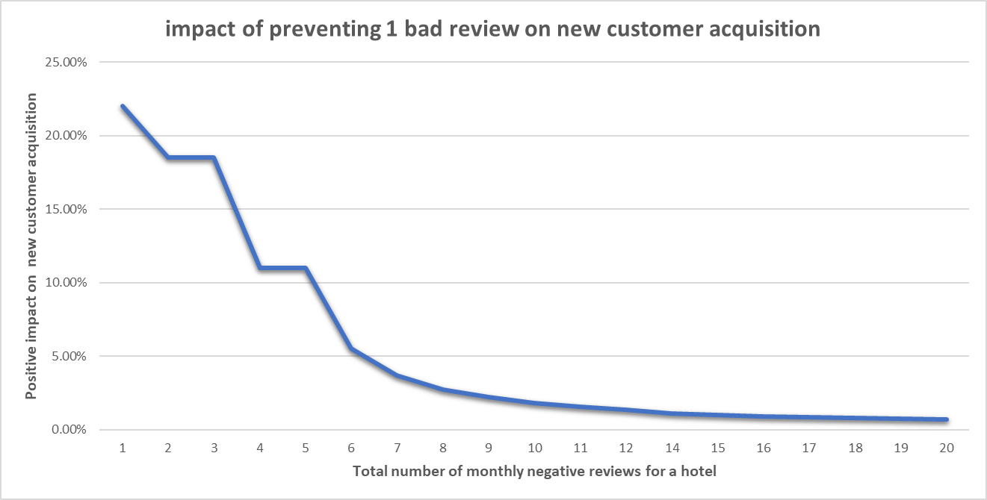
In summary, the inverted impact indicates that, while the immediate economic ramifications of avoiding a negative review may vary depending on a hotel’s previous review profile, the strategic value stays high across the board. Top-performing hotels must maintain their high standards, while lower-performing hotels may see the beginning of a much-needed positive transformation (Viqal, 2024). The Trump International Hotel and Tower must maintain high standards being a top-performing hotel.

INCOME:
A hotel’s reputation as reflected in internet reviews, has a direct impact on its ability to charge premium rates. Hotels that receive consistently favourable feedback can justify higher room prices since guests are willing to pay a premium for quality and service excellence. Hotels with negative evaluations, on the other hand, may struggle to maintain pricing power and may be obliged to provide room discounts in order to attract guests, resulting in decreased income per available room (May, 2024). Consistently poor customer service can have a severe and costly influence on a hotel. However, if corrective efforts are performed immediately, a hotel management can avoid a long-term consequence for their business’s reputation and revenue (Vallauri, 2016).

SCOPE:
The care that hotels give their guests before, during, and after their stay is known as hotel customer service. Hotel customer training is a crucial component of a hotel’s customer service strategy since establishments mostly depend on repeat business and positive word-of-mouth advertising. Although it’s challenging to get properly, doing so will result in repeat business. Keeping track of who stays at the hotel using tools such as sign-in forms, surveys, and email list can assist hotels in providing experiences that expectations of their customers (Zendesk, 2024).

PESTEL:
A PESTEL analysis is a strategic framework used to assess a company’s operating environment. Management teams and boards use the framework for strategic and enterprise risk management planning. PESTEL research is widely used by management consultants to assist their clients in developing creative product and market efforts, as well as by financial analyst community, where factors can impact model assumptions and financing decisions (Peterdy, 2024). Using the PESTEL framework will help understand the external factors influencing customer service quality.

Political: Regulations and policies. The hotel operates in a highly regulated industry, influenced by local, state, and federal regulations. As to which the hotel must comply with local, state and federal regulations, including zoning laws and building codes. Political stability in the region can affect tourism and business travel.Changes in government policies, such as tax incentives for tourism or hospitality, can impact profitability.
Economic: Economic conditions, such as recession or growth, directly affect the hospitality industry. Higher disposable income can lead to increased bookings. Currency fluctuations can affect international travellers spending power. With Trump’s economic and legislative changes, the hotel sector will adjust to the changing landscape of travel and client expectations, both domestically and internationally (Dabo, 2024).
Social: Changing consumer preferences, such as the demand for sustainable practices or unique experiences, can influence the hotel’s offerings. The reputation of the Trump brand may affect customer perceptions and patronage based on social and political views (The Peninsula, 2021).
Technological: advance in technology, including online booking systems and customer service platforms, can enhance operational efficiency and guest experience. To accommodate guest video stream Trump International collaborated with WIFI manufacture Zebra to install 802.11ac access points as part of an entire network management update spearheaded by GuestTek, a provider of broadband and interactive services to the hotel industry (Franklin Jr, 2015).
Environmental: Increasing awareness of environmental issues can lead to demands for sustainable practices in hotel operations. While pro-business policies and infrastructure improvements are likely to promote growth an innovation, concerns have been raised about the potential impact of restrictive immigration restrictions and the rollback of environmental programs. Compliance with environmental regulations is essential for maintain operations and brand image (Dabo, 2024).
Legal: The hotel must adhere to various laws, including labour laws, health and safety regulations, and consumer protection laws. Legal challenges related to the brand or management can impact operations and public perception. The Trump Tower is one of the largest users of water from the Chicago River for cooling, and failure to comply with permit requirements resulted in the deaths of thousands of fish and other aquatic organisms sucked into the building’s cooling system by the intake structure or trapped between its screens. The hotel also failed to appropriately quantify and record the rate at which the skyscrapers cooling system withdraws water by around 44% for more than a decade (Sierra Club, 2024).

SWOT analysis:
The SWOT analysis will identify the internal strengths and weaknesses of the Trump International Hotel & Tower New York.
Strength:
- Prime location in Manhattan, attracting tourists and business travellers (Trump Hotels, 2024).
- High-quality amenities and services, including fine dining and spa facilities. Only the finest linens, marble, and hand-picked décor is used in the Trump suites, with noticeable accents befitting the Donald, such gilded fixtures in the bathrooms and Christofle serving trays. Hotel guests also get their own personal attaché, making luxury living even more accessible (Forbes Travel Guide, 2024).
- Luxury brand recognition associated with the Trump name. The most recognisable of Donald Trump’s accomplishments, New York City’s Trump Tower, debuted in 1983 and continues to act as the nerve centre for the Trump family’s corporate operations (Cobalt, 2024).
- Strong customer loyalty from repeat guests. It is New York’s first 5-star hotel with a 5-star restaurant, catering to business and leisure tourists who expect the finest standards of service. It also provides the luxury and exclusivity that the Trump brand is known for. This property is widely regarded as the crown jewel of the Trump Collection. Having a high number of repeat customers (Luxury Holidays, 2024).
Weaknesses:
- High operational costs associated with maintaining luxury standards.
- Dependence on the reputation of the Trump brand, which can fluctuate.
- Negative reviews. According to recent TripAdvisor reviews guest have commented that the hotel is overrated, “Pretentious staff when you walk in and at the front desk!! Barely any light in the room” (Tripadvisor, 2024).
Opportunities:
- Growing demand for sustainable and eco-friendly practices in hospitality. The tower’s sustainability strategy includes using Chicago River water to cool it. Unlike typical cooling towers, the building’s cooling system returns water to the river (Council on Tall Buildings and Urban Habitat, 2024).
- Potential to host high-profile events and conferences, boosting occupancy. 141 Members of Congress have visited Trump’s properties 344 times. Senate Judiciary Committee Chairman Lindsey Graham leads the way with 27 visits, followed by Sen. Rand Paul and Reps. Matt Gaetz, Jim Jordan, and Kevin McCarthy. The Trump Hotel in Washington, D.C. has received the majority of these visits (Crew, 2021).
- Expansion of technology integration for enhanced guest experiences. Trump Hotels has adopted BirchStreet Systems’ ReactorNet procure-to-pay (P2P) solution throughout its properties in the United States and Europe. The rollout intends to improve operational efficiency, data consolidation, and worldwide procedures at Trump Hotels (Hotel Management Network, 2024).
Threats:
- Intense competition from other luxury hotels in New York City. The Trump Organisation’s rivals and comparable businesses are Marriott International, Hyatt Hotels, Hilton, and MGM Resorts (Craft, 2024).
- Changes in regulations – Donald Trump’s election is expected to cause major changes in the United States’ economic and regulatory landscape. His initiatives will have an impact on emerging markets, sustainable investing, and a wide range of sectors. Some businesses may gain from deregulation and tax cuts, the long-term consequences could include increased market volatility, environmental hazards, and difficulties to global trade dynamics (Thomson Reuters, 2024).
- Trump himself – Donald Trump’s self-inflicted wounds jeopardise not only his chances for the presidency, but also his economic empire’s most valuable asset: his name. Having long depicted his life as a resounding success, he has launched a controversial political campaign that may drive away customers. It has already cost him at least one business associate, who was offended by Trump’s comments on women, soldiers, Mexicans and others (The Peninsula, 2021).

TOWS:
The TOWS (Threats, Opportunities, Weaknesses, Strengths) analysis expands on the SWOT approach. It allows to consider plans for both internal and external sectors. A TOWS study should be conducted at any level of an organisation, including the entire organisation, a department, or even a team.
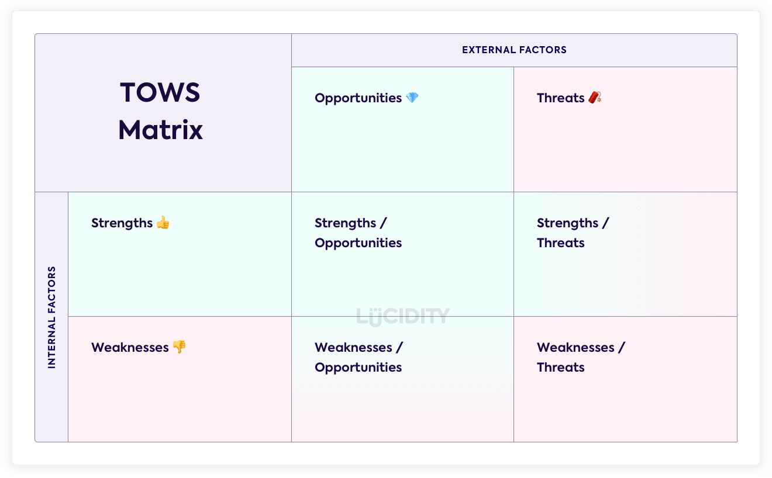
(Lucidity, 2024).

- Strengths to opportunities: The strength of The Trump International hotel and Tower New York is a luxury hotel with high end amenities and services, being New York’s 5-star hotel with a 5-star restaurant responds to the potential opportunities in the market of hosting high-profile events and conferences.
- Strengths to threat: The strength of a luxury brand associated with the Trump name, can mitigate a threat as Trump himself launched a controversial political campaign that may drive away customers.
- Weakness to Opportunities: the opportunity of integrating sustainability in hotel operations can overcome the weakness of high operational costs, as more and more guests are more environmentally conscious and prefer to stay in a sustainable hotel regardless of price.
- Weakness to Threats: The weakness of having negative reviews can develop or enhance the threat of the business as this will push guests towards the competitors which is a threat to the hotel.

Recommendation and Change Management:
A hotel may have a gorgeous pool, a well-stocked bar, or an out-of-this-world spa, but without excellent customer service, a hotel won’t get very far in the hotel business. Customer service pervades every aspect of a hotel, from the tone of the voice of its employees to the technologies it employs to make guests’ life simpler. Make a bad impression on even one guest, and the hotel may receive a complaint, or worse, a negative review. This means hotels must discover ways to increase customer service and increase overall guests’ happiness.
Hoteliers may improve their customer service in several ways (Alemar, 2024). To overcome bad customer service at the Trump International Hotel and Tower New York, several recommendations can be implemented:
- Staff Training:
Investing in efficient staff training is crucial for improving customer service in hotels. When a new staff member joins the team, it’s important to prioritise training to meet hotel standards. This goes beyond simply handing out an employee handbook. Job shadowing an experienced member of staff is an excellent technique to train new members on problem-solving and decision-making processes. It’s crucial to continue training beyond the initial induction. Holding frequent team-building days is an excellent method to improve abilities and bring the team closer together (1834 Hotels, 2022).
- Adopt a customer-centric approach:
It is critical for a business to stay current with the latest trends. Understand what the target customers want, apply those services and amenities into the hotel, and stay on the lookout for innovation and improvement. A hotel should be all about serving the visitors and catering to their wants and experiences.
- Take Regular Feedback:
The best method to give excellent hotel customer service is to listen to the guests. Allow guests to speak up, show them that you recognise their issues and are striving to fix them. Always be available to the guests and ask for their comments on how their stay is going, how they’re enjoying their time at the hotel and if there’s anything the hotel can do to improve their experience. Address any problems the guests may have and provide regular updates (Bhatnagar, 2021).
- Analyse customer feedback:
No matter how excellent a hotel’s service is, negative reviews and complaints are an unfortunate fact of the hotel industry. However, the best-performing hotels do not take this type of feedback personally. Instead, they employ it to boost their properties or chains. Analysing guest feedback is a great to identify patterns or trends within customer service. E.g., do complaints occur at a specific time? Are guests unhappy with one employee, or one department? When the data is analysed meet with the team to reveal insights. Frame the talk positively and incorporate it into future training (Alemar, 2024).
- Empower Hotel Employees:
Providing hotel employees with the freedom they require to accomplish their jobs properly is critical to ensuring guest satisfaction. Typically, as the hotel front of house team is the primary point of contact for guests, it is essential for staff to practice improvising skills. it is also vital to empower employees with the authority to make judgements and act on unplanned ideas (Andriopoulus, 2023).
- Treat guests as individuals:
A prevalent mistake, particularly at large or chain or chain hotels, is to treat people as numbers. That is, treat your customers like a booking code rather than a real person. Changing the approach from management to direct contact staff can fundamentally transform customer service, making it much more human and intimate. This shift in approach can be observed in simple actions like greeting the guest by name or providing a tailored experience (ihcs, 2024).
- Employee training programs:
Avoid the usual lecture-based approach to training. Instead, include interactive features like group discussions, case studies, and role-playing activities. These approaches engage participants, making the learning experience more fun and memorable. Hotel employees can practice their abilities in a secure setting by immersing themselves in realistic customer service scenarios with technology such as virtual reality simulation. This revolutionary method of training not only improves learning but also prepares employees for real-world scenarios (Hotel Tips 101, 2023).
- Make things right:
Priority would be to identify the issue and respond to the reviews as soon as possible this shows the guests that their review was acknowledged. Contact the guest direct and offer a complimentary stay to be able to reexperience the stay. Ensure the staff are trained and issues are made evident to the relevant department so that the guest don’t reexperience the same situation (Bainbridge, 2024).
- Follow up with guests:
After resolving any issues, follow up with guests to ensure they are satisfied with the outcome. This shows that the hotel values their feedback and is committed to improving their experiences (Bainbridge, 2024).

- Shadow the staff:
It’s all about training and attitude, when an issue has been evident of a department or staff, management should shadow the department and staff to understand better the situation and set expectations of attitude expected (Dixon, 2024).
- Allocated time to retrain staff:
Allocate time to all members of staff to retrain staff on the expectations required and refresh staff training. Implement a 16-hour refresh training program (Johnson, 2024).
- Improved communication:
Ensuring clear communication among staff to avoid misunderstandings that can lead to poor service. Regular team meetings can help align everyone on service goals and address any ongoing issues (Lacalle, 2022)..
Following these recommendations The Trump International Hotel and Tower can overcome the negative reviews posted online regarding bad customer service.

Change management:
Virtually every organisation will go through a transition or change in order to stay viable and scale. Whether it’s onboarding new staff, expanding a department, or merging with another company, these changes can have a huge impact on the direction of an organisation. Unfortunately, organisational change is not always straightforward to manage and can be daunting for all team members who are affected by it (Stobierski, 2020).
Changes can be challenging for employees, so it’s critical to have a strategy in place to help them get through the transition. There are numerous benefits to change management. Some of these advantages include enhanced communication, increased productivity, lower stress, and better decision making (IMD, 2024).
Any hotel will inevitably receive complaints from guests who voice dissatisfaction or criticism on a particular aspect of their stay. This might have to do with how they feel about the accommodation, personnel, cuisine, and other things. Whether the feedback is direct or through internet forums, complaints have the potential to damage or interfere with business operations. A hotel operator who ignores complaints from customers will soon lose their good name, whereas one who effectively resolves problems will swiftly enhance their service for all future guests (Elphick, 2024). The Trump International hotel and Tower New York have received a few negative reviews on trip advisor and the booking.com site and to address these bad customer service reviews and facilitate a seamless transition, several change management strategies can be implemented:
- Staff training and development programs:
Determine which areas of customer service require improvement, get guest input, and get the team ready for impending changes. To solve service gaps like lengthy wait times, delayed response times, or managing demanding clients’, this may involve handling training sessions (Aggarwal and Subhashis, 2024).
- Feedback mechanisms:
Establish robust feedback systems, such as surveys and suggestion boxes, to gather insights from guests about their experiences. Actively encourage guests to share their thoughts and ensure that management reviews this feedback to identify areas for improvement (Naser, 2024).
- Leadership Involvement:
Leading by example allows leaders to build trust, inspire others, and create a good environment that helps people to embrace and adapt change. Ensuring management is actively involved in the change process. Leaders should communicate the importance of excellent customer service and demonstrate commitment to improving guest experiences. Regular meetings can help staff informed and motivated (Hone, 2023).
- Clear Communication:
Develop a clear communication plan that outlines the changes being implemented and the reasons behind them. Including updates on progress and success stories to keep staff engaged and informed (Waite, 2024).
- Recognition and Rewards:
Create a recognition program to reward employees for outstanding customer service. This can motivate staff to prioritise guest satisfaction and create a positive work environment (LinkedIn, 2023).
- Crisis Management Plan:
Develop a crisis management plan to address any future customer service issues promptly. This should include protocols for addressing complaints and ensuring that guest feel heard and valued (Althris Training, 2024).
By implementing these recommendations and change management the Trump International Hotel and Tower New York can see potential benefits including increased revenue and decrease in negative reviews. This will help towards improving customer service and creating a more positive experience for guests.

To review and measure the impacts and success rates of the change management strategies implemented at the Trump International Hotel and Tower New York, several methods can be utilised. Conducting regular surveys to gather feedback on guests’ experiences before and after the implementation of changes. This can include questions about service quality, staff responsiveness, and overall satisfaction can help gather information and measure success (Hauck, 2024). Quantitative data is crucial in determining customer service effectiveness. Tracking Key performance indicators (KPIs) such as customer complaint resolution times, repeat bookings, and occupancy rates. Analysing these metrics over time can show trends in service quality and guest satisfaction (Kaufman, 2024). The hotel can monitor social media platforms and review sites for guests’ feedback and ratings. Changes in sentiment and ratings can be a direct reflection of improvements in customer service (Abbas, 2022). Another way to measure the success rate of the change management plan would be to collect feedback from the staff regarding the effectiveness of the training programs and changes in procedure. This will help identify if further support or training is required (Whatfix, 2023).

Benefits of implementing strategies:
The potential benefits that the Trump International Hoel and Tower New York could experience by improving its customer service include:
- Increased customer loyalty:
- Positive reputation
- Competitive advantage
- Higher occupancy rates
- Financial performance
- Operational efficiency
Good customer service requires listening to and respecting the customers. Good customer service reflects a company’s culture; both are inextricably linked. Maintain good customer service, and the customers will recognise the corporate culture. Providing an excellent customer service experience has various real-world implications for the businesses performance and the company is perceived by the public. Good customer service always helps keep the customers; this is what keeps the customers returning for more purchases. Retaining customers enhances revenue, and it also far cheaper to keep existing customers rather than to acquire a new one (intuit mailchimp, 2024). Good customer service showcases a brand’s dependability. Reliable service fosters confidence and loyalty. As reputation grows so will the revenue (Pitman training, 2024). Providing good customer service can result in satisfied customer who are more inclined to promote the company to others (ixion, 2024).
Overall, there are many benefits to good customer service. By realising these benefits, the Trump International Hotel and Tower New York, can create a positive guest experience, drive customer loyalty, and ultimately enhance its overall success in the hospitality industry.

Cost:
Companies spend in employee training programs to boost skills and retention rates. Staff training costs can vary greatly based on the type of training provided and the size of the company (Indeed, 2024). A full day of in-person customer service training typically costs between $500- and $1000 per person. Discounts are available for group training. Training that is self-paced or conducted online can range greatly in price, from free to several hundred dollars (teachfloor, 2024).

Action Plan:
Problem: The Trump International hotel and Tower New Yorkl has been experiencing a decline in guest satisfaction due to inadequate customer service received from the front of house staff members. Complaints have highlighted such as unresponsive staff, very bad attitude. This has led to negative reviews (Tripadvisor, 2024), which is a potential loss of business if not rectified.
Solution: To address these issues, the hotel will implement a comprehensive customer service training program for all of the front of house staff members as the reviews were due to the front of house team. The program will focus on key areas such as effective communication, problem solving skills, empathy skills, and understanding guests’ needs (Seismic, 2024). Additionally, introducing a customer feedback system that will allow guests to leave feedback on their experiences. This will help identify areas for immediate improvement and ensure that staff can respond swiftly to concerns (Vardhan, 2024).
Desired Outcome: After training, employees will excel in interacting with diverse customers, create excellent initial impressions, provide customers with what they need, employees will have excellent communication skills, the employees will be able to manage different customer scenarios and have better knowledge in reading customers’ body language (Pitman training, 2024). Having a good customer service strategy in place boosts sales, enhances brand loyalty, produces referrals, aids in client retention, and gives businesses a competitive advantage over competitors in their field (Grant, 2024). The aim is to achieve a 20% improvement in guest satisfaction ratings within six months of implementing the training program, to then aim to see a 15-20% increase in repat bookings.
Time Scale: The training program will be rolled over a three-month period, with fortnightly sessions. The feedback system will be implemented simultaneously and will be monitored continuously. After six months, a thorough review of customer satisfaction metrics will be conducted and based on results strategies will be adjusted.
Planned budget: The estimated cost of the training program will be approximately $15,000, which will include materials, facilitator fees and staff time. An additional cost of $5000 for the feedback system, reporting services that include in-depth analysis and comprehensive written reporting usually range in price from $1,200 to $4,500 (Amplitude Research,2024). Overall estimate will be about $19,000-$20,000, which will expect to yield return in terms of improved guest experiences and increased revenue in the long term.

Conclusion:
To conclude, addressing the issue of bad customer service that resulted to negative reviews online at the Trump Internation hotel and Tower New York is not only essential for enhancing guest satisfaction but also vital for the long-term success of the hotel. S.B. & Partners will assist the Trump International and hotel Tower New York overcome this issue implementing their specialised strategies. The implementation of a customer service training program will equip staff with the necessary skills to engage with guests effectively. Training sessions will emphasise the importance of communication, empathy, and problem-solving, enabling employees to address guest concerns promptly and professionally. This approach can significantly reduce the likelihood of negative experiences, fostering a welcoming environment that encourages repeat visits. The introduction of a feedback system will serve as a valuable tool for continuous improvement. By allowing guests to share their experiences, the hotel can identify issues as they arise and take immediate actions to correct the issue. This responsiveness will demonstrate a commitment to guest satisfaction and will also empower staff to take ownership of their roles enhancing the overall experience. The insights gained from guest feedback will inform ongoing training and operational adjustments, ensuring that the hotels remain aligned with guest expectations.
The action plan presented in this report offers a comprehensive and strategic approach to address the challenges posed by inadequate customer service at the Trump International Hotel and Tower New York. By prioritising staff training and implementing a strong feedback system, the hotel can create a culture of excellence that not only meets but exceeds guest expectations. This will result in improved customer satisfaction, increased repeat booking, a strong reputation in the hospitality industry, increased revenue and will enhance the hotel’s success in the hospitality’s competitive market.

References

1834 HOTES (2022) How to Improve Customer Service in a Hotel. Available at: How to Improve Customer Service in a Hotel - 1834 Hotels (Accessed: 07 November 2024).

Abbas, T. (2022) How to Use Social Media for Change Management. Available at: https://changemanagementinsight.com/how-to-use-social-media-for-change-management/#google_vignette (Accessed: 11 November 2024).

Aggarwal and Subhashis, B.S. (2024) Change Management Models: A Customer Service Perspective. Available at: https://www.sprinklr.com/cxm/change-management-models/#:~:text=A%20change%20management%20model%20aligns,enhanced%20customer%20satisfaction%20and%20loyalty. (Accessed: 10 November 2024).

Alemar, S. (2024) Customer Service in the Hotel Industry: 9 Ways to Improve. Canary Technologies. [blog]. 22 May. Available at: Customer Service in the Hotel Industry: 9 Ways To Improve (Accessed: 07 November 2024).

Althris Training (2024) The Role od Change Management in Crisis Situations. Available at: https://www.linkedin.com/pulse/role-change-management-crisis-situations-althris-vwj4e/ (Accessed: 11 November 2024).

Amplitude Research (2024) Competitive Pricing for Client and Customer Surveys. Available at: https://www.amplituderesearch.com/customer-survey-cost.shtml (Accessed: 11 November 2024).

Andriopoulos, S. (2023) Seven ways to improve customer service in hotel industry. Available at: Seven ways to improve customer service in hotel industry (Accessed: 07 November 2024).

Asif (2023) The Consequences of Poor Customer Service: Impact on Businesses and Customers. Available at: The Consequences of Poor Customer Service: Impact on Businesses and Customers - Support Genix (Accessed: 31 October 2024).

Bainbridge, T. (2024) Conversation with Syeda Shabna Begum, 08 November.

Barten, M (2024) Hospitality Consulting: What is It and How Can It Benefit You? Available at: https://www.revfine.com/hospitality-consulting/ (Accessed: 30 October 2024).

Bhatnagar, P. (2021) Good vs. Bad Customer Service: How to improve customer service. Hotelogix. [blog]. 11 May. Available at: Good vs. Bad Customer Service: How to improve customer service (Accessed: 07 November 2024).

Booking.com (2024) Trump International New York. Available at: Trump International New York, New York (updated prices 2024) (Accessed: 30 October 2024).

Cobalt (2024) The Towers that Trump Built. Available at: https://www.cobaltrecruitment.co.uk/blog/2016/10/the-towers-that-trump-built?source=google.com (Accessed: 07 November 2024).

Council on Tall Buildings and Urban Habita (2024) Trump International Hotel & Tower. Available at: https://www.skyscrapercenter.com/building/trump-international-hotel-tower/203#:~:text=As%20part%20of%20the%20tower's,buildings%20with%20conventional%20cooling%20towers. (Accessed: 07 November 2024).

Craft (2024) The Trump Organization’s competitors. Available at: https://craft.co/the-trump-organization/competitors (Accessed: 09 November 2024).

Crew (2021) President Trump’s 3,400 conflicts of interest. Available at: https://www.citizensforethics.org/reports-investigations/crew-reports/president-trumps-3400-conflicts-of-interest/ (Accessed: 07 November 2024).

Customer Alliance (2024) Why hotel online reputation management should be your top priority. Available at: Why hotel online reputation management should be your top priority (Accessed: 06 November 2024).

Dabo, M. (2024) Trump’s presidency and the path ahead for hospitality. Available at: https://www.hotelmanagement-network.com/news/trumps-presidency-and-the-path-ahead-for-hospitality/ (Accessed: 10 November 2024).

Daoust, C (2021) The importance of customer service in the hospitality industry. Available at: The importance of customer service in the hospitality industry – Hotello (Accessed: 01 November 2024).

Dixon, R. Conversation with Syeda Shabna Begum, 11 November.

Elphick, D. (2024) Hotel complaints: Guide to handling guest complaints in hotels. Available at: https://www.imd.org/blog/management/change-management/#:~:text=Changes%20can%20be%20difficult%20for,stress%20and%20improved%20decision%20making. (Accessed: 10 November 2024).
Forbes Travel Guide (2024) Trump International Hotel & Tower New York. Available at: https://www.forbestravelguide.com/hotels/new-york-city-new-york/trump-international-hotel-tower-new-york (Accessed: 07 November 2024).

Franklin Jr, C. (2015) Trump Hotel Powers Up Demanding Guests’ Wi-Fi Experience. Available at: https://www.informationweek.com/it-leadership/trump-hotel-powers-up-demanding-guests-wifi-experience (Accessed: 10 November 2024).

Grant, M. (2024) What Is Customer Service, and What Makes It Excellent? Available at: https://www.investopedia.com/terms/c/customer-service.asp#:~:text=Customer%20service%20is%20a%20very,others%20in%20the%20same%20industry. (Accessed: 11 November 2024).

Guest Ban (2024) How Are Negative Hotel Reviews Affecting You? Available at: How are Negative Hotel Reviews Affecting You? - Guest Ban (Accessed: 01 November 2024).

Hauck, T. (2024) Lost Without a Map? A Change Strategy to Guide Your Success. Prosci. [blog]. 6 August. Available at: https://www.prosci.com/blog/change-management-strategy#:~:text=Regularly%20monitor%20the%20progress%20of,understand%20where%20your%20project%20stands. (Accessed: 11 November 2024).

Ixion (2024) Five benefits of good customer service. Available at: https://www.ixionholdings.com/five-benefits-of-good-customer-service/ (Accessed: 11 November 2024).

Hone (2023) The 5 Essential Responsibilities of Leadership in Change Management. [blog]. 6 June. Available at: https://honehq.com/resources/blog/leadership-in-change-management/#:~:text=By%20leading%20through%20example%2C%20leaders,that%20supports%20the%20change%20vision. (Accessed: 10 November 2024).

Hotel Management Network (2024) Trump Hotels adopts ReactorNet P2P tool across global portfolio. Available at: https://www.hotelmanagement-network.com/news/trump-hotels-adopts-reactornet-tool/?cf-view (Accessed: 09 November 2024).

Hotel Tips 101 (2023) How to Train Hotel Staff for Exceptional Customer Service Skills. Available at: How to Train Hotel Staff for Exceptional Customer Service Skills - Hotel Tips 101 (Accessed: 07 November 2024).

IHCS hotel consulting (2024) 9 tips to improve customer service in the hotel industry. Available at: 9 tips to improve customer service in the hotel industry - IHCS (Accessed: 07 November 2024).

IMD (2024) Everything you need to know about change management. Available at: https://www.imd.org/blog/management/change-management/#:~:text=Changes%20can%20be%20difficult%20for,stress%20and%20improved%20decision%20making. (Accessed: 10 November 2024).

Indeed (2024) A guide to staff training costs (plus tips to reduce them) Available at: https://uk.indeed.com/career-advice/career-development/staff-training-cost (Accessed: 11 November 2024).

International Hotel Consulting Services (2024) Hotel Consulting, what is it really about? Available at: https://www.ihcshotelconsulting.com/blog/hotel-consulting-what-is-it-really-about/ (Accessed: 30 October 2024).

Intuit mailchimp (2024) Importance of Customer Service. Available at: https://mailchimp.com/resources/importance-of-customer-service/ (Accessed: 11 November 2024).

Johnson, M. (2024) Conversation with Syeda Shabna Begum, 08 November.

Kaufman, N. (2024) How do you measure the success of your customer service strategies? Available at: https://www.linkedin.com/advice/1/how-do-you-measure-success-your-customer-7jl5c (Accessed: 11 November 2024).

Khalil, S.S.A. (2023) The Power of Guest Feedback! How Negative Reviews Impact Hotel Business! Available at: https://www.linkedin.com/pulse/power-guest-feedback-how-negative-reviews-impact-hotel-samer-khalil/ (Accessed: 06 November 2024).

Lacalle, E (2022) 10 best practices for employee communication. MEWS. [blog]. 29 June. Available at: https://www.mews.com/en/blog/hotel-employee-communication (Accessed: 11 November 2024).

LinkedIn (2023) How do you reward change management success? Available at: https://www.linkedin.com/advice/1/how-do-you-reward-change-management-success#:~:text=By%20aligning%20rewards%20with%20goals,engagement%2C%20commitment%2C%20and%20performance. (Accessed: 11 November 2024).

Lucidity (2024) An introduction to TOWS Analysis. Available at: https://getlucidity.com/strategy-resources/an-introduction-to-tows-analysis/ (Accessed: 11 November 2024).

Luxury Holidays (2024) Trump International Hotel & Tower, New York. Available at: https://www.luxuryholidays.co.uk/destinations/usa/new-york/trump-international (Accessed: 07 November 2024).

Makos, J. (2024) What is PESTLE Analysis? Available at: What is PESTLE Analysis? (Free Template) (Accessed: 01 November 2024).

May, C. (2024) How Google Reviews and Others Impact Hotel Revenue. Available at: How Google Reviews and Others Impact Hotel Revenue | HotelTechConsultant.com (Accessed: 05 November 2024).

Naser, M. (2024) The Importnace of Customer Feedback. SmartSurvey. [blog]. 29 July. Available at: https://www.smartsurvey.co.uk/blog/importance-of-customer-feedback (Accessed: 10 November 2024).

Operto (2024) 85.6% Of Travelers Say They Would Pay More for An Eco-friendly Choice Of Hotels. Available at: https://operto.com/green-hotels-consumer-report/ (Accessed: 11 November 2024)

Peterdy, F. (2024) SWOT Analysis. Available at: SWOT - Definition, Examples, Process, Uses (Accessed: 01 November 2024).

Peterdy, K. (2024) PESTEL Analysis. Available at: https://corporatefinanceinstitute.com/resources/management/pestel-analysis/ (Accessed: 06 November 2024).

Pitman Training (2024) Why is Customer Service Important to a Company? Available at: https://www.pitman-training.com/advice-hub/pitman-blog/why-is-customer-service-important-to-a-company/ (Accessed: 11 November 2024).

Seismic (2024) The customer service training guide. Available at: https://seismic.com/enablement-explainers/customer-service-training/ (Accessed: 11 November 2024).

Sierra Club (2024) Judges Sides with Sierra Club, Rules Trump International Violated Illinois Environmental Protection Act. Available at: https://www.sierraclub.org/press-releases/2024/09/judge-sides-sierra-club-rules-trump-international-violated-illinois#:~:text=The%20Trump%20Tower%20is%20one,or%20trapped%20against%20its%20screens. (Accessed: 11 November 2024).

Shubham (2024) Importance of Guest Feedback for Hotels-Why Does it matter? Available at: https://botshot.ai/resources/blog/importance-of-guest-feedback-for-hotels (Accessed: 02 November 2024).

Stobierski, T. (2020) ORGANIZATIONAL CHANGE MANAGEMENT: WHAT IT IS & WHY IT’S IMPORTANT. Harvard Business School Online. [blog]. 21 January. Available at: What Is Organizational Change Management? | HBS Online (Accessed: 10 November 2024).

Teachfloor (2024) What is Customer Service Training? Available at: https://www.teachfloor.com/elearning-glossary/what-is-customer-service-training (Accessed: 11 November 2024).

Telegraph Media Group Holdings Limited (2024) New York City. Available at: https://www.telegraph.co.uk/travel/destinations/north-america/united-states/new-york/hotels/Trump-International-Hotel-and-Tower/ (Accessed: 31 October 2024).

The Peninsula (2021) A major threat to Trump the brand? Trump the candidate. Available at: https://thepeninsulaqatar.com/article/21/10/2016/A-major-threat-to-Trump-the-brand-Trump-the-candidate (Accessed: 09 November 2024).

The Trump Organization (2024) The Trump Story. Available at: https://www.trump.com/timeline (Accessed: 01 November 2024).

Thomson Reuters (2024) The economic & regulatory implications of Trump’s 2024 election victory. Available at: https://www.thomsonreuters.com/en-us/posts/government/trump-economic-regulatory-implications/ (Accessed: 09 November 2024).
Tripadvisor (2024) Trump International Hotel and Tower New York. Available at: TRUMP INTERNATIONAL HOTEL AND TOWER NEW YORK - Updated 2024 Reviews, Photos & Prices (Accessed: 30 October 2024).

Trump Hotels (2024) TRUMP INTERNATIONAL HOTEL & TOWER NEW YORK. Available at: https://www.trumphotels.com/central-park (Accessed: 07 November 2024).

TRUMP INTERNATIONAL HOTELS MANAGEMENT LLC (2024) Services & Amenities. Available at: https://www.trumphotels.com/central-park/manhattan-luxury-hotel-amenities (Accessed: 01 November 2024).

Viqal (2024) Bad Hotel Revies and Their Financial Impact. Available at: Bad Hotel Reviews and Their Financial Impact (Accessed: 06 November 2024).

Vallauri, D.J. (2016) The Costly Effects of Bad Customer Service on Hotels. Available at: The Costly Effects of Bad Customer Service on Hotels. : 4Hoteliers (Accessed: 05 November 2024).

Vardhan, H. (2024) Customer Feedback Guide: How to Collect and What to Do With It? Hiver. [blog]. 21 October. Available at: https://hiverhq.com/blog/collect-customer-feedback#:~:text=Customer%20satisfaction%20is%20the%20primary,to%20nurture%20them%20into%20advocates. (Accessed: 11 November 2024).

Visual Paradigm (2024) TOWS Analysis: A comprehensive Guide. Available at: TOWS Analysis: A Comprehensive Guide (Accessed: 01 November 2024).

Waite, R. (2024) 5 Key Metrics To Measure During A Change Management Process. Available at : https://www.robinwaite.com/blog/5-key-metrics-to-measure-during-a-change-management-process#:~:text=Stakeholder%20analysis:%20The%20project%20manager%20identified%20all,to%20inform%20stakeholders%20about%20the%20purpose%20of (Accessed: 10 November 2024).

Whatfix (2023) 9 Change Management KPIs & Metrics to Track in 2024. Change Management. Available at: https://whatfix.com/blog/change-management-kpis/ (Accessed: 11 November 2024).

Whittaker System (2022) The Impact Of A Negative Hotel Review. Available at: https://www.whittakersystem.com/blog/the-impact-of-a-negative-hotel-review/#:~:text=One%20negative%20review%20can%20undo,impact%20on%20a%20property's%20success. (Accessed: 02 November 2024).

Zendesk (2024) Making guest feel welcome with hotel customer service. Available at: Hotel Customer Service For Best Customer Experience | Zendesk (Accessed: 06 November 2024).

I confirm that I have not used any AI tools in the research and creation of this assignment. I confirm that I have not presented and AI generated materials as my own work. I confirm I have copies of my drafts, notes, and other resources I used, which I may be asked to provide in evidence.

