

Student name: Parwana Rezaeie
Student ID: 1916557
Module name: BSc (Hons) Health and Social Care
Module code: BMHP6020-Independent Project
Supervisor’s name: Jolly Nwankwo

  Diocese Of London (2026) |  | An exploration of the impact of social isolation on the mental health and wellbeing of autistic children in the United Kingdom  Aim: to explore the impact of social isolation on the mental health and wellbeing of autistic children in the United Kingdom and identify evidence-based recommendations to promote social inclusion and improve mental wellbeing within health and social care practice.  Objectives  - To examine the social, educational and environmental factors contributing to social isolation among autistic children in the United Kingdom.  - To critically analyse the impact of social isolation on the mental health and wellbeing of autistic children in the United Kingdom.  To develop evidence-based recommendations for families, educators and health and social care professionals to promote social inclusion and improve mental wellbeing.  This project will use secondary research by doing a scoping review of existing UK studies published between 2014 and 2025. |  | Diocese Of London (2026)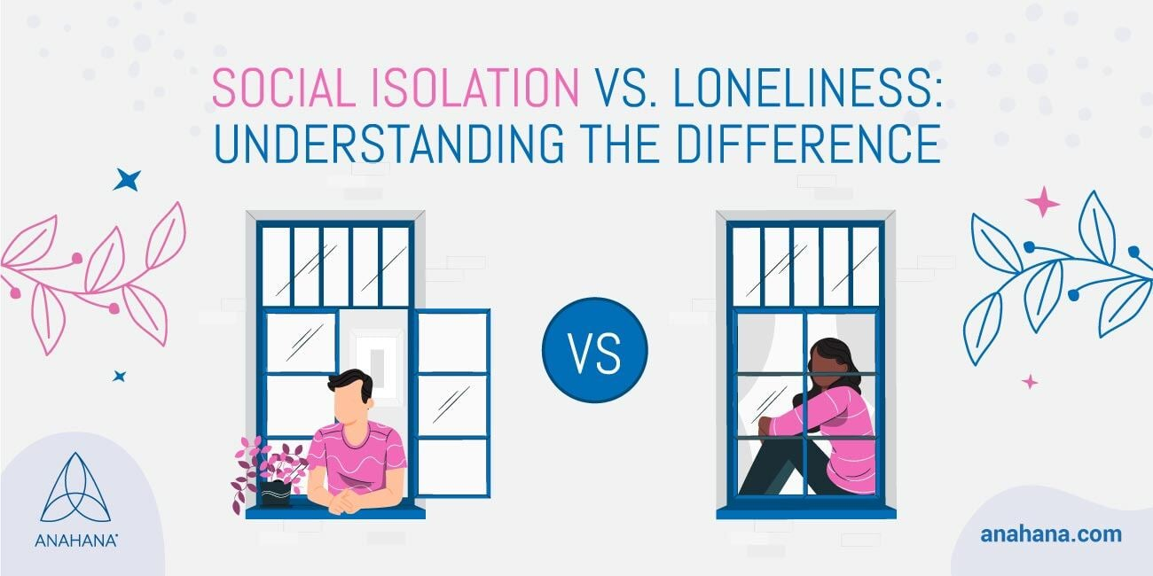
Methodology  Drawing on secondary research, a scoping review methodology was used to analyse existing literature, including three UK-based studies and two international studies. Databases such as Google Scholar, PubMed, and NICE Evidence were searched using keywords related to autism, social isolation, children, and mental health. A thematic analysis was applied to identify common patterns across the selected studies.  Key Finding:  Theme 1: Social Isolation and Emotional Distress  The reviewed literature associated social isolation with anxiety, stress and emotional difficulties among autistic children. Pellicano et al. (2022) highlighted the challenges experienced by autistic people and their families during COVID-19, when reduced social contact and disrupted routines affected wellbeing.  Theme 2: School Exclusion and Limited Support  School environments and the availability of appropriate support play an important role in social inclusion. Martin-Denham (2022) explored caregivers’ perspectives on autism, marginalization and school exclusion, highlighting challenges experienced by children and their families.  Theme 3: Supportive Relationships and Inclusion  Supportive relationships with families, teachers and peers may help autistic children participate in social activities and develop meaningful connections. Inclusive environments and appropriate support are important considerations in promoting wellbeing (National Autistic Society, 2022; NICE, 2021 |  |  |  | Data Analysis  The findings will be analysed and compared to identify common themes, risk factors, and good practices for supporting autistic children’s mental health.  Ethical considerations  This study was a secondary qualitative analysis that relied solely on existing published literature, with no primary data collection or participant recruitment involved. I obtained ethical approval from the UWSTD. All sources used were publicly accessible and referenced in line with academic integrity norms. Throughout the study, confidentiality, data protection, and the prevention of harm were prioritized. The research was conducted in accordance with the BHBIA (2020) ethical framework for secondary data utilization.  Implications for Health and Social Care:  The findings highlight the importance of:  - Improving autism awareness among teachers and health and social care professionals.  - Promoting inclusive school environments and positive peer relationships.  - Strengthening communication between families, schools and support services.  - Recognizing emotional distress and providing appropriate support.  - Improving access to inclusive social activities and autism-informed services.  These approaches may help reduce barriers to participation and support the mental wellbeing of autistic children.
Data Collection method
This study involves secondary research; therefore, no direct contact will be made with children, families, or professionals.
However, the research will follow ethical guidelines by ensuring all sources are accurately cited to avoid plagiarism.
The researcher will use respectful and person-centred language when referring to children with ASD to prevent stigma or discrimination.
Sensitive topics, such as mental health and isolation, will be discussed with care and confidentiality.
The study will also ensure that all information is obtained from credible and reliable sources to maintain honesty, transparency, and academic integrity

Conclusion:
Social isolation is an important concern for the mental health and wellbeing of autistic children in the United Kingdom. The reviewed literature highlights the role of peer relationships, school inclusion and appropriate support in shaping children's social and emotional experiences.
A coordinated approach involving families, educators and health and social care professionals is important in promoting inclusion, identifying support needs and improving wellbeing.

References:

Martin-Denham, S. (2022) ‘Marginalisation, autism and school exclusion: caregivers’ perspectives’, Support for Learning, 37(1), pp. 108–143. Available at: https://doi.org/10.1111/1467-9604.12398. (Accessed: 9 October, 2026).
National Autistic Society (2022) ‘Loneliness’. Available at: https://www.autism.org.uk/advice-and-guidance/loneliness (Accessed: 11 October 2026).
National Institute for Health and Care Excellence (NICE) (2013, updated 2021) Autism spectrum disorder in under 19s: support and management. NICE guideline CG170. Available at: https://www.nice.org.uk/guidance/cg170 (Accessed: 11 October 2026).
Pellicano, E., Brett, S., den Houting, J., Heyworth, M., Magiati, I., Steward, R., Urbanowicz, A. and Stears, M. (2022) ‘COVID-19, social isolation and the mental health of autistic people and their families: A qualitative study’, Autism, 26(4), pp. 914–927. Available https://doi.org/10.1177/13623613211035936. (Accessed: 10 October 2026).

Diocese Of London (2026) Mental health and isolation Available at: https://www.london.anglican.org/church-and-parish-support/compassionate-communities/mental-health-isolation (Accessed: 11 October 2026).
Diocese Of London (2026) Mental health and isolation Available at: https://www.anahana.com/en/mental-health/social-isolation/ (Accessed: 11 October 2026).

