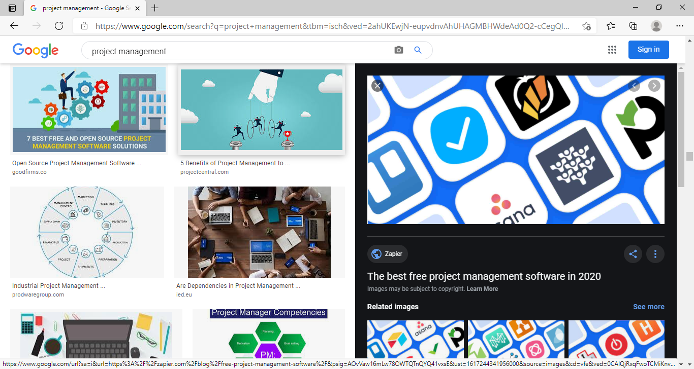
Cover page:
UWTSD
BIRMINGHAM CAMPUS
BMSW5104
Managing Projects in the Organisation
Sajida Bi
1810155
Lecturer name: Paul Ranson

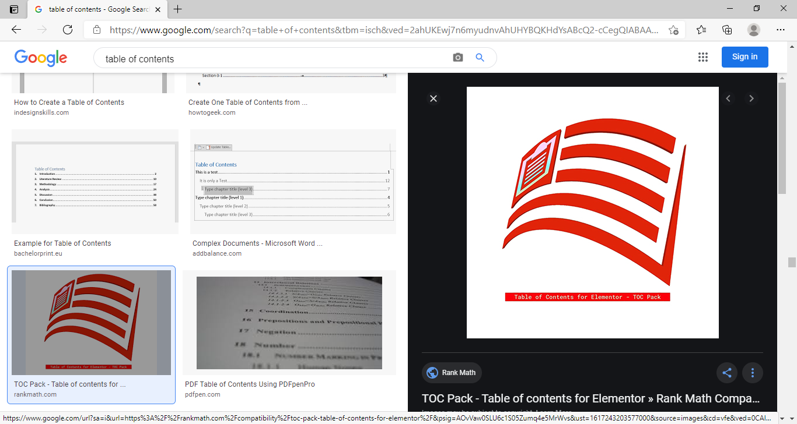
Table 1of 1content 1page:
Cover 1page: 11
Table 1of 1content 1page: 12
Introduction: 13
My 1role: 13
Waterfall 1approach: 14
7 1Red 1lines: 14
PRINCE2: 14
Stakeholder 1mapping: 15
The 1project 1cycle: 16
Other 1project 1roles: 16
Iron 1Triangle: 17
Project 1scope: 18
User 1Stories: 18
Project 1problems: 19
Trello 1Software: 110
Sticky 1note 1approach: 110
Gantt 1chart: 111
Wisdom 1of 1crowd: 111
Time 1& 1Cost: 112
Conclusion: 113
References: 14
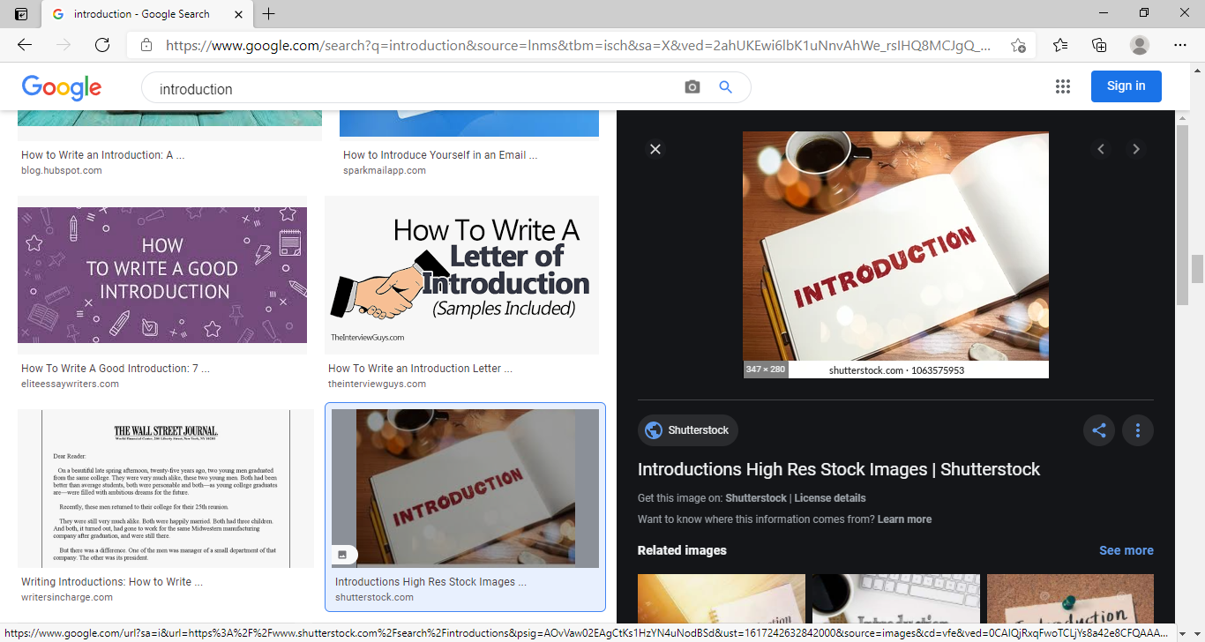
Introduction:
I will be discussing in this assignment about how I will be helping Vintners relocate their business from Shirley to Sparkhill, In this process I will be using my past experience, knowledge and skills to make this move as calm as possible, it will be my upmost and vital priority to fulfil Vintners demands to make this project a successful move so they don’t need to worry about the relocation and can stay focused on their business itself without worrying about other things which I can sort out for them.
I will talk to suppliers and find who would be happy to work with the Vintners to make their project grow and be successful through planning and management and also to set tasks for their business so it will be easier for them to achieve their goals in the future. My upmost and vital aim is to make sure that the Vintners are satisfied with my service and expertise (Barsky, 1992), and also will help them to understand the need of user stories and how to correctly prioritise them as this will help them to successfully achieve their set targets.
My role:
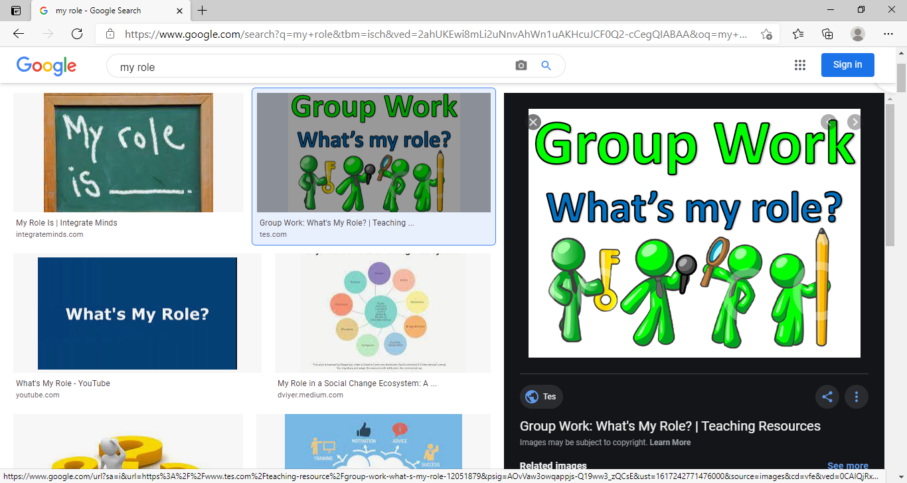
After my research about your business I have come to know that you are interested in running your business like the television show Salvage Hunters, keeping in mind that you are new to project management and would require full training on how to write and prioritise user stories, with my knowledge and skills that I have gained through my studies I have learnt various ways to reduce risks involved in projects.
My role in this project will be as a project manager, I will support Vintners to successfully accomplish their business throughout their project duration, I will be discussing every single task with the project sponsor to get it approved before finalising this, through my past experience, knowledge and skills I will be using various methods to successfully complete Vintners project.
Considering Vintners project now I will be discussing different methods and approaches which will reduce the failing risk and support the completion of this project successfully.

Waterfall 1approach:
For 1simple 1and 1structured 1projects 1Waterfall 1approach 1is 1best 1used 1because 1of 1its 1linear 1and 1easy to 1follow 1design, 1its 1visual 1representation 1makes 1it 1easy 1to 1understand 1the 1steps 1that 1must 1be completed 1to 1achieve 1project 1objectives,
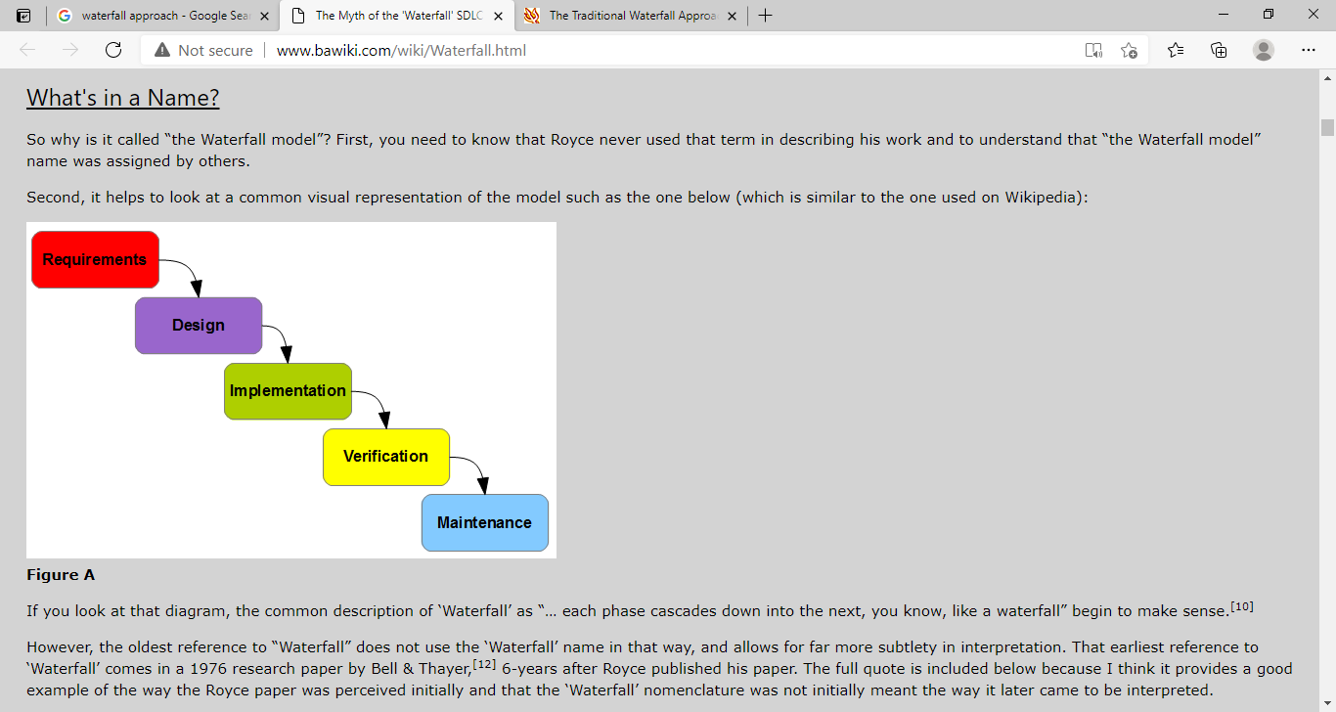
Waterfall 1approach 1is 1an 1extremely 1rigid 1model 1that 1designates 1the 1steps 1needed 1to 1push 1further down 1the 1sequential 1stages 1of 1a 1project, 1It’s 1easily 1understood 1because 1it 1follows 1the 1same pattern 1for 1each 1project 1and 1requires 1no 1prior 1knowledge 1or 1training 1to 1get 1started, 1each 1of 1the phases 1has 1specific 1components 1that 1need 1to 1be 1met 1and 1reviewed, 1making 1it 1easy 1to 1maintain control 1over 1each 1step, 1because 1the 1start 1and 1end 1points 1of 1each 1step 1are 1determined 1at 1the onset 1of 1a 1project, 1it’s 1easy 1to 1share 1progress, 1report 1on 1missed 1deadlines, 1and 1eliminate 1risk associated 1with 1project 1management.
7 1Red 1lines:
The main concept behind 7 red lines in project management is to understand the reason why most projects fails in their initial stages, after viewing this YouTube short video The Expert we can clearly understand that when everybody gives their ideas and nobody listen to each other and everyone thinks they have the great idea rather than considering other ideas is the main reason behind failing a project.
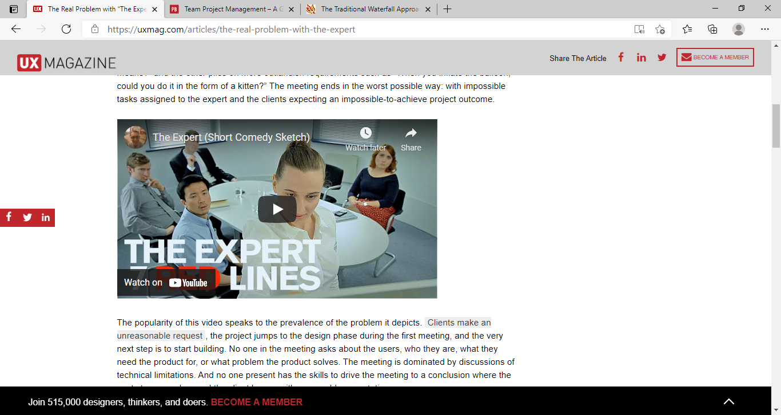
Therefore it is highly recommended that during business meetings we appreciate each other ideas and consider all ideas all together and then come to a final decision where we can choose the best idea out of all available ideas as to gain success it is very important to share and listen each other ideas very carefully.
PRINCE2:
Prince2 1is 1among 1the 1most 1widely 1practiced 1project 1management 1methodologies 1around 1the world. 1Initially, 1it 1was 1created 1for 1the 1United 1Kingdom 1government 1as 1a 1way 1to 1manage 1IT projects 1effectively. 1However, 1due 1to 1its 1success, 1Prince2 1has 1quickly 1spread 1to 1the 1private 1sector, PRINCE2 1is 1the 1world’s 1leading 1structured 1project 1management 1methodology, 1it 1provide 1clear guidance 1about 1the 1best 1ways 1to 1manage 1projects 1and 1It 1also 1helps 1organizations 1get 1better control 1over 1projects 1and 1better 1return 1on 1investment.
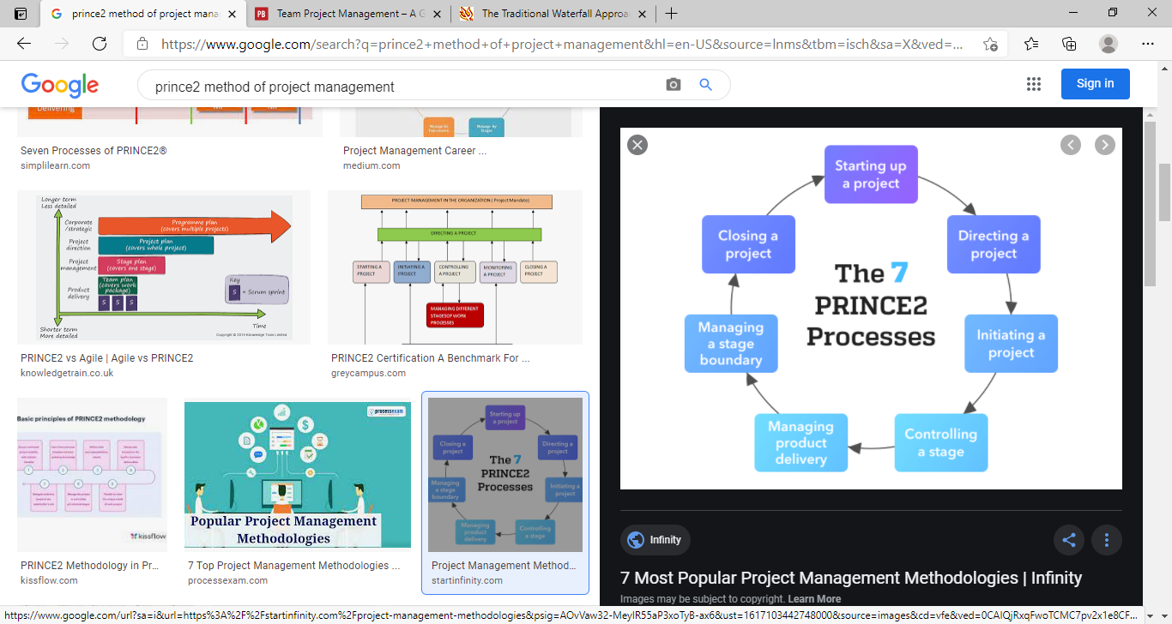
It 1helps 1to 1work 1out 1who 1should 1be 1involved 1in 1a 1project, 1their 1role 1and 1their 1responsibilities. PRINCE2 1has 1a 1set 1of 1processes 1to 1work 1through 1and 1it 1explains 1what 1information 1needs 1to 1be gathered 1(Axelos 12020), 1the 1method 1is 1the 1de-facto 1standard 1for 1project 1management 1in 1the 1UK and 1is 1practiced 1globally, 1PRINCE2 1is 1very 1adaptable 1and 1can 1be 1applied 1to 1all 1sorts 1of 1projects, no matter 1how 1big 1or 1small 1the 1project 1is, 1even 1projects 1lasting 1a 1few 1days 1will 1benefit 1from selective application 1of 1PRINCE2 1guidelines.
Stakeholder 1mapping:
Stakeholder 1mapping 1is 1a 1process 1of 1finding 1out 1the 1key 1stakeholders 1relating 1to 1a 1project, 1the process 1involves 1identifying 1all 1individuals 1who 1have 1an 1interest 1in 1the 1project 1outcome, 1a 1project stakeholder 1can 1be 1one 1individual 1or 1multiple 1individuals, 1once 1all 1the 1project 1stakeholders 1are identified 1the 1project 1manager 1must 1map 1or 1categorize 1them 1according 1to 1different 1levels 1of engagement, 1mapping 1of 1the 1stakeholder 1should 1be 1done 1according 1to 1the 1following 1two 1levels.
The 1level 1of 1interest.
The 1level 1of 1influence.
By 1influence, 1it 1means 1stakeholders 1have 1power 1in 1setting 1and 1modifying 1project 1requirements and 1on 1the 1other 1hand, 1interest 1means 1that 1stakeholders 1are 1affected 1by 1the 1project 1outcome but they 1do 1not 1have 1any 1power 1to 1influence 1project 1requirements.
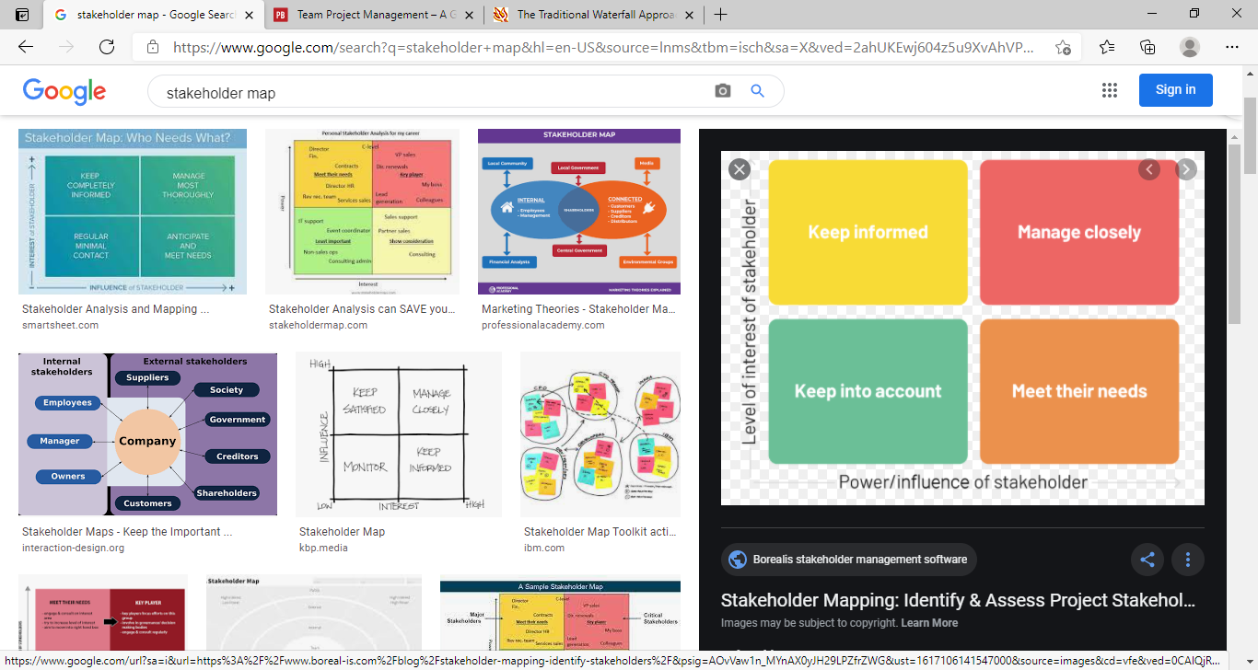
Stakeholder 1mapping 1is 1essential 1for 1the 1success 1of 1a 1project, 1when 1you 1have 1mapped 1the stakeholders 1it 1will 1help 1in 1better 1managing 1their 1expectations 1so 1actively 1engaging 1with 1the stakeholders 1will 1result 1in 1increased 1perception 1of 1success.
The 1project 1cycle:
A 1project 1cycle 1is 1the 1sequence 1of 1phases 1that 1a 1project 1goes 1through 1from 1its 1initiation 1to 1its closure, 1the 1number 1and 1sequence 1of 1the 1cycle 1are 1determined 1by 1the 1management 1and 1various other 1factors 1like 1needs 1of 1the 1organization 1involved 1in 1the 1project, 1the 1nature 1of 1the 1project, and its 1area 1of 1application, 1the 1phases 1have 1a 1definite 1start, 1end, 1and 1control 1point 1and 1are constrained 1by 1time, 1the 1project 1cycle 1can 1be 1defined 1and 1modified 1as 1per 1the 1needs 1and 1aspects of 1the 1organization, 1even 1though 1every 1project 1has 1a 1definite 1start 1and 1end, 1the 1particular objectives, 1deliverables, 1and 1activities 1vary 1widely, 1the 1project 1cycle 1provides 1the 1basic 1foundation of 1the 1actions 1that 1has 1to 1be 1performed 1in 1the 1project, 1irrespective 1of 1the 1specific 1work 1involved.
The 1project 1cycle 1has 1five 1phases.
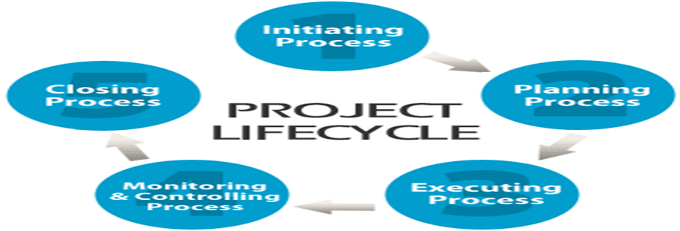
Project 1Initiation:
Project 1Planning
Project 1Execution
Project 1Monitoring 1and 1Control
Project 1Closure
Other 1project 1roles:
I strongly believe to be successful in any business it is highly vital to set goals and targets to follow which will take you high up the ladder to success. As a project manager it is my responsibility to make all the members of the group aware of the role they are doing and to use all of their knowledge, skills and understanding to complete their tasks and first of all to set goals in order to successfully achieve the completion and progress of the job (Robert, 2011).
To gain success you need to be well organised and as a project manager it is my job to check everything before finalising it, be it new business proposals or financial planning this will be carefully checked and then made a decision off after careful planning and consideration.
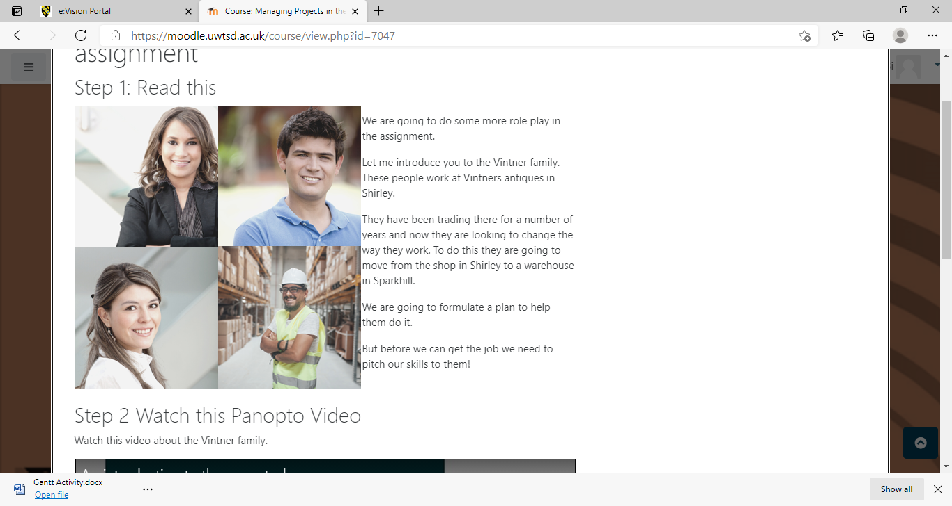
Denis is a person who likes to travel and he has ideas of where to bring stock from on a good and reasonable price so considering this I would highly suggest him to be the project sponsor. During this project as a project sponsor Denis needs to fully check that everything is running smoothly and efficiently.
Doreen is a well settled woman and her main responsibilities are to deal with all financial work such as bills, invoices, tax and revenue etc. In this project Doreen’s role is very important so she needs to take interest in sharing ideas and in writing and prioritising user stories.
Suha is Vintners long-time family friend and is very good in talking people in to things, she loves to use all her strength to persuade individuals with this skill she is a very important member of the team.
As a steering group specialist Omar has great value in this company and project he’s main responsibilities are to gather all ideas and make a final decision after taking advice from all of the team members.
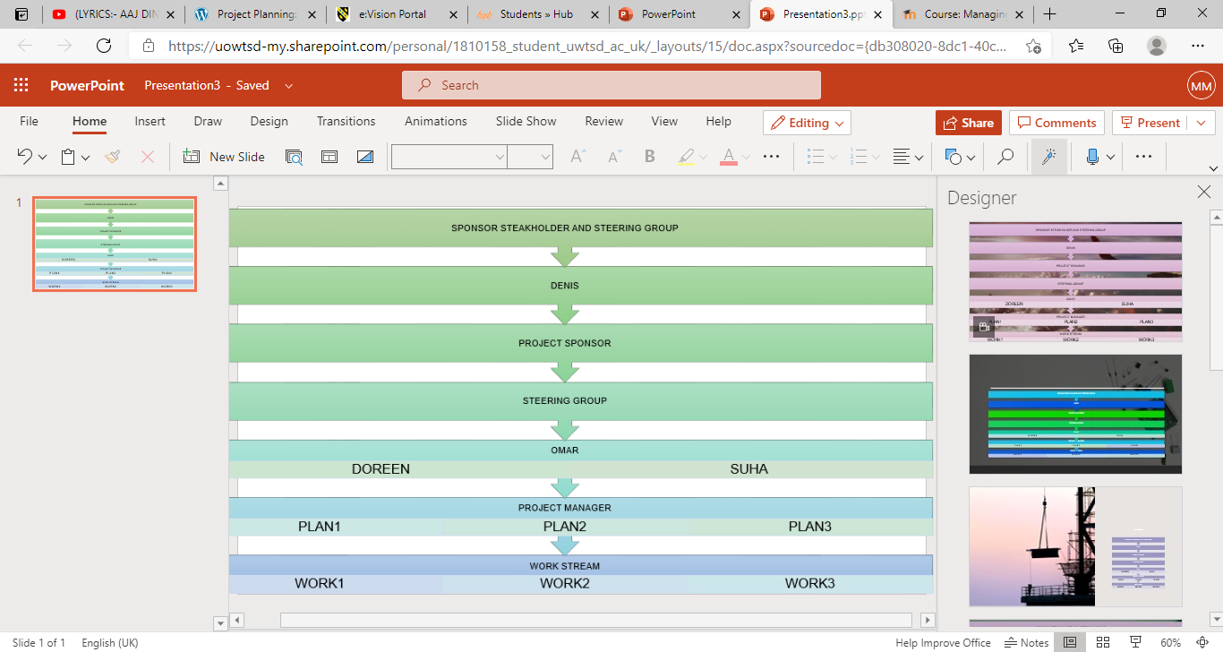
This sponsor, stakeholder and steering group chart has been created by using Microsoft Smart Art on power point and then I copied and pasted it on this report (Microsoft 2020).
Iron 1Triangle:
The 1Project 1Triangle 1or 1Iron 1Triangle 1expresses 1the 1triple 1Constraint 1of 1time, 1cost 1and 1quality 1or scope 1that 1must 1be 1managed 1in 1project 1delivery, 1each 1constraint 1is 1connected 1and 1moving 1one point 1of 1the 1triangle 1will 1impact 1the 1other 1two 1points.
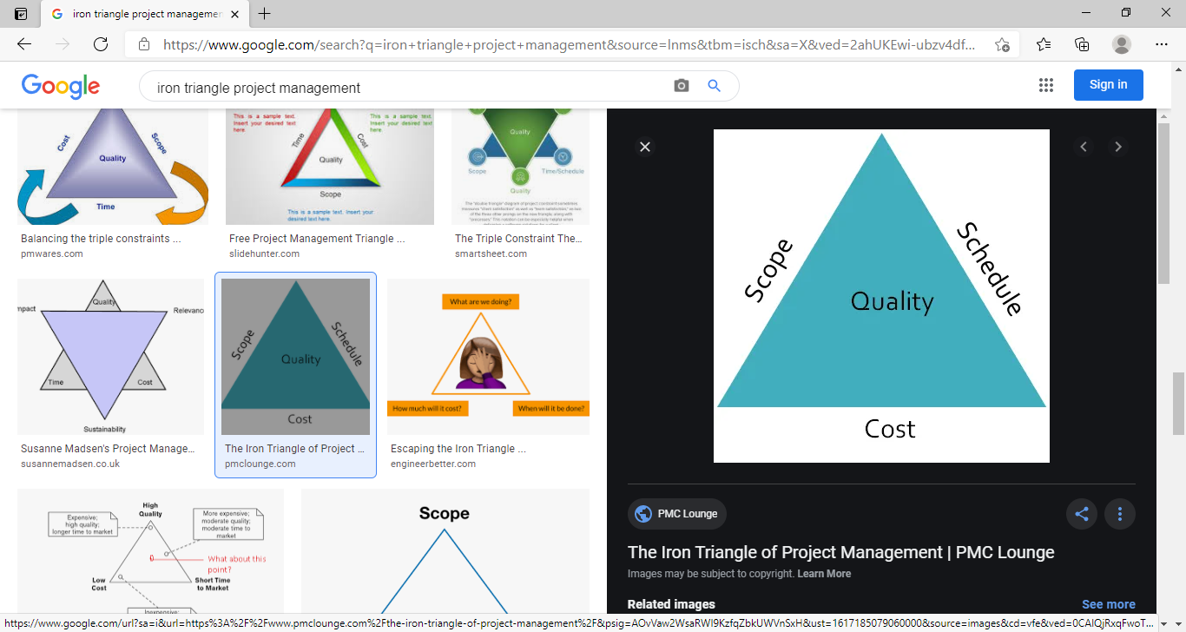
During 1the 1project 1it 1is 1important 1not 1to 1change 1any 1of 1these 1values 1as 1they 1have 1direct 1impact on 1each 1other 1as 1a 1project 1can 1be 1completed 1early 1by 1reducing 1time 1but 1it 1will 1effect 1on 1quality, scope 1and 1cost 1or 1reducing 1cost 1will 1put 1impact 1on 1quality 1time 1and 1scope 1of 1project.
Project 1scope:
Project scope is a task which has to be completed in order to successfully deliver a product according to the project scope requirements, in order to meet the scope of your project all team member must work together and complete their given tasks on time, all members need to share ideas and then should come to decision which is beneficial for the success of project scope (Morgan, 2017), it is very important part of project and you should pay extra attention to every step of this process.
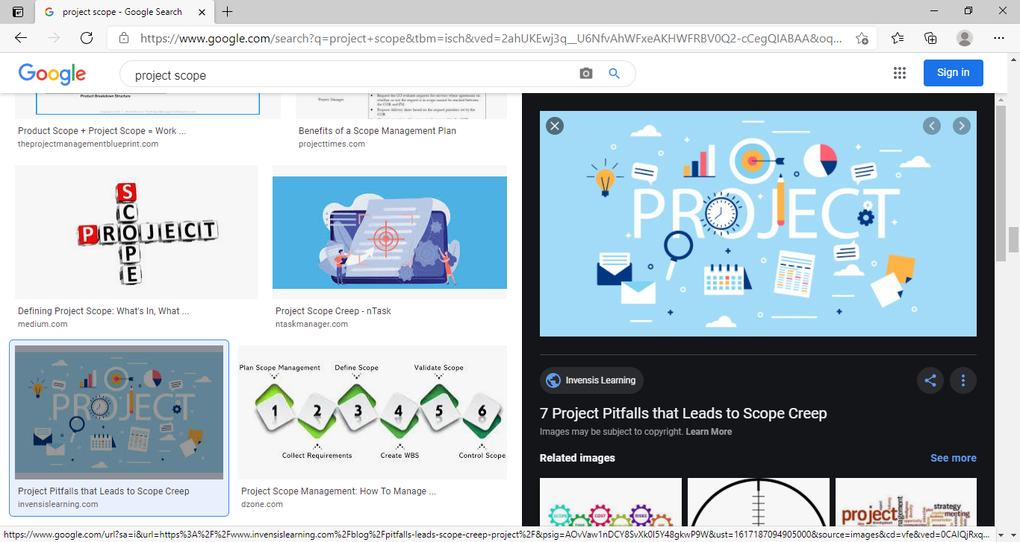
Project 1scope 1is 1a 1detailed 1outline 1of 1all 1aspects 1of 1a 1project, 1including 1all 1related 1activities, resources, 1timelines, 1and 1deliverables, 1as 1well 1as 1the 1project’s 1boundaries. 1A 1project 1scope 1also outlines 1key 1stakeholders, 1processes, 1assumptions, 1and 1constraints, 1as 1well 1as 1what 1the 1project 1is about, 1what 1is 1included, 1and 1what 1isn’t.
User 1Stories:
User 1stories 1are 1short, 1simple 1descriptions 1of 1a 1feature 1told 1from 1the 1perspective 1of 1the 1person who 1desires 1the 1new 1capability, 1it 1is 1a 1small 1self-contained 1unit 1of 1development 1work 1designed 1to accomplish 1a 1specific 1goal 1within 1a 1project, 1a 1user 1story 1is 1usually 1written 1from 1the 1user’s perspective 1and 1follows 1the 1format, 1“As 1[a 1user 1persona], 1I 1want 1[to 1perform 1this 1action] 1so 1that [I 1can 1accomplish 1this 1goal].”
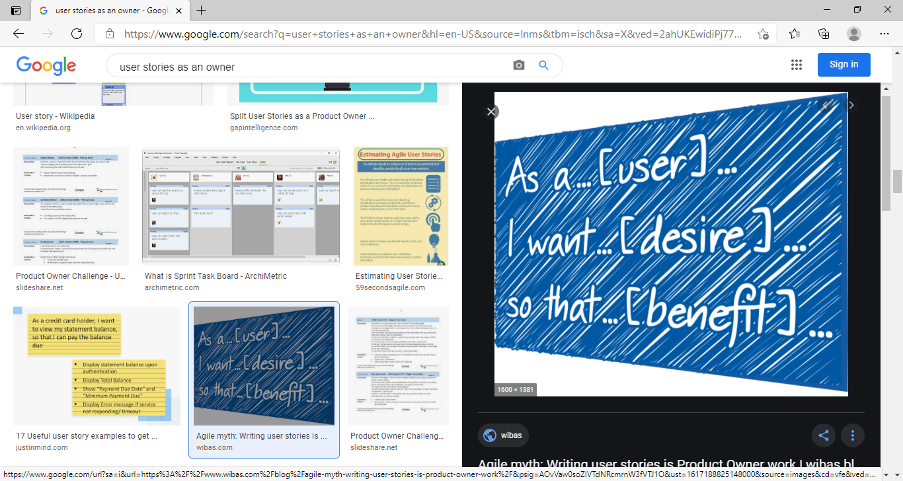
To complete this project I will strongly advise Vintners to use and parities user stories as this is the best way to understand all the issues you have within your project.
During my research all the data that I have gained about Vintners business I fully understand that they have no idea about the important need of writing and prioritising user stories to make this project successful. When writing user stories it is important to keep the information minimal and to the main point of project user stories can be written on a white board in different groups where we can group each story in the necessary groups and can remove what is not required, this can be written by users stakeholders, staff members or anyone else who has interest in the company and project.
Project 1problems:
During 1this 1project 1Vintners 1need 1to 1work 1on 1a 1lot 1of 1different 1problems 1so 1by 1using 1Trellow Software 1I 1am 1going 1to 1show 1some 1of 1these 1problems 1in 1the 1form 1of 1user 1stories 1screen 1shorts as below.
Business 1set 1up 1plan:
As 1a 1project 1manager 1I 1like 1to 1set 1a 1business 1plan 1as 1it 1will 1help 1to 1complete 1all 1tasks 1on 1time.
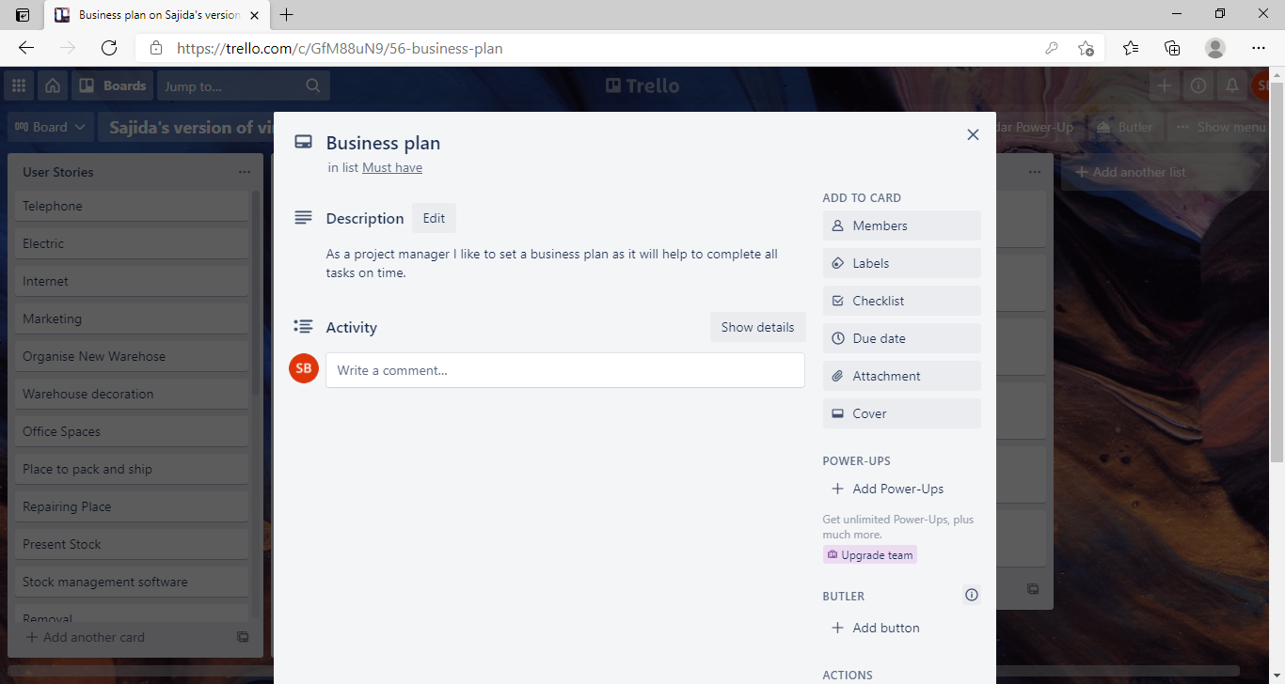
Utalities 1installation:
As 1an 1owner 1I 1want 1all 1required 1utilities 1like 1electric, 1gas 1phone 1line 1and 1internet 1to 1work 1as 1no work 1can 1be 1done 1without 1these 1facilities.
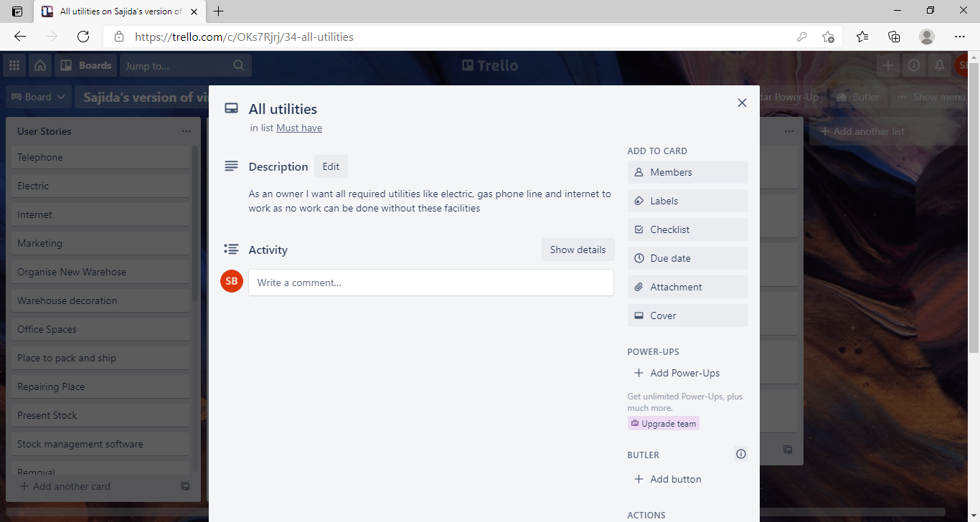
Stock 1move:
As 1an 1owner 1I 1want 1present 1stock 1to 1be 1moved 1from 1Shirley 1to 1Sparkhill 1because 1we 1are 1moving to 1a 1warehouse 1in 1Sparkhill.
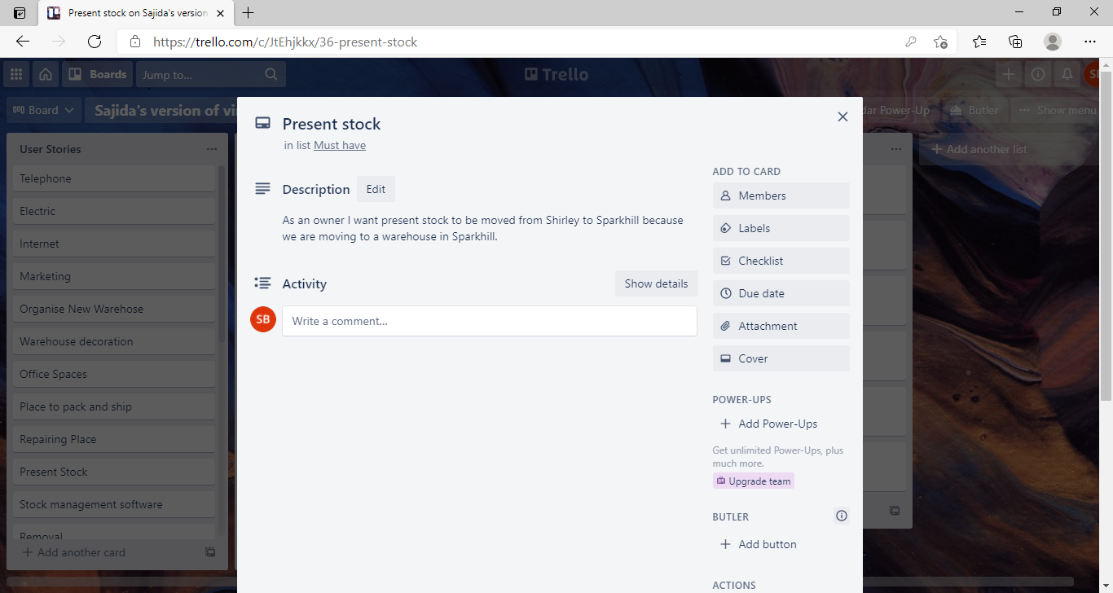
Spaces:
As 1a 1staff 1member 1I 1want 1separate 1office 1spaces 1for 1all 1staff 1because 1it 1will 1give 1them 1privacy and relaxation 1to 1do 1their 1duties 1properly.
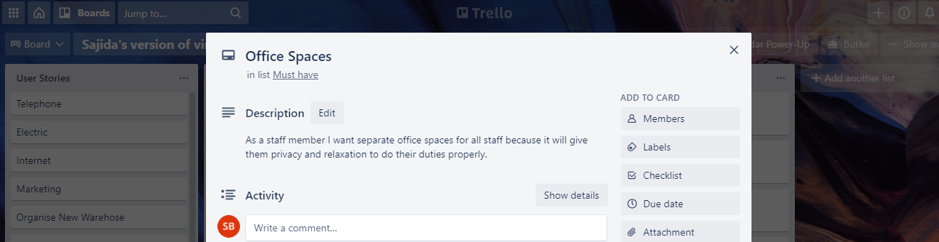
Trello 1Software:
Trello 1software 1is 1a 1popular 1project 1management 1and 1team 1collaboration 1tool, 1the 1app 1looks 1and works 1like 1a 1yellow 1note 1paper 1on 1a 1whiteboard, 1you 1can 1organize 1teams, 1projects, 1and workflows by 1simply 1dragging 1and 1dropping 1cards 1on 1the 1screen, 1it 1has 1a 1similar 1appearance 1to 1a 1board 1with sticky 1notes, 1projects 1and 1tasks 1can 1be 1organized 1into 1columns 1and 1moved 1around 1easily 1to indicate 1workflow, 1project 1ownership, 1and 1status, 1it 1also 1tells 1you 1what's 1being 1worked 1on, 1who's working 1on 1what 1 1and 1where 1something 1is 1in 1a 1process 1in 1project.
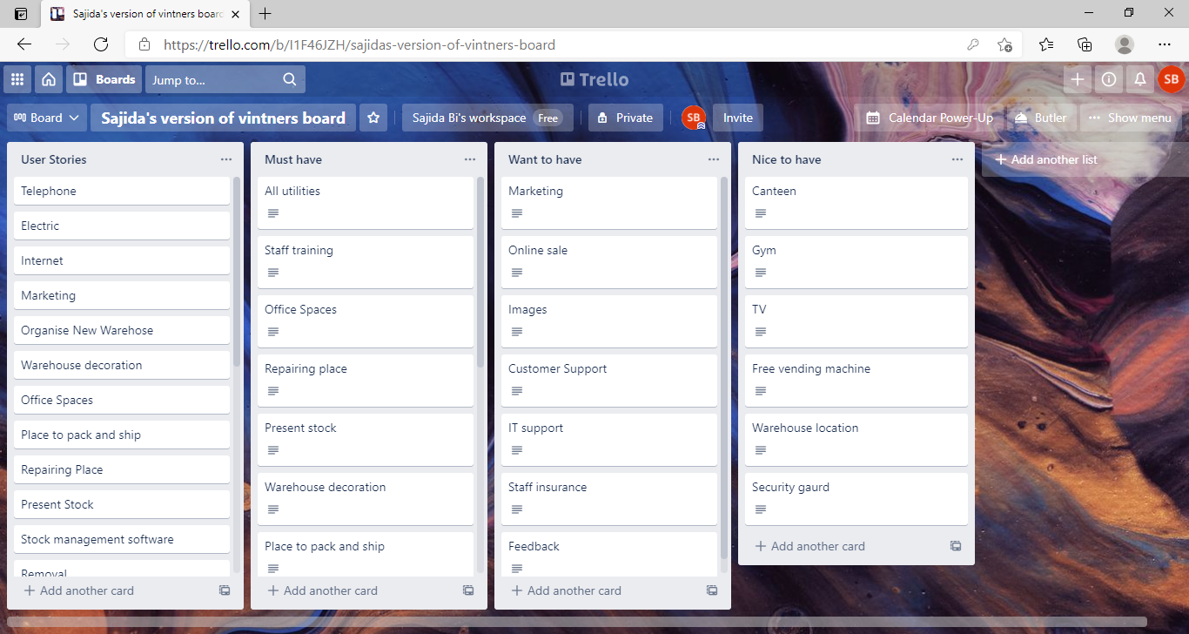
There are different ways to write and prioritise user stories but In this project I will use Trello application due to present coronavirus condition and I will use Heagney’s Sheveron Technique where I will consider most important tasks and all the unnecessary or extra tasks will be done in latter projects (Heagney, 2016), this technique will help Vintners to understand their problem more easily and clearly.
Sticky 1note 1approach:
Sticky 1note 1approach 1tool 1is 1one 1of 1the 1best 1and 1simplest 1way 1to 1understand 1the 1problem 1in different 1tasks 1as 1Projects 1don't 1just 1happen 1they 1need 1planning 1so 1it’s 1not 1only 1project manager’s responsibility 1but 1it 1requires 1your 1whole 1team 1to 1work 1together 1and 1take 1part 1in 1developing 1and completing 1the 1plan, 1this 1approach 1ensures 1team 1members' 1experience 1gets 1considered 1and 1each person 1has 1a 1commitment 1to 1and 1ownership 1of 1the 1plan.
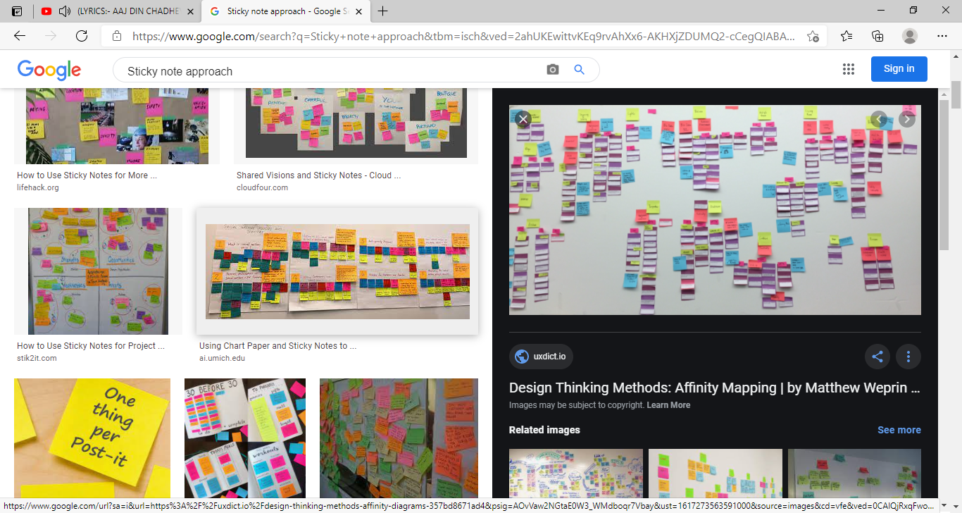
It is very simple process where you can first write all problems within the project on sticky notes and once you finalise everything you can transfer your findings to computer for further process, in this project as a project manager it is my responsibility that I make all staff members aware of the importance of sticky notes approach as this is the best method where stakeholder can share their ideas with each other.
Gantt 1chart:
A 1Gantt 1chart 1is 1a 1bar 1chart 1that 1provides 1a 1visual 1view 1of 1tasks 1scheduled 1over 1time, 1it 1used 1for planning 1projects 1of 1all 1sizes 1and 1it 1is 1a 1useful 1way 1of 1showing 1what 1work 1is 1scheduled 1to 1be done on 1a 1specific 1day, 1It 1can 1also 1help 1you 1view 1the 1start 1and 1end 1dates 1of 1a 1project 1in 1one 1simple chart 1(Clark, 11922).
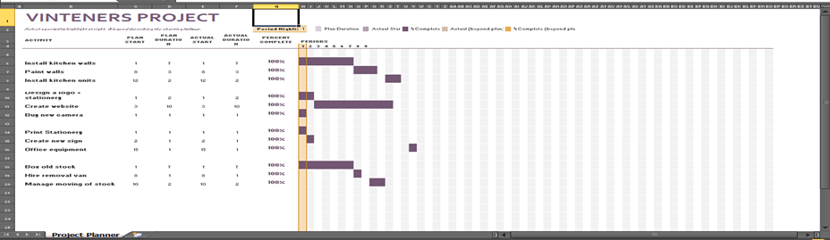
It 1is 1one 1of 1the 1most 1popular 1and 1useful 1ways 1of 1showing 1activities, 1tasks 1or 1events 1displayed against 1time, 1on 1the 1left 1of 1the 1chart 1is 1a 1list 1of 1the 1activities 1and 1along 1the 1top 1is 1a 1suitable 1time scale, 1each 1activity 1is 1represented 1by 1a 1bar, 1the 1position 1and 1length 1of 1the 1bar 1reflects 1the 1start date, 1duration 1and 1end 1date 1of 1the 1activity.
Wisdom 1of 1crowd:
The 1wisdom 1of 1the 1crowd 1is 1the 1process 1of 1taking 1into 1account 1the 1collective 1opinion 1of 1a 1group of 1individuals 1rather 1than 1a 1single 1expert 1to 1answer 1a 1question. 1A 1large 1group's 1aggregated answers 1to 1questions 1involving 1quantity 1estimation, 1general 1world 1knowledge, 1and 1spatial reasoning 1has 1generally 1been 1found 1to 1be 1as 1good 1as, 1and 1often 1better 1than, 1the 1answer 1given 1by any 1of 1the 1individuals 1within 1the 1group.
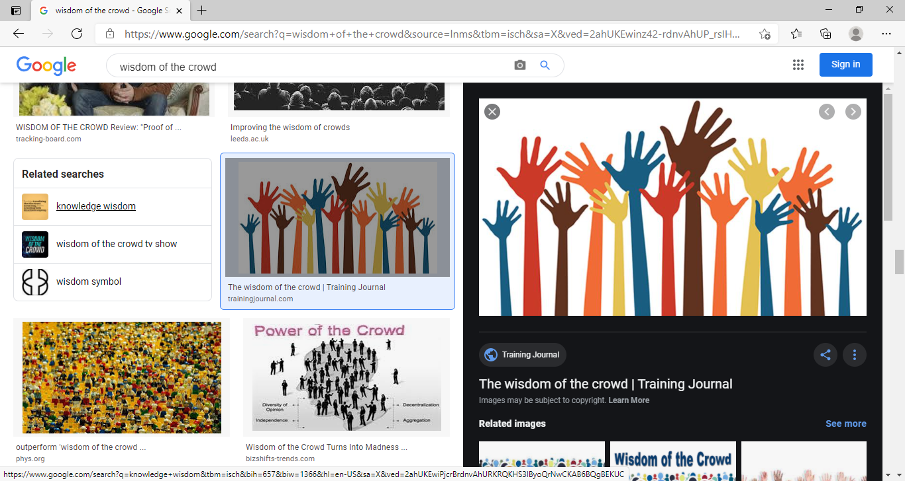
Considering 1ox 1and 1jelly 1beans 1examples 1where 1group 1estimate 1is 1always 1correct 1rather 1than considering 1single 1guess 1answer 1(Hasson 1et 1al.,2000), 1so 1wisdom 1of 1crowed 1clearly 1explain 1when working 1on 1a 1project 1you 1should 1defiantly 1consider 1group 1estimate 1rather 1than 1really 1on individual answer 1as 1average 1grout 1estimate 1is 1always 1turn 1out 1to 1be 1near 1to 1accurate 1guess.
Time 1& 1Cost
To workout completion time of this project I will be using Roberts Roberts project product plan as this technique can give us most accurate estimate of duration and amount of work involved in each task to be completed (Roberts,2012).
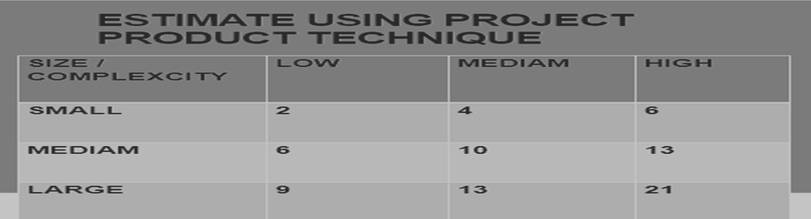
And to work out the correct cost we have to go through a number of processes as this is very important step to consider in project management as if you make a mistake during this process it can effect on whole project or may result of project failure so considering all the information and requirement my best estimate can be seen as below, please note this is an estimate defined by PMI so final price can increase or decrease as it depends on how we meet all our set targets (PMI 2008).
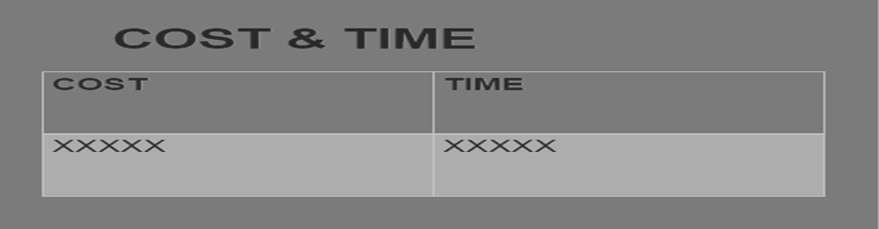
Conclusion:
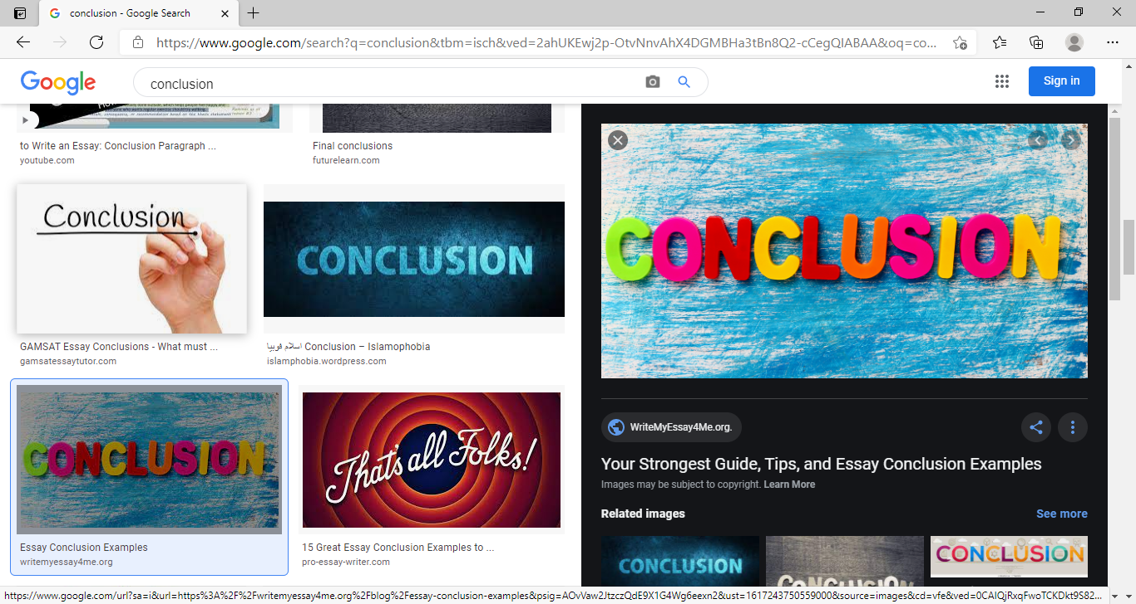
I have come to the conclusion that when planning a project it is very important to use all the available techniques and ideas as no business can achieve progress without proper planning so considering Vintners project they need to train their staff how to use and prioritise user stories because they do not have any idea of how project management works so they really need help from someone professional who can guide them to complete this project from start to end, they need to keep their thoughts and ideas in front when planning this project, they need to understand the importance of user stories in project and the cheveron’s technique, they should be fully aware of risks involved and also understand that without carefully planning everything, things can get all muddled up later because if by chance they need to change one element the other elements will automatically change too this is called the iron triangle as all these elements work with one another so changing one will make the rest also change.
As a project manager it is my duty to make sure project sponsor is aware of every move taking place during this project (Anantatmula, 2010), final decision is still under project sponsor’s control as I am here only to give advice, to make their project successful Vintners need to understand their responsibilities and roles so finally I would say to achieve progress in any project it is very important to use all methods and techniques correctly as discussed in this assignment.

References:
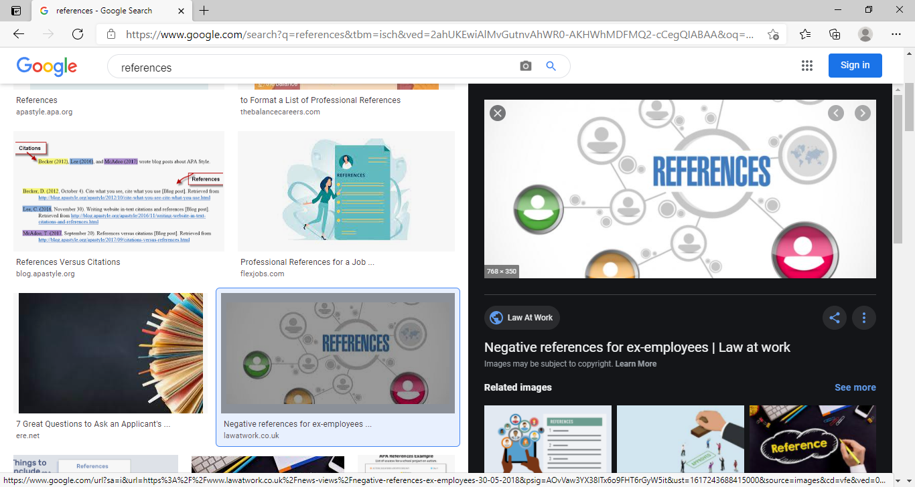
Axelos (2020). What is PRINCE2? / Methodolog and qualification/ AXELOS. (online) Axelos.com. Available at: https://www.axelos.com/best-practice-solutions/prince2/what-is-prince2 (Accessed 30 Jan. 2020).
Anantatmula, V.S., 2010. Project manager leadership role in improving project performance. Engineering management journal, 22(1), pp.13-22.
Barsky, J.D. and Labagh, R., 1992. A strategy for customer satisfaction. Cornell Hotel and Restaurant Administration Quarterly, 33(5), pp.32-40.
Clark, W. (1922). The Gantt Chart. New York: The Ronald press company.
Hasson, F, Keeney, S. and Mckenna, H. (2000). Research guidelines for the Delphi survey technique. Journal of Advanced Nursing. 32(4), pp.1008-1015.
Heagney, J. and Lewis, J. (2016). Fundamentals of project management. New York: Amacom, American Management Association.
Microsoft (2020). Create a SmartArt graphic (online) Office Sport Available at: Https://Sportoffice.com/en/gb/article/create-a-smartart-graphic-fac-94c39-500ba0a-97af-124040594842 (assessed 30 Jan. 2020).
Morgan, P. (2017) Business students guide to study and employability. Los Angeles: SAGE.
PMI (2008) A guide to project management body of knowledge. Newton Square, Pa: Project management Institute.
Roberts, P., 2011. Effective project management: Identify and manage risks plan and budget keep projects under control. Kogan Page Publishers.
Robert’s. P. (2012) Effective project management London.

