Coinage in Lattara

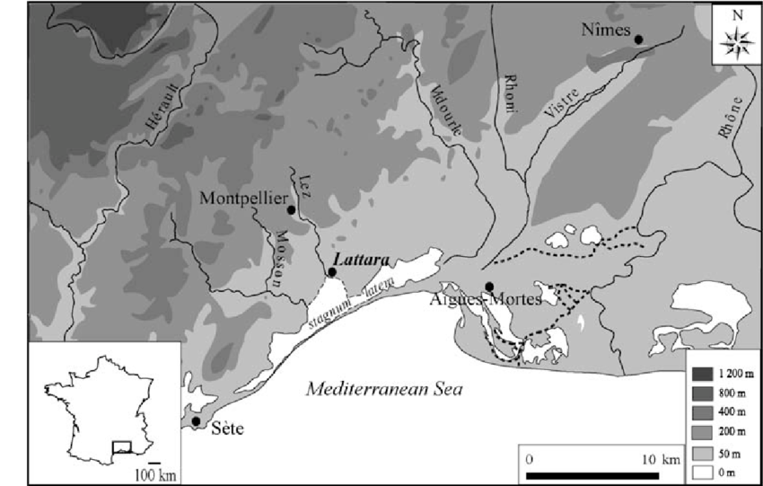
This essay will be focusing on coinage in ‘Celtic’ Lattara in Southern France and how the use of a, at least partly, monetised society was adopted through trade with Massalia, Etrusca, and the conquest of ‘Transalpine Gaul’ by the Roman Empire. The time period being focused on will be the periods between the 3rd and 1st Century BC. First this essay will be focusing on the geographical location and means for trade, as well as where the trade came from. Secondly, a basic guide to the use of coinage in Ancient Rome and Greece will be included to give an idea on how monetisation in Lattara would have been introduced. Then what the coins found in Lattara were made from and how they were used and imported from Rome, Massalia and Gaul. Finally, it will be argued that the use of coins in a votive sense in Lattara has not been regarded and analysed by modern scholars and has been disregarded completely by Luley in his paper on coinage in Lattara, the only comprehensive guide to the possible economic structure in Lattara written in English.
Fig 1.
Map of Southern France
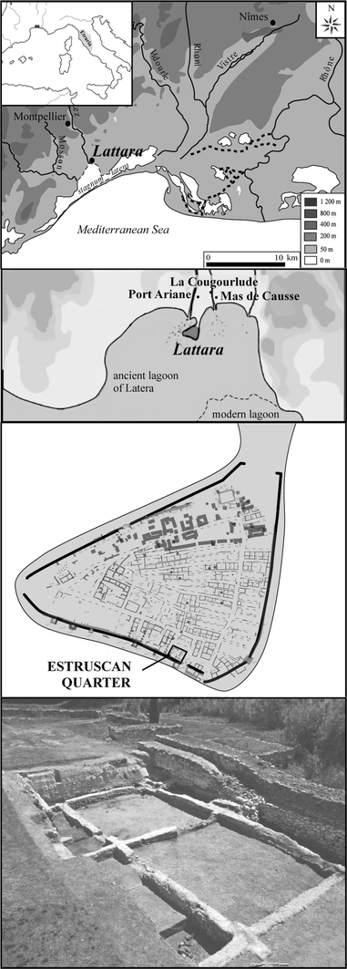
Lattara was a substantial ‘oppidum’ founded in the late 6th to early 5th century BC (Alonso & Rovira 2016, pp.323), with a population of over four thousand by 400BC; it continued to thrive until it was abandoned six hundred years later (Py and Garcia 1993). It is well known to have been a Celtic-language speaking settlement (Luley 2014, pp.36). Due to the large amount outside influence and interaction, primarily from Massalia before the Roman conquest in 121 BC, there seems to have been a large amount of hybridisation in the oppidum (Gailledrat 2015, pp.25). In the 2nd century BC Lattara came under Roman rule, and local production of food as well as increased trade with their neighbours (Luley & Piques 2016, pp.129). However, despite the increase in trade, there does not seem to be a rigid societal hierarchy in Lattara as there is in most of Gaul, Rome and Greece in the periods from the 3rd to 1st century BC (Py 2009, pp.333). This can be seen by the structure of the oppida itself as well as the fact that there has been no evidence found so far which shows differentiation in the habits of consumers in regard to food and other expendables (Luley 2014, pp.46). The reason for this may be due to the specialisation of trade between sectors throughout the settlement (Luley & Piques 2016, pp.135), perhaps making the individuals who lived and worked alongside each other differentiate status through trade instead of by wealth alone, as well as the mix between different peoples and travelers to the area (Gailledrat 2015). The presence of a sector dedicated solely to the Etruscan population created in early 5th century BC is an example of this coming together of peoples. However, it was damaged by a (probably deliberate) fire around 475 BC (Alonso & Rivera 2016, pp.234), indicating that the conglomeration of people may not have been entirely successful during the beginning stages of the settlement. In the oppida, a large amount of monetary exchange seems to have taken place for many items, but especially for wine and, consequentially, amphorae; this can be seen through the extremely high number of sherds found within the oppidum (Py 2006, pp.1157). During the beginning of the second century BC, most of the amphorae being imported to Lattara originated from Massalia and Greece, but after Sexton Calvinus created two new large settlements around 124 BC nearby, sherds from Massalia are found less often and are replaced with amphorae from Italic areas (Luley 2008, pp.188). This shows us a continuous link of trade and imports with Rome and Greek Massalia during the 3rd-1st century BC. Trade can also be seen coming from further afield due to the presence of date seeds within the ‘oppida’ which most likely originated from Jordaea; although these have been dated from the 4th century BC and therefore cannot be delved into deeper in this essay (Rivera 2018 pp.12).
Fig 2.
Etruscan Quarter in Lattara

Coinage was used by the Greeks from around 550BC onwards and had origins from further East in Asia Minor (Grierson 1975, pp.11). However, coins in Ancient Greece were not used habitually, but usually only in social transactions occurring between individuals of status (Kurke 2002, pp.92). From around 200BC, coins were used by the Romans and eventually the empire became one based on monetary exchange. This change was simply a consequential bi-product of its facility for exchange purposes and would have only been truly prominent in major settlements; in more rural areas more, agricultural exchanges would have been more commonplace (Aarts 2005, pp.6). Lattara, as a province of Rome from the 2nd century BC was at least a partly monetised society by the end of the 1st Century BC. Since the recent discovery of a tavern in Lattara post-occupation, it seems more likely for this to be the case, as taverns were more likely to use a monetary system (Luley & Piques 2016, pp.129).

Of the many coins found in Lattara, 75 percent were from Massalia, and only an extremely small amount were minted by the Romans; within Lattara itself, local coins were not minted, which is unusual for most Gaulish ‘oppida’ (Luley 2008 pp.179-180). Similar to the Greek world, pre-Roman conquest Lattara seems to have valued silver in coins above all other metals, but probably only used it as bullion (Peacock 2013 ch.2), therefore, coins were probably used in an equivalent exchange-based system or as a calculation of wealth (Luley 2008, pp.183). Post-conquest, bronze coins increase drastically and outnumber silver (Py 2006), indicating that the people of Lattara were adopting a more Roman-like economy structure. Most silver coins found in Lattara post 121 BC are local Gaulish coins which sported a cross and are often referred to as ‘monnais a la crux’ (Luley 2008 pp.184). According to George Dalton’s definition of a monetary society (Dalton 1961), classing Lattara as one cannot be accurate as it does not seem as though all trade was primarily done through monetary exchange, it is still likely that other forms of exchange were occurring. Luley argues that from the coins found within Lattara, it is noticeable that they do not seem to have been used in a religious context, therefore indicating that they were primarily used for trade purposes, though it is important to note trade through coin seems to occur post-Roman conquest (Luley 2008, pp.182-183). However, he does not mention that there has been at least one find which indicates that they have been, namely the find of a votive offering from late 1st century BC which included a coin (Rovira & Chabal 2008 pp.192). Therefore, perhaps like many other settlements around Gaul, the people of Lattara were indeed using coins in a religious context and not solely for the use of trade, even after the conquest of Transalpine Gaul.

To conclude, it is apparent from the nature and origin of coinage in Lattara that all coins found within the oppida’s precincts mainly originated from Massalia, Gaul and Rome. Through regular interaction with these two empires, as can be seen by the sherds of amphorae found, Lattara probably adopted a partly monetised society which focused on regular exchange of coinage, although other forms of trade were most likely occurring alongside this economical system. Like Massalia and other Greeks, it seems as though during the 3rd-2nd century BC, the peoples of Lattara most likely used coinage as a form of bullion and social status. After the conquest of Gaul by Rome, and Lattara itself around 121 BC, monetary exchange seems to have increased significantly. As the main source on monetary exchange in Lattara, Luley has not acknowledged the votive find from Lattara which included a coin at all, and more research should be done in regards to why this was purposely placed in the ground during the 1st century BC, as well as the meaning behind its placement.

Bibliography
Aarts, Joris (2005) Coins, money and exchange in the Roman world. A cultural-economic perspective, Archaeological Dialogues (12.1) pp.1-28
Alonso, Natalia & Nuria Rovira (2016) Plant uses and storage in the 5th century BC Etruscan quarter of the city of Lattara, France, Vegetation History and Archaeobotany (25) pp.323-337
Dalton, George (1961) Primitive money American anthropologist (67) pp.44-65
Gailladrat, Eric (2015) New Perspectives on Emporia in the Western Mediterranean: Greeks, Etruscans and Native Populations at the Mouth of the Lez (Herault, France) during the Sixth-Fifth Centuries BC, Journal of Mediterranean Archaeology (28.1) pp.23-50
Grierson, Phillip (1975) Numismatics, Oxford University Press
Kurke, Leslie (2002) Money and mythic history. The contestation of transactional orders in the fifth century BC, in W. Scheidel and S. von Reden, The ancient economy, pp. 87–113.
Luley, Benjamin P. (2008) Coinage at Lattara. Using archaeological context to understand ancient coins, Archaeological Dialogues (15.2) pp.174-195
Luley, Bejamin P. (2014) Cooking, Class, and Colonial Transformations in Roman Mediterranean France, American Journal of Archaeology (118.1) pp.33-60)
Luley, Benjamin P. & Gaël Piquès (2016) Communal eating and drinking in early Roman Mediterranean France: a possible tavern at Lattara, c. 125–75 BC, Antiquity (90) pp.126-142
Peacock, Mark (2013) Introducing Money, Routledge
Py, Michael (2006) Lattara 19: Les Monnaies preaugusteennes de Lattes et la circulation monetaire protohistorique en Gaule meridionale
Py, Michael (2009) Lattara: comptoir gaulois mediterraneen entre Etrusques, Grecs et Romains
Py, Michael & D. Garcia (1993) Bilan des recherches archeologiques sur la ville ´ portuaire de Lattara, Gallia (50) pp.1-93
Rivera, Diego, Concepción Obón, Francisco Alcaraz, Emilio Laguna, Dennis Johnson (2018) Date-palm (Phoenix, Arecaceae) iconography in coins from the Mediterranean and West Asia (485 BC–1189 AD), Journal of Cultural Heritage (10.1) pp.1-16
Rovira, Nuria & Lucie Chabal (2008) A foundation offering at the Roman port of Lattara (Lattes, France): the plant remains, Vegetation History and Archaeobotany (17.1) pp.191-200
Image Sources
Fig. 1 https://www.researchgate.net/figure/Location-of-Lattara-in-France-and-reconstitution-of-the-coastline-and-the-lagoons-of_fig1_225355280
Fig. 2 https://link.springer.com/article/10.1007/s00334-015-0553-8

