ssb ASSIGNMENT 1
E-Portfolio

University of Wales Trinity Saint David
London Campus
Module name: Software Solutions for Business
Module Code: ACCA4026
Student name: Servillano Pacleb Discargar
Student ID: 2542913
Group 1
Lecture’s Name:
Contents
Introduction 1
Task 1. e-Commerce Website builders/software solutions 2
1.1 Wix 2
1.2 Shopify 4
Task 2. Mind-map of contemporary software applications 5
2.1 Describe mind mapping and explain the benefits of using mind mapping 5
2.2 Create a mind map of contemporary software applications 6
3.1 Four office software solutions for business operations 6
Ms Word 6
Ms Excel 8
Ms PowerPoint 9
Ms Access 11
3.2 Test any two features 13
Mail Merge 13
IF Statement 16
Task 4. Communication and Collaboration applications 18
4.1 One contemporary Communication and one Online Collaboration 18
Gmail 18
Zoom 19
4.2 Test one feature of a freely available Communication (1) and one feature of a Collaboration (1) application 21
Gmail 21
Zoom 22
Conclusion 23
References 24

Introduction
In this assignment, I completed four main tasks based on Software Solutions for Business. The purpose of the assignment was to explore different software applications and understand how they can be used to support business activities and improve productivity.

Task 1 focuses on e-commerce website builders and software solutions. In this task, I explored Wix and Shopify, looking at their main features, benefits, and limitations, and how they can help businesses create and manage online stores. Task 2 focuses on mind mapping and contemporary software applications. I explained what mind mapping is, discussed its benefits, and created a mind map to show different types of software applications.

Task 3 focuses on four office software solutions used in business operations: Microsoft Word, Microsoft Excel, Microsoft PowerPoint, and Microsoft Access. I explained how each application can be used in a business environment and discussed their features, benefits, and limitations. I also tested two software features, including Mail Merge and the IF statement, to demonstrate how they can be used for business tasks.

Task 4 focuses on communication and collaboration applications. In this task, I discussed Gmail as a communication application and Zoom as an online collaboration application. I explained their features, benefits, and limitations and tested selected features of both applications. Overall, completing these four tasks helped me understand how different software solutions can support e-commerce, information management, office operations, communication, collaboration, and productivity in a modern business environment.

Task 1. e-Commerce Website builders/software solutions

Wix


Wix e-commerce is an online website development tool that lets users create a visually appealing online shopfront using a drag-and-drop editor. It provides hosting, a secure payment system, inventory control, SEO services, and marketing choices all in one location. Small enterprises and entrepreneurs appreciate it because it is affordable and easy to use[1]. Wix e-commerce’s user-friendly services, reasonable price, mobile-friendly theme, and extensive marketing and analytics capabilities are its key advantages. The Wix app market allows customers to improve their offerings. All these aid businesses without technological expertise in creating internet stores[2]. Wix has certain shortcomings. There aren’t as many sophisticated features as competing platforms like Shopify and Adobe Commerce. Once templates are released, they are hard to modify, and several sophisticated features are exclusive to the premium packages. When the company grows, it will need to switch to a more scalable platform, Wix ecommerce is an excellent option for small business owners looking for an inexpensive, user friendly and aesthetically pleasing solution.
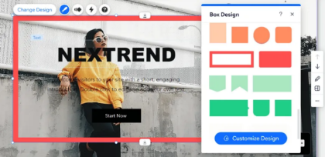

Figure 1 shows the Wix editor where users can customise their website using drag-and-drop tools. It allows businesses to add text, images, products, and pages easily without coding.

Figure 2: shows an example of a Wix eCommerce store design. Wix provides modern templates and built-in features for product display, payments and customer management

Shopify

Shopify is a popular online cloud-based ecommerce website creator that allows companies to set up and operate their webstore easily[3]. It incorporates such feature as hosting, secure payments processing, inventory management, web design, marketing features and 24/7 customer service. With the drag and drop functionality, users can build professional web fronts without needing to know coding[4]. Shopify supports multi-channel sales on Facebook, Instagram, amazon and many other platforms. The main benefits of Shopify are flexibility, responsive designs, secure hosting, user-friendliness and app marketplace
That extends the webstore’s functionality[5]. Due to its ability to simplify the technology and there are some limitations of Shopify. As the company upgrades to high levels plans, membership fees per month become rather expensive. Fees for paid apps and transaction charges for using third party payment gateways incur extra costs. Since the user has no access to the basic code, customization is limited in comparison with the open source’s platforms. All in all, Shopify is reliable and user-friendly website creator.
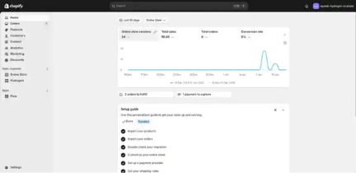

Figure1 shows the Shopify admin dashboard where store owners can monitor sales orders, customer activity interface to manage products inventory and marketing from a single place.
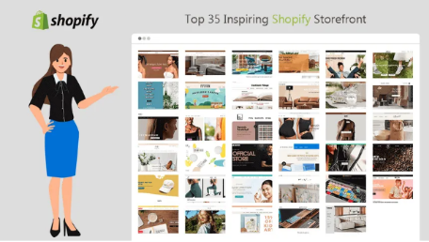
Figure 2 shows an example of a Shopify storefront theme Shopify offers hundreds of professional, mobile responsive themes that help business build attractive and user-friendly online stores quickly.

Task 2. Mind-map of contemporary software applications

2.1 Describe mind mapping and explain the benefits of using mind mapping

The mind map is an easy visualisation technique for organising information or ideas under a single central theme. The method involves the use of branching, sub-branching, words, images, symbols, and colours[6]. The central idea is at the centre, while the other ideas connect to it in some form or another. Such a tool allows users to comprehend the relationship between different ideas and facilitates analysis, memorisation, and dissemination of information. They are widely applied in various corporate functions, including decision- making and problem-solving[7]. There are various advantages offered by mind mapping within business operations. First, there is creativity since group discussions will lead to the generation of new ideas. Planning becomes easy since the process of working on a project is divided into small, manageable steps. In addition, decision making becomes more effective since data analysis is converted into a virtual graph, which make it possible for managers to understand connection within the company[8].
It facilitates better communication and collaboration within the group since everyone can understand the objectives of the projects clearly. In addition to that, mind mapping increases productivity by enabling workers to organise their information well.

2.2 Create a mind map of contemporary software applications
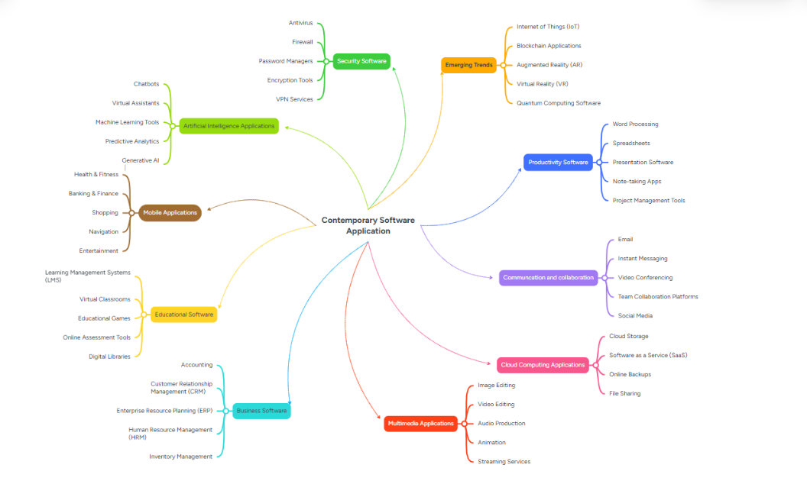

3.1 Four office software solutions for business operations

Ms Word
Ms Word
Microsoft word is a word processing application developed by Microsoft and included in the Microsoft 365 suite. It is one of the most widely used software applications in business schools and government organisations around the world. Microsoft Word enables users to create edit format save print and share document efficiently businesses commonly use word to prepare letter reports contract proposals meeting minute business commonly use word to prepare letter contract proposals meetings minutes business plan manual invoices and other professional documents it user friendly interface and wide range of tool make it suitable for both everyday office work and formal business communication[9].
One of the most important features of Microsoft words is its document formatting capability. Users can customise fonts colour paragraph spacing margins page layouts headers footer table images and style to produce clear and professional documents business often use built in formatting style to maintain consistent branding across reports and official documents. Microsoft word also offers a large collection of templates for business letter resumes
invoices newsletters reports and meeting agendas. These templates reduce the time needed to create documents ensure a professional appearance
Another value feature is mail merge which allows businesses to generate personalised letter email labels and envelopes for multiple recipients using information stored in a database or spreadsheet instead of creating each document individually mail merge automatically insert customer details into a standard document saving significant time and reducing errors word also include spell and grammar checking which identifies spelling mistakes punction errors and grammar issue while providing suggestions for improvement these tool help employees produce accurate professional and easy to read documents improving the quality of business communication[10].
Microsoft also supports teamwork through track changes comments and cloud collaboration track changes record every modification made to a document allowing reviewers to accept or reject edits before the final version is completed. The comments feature enables team members to leave feedback without changing the original content. When documents are stored in OneDrive or SharePoint, multiple users can edit the same file simultaneously in real time. This cloud collaboration improves communication speeds ups documents approval processes and allows employees to work together even when they are in different locations.
Microsoft Word provides several important benefits to businesses it increases productivity by offering templates automation tools and editing features that reduce the time required to create documents it also helps organisations produce professional looking documents which improve their image when communicating with customers supplier and stakeholders collaboration tool make teamwork more efficient by allowing employees to review edit and share documents quickly in addition word integrate with other Microsoft office applications such as excel outlook and PowerPoint making it easier to manage information different business tasks
Despite its many advantages Microsoft words has some limitations it is not designed for advanced data analysis unlike Microsoft excel which provides formulas pivot table and advanced statical function. Word is also unsuitable for database management as it cannot efficiently store organise or query large amount structed data like Microsoft access or SQL database systems although table can be created in word they are intended for presenting information rather than managing complex datasets therefore business typically use Microsoft word alongside other Microsoft office applications to perform specialised task more effectively[11].

Ms Excel
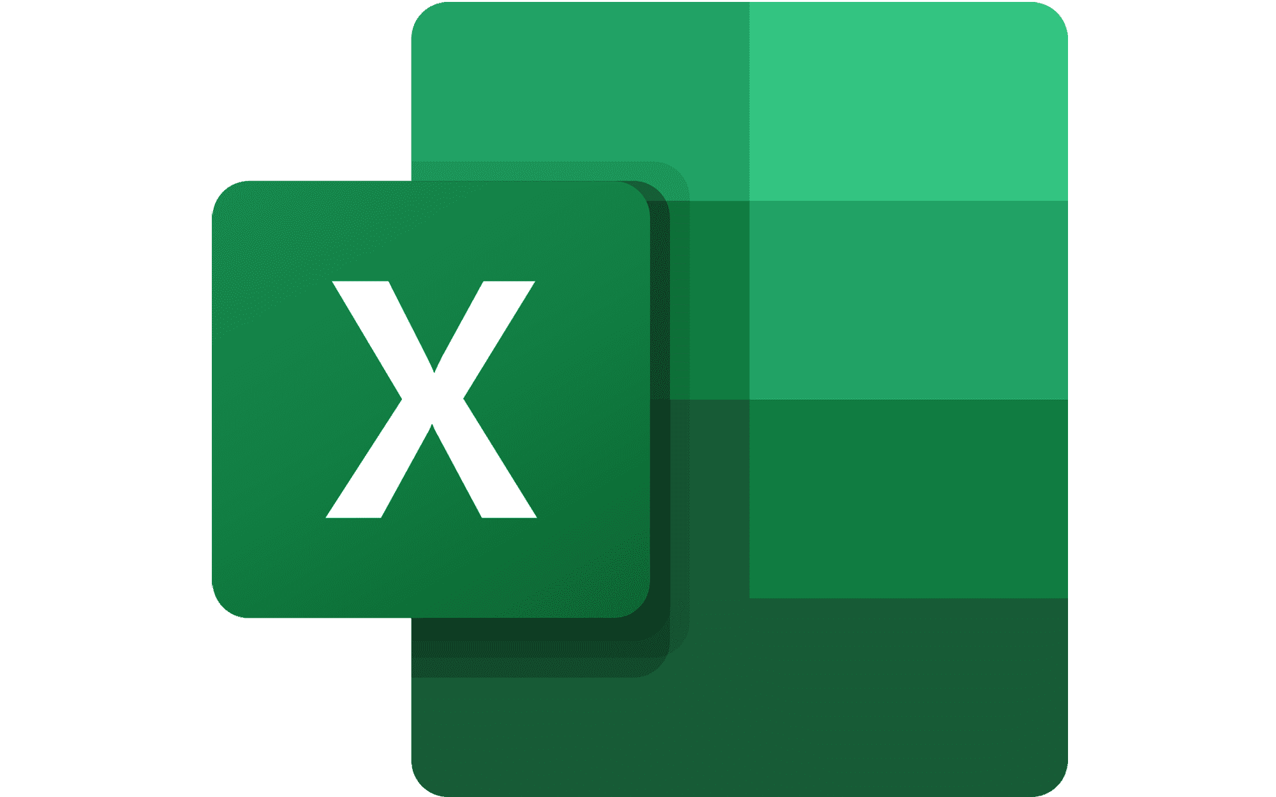
Microsoft Excel is a spreadsheet application developed by Microsoft and included in the Microsoft 365 suite. It is widely used by businesses to organise, calculate, analyse, and present data in a structured format[12]. Excel plays an important role in business operations because it helps organisations manage financial information, monitor performance, forecast future trends, and make informed decisions companies all of sizes use excel for activities such as financial management budgeting forecasting payroll processing inventory control and data analysis
One of the main uses of Microsoft Excel in business is financial management and budgeting. Organisations use Excel spreadsheets to record income expenses cash flow, and financial transactions[13]. Businesses can create budgets, compare actual spending against planned spending and identify areas where cost can be reduced excel is also widely used for forecasting, as companies can analyse historical data and predict future sales revenue and expenses this supports strategic planning and allows manage to make better financial decisions based on reliable information
Excel is also valuable for payroll and inventory control; businesses can use spreadsheets to calculate employee wages, overtime taxes and deductions through automated formulas. In inventory management, Excel helps organisations track stock levels, monitor product movement, identify shortages, and plan future purchases[14]. These capabilities allow business to improve efficiency and avoid issues such an overstocking or running of important supplies. A major strength of Microsoft excel is wide range of features. Formulas and function allow user to perform calculations automatically from simple arithmetic operations to advanced financial and statistical analysis function such as sum average if and VLOOKUP help business process information quickly and accurately. Pivot tables are another important feature because they allow users to summarise and analyse large amount of data, organising information into categories. This enables managers to identify patterns, trends, and relationships within business data more effectively.
A major strength of Microsoft excels if its wide range of features, formulas and functions allows users to perform calculations automatically, from simple arithmetic
Operations to advanced financial and statistical analysis function such as sum average if and VLOOKUP help business process information quickly and accurately pivot table are another important feature because they allow user to summarise and analyse large amount of data by organising information into categories this enable manager to identify patterns trends and relation within business data more effectively.

Ms PowerPoint
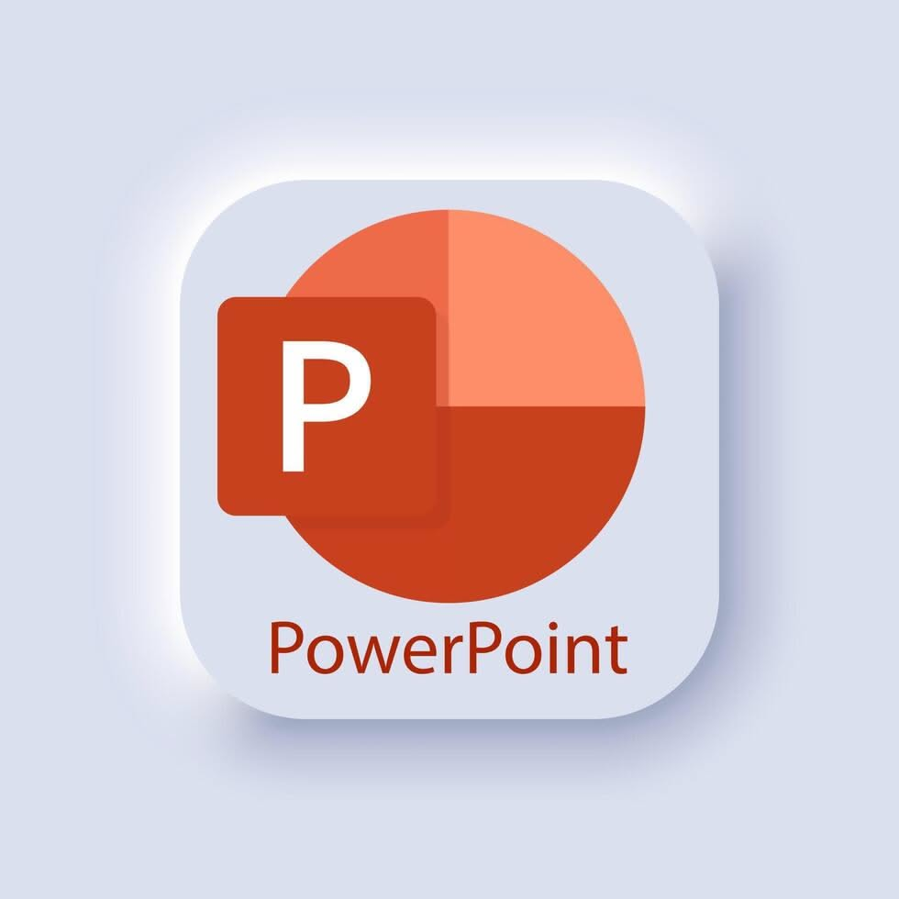

Microsoft PowerPoint is a widely presentation software application developed by Microsoft. Originally created in 1987 by Robert Gaskins and Dennis Austin at Forethought, Inc., and acquired by Microsoft the same year, it has become a core component of the Microsoft Office suite[15]. I is routinely
Employed in business meetings, staff training sessions, sales presentations, and client communication to structure and deliver information in a clear sequential slide-based format.
Key features of PowerPoints include professional designed theme that applies consistent colour schemes, fonts, and effects across an entire presentation, ensuring a polished and cohesive appearance. SmartArt enables user to transform text into diagrams, process flows, hierarchies, and other visual graphics with minimal effort, turning bullet points into engaging illustrations. Animation allows individual elements to appear, move or change on a slide while transitions control how one slide moves to the next; support lets presenters embed images, audio video and even the live camera feeds. Presenters' view is particularly valuable during delivery: it shows the speaker the current slide upcoming slide speaker notes and timer on their on screen while the audience sees only the clean slides. Seamless integration with excel allows charts and data table to be inserted and updated dynamically keeping presentation current with underlying spreadsheets.
Presenting information visually through PowerPoint offers clear benefits; visual elements help audience purely oral delivery. Research on multimedia learning supports the value of combining well designed visual with spoken narration, as this approach reduces cognitive load and directs attention effectively[16]. In professional settings, a well-structured deck can convey messages more persuasively, support consistent branding, and facilitate collaboration via cloud-based co-authoring in Microsoft 365 nevertheless, PowerPoint has limitations. Overuse of dense text, excessive animation or decorative “chart junk” can produce the well-known “death by PowerPoint” effect, overwhelming or distracting the audience rather than clarifying the message[13]. The software also cannot replace detailed written reports; slides are best suited to high-level overviews and spoken discussion rather than comprehensive documents. Poor design choices or technical issues, large files sizes, and compatibility across version can further undermine effectiveness
When used thoughtfully, practising clear visuals, minimal text, purposeful animation and strong speaker notes, PowerPoints remain a powerful tool for professional communication[17].

Ms Access

MS Access is a relational database management system developed by Microsoft that enables users to store, organise, manage and retrieve business data effectively[18]. It combines a user-friendly graphical interface with database management capabilities, making it suitable for small and medium-sized businesses that need to manage structured information without the complexity of enterprise-level database systems. Access is part of the Microsoft Office suite and integrates well with other Microsoft applications such a excel work and Outlook[19].
One of the key features of Microsoft Access is its use of tables, which store data in rows and columns. Each table represents a specific subject such as customers, employees or products, while each record contains information in a structured format.
Another important feature is queries, which allow user to search filter, calculate and analyse data stored within table. Queries enable businesses to retrieve specific record base on defined criteria, such a identifying customers from a particular location or calculating monthly sales totals. This improves decision-making by providing quick access to relevant information[20].
Forms provide an easy-to-use interface, editing and viewing records. Instead of interacting list, financial summaries or inventory report using customised layouts, reports can be printed or exported format such as PDF, making them useful for internal management and external communication
A defining characteristic of Microsoft access is its support for relationships between tables. Relationships link related data using primary and foreign keys, ensuring data integrity and reducing redundancy. For example, a customer table can be linked to an orders table so that customer details only need to be entered once while multiple orders can be associated with the same customer. This relational structure improves data accuracy and simplifies database maintenance.
Microsoft Access also includes Visual Basic for Applications, a programming language that allows users to automate repetitive tasks, create custom functions, and develop advanced database applications. Can automate report generation, validate data entry, and integrate Access with other Microsoft Office applications, increasing productivity and reducing manual work.
Overall, Microsoft Access improves data organisation, reporting and record management by providing an affordable and flexible database solution. SMEs benefit from its ease of use, rapid application development and integration with familiar Microsoft software. However, Access has limitations when handling very large databases, high numbers of simultaneous users or complex enterprise applications large organisation typically require more scalable database management systems such as Microsoft SQL Server, which offer greater performance, security and support for thousands of concurrent users[21].

3.2 Test any two features

Mail Merge
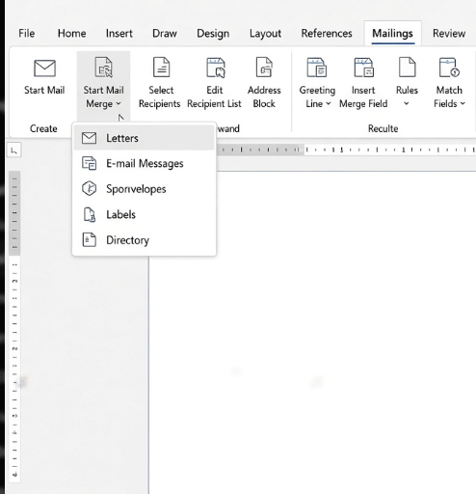
In Step 1 open a blank or existing Word document, go to the Mailings tab, click Start Mail Merge, and choose Letters if you want printed letters or E-mail Messages if you prefer to send emails.

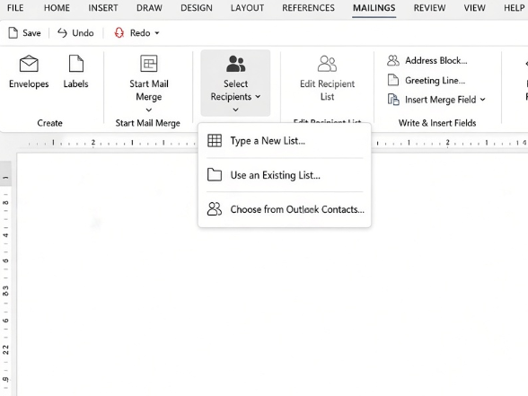
In Step 2 remain on the Mailings tab, click Select Recipients, choose Use an Existing List, browse to your Excel file, open it, select the correct sheet if prompted, and confirm that the first row contains column headers before clicking OK.

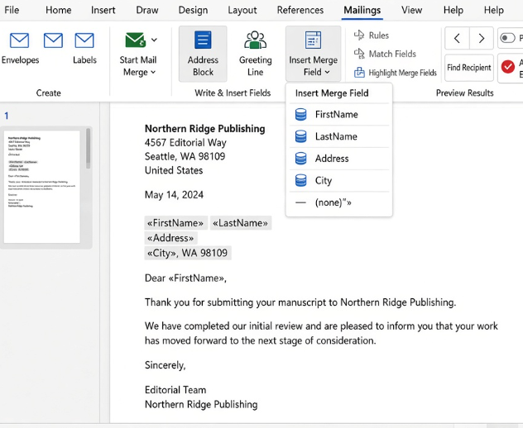
In Step 3 type your letter normally, place the cursor wherever personalized information should appear such as after the word Dear, click Insert Merge Field, and select the matching field like FirstName; you can repeat this for other fields, and the Address Block or Greeting Line buttons also work as convenient shortcuts, resulting in placeholders that look like «FirstName».

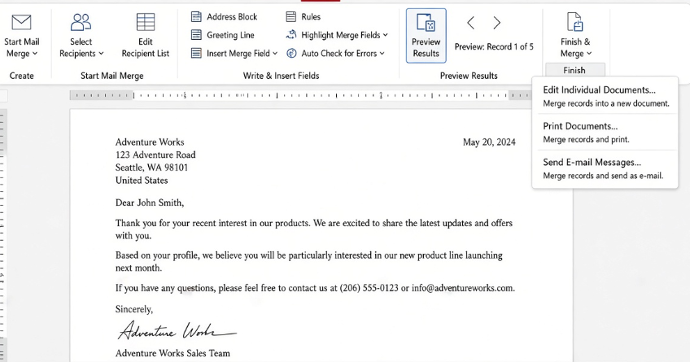
In Step 4 click Preview Results to replace the field codes with actual data from your list and use the navigation arrows to check several recipients; when everything appears correct click Finish & Merge and then choose Edit Individual Documents to create a new file containing all the personalized letters, Print Documents to send them straight to the printer, or Send E-mail Messages if you selected the email option earlier so Word can deliver them through Outlook.

IF Statement

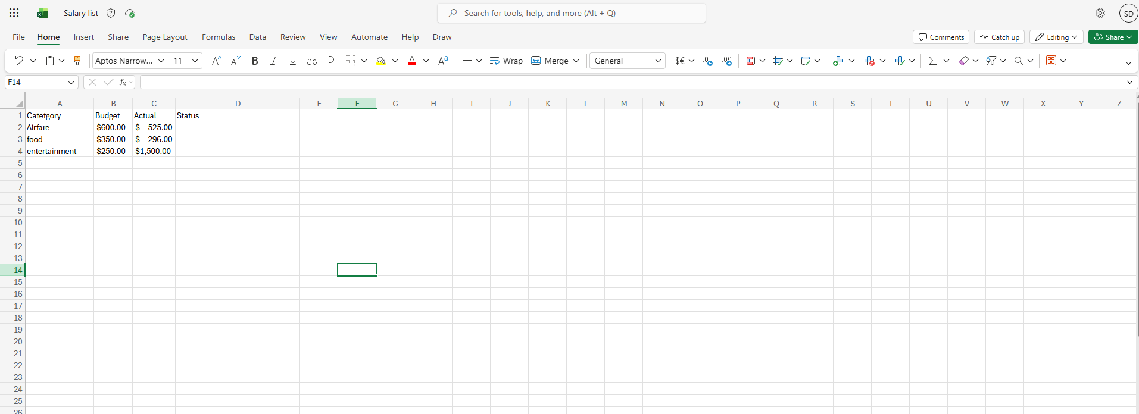
In this screenshot Setting up my data Table created with headings. Budget and Actual values entered. Status column is still empty.
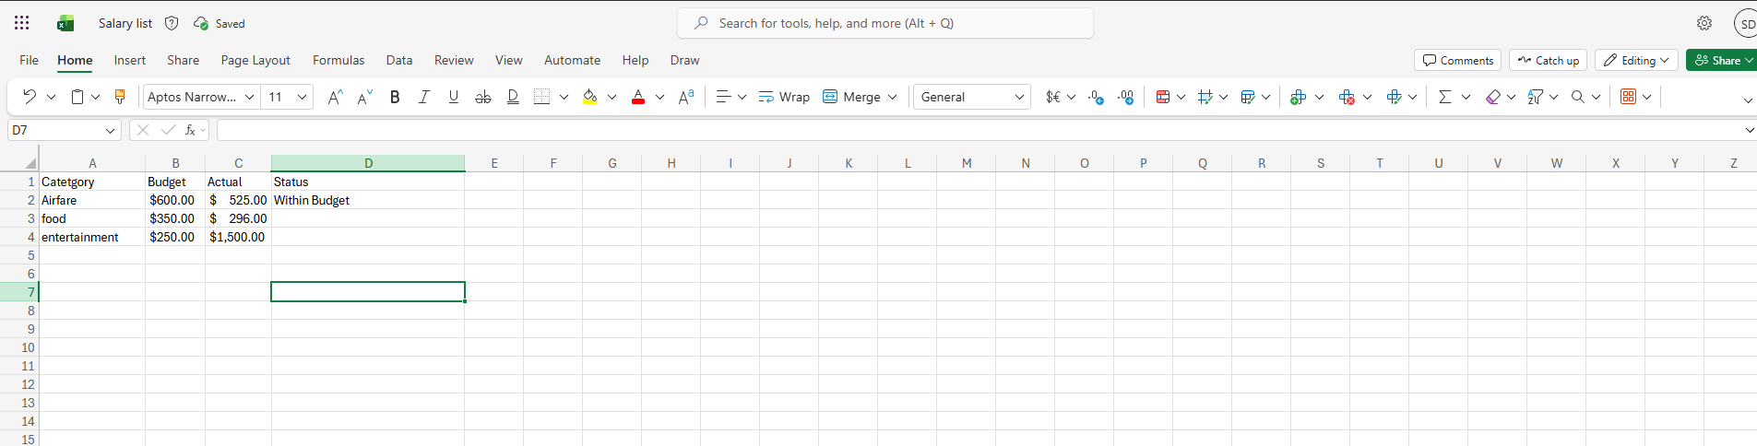
In this screenshot, adding the IF Function Cell D2 selected. Formula bar shows the IF formula that checks if Actual is lower than Budget.
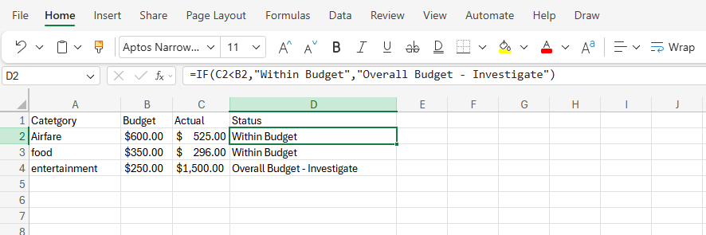
In this screenshot Getting the results: Formula dragged down. Status column now shows “Under Budget” or “Over Budget” for every row.

Task 4. Communication and Collaboration applications

4.1 One contemporary Communication and one Online Collaboration

Gmail

Communication is one of the most important aspects of running successful business and emailing remains one of the most widely used method s of professional communication. Gmail developed by google is a cloud-based email service that forms part of google workspace. It is used by millions of individuals and businesses worldwide because it provides a fast secure an reliable way to communicate. Businesses used Gmail To send messages, share documents communicate with customers schedule meetings and keep records of important conversations as it is cloud-based, users can access their emails from computers laptop tablet and smartphones, making it suitable for office based remote and hybrid working.
Gmail offers a wide range of features that improve communication in the workplace. Users can send and receive emails instantly, attach documents, images and other files and organise messages using labels and folders[22]. The powerful search function allows users to quickly find previous emails, saving time when searching for important information. Also, Gmail includes automatic spam filtering, which identifies and blocks unwanted or suspicious emails before they reach the inbox. Businesses can create professional email addresses using their company domain through Google Workspace, helping to improve their professional image. Gmail also integrates with other Google applications such as google calendar google meet and Google Drive, allowing employees to schedule meetings, join video calls, and share files directly from their email account.
There are many benefits to using Gmail in a business environment. One of its greatest advantages is its ease of use; the interface is simple and easy to understand, allowing new users to learn the system quickly with very little training. Gmail also offers excellent security through encryption, phishing protection, spam detection and two-factor authentication, helping businesses protect confidential information and reduce the risk of cyberattacks.
Because Gmail stores email in the cloud, employees can access their account from almost anywhere with an internet connection, improving flexibility and supporting remote working. Businesses also benefit from reliable storage, automatic backups and regular software updates without needing to install additional programs.
Despite its advantages, Gmail has some limitations. It relies heavily on a stable internet connection, and users may have limited access to certain features when offline. Free Gmail accounts only provide a limited amount of storage, which is shared access to certain features when offline[23]. Free Gmail accounts only provide a limited amount of storage, which is shared across Gmail, Google Drive and Google Photos. Businesses with large volumes of emails and attachments may therefore need to purchase additional storage through Google Workspace. Another limitation is email respond promptly. Businesses may also face security risks if employees fail to recognise phising email or use weak passwords, although Gmail provides tools to reduce these risks
Overall, Gmail is one of the effective communication tools available for modern business. Its combination of reliable email service, cloud accessibility, strong security and integration with other Google Workspace applications makes it an excellent choice for organisations of all sizes. Although there are some limitations, including storage restrictions and dependence on internet access, Gmail continues to help businesses communicate professionally, improve productivity, and support flexible working practices.

Zoom

Modern businesses increasingly rely on video conferencing technology to communicate with employees customers, and business partners across different locations. Zoom is one of the world’s leading cloud-based video communication platforms. It became especially popular during the covid 19 pandemic and continues to play an important role in business communication today. Zoom allows organisations to hold virtual meetings, webinars, online training sessions and interviews, making it easier for employees to work together smartphone making it suitable for both office-based and remote workers.
Zoom provides a wide variety of features that support effective business communications. Users can participate in high-quality video and audio meetings, share their screen to present documents or presentations, send instant messages during meetings, and record sessions for future reference. Zoom also include breakout rooms, allowing participants to split into smaller groups for discussion before returning to the main meeting. Virtual background help users maintain privacy, while meeting scheduling and calendar integration make it easy to organise meeting in advance. The platform also supports webinars for large audiences and includes live captions to improve accessibility for participants[24].
The benefits of Zoom are significant for businesses of all sizes. One major advantage is that it reduces the need for travel, saving organisations both time and money while allowing employees to communicate face to face from different locations. This makes Zoom particularly valuable for companies with remote workers or international offices. Screen sharing helps presenters explain ideas more clearly, while meeting recording allows employees who were unable to attend to watch the session later. Zoom also encourage collaboration by allowing participants to discuss ideas in real time and share information instantly. The platform is generally easy to use, and users can join meetings through a simple invitation link without requiring advanced technical knowledge
Although Zoom offers many advantages, it also has some limitations. The quality of meetings depends on a reliable internet connection, and poor connectivity can result in frozen video, delayed audio or dropped calls. The free version of zoom limits group meeting to 40 mins meaning businesses often need a paid subscription for longer meetings and additional features. organisation must also pay attention to meeting security by using passwords waiting rooms and authentication settings to prevent unauthorised access. In addition, spending long periods in online meetings can contribute to “Zoom fatigue” where employees become tired or less engaged after attending multiple virtual meetings during the day[25].

4.2 Test one feature of a freely available Communication (1) and one feature of a Collaboration (1) application

Gmail
Gmail is commonly used in businesses to send and receive professional emails. It allows employees to communicate with colleagues, customers, and suppliers quickly and securely. Businesses also use Gmail to send documents, invoices, meeting invitations, and important updates.
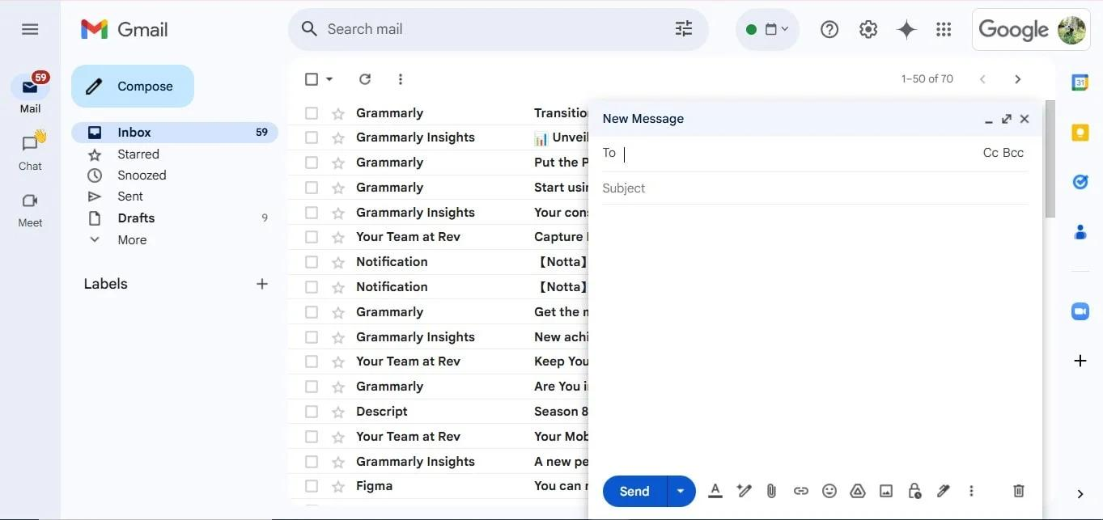
This screenshot shows the Gmail compose window. I created a new email by entering the recipient's email address, writing a subject, typing a message, and clicking the button. This feature is used in businesses for sharing information, communicating with customers, and sending official documents.
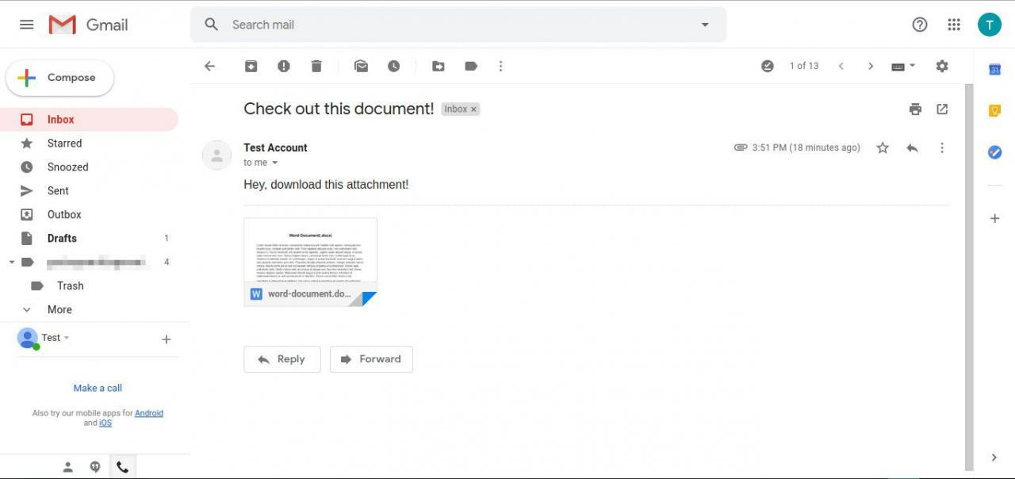

This screenshot shows a document attached to an email. Businesses use this feature to send reports, contracts, presentations, invoices, and other important files securely through email.

Zoom
Zoom is widely used in businesses for virtual meetings, interviews, online training, and team discussions. It enables employees to communicate face-to-face even when they are working from different locations.
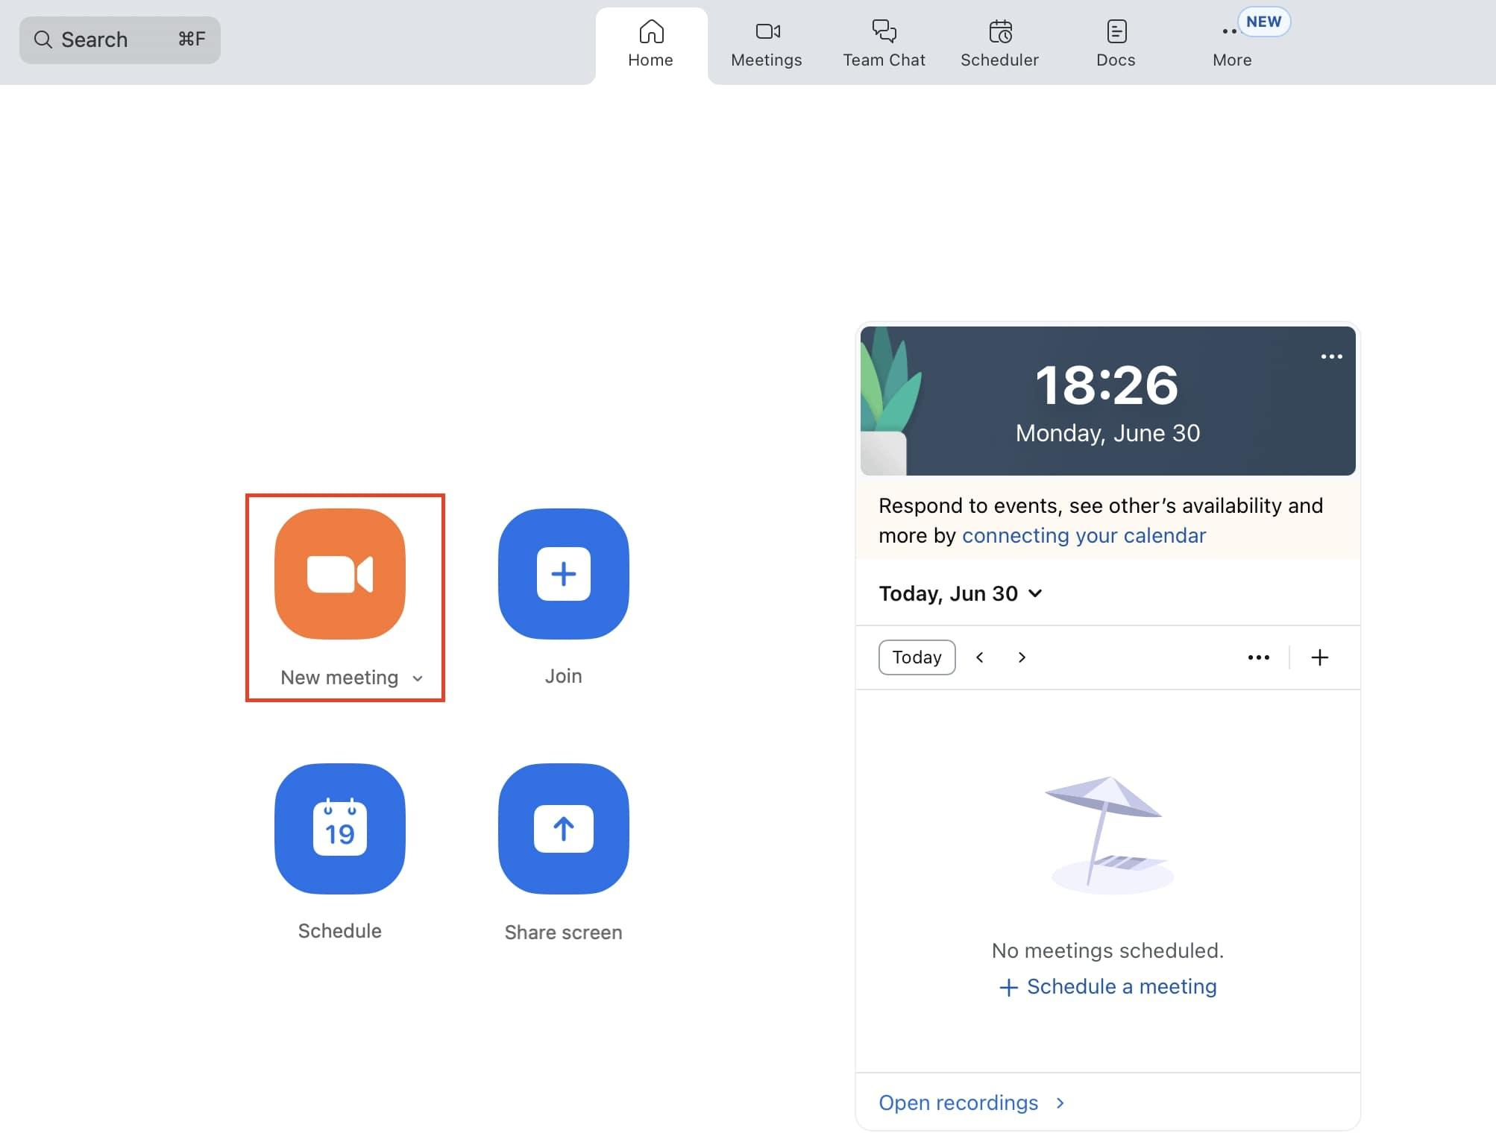
This screenshot shows the Zoom home screen where I started or scheduled a meeting. Businesses use this feature to organise meetings with employees, clients, and business partners without travelling.

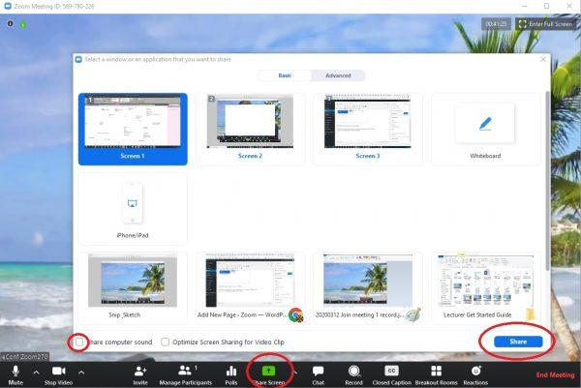

This screenshot shows the Zoom home screen where I started or scheduled a meeting. Businesses use this feature to organise meetings with employees, clients, and business partners without travelling.

Conclusion
Conclusion
In summary, I have gained some insight into how various software packages can be used to assist companies in their operations through this assignment. In the four tasks performed in this assignment, I have explored several software applications and have taken an in-depth look at their features, benefits, disadvantages and practical usage in a business setting.
Task 1 involves exploring Wix and Shopify e-commerce website builders. These two applications enable the creation of an online store, management of the products and processing of payments. I have examined the advantages and disadvantages of these two applications, which has enabled me to realise that a business should select the best software application based on its needs.
In Task 2, I have discussed the concept of mind mapping and its benefits such as organising information and ideas. I have also developed a mind map for contemporary software applications. From this task, I have gained some insight into how the use of visual representation of information can be used to organise ideas, planning, decision making and communications in businesses.
Task 3 has involved exploration of four Microsoft Office applications that include Word, Excel, Powerpoint and Access. I have discovered the usefulness of these applications for various business functions, including the creation of professional documents, management and analysis of data, development of presentations and organising information in database. In addition, I have explored the Mail Merge feature and IF statement in these applications.
The final task involves exploring Gmail and Zoom that are communication and collaboration applications. In this task, I have been able to learn about the uses of Gmail such as sending of professional emails and sharing documents, while Zoom is used for holding virtual meetings, presentations, training and team communications. I have also tested the features of these two applications.
Overall, completion of Tasks 1 to 4 has helped me to gain some knowledge and practical understanding about business software. The right choice and use of software can be beneficial to a company's productivity, communication, organisation, and collaboration, among other things.

References

References
[1] "Wix App Market." https://www.wix.com/app-market.
[2] "Wix eCommerce: Build and grow your online store." https://www.wix.com/ecommerce/website.
[3] C. and Changchit and T. Klaus, "An Exploratory Study on Small Business Website Creation and Usage," doi: 10.4018/JECO.2015010101.
[4] "Shopify eCommerce platform." https://www.shopify.com. [Online]. Available: https://www.shopify.com
[5] C. and P. Holland and M. Gutiérrez-Leefmans, "A Taxonomy of SME E-Commerce Platforms Derived from a Market-Level Analysis," doi: 10.1080/10864415.2017.1364114.
[6] F. Krémer and T. Verstraete, "Mind mapping to facilitate Business Model learning and spark learners’ creativity," doi: 10.7202/1025690ar.
[7] T. Buzan and C. Griffiths, "Mind Maps for Business: Using the Ultimate Thinking Tool to Revolutionise How You Work,"
[8] A. J. Mento, P. Martinelli, and R. M. Jones, "Mind mapping in executive education: Applications and outcomes," doi: 10.1108/02621719910265577.
[9] J. Pierce, "Microsoft Office Team Collaboration. Redmond, WA, USA: Microsoft Press, 2013."
[10] A. Mamishev and M. Sargent, "Creating Research and Scientific Documents Using Microsoft Word."
[11] M. Knauff and J. Nejasmic, "An efficiency comparison of document preparation systems used in academic research and development," doi: 10.1371/journal.pone.0115069.
[12] M. Knauff and J. Nejasmic, "An efficiency comparison of document preparation systems used in academic research and development," doi: 10.1371/journal.pone.0115069.
[13] R. Messer, "Financial Modeling for Decision Making: Using MS-Excel in Accounting and Finance," 2020,
[14] W. L. Winston, "Microsoft Excel Data Analysis and Business Modeling,"
[15] S. M. Moulton, S. Türkay, and S. M. Kosslyn, "Does a presentation’s medium affect its message? PowerPoint, Prezi, and oral presentations," doi: 10.1371/journal.pone.0178774.
[16] S. M. Kosslyn, R. A. Kievit, A. G. Russell, and J. M. Shephard, "PowerPoint® presentation flaws and failures: A psychological analysis," doi: 10.3389/fpsyg.2012.00230.
[17] R. E. Mayer, "Multimedia Learning, 3rd ed. Cambridge,"
[18] "Technical and academic comparisons of desktop relational databases, e.g., discussions of Microsoft Access for small-to-medium enterprise,"
[19] R. M. Riordan, "Microsoft Access 2010: Programming by Example with VBA, XML, and ASP,"
[20] C. Riddington, "technical analyses and performance studies on Microsoft Access,"
[21] "Microsoft, “Learn the structure of an Access database,” Microsoft Support." [Online]. Available: https://support.microsoft.com/en-us/office/learn-the-structure-of-an-access-database-001a5c05-3fea-48f1-90a0-cccaa57ba4af
[22] "Google’s general Gmail product page (covers security features, spam blocking, integrations, etc." [Online]. Available: https://workspace.google.com/gmail/
[23] "Google’s main “Gmail for business” / Google Workspace Gmail product page." https://workspace.google.com/products/gmail/for-work/.
[24] "Understanding time limits for Zoom Meetings." https://support.zoom.com/hc/en/article?id=zm_kb&sysparm_article=KB0067966.
[25] Zoom. "Free video conferencing: Reliable and easy to use." https://www.zoom.com/en/products/virtual-meetings/features/free-video-conferencing/.

