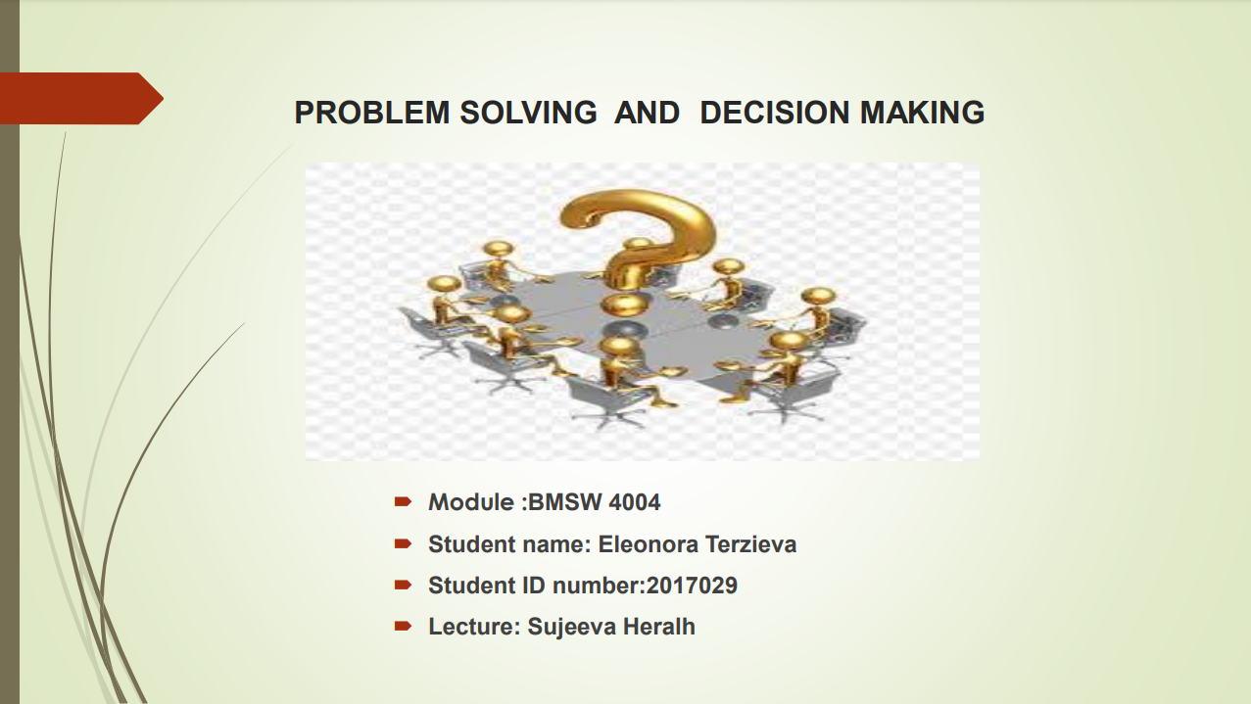

Contents
Introduction 3
What are the reasons? 3
Nature and impact of work-related stress 4
Definition of stress 4
How can we manage work stress? 4
Symptoms on employees 5
PESTEL Analysis 6
What is a PESTEL analysis and uses 6
How different factors impact stress 6
Fishbone Diagram 8
What is a fishbone diagram and uses 8
How different factors impact stress 8
Solutions to work related stress 9
What should the company do? 9
My preferred solution 10
How would I implement this? 10
Conclusion 11
References 12

Introduction

When at work, employees have expectations and demands they have to meet. Failure to meet these demands usually leads to feelings of worthlessness and other negative thoughts. Unrealistic expectations will often force the employees to work themselves harder than they can manage, leading to dissatisfaction and high levels of stress.

What are the reasons?
Among the many reasons of work-related stress, there are too long hours, an overly heavy workload, job insecurity and inter-personal conflicts with colleagues or higher-ups.
This results in a wide range of effects or symptoms, most notably a drop in work performance, depression and anxiety, and possibly sleeping difficulties. According to the Health and Safety Executive (HSE), in 2017/18, 595,000 people in the UK reported work-related stress to a degree that they considered was making them sick. Those figures amount to a 40% of all work-related illness.

The psychological problems, stress, anxiety and depression make up as much as one in five visits to the GP.
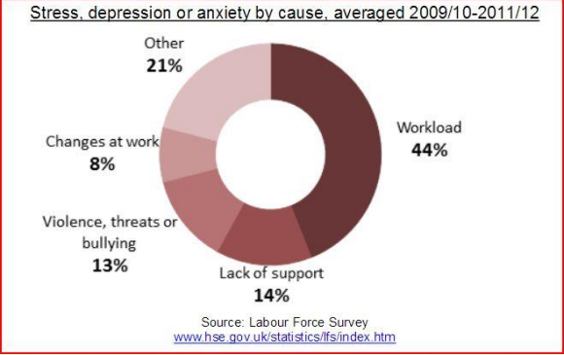
Here we can see a chart showing what workers feel are the biggest reasons for their stress and anxiety, we can see workload is the major reason, making up a 44% of the chart.

Nature and impact of work-related stress
Some pressure at work can be motivating, but when it becomes excessive it can eventually lead to work-related stress.
Definition of stress
Stress is defined as “great worry caused by a difficult situation, or something that causes this condition”, according to the Cambridge online dictionary (2021).
Work related stress, as defined by MacKay et al. (2004) as well as the HSE is the adverse reaction people have to excessive pressures or other demands placed on them’.

In the 1990s the Swedish labour market underwent substantial changes, resulting in smaller organizations, staff reductions and reorganizations. This is considered one of the main reasons for the dramatic increase during the early 21st century in sick leave due to stress-related mental disorders such as depression, anxiety, and burnout/exhaustion. A low satisfaction level in employees leads to lower productivity levels, when work impacts workers personal lives this leads to a decrease in efficiency. Quality work is achieved through satisfactory environments as energetic active workers impact productivity positively.

Examples of the impact stress can have are,
- Dry mouth
- Higher heartbeat rate
- Loss of appetite
- Loss of libido
- Headaches and other pains

These are very real issues, so it is important we ask ourselves how to manage stress to prevent issues.

How can we manage work stress?
Good stress management is critical to a person’s overall health, one of the key skills to being able to achieve this is learning how to say no and how to enforce boundaries.
Constantly saying yes can seem like the nice thing to do for colleagues/bosses and it certainly gains us favour points in the short-term. But if over-done, if taking on too much one can easily fail to stay up to standards and experience burnout, which makes this a terrible long-term strategy.

Symptoms on employees
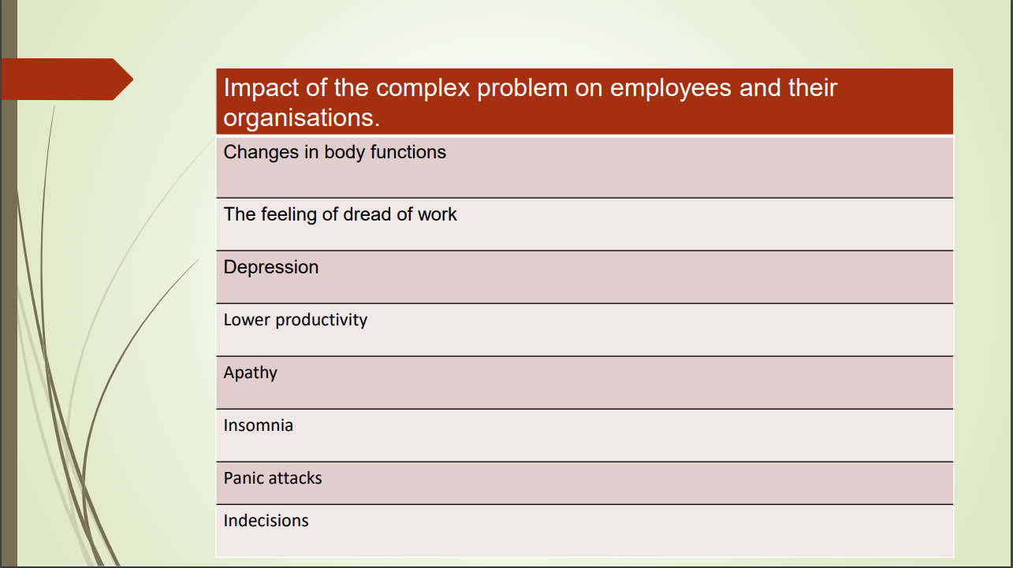

In this chart are listed the biggest symptoms of work-related stress:
- Changes in body functions, such as fatigue.
- The feeling of dread of work, signs of panic.
- Depression, loss of motivation and ambition
- Lower productivity, worse performance when working.
- Apathy, not caring about oneself or others anymore.
- Insomnia, trouble sleeping at night.
- Panic attacks, loss of self-control and overwhelming feelings.
- Indecisions, lack of initiative and needing to be told what to do.

PESTEL Analysis
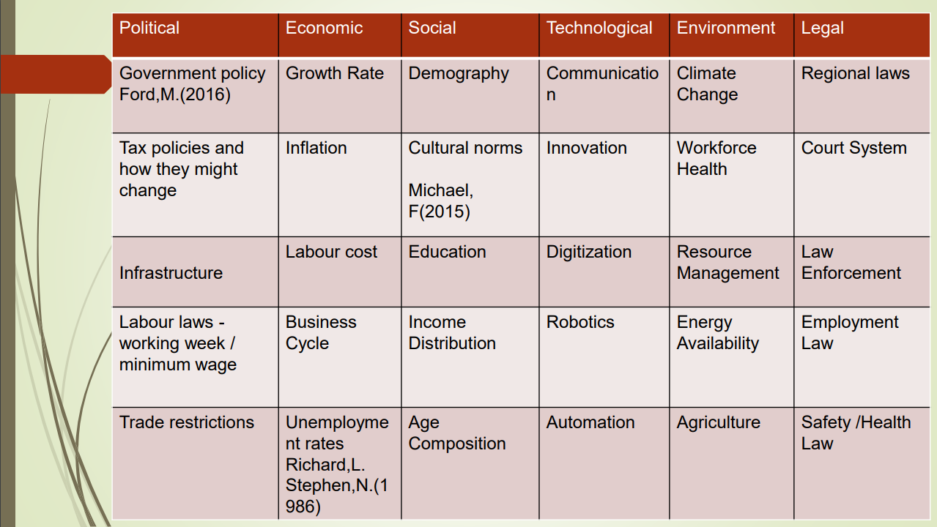

What is a PESTEL analysis and uses

By conducting a PESTEL analysis we can look at all the important aspects which have an effect in the outcome of a business or subject. PESTEL stands for several factors, these are Political, Economic, Social and cultural, Technological, Environmental and Legal factors.

This analysis is a tool used to analyse and monitor all external factors that impact businesses or industries. The desired outcome of carrying out this analysis is to deepen the understanding of how much and which factors exactly have a sway over the success or failure of a business, or the effects on a matter of discussion.

How different factors impact stress
Ford, M. (2016) mentions how government policy in some areas can change at any time, and it can unexpectedly affect stress levels at work. For example, an unfavourable change in minimum wage.

Tax policies are also subject to change and could effectively lower the total income of workers, adding to their financial stress, things like raising the tax for common bills like water or electricity.
Infrastructure and procedures can change and be less helpful for the comfort of workers, so can change labour laws or the trade laws related to a business, all of these are factors that can threaten a worker’s income and understandably cause worry.

Economic issues are directly tied in with the economy instead of indirectly like political issues.
This can be a change in labour cost due to simple supply and demand or inflation taking place.
Unemployment rates can also be high due to economic issues causing too many workers and not enough businesses willing to conduct work in the country. Job shortage is another stressor that workers might have to deal with, on top of making people already with a job more likely to withstand unfavourable conditions and overwork themselves just to keep job security.
Social issues can be education requirements, as not everyone has had the same opportunities throughout life despite the government’s efforts against it. It causes stress to compete with others when job hunting specially in some high demand job markets. People are forced to compete with possibly better prepared colleagues, and this is a stressful thought.

Technological issues can take place when technology keeps evolving and it is hard as a worker to keep up with all the innovation, always having to stay on top of the newest developments is stressful and adds extra work. Automation and robotics are also a valid concern for many workers as there is general widespread fear that manual jobs such as factory positions, could be made unnecessary and taken over by automation and robotics.

Environmental issues are mainly to do with climate change and green energies, these two things are a great worry to many people and many worry that not enough is being done. This definitely adds a sense of doom to people’s thoughts and can impact negatively on their job performance and personal life.
Legal issues are usually conflicts between employees and employers, where many employees worry that the law is not always strict enough to look out for their best interest and leave legal loopholes for the company to not take responsibility.
For example, safety and health law might not be specific enough and lead to workers working in unsafe or dangerous situations which would make them worry.

Fishbone Diagram
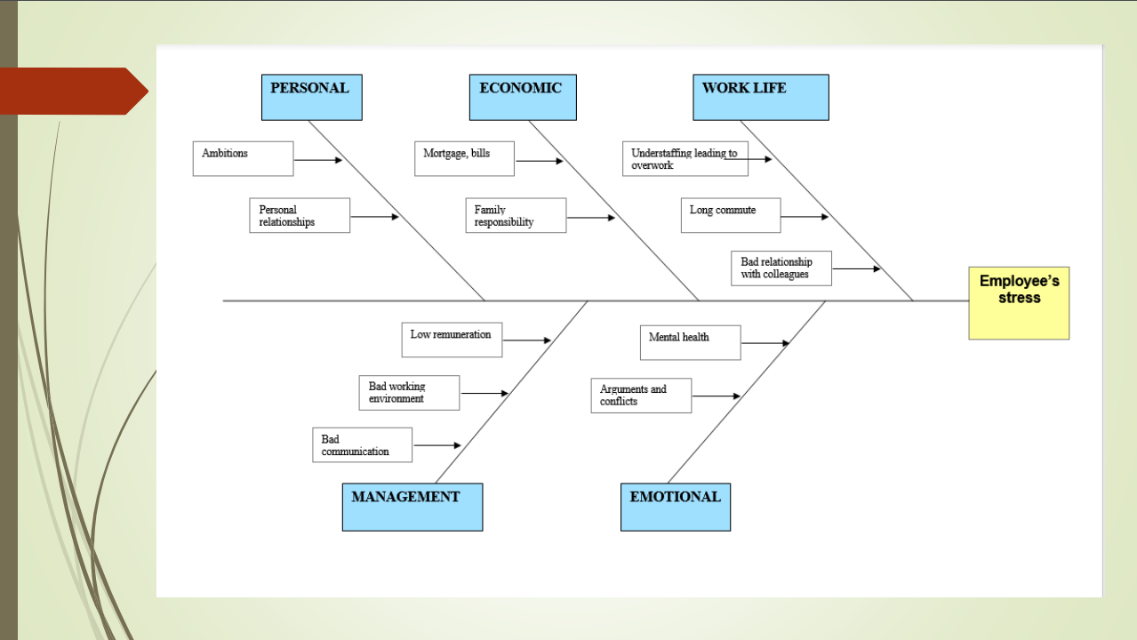

What is a fishbone diagram and uses
This fishbone diagram identifies different possible things that can have an effect on employee’s stress.
A fishbone diagram is useful because it can help us brainstorm to easily identify possible causes and to sort them out in useful categories, it provides a visual approach to the problem.

How different factors impact stress
Personal things that can contribute to the problem are the employee’s ambitions and personal relationships, they can both carry positive and negative effects on their stress levels and how susceptible they are to it at work.

Economic factors include family sustenance, and paying their bills or mortgage, knowing they must pay their debts can be a cause of stress for people living payslip to payslip.

Work life, aspects of life at work like the time it takes to commute or bad interpersonal relationships with colleagues, or simply being understaffed at work, are all things that can negatively affect someone.

Management can be bad at communication or not incentivize and remunerate their employees enough, causing a bad ambient at work and dissatisfaction which can lead to stress.

Emotional factors like the mental state of any given employee can mark the difference between dealing with stress in a healthy way or burning out.

Solutions to work related stress
Long-term exposure to unmanaged stress can take a toll on your body and mental health, there's a potential link between work-related burnout and depression and anxiety.

Therefore, we have to know how to keep work stress from taking over our lives, the steps are simple:
- Recognize it
- Write it out
- Recharge
- Manage your time
- Balance work and play
- Reframe thoughts
- Rely on others
- Meet your needs
- Relax regularly
- Avoid gossip
- Embrace the imperfect
- Take a trip
- Talk to your boss
- Seek help

What should the company do?
The company should also take preventive steps to avoid having to deal with fallouts later.
There’s a few general things any company should ensure:
- Sufficient training courses should be provided to new hires to ensure they are comfortable working by themselves, a mentoring system could be put in place for this
- Appropriate working conditions, employees should have up to date software and hardware like machines. It should also be attempted to keep a good temperature and tidiness of the working space where possible.
- Break times, employees should have the necessary rest from the workload. Make sure that employees have commodities in the break room. such as microwaves and sofas.
- Rewarding appropriately, employees should be properly rewarded for their efforts, this helps motivate them to keep working to a high standard, examples of this can be monetary rewards, company car or promotions.
- Regular meetings managers should strive to improve the flow of communication between employees, to make sure that everyone can voice their opinions and concerns, a good technique for this is brainstorming.

My preferred solution

Here's a PMI chart of my preferred solution to work related stress, which is regular meetings between employees and employers, where everyone can voice their opinions. I evaluate the pros and cons this would bring.
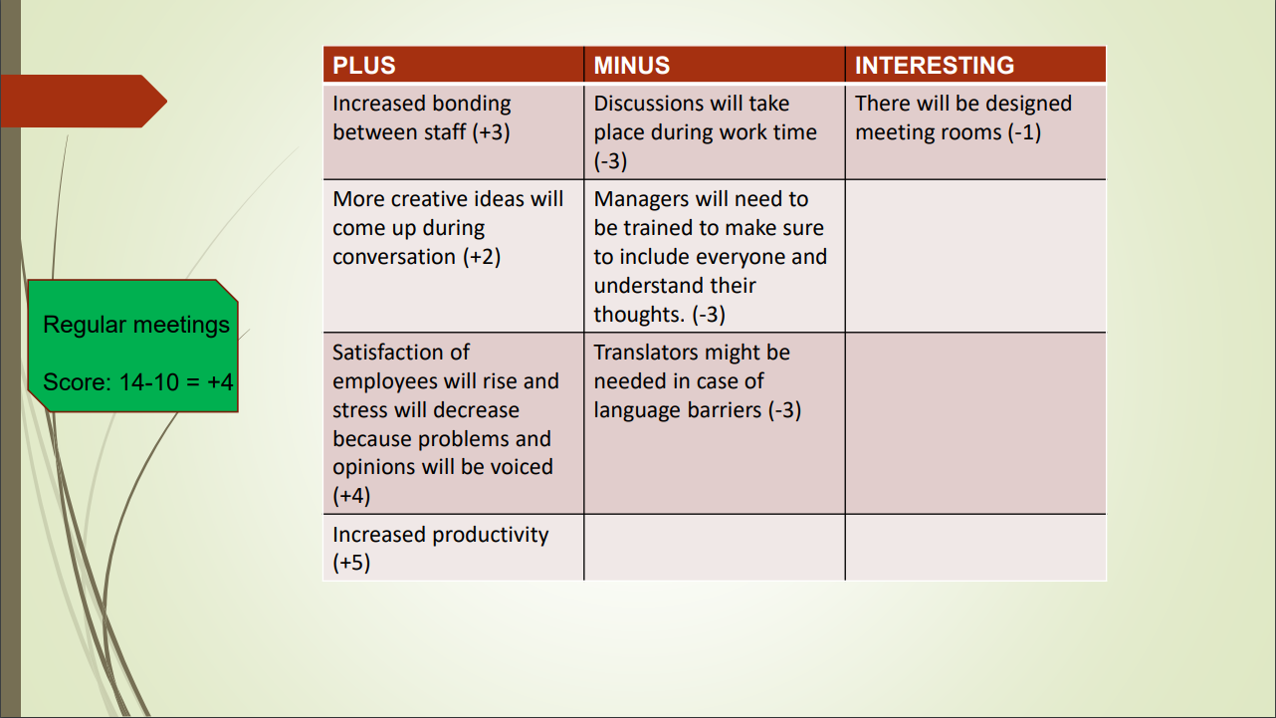
Overall, the benefits of my solution outweigh the disadvantages with a total positive score of +4.

How would I implement this?

Step 1: Identify the best time.
Managers should talk about and decide which is the least busy day of the week.

Step 2: Set a weekly meeting on the decided day.
Tell all staff that there will be weekly meetings on the determined days, and that they will be free to discuss their opinions about anything work related, everyone would have a chance to voice their minds and bring up issues or ideas that they consider relevant.

Step 3: Note down ideas.
During the meeting, make sure to take note of the complaints of the employees and of their ideas to better the business.

Step 4: Act.
Take the employee feedback into account and try to remedy the issues they are having, as well as consider their ideas for improving the business as many of them might be worth in terms of profit and general success & well-being.

Following a change meant to improve employee well-being, in the next meeting managers should collect a poll rating of employee satisfaction concerning a specific issue, and also a rating concerning general happiness. This will help management track the effectiveness of their actions and tip them off if they are not doing enough or what else could change.

Conclusion

Due to several factors stress at work is increasing dramatically in the last decades, this is leading to a huge increase in sick leave related to stress as well as an overall worse mental health of employees, These issues can largely be resolved by increasing the flow of communication and letting workers speak up when they feel they are not up to the task, or that the pressure is too high, as well as resolve any other issues with the working environment. By doing this companies have everything to gain as research shows that increased worker satisfaction results in higher productivity, and employees will feel valued and respected which will increase their overall happiness and well-being.

References

Cambridge Online Dictionary, 2021. ‘Stress’ definition and Meaning. Available at: https://dictionary.cambridge.org/dictionary/english/stress Accessed on: 04/12/21

Ford, M., 2016. The impact of Brexit on UK labour law. International Journal of Comparative Labour Law and Industrial Relations, 32(4).

Frese, M., 2015. Cultural practices, norms, and values. Journal of Cross-Cultural Psychology, 46(10), pp.1327-1330.

Gensler Workplace Survey, 2013

Layard, R. and Nickell, S., 1986. Unemployment in britain. Economica, 53(210), pp.S121-S169.

MacKay C.J, Cousins R., Kelly P.J., Lee S. & McCaig R.H, (2004) ‘Management Standards’ and work-related stress in the UK: policy background and science, Work & Stress, 18:2, 91-112, DOI: 10.1080/02678370410001727474

Stefansson, C.G. Major public health problems—Mental ill-health. Scand. J. Public Health 2006, 34, 87–103.

Stenbeck, M.; Persson, G. Working life, work environment and health. Scand. J. Public Health 2006, 34, 229–245

