An investigation into the fall and rise of Primark

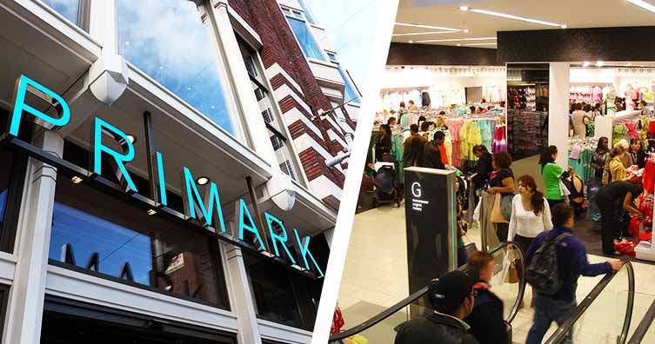

Business Consultant
Hema Sharma
1812759

Title Page

- Title of Report- An investigatigation into the fall and rise of ‘Primark’.
- Name of Author- Hema Sharma
- Name of Host Organisation- Primark
- Date of Report Publication- 12.07.19

Executive summary

In this report the ‘CEO of Primark’ asked to the ‘researcher’ to compile a report about the major development the organisation has faced since its launch in 1969, Primark’s current product and store location portfolio and investigate and discuss how Primark has planned, communicated, monitored and reviewed previous attempts to resolve problems with suppliers. Researcher talked about some of the major problems for example, Primark’s cheap and non-eco-friendly clothes, targeting under 35 year of age and lack of plus size clothes, paying less than the minimum wages to the employees, not spending money on advertising and not selling online etc. Researcher suggested that the company is mostly rely on other countries for the products, but countries like India they are using child labour by offering very less pay. Organisation need to work with ‘Sustainable Apparel Coalition’(SAC) to improve supply chain sustainability. Organisation needs to do the check on their key sourcing countries to find out about the standards of their products as well.
Organisation should increase the pay of the employees and give bonus, incentives as a reward to motivate, employees should be given proper trainings regarding how to organise and good customer services. Company needs to promote their own brands goods, suggested to start their website to sell the goods which will increase the organisation’s business.

Contents list

- 1.0 Terms of Reference………………………………………………………. 5
- 2.0 Procedures……………………………………………………………………. 6
- 3.0 Findings………………………………………………………………………… 7 - 13
- 4.0 Conclusion……………………………………………………………………. 14
- 5.0 Options………………………………………………………………………… 15
- 6.0 Appendices…………………………………………………………………… 16 - 18
- 7.0 Acknowledgements………………………………………………………. 19
- 8.0 Reference list……………………………………………………………….. 20 - 21

- Terms of Reference

The CEO of ‘Primark’ requested the report from Researcher, ‘Hema Sharma’ on 5.06.19 to write a 3000 words report on major development the organisation has faced since its launch in 1969, about its product and store location portfolio, how Primark planned, communicated, monitored, and reviewed, previous attempts to resolve problems with suppliers, the nature, scope and impact of the current problems ‘Primark’ is facing and to suggest possible business options that enables decision makers at ‘Primark’ to resolve the identified problems. The purpose of report is to examine the fall and rise of ‘Primark’ and the date of submission is 12.07.19.

- Procedures

  - Researcher used Books and websites as a Source of information.

3.0 Findings
3.1-The company was launched in 1969 in Ireland trading a Penny’s. Primark is a subsidiary company of the ABF (Associated British Foods) Group. Primark is seen as one biggest fashion retail success stories of the past decade. Best known for its low price and high value offering, "Amazing fashion, amazing prices". In ‘1969’, Primark opened first store in ‘Dublin’ and now got 38 stores, ‘1973’ in UK, Primark opened its first store, which increase by 174 stores. In ‘2006’ in Spain first store was opened in ‘Medard’, now got 42 stores. By the year 2012 Primark had 238 branches across the UK, Ireland and Europe. (More information is on ‘timeline diagram’ which is on, appendices- 1)
3.2- “Primark: A brief overview of the Business Primark is a brilliant and unique organisation with a mission statement to enrich the life of everyone with fashionable clothing regardless of social status”. (Azad, 2013) Primark’s products are mainly sourced from suppliers in Europe and Asia. Its supplier countries are China, India, Bangladesh and Turkey. It provides a wide range of women accessories, man’s wear, women’s wear and children’s wear, footwear, beauty, hosiery, homeware etc. By 2000, there were over 100 stores across Britain and Ireland, in 2012 Primark had 238 branches across the UK, Ireland and Europe. Company’s success is based on sourcing supply cheaply and directly by factories without involving agents. The organisation’s costs are extremely low as they do not run expensive advertising campaigns, instead of this, company got wonderful strategic marketing approach.
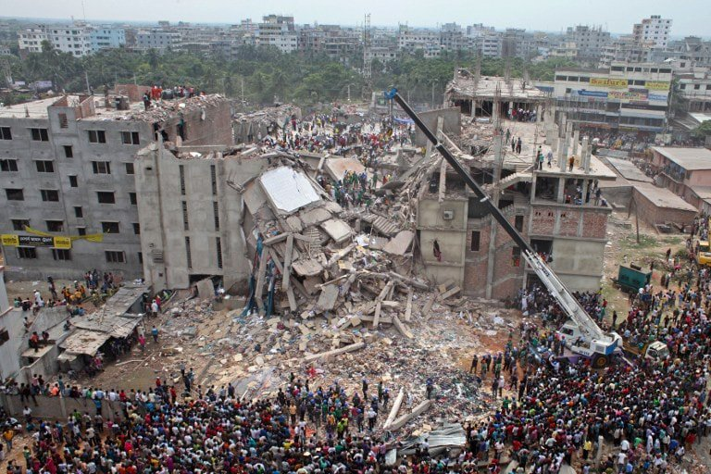
3.3- Primark does not manufacture goods for itself. Organisation understands the needs of customers and works with its supplier to produce goods to Primark’s specification. Primark always rely on low cost and high customer’s satisfaction. Primark’s key sourcing supplier countries are China, India, Bangladesh and Turkey. On 24th April 2013, a building named ‘Rana plaza’, housing five garments factories which manufactured products for nearly 28 brands including Primark, collapsed in near Dhaka, Bangladesh, claiming the lives of 1,138 workers and injuring more than 2,000 individuals. For this loss, Primark was the first one to sign the ‘Accord on Fire’ and building safety in Bangladesh. Primark was the first to ensure the factory victims and families affected by the collapse get financial support and food aid quickly. Organisation paid short- and long-term compensation and 14 million dollars to those who affected.

(Hendriksz, 2017)

Since then Primark has continued to work with local partners and non-profit organisations to ensure any funds or support, they gave to workers and their families would be secure by offering financial advice and guidance. (Hendriksz, 2017)
At the moment Primark has a team of over 80 experts, who regularly visit factories for checks. Primark is now working with Cotton connect and the self- employed women’s Association (SEWA) to support female cotton farmers in India. After its past experience, Primark understand that all internal and external stakeholders want different things, for example- Internal stakeholders such as, shareholders want a return on their capital, employees want good pay, job satisfaction and security and all this will depend on the profit made by Primark. External stakeholders such as customers want good quality products in reasonable price. Primark has decided to become more concern about its commitment in producing responsible fashion (Hendriksz, 2017)
3.4-The current problems which Primark is facing now a-days:
Nature- One major problem is that, Primark’s product prices are very low and cheap quality and child labour, as Primark has to depend on their suppliers from Asian- countries, for goods but they are using child labour. Another problem is, the organisation is paying less than the minimum wages to its employees and organisation is not having systematic way about how to put clothes in proper way and customers are facing poor staff service. One more problem is, Primark don’t sell their products online like Gap etc as it is time-saving for the customers. Other big retailers like Debenhams, H & M etc. they are also like a threat for Primark because they are struggling with the prices due to Primark and not happy with that.
Scope- Due to the low- price products other retailers like Debenhams Mark and Spenser are also not feeling safe and struggling with the prices. After, the incident of child labour caught in there three suppliers’ chain, Primark cut down the orders and sent some goods back then the Company has to face lack of products and they cut down the employees (McDougall, 2008). So, employees are affected by the unemployment and moreover they are taking less than the minimum wages from the organisation. Due to the unemployment their families will be affected. Government will be affected as it will be a pressure on the government if people are unemployed. Community and customers will be affected as they are struggling with cheap quality goods and poor staff services in Primark.
Impact- Employees wanted job security, job satisfaction and good pay rate. Shareholder wanted a return on their capital, and all this depend on the profits of Primark. Customers has to suffer because they will not get their desired and best quality products in time. Government has to suffer because if the company will be in loss, lots of people will stay jobless and their families will struggle, ultimately the pressure will go to the government as well. Suppliers will not get orders and money in time and unemployment will be the result. Shareholders will be in loss as they invested money in the firm, share price will go down. If all the problems will grow day by day, no trust will be remained, and the company cannot survive or may be taken over.

3.4.1 Analysis of Primark:
Primark is one the most recognizes names in clothing chain in UK. It was launched in 1969, in Mary Street Dublin under the trading name of PENNEYS. Primark including Children wear, men wear, women wear, footwear, swim wear, accessories, beddings and household etc. Currently there is 196 stores in total running by the name of Primark. Which is, in UK-138 branches, in Ireland-38, Spain-14, Portugal-2, The Netherlands-1, Belgium-1, Germany-2.
Primark is targeting consumers under the age of 35. There can be two methods for the business to earn the profits more than normal prices, either by product leadership or by cost leadership. In cost leadership the organisation provides the same product at lower price, whereas, in product leadership customers are ready to pay more for the products. Primark’s strategy is based on cost leadership. That’s why Primark believes on selling the products in affordable prices.
To maintain the above strategy Primark was always looking for the cheap suppliers as the organisation does not manufacture goods itself. Company has to rely on its supplier countries, i.e. China, India, Bangladesh and Turkey’s goods at low labour cost. That’s why company saves huge cost. Primark uses computerised customs clearance to keep a strong warehousing and distribution network because one of its strategy is to reduce the time-to-market as much as possible (UKessays, 2016). Related picture can be seen in appendices-2.

3.4.2 Primark is one of the most recognized names within the ‘Fast’ fashion industry. Primark is a subsidiary company of the ABF (Associated British Foods) group. Here is the SWOT analysis of Primark:

Strengths of Primark:

Primark’s success in the home market of Ireland has led the organisation to expand to the UK and many other countries. In March 2019 Primark has over 350 stores. Primark offers many job opportunities and employs more than 27,000 people.

To attract its customers Primark offers affordable and wide range of products for women, men, kids, beauty and home, at very low prices. The organisation doesn’t spend too much money in advertising and most of its products are Bangladesh, India, China and Pakistan made, as these countries offers low labour cost, that’s why Primark sell their products at very low prices. Primark’s prices are nearly 30 or 40 percent cheaper that other retailers or its competitors.

Primark will be the biggest cloth selling retailer in the UK soon, as in May 2018 the company got 7% market share, whereas Marks & Spencer’s got 7.6% market share which is known as a market leader. So, the organisation is going to give the competition soon (Rahman, 2017).
Primark is taking Ethical Trading Initiative, as its main aim is to focus on employees’ rights, better quality good’s production and to stop child labour.

Weaknesses of Primark:
Though Primark is one of the leading organisations, it got many weaknesses. One of the major weakness is, that Primark does not sell its product online. Company makes very less margins from low prices thus cannot spend too much on online trading and publicity. There competitors have advantage over them because Primark does not advertise.

Primark offers fashionable clothes at very low price, but many customers complaint about its poor quality, lack of unique style and plus size clothes, and non- eco-friendly clothes.

Primark is one of the 260 employers who have been identified by UK government, for paying less than the minimum wages. Primark’s poor working condition and disrespecting workers’ rights is also including in the weaknesses. Although Primark is taking Ethical Trading Initiative, there are many complaints about its goods which includes poor working conditions, disvaluing workers’ rights and using child labour to manufacture goods.

Opportunities of Primark:
Due to increased sales and demand Primark is constantly focuses on further growth in the UK and Ireland. Primark is about to open its biggest store in Birmingham and has plans to open new stores in USA. Moreover, Primark is planning to open stores in Poland, Slovenia, and Czech Republic as well. Primark opened 47 new stores in the UK, and going to open 7 new shops in Spain, Now Primark is giving competition to other big companies, i.e. H&M and Matalan. Other companies have to spend more on advertising to stay in competition with Primark, as the organisation is not doing advertising.
Obesity rate is going high and its predicted that by 2050 it will be the 50% of the population. Other retailers are giving competition to Primark as they are making plus size clothes, so it’s an opportunity for Primark to make plus size clothes to grow in the clothes business (Kush, 2017).

Threats of Primark:

Primark is facing many problems as a threat, organisation is facing threats from its competitors in the United States, which are Walmart, Gap’s Old Navy, Forever 21, Kohl’s, J.C. Penny and Macy’s. Organisation’s main competitors within UK are, Mark & Spenser, ASDA, Tesco, Tk Maxx, JS Sports, Debenhams, Zara, Next, Matalan, Peacock Arcadia Group, and Sports Direct etc. Each competitor analyse that Primark has better business power and high market share but in the other hand organisation got poor management and low standards of hi-tech position.
Primark needs to take care about several environmental changes to define its marketing strategy. One of the big threats is because of organisation’s poor and cheap quality products (Blythe, 2012). Moreover, company do not advertise whilst their competitors do.

3.4.3 PESTEL Analysis of Primark:

Social:
Growth of plus size fashion: The social problem that many retailers are now facing in the UK are obesity and an ageing UK population. According to the NHS (2015) UK is now known as the “fat man of Europe” in which 6 out of 10 women are obese or overweight. Primark have a lack of plus size ranges and sizes, that’s why many obese female customers avoid going for a shopping in Primark. It’s been predicted by NHS the half of the UK population predicted to be obese by the year 2050, for that retailers like Primark need to start investing on plus size clothes, by that organisation can attract a large number of customers.
Ethical equivalent of maximising consumer choice may well appeal to the business mentality which is familiar with the aim of respecting the sovereignty of the consumer (Harvey, 1994)

UK’s ageing population: According to the national statistics over the 40-year period the medium age of the UK population half the population is younger, and another half is older. with the number of over-65s getting closer and counted as a fifth of the UK’s population. Over 65 customers have more income before, as they worked full time and thus earn more money, they tend to buy clothes online, it defines that Primark should start online website so that the organisation can increase its sales and business market.

Technological factors
The development and growth of e-commers is continues open up the door for more competition the UK clothing retail business, like Asos, Amazon, Boohoo and others. People like that kind of stores due to ease and low cost. Primark does not have any e-commerce website. The organisation is not spending money on advertisement either which makes the organisation vulnerable in the business of clothes industry. If the organisation will make website and use the technical field such as advertisement, company can see a huge sale difference as some people prefer online shopping due to lack of time, business, or due to the age etc.

Environmental factors
Some other factors that is influencing UK clothing business includes the rise of environmentally and ethically conscious consumers. Some consumers continuously demand all the firms to adopt practices such as paper packaging. Consumers also pressurise the firms to use the recycled materials. Retailers like H&M have already started sustainable clothing lines made from organic cotton and environmentally friendly materials. Government also pressurise all the firms to do proper waste disposal. Consumers complaint that Primark’s clothes are not ethically made, and they are not eco- friendly. The consumer complaint about the cheap quality as well. So, Primark has to think about all these factors in order to stay and grow in the business of clothes industry (Kush, 2017).

3.4.4 According to the researcher, all businesses depend on a variety of stakeholders. The main stakeholder of Primark are its Customers, Employees, Community, suppliers, stakeholders and the Central Government and its agencies etc.

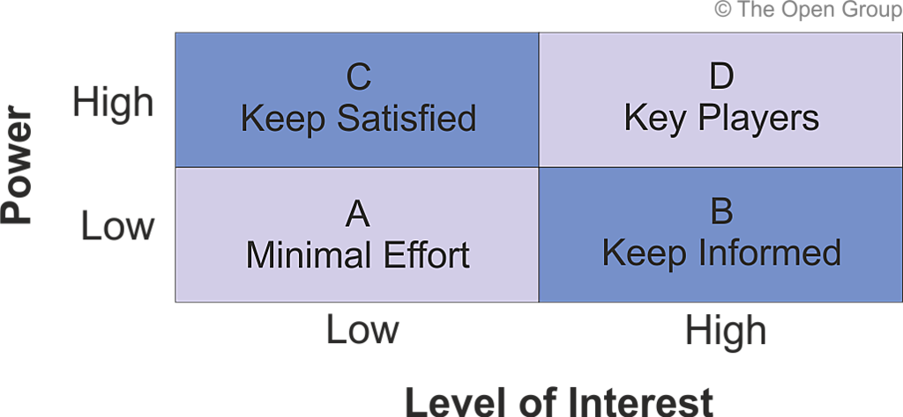
Power/Interest Matrix

Employees- The researcher can put the employees in high power and high interest because the employees are the base of the organisation who are responsible for most of the services and duties done in any organisation. Primark needs to make them happy by giving good wages, bonus and incentives so that employees interests will grow and by their good productivity the organisation can grow rapidly.

Community- community can be put in high power and high interest. Companies and communities, they are in two-way relationship, as community provides organisation employees and customers and organisation provides company goods. So, if the community will not happy with Primark, their sales will go down. Moreover, if the employees will not satisfy with the wages, they will leave the job and company will be affected.

Suppliers- Firms source the resources required to produce goods and services from suppliers and business needs to have strong relationship in order to get quality resources in time, with reasonable price. That’s why suppliers can be put high interest and high power in stakeholder analysis diagram.

Central and local Government- According the researcher, The Government plays very important role for any organisation, as economic policies affect firms costs through taxation and interest rate. A successful firm is good for the Government as it creates employment and wealth. So, the Organisation can put power and interest both high for the Government.

Shareholders and Owners- Organisation can put both Shareholders and Owners in high power and high interest category, because if the owner and shareholder are not satisfied with the policies and strategy of the organisation then no attention will be paid towards the company and it will go to loss, sometimes can be taken over. Owners and shareholder invested a lot money in the organisation, that’s why the interest rate is also high.

3.4.5- Stakeholders are usually the people, who are affected by and affect the actions of a firm. There are many stakeholders inside or outside the organisation who can help to resolve the current problems. Researcher discussed about the points. These are as follows:

Owners- Primark and owners need to think about employee’s rights and to provide the employees better environment and good salary, incentives and bonus. Owners need to promote their own brand clothes instead sources from another countries, the quality of goods needs to improve. Primark need to think about 35 aged over and plus size clothes, to create an online website and spend more money on advertising to stay in front of its competitors and increase the sale. Primark should have a strong and well-experienced management board that would be responsible for the implementation of policy direction and strategies set by the board and the day-to-day running of the business.

Staff or employees- Staff needed to develop their skills through proper trainings regarding the work for example how to organise everything, how to present good customer services.

Customers- Customers can contribute the support by purchasing the fashionable and nice clothes at affordable prices in comparison to other organisation where the customers need to spend a lot in the high street.

Investors- Primark has the ability to make profit. If Primark will increase its margin and profit by promoting its own brand clothes, by advertising, by selling through online websites then investors invest more money as they will get profit and with that the company will get advantage as well.

- Conclusion

4.1-Primark is one of the leading and most recognised names in the fashionable clothes industry. It was launched in 1969 and by 2019 Primark has over 350 branches across UK, Ireland and Europe. Primark offers a wide range of menswear, womenswear, children-wear, footwear, lingerie etc at very reasonable prices. Primark offers many job opportunities and employs more than 27,000 people. The organisation doesn’t operate any website and not spending much money in advertising, moreover its most of the products are made by India, Bangladesh, China and Turkey, and these countries give low labours cost, hence the price of the products are low in comparison to their competitors. Though being one of the leading organisations, it got many weaknesses. People complaint about the quality and prices of the product by saying that the organisation is selling cheap quality clothes, they are not ethically made, they are focused on under 35 years of age, they don’t sell plus size clothes and moreover the organisation is not selling their products online and the organisation is paying less than the minimum wages to their employees.
The organisation is facing most of the problems due to because the firm is dependent on other countries for their goods. If for some reason’s organisation stops their orders, then the organisation will face lack of goods and cannot survive. Researcher can give the example when Organisation found that the countries like India, is using child labour, then organisation stopped the orders and send some goods back.

4.2-According to the researcher, the main areas of concern to the organisation are:
Organisation’s dependency over other countries for goods, the price of the products, paying less than the minimum wages etc. All the rest is can be seen in Appendices-3.

4.3- According to the researcher, here are the main areas of Primark as a strength: Primark’s success in the home market of Ireland has led the organisation to expand to the UK and many more countries. Primark’s main stakeholders are their employer, who need to promote their own brand instead of their depending on other countries. Employers need to give employees better wages, bonus and incentives to motivate the staff. Staff need to have proper trainings to improve work quality. Employer needs to use their technical knowledge by developing website and advertising their brand.
Researcher collected the information, which can be shown on Appendices - 4.

Options

5.1-When sourcing the materials, there are many issues which suppliers needs to think in accordance to sustainability. For example, the suppliers need to think responsibly about a range of manmade fibres or natural fibres which plays an important role in production. Suppliers needs to think about environment, does the things are leaving bad impact on environment by causing harm with the pollution by chemical or by waste materials.
“Environmental ethics considers not only natural but also urban environments: how human beings are affected by physically mentally and spiritually by the design and materials of the buildings in which they live and work” (Benson, 2000). The suppliers need to think about the people living around or working, who are affected by the factories. The more information is on Appendices-5.

- - Appendices
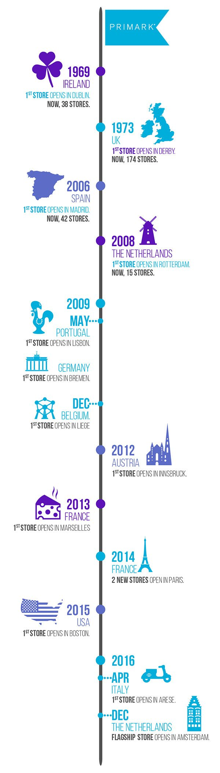
Appendices - 1 (related to 3.1)

(Hendriksz, 2017)
Appendices – 2 (related to 3.4.1)
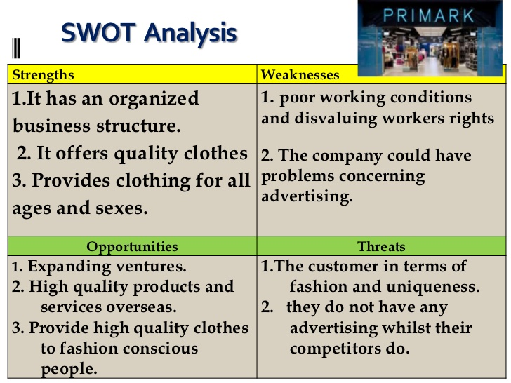

Appendices - 3 (Related to 4.2)

No. | Weaknesses
1. | Organisation does not make most of the goods and organisation needs to depend on other countries for their products and countries like India, using child labour at very low rate.
2. | The organisation offers low quality products at very low rate.
3. | Organisation is lacking about plus size clothes and targeting only under the age of 35 people.
4. | Poor customer services and unhealthy environment.
5. | Organisation is offering the employees less than the minimum wages.
6. | The organisation does not operate any website to sell their products and not spending much in advertising, which their competitors does.

Appendices – 4 (related to 4.3)

No. | Strengths
1. | To attract its customers Primark offers affordable and good quality products.
2. | Primark’s strategy depends on low margin and high sales.
3. | By March 2019, Primark has over 350 stores in total.
4. | Primark offers many job opportunities and employs more than 27,000 employees.
5. | Organisation’s most of the goods are source from the countries like China, Bangladesh, India and Turkey, by that the company is helping them by giving employability.
6. | Primark is taking ethical trading initiative, as its main aim is to focus on employees’ rights and to stop child-labour.

Appendices – 5 (related to 5.1)

No. | Options
1 | Suppliers and related factories need to think about internationally organised standards. For example, employees pay, employment policies and health and safety issues.
2 | Every worker and factory management should be aware about the standards, and for this check should be done monthly or weekly basis to see weather international standards are being met or not.
3 | Suppliers need to think about environmental impact through manufacture process. For example, the chemical which suppliers are using to dye clothes should be made from zero discharge of hazardous chemical, need to think how raw material such as cotton are sourced.
4 | Suppliers need to work with SAC, which means Sustainable Apparel Coalition, to improve the supply chain sustainability.
5 | Every supplier should follow Code of Conduct, every supplier must commit to it, before the starting of work. It includes the issues like, Child labour, bribery, ensure workers for not to do excessive hours, workers right to form trade union etc. to make a healthy environment to work with.

7.0 Acknowledgements

First of all, senior lecturer, Maria Heffernan helped the analyst research the needed information regarding this report by giving the guidance and support which was helpful too. Also, the librarians of UWTSD offered to help and assist the researcher/writer in finding the relevant books needed for this task.

8.0 Reference List

- Azad, S., (2013). Primark: Overview. [Online]
Available at: https://www.slideshare.net/selimjigsaw121/primarkoverview
[Accessed 12 June 2019].

- Benson, J., (2000). Environmental Ethics. London and newyork: Routledge.

- Blythe, (2012). Primark SWOT Analysis. [Online]
Available at: https://businessteacher.org.uk/swot/primark.php
[Accessed 28 June 2019].

- CustomWriting, (2019). SWOT Analysis of Performance Analysis of Primark. [Online]
Available at: https://customwritings.co/swot-analysis-of-performance-analysis-of-primark/
[Accessed 2 July 2019].

- Harvey, B., ed., (1994). Business Ethics. Hemel Hempsead Hertfordshire: Prentice Hall International Ltd.

- Hendriksz, V., (2017). A closer look at Primark’s stance on responsible fashion. [Online]
Available at: https://fashionunited.uk/primark-sustainability
[Accessed 12 June 2019].

- Hendriksz, V., (2017). A closer look at Primark’s stance on responsible fashion. [Online]
Available at: https://fashionunited.uk/primark-sustainability
[Accessed 13 June 2019].

- Hendriksz, V., (2017). A closer look at Primark’s stance on responsible fashion. [Online]
Available at: https://fashionunited.uk/primark-sustainability
[Accessed 7 June 2019].

- Hendriksz, V., (2017). A closer look at Primark’s stance on responsible fashion. [Online]
Available at: https://fashionunited.uk/primark-sustainability
[Accessed 25 June 2019].

- Hendriksz, V., (2017). A closer look at Primark’s stance on responsible fashion. [Online]
Available at: https://fashionunited.uk/primark-sustainability
[Accessed 29 June 2019].

- Kush, J., (2017). PESTLE AND SWOT ANALYSIS OF PRIMARK 2016-2017. [Online]
Available at: https://www.123writing.com/sample/pestle-and-swot-analysis-of-primark-2016-2017
[Accessed 29 June 2019].

- Kush, J., (2017). PESTLE AND SWOT ANALYSIS OF PRIMARK 2016-2017. [Online]
Available at: https://www.123writing.com/sample/pestle-and-swot-analysis-of-primark-2016-2017
[Accessed 29 June 2019].

- McDougall, D., (2008). The hidden face of Primark fashion. [Online]
Available at: https://www.theguardian.com/world/2008/jun/22/india.humanrights
[Accessed 25 June 2019].

- Rahman, M., (2017). SWOT analysis of Primark. [Online]
Available at: https://www.howandwhat.net/swot-analysis-primark-primark-swot-analysis/
[Accessed 29 June 2019].

- UKessays, (2016). Strategic Planning And Analysis Of Primark Marketing Essay. [Online]
Available at: https://www.ukessays.com/essays/marketing/strategic-planning-and-analysis-of-primark-marketing-essay.php
[Accessed 2 July 2019].

