Module: Managing Enterprise in the 21st Century (BMSW 4006)

◆ STUDENTS NAME AND ID
◆ ALTAYE (1920308)
◆ DURGA (2018531)
◆ FAZAL (2019436)
◆ MIHAI (2018288)
◆ PRITPAL KAUR (2021156)
◆ GROUP 3
◆ LECTURER NAME: DR NGOZI IBEJI

Pritpal Kaur (2021156)

Table of Contents
Introduction 2
Executive summary 3
Company overview 3
Our mission is 4
Service 5
The products we are selling 5
1.Eyebrows define shaping/tinting 5
3. Makeup products 6
How to book our services and buying our product 6
Market audit- competitors Analysis 7
SWOT (strength, weakness, opportunity, threats) Analysis 8
PESTEL Analysis 9
Target marketing 10
Market Plan 11
Management team 12
Finance plan 14
Cash Flow Forecast 15
Profit and loss 17
Conclusion 17
Statement of Orla Period 31/12/2021 18
Reference 19

Introduction

In these days, all people be likely to have less time to go to traditional salons to get their hair or nails done on time. By making a salon mobile, we provide clients with the convenience of not having to drive to the salon and wait for their turn. Less driving time and above all. This service is also attractive for busy people. The mobile salon offers hair, nail, facial, makeup and an eco-friendly salon that offers harmless chemicals with no waiting time. In the UK, 45% stay at home. So, providing them a beauty treatment their own home makes them happy and increase our income. Our company is new in the market in Birmingham. We are providing many qualities treatment and product to our clients at their home to make their life easier.
In the past, being a beautician was similar with running a beauty salon business, but in an era where suitability is paramount, many businesses owner find it more rewarding to start their own mobile beauty business rather working for other. I found that waiting in queue and wasting time in travelling we should provide services to comfort to client their own home. Our mission is about treating our clients from the comfort of their home. Although, as booking in salon or waiting in salon.

Executive summary

This business report provide examiner to our whole business idea include finance plan. In our report we explain our strength and weakness and business sector.
Here, we are Orla Beauty Salon franchises offering personal care at your own door. Our business is based online and work from home. One of our members will set a room for business and product. We will hire qualified people on commission/ wages basis. We are offering clients a variety of Services and treatment services for all ages, gender, and race. Our recruited beauty therapist will provide high class treatment to clients on their own home.
We will run our business online and set an app to book an appointment and people who do not have access of internet and online services they can reach us by phone.
We will run our business all over Birmingham and surrounding area, first one year then after growth we will cover all UK and Scotland.

We provide services 24x7

Company overview
Our company is new in the market in Birmingham. We are providing many qualities treatment and product to our clients at their home to make their life easier. Sometime people do not have time to go out for many reasons. So, if they cannot come out for relaxing and pamper, we are here to provide them all suitable facilities according to their choice.
We are running Orla Beauty salon /Hair/Makeup services. We are five friends became partners of Stars Dust business. Partnership is where all group of people can trust and share responsibilities between group member and use each other resources with equal opportunity for success of work. (G & C Merriam,1976.). Partnership is developing target to achievement for business (Josey Bass, 1989.) P11
Our services can be booked by online, walk in and by phone calls and our recruited qualified beautician will work 24x7 according their work availability

Our mission is
Personal Care by beauty at your own home with best quality treatment at value for money and time. We collaborate with selected top qualified and experienced beauty therapist

Our vision is

To provide amazing relaxing atmosphere with best quality products door to door to shining face to future together.

Service
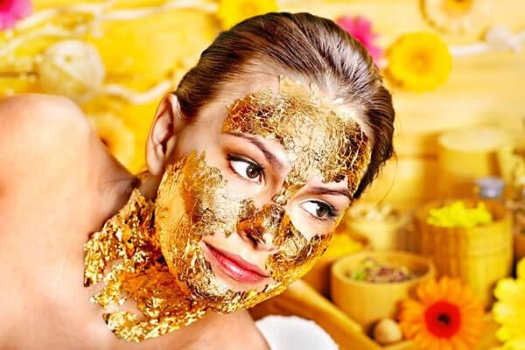
We are providing different type of treatment service those are, Makeup, Waxing, Facials, Body Massage, Haircut, Hairstyle, Pedicure and Manicure.
Waxing
Makeup
Facials
Haircut
Body massag e
Hairstyle
Manicur e
Pedicur e

The products we are selling
We are collaborating with selected top qualified and experienced services providers, and we use certificated bio products 100% proven by scientific tests. The product we are selling are 100% organic, our provider is based in London, if we are win the £25000 grant, we will add different product from India and Holland. The product we are selling, facial kit, waxing kit and eyebrow define shaping/tinting.
1.Eyebrows define shaping/tinting 2. Facial kit and Waxing kit
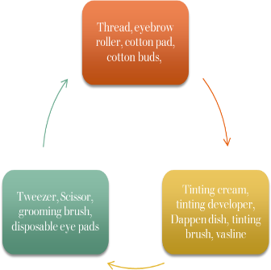

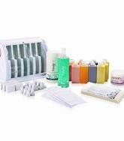

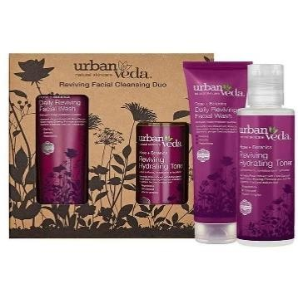

3. Makeup products
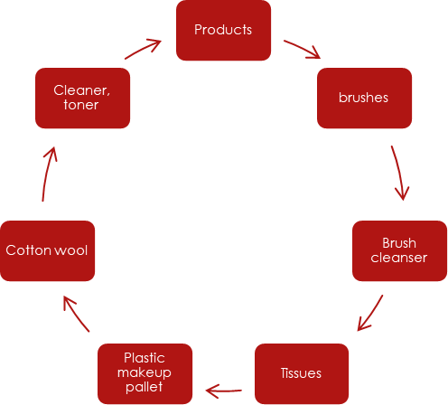
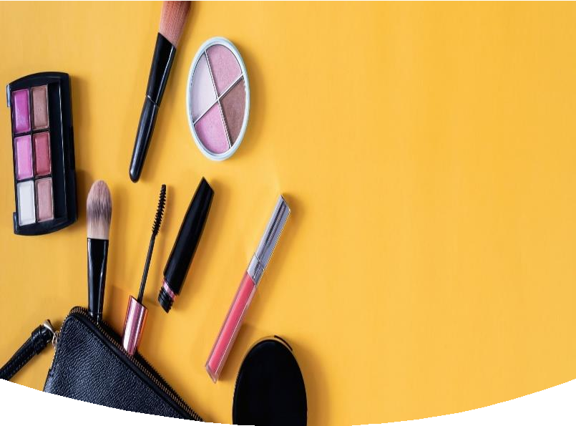

How to book our services and buying our product
The customers can book our service or buy products by using different ways depend on them choice and interest, it can be online from our website, from our app and over phone. When the customer book one of our services, for example makeup service, we highlight the customer to read our term and condition after will check the treatment price then they must choose the time and fill them personal details, name, phone number, email, address, and payment details. When the system accepted all the details the job automatically send notification to our qualified registered beauty career to see the service requested, the price, the time, and the address anyone happy to do this treatment can accept then we will send automatically to her /his details to the customer. When the job done, we paid to our partner 75% the service and we take commission 25%. Finally, we will send link for both to rate each other and rate our beauty service, if we see any concern, we will do further questions and investigation.

Market audit- competitors Analysis

Advertising option | Leaflet/online promotion  on Facebook/ Instagram/twitter/radio/participate in special event , drop leaflet  on shops/library/and advertising board | leaflet | leaflet | leaflet
Location | All over Birmingham and nearby area | Sandwell  /Hainsworth | Walsall/Dudley | Oldbury/Wolverhampton

We have market research above the table for our business where we find our competitors and our opportunity to success of our business.

SWOT (strength, weakness, opportunity, threats) Analysis
A SWOT analysis is a method of strategic planning and management used to help a person or organization identify strengths, weaknesses, opportunities, and threats related to business competition. This is sometimes referred to as situation assessment or situation analysis. (Weihrich 1982)

Strength

According to our market audit we know our SWOT, we have high chances to entry as our competitors are not running 24x7 and quick booking. We are offering reasonable price according to our competitors.

Weakness

Our competitor can offer similar product and services and we pay high cost for transport. as we run online and we are 5 friends, we have limited meeting and time problem due to living in different places.

Opportunity

It would be strong market growth as we booked most of the treatments online and we will go to people home to offer them their desire services. As we are offering home services which build our customer confident due to save their time rather spend hours and waiting in salon.

Threats

In these days everyone working online so internet market is our biggest threat. Some people might would not allow home visiting due to their privacy or people want to go out for their treatment to spend some time in salon. Many people are stating up new business might new salon opening in the area can be effect to our business and our competitor can offer discounted treatment to people.

PESTEL Analysis

political | Economical | social | technology | Legislation | Environment
Product ingredient requirement | Product hygiene | Brand name | Online shopping | Health and safety Law (PPE) | Product disposable
VAT rates | Packaging | Product trend in social media | Online promotions on products | New and changing law on tax rates | weather
Personal care product safety | Size of product | Product promotion | New trend and fashion of hair and makeup and beauty on internet | FDA regulation The Federal Food Drug and cosmetic act (FD&C Act)  Fair Packaging and Labelling Act (FPLA) | Occasion or event
Recession | Pandemic and business closer | Age culture / human behaviour |  | Advertising standard | Covid (Lockdown)

Our PESTLE research can impact on our business likewise environment due to Covid people would not allow our beauty therapist to entre their house for their safety and economically if our business closer due to lockdown we can lost many customers which can impact on our wages, products, and services. Politically due to Covid increase VAT rates of shipping, product can impact on our business.

Target marketing
Product – our target to provide best skin care and relaxation services to our client. In market there are huge product of skin care. So, our aim to offer best skin care product to our clients likewise natural product which will attract the client as many of people has many skin conditions where they are not allowed to apply chemical product. We promote chemical free product.
Price - our price is value price where we offer high standard treatment in quality price which attract to all age mostly teen age and pensioner.
Place –our business run by online or by phone calls or text massage

Promotions -our focus to provide all customer person care treatment and services, so social media is the best way to promote our business and our leaflet.
We create a survey where every costumers can leave feedback, make complains, or give us some advice how to improve our services . Here we collect the costumers experience , satisfaction, quality of services.

Targeted marketing is a way that helps group of individuals, group team to learn how to make decisions about the different markets they need to enter. It depends on the real resources and experience of the research by team or group about budget and products which offer by consumer

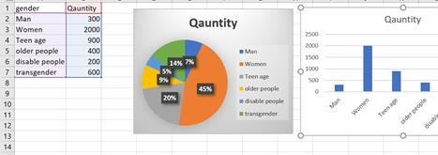
To know about our business, we have online survey where we find: people like to treatment at their homes
According to our survey we find Man 300
Woman 2000
Teen age 900
Older people 400
Mentally challenged 200
Transgender 600

Age 1000
2000

Between 13 to 20

21 to 50

51 to 70 1500

Market Plan
Our market plan to advertise our business via
Social media
Promotions/raffle
prize
Voucher
Google
advertisement
Leaflet
Partner with
local business
Radio
Online review

Management team

Pritpal Kaur

Experience: 6 years

It specialist and beauty therapist

VTCT Qualification: level 5 in beauty, Level 3 Makeup artistry , Level 3 Bridal hair and makeup, Diploma in Ayurveda beauty treatment, Diploma in making organic products for skin care IT specialist in Microsoft and customer care , Skills: communication, team player, Time management
Duties: book appointment, provide beauty services to client and arrange product

Durga

Experience: 6 years Expertise: recutting & shift HR manager
Duties Beauty Salon Manager: Overseeing daily salon operations. Hiring and training beauticians, as needed. Organizing employees shifts, considering peak times and seasonality.
Skills: communication, team working and leadership.

FAZAL

Experience 5 years Financial manager
Auditing the outcome and income of the company, paying any bills. Maintain staff records, include salaries and working schedules. Qualification: finance degree, level 4

Skills: good financial management, team management and communication.

MIHAI

Transport manager.

Arranging transportation for delivery and planning for the company future. Qualification: diploma general management, level 5 IT
Skills: writing, and communication

ALTAYE

Experience: 7 years Warehouse manager
Managing the products and checking the customers review, feedback and our employee Qualification: level 4 warehouse heathy and safety awareness
Skills: Team working, decision maker and positive thinker

Finance plan
◆ Our 5 members have invested in this business
£10,000
◆ We have business loan grant £10,000our total income is for the business £20,000
◆ We Spent on Product and stock £9,100
◆ Each product will give 5 or 6 treatments depend on the treatment
◆ One unit is product is £10, if we multiply 1 unit with 6 people it will give £300 so, we have huge saving in our products,
◆ Next slide will explain cash flow
◆ We are agreeing to work full time

Cash Flow Forecast

CASH FLOW FORECAST ORLA BEAUTY

SALON

Jan Feb Mar April May Jun Jul Aug Sept Oct Nov Dec

Totals

Sales Income | £5,000 £7,500 | £11,000 | £12,000 | £14,000 | £15,000
£16,000 | £16,500 | £19,500 | £20,000 | £21,400 | £21,500
£179,400

Grants£10,000

£10,000

Bank Loan

£0

Investment by Owner £10,000

£10,000

Total Incoming £25,000 £7,500 £11,000 12000 14000 £15,000

£16,000 £16,500 £19,500 £20,000 £21,400 £21,500

£199,400

Stock/ Materials | £7,000 | £500 | £600
£1,000 | £9,100

Wages£2,000 £2,000 £2,000 £2,000 £2,000 £2,000 £2,000 £2,000 £2,000 £2,000 £2,000

£2,000 £24,000

Rent & Rates £1,600 | £800 £800 | £800 | £800 | £800 | £800 | £800 | £800 | £800
£800 £800  Drawings and N.I.C | £10,400 |  |  |  | 500 | 520 | £600 | 640 | 680

£700 710 £4,350

Utilities £300 £300 £300 £300 £300 £300 £300 £300 £300 £300

£300 £300 £3,600

business insurance £150 £150 £150 £150 £150 £150 £150 £150 £150

£150 £150 £150 £1,800

Motor Expenses £1,000 £500 £200 £450 £600 £800 £400 £600 £700

£200 £200 £200 £5,850

Phone/Internet £300 £200 £200 £200 £200 £200 £200 £200 £200

£200 £200 £200 £2,500

Grant Repayments £200 £200 £200 £200 £200 £200 £200 £200 £200

£200 £200 £200 £2,400

Total Outgoing £12,550 £4,150 £3,850 £4,600 £4,250 £4,950 £4,570 £5,450

£4,990 £4,530 £5,550 £4,560 £64,000

CASH FLOW £12,450 £3,350 £7,150 £7,400 £9,750 £10,050 £11,430

£11,050 | £14,510 |  | £15,470 | £15,850 | £16,940
Opening Balance | £0 | £100 £3,250 £3,900 £3,500 £6,250 £3,800 £7,630 £3,420
£11,090 | £4,380 | £11,470

Closing Balance £100 £3,250 £3,900 £3,500 £6,250 £3,800 £7,630 £3,420 £11,090

£4,380 £11,470 £5,470 £5,470

Profit and loss

Forecast profit and loss account
Business Name: ORLA BEAUTY SALON
Period: Year to 31 December, 2021
Sales: | 179400 | (A)
Less direct (variable) costs:
materials
direct wages
other
Total direct costs | £ –
Gross profit/contribution: | 179400 | (B)
Fixed costs (overheads):
wages/salaries (incl. taxes) | 24000
heat/light/power | 3600
insurance | 1800
transport/travel | 5850
telephone | 2500
grant repayment | 2400
stock | 9100
Total fixed costs | 49250
Net profit | 90424
Less drawings or dividends | 4350
Profit retained in the business | 86074

Conclusion

Our business plan to provide beauty services door to door include our research and cash flow chart give us an idea to growth of our business where we involved in market research for our business success.

Statement of Orla Period 31/12/2021

We have £10,000 grant

£10,000 our own saving (5x2=10,000) We each will contribute £2,000
Our sales from January to December

Closing balance from February is £100 and December is £5,470 Our sales are £179,400
Total fixed cost is £49,250

Net profit £179,400- £49,250 = £90,424 net profit £90,424
net profit £90,424 - £4,350 (Less drawings)

= 86,074

Profit Retained £86,074

£86,074x5 = 17214.8 for each member of group

Reference

beauty-make-up-and-hair-inspiration.jpg (640×960) (weddbook.me) hive waxing kits - Bing images
instagram - Bing images

24k-gold-facial.jpg (600×400)

Gray, B. Collaborating: Finding Common Ground for Multiparty Problems. San Francisco:
Josey Bass, 1989.) p.11

(Webster. Webster's New Collegiate Dictionary. Springfield, MA: G & C Merriam, 1976.

Weihrich 1982, p. 54: "For convenience, the matrix that will be introduced is called TOWS, or situational analysis"; Sevier 2001, p. 46
What is Target Marketing? Definition, types and examples -The Investors Book

