
Psychology in Health & Social Care: Assessment Component 2
Individual Report
Student Name: Erkan Paca

Student ID: 2010132

Table of Contents
1.Introduction 1
2.Erikson’s Psychosocial Theory 1-3
3.The Stages of Erikson’s Theory 3-4
4.Reflection 4-5
5.Conclusion 5-6
6.References. 6-7

Module Name: Psychology for Health & Social Care
Module Code: BMHP4003 – London
Lecturer Name: Bianca Sanfilippo
Word Count: 1500

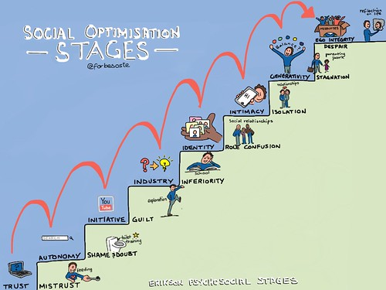
Image Powered by Microsoft Bing 2021
Introduction

This report views Erikson’s Psychosocial Theories and its connection for application in healthcare practice.

2. Erikson’s Psychosocial Theories.

In comparison to Erikson’s theory Piaget perspective (1896-1980) leading researcher on developmental psychologist states that babies learn through five senses, it is called sensorimotor stage (0-2). Seeing, Hearing, Touching, Tasting and Smelling. In this period which has 6 categories that intelligence is expressed via motor movement using no symbols. Awareness of the world is restricted. (but developing), because its build on physical movements and involvement. Infants obtain object permanence when they were 7 months of age. Physical abilities permit the infants to start progressing new cognitive capabilities. Figurative language skills are progressed at the end of this period. Huitt & Hummel (2003).
Additionally, Mcleod (2016) article on Bandura’s theory simply justifies that children learn by watching others and through imitation, usually the infant imitates the main carers around them. The well-known Bobo doll (1961) experiment infants monitor the people around them acting in numerous courses of action.

Lewis (2020) article on Erikson’s theories:
Infancy (0-18 months old) Trust vs. Mistrust: Infants need constant care of consistency from their care givers. Predictability, consistency, reliability are the key fundamentals for the infants to have by their care givers.
If the conflict or the crisis has been handled flourishingly and positively the child will develop faith of HOPE, on the contrary FEAR replaced hope causing low self-esteem, lack of confidence and anxiety toward others. Once the infant develop HOPE, this will aid them to cope the next stage positively, knowing that primary carers will help them to solve the crisis.

Image 1 Infancy by Microsoft Bing
Early childhood (Self-control, courage, and will-18 months to 3 years old) Autonomy vs. Shame & Doubt:
In this stage we learn to conquer physical skills like walking, talking and feeding ourselves with finer motor skills as well as potty training where we develop self- esteem and autonomy as we acquire more control over physical abilities acquiring what is right or wrong. During this stage so called “terrible two’s” teaches us to say “NO” it may be painful stage for carers, bit it progress us the fundamental skills of the will. The major essential relationship with carers if we were not encouraged during this potty training, we may feel shame and doubt which later in life cause for low self-esteem.
Initiative vs, guilt (3-5 years old): Lewis (2020: It is called pre-school years; infant develops rapidly that they are beginning to be more social with their surroundings. They have the control now and can take the first step. Give them opportunities to explore what is around them, motivate to do things to obtain their targets. Be a play friend for allowing them to be a teacher, nurse or doctor while you reflect to be a responder such as patient and student. This period is purely about social interaction; thus, infant develop self-confidence and sense of aim. If parents are very dominantly controlling and not encourage them to make personal decisions consequently infant may have reduced ambition and resulting your child to developing the feeling of guilt which will stop them to be a creative person in later life.
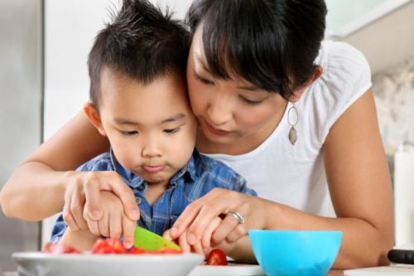
Industry vs. Inferiority (5-12 years old): At this period your child starts to compare themselves not only personally they compare it with other families too. If they gain a success in any field, they will progress to have a sense of pride and achievement. If infant is not successful in particular area look for an alternative area so that they can flourish. Be patient with infants encourage them to help out taking responsibility with their brothers or sisters. When they feel the success, they will develop to have a sense of hard-working person to achieve their target. On the contrary they may feel sense of in inadequacy and worthlessness to do the things they want to conquer.
Image 2 Initiative vs Guilt by Microsoft Bing

Identity vs, Confusion (12-18 years old): Teenage period your child needs to develop sense of self. They are now shaping their identity by questioning their targets, values and beliefs asking themselves who am I, what is happening to my body. In this conflict Erikson’s suggestion how much, you put into encouraging your child as a family especially with social interactions will bond their values and attitudes. If they are successfully pass this stage, they will have strong self-identity. Be persistent to teach your own values, on the contrary they will develop a sense of confusion.
Image 3 Identity vs confusion by Microsoft Bing


Intimacy vs, Isolation (18-40 years old): Memorise that each period builds on the next stage. People with strong identity are now ready to unite their life with others. According to Erikson to construct long-term loving and safe relationship. If this stage is solved successfully, they will have a sense of commitment and love. If the previous stage was not successfully achieved, they will not develop to have a strong sense of identity, causing loneliness and depressive behaviour.
Image 4 Intimacy vs Isolation by Microsoft Bing

Generativity vs, Stagnation (40-65 years old): This period is fundamentally about your contribution at home to others or communities for a better environment. People who are manage to solve this stage they develop of sense of satisfaction that you are a person who is needed. On the contrary they will develop to have a sense of deflation, weak, frustrated,
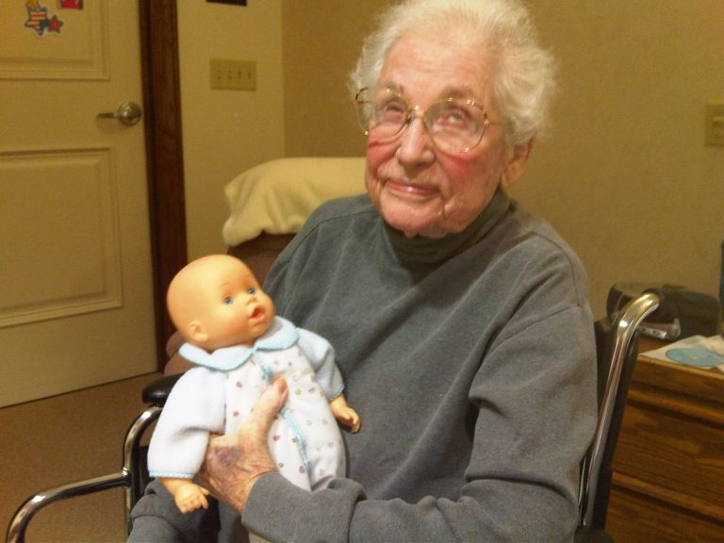
and disconnected thus, they will not be able to build a family, or even they may feel demotivated investing personal development or being productive.
Image 5 Generativity vs Stagnation by Microsoft Bing
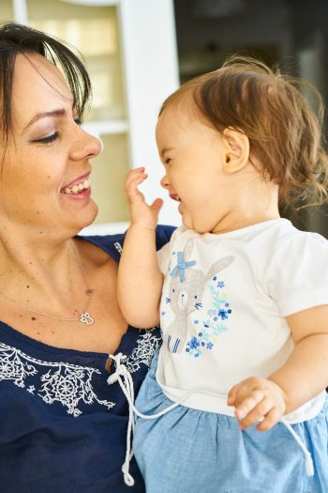
Integrity vs. Despair (Over 65 years old): This period is called reflection or contemplation. In this late adulthood stage, we usually look back to examine what we have obtained throughout our life span. If they feel proud what was gained in the past, then, they will have a sense of satisfaction. On the contrary if the previous stage was not solved successfully, they will have a sense of loss and regret resulting depression. In this period Erikson’s view is fluctuates because people quite often rotate between the feelings of satisfaction and regret which later becomes sense of closure facing death without anxiety.
Image 6 Integrity vs Despair by Microsoft Bing
3. The impact of Erikson’s Psychosocial Theory on the role of healthcare practitioners in supporting the wellbeing of individuals in health or social care settings:
Solving each stage successfully will have an impact on the next stage positively, on the contrary this will have a negative effect of unhealthy attitude, low self-esteem and poor overall holistic development such as physical, intellectual, emotional and social. Graves, Larkin (2006). Psychological theories are based on two fundamentals. Firstly, describe and explain a behaviour, secondly forecast the future behaviour which is connected to a particular life stage. Cherry. (2020). Erikson’s theory supplies us the clarification of the various issues connected to each life stage in the human life span development. In this way this assist healthcare professionals to understand the attitudes shown in each life stage and predict future approach. Thus, behaviour is known for practitioners to provide support and prepare a care plan that can reflect these needs to service users. Supported theory in this way structured holistically. For an instance, it is essential to supply a key person in early years settings. Thus, infants can progress a sense of trust when their parents leave them in nursery.
It is fundamentally important for healthcare professionals to display empathy. (Moudatsou et al, 2020). Empathy and being a good communicator are essential that we try to understand them and relate ourselves in their shoes moreover alter their communication to assist the service user’s health and wellbeing. Therefore, Erikson’s theory teaches us to develop and show empathy by elaborating the conflict in each life stage so that relevant support can be given to service users. Purely healthcare professionals now will be able grasp the conflict faced by service users and their urgency. Especially the communication skills needed in the stage of industry vs. inferiority (5-12 years old). Negative criticism faced by infants who will develop a sense of worthlessness. Therefore, Erikson’s theory can help healthcare professionals to understand the mental disorders and illnesses and reflect to service users in positive approach. (Orenstein and Lewis 2020).Failure to do so can have an impact of developmental deficiency such as mistrust towards others in infants (0-18 months), shame in early childhood (18 months-3 years old), guilt (3-5), inferiority (5-12), role confusion (12-18), isolation (21-39), stagnation (40-65), despair (65+) thus healthcare professionals can assist the appropriate mediation, such as counselling, therapy etc.
Erikson’s theory can help to assist healthcare professionals for service user’s health and wellbeing them successfully overcome the conflicts, developing the tendency.
4. Reflection: How I will apply Erikson’s Psychosocial Theory in my own practice;
I will apply this particular theory to adjust my communication skills to help the service user’s needs, and to generate care or action plan in order to provide intervention by displaying empathy to support their health and wellbeing.
In my future career Erikson’s theory will guide me in understanding service user’s mental disorders and capacity.
For an instance, I would like to work with infants. Knowing the facts of Erikson’s theory and crisis that babies going through between trust vs mistrust will help me to support babies to develop trust. Furthermore, if babies will develop mistrust, I will know the causes reflectively I will be able to provide and suggest intervention strategies to support the babies to develop trust.
5. Conclusion:
Theory is connected how well an infant overcome the particular conflict successfully and be ready facing the next stage fundamentally depend on the carer predictability and the quality of care infants receive during each stage. Erikson. (1959).
Erikson’s psychosocial theory is very important tool for self-awareness and personal progression for leading us to help others. By completing each stage successfully, the better we will deal with problems in later life.



Google images 2021

References:

Bandura (1961). Social Learning Theory. Bobo doll experiment [online]. Available at: https://www.simplepsychology.org/bandura.html. Accessed. (02/08/2021).
Cherry, K. (2021). Theories of Psychological Theories. [online]. Available at: https://www.verywellmindcom/what-is-a-theory-2795970. Accessed. (09/08/2021).
Erikson, E. (1950). Childhood and Society. New York: W.W. Norton & Company. [online]. Available at: https:// https://doi.org/10.1300/J194v04n02 05. Accessed. (29/07/2021).
Erikson, E. H. In A. Kazden (Ed.). Encyclopedia of Psychology. Washington, DC & New York: American Psychological Association & Oxford University Press [online]. Available at: https://doi.org/10.1300/J194v04n02 05. Accessed. (29/07/2021).
Google Images (2021). Why Beginning is Hard. Available at: https://www.googleimages.com. Accessed. (13/08/2021).
Graves, B. S. Larkin E. (2006) Lesson from Erikson, Journal of Intergenerational Relationship, 4:2, 61-71 [online] available at: doi:10.1300/j194v04n02/05, Accessed (13/07/2021).
Infancy Cognitive Development. Child Development & Parenting: Infants (0-2) [online]:available at: https://www.gracepointwellness.org/461-child-development parenting-infants-0-2/article/10112-infancy-cognitive-development. Accessed: (14/07/2021).
Huitt, W, Hummel, J. (2003). Piaget’s theory of cognitive development. Educational Psychology Interactive. Valdosta State University. [online]. Available at: https://chiron.valdosta.edu/whuitt/col/cogsys/piaget.html. Accessed. (01/08/2021).
Lewis. R. (2020). Erikson’s 8 Stages of Psychosocial Development, Explained for Parents. [online]. Available at: https://www.healthline.com/health/parenting/erikson-stages, Accessed. (30/07/2021).
Moudatsou, M., Stavropoulou, A.,Philalithis, A., & Koukouli, S. (2020) ‘The role of empathy in Health & Social Care Professionals’, Healthcare,8(1), 26.
Mcleod, S. A. (2016). Bandura. Social Learning Theory. [online]. Available at: https://www.simplepsychology.org/bandura.html. Accessed. (02/08/2021)
Microsoft Bing Image 1,2,3,4,5,6 (2021). Erikson Psychosocial Stages. [online]. Available at: https://www.bing.com/eriksonpsychosocialstages/. Accessed. (12/08/2021).
Nursery World (2000). Good habits. Learning through routines. [online]. Available at: https://www.nurseryworld.co.uk/news/article/good-habits-learning-through-routines. Accessed. (03/08/2021).
Orenstein, G.A, Lewis L. (2020), Erikson’s Stages of Psychosocial Development. [online]. Available at: htpps://www.ncbi.nlm.nih.gov/books/NBK556096/. Accessed. (12/08/2021).

