

Bereavement Campaign
“Help for the elderly”

David Jenkinson (2019)
Summary
Mercan, (2016) suggests that healthy ageing is important for elderly people to be independent and enjoy a satisfactory quality of life. However, bereavement can lead to adverse health effects and affect healthy ageing. Therefore, it is important that individuals are able to manage their own bereavement process effectively in order to regain a normal healthy life as soon as they can. This briefing report intends to explore some of the methods that are available to support individuals who are moving through the grieving process and provide an evaluation to the most suitable model to propose to individuals to guide them through the process.
Introduction
What does grief mean?
As we are not immortal, death is unavoidable and inevitable. In the event of a death, grief is likely to occur, it will impact everyone different and may occur at different times, grief can also appear at different times in ones life from thinking about someone’s death, thoughts of grief may also occur for different losses other than life (Everly, 2019)
What does bereavement mean? Is it different from grief?
Bereavement is a period of sadness or loneliness individuals experience after a loss, while some individuals can cope well with bereavement, it can cause other individuals to experience pathological or exaggerated responses which can cause some people to experience major depressive episodes (Assareha, 2014). Shear, (2015) suggests that grief is a response to bereavement and includes physiological and psychological indicators which progress over time. Bereavement is a growing concern in elderly people and can cause psychological illnesses such as depression, the majority of elderly people can deal with grief without any kind of help or intervention but some people can’t, which raises the importance of recognising depressive symptoms earlier in older people (Hashim, 2013). Enez, (2018) states that there are two types of grief, normal and complicated grief. Normal grief refers to the normal reactions to the loss of a loved one such as, sadness, yearning and separation distress, although most people are able to overcome this grief and successfully adapt back to life, approximately one third of people develop complicated or pathological grief responses without the help of an intervention.

Coping with bereavement and grief
Coping with the death of a loved one can be extremely hard especially in old age, as some individuals are dealing with a lot of emotions, including financial and social instability and can find it hard to move on. Grief is normal process for most individuals to go through after losing someone. However, there is no right or wrong way to grieve, every individual will take their own time and move at their own pace (Age UK, 2019).

Interventions: What can be done?
Cognitive Behavioural Therapy

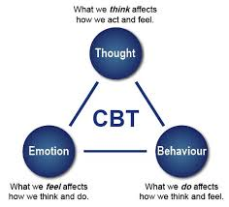

One form of intervention that can help the bereaved older person to deal with the grief process is a psychotherapeutic intervention for example Cognitive Behavioural Therapy (CBT). CBT is a treatment approach where cognitive processes are connected to the development of psychopathology with regards to impaired functioning and emotional distress (Kazantzis, 2018). A study conducted by Khashab, (2017) looked at the effectiveness of CBT on emotional intelligence and spiritual well-being of elderly mourners. Khashab’s study comprised of 30 elderly mourners, who at the time were living in nursing homes and were aged between 60 and 75. For the purpose of the study 15 participants were assigned to a control group and the other 15 participants were assigned to the experimental group. Results of the study found that group cognitive behavioural therapy increased spiritual well-being and emotional intelligence. There were, however, some limitations to the study including the small sample size, this may have limited the validity of the results. A further limitation to the study was that no other research had been carried out in Iran on this topic so there was no other research to compare it to, however in the future, other studies could build on these findings. Conclusively, the study stated that it is necessary to use cognitive behavioural therapy on elderly mourners to empower and help them cope with loss and grief also to increase spiritual well-being and emotional intelligence.

Dual-Process Model of coping with bereavement
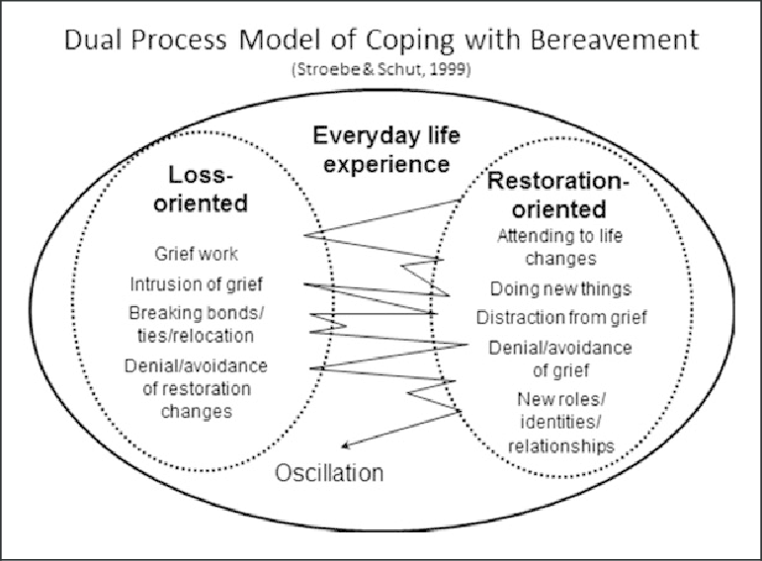

The model identifies two types of stressors, a dynamic, regulatory coping process of oscillation also loss- and restoration-oriented whereby the grieving individual at times challenge, at other times elude, the different duties of grieving. The dual purpose model proposes that adaptive coping is composed of confrontation – avoidance of loss and restoration stressors. The researchers of the dual process model also argue the need for dosage of grieving, that is, the need to take respite from dealing with either of these stressors, as an integral part of adaptive coping (Stroebe & Schut, 1999).
A study by Chow et al, (2019) looked at examining primary and secondary outcomes of a theory-driven group bereavement intervention for widowed older adults. Twelve randomly assigned community centres that provided social and health services to elderly people, were split and half were used for the experimental condition, the dual-process bereavement group intervention. The other half were assigned to a control condition, the loss-oriented bereavement group intervention. Both of the interventions were comprised of weekly, two hour sessions, for seven weeks with a 16 week follow up to assess levels of depression, anxiety, social support and loneliness, 125 participants were used in total for the study. Results of the researcher’s study found that both interventions helped to produce improvements in social support, depression and grief, but the dual process model had better effects and helped with reducing anxiety, social and emotional loneliness. A previous study by Utz, (2016) looked at caregivers for a person with terminal cancer from the time they were admitted to a hospice and 18 months post bereavement. The study used a total of 237 caregivers were for the study, 120 received a tailored bereavement intervention based on the dual process model and 117 received the normal hospice bereavement service. Results of the study found that those who received the dual process model showed significant improvements in the two types of coping (loss and restoration) also in hopefulness and daily living competencies, which shows the benefits of a more tailored, individualised service for bereavement.

Complicated grief therapy
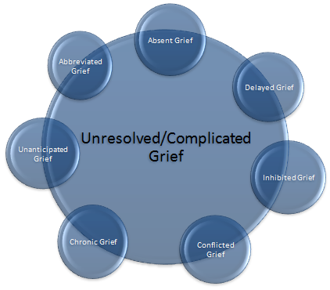

According to Wetherell, (2012) complicated grief therapy is a relatively new model of psychotherapy drawn from attachment theory and shares similarities with interpersonal therapy and cognitive behavioural therapy, the treatment involves focusing on personal goals and relationships also using techniques like prolonged exposure.
A study by Shear et al, (2014) looked at determining whether complicated grief therapy produces better results on improving complicated grief and depressive symptoms compared to interpersonal therapy. The researchers for the study used 151 participants, all aged 50 and over, with a mean age of 66. The participants were randomised to receive either complicated grief therapy or interpersonal therapy over sixteen weekly sessions. Results of the study found that both treatments showed improvements in complicated grief symptoms. However, some questions arise as the reliability of the results, the overall response rate for complicated grief therapy was more than twice that of interpersonal therapy, leaving less robust findings. Furthermore, complicated grief therapy showed a significantly greater change in illness severity, complicated grief therapy has been shown to significantly produce greater response times of complicated grief and depression than interpersonal therapy.
Worden’s four tasks of mourning
Worden’s four tasks of mourning are, accept the loss, acknowledge the pain of the loss, adjust to a new environment and reinvest in the reality of a new life, This model is specific to the loss of a loved one, but like the stages of grief model it implies a stage or step-like experience that we go through after a loss (O'Brian, 2016). Worden proposes that grieving can be task orientated rather than phase orientated. This process can be a useful guide for clinicians to use, where there are clear steps for individuals to follow, leaving less margin for distraction. The initial step in Worden’s four step challenge proposes that individuals who are in mourning, should accept the reality of the loss of the deceased. Many individuals who are at the beginning of their bereavement process may use denial as a form of protection against the pain of the reality. Although denial is a normal occurrence in bereaved individuals, it can have long term negative effects on an individual’s mental health. Worden’s second task proposes that individuals should be able to experience their pain of their grief and bereavement. The researchers state that in many instances there is some stigma surrounding grieving and many individuals feel some pressure towards them to move quickly past their grief. It is necessary for the individual to experience the pain to avoid negative effects later in life. Worden’s third task advises the bereaved individual to adjust to a world where the deceased individual does not exist. It is suggested that the individual adjust both mentally, physically and focus on who they are now as an individual, not who they were before. The fourth and final task that is required in order to successfully grieve, requires the individual to withdraw their emotional energy from the deceased individual. This involves still keeping the deceased individuals valid in their memories but finding a new strategies to move throughout life without the deceased individual. This can especially difficult for elderly individuals where most of their life may have been spent with a partner and may struggle to find their own status and identity (Martin & College, 2019).
----------------------------------------------------------------------------------------------------------------
Conclusive summary
This briefing report has been established to provide information towards successful and beneficial bereavement support that is available for elderly individual who are experiencing grief or who are going through the bereavement process. This report has discussed a number of models and provided some empirical evidence towards the effectiveness of each model. In this instance, the models discussed were cognitive behavioural therapy, the dual process model of mourning and complicated grief therapy. Although most of the models appear to have many potential benefits that can aid an individual through their bereavement process, awareness has been made towards the limited amount of empirical evidence that is available for bereavement support for the elderly. Future research will be key in this area, where the ageing population continues to grow with more individuals living longer.

References
Abas Solaimani Khashab, H. G. (2017). Effectiveness of Cognitive Behavioural Therapy on Spiritual Well-Being and Emotional Intelligence of the Elderly Mourners. Iranian Journal of Psychiatry, 12(2), 93-99.
Age UK. (2019). Retrieved from https://www.ageuk.org.uk/information-advice/health-wellbeing/relationships-family/bereavement/
Amelia A. Assareha, ∗. C. (2014). Biological determinants of depression following bereavement. ELSEVIER, 171-181.
Amy Y M Chow, M. C. (2019). Dual-Process Bereavement Group Intervention (DPBGI) for Widowed Older Adults. The Gerontologist, 59(5), 983-994.
Enez, O. (2018). Complicated Grief: Epidemiology, Clinical Features, Assessment, and Diagnosis. Current Approaches in Psychiatry, 10(3), 279-289.
George S. Everly, J. M. (2019). Grief, Loss, and Stress. Springer, 523-543.
M. Katherine Shear, Y. W. (2014). Treatment of Complicated Grief in Elderly Persons. JAMA Psychiatry, 71(11), 1287-1295.
Margaret Stroebe, H. S. (1999). THE DUAL PROCESS MODEL OF COPING WITH BEREAVEMENT: RATIONALE AND DESCRIPTION. Death Studies, 23(3), 197-224.
Murat Anil Mercan, H. B. (2016). Late-Life Bereavement: Association Between Familial Death and Weight Loss Among Elderly in the United States. OMEGA - Journal of Death and Dying, 74(1), 3-15.
Nikolaos Kazantzis, H. K. (2018). The Processes of Cognitive Behavioural Therapy: A Review of Metanalyses. Springer US, 42(4), 349-357.
O'Brian, S. (2016). Transforming Grief: Models and Integrative Tools. International Journal of Complementary & Alternative Medicine, 3(1), 1-2.
R. Utz, M. C. (2016). SUPPORTING WIDOWED PERSONS: AN INDIVIDUALIZED BEREAVEMENT INTERVENTION BASED ON DUAL PROCESS MODEL. The Gerontologist, 56(3), 382-383.
Shear, K. (2015). Complicated Grief. The new England journal of medicine, 372(2), 153-160.
Syahnaz Mohd Hashim, T. C. (2013). Bereavement in the elderly: the role of primary care. Mental Health in Family Medicine, 10(3), 159-162.
Terry L. Martin, H. C. (2019). Book Review. Journal of Death and Dying, 80(2), 331 - 334.
Wetherell, J. L. (2012). Complicated grief therapy as a new treatment approach. PMC, 14(2), 159-166.



Bereavement Support Campaign
“Help for the Elderly”



Introduction
Death is the unavoidable end point of every individuals’ life. Since death is inevitable, grief is not only predictable but also likely to occur repeatedly during one’s life time. Since it is impossible to avoid the pain and loss of losing someone you have cared about, it is important that there is appropriate support available for all. Elderly individuals are more likely to experience death of a loved one, and this leaflet aims to provide practical support towards managing the process of bereavement and grief.
Bereavement and Grief
Grief is termed as the mental and physical emotions that may come after the loss of a loved one, whereas bereavement is the process of mourning, after a death has occurred. Many individuals find that Coping with the death of a loved one can be extremely hard especially in old age, as some individuals are dealing with a lot of emotions, including financial and social instability and can find it hard to move on. Grief is normal process for most individuals to go through after losing someone. However, there is no right or wrong way to grieve, every individual will take their own time and move at their own pace (Age UK, 2019).
Making Yourself Feel Better
It is important that you continue to take care of yourself when managing your grief and going through the bereavement process. Stang (2019) suggests making sure that you are eating well, drinking adequate amounts of water. It may be beneficial to take yourself for a check up to the doctors to ensure that you are feeling physically well. It is also be beneficial to partake in some sort of physical activity to increase endorphin levels. Perhaps the most vital task you can complete is to connect with family and friends to avoid feelings of isolation and loneliness.
Worden’s Four Tasks of Mourning
Some individuals may find it helpful to follow a more structured plan to manage their way through the grieving process. Here are some suggestions from Worden (2018) and Martin, and College (2019) who suggest tasks to follow to begin the bereavement process. Take the time you need for each task.
Task one
The first step in Worden’s four step challenge proposes that individuals who are in mourning, should accept the reality of the loss of the deceased. Many individuals who are at the beginning of their bereavement process may use denial as a form of protection against the pain of the reality. Although denial is a normal occurrence in bereaved individuals, it can have long term negative effects on an individual’s mental health.
Task two
Worden’s second task proposes that you should be able to experience their pain of their grief and bereavement, in many instances there is some stigma surrounding grieving and many individuals feel some pressure towards them to move quickly past their grief. It is necessary for the individual to experience the pain to avoid negative effects later in life. There is no set time for this process but is a necessary step.
Task three
Worden’s third task advises the bereaved individual to adjust to a world where the deceased individual does not exist. It is suggested that you should try to adjust both mentally and physically. It is important to mentally and focus on who you are now as an individual, not who you were before.
Task four
The fourth and final task that is required in order to successfully grieve, requires the individual to withdraw their emotional energy from the deceased individual. This involves still keeping the deceased individuals valid in their memories but finding a new strategies to move throughout life without the deceased individual. This can especially difficult for elderly individuals where most of their life may have been spent with a partner and may struggle to find their own status and identity. It is however necessary that you begin to find your own way to a new future.
Conclusion
Losing a loved one is not an easy process for anybody to go through, there will be periods where sometimes are better than others and sometimes the lows will be lower than before. Many individuals may find it difficult to reach out and ask for help or support during this time and may feel like a burden for asking. However, it is important that you do ask for help, whether it be from a doctor or from family or friends. To be able to work through the grieving process at your own pace it is important that you take care of your mental, physical and emotional wellbeing to obtain the best possible chance of moving on a smooth as possible.

References
Age UK. (2019). Retrieved from https://www.ageuk.org.uk/information-advice/health-wellbeing/relationships-family/bereavement/
O'Brian, S. (2016). Transforming Grief: Models and Integrative Tools. International Journal of Complementary & Alternative Medicine, 3(1), 1-2.
Stang, H. (2019, 12 13). 9 Self-Care Tips for Grief: Reduce Your Suffering in Mind, Body & Spirit. Retrieved from Mindfulness and Grief Institute: https://mindfulnessandgrief.com/9-self-care-tips-for-grief/
Terry L. Martin, H. C. (2019). Book Review. Journal of Death and Dying, 80(2), 331 - 334.
Worden, J. (2018). Grief Counselling and Grief Therapy: A Handbook for the Mental Health Practitioner (3rd ed.). New York: Springer Publishing Company.

