PORTFOLIO

2312256
BMPL5012
Task 1: Mind Map

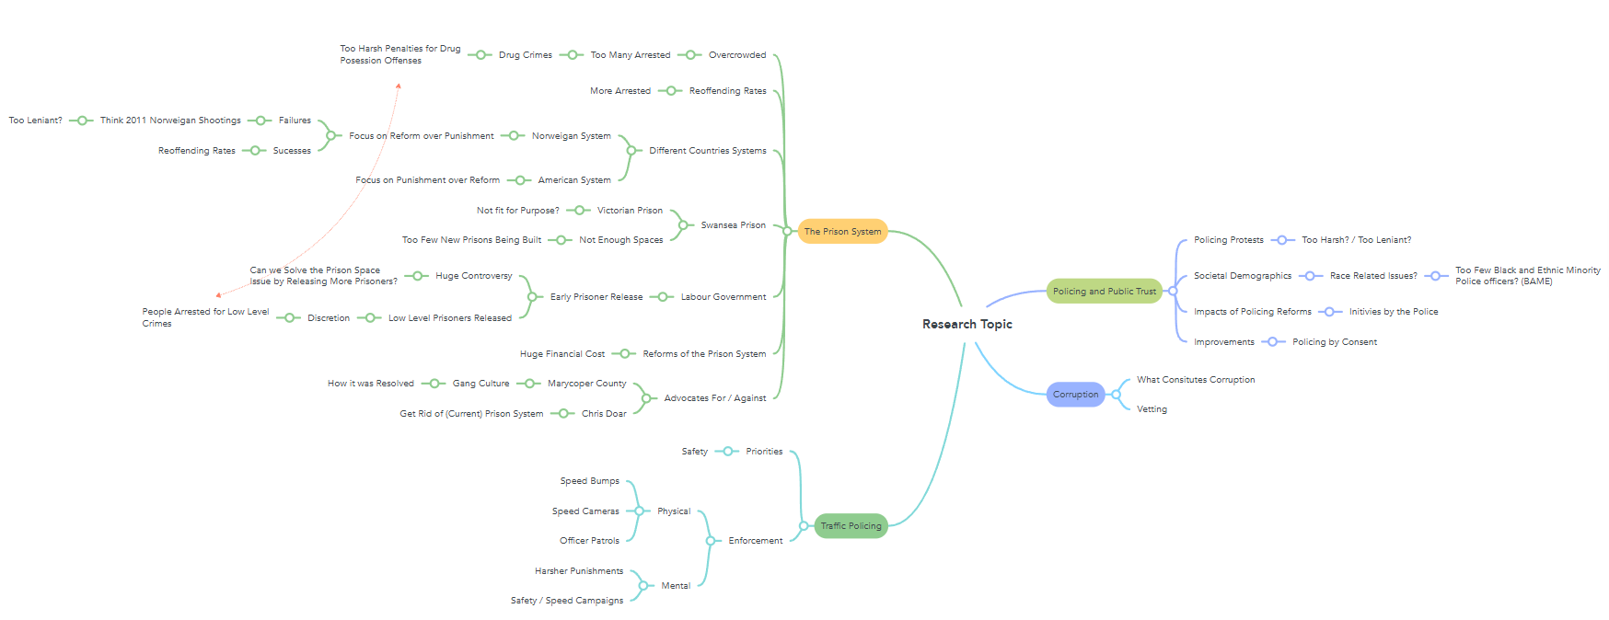

Task 2: Proposal Form



UNDERGRADUATE DISSERTATION
RESEARCH PROPOSAL FORM

NAME: Ellis William John Rees | Student number: 2312256
DRAFT RESEARCH TITLE QUESTION:
How has overcrowding contributed to the current prison crisis in the UK?
Overcrowding is one of the most pressing challenges facing the UK prison system today. It affects living conditions, rehabilitation efforts, staff safety, and overall effectiveness in reducing reoffending. With prison populations continuing to rise despite government initiatives, understanding how overcrowding contributes to the wider prison crisis is crucial. This topic is important because it highlights issues of human rights, justice, and resource management, while also exploring how policy and reform could improve conditions and outcomes within the UK’s criminal justice system.

SUMMARY OF RESEARCH AIM & OBJECTIVES:
Aim
To investigate how overcrowding has contributed to the current prison crisis in the United Kingdom, assessing its impact on living conditions, rehabilitation, reoffending rates and the effectiveness of government policies and reforms.
Objectives
- Identify the key issues of overcrowding in the UK prison system – what it effects, what is the outcome.

- Assess the impacts of overcrowding on prison rehabilitation, mental health, and rates of reoffending

- Evaluate the role of Government policies and financial implications in shaping prison reforms

THEORETICAL CONTEXT:

- The Honest Politicians Guide to Prisons and Probation
King and Willmott (2021)

- Overcrowding and its impact on prison conditions and health
Macdonald (2018)

- The Prison Overcrowding crisis and some constructive perspectives for crime policy
Losel and Crim (2007)

SUMMARY OF RESEARCH –SURVEY METHOD:
For this research a quantitative survey method will be used to gather data on public perceptions of issues related to prison overcrowding in the UK. The survey will include a combination of multiple-choice questions, allowing participants to express their level of agreement or disagreement with key statements about the causes and effects of overcrowding.

This method was chosen because it enables the collection of statistical data from a broad sample, providing measurable insights into general public attitudes toward prison conditions, sentencing, and rehabilitation. Online distribution through social media and community forums will help reach a varied demographic, ensuring a balanced range of opinions.

The collected data will be analysed using basic descriptive statistics (percentages, averages, and frequency counts) to identify trends and patterns in public views about overcrowding and its impact on the prison system.
SUMMARY OF SAMPLING FRAMEWORK:
This study will use a purposive sampling framework to ensure that participants represent a range of perspectives and experiences relevant to the issue of prison overcrowding. The sample will include individuals both directly and indirectly affected by the UK prison system.
Target Groups:
- Members of the public – to gather general opinions on the effectiveness of the prison system and awareness of overcrowding.

- Criminal justice professionals – including prison officers, probation staff, lawyers and court personnel, to contribute professional viewpoints on the causes and consequences of overcrowding.
INITIAL REFERENCE LIST:
- King, R.D. and Willmott, L. (2021). The Honest Politician’s Guide to Prisons and Probation. University of Illinois, [online]. (date accessed 10/10/2025). Available at: https://doi.org/10.4324/9781003201748.

- ‌Losel, F. (2007). The Prison Overcrowding Crisis and Some Constructive Perspectives for Crime Policy. Howard Journal of Criminal Justice, [online]. (date accessed 10/10/2025). Available at: https://heinonline.org/HOL/LandingPage?handle=hein.journals/hjcj46&div=68&id=&page=.

- ‌MacDonald, M. (2018). Overcrowding and its Impact on Prison Conditions and Health. International Journal of Prisoner Health, [online]. (date accessed 10/10/2025). Available at: https://www.emerald.com/ijoph/article/14/2/65/163665/Overcrowding-and-its-impact-on-prison-conditions

