!AI- Statement!

I confirm that I have not used any AI tools in the research and creation of this assignment. I confirm that I have not presented any AI generated materials as my own work. I confirm I have copies of my drafts, notes, and other resources I used, which I may be asked to provide in evidence.
Student Name: Tahmina Islam
Student Number: 2124414

Managing Hotel Administration
(BMIH6004)

Student Name: Tahmina Islam
Student Number: 2124414
Lecturer name: Jessica Newport

Contents
Introduction: 1
Evaluation of work experience 1
Reflection with model 2
• Experience 2
• Reflection 3
• Action 3
Conclusion 3
Appendix-1 4
References 5

PART-2
Reflective Journal:
Introduction: Hotel administrative operation is a fundamental of marketing to run a hotel business wherever hotel provide all their services to provide higher satisfaction towards their customers (Bogan, 2024). As part of hotels administrative operation, I was working 5 weeks in the front desk of Delta hotel by Marriott, Swindon. Meanwhile The front office is the main key of operation to welcome guests in a warm and friendly manner (Bardi,2011). In my placement, I am working as a front office associate wherever I need shadowing a supervisor or manager during my shifts that enhanced the understanding of managing guest as well as service expectations within the hotel. Making the operation smoothly, the front office associates are responsible for settling guest accounts and maintaining records on hotel guests, including the duration of their stay and any preferences they have outlined (Workforce Singapore, 2017). Delta hotel used Opera as their PMS system for easy check- ins and check-outs wherever they can check the mobile check in, maintenance, housekeeping, and all other booking sites to cater for guests with differing demands (Delta hotels Marriott, 2024). This building has operated by Parking eye the 24-hours CCTV monitoring company. However, customers need to pay £5 per night in front desk on their arrival. There are also grab & go products that also need to pay in front desk.
Evaluation of work experience: In my first week, I had an induction to learn about the property whereas all the facilities are during the shift as well as health and safety taken care. As I can see firsthand how supervisors balance people management, operational challenges, and customer satisfaction. In additionally, I was learning about the PMS as well as cloud-based OPERA. However, PMS is elaborate as Property Management Systems. It secures all information of the property to organise, programme and execute the regular performances and connections involved in the hotel business (Vallen & Vallen, 2014). Next, I was Learning about mobile check-ins and working out with scan machines to scan few documents. I always helped to express check out boxes to guest check outs who does not want any hassle. As I am working for experiencing, not allowed to use computer. In my previous placement was in the same property. There are few changes made during this time. Full management of Delta Hotels changed the guest rooms are newly renovated as well as the lobby. Everyone in the front desk is talking about the targets that they have got, and online trainings are onwards to boost associate’s knowledge towards the guest satisfaction increase. Now a days technical skills are necessary to stay competitive in a progressing job market (Brewer,2015). Getting the technical skills that boost my self-confidence to perform the best ability of my daily task. With the help of the supervisor and the manager, my placement experience has enhanced my understanding of managing guest service expectations. Beforehand I can use the computer to help the associates with the checkouts and others. Now, all my time was spending to stand behind the associate or supervisor.
Reflection with model: I am using ERA cycle to reflect my experiences. According to ERA cycle, work experience contains three stages. At first need to find the individual experience. After, examining the situation deeply describe to the reflection part. Next, integrate the direction towards the action to be undertake in future assistance (Seaman, 2008). Throughout the shadowing experience, I had given the opportunity to reflect on what I have learned and provide feedback. The reflection of my work experiences are as follows that covers all the ERA stages (appendix-1) -
- Experience: While working in my placement in Delta Hotels by Marriott in Swindon, I learn few tactics to oversee the guest complaints. For example- In my first week of placement, one of the guests complained regarding the bed sheets was stain in the middle during their check outs. Guest presented few images of the stains and wanted 50% discount on his terrible experience otherwise he will complain in Marriott Bonvoy. However the guest raised complain of housekeeping, I was wondering what action the manager should took as I was first experiencing such complaint. Then I was amazed with the behaviour of the manager. He was so politely listened to him and apologised even though it was not hotel’s fault. And offer 20% discount of the total amount on his behalf. But the guest was still saying that he will complain to Marriott Bonvoy about the service. Then manager replied courteously, “if you do so, I cannot even offer you 20%.” Surprisingly, the guest agreed and checkout with 20%. I was standing behind the manager all the time and experienced it. After the guest left, I asked manager that this was guest fault as it was clear to see. If housekeeping changed the sheet, it will clearly visible the stains. Manager replied to me, “It’s obvious, but some guests were bit cheeky to do those things for getting discounts.”
- Reflection: Reflection upon my experience, I felt the decision of giving 20% discount was no use as it was the guest fault. And they did not complain when found the stain. But being conscious to learn and make my doubt to get clear I questioned straight away. As I followed the Albert Einstein’s thoughts “Learn from yesterday, live for today, hope for tomorrow. The important thing is not to stop questioning” (Mcqueen,2014). Lack of experiencing during this situation make me confused me to forgot that I always learn with my lecturers is- ‘customers are always right.’ Additionally, my manager was happy to answer and feedback me, “keep questioning unless you do not want to learn.” He added that every guest is different, you need an elevated level of self-confidence to get good customer satisfaction. I felt that my lack of experience in this department and confidence were the main reason to think about the decision was wrong.
- Action: I learned to calmer during any situations, ways to adequate the guests. Intended for this I would taking deep breaths in case of any sort of anxiety. If I fall into the same situations again, I will keep my confidence and planned out an expertise for the guests. However, I will be questioning to learn more experiencing thing from the colleagues, make a note for this to future use. Furthermore, keeping the feedback from my manager in mind, I understood that every guest is different, and we need to put every guest in different framework of questions while providing the service of guests. So, in future I will ensure to manage the guests as per their needs.
Conclusion: To conclude my reflection by deploy the ERA model to show the awareness on based of certain context. Shadowing is important to learn from the more experienced employees and their performance towards their job (Loew, 2022). In my work experiencing helps me to addressing the guest’s complaints and requests to feel the guest more comfortable stay where it will help me to future assistance. I had learned teamwork, customer service, how to manage the client reservations and informing guests of specials and other incentives. Also helps the guest to register their car, tidying & selling few items from Grab & Go. Supervisors often juggle competing demands, and I had experiencing how they assess situations, weigh options, and make decisions that balance business objectives with team well-being. Likewise, meeting and managing guest service expectations requires a combination of technical knowledge, interactive skills, and an understanding of industry best practices. Nevertheless, I can learn more if I have a chance to use the computer. However, as a placement worker keeps notes of their work to adopt the hard and soft skills to reflect and learn it when required (ASET, 2022). Therefore, it will boost my employability, helps me assemble a professional network, plus keeps me with industry-precise skills. It can also simplify the career objectives, offer commercial advantages, and better academic execution.

Appendix-1:

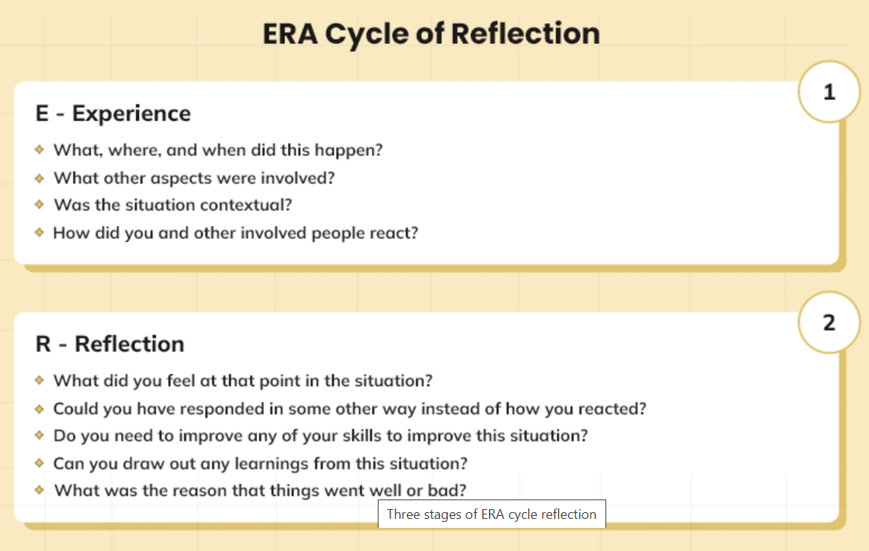
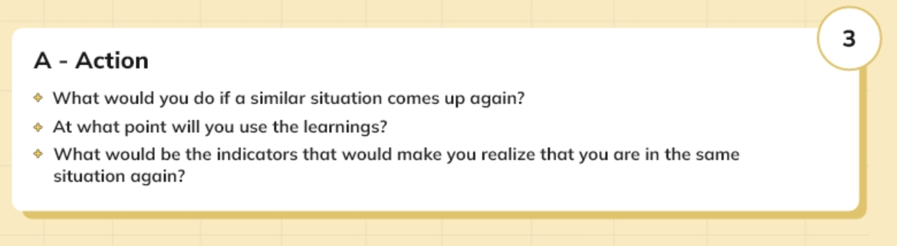

References:
- ASET (2022). ‘ASET Good Practice Guide for Work based and Placement Learning in Higher Education.’ Available at: https://www.asetonline.org/wp-content/uploads/2024/04/ASET-Good-Practice-Guide-Work-based-and-Placement-Learning.pdf (accessed on: 24th October 2024).
- Bardi, J.A (2011). ‘Hotel Front Office Management.’ 5th Ed. Hoboken, N.J: Wiley. (Accessed on: 24th October 2024).
- Delta hotel Marriott (2024). ‘Overview.’ Available at: https://www.marriott.com/en-us/hotels/brssd-delta-hotels-swindon/overview/?scid=f2ae0541-1279-4f24-b197-a979c79310b0 (accessed on: 16th October 2024).
- Ian Loew (2022). ‘5 Ways Organizations Can Benefit from Job Shadowing.’ [Blog]. Available at: https://360learning.com/blog/benefits-job-shadowing/ (accessed on: 24th October 2024).
- Iwona Bojan (2024). ‘Improving Operations Management in Hotels: A Full Guide.’ Fango. [Blog]. Available at: https://fango.co.uk/blog/improving-operations-management-in-hotels-a-full-guide/#:~:text=This%20includes%20everything%20from%20room,even%20overseeing%20elements%20of%20marketing. (Accessed on: 16th October 2024).
- Laura Brewer (2015). ‘The importance of core work skills.’ International labour organisation. Available at: https://www.ilo.org/media/288551/download#:~:text=%E2%80%A6%20the%20skills%2C%20knowledge%20and%20competencies,periods%20of%20the%20life%20cycle. (Accessed on: 16th October 2024).
- Melissa Macqueen (2014). ‘When, where, and why did Albert Einstein say, "Learn from yesterday, live for today, hope for tomorrow”?’ Quara. Available at: https://www.quora.com/When-where-and-why-did-Albert-Einstein-say-Learn-from-yesterday-live-for-today-hope-for-tomorrow#:~:text=Albert%20Einstein%20is%20believed%20to,October%20of%20that%20same%20year. (Accessed on: 24th October 2024).
- Seaman, J. (2008). ‘Experience, reflect, critique: The end of the ‘learning cycles’ era.’ Journal of Experiential Education. 31(1), 3-18. Available at: https://dx.doi.org/10.1177/105382590803100103 (accessed on: 24th October 2024).
- Vallen, G.K. & Vallen, Jerome J. (2014). ‘Check-In Check-Out: Managing Hotel Operations.’ 9th Ed. Harlow: Pearson Education Limited. (accessed on: 24th October 2024).
- Workforce Singapore (2017). ‘A day in the hotel industry.’ [YouTube]. Available at: https://youtu.be/r_VPsyxYz2k?si=Stfd0GacqBbA5C56 (accessed on: 16th October 2024).

