Creative Realisation Evaluative Report
Liam Wyn Jones
P143935

Executive Summary
This report seeks to evaluate the test case accomplished by Clockwork Dragon Solutions in developing game functionality for the Diaulos project for the Awesome Trio Student games development team and to review the following points:
- Whether the contracting and development methodologies utilised in the test case are effective.
- Whether or not there is evidence that Clockwork Dragon Solutions is a sustainable business.
- The overall development and quality of the Diaulos project and the development team’s feedback.

This report draws attention to the demonstration that all tasks in the project were developed using an adapted waterfall methodology, and that, though some tasks were repeated or refined in order to ensure the highest quality possible for the client all tasks were completed according the clients goals and deadlines. It draws attention to the fact that the business demonstrates as sustainable if similar pricing rates are charged for future jobs. Finally, it draws attention to the positive feedback from the client and justifies that the business’ client base could potentially grow quickly through client referrals but also suggests alternate ways for the company to grow.

This report concludes that the current model shows a sustainable business and as long as a positive work ethic and competitive pricing rates are maintained, has potential to grow largely through a number of avenues.

It is recommended that Clockwork Dragon Solutions:
- Invests in alternate forms of advertising and networking.
- Seeks to employ additional consultants and an accountant.
- Expand potential client base by diversifying employee skill sets through training and hiring.
- Maintain a professional, efficient and friendly work ethic.

Contents
Executive Summary 1
Review of Research Methodology and Methods 3
Paperwork 3
Project 5
Review of Creative/Enterprise Strategy 7
Funding 8
Pay & Tax 9
Critical Appraisal of the Final Proposition 10
Mechanics 10
Future Trajectories 14
References 15
Bibliography 16
Appendices 17
Appendix 1 – Original Contract 17
Appendix 2 – Contract Amendment 26
Appendix 3 – Blank Timesheet 30
Client Declaration: 30
Freelancer Declaration: 30
Appendix 4 – Invoice 31
Appendix 5 - Questionnaires 32
5a. Blank 32
5b. Awesome Trio Member 1 33
5c. Awesome Trio Member 2 34

Review of Research Methodology and Methods
The goal of the project will be to establish the business’ basis in what sort of work it will be undertaking, as such: Freelance work will be emulated for the ‘Awesome trio’ student games development team.

Paperwork
To begin, a contract will be created to establish the freelancer’s responsibilities to the client development team. This will also outline clauses that will cover the obligations of both parties in regards to the agreement. This contract will cover:
- Project Deliverables
This will define what will have to be given to the client during and after the contract is effective. This will likely involve delivering engine files on a regular basis.
- Project Schedules
This will define how long the contract will be effective for and therefore how long work will be undertaken on the project and in which order and priority tasks should be completed.
- Pricing
The price of the work will be set according to project-based pricing, allowing a set amount for the work produced as opposed to based off of time. For additional work, depending on the complexity, and necessity, additional cost, if required, will be negotiated with the client. For this project, the price will be set at £5000 for the eight week period between the 22nd of January 2018 and the 16th of March 2018.
- Payment Terms
This will establish that payment for the work for the project will be expected within seven days of the client receiving the invoice.
In addition to these, the contract will include attachments that cover the obligations of both parties concerning the following aspects:
- Intellectual Property Rights
- Conflict of Interest
- Termination Rights
- Additional Work
- Late Payment
- Liability Limitation
- Inspection and Acceptance
While this contract will be designed to be legally acceptable, as this is a student project, the contract will be considered a mock-up for academic purposes, and that it is not legally binding and will be suitably marked to establish this.
Once the contract is agreed upon with the development team, work will begin on the Technical aspects agreed upon therein for the client.
At the end of each week, a timesheet outlining the hours worked and the aspects that were worked upon in that time will be produced for the client to sign off on (See Appendix 3 - Blank Timesheet), once again there will be no legal obligation or expectation of payment due.
Work will be undertaken based off of a schedule provided by the client, with any adjustments necessary to account for bottlenecks.
In the event that any task, requested or required, has been left off of the agreed task list (See Appendix 1 - Contract) the freelancer will discuss with the client and negotiate an addition to the contract that will likely change time-allowance for tasks, or potentially replace existing tasks, and payment requested to incorporate the new requirements. This should allow for a stronger dynamic between the freelancer and client and allow a final product that will more closely match the client’s goal. Once the contract expires and the client chooses not to renegotiate, an invoice will be created and presented to the client and payment will be expected as stipulated in the contract.
It is believed that this form of agreement and flexibility within the confines of the set targets allowed for a better working relationship between the company and the client due to allowing for the changing nature of game development which should increase the chance of repeat custom in the future (See Appendix 5 - Questionnaires).

Project
The project currently designated “Olympus” will be a local-multiplayer Mario-kart/Sonic R style racing game as designed by the client. It will be agreed that the majority of mechanics within the Olympus project will be developed by Clockwork Dragon Studios with additional consultancy for the Awesome Trio development team with engine development in other systems such as Child blueprints, Material instances and Animation Blueprints as necessary (See Appendices 1 and 2 for complete task lists including amendments).
The clients will be worked with closely in order to ensure the deliverables are to the client’s expectations and to allow a back-and-forth between the freelancer and the development team to ensure the best result possible is achieved. In accordance with this, the freelancer will endeavour to integrate into the development team’s form of time and project management in order to avoid any potential bottlenecks or unrealistic timeframes.
Each task for the project was approached systematically in order of priority as defined through discussion with the development team. Each was approached using a waterfall methodology (Powell-Morse, 2016) adapted for the project utilising the following stages (See Figure 1):
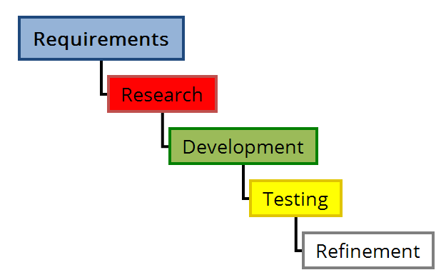
Figure 1: Visual representation of adapted waterfall methodology.
- Requirements
This stage involved outlining exactly what each mechanic was meant to achieve in discussion with the development team in order to avoid any confusion. For example, one task was to develop a lava hazard, which would be assumed to be a damaging hazard, when in fact the development team desired a slowing effect.
It is believed that this was an effective step to be included in the development as it avoided work having to be repeated by removing any ambiguity in the task and refining exactly what was desired from each mechanic and reducing the chance of error.
- Research
If required, this stage involved researching how each mechanic could be implemented if a method was unknown. If an effective method was already known, this stage was skipped.
It is believed that this was an effective step in reducing development time as it avoided undue experimentation to create mechanics that were not unique such as local multiplayer.

- Development
This stage in the methodology involved development of the functionality using systems within Unreal Engine 4 as well as any experimentation required due to lack of research materials.
- Testing
This stage involved testing each mechanic alone (if possible) and in conjunction with other systems in order to examine whether or not they operate correctly and achieve the goal set out in the requirements stage. In the case testing shows the functionality a failure, stage 3 would be returned to and the script will be corrected if possible, if not, another method would be developed.
While to accomplish this stage thoroughly costs considerable development time, it is believed this stage is indispensible in the development of functionality as it allows unexpected errors or glitches to be noticed quickly and their sources identified in as simple a method as possible and therefore prevent catastrophic failure that could take place if development continued without this stage.
- Refinement
This stage involved refining the mechanics after testing, this includes making the script more efficient and removing defunct variables and blueprints, and perhaps finding more effective methods if required.
It is believed that this stage is important as it helps ensure the best product is delivered to the client despite the increase in development time.

Review of Creative/Enterprise Strategy
The aim of Clockwork Dragon Solutions is to provide reliable functionality development, repair and consultancy services to video game development teams.
CDS aims to appeal to game developers in the indie sector of the industry. This is believed to be the best path for the company as larger companies would likely have hired in-house technical artists and would rarely require freelance agents, whereas smaller indie companies would likely require extra help and would rather hire a freelancer on a short basis as opposed to a full-time employee to reduce costs.
Clients will be sought out using various methods that are likely to attract the demographic. These include:
- Direct Networking
By communicating directly with potential clients it is intended to identify if they have need of CDS’ services and if so, offer them. By doing so it is hoped that new, immediate customers could be gained. It is believed that this method would be more effective if a previous link is established with the development team as it would be less presumptuous if the client is already an acquaintance of the company.
This method showed to be effective in the test case as the same office was utilised by both the client and Clockwork Dragon Solutions and allowed for establishment of a working relationship and a contract quickly. However, it is believed that this method should not be purely relied upon in practise as this is due in part to the test environment and the previous contact with the development team.
- Social Media Networking
By communicating through social media platforms such as Facebook, Twitter and Slack.com it is believed that the company could reach a wider audience locally and potentially reach clients internationally.
While this was not used in the test case due to the client being contacted directly, it is believed that this method would be effective for the company as it is has low monetary cost to maintain and has the potential to reach and communicate with clients both nearby and internationally. However, if international clients do not allow those working with them to work out of studio it may be detrimental to CDS to have to deny the client and it may be too costly for consultants to travel to the client.
- Games Development Social Events
By attending games development social events such as Games Wales South and Develop:Brighton it is believed that the company could grow its client base significantly, advertise their services, seek talent to employ and meet new industry colleagues all through in-person networking. This could potentially allow faster growth of the company within the industry by creating lasting connections with clients and colleagues alike.
As the test case involved purely direct networking, this was not attempted. However, as can be seen in other direction within the games industry, networking in this form has proven invaluable in business growth. Therefore it can be assumed that it would be a vital direction for CDS’ growth despite the potential travel costs to attend a variety of conferences.
- Word of Mouth/Client Referrals
By maintaining a friendly, approachable, efficient and effective service it is hoped that current or past clients will recommend CDS’ services to other developers and as such, attract further customers to the company. In addition to this, advertising to possible clients could potentially result in them passing on the company’s information to other development teams in need of CDS’ Services.
It is believed that this would be a very effective tool to achieve more clients as it would not only be seen as a potential solution to a client’s problem but also would be seen as a peer’s recommendation, which should establish confidence in the company. However, this method has the potential drawbacks of negative feedback if anything were to go wrong during a project.
After the test case was completed, the development team members were asked to complete a questionnaire (See Appendix 5 - Questionnaires) and from the feedback given have shown that they would recommend the company’s services to a friend or colleague as well as liable to review CDS in a good light if asked by another.

Funding
Clockwork Dragon Solutions will get its income through the billing of customers, as such; pricing will be made on a project-by-project basis depending on the time required and work involved (DeGuzman, 2012). As the client audience is small indie sector game development teams and individual game developers, prices can be adjusted to account for the client’s budget as long as the amount still supports sustainability and preferably growth for the company. It is believed that this is the best pricing model (Project-Based Pricing) for the company as it could prove unsustainable to charge on an hourly basis as smaller or repeated jobs could only take a very small amount of time but be of great worth to the customer. While it is believed this will bring to most profit, there is a danger of under-pricing a job by underestimating the costs and making a net loss, or only a small profit, on longer contract (Weaver, 2017). Following this pricing strategy opens opportunities to shorten development times while maintaining prices as already developed technical art solutions to similar problems can be re-used or repurposed to greatly reduce the potential time cost for a project.
The test project that was conducted evidenced that this is an effective form of funding for the company, as the payment agreed was £5750 for the term of nine weeks. This would amount to around £30,000 a year if the price was consistent. However, due to varying project sizes and overlapping projects, the full amount could be far more or less, though it is believed that the average would meet close to £30,000 Per Annum. This shows that this pricing model allows for sustainability and growth for the company as it can be assumed that each additional consultant hired in the future could expand the profits by an equal amount.

Pay & Tax
To begin with, Clockwork Dragon Solutions will be established as a limited company to ensure legal safety and a business bank account will be created to ensure the business’ money remains its own and can be accounted for as its own entity. In addition to this, maintaining a separate business account allows claim to some tax relief (Burton, 2017). Each employee will take a living wage of £16,500 per annum with view to increasing salary as the business grows. It is believed this will allow for consultants to live comfortably while allowing the business to invest additional income into its own growth as well as accounting for employee sickness, leave, pension and insurance. Being established as a limited company would also allow legal liability to be on the company itself, as legally it would be its own entity. This would limit the personal liability of the employees in the event of a lawsuit.
Once registered as a limited company with HMRC and registered for corporation tax, a tax return will be completed annually based off of retained receipts, invoices and bank statements (Company Bug, 2017). This will inform HMRC of the tax that is required to be paid and to bill the company appropriately which would likely amount to 20 percent as company profits are unlikely to exceed £300,000 until growth occurs (Gov UK, n.d.b).
As the test case is established as for academic purposes only, no actual income will be taken, and as such, wages or taxes will not need to be taken into account.

Critical Appraisal of the Final Proposition
Overall, the test case conducted with the Awesome Trio development team went well as time was planned well for the accomplishment of tasks under the purview of Clockwork Dragon Solutions and any and all changes made to the scope of the project were informed with plenty of time to negotiate and implement. This was accomplished by plotting a generous amount of time for each mechanic to avoid falling behind in the case one task took longer than expected or had to be re-implemented.

Mechanics
During the course of development, a few systems were changed as, while functional, the methods used to accomplish the original results were either not stable or otherwise inefficient. As it is the goal of Clockwork Dragon Solutions to deliver high-quality solutions to games functionality, these were remade or refined in order to address these issues, these were:
- Race Positioning
This system was intended to track the positioning of players on the racetrack and return which was in what position (1st, 2nd, 3rd etc.) each player is in. To accomplish this, it was attempted by using a recursive distance check for each player along a line (called a spline in Unreal Engine 4) that spanned the entire map. This involved checking if the player was closer to the beginning or the end of the line and then updating the start or end point respectively by half repeatedly until an accurate position was located or the repeat limit was reached. For Example: the line is represented by a decimal between 0 (start) and 1 (end), if player is closer to the end, the start is changed to 0.5, and subsequently 0.25 in the same conditions. This would repeat for each player active in the race. This method proved to be functional and accurate but was assessed as possibly unstable and inaccessible to the development team.
As such, an alternate, simpler method was developed and implemented in its place. This method involved each player passing through checkpoints and measuring the distance from the player to the next checkpoint and measuring the values against each other. For Example: if player 1 is on checkpoint 7 and player 2 is on checkpoint 5, player one is clearly in the lead (Position 1) and no further checking is necessary, however if both players are on checkpoint 7 the distance between each player and checkpoint 8 is measured and whoever is closest is positioned in the lead. While this was a more brute-force and less elegant system it demonstrated as perfectly stable and functional and therefore was the best option, especially as it is a background system that players would not see the difference in the systems.

- Mini-map

Figures 2 and 3 (Above): Mini-map before and after alteration respectively.
This system was intended to allow the player to view their own and their opponent’s positions on the map using a real-time UI mini-map. This was accomplished utilising Unreal Engine 4’s Render Target class that allows a camera to translate what it sees into a 2D texture. This was set high above each player pointed downwards in order to capture the map and centre the mini map on the owning player. This was effective and functional method, though after undergoing testing, it was found that each rendered map caused a significant potential impact on the games performance (No effect on the development machines, but would likely have caused large issues to lower-end machines).
Therefore further research was undertaken into render targets and other possible methods. The best solution found was to force the render target to only render specified actors, of which a large plane with a drawn map on was selected. This noticeably reduced the potential performance impact by preventing the render targets from having to render the entire world for each player.
Figures 4 (Top) and 5 (Bottom): Showing GPU visualizer before and after alteration respectively (Purple bars represent UI impact).
It is believed that this was an important revision as while the change may be small on single player, the impact is greatly reduced at higher player numbers.

- Split-screen
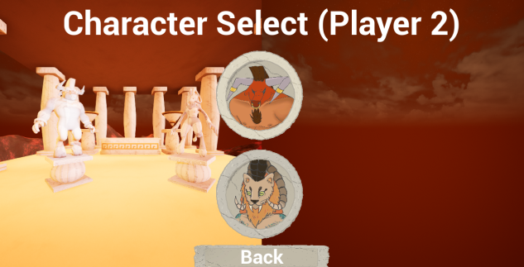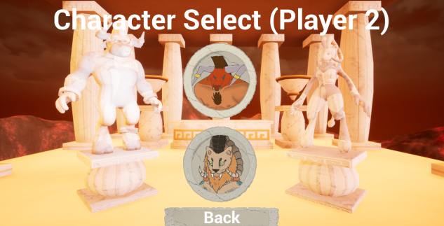
Figures 6 and 7: Character select before and after split screen fix respectively.
While implementing local split-screen multiplayer proved to be fairly simple, it resulted in a sudden, jarring split of the screen once two players was selected (See Figures 6 and 7) and a character chosen as another player was then “spawned” and resulted in the split-screen immediately being activated before actual gameplay began. Through research there was no method native to UE4 blueprints to stop this occurrence and maintain character select ability for a second controller. As such, in order to deliver the best product to the client, a method was researched, learned and implemented in the C++ coding language (See Figure 8) and a blueprint node was created to allow split screen control (See Figure 9), which therefore allowed the splitting of the screen to be exclusive to actual gameplay.
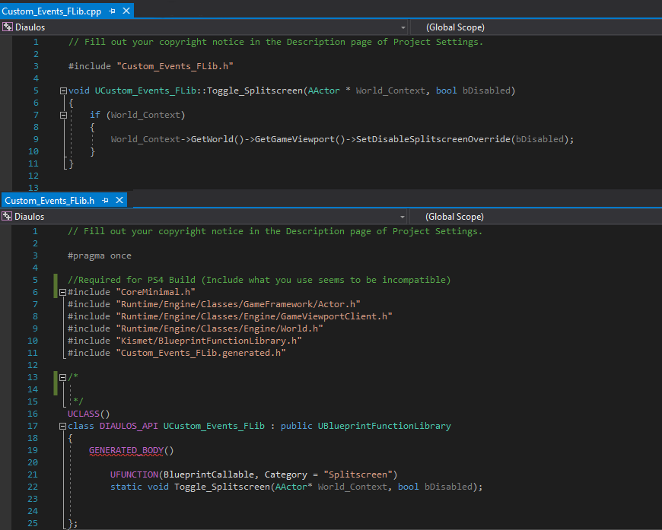
Figure 8: C++ Code to implement split-screen control node (CPP and Header Files)
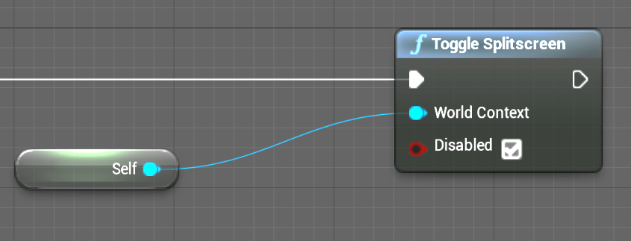
Figure 9: Resulting blueprint node for easy split-screen control.
This custom node created some issue with the PlayStation 4 build as all required libraries were not required to be included to operate in the UE4 editor and PC builds but were required in the PS4 builds, this was resolved though researching what libraries were required for the created code and including them into the header file so the main code had access to these classes (See Figure 8).

During the course of the project, tasks that were omitted from the original contract were identified and due to changes during development some changes to existing tasks had to be made. As such, a contract amendment was created to change or include these tasks (See Appendix 2 – Contract Amendment).
The most beneficial of these changes for the company was the replacement for Time-Attack functionality in place of Racing AI as it replaced an advanced system for a more simple one, as such, less time was spent on the development stage of the development and more was allowed for testing and refinement, resulting in a better product overall.
It is believed that allowing for negotiation and change within the contract and project scope within reason is very beneficial to both parties as the development team feels as if their needs are met and CDS benefits from having better feedback and happier customers (See Appendix 5 - Questionnaires) without necessarily adding more development time, and if time were added, the freedom to negotiate prices or refuse further involvement in worst cases. It is believed that this flexibility and a professional, friendly and efficient work ethic will allow Clockwork Dragon Solutions to grow significantly in scale, income and client base.

Future Trajectories
In order to make the business more sustainable, multiple paths could be taken:
- Training in coding
In future, the freelancer will undertake training in coding, specifically in the C++ and C# Languages. It is believed this will encourage quick growth in the client base as it will create opportunities to work with clients using differing game development engines such as CryEngine, Unity and Frostbite as well as being capable of more possible solutions to problems in more efficient and effective methods than UE4 Blueprints are currently capable of. This should logically allow the business to grow quickly due to wider demand.
- Undertaking more traditional roles in the industry
In the event the business does not attract sufficient clientele, more traditional roles in the games industry would be sought out, as a technical artist or game programmer (in the event training in coding has been undertaken) in order to gain credit on known game titles. This would allow the freelancer to display that they have worked on said games, which would likely attract more custom as their work would be known, or at very least accessible to see.
- Hiring more consultants
Should the business grow successfully, more consultants could be hired in order to expand the number of clients that could be dealt with simultaneously, thus allowing for a higher volume of income, as well as allowing for more clients to be gained in a timely fashion by lowering the chance that a potential client would be denied, delayed or lost due to previous engagements taking the desired time. It is believed this would allow the company to grow quickly and make more revenue, but would also require higher costs to the business due to increased employee wages, benefits, pension and insurance.
This path is potentially the most beneficial on its own as consultants with differing experience and talents could be hired to expand more quickly to reach customers with different needs such as a differing engine to Unreal Engine 4 or differing coding languages.
  - Hire accountant
Once the company has been officially established, an accountant will be needed to manage the business accounts and tax returns. It would also benefit the company to attempt to reduce tax and save employees the time that would otherwise be taken by accounting duties.

It is believed all of these paths should be explored in the future with the exception of undertaking more traditional roles in the industry in the event the business becomes successful without it. This is because each could potentially expand the business and therefore income, exponentially and none interferes with the others.

References
DeGuzman, G., 2012. 5 Ways to Strategically Price Your Freelance Rates. EnvatoTuts+, [Blog] 22 February. Available at: <https://business.tutsplus.com/articles/5-ways-to-strategically-price-your-freelance-rates--fsw-25201> [Accessed 30 January 2018]
Burton, Liz., 2017. Definitive Guide to Sole Trader Tax. theHub, [Blog] 27 July. Available at: <https://www.highspeedtraining.co.uk/hub/sole-trader-tax/>[Accessed 10 March 2018]
Company Bug, 2017. Limited Company Tax – The Basics. [online] Available at: <http://www.companybug.com/limited-company-tax-basics/> [Accessed 10 April 2018]
Gov UK, n.d.a. Income Tax rates and Personal Allowances. [online] Available at: <https://www.gov.uk/income-tax-rates> [Accessed 08 March 2018]
Gov UK, n.d.b. Corporation Tax Rates and reliefs. [online] Available at: <https://www.gov.uk/corporation-tax-rates> [Accessed 08 April 2018]
Powell-Morse, Andrew., 2016. Waterfall Model: What Is It and When Should You Use It?. Airbrake, [Blog] 8 December. Available at:<https://airbrake.io/blog/sdlc/waterfall-model>[Accessed 22 February 2018]
Weaver, B., 2017. 7 Pricing Models – and Which You Should Choose. Creative Bloq, [Blog] 15 November. Available at: <https://www.creativebloq.com/advice/7-pricing-models-and-which-you-should-choose> [Accessed 01 February 2018]
www.rossmartin.co.uk, 2018. Sole Trader v. Limited Company: Key Tax & Legal Differences. [online] Available at: <https://www.rossmartin.co.uk/starting-in-business-77750/140-sole-trader-v-limited-company-key-tax-a-legal-differences> [Accessed 10 April 2018]

Bibliography
Johnson, K., 2016. Eight Clauses Your Freelance Contract Shouldn’t Be Without. Crunch., [Blog] 20 October. Available at: <https://www.crunch.co.uk/knowledge/contracts/eight-clauses-your-freelance-contract-shouldnt-be-without/> [Accessed 22 January 2018]
Bowes, J., 2014. Agile vs Waterfall: Comparing project management methods. Manifesto, [Blog] 17 July. Available at: <https://manifesto.co.uk/agile-vs-waterfall-comparing-project-management-methodologies/> [Accessed 23 February 2018]
Bytestart, n.d. Sole Trader Tax – A Guide for Start-ups and the newly self employed. [online] Available at: <http://www.bytestart.co.uk/sole-trader-tax-guide.html>[Accessed 14 March 2018]
CompanyWizard.co.uk, n.d. Paying Yourself. [online] Available at: <https://www.companywizard.co.uk/support/guide_paye_dividends> [Accessed 24 March 2018]
Develop:Brighton, 2018. Develop:Brighton. [online] Available at: <https://www.developconference.com/> [Accessed 28 April 2018]
Entrepreneur, n.d., Paying Yourself: From Startup and Beyond. [online] Available at: <https://www.entrepreneur.com/article/80024>[Accessed 30 March 2018]
FDWorks, 2017. The Best Way to Pay Yourself as a Company Director. [online] Available at: <https://www.fd-works.co.uk/insights/directors-pay/> [Accessed 28 March 2018]
Games Wales, 2018. Games Wales South: Recent News. [online] Available at: <http://gameswales.org/south/> [Accessed 28 April 2018]
PandaDoc, n.d., Freelance Contract Template [online] Available at: <https://www.pandadoc.com/freelance-contract-template/> [Accessed 22 January 2018]
Start Up Loans, n.d. Main Taxes that apply to small businesses. [online] Available at: <https://www.startuploans.co.uk/business-advice/taxes-for-small-businesses/> [Accessed 22 March 2018]
Upwork, 2016. Unreal Engine Freelancers. [online] Available at: <https://www.upwork.com/o/profiles/browse/?q=unreal%20engine> [Accessed 30 January 2018]
Xero, n.d. Small Business Guides: How Much Should You Pay Yourself? [online] Available at: <https://www.xero.com/uk/resources/small-business-guides/business-management/pay-yourself/> [Accessed 22 March 2018]

Appendices
Any documents requiring signatures have been signed but unsigned versions have been used for the purposes of this document. Signed versions are included in the artefact submission for Creative Venture 2, and are available on request. Additionally, each document’s formatting has also been altered to avoid conflict with the report (Removed heading formatting etc.).

Appendix 1 – Original Contract


Technic Artist - Freelance Contract
Prepared By: Liam Jones – Clockwork Dragon Solutions

Prepared For: Awesome Trio Development Team

Note: This document is a Mock-Up for academic purposes and there are no legal obligations or expectation of payment.
This Contract is Entered into and made effective as of 22/01/2018, between:

Daniel Gates, Millaray Contino and Ruth Heneghan of Awesome Trio, with an office located at Alex Building, Alexandra Road, Room AA207, Swansea (“Client”), and Liam W Jones of Clockwork Dragon Solutions, with an office located at Alex Building, Alexandra Road, Room AA207, Swansea (“Freelancer”).

Whereas:
- Client has a need for video game functionality development; and
- Freelancer has an interest in performing these services for the Client; and
- The parties wish to set out the terms and conditions upon which such services will be provided to the Client;
Therefore, in consideration of the foregoing, and the mutual promises herein contained, the parties hereby agree as follows:

Description of Services

The Freelancer will provide video game functionality development for the project currently designated “Attack on Olympus”. The specific mechanics and responsibilities requested for the project are as follows:
- Local Multiplayer Implementation
- Respawning
- Racing AI
- Implement Map Lighting / Post Process
- Climbing
- Collision
  - Characters
  - Debris
  - Lava
- Pickups
  - Lightning (Stun)
  - Cloud (Jump)
  - Weight (Slow)
- Character Movement
  - Mobility
  - Attack
- Particle Systems
  - Ash
  - Dust Cloud (Character Run)
  - Smoke
  - Pickup Sparkle
- Character Special Abilities
  - Charge (Minotaur)
  - Double Jump (Chimera)
- HUD and Game Shell
  - Start Menu
  - Character Select Menu
  - Minimap
  - Finish Screen
  - Current Power-up
- Assist Animator (Dan Gates) with engine animation functionality such as:
  - Animation Blueprints
  - Animation Blendspaces

The freelancer will make as many re-iterations as necessary within the time allowance to ensure each mechanic is delivered to the clients specifications.
Any additional mechanics not stated above will be negotiated between the freelancer and the client as required.
The freelancer agrees to make all created functionality as accessible as possible for ease of use by the client without the Freelancer’s presence.
Timesheets will be provided on the Friday of each week in order to confirm that services were provided and to record hours worked for invoicing purposes.

Deliverable

- The freelancer will be expected to deliver Unreal Engine 4 Project Files containing the created functionality on a weekly basis.

Project Schedule

This contract will be effective for eight weeks, beginning on the 22nd of January 2018 until 16th March 2018. Milestones will follow the above list of requested mechanics as each will be worked on individually.
The timeframes for each milestone will be established before or during development according to discussion with the client’s needs.

Pricing/Rates

The freelancer will be expected to work 40 hours a week for the client or until the assigned tasks for the week as assigned by the development team are completed.
In total the Freelancer will charge £5000 for the contracted time.
Overtime hours may be negotiated if and when they become required.
If the scope or timeframe of the project change, a new contract may be negotiated between the freelancer and the client as necessary.

Payment Terms/Schedule

Payment to the freelancer will be expected within seven days of receipt of the invoice.

Terms and Conditions
By signing below, the parties have caused the contract, inclusive of attachment A, to be executed and effective as of the effective date stated above.

Liam W Jones – Clockwork Dragon Solutions

Daniel Gates – Awesome Trio

Millaray Contino – Awesome Trio

Ruth Heneghan – Awesome Trio

Attachment A – Freelance Contract Terms and Conditions

- Intellectual Property Rights
  - Retained Rights.
Each party will retain all right, title, and interest in and to its own Pre‐Existing Intellectual Property irrespective of any disclosure of such Pre‐Existing Intellectual Property to the other party, subject to any licenses granted herein.
  - Pre‐Existing Intellectual Property.
  - Freelancer will not use any Freelancer or third party Pre‐Existing Intellectual Property in connection with this Contract unless Freelancer has the right to use it for Client’s benefit. If Freelancer is not the owner of such Pre‐Existing Intellectual Property, Freelancer will obtain from the owner any rights as are necessary to enable Freelancer to comply with this Contract.

  - Freelancer grants Client a non‐exclusive, royalty‐free, worldwide, perpetual and irrevocable license in Freelancer and third party Pre‐Existing Intellectual Property, to the extent such Pre‐Existing Intellectual Property is incorporated into any Deliverable, with the license including the right to make, have made, sell, use, reproduce, modify, adapt, display, distribute, make other versions of and disclose the property and to sublicense others to do these things.

  - Freelancer will not incorporate any materials from a third party, including Open Source or freeware, into any Deliverable unless (i) Freelancer clearly identifies the specific elements of the Deliverable to contain third party materials, (ii) Freelancer identifies the corresponding third party licenses and any restrictions on use thereof, and (ii) approval is given by Client in writing. Freelancer represents, warrants and covenants that Freelancer has complied and shall continue to comply with all third party licenses (including all open source licenses) associated with any software components that will be included in the Deliverables or any other materials supplied by Freelancer. Freelancer shall indemnify Client against any losses and liability incurred by Client due to failure of Freelancer to meet any of the requirements in any of the third party licenses.

  - Ownership of Deliverables.
Subject to Freelancer and third party rights in Pre‐Existing Intellectual Property, all Deliverables, whether complete or in progress, and all Intellectual Property Rights related thereto shall belong to Client, and Freelancer hereby assigns such rights to Client. Freelancer agrees that Client will own all patents, inventor’s certificates, utility models or other rights, copyrights or trade secrets covering the Deliverables and will have full rights to use the Deliverables without claim on the part of Freelancer for additional compensation and without challenge, opposition or interference by Freelancer and Freelancer will, and will cause each of its Personnel to, waive their respective moral rights therein. Freelancer will sign any necessary documents and will otherwise assist Client in securing, maintaining and defending copyrights or other rights to protect the Deliverables in any country.

  - No Rights to Client Intellectual Property.
Except for the limited license to use materials provided by Client as may be necessary in order for Freelancer to perform Services under this Contract, Freelancer is granted no right, title, or interest in any Client Intellectual Property.

- Conflict of Interest
  - Freelancer represents that its execution and performance of this Contract does not conflict with or breach any contractual, fiduciary or other duty or obligation to which Freelancer is bound. Freelancer shall not accept any work from Client or work from any other business organizations or entities which would create an actual or potential conflict of interest for the Freelancer or which is detrimental to Client’s business interests.

- Termination
  - Rights to Terminate.
- Client may terminate this Contract and/or an individual project for its convenience, without liability at any time, upon prior written notice to Freelancer.

- Freelancer may terminate this Contract upon thirty days prior written notice provided there are no open projects at the time notice is given.

- Client may terminate this Contract and/or any open projects immediately for cause if the Freelancer fails to perform any of its obligations under this Contract or if Freelancer breaches any of the warranties provided herein and fails to correct such failure or breach to Client’s reasonable satisfaction within ten (10) calendar days (unless extended by Client) following notice by Client. Client shall be entitled to seek and obtain all remedies available to it in law or in equity.

  - Upon termination of any project or work given Freelancer hereunder, Freelancer will immediately provide Client with any and all work in progress or completed prior to the termination date. As Client’s sole obligation to Freelancer resulting from such termination, Client will pay Freelancer an equitable amount as determined by Client for the partially completed work in progress and the agreed to price for the completed Services and/or Deliverables provided and accepted prior to the date of termination.

  - Upon termination or expiration of this Contract or a project performed by Freelancer hereunder, whichever occurs first, Freelancer shall promptly return to Client all materials and or tools provided by Client under this Contract and all Confidential Information provided by Client to Freelancer.

  - Force Majeure.
Neither Party shall be liable for any failure to perform under this Contract when such failure is due to causes beyond that Party’s reasonable control, including, but not limited to, acts of governmental authorities, acts of terrorism, natural catastrophe, fire, storm, flood, earthquakes, accident, and prolonged shortage of energy. In the event of such delay the date of delivery or time for completion will be extended by a period of time reasonably necessary by both Freelancer and Client. If the delay remains in effect for a period in excess of twenty days, Client may terminate this Contract immediately upon written notice to Freelancer.

- Extra Work
  - Any additional work introduced to the freelancer by the client will be subject to extra charge or negotiation between the two parties at their discretion.

  - Any extra work required beyond the expiration of this contract can be negotiated and sealed with a new contract.

- Late Payment
  - If the client fails to pay the freelancer money owed within the timeframe specified above, the freelancer reserves the right to charge the client statutory interest of 8 percent in addition to the base rate for business to business transaction as set forth by the Bank of England and in accordance to the law.

- Limitation of Liability
  - Except as set forth in this section below, in no event will either party be liable for any special, indirect, incidental, or consequential damages nor for loss of data, profits or revenue, cost of capital or downtime costs, nor for any exemplary or punitive damages, arising from any claim or action, incidental or collateral to, or directly or indirectly related to or in any way connected with, the subject matter of the agreement, whether such damages are based on contract, tort, statute, implied duties or obligations, or other legal theory, even if advised of the possibility of such damages.

  - Notwithstanding the foregoing, any purported limitation or waiver of liability shall not apply to freelancer’s obligation under the indemnification or confidential information sections of this agreement or either party’s liability to the other for personal injury, death or physical damage to property claims.

- Inspection and Acceptance
  - Non-Conforming Services and Deliverables.
If any of the Services performed or Deliverables delivered do not conform to specified requirements, Client may require the Freelancer to perform the Services again or replace or repair the non-conforming Deliverables in order to bring them into full conformity with the requirements, at Freelancer’s sole cost and expense. When the defects in Services and/or Deliverables cannot be corrected by re-performance, Client may: (a) require Freelancer to take necessary action, at Freelancer’s own cost and expense, to ensure that future performance conforms to the requirements and/or (b) reduce any price payable under the applicable project to reflect the reduced value of the Services performed and/or Deliverables delivered by Freelancer and accepted by Client.

  - If Freelancer fails to promptly conform the Services and/or Deliverables to defined requirements or specifications, or take action deemed by Client to be sufficient to ensure future performance of the project in full conformity with such requirements, Client may (a) by contract or otherwise, perform the services or subcontract to another Freelancer to perform the Services and reduce any price payable by an amount that is equitable under the circumstances and charge the difference in re-procurement costs back to Freelancer and/or (b) terminate the project and/or this Contract for default.

- Miscellaneous
  - Independent Freelancer.
Nothing contained in this Contract shall create an employer and employee relationship, a master and servant relationship, or a principal and agent relationship between Freelancer and Client. Client and Freelancer agree that Freelancer is, and at all times during this Contract shall remain, an independent freelancer.

  - Non-Exclusivity
The working relationship between freelancer and client is non-exclusive and as such the freelancer retains liberty to seek extra employment simultaneously inasmuch as this contract is not breaching in doing so.

  - Entire Contract.
This document and all attached or incorporated documents contains the entire agreement between the Parties and supersedes any previous understanding, commitments or agreements, oral or written. Further, this Contract may not be modified, changed, or otherwise altered in any respect except by a written agreement signed by both Parties.

Appendix 2 – Contract Amendment

Awesome Trio Contract Amendment #1 22/01/18
Prepared By: Liam Jones – Clockwork Dragon Solutions

Prepared For: Awesome Trio Development Team

Note: This document is a Mock-Up for academic purposes and there are no legal obligations or expectation of payment.
This is an amendment to the contract between Clockwork Dragon Solutions and the Awesome Trio that came into effect 22/01/18 that enacts the following changes:
- AI is no longer required and has moved to a wish list.
  - In its place, time attack functionality for single-player will be implemented.
  - This will involve leader board functionality.
- Additions to HUD
  - Race Position in multiplayer.
  - Current time in Single Player.
- Builds for PlayStation 4 Required.
- Game Shell Alterations
  - Main Menus to be changed to primarily 3D.
  - Added Leader board Screen
- Start/Finish camera systems
- Implement Game Sounds

Project Schedule
The contracted time will be lengthened to end on the 25th March 2018.

Pricing/Rates
For the additional week, an additional £750 will be charged, making the total £5750.

Attachment Amendment
- Intellectual Property Rights
iii. Ownership of Deliverables
Subject to Freelancer and third party rights in Pre‐Existing Intellectual Property, all Deliverables, whether complete or in progress, and all Intellectual Property Rights related thereto shall belong to Client, and Freelancer hereby assigns such rights to Client. Freelancer agrees that Client will own all patents, inventor’s certificates, utility models or other rights, copyrights or trade secrets covering the Deliverables and will have full rights to use the Deliverables without claim on the part of Freelancer for additional compensation and without challenge, opposition or interference by Freelancer and Freelancer will, and will cause each of its Personnel to, waive their respective moral rights therein. However, Freelancer maintains the right to advertise their services utilizing content created for the deliverable without client’s written permission, and maintains that Freelancer retains the right to advertise that their work is contained within the project. The freelancer agrees that this content will only be used if:
- The Project is cancelled.
- The Project is put on indefinite hiatus and a minimum of 3 months has passed.
- The Project has been completed and released.
Freelancer will sign any necessary documents and will otherwise assist Client in securing, maintaining and defending copyrights or other rights to protect the Deliverables in any country.

Terms and Conditions
By signing below, the parties have caused the contract, inclusive of attachment A, to be executed and effective as of the effective date stated above.

Liam W Jones – Clockwork Dragon Solutions

Daniel Gates – Awesome Trio

Millaray Contino – Awesome Trio

Ruth Heneghan – Awesome Trio

Appendix 3 – Blank Timesheet

Weekly Freelancer Timesheet

Week Ending Date:
Freelancer Name: | Liam Wyn Jones
Company Name: | Clockwork Dragon Solutions
Place of Work: | Alex Building, Alexandra Road, Swansea, Room AA207

 | Monday | Tuesday | Wednesday | Thursday | Friday | Saturday | Sunday
Hours Worked:

 | Monday | Tuesday | Wednesday | Thursday | Friday | Saturday | Sunday
Overtime Agreed and Worked:

Detail of work completed:

Client Declaration:
I confirm that these services were provided and accept that my company will be invoiced accordingly.

Client Name: Date:

Client Signature:

Freelancer Declaration:
I confirm that these are an accurate record of services provided in accordance to the contractual terms and conditions.

Freelancer Name: Date:

Freelancer Signature:

If you have any questions regarding the timesheets or working hours please contact Liam W Jones at Clockwork Dragon Solutions.

Note: This document is a Mock-Up for academic purposes and there are no legal obligations or expectation of payment.

Appendix 4 – Invoice

Clockwork Dragon Solutions - Invoice

Alex Building, Room AA207
Alexandra Road Date: 26th March 2018
Swansea Invoice #: 1

Bill to:
Awesome Trio
Alex Building, Room AA207
Alexandra Road
Swansea

ID | Description | Number of Tasks | Price
01 | UE4 Functionality Creation, Consultancy and Repair - Diaulos | 34 | £5000
02 | UE4 Functionality Repair & Refinement | 9 | £750

Total:
£5750

All cheques payable to Clockwork Dragon Solutions.
Online payment payable to: Pay@CDS.co.uk (False Email Address for academic purposes)
Payment is due within seven days.
If you have any questions regarding the invoice please contact Liam W Jones at Clockwork Dragon Solutions

Appendix 5 - Questionnaires

5a. Blank
- Were you happy with the services provided? Was there anything that stood out?
- Were your goals and deadlines met?
- Did you find the service professional?
- Did you find the consultant Friendly, approachable and accessible?
- Were the contract and all subsequent documents (Amendments, timesheets etc.) clear and understandable?
- Would you recommend our services to a friend or colleague?
- What would you be likely to say to someone who asked about us?
- How likely are you to use our services again and why?
- Is there anything we can improve on?
- Did you find our service flexible enough to meet the changing needs of development?
- Do you have any questions, comments or concerns? If so, please state below.

5b. Awesome Trio Member 1
- Were you happy with the services provided? Was there anything that stood out?
Yes, all work requested was completed in a timely manner to a high quality.

- Were your goals and deadlines met?
Yes.

- Did you find the service professional?
Yes.

- Did you find the consultant Friendly, approachable and accessible?
Yes.

- Were the contract and all subsequent documents (Amendments, timesheets etc.) clear and understandable?
Yes.

- Would you recommend our services to a friend or colleague?
Of course, anyone with engine trouble would benefit from advice.

- What would you be likely to say to someone who asked about us?
Good, professional work completed in a timely manner, and always open to edits (so long as they’re given with plenty of time to implement).

- How likely are you to use our services again and why?
Very likely, any and all problems and ideas posed were completed.

- Is there anything we can improve on?
Not that I am aware of right now.

- Did you find our service flexible enough to meet the changing needs of development?
Yes.

- Do you have any questions, comments or concerns? If so, please state below.
Nope, all went well despite the constant ambiguity within our development team.

5c. Awesome Trio Member 2
- Were you happy with the services provided? Was there anything that stood out?
Yes all work was provided when asked. All services were done quickly and to a professional manner.

- Were your goals and deadlines met?
All primary goals were achieved, work had to be prioritised over other goals.

- Did you find the service professional?
Service was very professional and stuck to timeline.

- Did you find the consultant Friendly, approachable and accessible?
Yes, very quick communication and easy to explain work.

- Were the contract and all subsequent documents (Amendments, timesheets etc.) clear and understandable?
Everything was clear and understandable.

- Would you recommend our services to a friend or colleague?
Yes definitely, work was great and achieved by set time.

- What would you be likely to say to someone who asked about us?
Hard worker, sticks to timesheets, easy to communicate and works well with others.

- How likely are you to use our services again and why?
Very likely. If there is anything within the engine that needs fixing. This is the person to go to.

- Is there anything we can improve on?
Not that I can think of.

- Did you find our service flexible enough to meet the changing needs of development?
Yes, services were flexible. If anything new came it was easily prioritised.

11. Do you have any questions, comments or concerns? If so, please state below.
Nothing sorry.

