Problem Solving and Decision Making
Prepared by-
Maria Luisa Salvagno (1818772)
Lecturer: Fernando Suneth
BMSW4004_LON
Category: CertHE (London)

The Propose and Presentation Objectives:
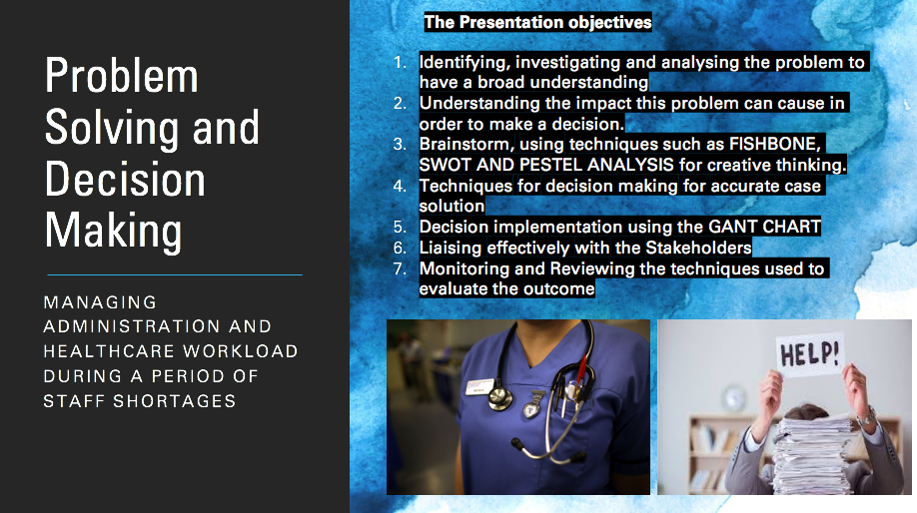
The propose of this report and presentation altogether is to show a wide range of skills and techniques gained during the last term at university.
I will show aspects of the problem at work and how it was to solve during the process of decision making.
For this task, I will utilise some crucial steps in which I will demonstrate throughout the presentation using real-life and experiences I dealt with in my previous work experience at a GP Surgery.

Speaker Notes:
In this PowerPoint, I have pinpointed the main aspects of what I will talk about throughout the entire presentation, such as:
1- Identifying the problem, investigating the facts during the collection of data to analyse the problem. It is essential to have this information gathered adequately to have a broad understanding to solve the problem and all the smallest details to avoid any flaws and minimise the reoccurrence.
When data is gathered correctly, the more likely it is to eliminate all the problem all at once. Data must come from the trustful source and real facts of what is going on.
2- Understanding the impact this problem can cause in order to make a decision. A problem can impact peoples and businesses lives drastically and understanding what the problem can cause, is a huge step in order to fail or succeed.
3- Brainstorm using different types of techniques such as Fishbone diagram, SWOT and PESTEL Analysis will help to see the facts from different angles and even improve the understanding of a case with creative thinking.
4- Different systems may have to be performed before a case conclusion. A previous plan may have to be adjusted until a correct decision making becomes accurate, and the problem no longer reoccur.
5- A Gant chart will be at excellent use to identify solutions and implement decision making
6- Having gathered all of the steps above and coming up with a great plan based on truthful knowledge, then it's time to move on with those pieces of information and present it to the stakeholders. Liaising clearly with stakeholder will help integrity and trust to remain intact and build a proactive relationship.
7- During the Monitoring and reviewing phase, I will be able to pinpoint the changes that must be made, such as in leadership, time management, technology, and strategies in order to innovate and grow more durable from the problem.
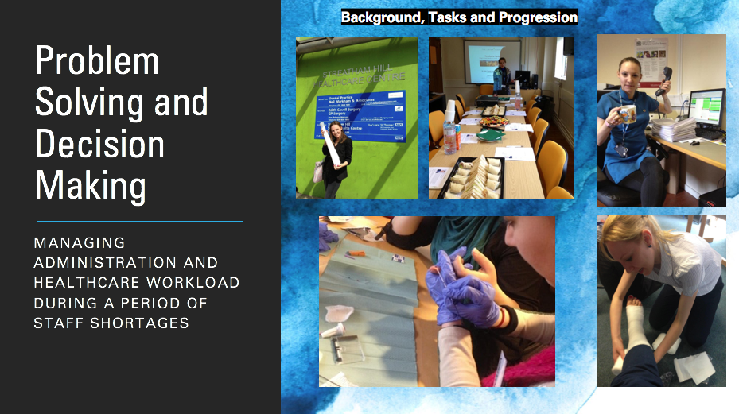
Disclaimer: These are some photos I have collected of myself, they were used in the employees practice Surgery Blog as we developed ourselves, it helped the crew to stay in focus, a reminder to keep striving for progress during good and challenging times.

Speaker Notes:
Before I immerse in the complex of the problem, I would like to give some information about my background experience,
In the first two years of my career, I was hired to work as a Receptionist – Administrator, and I did not know anything about the software system that I would have to use. The NHS software is bespoke, and it is not like you can go elsewhere, pay and learn to get those qualifications, I was trained in – house by previous members of staff, because it’s a unique software which holds important patient confidentiality.
During my administration years, I had to learn a lot of many mandatory pieces of training, two years later, I was offered to be trained to become a Health care Assistant, and it happened.
I became qualified, and I was signed off by the doctors and nurses, it happened gradually, and soon I was running my clinics.

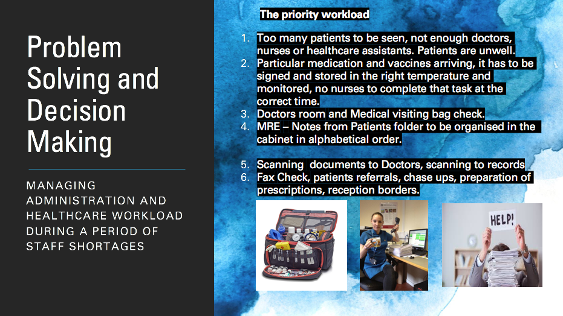

Speakers Notes:

As you can see, it was a lot of information and tasks to complete.
On my second year running as a health Care assistant, The economy had a big crash, and the NHS suffered and sadly most of my colleagues were made redundant, that included Administrator receptionists, nurses, doctors and Health Care Assistants.

We knew things would become tight, and so they did.
At that time, a new manager had just been hired; he was learning most of the tasks and NHS mandatory pieces of training.
As you can imagine, we had to step up as a team and resolve these big problems.
We had to stay rational and become creative, very fast. We had to innovate to fulfil the administration and healthcare team using the best of our abilities, and I had to step up myself, as an individual and as a professional. I was so glad to have all that backlog of experience.

For that mission, we separated the most critical and Non - Negotiable tasks that had to be dealt with as you can see in the slides, which we called the “Priority workload”.
We had a lot to review as an individual, and as a team to start a decision - making process and negotiation of what tasks the remaining of us would take on board, and not to forget, we also had to help our new manager understanding the healthcare side of the
business, because not all managers understand all of the clinical terms and what it involves, great communication and understanding at least 80% of the problem is vital to create a well - structured plan and time management.
According to Harahsheh (2019), adopting plans for strategies, specific resources and prioritizing the most critical tasks will impact positively in the performance of employees.
Generating unique solutions to severe problems is something that many managers have to do, particularly those leading competing businesses where reform is the primary source of competing for service (Morgan, 2017)

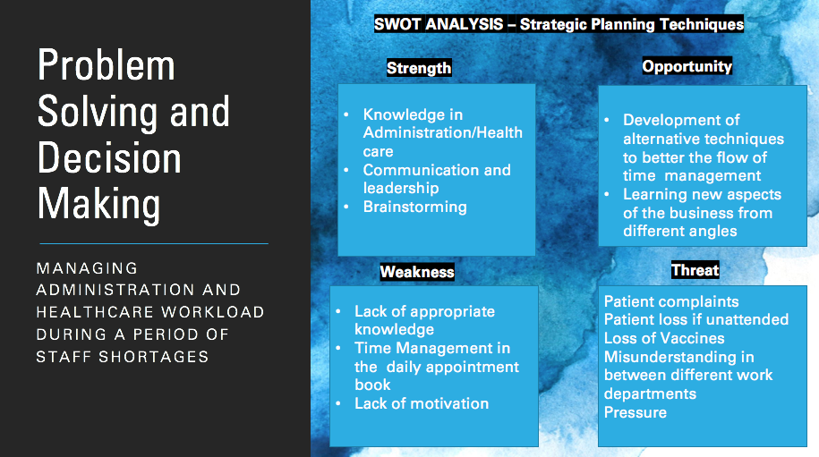
Speaker Notes:
After organising the priority tasks, we then move on to what I will talk about in this next slide.
In business, it’s imperative to tackle issues using different problem techniques, I have prepared a SWOT Analysis is to help us identify the strengths, weakness, opportunities and threats that the GP could face as a whole.
According to David et al., (2019), in a SWOT analysis, the term used applies to the requirement for each external and internal circumstance to be significant and helpful in finally determining what steps or strategies a company should study pursuing how to tackle
SWOT Analysis stands for Strength, Weakness, opportunity and threats.

Strength:
I have the understanding in both departments, administration and healthcare.
Having this knowledge takes the pressure when allocating the designated extra tasks to the remaining employees and be able to brainstorm efficiently in excellent communication, removing any blocks a leadership could face.

Weakness:
Our new manager, have never been instructed to be healthcare, we would have to keep that in mind to give him extra support and explanations about the healthcare tasks, otherwise he would feel confused and avoid stress or lack of motivation in such a difficult time where we all must be on the same page.
Another weakness we must keep in mind is about the daily appointments, and how a small team would cope with a large number of patients to be seen.

Threats:
As a threat, we could face patients placing formal complaints.
Patients need their medication in time; referrals must be completed.
Patients could die if not treated in time, there are loads of patients in palliative care and due to shortage of staff this could even end up in legal disputes.
More problems would be generated, delaying the process of solution of the existent problems.

If the team is not working together, liaising one with another, misunderstandings in both different departments would occur, and it could cause unnecessary pressure, yet, again, loss of motivation.

According to Morgan (2017), assigning people with unmatching skills, won’t help in the process of creative outcomes, because if you keep overthinking on how to resolve a problem, the less likely it will be the possibilities to come up with a successful outcome.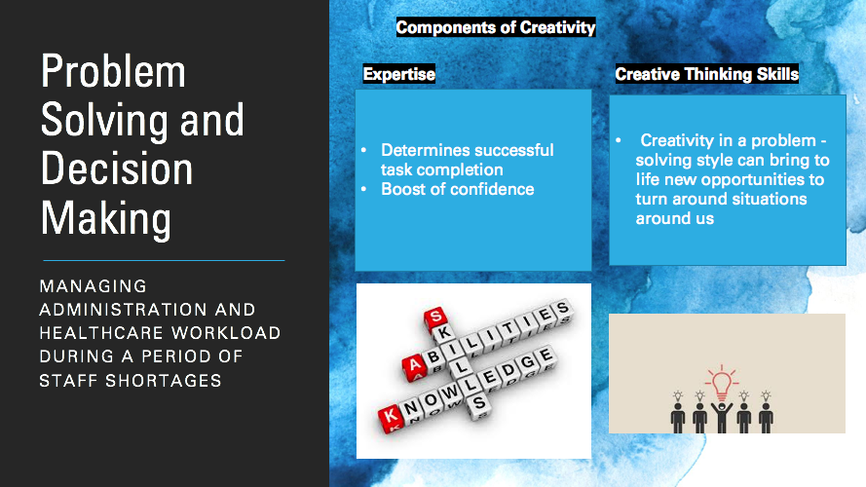
Components of Creativity:
Speaker notes:
I created this slide with essential elements of Creativity, and I would like to use some important in-text citations to support my sayings.
Expertise:
According to Vaughan R et al.,(2018), the nature of decision and evaluation of risk are critical determinants of successful work completion. Professionals are cautious in their choice-making knowledge, it will all depend according to their substantial expertise levels.
I would also like to mention that expertise is a real boost in confidence of an employee when they complete a task.
Moreover, I believe our GP Surgery directors kept an expert team because he trusted we would be able to take care of the problems effectively.
Creative Thinking:
According to Morgan, (2017), Creativity in cycles of problem-solving means we can see a query in a different approach, or we can recognise new opportunities that have the potential to turn something around us into a new system.
Creativity masters the composition or creation, when analysing critically different methods of work. The meaning of the word "creative" implies a significant ingredient of showing thought, aesthetic or rational inventiveness (Paul and Elder, 2019).
According to Power J.D (2019), business users might use the terms "rational or analytical" as in the same way for the exact, evidence-based when making decisions
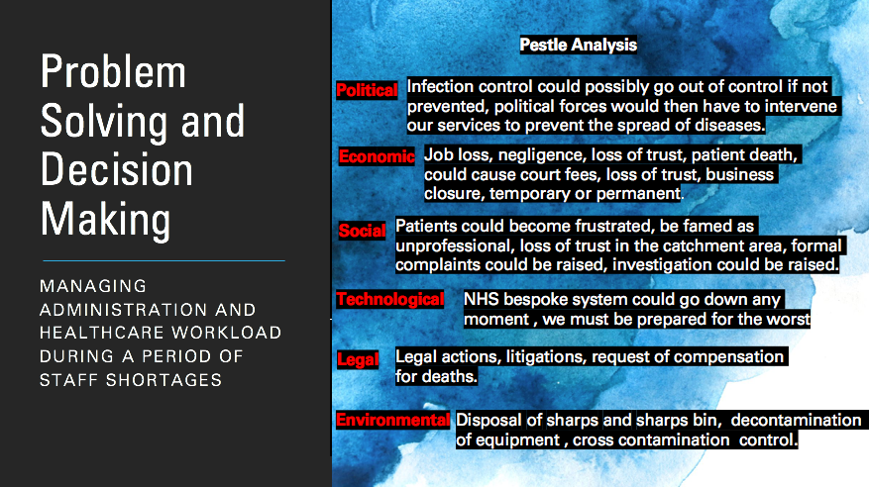
Now that we have understood the SWOT Analysis and components of creativity, I will move on to a different problem - solving technique more in-depth, such as Pestle Analysis.
Speaker Notes:
Pestle Analysis is another tool for a problem-solving technique to help us gather external facts that go beyond our control, using this tool I was able to collect vital information to prevent the business going out of control.
Political:
Making sure infection control is taken care appropriately will ensure, the business and the society is kept under control, otherwise external political forces would have to intervene in our services to spread the disease to the community.
Political sources and their team of experts could be a threat and close down the GP Surgery services temporarily and even for good, for fail in We could be punished for breach of regulations and negligence of infection control.
Economic:
An economic problem has already been generated at a certain degree; since we are dealing with the cuts and we have lost employees in our team, we must now deal with these existent losses.
Social:
Patients could become frustrated with the delay of the service and decide to move themselves to another GP surgery in the catchment area.
The news could quickly spread throughout the neighbourhood, we would look unprofessional.
In the worst-case scenario, patients or members of the family could also raise a formal complaint the NHS Constitution of England, and the Department of Health and Social Care, this could lead us to be investigated for negligence.
Technological:
MRE Cabinets with patients physical documents folder must be kept extremely organized and revised.
Sometimes, the NHS bespoke online software system goes down, and we are not able to access patients notes online, having the physical records at hand, will ensure no delays in the workflow will occur.
When the system goes down, it’s an issue itself, because it’s completely out of our control, and with a shortage of staff we can’t afford any delays awaiting the system to go back to work, clinics must run in time so that we can save lives.
Legal:
If patients feel that they are being neglected because have not been treated in time, we could also suffer families taking the practice surgery to the court requesting compensation for their losses.
We also would lose trust in the community who puts their health and life in our hands.
Environmental:
As we have of staff cut and the workload has increased, we will have to take measurements to keep an eye in the disposal of sharps bin and the decontamination of medical equipment.

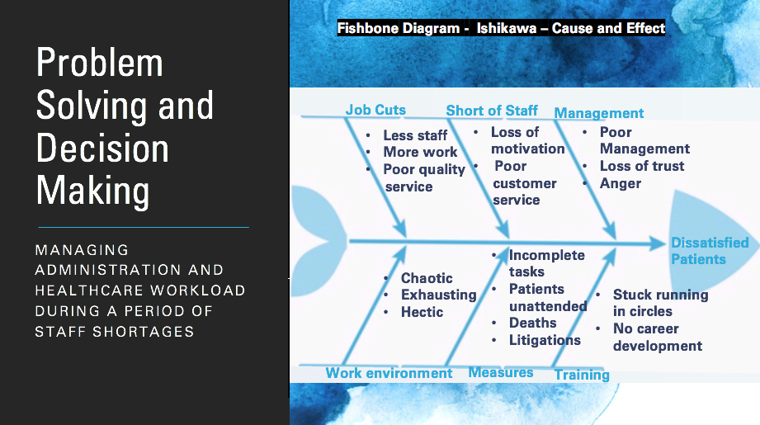
The Fishbone – Ishikawa Diagram – Cause and Effect
Speaker notes:
In this diagram, I present the root of cause and effect caused in the GP Surgery.
This diagram allowed me to explore the main reason of the problem and the effects it causes if no measures are taken, it’s another problem technique, different than the other ones I already have presented.
Job Cuts:
Job cuts were caused by the government economy crash, with less staff to perform workload, the remaining members of the team must address more work, and it can lead to poor quality service
Work Environment:
The work environment becomes chaotic; members of staff can become exhausted and at times perform tasks incorrectly, it can lead to more problems, the hectic times are toxic to business, staff and patients.
Short of Staff:
The increased workload and no increase in salary can cause employees loss of motivation, and at times it can lead to poor customer service.
Measures:
Unattended measures can lead employees to forget about completing essential tasks. Patients could be neglected because there is not enough staff to pick up phone calls to book appointments, patients on palliative care suffer the risk of death, litigations starts appearing resulting in more problems to be resolved.
Management:
Poor management can lead patients to suffer and lose trust in the business; angry patients turn up to the reception to argue in person, a complete disaster as other patients feel the same way and decides to complain together, the problem is then generalized collectively.
Training:
Since members of the staff are stuck with the endless quantity of tasks, running in circles, there is no time and space for development, and innovation becomes second to none. 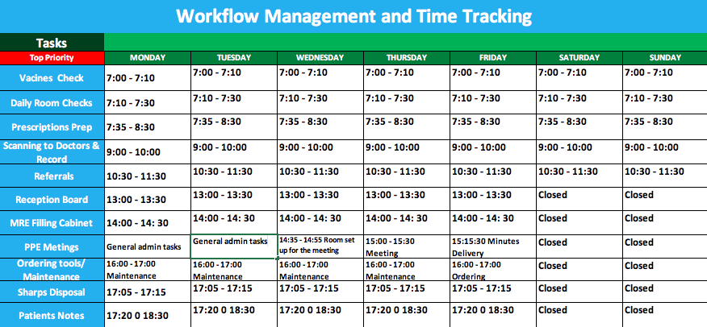
Speaker Notes:
I have created a Management plan including time tracking for each priority task, for each day of the week, excluding Saturday and Sunday Afternoon because the GP practice is closed for business those times.
I have created in Excell format, and this template is available for all remaining employees to access daily at:
• My Computer
• U-Drive
• Daily Priority Tasks Folder
This sheet has everything that has to be completed by the hour, and I will give explanations about how this is happening.
The way I have organized everything ensures nobody will feel overloaded, and everyone is having the same cut of every task at the same time. However, it’s divided by departments (Administration and Healthcare), reason why, is because not all Receptionist – Administrators are trained in healthcare.
Clinic running hours will remain the same apart from:

17:20 to 18:30
Doctors will stop public to conclude patients notes. Then you ask me, does it mean doctors will be running the shorter amount of clinics?
And the answer is, no, clinics will normally run, as usual, although the allocated time for each clinic will be shorter, we will decrease from standard time of fifteen minutes per patient to ten minutes, and I will explain why.
Normally after seeing a patient, doctors need an extra five to ten minutes to write patients notes into the NHS system. At times doctors can run late.
We have implemented a different system, we have purchased a recording device to each member of our clinicians.
Clinicians will record patient medical problems, this method will speed up the visit, and more patients will be seen throughout of the day, our Patients, in this case, our (Stakeholders), will be notified about this decision, consent will be requested.
This decision ensures no patient is left unseen or feeling neglected. Everyone will be treated as the days goes by. At the end of the day, Doctors will be able to use the time from 17:20 till 18:30 to listen calmly to the patients recordings and write it down to the NHS System, ensuring nothing is left behind.
Now going back to the beginning of the day:

7:00 to 7:10
The vaccines fridge temperature will be checked, and the temperature will be logged to the nurse's book.
Straight after the Doctor, Nurses and HCA’s room will be checked, to make sure ophthalmoscope, probes, cuffs, peak flows, gloves, urine tests and everything they need are in place or stocked up, so their clinics can run smoothly. This will ensure they don’t waste any extra time chasing a member of staff to get a hold of those materials.

7:35 – 8:30
Nurses and Healthcare assistants will ensure “repeat prescriptions” are done and signed by doctors for the patients collection.
Routine prescriptions will be given to patients during the consultation as it happens (they are two different things).

8:30
Doors open to the public, then Doctors, Nurses and healthcare assistants will run the clinics as usual, meanwhile, in the office, the receptionists and administration team will follow the time completing tasks and pushing forward the plan.
By this time there will have received the paperwork from hospitals by fax, and these documents must be scanned and allocated to Doctors and to the NHS records.
Usually, these documents include discharging notes, medicines prescribed by specialists, exams results, also pharmacies send us paperwork as well in regards to medicine to housebound patients, and many other documents. These documents must be taken care because they will be read by clinicians on follow up visits.
Some of these documents will be shredded in order to comply with patient confidentiality guidelines, and others will be stored in their MRE cabinet, where it is secured and locked with key code.

10:30 to 11:30
Referrals requested by doctors will be prepared or chased, because sometimes, hospitals take longer to process and book those appointments, because they are also short of staff.
For referral and chase ups, I have made the use a yellow note available. The head office IT Team was contacted and made a set up of that for us.
Doctors will allocated the request of referrals and chase ups vial Yellow note reminder; then Administration team will look at those notes and complete those tasks during the designated time.

11:30 to 13:00
Members of staff rotate their times for lunchtime, that’s why we have this gap of time, and no tasks were allocated.

13:00 to 13:30
Everyone is back together again; the clinical team continues seeing patients and reception/admin team works in the “Reception Board”.
The reception board is one of our method of communication to our stakeholders (in this case, our patients are the stakeholders).
Printed sheets are displayed in the reception board, it makes sure our patients have the information about the changes in our service.
The same data is also emailed or sent via post to our elderly patients.
The IT department has a system, in which lets us identify which patient has an email or not as a whole.
Sending letters through the post is very important because some patients are elderly and do not make use of computer, internet nor have email access.

14:00 – 14:30
MRE Cabinet job gets done, this time was chosen purposely because most of the Elderly patients are booked in the morning time, they usually are fasting to get their blood tests done and straight after they have a follow-up appointment.
Doctor may request their older files to be taken from the cabinet, but by 14:00 these patients are gone. It’s the perfect time to replace those files in the cabinet office back again, we must be very organized at all costs, and this is a real priority since those documents are not in the computer as a back-up plan.

15:00 0 15:30
PPE Meetings will only occur every Thursday, this is when we close the practice Surgery for half an hour, and all members of staff come together for the meeting.
The meeting is very straight forward to monitor what was successful and what shall be changed, we also bring some refreshments as a thank you for all the employees' cooperation and hard work.
A day later (Fridays) from 15:15 to 15:30 the meeting minutes will be sent to all members of staff. We keep working on our plan and monitoring daily before next Thursday when we review the plan of action again.

16:00 to 17:00
Health Care Assistants will together place orders of any equipment, medicine or material running out of stock. Nurses will take care of medical material maintenance and disinfection, at the same time the Admin team will order stationary materials needed and a general tidying up of the office and reception to ensure no document left behind.

17:05 – 17:15
Nurses will deal with Sharps bin disposal. and lock it, to ensure Health and Safety, and Infection Control guidelines are followed, and no harm to the environment will be caused.

17:20 to 18:30
Nurses and Doctors will work in the Patients notes task.
The administration team will have this free time to prepare and separate any prescription in alphabetical order for pharmacies collection.
Health Care assistants will ensure "Home Visit" bags are prepared for the day after.

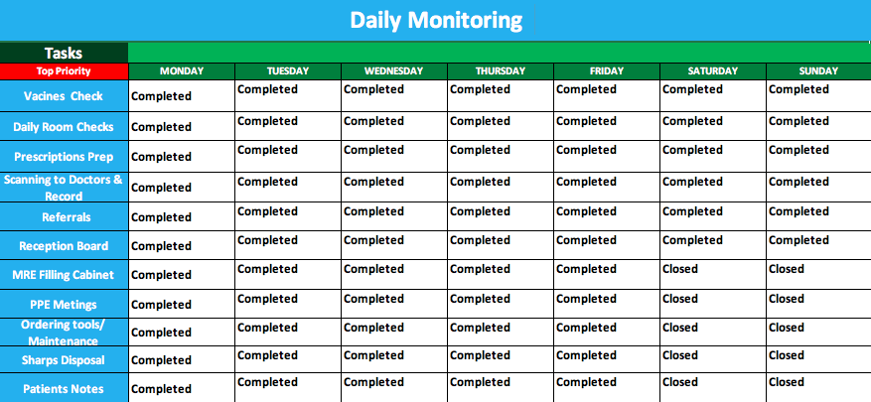
Monitoring and Weekly reviewing
Speaker Notes:
This workflow management and time tracking ensure all tasks are completed in a balanced proportion to all of the members of staffs, and nobody feels overloaded.
We hope within time, the government will invest money in Healthcare, and our Practice Surgery will be able to hire the lost members or a new crew.
Having the correct amount of employees will help us to go back to the natural pace, supporting the community and career development to best serve and cath up with outside innovations.
We are daily monitoring the tasks to solve the problems.
a Daily electronic sheet has been created in the system, and we are following up with it every day.
We created a plan in which, and when clinicians and Administration team end each task individually, they fill up their own daily sheet adding up the word “completed” to it. We revise it daily, and weekly during the PPE Meetting, every Thurdsay. These new implementations ensure the plan for the solution is going well and how everyone is feeling about it.
So far, the plan is going well, and we have achieved everything successfully. We have reviewed it for a month already, and no changes had to be made until this point.

Final Words
To finalise this problem solving and decision-making plan, I would like to mention that using a range of problem-solving techniques helped us to have a broader understanding of the worst-case scenarios and it was imperative in the implementation of a solution plan.

Liaising with patients (stakeholders), made them feel appreciated and far from been abandoned or neglected, it helped us avoid possible complaints and litigations.
The addition of our new tool, "the recording machine", diminished the time doctors would be spending on patients notes. It helped them to speed up clinics.
Allocating time for doctors to write patients notes, took a significant weight out of their shoulders because, at times, they need a clear frame of mind to think and develop a plan to treat disease on an ongoing basis continuously.
Having a separate time for the notes gives time for the doctors to research alternative solutions without the pressure of seen the next patient.

Patients (stakeholders) are happy having them to be notified about our current circumstances, and they can see that we are doing our best to look after them with all with care, compassion, competence, communication, courage, and commitment.
We had no complaints, and no patients left our business, which it is very positive, their trust remains in place towards us, as a business and as individuals, they understand we are a reliable team.
We will continue to strive to remain independent, maximizing well – being and improve health outcomes while working with people to provide a positive experience of care and measuring impact.
We aim to strengthen leadership, ensuring our staff have the right skill in the right place and also supporting a healthy well- being in the workplace when dealing with problem-solving and decision making.
We will continue reviewing our work as long as it takes to keep all those measures in place.
Expert creative thinking, SWOT, PESTLE, Fishbone and Gantt took huge part in the whole process.
I believe not only creative, but we are also rationally proactive thinkers, and we worked well as individual professionals and as a team. It is very satisfying when patients, management and work colleagues recognise our hard work.
We received many gifts in the form of appreciation.
Many thanks for the time and attention during this presentation.

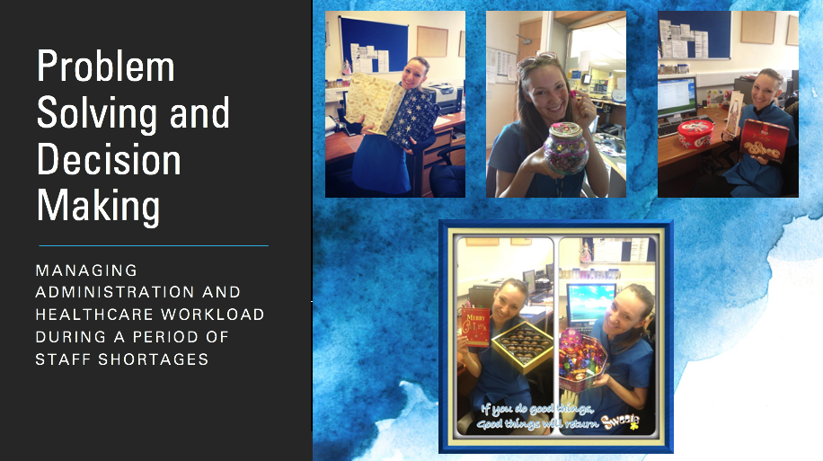

Reference List:
Harahsheh, F. (2019) Management Science Letter – The Effects of Time Management Strategies on Employees Performance Efficiency [Online] Available at:
http://growingscience.com/beta/msl/3246-the-effects-of-time-management-strategies-on-employees-performance-efficiency-evidence-from-jordanian-firms.html
Last Accessed 1st May 2020
Morgan, P. (2017) The Business Student Guide to Study and Employability P.297 1st Ed Sage Press
Morgan, P. (2017) The Business Student Guide to Study and Employability P.304 1st Ed Sage Press
Morgan, P. (2017) The Business Student Guide to Study and Employability P.318 1st Ed Sage Press
Paul and Elder. (2019) The Nature and Functions of Creative and Critical Thinking P. 5 3rd Ed [Online] Available at:
https://books.google.co.uk/books?hl=en&lr=&id=KjWbDwAAQBAJ&oi=fnd&pg=PA2&dq=Creative+thinking+&ots=ZHoOBRyuyU&sig=m7d1SEyqZEwPgaqdQaUfnTGNdGs&redir_esc=y#v=onepage&q=Creative%20thinking&f=false Last Accessed 2nd May 2020
Powel. J.D et al., (2019) Journal of Decision Systems and Evidence: The Quest for Rational Decision Making Online] Available at:
https://orsociety.tandfonline.com/doi/full/10.1080/12460125.2019.1623534#.XsP0ymaZPEY
Last Accessed 6 May 2020
Vaughan R. et al., (2018) European Journal of Sport and Science [Online] Available at:
https://www.tandfonline.com/doi/abs/10.1080/17461391.2018.1510037
Last Accessed 1st May 2020

