

Data Analysis

Student Name: Vishvarajsinh Surendrasinh Rana
Student ID: 2527154

MSc Data and Artificial Intelligence
Module: Advanced Statistical Programming
Module Code: ACCA7022

Lecturer: Dr. Aliyu Sambo

Table of Contents
TASK 1: RESULTS 3
1. Introduction 3
2. Section 1: Data Import & Summary 3
Table 1: Pollutant Summary Statistics (µg/m³) 4
Table 2: PM₂.₅ Summary by Season 4
Table 3: Weather Variables Summary 4
3. Section 2: Exploratory Visualizations 4
Figure 1: Monthly Average Trends - PM2.5 and NO2 5
Figure 2: PM2.5 vs Wind Speed 6
Figure 3: Temperature vs PM2.5 by Season 7
4. Section 3: Pollutant Correlation Analysis 7
Table 4: Spearman Correlation Coefficients 8
Figure 4: Pollutant Correlation Heatmap 9
Figure 5: PM2.5 vs PM10 Scatterplot (r = 0.691) 10
Figure 6: PM2.5 vs NO2 Scatterplot 10
Figure 7: NO2 vs Ozone Scatterplot 11
5. Section 4: Hypothesis Testing 12
4.1 Methodology 12
4.2 Hypotheses 12
Figure 8: PM₂.₅ Distribution by Wind Speed Category. 13
4.3 Results and Interpretation 13
6. Section 5: Seasonal Group Comparison 14
5.1 Methodology 14
5.2 Hypotheses 14
5.3 Results 15
Table 5: PM₂.₅ Summary by Season 15
Figure 9: PM₂.₅ distribution by season. 15
5.4 Interpretation 16
TASK 2: SUMMARY 17

TASK 1: RESULTS

1. Introduction

Air quality is a critical environmental concern directly impacting public health and urban planning. This report analyses the Port Talbot Hourly Air Quality dataset (2015–2024), comprising 87,672 hourly observations. Using $PM_{2.5}$ as the primary indicator, we evaluate temporal variations, pollutant interrelationships, and the influence of meteorological factors. The study employs a structured data science workflow, incorporating exploratory visualization, correlation analysis, and non-parametric hypothesis testing to assess the impact of wind and seasonality on pollutant dispersion.

2. Section 1: Data Import & Summary

The Port Talbot Hourly Air Quality dataset was imported into R, creating the AirQuality data frame, which contains 87,672 hourly observations collected between 2015 and 2024. The dataset comprises 24 variables, including key air pollutants$PM_{2.5}$, $PM_{10}$, $NO_{2}$, $SO_{2}$, Ozone ($O_{3}$), and Carbon Monoxide ($CO$)—alongside meteorological variables such as wind speed and temperature.
Before analysis, the dataset was examined to verify column names, data types, and overall data quality. The initial inspection identified non-numeric "No data" entries within several pollutant variables. These values were converted to missing values (NA), after which the pollutant measurements were converted to numeric format. This cleaning process ensured the dataset was suitable for subsequent statistical analysis.
Table 1 presents the descriptive statistics for the six primary pollutants, summarizing mean, median, standard deviation, and range. Preliminary inspection reveals clear seasonal variability in concentrations; specifically, the data indicates a peak mean concentration during Spring (11.2 ) and a minimum during Autumn (8.11 ).

Table 1: Pollutant Summary Statistics (µg/m³)

Pollutant | Mean | Median | SD | Min | Max
PM25 | 9.33 | 7.30 | 7.66 | -5.00 | 208.00
PM10 | 23.48 | 16.60 | 23.12 | -3.87 | 574.89
NO2 | 13.94 | 11.06 | 10.64 | 0.06 | 150.52
SO2 | 2.94 | 0.67 | 7.98 | -0.13 | 253.85
Ozone | 53.03 | 54.48 | 20.30 | -0.15 | 164.84
CO | 0.18 | 0.08 | 0.33 | -0.01 | 9.46

Table 2: PM₂.₅ Summary by Season

Season | N | Mean | Median | SD
Winter | 21672 | 9.33 | 7.1 | 7.54
Spring | 22080 | 11.12 | 8.2 | 9.59
Summer | 22080 | 8.88 | 7.5 | 6.17
Autumn | 21840 | 7.96 | 6.6 | 6.46

Table 3: Weather Variables Summary

Temp_Mean | Temp_SD | Wind_Mean | Wind_SD
9.58 | 4.78 | 5.46 | 2.89

3. Section 2: Exploratory Visualizations

Exploratory visualizations were conducted to examine temporal trends in multiple pollutants and investigate relationships between pollutants and meteorological variables. Six plots were generated using visualization techniques selected specifically for their suitability to the analytical objectives.
Figure 1 uses a time series plot to examine temporal trends in PM₂.₅ and NO₂, ideal for detecting long-term patterns and co-variation over the decade. Monthly aggregation reduces hourly noise while preserving trends.

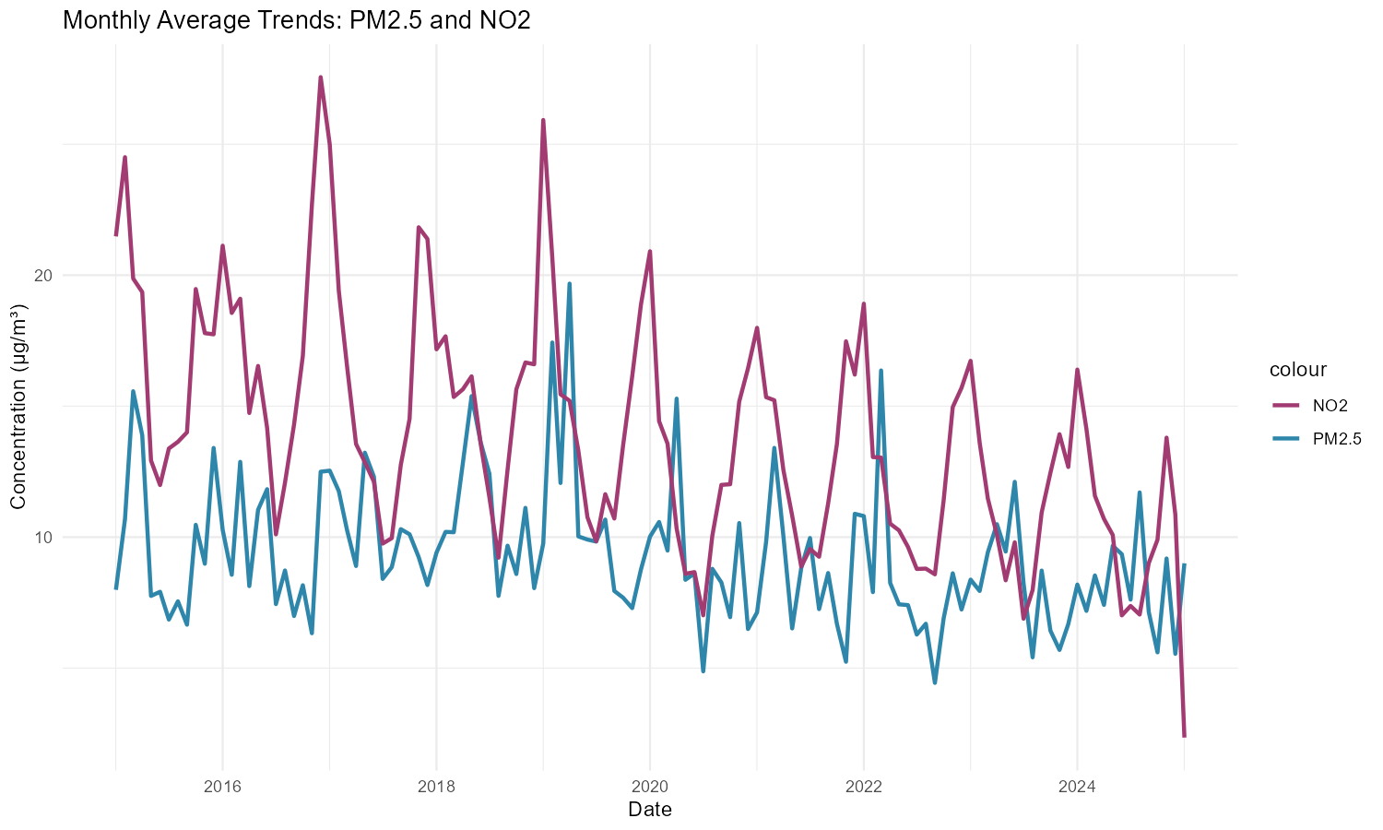

Figure 1: Monthly Average Trends - PM2.5 and NO2

PM2.5 and NO2 show similar cyclical seasonal patterns and coinciding peaks, with a weak decline over the decade consistent with traffic being a shared emission source for both.

Figure 2 uses a scatterplot to explore the wind speed-PM₂.₅ relationship, with the regression line quantifying trend direction and point transparency handling overplotting from 87,672 observations.

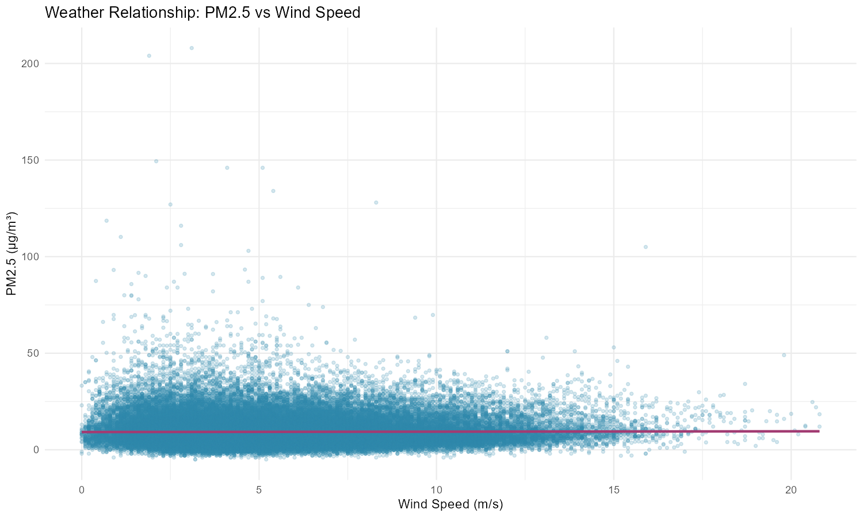

Figure 2: PM2.5 vs Wind Speed

The regression line reveals a weak negative relationship, with higher wind speeds slightly lowering PM2.5. However, substantial variability even at high wind speeds (outliers reaching 200+ µg/m³) suggests wind provides only modest dispersion, not the primary driver of PM2.5 variation.

Figure 3 employs a season-stratified scatterplot to investigate whether the temperature-PM₂.₅ relationship varies across seasons. Color-coding by season enables direct comparison of regression slopes, revealing whether atmospheric dynamics differ seasonally. This design detects interactions between temperature and season.
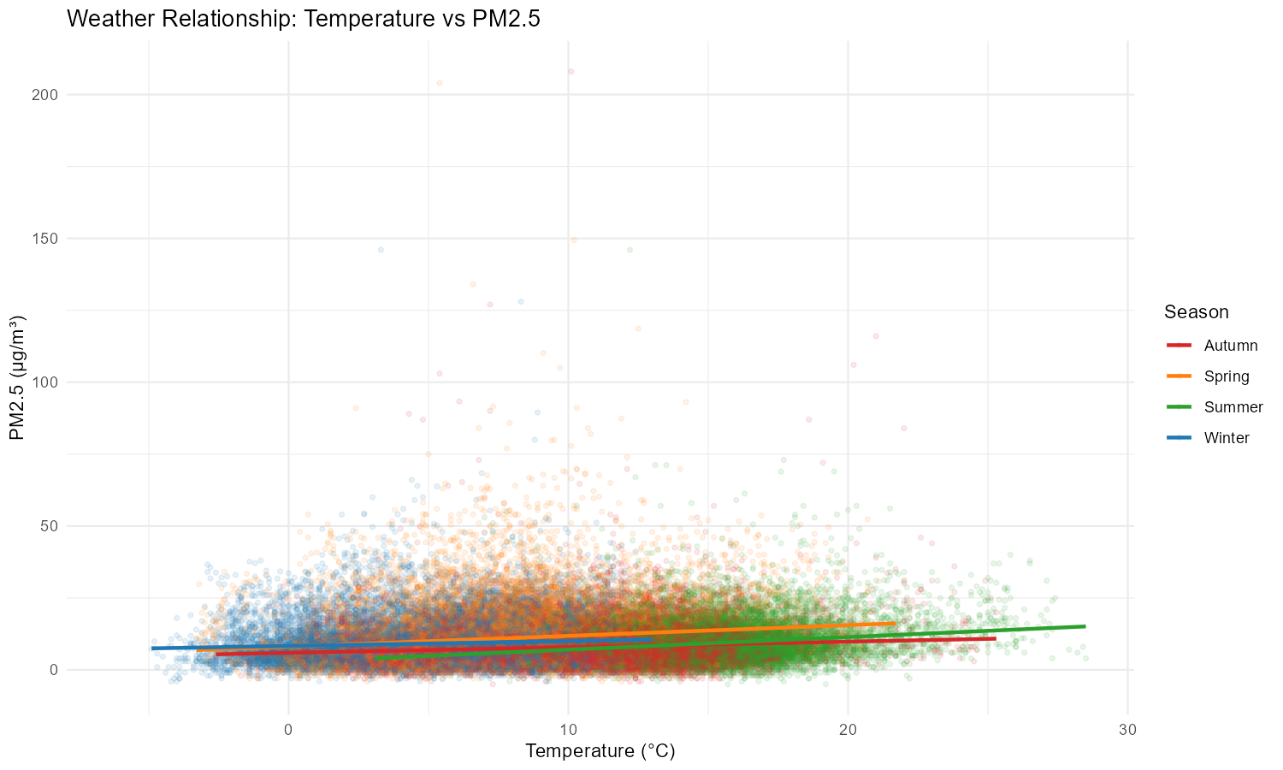

Figure 3: Temperature vs PM2.5 by Season

Season-specific regression lines show the temperature-PM₂.₅ relationship varies considerably: Winter and Autumn show nearly flat slopes (minimal temperature effect), while Spring and Summer show positive slopes, possibly from increased atmospheric stability or secondary pollutant formation in warmer conditions. This confirms atmospheric dynamics shift significantly across seasons.

4. Section 3: Pollutant Correlation Analysis

Correlations were calculated between the six primary pollutants—$PM_{2.5}$, $PM_{10}$, $NO_{2}$, $SO_{2}$, Ozone ($O_{3}$), and Carbon Monoxide ($CO$)—to identify relationships and potential common emission sources. Given the non-normal distribution of the air quality data (confirmed via the Shapiro-Wilk test), Spearman’s rank correlation was employed. This non-parametric method is more robust to outliers than the Pearson correlation and does not assume a linear relationship, making it the most appropriate choice for evaluating the non-linear dependencies often found in air quality datasets.

Table 4: Spearman Correlation Coefficients

 | PM25 | PM10 | NO2 | SO2 | Ozone | CO
PM25 | 1.000 | 0.691 | 0.354 | 0.371 | -0.035 | 0.389
PM10 | 0.691 | 1.000 | 0.265 | 0.494 | 0.129 | 0.409
NO2 | 0.354 | 0.265 | 1.000 | 0.387 | -0.411 | 0.475
SO2 | 0.371 | 0.494 | 0.387 | 1.000 | 0.009 | 0.415
Ozone | -0.035 | 0.129 | -0.411 | 0.009 | 1.000 | -0.260
CO | 0.389 | 0.409 | 0.475 | 0.415 | -0.260 | 1.000

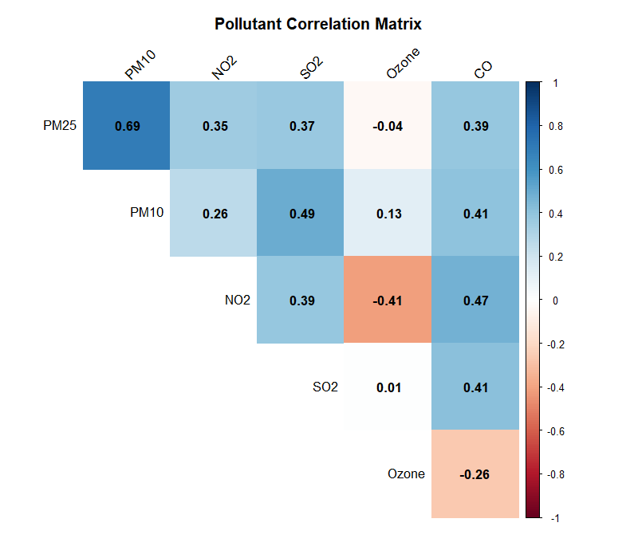

Figure 4: Pollutant Correlation Heatmap

The heatmap visualizes all pairwise correlations between the six pollutants. Color intensity indicates relationship strength: dark blue represents strong positive correlations, light blue represents weak positive correlations, and orange/red represents negative correlations. The upper triangular matrix format provides a clear overview of all relationships.

Findings:
- PM₂.₅ and PM₁₀ (r = 0.691): Strong positive correlation indicates shared traffic and dust sources.
- PM₂.₅ and NO₂ (r = 0.354): Weak positive correlation reflects partial overlap in traffic-related sources but distinct origins.
- NO₂ and Ozone (r = -0.411): Negative correlation characteristic of urban photochemistry where NO₂ consumes ozone.
- NO₂ and CO (r = 0.475) and PM₂.₅-CO (r = 0.389): Both moderate positive correlations reflect shared combustion/traffic origins.

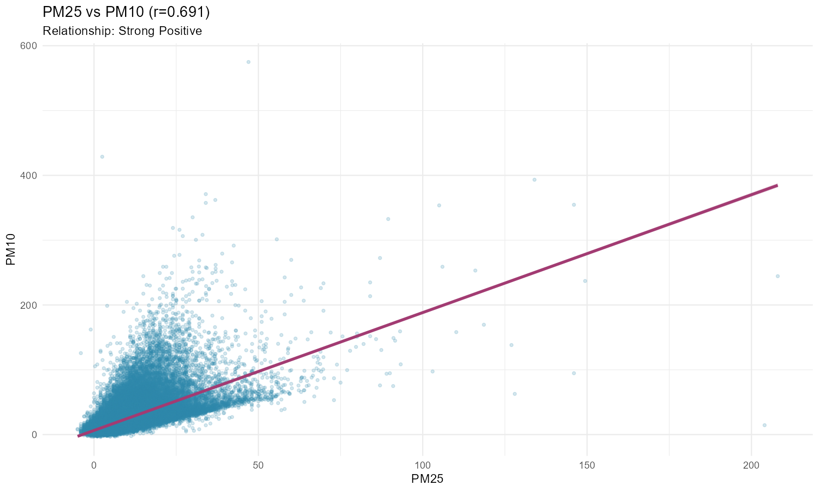

Figure 5: PM2.5 vs PM10 Scatterplot (r = 0.691)

The scatterplot confirms the strong positive relationship (r = 0.691), with most values clustered at lower concentrations and occasional high-pollution events reaching 200+ µg/m³.

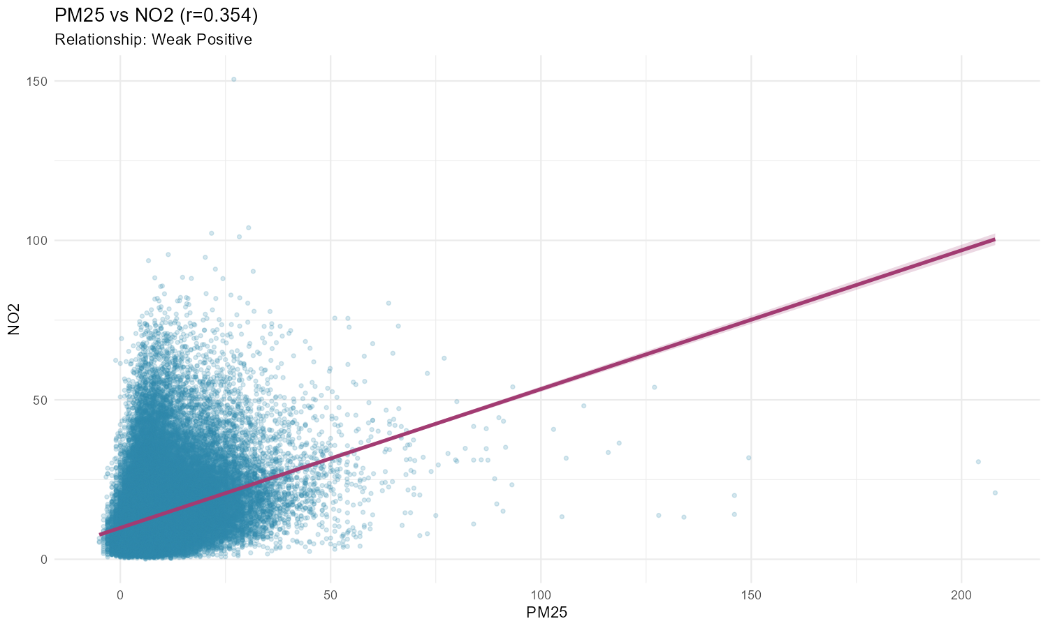

Figure 6: PM2.5 vs NO2 Scatterplot

The gentler slope and wider scatter compared to Figure 5 confirm the weaker relationship (r = 0.354), reflecting the distinct source contributions to each pollutant.

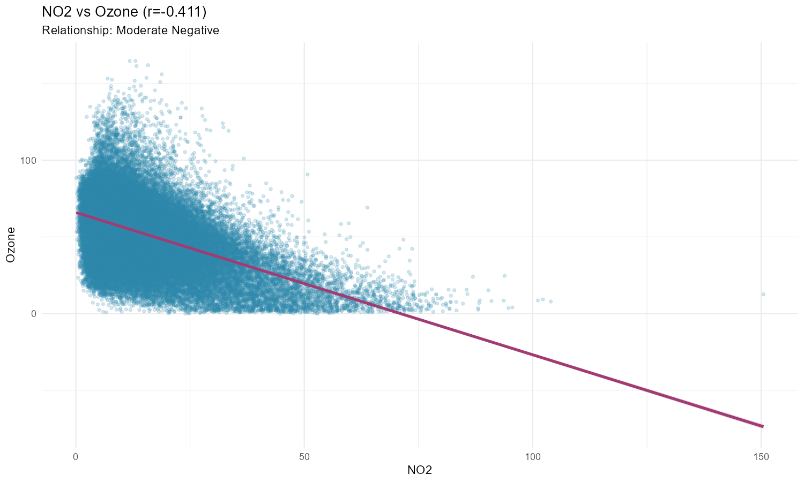

Figure 7: NO2 vs Ozone Scatterplot

The negative trend line confirms the inverse relationship (r = -0.411), consistent with NO₂ consuming ozone in polluted urban air.

5. Section 4: Hypothesis Testing

4.1 Methodology

Hypothesis testing was conducted to determine whether wind speed significantly affects PM₂.₅ concentrations. PM₂.₅ was selected as the pollutant of interest due to its health relevance. Wind speed data was categorized into two extreme groups-low (≤ 25th percentile) and high (≥ 75th percentile) to isolate the effects of calm versus windy conditions on pollutant dispersion.
The Shapiro-Wilk test was performed to assess normality, yielding a p < 0.001, confirming the data is non-normally distributed. Consequently, the Mann-Whitney U test (a non-parametric alternative to the t-test) was selected to compare the median PM₂.₅ concentrations between the two independent groups.

4.2 Hypotheses

- Null Hypothesis (): There is no significant difference in the median PM₂.₅ concentration between low and high wind speed condition.
- Alternative Hypothesis (): Median PM₂.₅ concentrations differ significantly between low and high wind speed conditions.

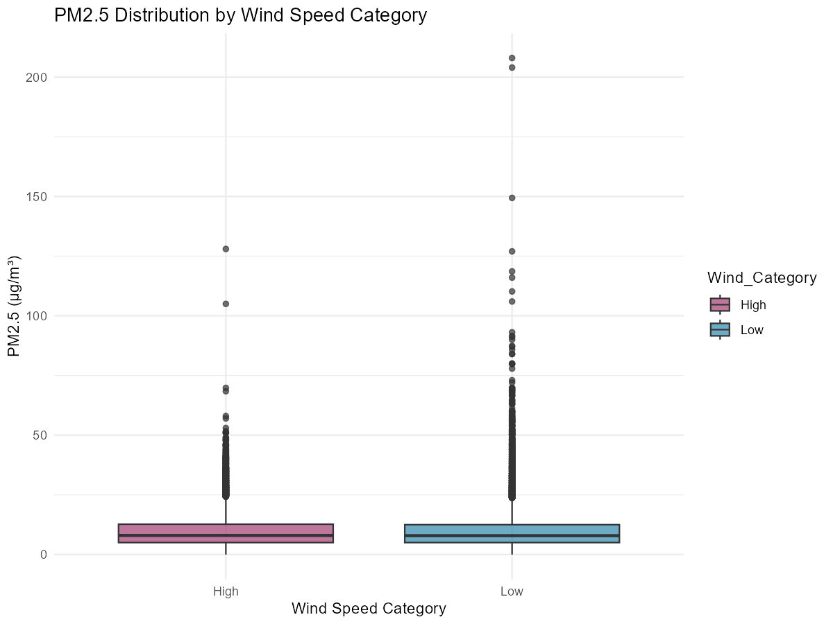

Figure 8: PM₂.₅ Distribution by Wind Speed Category.

4.3 Results and Interpretation

The Mann-Whitney U test returned a p < 0.001, allowing us to reject the null hypothesis at the 95% confidence level.
As illustrated in Figure 8, the median PM₂.₅ concentration is visibly lower during high-wind conditions compared to low-wind conditions. This finding aligns with established atmospheric science principles: higher wind speeds enhance air mixing and mechanical dispersion, which dilutes ground-level pollutant concentrations. Conversely, low-wind speeds facilitate the accumulation of particulates, contributing to higher concentrations. These results provide statistical evidence that wind speed is a primary meteorological driver of air quality variability in Port Talbot.

6. Section 5: Seasonal Group Comparison

5.1 Methodology

Group comparison analysis was conducted to determine whether PM₂.₅ concentrations differ significantly across the four seasons (Winter, Spring, Summer, Autumn). PM₂.₅ was selected as the pollutant of interest. Given the non-normal distribution of PM₂.₅ data and the comparison of more than two independent groups, the Kruskal-Wallis test (non-parametric alternative to ANOVA) was selected. Post-hoc pairwise comparisons using the Wilcoxon test with Bonferroni correction were conducted to identify which seasonal pairs differ significantly.

The Kruskal-Wallis test was selected as the appropriate statistical test for the following reasons:

- Non-Normal Distribution: PM₂.₅ data is right-skewed and non-normally distributed, as confirmed in Section 2. The Kruskal-Wallis test is non-parametric and does not assume normality.
- Multiple Groups: Comparison involves four independent groups (seasons), requiring a test for k≥3 groups. The Kruskal-Wallis test is the non-parametric alternative to one-way ANOVA.
- Robustness: The test is robust to outliers and unequal variances, both present in air quality data.

Post-hoc pairwise comparisons using the Wilcoxon test with Bonferroni correction were conducted to identify which seasonal pairs differ significantly.

5.2 Hypotheses

- Null Hypothesis (H₀): PM₂.₅ concentrations are identical across all four seasons. Any observed differences are due to random variation.
- Alternative Hypothesis (H₁): PM₂.₅ concentrations differ significantly between at least one pair of seasons.

5.3 Results

The Kruskal-Wallis test returned a test statistic of H = 1252.08 with a p < 0.001, allowing us to reject the null hypothesis at the 95% confidence level. This confirms that season is a statistically significant driver of variability.

Table 5: PM₂.₅ Summary by Season

Season | N | Mean | Median | SD
Winter | 21672 | 9.33 | 7.1 | 7.54
Spring | 22080 | 11.12 | 8.2 | 9.59
Summer | 22080 | 8.88 | 7.5 | 6.17
Autumn | 21840 | 7.96 | 6.6 | 6.46

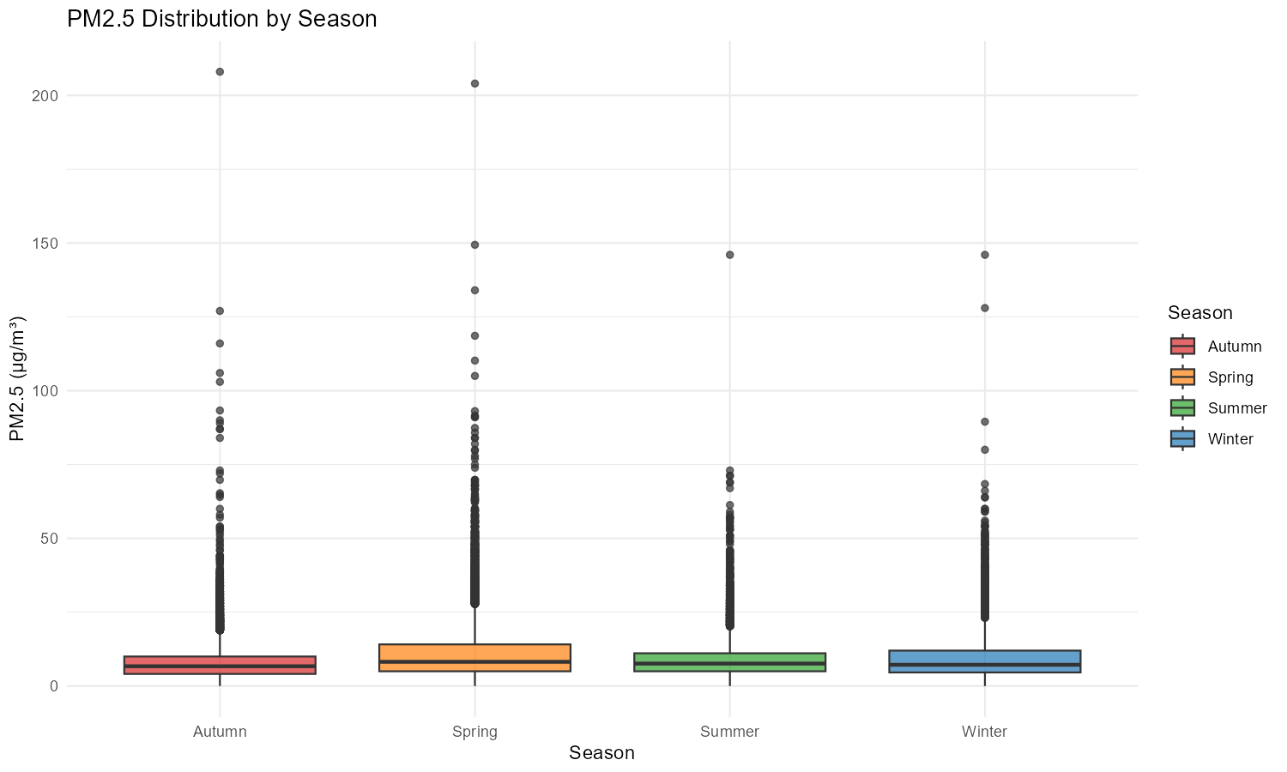

Figure 9: PM₂.₅ distribution by season.

5.4 Interpretation

The analysis reveals distinct seasonal trends in concentrations. Spring exhibits the highest median concentration (), which may be attributed to a combination of seasonal meteorological transitions and localized factors, such as increased dust resuspension during drier periods.
In contrast, Winter concentrations remain elevated (median) likely due to atmospheric stratification and reduced boundary layer heights, which trap pollutants near the surface. Summer concentrations, while moderate, reflect the influence of enhanced atmospheric mixing and vertical dispersion. The statistical significance of these differences demonstrates that seasonal atmospheric dynamics are a primary determinant of air quality in Port Talbot, providing a robust basis for future seasonal forecasting and targeted mitigation strategies.

TASK 2: SUMMARY

Understanding the Data Through Visualisations
The summary statistics gave a useful overview, but they did not show how pollution changed over time or related to weather. Creating visualisations helped me explore the data properly, and each plot answered a specific question that guided my later statistical choices.
The first plot was a histogram of PM2.5 concentrations. Most readings clustered at low concentrations, with a long right tail from occasional high-pollution hours. This told me the data was not normally distributed, which directly shaped my decision to use non-parametric tests later.
Boxplots comparing PM2.5 across seasons made the seasonal pattern much clearer than the summary tables alone. Spring showed the highest median PM2.5 concentrations, while Autumn had the lowest. This suggested that the seasonal hypothesis test was likely to identify significant differences.
The monthly time series plot (Figure 3) showed a repeated seasonal cycle across the full ten-year period, reinforcing that seasonality was a real, consistent pattern rather than a one-off. Scatterplots of PM2.5 against wind speed and temperature let me explore relationships before running formal tests. Although wind speed showed substantial scatter visually, the Mann-Whitney U test (p < 0.001) revealed wind speed significantly affects PM2.5 with higher winds enhancing dispersion and lowering concentrations. This demonstrated that statistical tests can uncover real effects despite visual noise in the data.

Challenges and What I Learned
The biggest challenge was a subtle bug I found in the timestamps. The dataset used "24:00:00" to mean midnight at the end of the day, but R's date functions only accept hours 00-23. Without noticing this, my code would have silently removed one midnight observation for each day in the dataset. Because the dataset spans around ten years, this would have resulted in the loss of thousands of valid observations with no error message at all. I only found this by manually checking the raw values and comparing how Excel handled the same data. Fixing it taught me that missing data can hide silently in code that appears to run correctly, and that I need to check my results, not just assume they worked.
A second challenge was that my expectation about wind speed was wrong. I assumed stronger wind would disperse pollution and lower PM2.5, but the test showed no significant difference (p = 0.364). Rather than reframe this to sound more interesting, I reported it honestly - this taught me that a non-significant result is still a real finding, and it pushed me to think about other explanations, like industrial sources dominating over wind dispersal at this specific location.
Missing data was also a real issue: some pollutants had up to 6.86% of readings recorded as missing. I chose not to estimate these values, keeping only complete, reliable observations, even though this meant a smaller sample for some analyses.
Deciding between Pearson and Spearman correlation taught me that choosing a statistical method isn't just about running a function - it's about checking the data's actual shape first (via the histogram) and picking the method that fits, then explaining that choice clearly.

Improvements for Future Work
If I continued this project, I would investigate why PM2.5 is consistently higher in spring, build a regression model combining season, temperature, and wind speed to explain PM2.5 more fully, and compare my findings against WHO air quality guidelines to give the results real-world public health context.

Generative AI Use Declaration
I used Claude (Anthropic) as a debugging and learning aid throughout this assignment - particularly to identify and understand the hour-24 timestamp bug, and to check my statistical reasoning against my lecture materials. All code was written, tested, and understood by me; the analysis, interpretations, and conclusions above are my own.

